Contents
Manipura 1
Om 2
Mani 4
Padme 5
Hum 5
Compassion 6
Womb 7
Adam 8
Relating to The Absolute 9
Absolute Good and Bad 10
Uniqueness 11
Sin 11
Falling asleep 14

Manipura
[A talk given by Eugene Halliday.
Comments in square brackets, drawings,
arbitrary headings and transcription by John Bailey.]

I’ve been asked to talk about a special Hindu concept, which comes under the title Manipura. I don’t know whether you’re old enough, any of you, to remember Dorothy Lamour in “The Moon of Manakoora”? Well this is the moon of Manipura. This is a little more serious than she and Bob Hope had been cast in.
[Female member of the audience] How do you spell it, please?
Pardon?
How do you spell it, please?
D-o-r-o-t-h-y [laughter from the audience].
I’ve actually put down d-o- [laughing]. It’s because you don’t like putting the machine on! [Overhead projector]
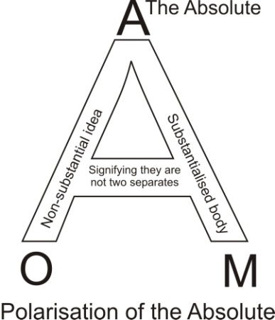
For your sake I’ll put it on.
Thank you.
Only for your sake. Nobody else must look. If you do, look this way. I’m going to write it vertically ... what’s wrong, David?
[David] Not at the moment you’re not.
Funny, that, isn’t it? I deliberately moved it to see if I’d get corrected [more laughter]. It was ok when I came in. This week’s deliberate mistake. Now, usually, this is written horizontally across the page, and you then tend to read it like a sentence, with a beginning, and a middle, and an end. I’m going to write it vertically for ontological reasons ... that is to say for reasons of the hierarchy in the universe.

Om
So I’m going to put a magical word to begin with. Can anybody pronounce that for me?
[Several people] Om.
Om? I know an Englishman who went away to India, especially to learn how to pronounce that word. And he came back and said he had learnt the secret of the sacred Om. [pronounced affectedly ‘ome’ as in ‘home’; followed by audience laughter]. Now are we to draw a line under that one? Because that means the pre-analytic wholeness of being, in two aspects: the O the intellective, not substantial; and the M, the substantial aspect of the same. So it means the totality of all conceivables, viewed in their simultaneity. It represents the omniscience of what is signified by the concept of god, including the concept of god. Now that is prior to analysis. So the next word must be analysis.
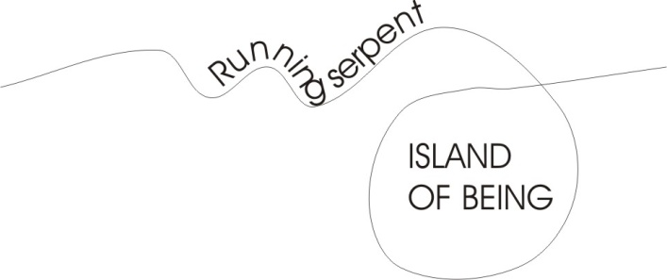
And this is a very charming word. The ‘M’ occurs again, but now it is subject to what is signified by A-N-I. Now do you know the A-N means a serpent, running? When the serpent runs ... shall I draw you a running serpent? I’ll draw you a running serpent, one running serpent, like this. Now sometimes the serpent, being a little sensuous, excites itself by dashing across itself like that. And at that point it makes a point or letter I pronounced ee, as in Italian. That point is the terminal vowel there. [4:07]
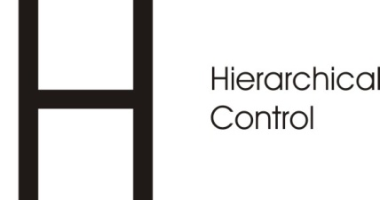
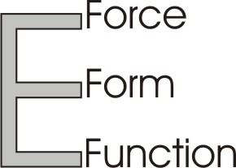
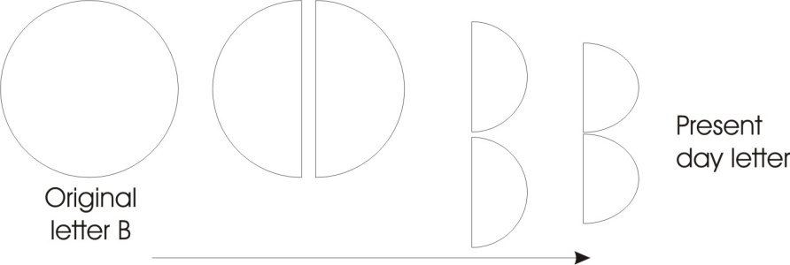
So imagine a running serpent suddenly crossing itself. Now you know that in crossing, it has made a closed zone here. If I do it very simply it crosses, and immediately here there’s an island of being. Now the letter B was originally a sphere, and then drawn on a flat surface as a circle, and signifies anything whatever that can be circumscribed with a line, and therefore recognised as a form. Now the M itself means the substantial aspect of that sacred OM — not the intellective aspect, the substantial aspect — and consequently we must view it as demoted. You know that we use an aspirate to signify spirit, our letter H ... and the soft form of it is a softer H. Can anybody pronounce a soft H for me, and a hard H?
A simple H like hhhhh, just breathe with your mouth hhhhh. That’s soft. Now block it at the back of your mouth with the back of your tongue ... that’s a hard one [like the German Ch or the Arabic Kh]. The gentle one is the fifth letter of the alphabet, which in English is E and in Hebrew is Heh, and it signifies a threefold force-form-function ... very gentle. It means life without impedances. But when you come to the hard H, called spiritus asper, you grip it, and life is then under control. And therefore the eighth letter, the H, signifies hierarchical control.
Now, the free spirit is represented by a letter which in English is ‘A’, so I’ll put that here, ‘A’ ... that’s the Absolute. And that is above the concept of the ‘O’ and the ‘M’ as polar opposites. Intellective, non-substantial idea, substantialised body which is simply the idea compressed, energetically. The A’s the Absolute so we could write it over the Om and let one arm of the A go down to M and one arm to O. That’s what we call polarisation. The tie in the middle signifies that they are not really two separates. They are two aspects of an Absolute.
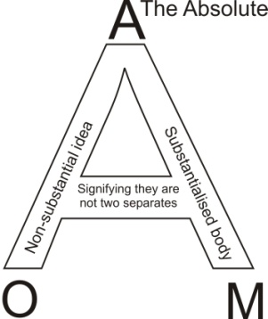
Now, the Absolute is utterly unconditioned. I want you to imagine this: an Absolutely Unconditioned Sentient Power. Now I’m going to represent it as consciousness with no object impeding it. What is it like? Think of your awareness. Think of your awareness without an idea to limit it, without an emotion to limit it, without an impulse of Will to limit it ... Pure, Infinite Consciousness. And when you see that letter A, think, that is the thing referred to, it is a no-thing. It is not a form at all. That is the A before the sacred OM, and the O polarity now splits. The M comes down like this to here, but it has been demoted because when you pronounce M you have to close your lips. If you close your nose as well at the same time, you can’t pronounce it. So when you pronounce an M there is an escape of N, just in order to articulate and express it. [8:34]
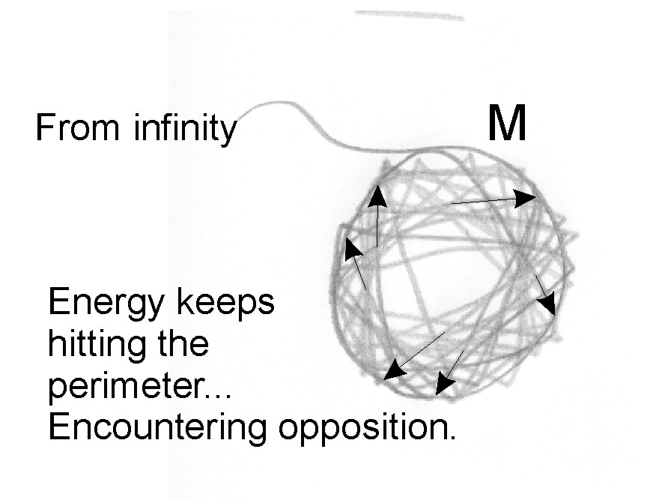
Now, the M is the mother letter — that is to say it’s the first letter of Mother — it’s Mem in the Hebrew, M.E.M., and it signifies the substantial aspect of being, and it is pure inertia and it has no initiative and no form of its own. It is just pure Glog. Can you imagine pure Glog? Do you know anybody like that ... thicker than someone who’s thicker than two short planks? I know some of those, and they’re very, very efficient in business, and they make millions quicker than anyone else because of their Glog. They see something and they close on it and they become terribly wealthy and very, very powerful. Unfortunately you could actually sell them an imitation Turner quite easily, painted by Tom Keating. So Imagine the M signifies second-class citizen. Substance, the so-called female, and remember we know that all human beings have both poles, an intellective pole here, the O, and an emotive substantial, body orientated. Recently, when a North American Indian was interviewed and asked about the difference between man and woman, he said woman as such in North-Indian philosophy was she who ignores the dictates of spirit. And man tries to obey, to his great sorrow, the dictates of spirit.
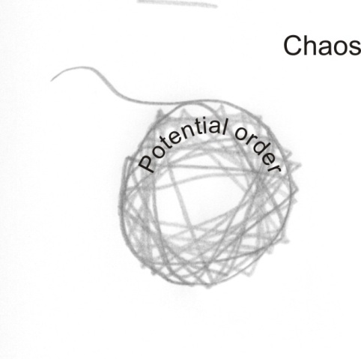
So we are to think of this M as a closure, and therefore, being closed, it is resenting. Now I want you to imagine — I’ll draw you a closed M — it has come from infinity and wound in and made a circle. The energy has gone inside it and hit the wall and bounced off the wall, and bounced again to hit the perimeter like this, and it keeps hitting it. And it goes round like this, always hitting the wall. So every time it hits the wall of its own enclosure, it feels impeded. But if you close your mouth for a moment and hum, you will feel in the MMMM that somehow your mouth is full of substance. Can you feel it? You can feel a vibration of energy. Air is vibrating, and that is what you mean by substance, namely resistance encountering opposition. The encountering of opposition is what we call resistance, and the experience of that makes us aware that we are physical body entities. We also have an idea of it, which is not substantial, and therefore is merely an idea. We call that an abstract idea. So when we see the letter M we must think that M is full of resentment. Resent means re-feel ... re-sent, sentire [Latin] to feel. It continuously — when the energies come in from the infinite — beats about inside, and gets very, very, very annoyed with itself because of the closure. But at the same time it feels itself to be a being of substance and meaning, and it doesn’t like to let go of that. [12:39]
If some of the energy bounces out of it by penetrating the wall, that bit of energy is suddenly launched into the void, and feels void, and therefore it tends to curve back in again. So you get a cycle. Let’s call outside there, chaos, that is, non-order. And inside here, is potential order ... order, because the word Ord, Rod, Rota, all signify this spherical enclosure. Nevertheless the polarity which was in the O and the M is now hidden in the M and the M remembers that it was once free Absolute, and it resents losing its freedom, but is delighted in finding its substantiality. [13:32]
So if we divorce the male aspect of the human being from the female, and consider the female aspect alone — remember that’s an abstraction because they always concur together in the same being — there is always a polarisation, a deep resentment of the limitation of being a physical being, and at the same time delight in being a physical being, because thereby we can demonstrate, separately from other beings. Apart from that closure we would not be separate. Here is another closure, if I’m lucky, and this being is not that being, it is separate from it although it came from the same Absolute. [14:19]

Mani
Now, Mani itself is translated as a diamond, or a jewel. The word jewel is a Semitic reference, and means God himself. You know the word Jew actually means mysterious perfection of God himself, and E.L. is the form, the first form of God, Elohim, which in the Muslim world is Allah.
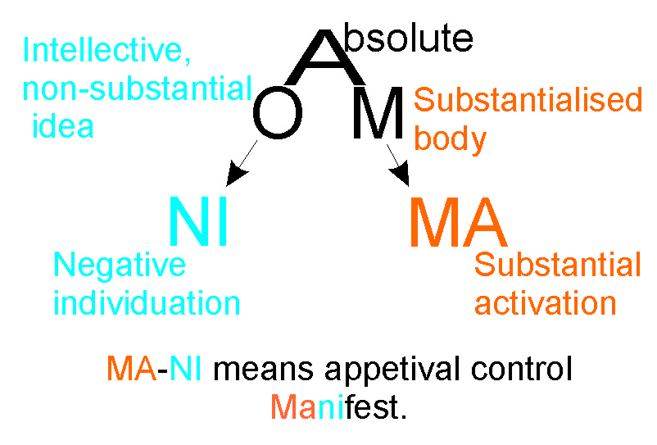
Now, imagine the M is activating itself inside by filling itself up as much as possible with energy. It’s determined to eat the infinite energy outside itself, and grow into a very big sphere full of what it calls being. That’s a verb isn’t it? Being is a verb. It’s a continuous form, the i.n.g., self consolidating, continuously expanding, continuously eating the infinite, and involving itself into itself as an Absolute appetival intent made manifest as a body. That means that the substantial aspect of being — whether it’s in the angels, or the humans, or the animals, or the vegetables, or the minerals — the substantial aspect is frustrated by existing, and delighted to be manifest. [16:05]
There is the MANI in manifest.
Now the word MA there means substantial [M] activation [A], and the word NI means negative [N] individuation [I]. That is to say we translate MA as an appetite through the infinite trying to gobble up the infinite and the NI is the negation of that ... it is the control of appetite. Mani means appetival control by the negation of form. Now we have these inside us as a polarity.
Now the O intellective there has become the N.I. here [left of the diagram], as the MA has become the M there. It means the dual and it means pure, self, substantialising, self negating, individuated control ... a diamond. [17:12]
Now, a diamond as you know has a shape, and it is structured in a certain way. If you find one and examine it carefully under appropriate magnifying glass, you will see that it is facetted internally. And a good diamond cutter can see the lines of cleavage, and he can then chip away what he doesn’t want, and the result of that is a faceted being. Some of you may recognise the facetted being. That is a simplified diagram, copied on the flag of Israel, and signifies the facetted whole. Now what is the difference between an O signifying wholeness without analysis, wholeness without formal separativity, just wholeness, like a W.H.O.L.E. or a Greek H.O.L., a whole with no parts.
Now if we cut it in the appropriate manner we can make it facetted; the light of consciousness shining through it comes out at different angles and displays marvellous colours. And this marvellous property of a diamond has fascinated the intelligence as far back as we can go in history. Always the diamond has been worshiped as the very, very type of being to be. So in Buddhism or Hinduism, or in the far east generally — China, Japan — this Mani, this diamond body, is tremendously important, and it signifies a being that was once an abstraction in the Absolute, brought down substantially, and then counting its own appetite — ‘man’ means to count — counting its own appetite and individuating the products of its counting, it has become a highly facetted individual. [19:23]
Now every subject matter we know that’s different from another subject matter, is a facet of our being. If you know algebra and you know geology and you know synthenology, or any other -ology clearly, precisely, definitionally, then the totality of that knowledge is your facetted being, it is your mani. And the ‘I’ there signifies the individual who has done the work of negating his own appetite in order to discover his facetted hidden self.
So whereas the wholeness is simply whole without form, the diamond — the mani — is the same wholeness analysed into an infinity of facets. So instead of knowing all there is, he knows not only all but each facet of existence. Well, if you count thoroughly all that you’re capable of, all of it, you discover the facets of your action possibilities so thoroughly, you can afford to relax and play with them. [20:42]

Padme
So the next phase is, when you’ve completed your mani phase, you have to bang reality to get something out of it ... we will have padme. And that means lotus, and the lotus means ‘play’.
Lotus is a very good spelling of the English, let us. You know when we say ‘let us pray’? Imagine saying lotus pray. That means if you thoroughly understand yourself, you know how to enjoy yourself.

Hum
So then we have a fourth phase here, and this means that the O.M. has become H.U.M. Right? And I’m going to draw a line round here, and I’m going to enclose those three because the OM is unanalysed, but these three have been analysed. And the O in the beginning has become a U down here, and the A up there which is Absolute beyond all definition, has now become the eighth letter H and means hierarchical. So a hierarchical differentiation of powers driving into the substance is the same O.M. but now developed through self-counting, and playing with that which has been counted ... with great joy, because you know what you are doing.
Now, therefore that particular mantra, that Om Mani Padme Hum, this cry you could four, and you can imagine it. This U.M. becomes in English like an N.G., so you can say, HUUU [forcefully].
Now say a gentle uhuhuh [said gently], how do you feel? How do you feel if you say, ‘who’ [said gently]? I mean, apart from it not being English, how do you feel? It’s a nice, gently breathed hoo-oo. Now compare that to before you’ve done your analysis, it’s like somebody at a party afraid to speak in case anybody knows they’ve come. And when they’ve gone through this process of self-counting, self-negation, self-control and play with that which has been discovered in the counting, you say oh? becomes HUUUUU [forcefully]. That means you’ve got the hierarchical power to feel any pre-analytic OM that may be walking about. Now at that point you have to remember, otherwise you will become a demon, a fiend, a hellish being. You are to remember the infinite compassion of the Absolute. You have become …
…I think I’ll give that one up, and try another. Think I’ll try a red one [may here be talking about his marker running dry]. [24:07]

Mani. Can you read that red? [the colour of the marker he is now using] ... and Pura.
Now that [mani] means the jewel and this [pura] means a city. Manipura means a diamond city. You are the city, your being, your very being, your physicality, your emotionality, your tactics, your strategy, your volition, your consciousness as a sphere of self-discovered being is called Pura. Now that PU means power, push drive, and the RA means discriminative activity and therefore rulership. So you have built your own being, your own body, your own mind, your own heart-felt evaluation, these are being built into a special magical city and nobody else can disturb or penetrate without your permission. You are manipura. Jewel or diamond city is the state of the attained man who has realised his origin. You see that same pura in a lot of Indian names for cities — Jaipur, Singapur, and so on — all these various names with a pur on the end are referring to this pura — this power, discriminative activity. [25:57]

Compassion
Now let’s examine what the compassion of god means. Now you know that the compassion itself as a word signifies with suffering. Com-passion: Passion, suffering; the prefix, with. Together suffering is compassion.
Now, absolutely there isn’t anything other than that which is signified by that letter A. That letter A, the Absolute, suffers itself. That is to say, whatever it does, it feels. Now, because of that, prior to creation — I want you to imagine its condition — prior to creation, an Absolute Infinite Sentient Power ... absolute, infinite, sentient power, feeling itself in its absoluteness, utterly unimpeded, unformed, unmanifest.
How does it feel?
Can we comprehend it? From the finite viewpoint of a human being, can we comprehend what it means to see nothing, feel nothing, and the nothing that we feel is our own absolute being, not manifest into ourselves. Now is it worth staying like that? [27:24]
[Member of the audience] No.
No. and therefore it says that god says, you get this in the Qoran, god said I was a hidden mystery, I desired to manifest myself, therefore I created the world. But particularly, not only the world. The world is like a vast map. He created not only the world ... but man. Man is the evaluator; mani is the perfected man, individuated to the nth degree. He perfected man as his count, his measure of the universe.
Now you know that if you have a map of a country and you don’t know how to read it, the map is not very useful is it? As a matter of fact when I was having a small cuppa today, there were some brilliant intelligence debating. One was Jonathan Miller, and the other fellow said, “if you had a device that could show the structure of a motor car engine, and you put it under the bonnet, it wouldn’t run the car.” You have to have something that could interpret the diagram, and you’d need a man to invent the diagram and the map and the engine, wouldn’t you? So individuated man, mani, is actually the evaluator of the absolute intention to self-discovery. I was a hidden mystery, I decided to make manifest myself, I made the universe, but then I had to make a man who could observe the universe, a man being here an evaluator. Therefore man was made. He was made after the angels. The angels are ideological energies, choiring in eternity. Man was made lower but destined to be higher, because man can actually comprehend everything whatever that there is, by simply comprehending himself. [29:43]
Why? Because all spheres are identical. It doesn’t matter how tiny they are or how big they are, they’re all functions of Pi ratio, are they not? So that to analyse one circle, one sphere thoroughly, is to analyse all spheres. So if you then know if you analyse yourself you will know all selves. Like it says of Jesus ... that because of his mighty works, people began to believe on him. But on that account he didn’t begin to believe on them, because he knew what was in man. So he abstracted himself from the mob, because he knew the mob perfectly, because he knew himself. He knew that every conceivable activity is a possibility for every individual.
So, com-passion: suffering-with. The A signifies the Absolute Infinite Sentient Power, source of all things. As infinite, there is nothing whatever beyond it. So that what we call creation at any level is a modality of that Infinite Sentient Power which is called the Absolute.
Now, the Absolute itself, in itself, for itself, has no finite limiting concepts or bodies such as we have. It has projected those internally, introjected them into itself to manifest qualities to itself which would otherwise remain hidden. So we all have inside us, every one of us, what every other being has inside them. So my friend Peter here has everyone in this room inside him. His wife there has everyone in the room inside her. He is inside her, she is inside him. So that when you are actually dealing with anyone whatever, you are really dealing with the Absolute and that’s why he says, inasmuch as you do it to the least of these you do it to me. [32:03]
Now the Absolute is all there is, there isn’t anything else, so whatever it does it suffers the consequences of doing it. There’s a lovely Hebrew saying that said, when god created he arced, that is encompassed, ensphered beings. And he thought he heard them complaining. He thought he heard them complaining because he was at the level of thought at his abstract level. He was not yet tied down to the incarnation in the gross physical body. So because he thought he heard them complain, he listened. You know, if you think you hear a complaint, listen. Maybe they are short of shoes you could sell them. Maybe somewhere there could be business ... so listen to the complaints. And he heard them complaining, if this creation is as good as he says it is, because he said having seen his creation, behold it was all very good. Now imagine the encapsulated little beings inside the great sphere that we call macrocosmos, and they are all restricted by the other beings in contingent relation pressing upon them. At the moment I’m speaking. Some of you may be listening, and if the vibrations of the air emanating from me hit you on the eardrum, then you have a legitimate complaint, unless you give me permission to speak. If you say to me shut up, and I’m a nice gentle obedient fellow who knows the meaning of the sacred Om [pronounced as in Ohm], I’ll shut up. But if I prefer, home to om, I won’t shut up unless there’s a great body of opinion coming up here and bashing me. I wouldn’t be surprised if it did. [34:07]

Womb
So, compassion means that in no way can the Absolute Origin escape the effect of its actions upon itself and therefore upon any creature that it produces in its creative activity. It’s a wonderful word that word in the Arabic for compassion, because in its basic letters, it’s R-H-M, and it means womb. Imagine that any enclosure is a womb. It’s a room without the discriminative forms within it — that’s furniture — waiting to be furnished.
The womb is the possibility of a developmental process, and it has two characteristics. One of them is protection against outer chaos, and the other one is enclosure in here so that you can actually get on with your work and be nourished. It’s not accidental that one of the manipura definitions involves connections with the navel. There’s quite a host of literature, for those that can read it, on this navel thing, because from there the child, hanging from a placenta there is being nourished and protected, swimming in an ocean of amniotic fluid. And the Absolute has involved and made itself a macrocosmic sphere which is the big womb of total reality, and inside that it has produced lots of little ones, of which human beings are some examples. [36:00]
So that that word, that Rahman, that Rahim — that compassion and that mercy — is presupposed in the fact that there is nothing other than the Absolute. In a sense the Absolute has no alternative if he’s playing fair, but to incarnate. So when he thinks he hears complaints and listens, he hears that they are saying if it is as good as he says it is, let him come inside and see how he goes on.
William Blake put that very simply, let god go into a circle and see how He goes on. So having heard that, God said, Ok, I will. So he entered into incarnation in man. [36:50]

Adam
The first that he entered into is called Adam. Now, Adam itself — translated man — is made of ad and am, da/ma, male/female in one body. Now this male/femaleness is like intellection and materiality in perfect balance.
Now, if you get two forces in perfect balance can they operate? In perfect balance? Get two forces in opposition ... do they move if they are equal?
[Member of the audience] No.
So, if the forces are exactly balanced, if the amount of energy in intellect is the same as in physical boy, there is no motion. Therefore, symbolically it says, it is not good for man, Adam, to be alone. So then experiments were tried, stimulated, offered it things — minerals vegetables animals — whatever was offered was insufficient. So then the Absolute, functioning as the god said I have blown my spirit into man but it’s in too balanced a state, so we have to take out of man half of him, which we will call developmental half, and you remember developmental — that’s it — Eve means the developmental half.
That’s very interesting if he was to write that in the Hebrew, anti-Hebrew direction like that, Hebrew we’d read it that way [right to left], we can read it that way [left to right]. We’ve written the word Eve, and we observe a funny thing. One of these ‘E’s is facing into the V, and this V here represents in the Egyptian hieroglyph a male reproductive organ ... in other words, the inseminator. And there are these letters are called Hé [pronounced hay] we’ll write it with aitches, hè-hè not he-he, like that. And this one is a va or vo. Now we’ve written two women — because that hè is a feminine letter, used to make feminine forms of nouns — we have two ladies with a man between them.
Now we have to say: are there really two ladies, or is it two functional possibilities of one lady, according to the preferences of the male between them when he looks for that which will simulate him and make him develop? [39:40]
So when eve is taken out of Adam, we’ve got ad, there, like that, and we’ve now got a substantial aspect here which is feminine. We’ve got an active aspect there which is masculine and a door through which they can pass like that. And this Eve turns on the sinister side of the shield, here, feminine, has got her back to the developmental male drive, and the other one has got her three-faced lady looking into that.
So woman, by this analogy, has two aspects from the point of view of man: one is honourable, domestic bearer of child at home ... reliable, trustworthy in every way. And the other one is magnificent ... a belly-dancing Arabian houri.
Now these two aspects are at the back of man’s mind ... at the back of the male mind. He’d like someone to take care of the house, naturally; he’d like someone to cook the meals; he’d like somebody to bear his children; and then mysteriously he’d like her to be full of jollity ... joy when she sees him. That’s his design.
Now every being is polarised and has a unifying agent between the poles. So the letter E has three parts, the head the chest, the tummy. That is a three fold thing ... the idea, the emotion and the physicality of it. So one lady is showing her three-fold nature to the man, and the other lady is turning her back on him. Now the sinister side ... you know when you draw a shield like this, we call that the sinister side and that the dexter side. You know that don’t you?
Right: the sinister side is feminine and she’s got her back to her husband. Can anybody tell me why? Why is her back to her husband? Any guesses?
[A member of the audience] She’s always got the option to turn around to face him.
She’s busy at the sink! [general chuckles] While the kept lady elsewhere is not kept busy at the sink: she’s got her three talents ready. So there is a general tendency in the male — shall we say in the unenlightened male? — to forget the lady at the sink who’s got her back to him, and to be delighted with the lady with the three talents. She can think well, very clearly, she emotes a response very well, and she’s got a rather fulsome, comfortable, tummy to put a head on. Obviously, in a pleasure orientated being, this one has the apparent advantage. And as long as she has sufficient number of clients, she’d prefer it that way. [43:14]

Relating to The Absolute
Now the person who knows the content of the whole field is, as we’ve said, a pura, a city ... of mani. He has knowledge that everyone is identical if you examine them closely. Now, the compassion of god is the compassion of the Absolute because he can not in all eternity avoid knowing the results of his creative activity. Therefore, logically, in all justice he has been required to descend into a being, and we are that being. The totality of all human beings in all history, past, present and future, all those beings add up to a man. That man is Adam ... Adam Kadmon, Cosmic Man.
The Arabs have a similar term with exactly the same meaning ... Universal Man. A Universal Man is nothing but the totality of all conceivable human possibilities. And we, each individual of us, have exactly those possibilities in us. So, we’re in an Absolute condition of an Absolute ethical categorical imperative to relate to each other, in the full awareness that we’re actually relating to the Absolute. [44:54]
How do we feel if we believe that for a moment? If we believe that when we talk to another person, or even look — there’s my friend Michael Graham Junior; I look at him — do you know, I’ve interfered with him by looking at him. If I know that, how should I compose? Should I frown at him, or lift the nose, or look sideways ... you see he may interpret what I do.
Like I say, there was a fellow the other day, who raised an ethical problem. He went like that to a policeman [the V sign] — did you see it in the news? It produced a serious discussion about whether that could be called insulting behaviour to the police, although throughout the whole of the war we used it. And Boadicea used it long ago. And when she did it, she did it that way, and she said if you kill one member of my family another member will get you, and that’s what she meant, and that was the origin of the victory sign. You kill me, you’ve touched a clan. The clan will revenge itself. Now, in this absolute compassion of the Absolute it is an absolute awareness that every being whatever, down to the smallest virus, is nothing but the Absolute in the place of that thing, being there what it is. And therefore the Bishop of Durham, asked a question, do you believe that God incarnated in Jesus Christ? ... replied, yes it was God being Jesus in the place of Jesus, and god being the bishop of Durham in the place of myself. [46:38]
Now we could all, if we understand it thoroughly, say the same thing. But if we did say it we don’t need direction from the Bishop of Durham, do we? You all know, don’t you, it is written what’s called The Now Bible, which is published for you all to read it, and in it, it says there is a hierarchy of importances: God, Runcie [Archbishop Runcie at the time of this talk], Durham. And as Durham doesn’t believe in God, there’s only Runcie in the way. That’s his analysis. But of course he does believe in God really, that was a joke. Not mine ... I quote. He believes that God is Infinite Intelligent Sentient Power, that there is nothing other than it, and that in every single individual microbe or human being, that spirit is blowing itself into that being to animate it, to vitalise it, to make it intelligent, and then suffer the consequences of the incarnation in it.
Can we seriously sit down as we are, with our various deficiencies, and look at them and say this is god here being deficient on purpose for some reason? Which if you think very carefully about, we know what the reason is. At one point somebody said to Jesus, here is somebody born blind. Now which man sinned, this one or his parents, that he was born blind? Now that meant to say they believed in reincarnation. Had this man now born blind as a baby, actually in as previous life sinned so badly that he deserved to be born blind, or was it the sins of the fathers that visited upon the children to the third and fourth generation of them that ????????? [unclear words]. And Jesus replied neither. This man was born blind that the works of God might be made manifest. [48:46]

Absolute Good and Bad
Now, we actually need concrete physical examples, not only of heroes, but of every known deficiency. If you see a blind man, don’t you appreciate eyes? Have you tried to talk to a thoroughly stone deaf person? Isn’t it difficult? Have you tried American sign language with a thalidomide, armless child? Wherever you see a deficiency, it is there to make you aware of what it is like to have the virtues, the talents, that you have already yourself got. So there is no such thing as an evil ‘evil’. There is no such thing as a good ‘good’ ... other than the Absolute.
An evil ‘evil’ could not exist, because actually ‘being’ itself is good, because through ‘being’, good is defined. The being is the definer of the good. You can’t define unless you first ‘be’. So you can have good ‘bad’s, but you can’t have bad ‘bad’s. There is no thoroughly. Thoroughly consists of evil evil. It could not exist. And that means that throughout the whole of eternity, throughout all time, in all worlds wherever there is evil ... it is only relative. It’s relative to some defined situation where a being, being bound and therefore finite, has made a definition of his own purpose.
So when you use the word bad, say good bad. If you think a thing is absolutely good, if you’ve read a story written by a great writer about a being that was good good, and so was everybody else in the story, would you pay ten pounds for the novel? Everybody’s good in the story, they’re all kind considerate compassionate and helpful! What a lovely story. Could you find a publisher that would buy it?
[Member of the audience] No.
No. [51:11]
Did any of you see ‘Sebastian’ the other night? No?
[Member of the audience] Member of the audiences calls out ‘yes’.
Yes? Where did that criminal voice come from? Who said yes? Show me your hand. You said you saw it? What did you think about it? Did you think it was bad bad?
I don’t know what to say. To be honest.
Well to say the least it would make some people think, wouldn’t it? But Mrs. Whitehouse or Whitehead or whatever would complain bitterly about the opening, wouldn’t she? But it’s not a bad bad, it’s a good bad, because it forces people to choose what they would like to do to themselves. So we must remember that, and then we can understand why judge not lest ye be judged.
If you think something’s a bad bad, get rid of it ... you’re wrong. If you thought in the finite world there was a good good with no admixture of bad in it, you’d be wrong again ... because the finite temporal creature is a throughput system, with intake of food at one end and excrement at the other. Now, you don’t like feedback of excrement immediately, do you? Like you’re eating and whoophew back again in the mouth? You like to say, I select, I ingest, digest, assimilate, excrete. That’s the whole process. So in the time process there is no pure good good without an admixture of evil. And this evil is a necessary part of temporal existence. And temporal existence is a necessary means whereby the manipura can be built. Only by experience of good and bad, jointly presented, can we choose in what way we are going to cut our diamond and show facets. [53:27]

Uniqueness
Now, the final result of the processes of the evolution of these beings is that there are an infinity of facetted diamonds. And although there’s an infinity of them, all the facets have been cut in a different order at different times ... so each one is unique. That’s a wonderful thing, but there’s only one truly unique ... namely god. But because he’s unique, when he creates he creates uniquenesses. So it’s not that man is all the same and god is unique, but every individual man and microbe is unique, because it’s made by the Unique, for unique intentions to express an infinity of formal, dynamic possibilities. [54:16]

Sin
[Member of the audience] Does that mean that the more people you recognise as unique, does that mean that you become good or ...
Do you mean good good?
[The same member of the audience] Good good. Or the more good that you recognise this, does that mean that you are evil to recognise evil?
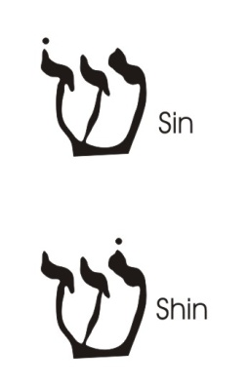
Does it mean that if you recognise good, you are good, and if you are recognising evil that you are evil? The answer is yes. But you can’t do one without the other. In order to cognise good you must have an idea of evil in you. So you must have experienced evils in order to know that is not this.
שּׂDoes that mean that that evil is not necessarily your sin, it’s the sin of the fathers?
No, it’s a sin of God. Let’s draw a sin of God. I’m going to draw a sin. That’s the Hebrew letter sin for you. Now, you can see immediately those two are close together, that one’s further apart, and I’m going to turn round and do it like that. I’m going to put there the tummy, there the chest, then a gap, and there the head. That is a simple drawing of a man. And if you put a point on that side, it is called shin, shine, enlightened. And if you put it on this side, it’s called sin. Now if you put this one dot here, that’s intelligent enlightenment, and if you put it down here, it’s genital subjection. You are a slave to the sexual impulse if you stress down there.
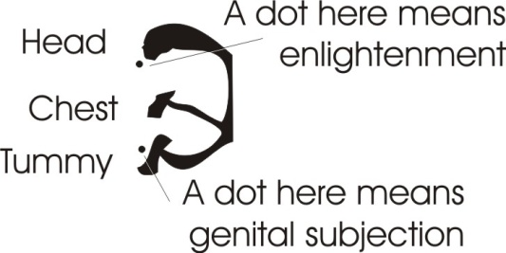
Now the whole being is nothing but energy. So that letter signifies fire, which is the symbol of energy. Now, what happens? There isn’t anything other than the absolute. And the Absolute is a good good, because the Absolute has Absolute Intelligence and knows that you can’t know what is good unless you posit what is evil to judge it with. So the Absolute Good posits the bad — yes? — to look at, to decide not to have it. [56:48]
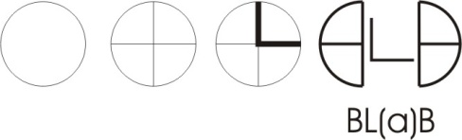
Let’s write the word bad. There is an O like that and two ‘B’s like that, and then we put a cross there like that, and that’s one letter B and that’s another letter B, and here is the letter L between it. I’ve actually written the name Babel there, as a symbol instead of linearising. If I separate it, I’ve got a B that one turned the wrong way round, and a B there and an L between. That spells Blab, doesn’t it? Do you know if you were to blab these secrets in the ancient world to the general public, you’d be put to death? You had to put the Bs together like that, hold them together like that, and don’t let ordinary, uninitiated, uncontrolled people know that there is not a bad ‘bad’ and a good ‘good’. They had to believe that the bad was bad, in order not to do it. They couldn’t choose. Bad is bad! And they had to know that the good was socially recommended ... that’s good good.
It isn’t true, but you cannot make a civilisation in its early stages without teaching good is good and bad is bad and never the twain shall meet. So, you mentioned the word sin, and you can’t think about sin without guilt, can you? If you got the concept of sin, don’t you mean something you shouldn’t do? And if you’ve got something you shouldn’t do, don’t you think there will be punishment? And doesn’t punishment come from this word? Power drive, negation. Yes? …punier, to negate [nere] power [pu]. That is, if you make a mistake and sin there is that separate, sin means separate activity, ignoring the whole, if you do that, you’ll be reduced in power. [59:14]
[Member of the audience] Doesn’t then that sin side which you were saying was the female eve side is the part that was, that is, brought out to help a person develop anyway, so therefore he had to sin to know it?
Do you sin deliberately, or accidentally, or under an external stimulus? You’re saying you have to sin in order to develop. But you can’t sin consciously: you can only sin by being unconscious and stupid.
[Member of the audience] Doesn’t the prodigal son sin? [obscure recording]
No, of course not. Then he became conscious with the pigs and the husks, and decided to go back home. When he left home he said to his father, give me my share of the inheritance. That meant the amount of energy allotted to him as a creature. So he was given an amount of energy, went out and spent it without thought, and he finished up with pigs and husks.
Pigs means obstinate people, husks means externality. You meet some very, very superficial … very, very obstinate people. Have you met any of those? Have you been creeping in the very lowest pubs in town? No. Well, you think it’s time to go home, don’t you? I remember once they had a program on the BBC on one occasion, and they thought we’d have a lovely weekly performance, a very cheap program, and they’d show that the average working man in a pub could discuss political issues and show himself fit to vote. So they launched the series. Now, how long did it take to give it up? [1:01:16]
Well the first night they had to say, We can’t do this again, safely. They were all talking tripe to each other. Even very high educated people can talk tripe. Last Thursday I was listening very late to Robin whatisname, whatsisname ... Night is it? [referring to Robin Day] Yes. Well there was some Irishman on the program, and Robin was being very establishment, and they were disagreeing with each other for agreeing with their opponents. And he pointed out, you can’t agree with him in the end, because he’s saying the opposite thing. And they all burst out laughing. [01:02:05]
Who says the Irish can’t hold two contrary opinions simultaneously? ... that’s a rotten Anglo-Protestant idea. We can say anything about anything, being Irish, because we are poets. And they would not let go of it. Now poets are mighty powerful people ... they terrified Plato. Plato wanted an orderly republic, but you know in Ancient Greece there were Irishmen. Did you know that? Before they migrated. No I’m serious, before they migrated down the Mediterranean to Ireland they were in Greece, interfering ... you know that there are red-headed Greeks with blue eyes, don’t you?
[Member of the audience] Yes.
Yes. Have you met them? Very interesting people ... and very poetic. But they ruined Plato’s Republic and made him write another book called The Laws, that practically contradicted everything he said. Because there are — and this is basic Islam — you must never think if you’ve got a true interpretation of anything whatever, that this interpretation is the only interpretation. There are an infinity of facets of the being, an infinity of viewpoints ... aren’t there? So we can never say, I’m right and you’re wrong. What are you thinking about it? Most people don’t actually think about the words’ meaning when they use the words. Do they?
[Member of the audience] No.
No. You know what an acronym is don’t you? Can anybody tell me what an acronym is? Acro-nym. No?
[Member of the audience] It’s the same read forwards as backwards.
Not necessarily.
[Member of the audience] A word made up of initials.
It’s a word made up of initials. Can you think of one?
[Member of the audience] Aids.
Aids? [Laughter] Do you know the meaning of the letters, or have you been stuck with the word? Have you got the meaning of the letters? Did you learn the word without the meaning of the letters? If you did, you are passive to it. Do you know what Chlamydia is? No. Those of you who were old enough, and there are not many here, to remember the last war in the middle of it, what did PLUTO mean?
[Member of the audience] Pipe Line Under The Ocean.
Pipe Line Under The Ocean. That’s an example. Now many, many, many words that we think are words are really sentences, cut down to their initials. And the people that don’t know their real meaning are passive to the short form. What does SCUBA mean?
Did somebody say Self Contained Underwater Breathing Apparatus? What does it mean if you don’t know its derivation? You’re passive to it, it could be anything. Didn’t the man that wrote Animal Farm complain very bitterly about the condensing of sentences into short words and making people learn the short word and react to it without knowing what it meant?
Now, we have to be very, very careful with terms, otherwise we cannot become Mani. Remember Mani means control your appetite while you evaluate its formal significance. Ma: substantial appetite, Ni: the negation control by the individual of every point in it, so that you really know what you are talking about, and then you can be Pura, a city of power ruling itself.
Either you rule yourself or somebody else rules you. There is no middle course between you rule you or somebody else does. They won’t ignore you, you know. They’ll use you, if you don’t use you.
Right. To say it very, very shortly, the absolute compassion of the Absolute is simply the logical result of the Absolute being the only power there is, and therefore the only response-able there is for the creative process that we know has produced the universe, including us. Therefore, we have a duty to God, means God has a duty to us. Therefore the incarnation of God in man is presupposed by Him creating and then in all fairness having to enter into the same kind of body that’s been imposed on the creature man. And this is true of everyone without exception. So we have absolute response-ability for each other. [1:07:41]
Absolute responsibility for each other. How does that feel? Does it mean we can’t do what we’re doing because we’re busy considering everybody? The answer is yes, of course it does. Can we remember to do it? Well, that’s difficult. We have inertia, we have original sin. Original sin means the sin of Adam in his stupidity when he reacted to an external stimulus given to the wife by a snake. In other words, if something comes from outside to you, to stimulate you to action, and you react to it without total compassion to your basic concept, you have fallen into sin. If you see through the stimulus for what it is, it’s a means whereby you become aware of some of the reaction possibilities in you, in which case you thank the stimulus which is called a temptation for showing you some of your own tendencies in you. Because then you can choose whether to subject — that means throw under — subject yourself to the stimulus, or whether you should go on centre in yourself and become absolutely self-determinant.
Now it is said that when the sages first reach this level they are totally paralysed and can’t do anything. It’s only for a time. Because then they say well, the universe is not static, so I’ve got to do something. The universe is not static, so I’ve got to do something. But the Absolute didn’t do something except from its Absolute Compassion.
Imagine that prior to creation there was an infinity of Sentient Power, and that Sentient Power was trying to manifest. And what is the condition of a Sentient Power that can feel a potential of actuality and can’t realise it. How does it feel? [1:09:39]
[Member of the audience] Frustrated.
Frustrated and horrible. So the Absolute said, ok, you want to act, I’ll give you a universe and put you in it and you can then act. And when you’ve learnt enough from that you can come back home. That’s the returning prodigal son. Now that’s fair. But he has to incarnate in man, the whole man, the cosmic man, in order to justify having created in the first place.
Now if we want to improve — that is to say to internally prove/probe ourselves — for to discover our own internal capacities of total creativity absolute self-determination, then we have to follow exactly the same process whereby the Absolute created the world.

Falling asleep
Now the Absolute is omniscient, so it can’t have accidents, and it can’t be unconscious of what it’s doing. Now, we find it very hard not to fall asleep, don’t we? Now, falling asleep is a very funny thing. It’s simple. It’s what you do if you identify with a finite and then go round and round in it, because its stimulus value drops, and constant uniform stimulation is reduced to no stimulation ... by repetition. You are then called dead in your sin, in your separativity, in your running round.
Now, how can you get out of the condition of total self-lockedness. Answer: if you are in that condition you cannot get out without grace rescuing you from outside. Grace means free spirit. Grace it’s the freedom of the Absolute to knock the creatures about and wake them up from their self-sleep of identification with finitude. We have an infinite possibility of actions, you couldn’t even begin to conceive all of them in any given time because it covers eternity. And we tend to fall into satisfaction with a very, very meagre output. [1:12:01]
I had three paintings sent to me to look at the other day. Actually, from Marian ... I must thank you for those Marian, very good. They are psyched paintings, and they were beautifully balanced in colour, tone value, symbolism within them, and I know that she thinks she didn’t do them ... as an egoic being. They certainly weren’t done by an egoic being. They’re too good. If she continues to develop in that way and doesn’t break into egotistic cleverness, they’ll manifest more and more and more of the creative content of her being. But the egoic self doesn’t trust it. It wants to keep its hand on the tiller, you know.
So, where does it leave us? We are, whether we like it or not, precipitates of the Absolute who has come from Absoluteness to Godhead to God, to cosmos, to individuals within cosmos, to the human being, and everywhere and nowhere where it is not, is the Absolute, operative as that being, in that way, in that time and place ... and that means now.
How do we feel in our relations with each other if we do that? I know how I feel at the moment through talking ... warm. Do you feel warm? I know I’m radiating some of my physical warmth a little bit. So if my friend Peter would come a bit nearer he’d get warmer. Unless through some concept or other he’s already warmer than I am. Are you?
[Peter] Very Warm.
Very warm. I thought your temperature went up when you started introducing the concept of sin.
[Laughter from the audience.]
Do you know that you are actually sitting on the representative of hellfire?
That’s a funny one. Think I’ll leave you with that one to think about.

Thank you.

Demotic, popular, belonging to the people ... distinct from Hieratic, which pertains to sacred things.
John 2:25
Mathew 25:40 And the King shall answer and say unto them, Verily I say unto you, Inasmuch as ye have done it unto one of the least of these my brethren, ye have done it unto me.
From "The Rossetti Manuscript" (1810) To God If you have form'd a circle to go into, Go into it yourself, and see how you would do. They said this mystery never shall cease: The priest promotes war, and the soldier peace.
Genesis 2:18 And the LORD God said, It is not good that the man should be alone; I will make him an help meet for him.
Gospel of John, chapter 9.
Matthew 7:1
George Orwell
https://www.mtholyoke.edu/acad/intrel/orwell46.htm
Compare with Gratis.

