Assimilation, Parts 1 and 2
A talk given by Eugene Halliday, transcribed by, and with arbitrary headings by John Bailey.
The drawings and tables aren’t originals, and all editor’s notes are in square brackets.
In many instances the remarks from the audience are indistinct.
The talk is available in two parts.

Part 1

[Question from member of the audience (Y)] What I wanted to ask about was the way in which you assimilate food ... you said it was similar, you assimilate out of the food what was similar to yourself. And I was thinking about the way in which you tend to group with similar people. And I wondered if there was a link there, kind of .... in this constant gathering of similars...
Yes. Well can you see logically why only like substances can assimilate? You know for instance, if you take the organic compounds, you’re really dealing with nitrogen compounds aren’t you? You must have something that is in some way similar to many things if you wish to bind a lot of things together.
[Y] Is that’s why it’s a catalyst, again?

Consciousness As a Catalyst
Similar, except that in the catalyst you have a substance that doesn’t itself take part in the reaction ... it’s just its presence that determines it. Like we said before, that consciousness is a catalyst. If you see a child playing, and it doesn’t know that you have noticed it, and you keep looking at it, very soon the child alters the character of the play. It’s aware that it’s under observation, and the fact that it is being watched changes the character of the action.
And the same thing happens with any human being ... the moment he becomes conscious of what he is doing, then the action tends to change itself. Consciousness in that sense is a catalyst, because consciousness does not itself participate in anything whatever ... it is a just a permanent background of all the activities. You can say, if you like, that every thing, every percept, is inside consciousness. The consciousness itself is not of them, but they are of it. They are like the ripples on the sea. Ripples can fall down and leave the sea there calm. You can imagine the sea calm without ripples, but you can’t imagine the ripples without the sea ... which establishes the priority of substance, doesn’t it?
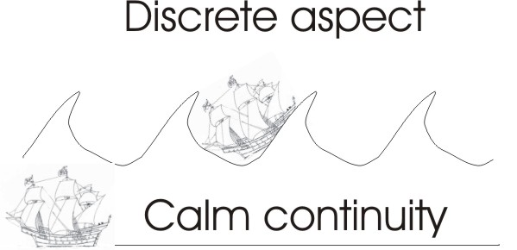
It’s as well to make a ... if we draw ourselves a wave and a body of water, we can say that the body of water represents substance — plastic substance — and these waves now are the basis of the possibility of counting. If we draw another body of water here, calm, we say that is one surface don’t we? ... because it is flat. At the moment waves come in it we can start counting the waves ... here are one, two, three, four and so on. This is like the tooth side of a saw ... we call this the discrete aspect. Discrete means grown apart. This is a discrete aspect of the phenomenal world. There is the substantial world — whatever it might be all this stuff as we call it in good old Saxon — this is the materia of the Latins, the stuff substance, the xyla or wood of the Greeks. And this is the carving of the wood or the rippling of the plastic substance [diagram]. Here we have continuity on the bottom.
Ships may pitch and toss, and sailors may complain up there as much as they like. Down below, a sunken ship is in calmness, isn’t it? Now this is very, very similar to a human mind. The ripples in the human mind are caused by forces acting on the mind from outside, which we call stimuli. But in the depth of the mind, the stimulus from outside cannot produce great disturbances ... which means that fundamentally everybody is quite ... quite calm. [04:41]

Would you like to put that in again ... so that it works? I had another one of those somewhere... [an aside]

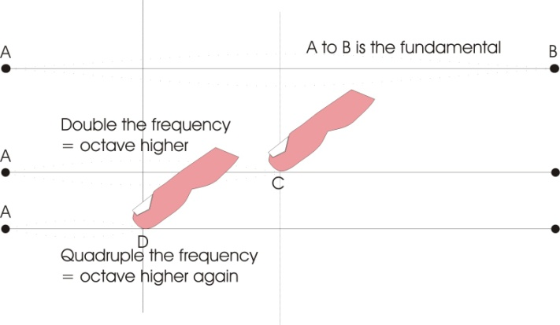
Anyhow, this question of assimilation now, we know that unless a substance has some factor identical with another substance, it cannot fuse with it. Now, supposing we consider that all matter is vibrating in a certain way, we can then if we like say: some matter has a characteristic wave form like that, and there’s its baseline from which it starts.
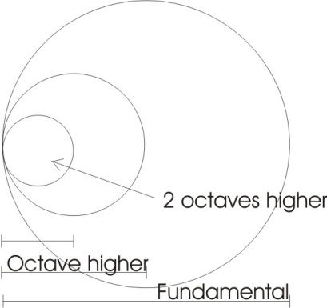
Now, supposing we take the string of a musical instrument — which is how Pythagoras would have done it — and we allow that string to vibrate. Supposing we pull it down there, and then let it fly across, it will then assume this position, and then that position [flying from one extreme to the other], won’t it? And it will give a beat we call the fundamental. But if we stimulate this string in various ways, plucking it, a wave will break through the middle, there. We can put a finger there on a violin string, and we will then get, if that finger is halfway from there to there, we’ll get the octave of this fundamental note. That means if that fundamental is, say, middle C on the piano, then putting the finger halfway along it would give you the C above it, which has double the frequency. Which means, if we take this character, we can reproduce it here and say that the wave length of that is half as long as that, but the frequency is double. [06:31]
This question of assimilation is very closely linked, because in effect it means that if we take the universe itself as a big sphere — I’ll take the diameter of it as the fundamental — then we can say there is a definite vibration which, to the appropriate tympanum, to the appropriate sensitive organ, say the divine ear, would sound the fundamental. And then if we divide it in the middle and stop it here, there would be an octave higher sounding there and there on both sides, which we would call, musically, a partial. And if we stopped at this again half here, this would be an octave higher than this one; and half again, that would be an octave higher; half, an octave higher still, this is going up to smaller and smaller divisions. And we see that the wavelengths of these parts are getting shorter. So we can then say that if we take this as the whole universe, that is the diameter of it, and then proceed to subdivide it until we can no longer divide it any more, we have reached the shortest wave in the universe ... haven’t we?
So we could then make a gamut of waves: the longest wave, the full diameter of the universe, and the shortest wave would be something like Schrodinger’s wavicle somewhere on the other side of the electron ... very, very tiny wave, very short wave of very high frequency. There are many of those per second of time. [08:05]
So supposing we say that if we make some food — we’ll draw a circle here — we say food is just something that can be assimilated. You see, the difference between the word food and good is G and F isn’t it? Now this concept ood or ad, id, means to eat, in the root in edible. The Sanscrit ad is also the same thing, ud. You say fud, food. Now good means the gross matter of food. So we say we get something — is if good for you? — you put it inside then send it down there, break it up and if you can assimilate it, and come out better, you call it good. But if instead of being able to assimilate it, it starts disrupting you, you call it a poison.
So we can see that this circle can be assimilated by this big one because it’s a half the fundamental, so it has a natural resonance doesn’t it? And we could say that there’s another one in here that could be assimilated by this one. And half way there’s another one, and there’s another one, and there’s another one ... you can see that all these small frequencies can be absorbed by the big one, can’t they?
But if we go on cutting these down in this manner, we’ll find that some of them will not assimilate with each other because of the relation between odd an even counts.
When we cut that we get two. We cut it again, four, eight, sixteen ... we haven’t got something yet we can divide by three, have we? You see that? So if we go on up and up and up, we find that the odd numbers will not assimilate with the even. Now you know Pythagoras said odd numbers are male, which means that they are active. Even numbers are balanced, equilibrated, and therefore feminine. The number five he said means marriage, because it contains two and three. The female number two — first female number — the equilibration, balance, means passivity, doesn’t it? Perfect equilibrium is the same as passivity. And an odd number is a stimulus. There’s an odd one in three. One itself is not odd ... that’s the whole that we begin with. You see that?
The funny thing about elementary arithmetic is that the behaviour of one and two are not like the behaviour of other numbers. We say one plus one equals two, and two times one is two. So whether you add or multiply one you get the same result, don’t you? [10:59].
But if we take the number 2, we say two times two are four, and two plus two are four. You see? And that behaves like one, doesn’t it? The same result whether you add or multiply, but when we come to number three, if you say three plus three are six and three times three are nine. So suddenly there’s a new emergent. And therefore there’s a special kind of mathematics for dealing with the peculiar behaviour of one and two. So one and two must be considered as first this big one — The One, the Whole One — and all these are parts. Now the word part itself is a rational cut, a pi-ra-t, and that pi-ratio is the function. You see here’s the radius and this is a par-t, a part. The par-t — the parrot bird — is so-called because it says things par-rote. Rationally rotating, then whatever you feed in ... it plays back.
If we keep cutting this two and two, we will always find that this half can be assimilated by this and this and this, but when we divide it in three we get a note which in music is called a fifth. Strange, that they should call it a fifth when it’s really a third of the length of the string, but there is a way of reconciling that. But the point is that that third will not vibrate harmoniously with that half. So that it cannot be assimilated by it. But if we take factors of odd and even numbers, and build them up, we can arrive at a number that can assimilate both odd and even, can’t we?
So, well, supposing we take three fives. Now that will assimilate two odd numbers, won’t it ... three and five? If we take three fours it assimilates an even number and an odd number. So there’s something mysterious about twelve, isn’t there? ... because it can assimilate an odd and an even number. We’re excluding one and two because they are special cases. The reason why they are special cases: this is one ... one inside and one outside. That makes two. The one outside is infinite, and the one inside is finite. So one and two are very, very special cases.
But from the point of three onwards, the first synthetic number — one isn’t synthetic, it’s unanalysed — the first synthetic odd number is three, and the next is four, and three times four is twelve. So in twelve we have a means of assimilating short frequencies derived from the third and from the half. You can cut the half into a half, quarters, eighths, sixteenths. And the third into sixths, twelfths and so on.
So this question of the fundamental beat of matter is very important. If we wanted to, we could cut that into thirteen times seven plus one, which would give us the atomic scale, namely ninety-two elements, ignoring isotopes for the time being. When we come down to the smallest particle, it is a definite subdivision of the diameter of the universe, which means to say that it has a definite resonance relation with other parts of the universe. That means that there is something in man — namely his physical body — which is made of the earth, which is made of primary elements vibrating at definite wavelengths, which are necessarily related to the planetary cycle, the whole mass of matter in the solar system, and to an octave structure — the sun itself — and then to the sidereal system, and then to the whole universe. So that then matter is no more than a series of sub-divisions, right down to the smallest subatomic particle there is, which has a definite periodistic function, a definite frequency of its own, and a wavelength. And the whole question of assimilation therefore is fundamentally one of frequency.
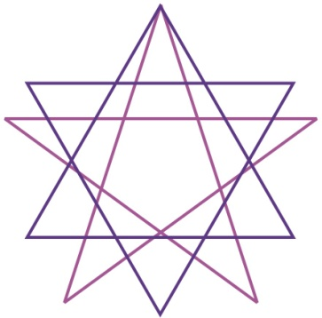
If we could get a saw and we make its teeth like this, and we get another saw with the teeth exactly the same pitch, they fit. If we get another saw where the teeth don’t fit, then it cannot assimilate, we can’t put them together. [15:36]
Now in the case of measuring on a Vernier, we have this sort of saw tooth, don’t we, and a finer saw tooth and at some point there will be a coincidence. There’s one on here, accidental. The rest of them will be out. Now if you remember we said before if we take the six pointed star, and put a five-pointed star in it, if we put one point of the five and one of the six, the rest are out of phase. So you can assimilate through one sense when you are concentrated and therefore not through the others at the same time.
So fundamentally we can say that this question of assimilation is one of frequency, and every particle of food that you eat, every drug, every chemical, is made of fundamental frequencies that must go into their own places somewhere along this diameter line of the universe.
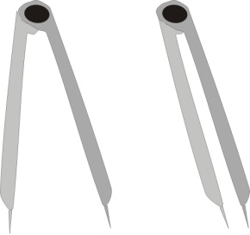
Now what we call thinking in a man is really formal presentation, serially, isn’t it? For instance, if we say, think of a cube ... there’s a cube. Now that is an image ... Plato would have said that is the lowest kind of thinking there is, because it’s imposed upon us. When we see that, we can tell that that peculiar thing isn’t the same as a crescent, and we cannot be deceived by that [crescent] to think that it’s that [cube]. It doesn’t allow us to do so. So in that sense, we are slaves if we work at the sense perception level. Because perceiving, say, these compasses closed, and then we open them, it’s not very smart to be able to tell that they are open when we do this and closed when we do this. It’s an imposition. So man’s freedom does not consist in the sense world, because the sense world merely reflects what there is outside. This is why it is said that man’s freedom is within. Man is not free in his relation with the external world, because it imposes upon him, giving him the so-called sense data ... which are what they are whether he likes it or not.
So we’ve got this idea that assimilation is fundamentally no more than the actual resonance of already related partials of a string, which in its widest sense may be called the diameter of the universe.
Now, when a person is thinking there is also a definite frequency in his mind. If he looks at the light, the light imposes on him. If he looks for a long time, and then looks against a dark curtain, he will then see an after-image from the light begin to superimpose itself. If you look at the light until it fills your eye with light, and you should begin to see colours round it, and turn into a dark place, the light will form itself, and you will then find that it will start drifting about. And with a little bit of practice you can cause it to come near to you, which is a very peculiar thing. You can actually make it come very close so you can examine the details. Although it really was up there, you begin to have a certain amount of power over it, because you are now dealing with something that is half from outside and half from inside. And the nearer it is to your inside the greater the degree of freedom you have over it. [19:08]
Now every frequency has a very definite chemical characteristic. And you know that when we are examining the chemistry of stellar bodies with a prism, we use spectrum analysis to determine the presence of sodium or other elements in stars. If a surface reflects light to us, we can tell by the characteristic colours in the spectrum, what chemicals there are, there. That is called ordinary physical science.

Diet
What is not usually realised is this: that an emotion is also a frequency, and it has a very definite relationship with particular material substances ... a frequency relationship. Such that if you eat certain food you are absorbing frequencies which tend to make you think and feel in a certain way. If you take a certain ... supposing we said that is a certain substance, and you eat it, well then all the partials — that is, the sub-divisions of that — will vibrate in you as well. And at the top level here, it is an identity of ideation, thinking and emotion.
So that it is upon this that the restrictions about diet are based in yoga: namely that thought itself is a kind of motion with a definite frequency and wavelength, with definite relations to the foods that you eat. So that if you are in a certain mood, you can assimilate certain foods; and if you are in another mood you may be unable to assimilate the same food.
Sometimes you find a fellow saying, I’ve just been put off my food by so-and-so. He had a good appetite and he was about to eat and then up spake Spurious Latius or somebody and suddenly his appetite is gone. Why? His food is the same, the man is the same, but a stimulus has come, stimulated something in his memory and altered his fundamental frequency, so that now he cannot deal adequately with that food. If you persuade him to swallow it, it does not follow that his stomach can deal with it. It might lie very heavily on his stomach for a long time. So that really, you have to tune yourself in to the food that you get. [21:35]
[question from the audience] Would you say for instance if you start to receive new ideas it might start you to want to eat different kinds of foods.
Oh, yes. Well you know that, in the case of a pregnant woman, don’t you? You know that they have ... they start thinking that they want things they didn’t want before. And those are genuine things, they’re not empty fantasies. They are chemical needs. There is a certain chemical need for making the child which previously they did not themselves need because they hadn’t got that kind of emotion. Sometimes a woman may think to herself, I’m such-and-such a being, and then suddenly she has a child and she thinks she’s another kind of being, because chemical changes have occurred. She may be alright to live at a certain level; and then when she changes her level emotionally, she changes her chemical need. Because there is nothing in the universe, whatever it is, a gross material, subtle material which is the mind ... the mind itself is a very fine matter: and the soul, feeling, the soul specifically is the sentiency. Being, feeling, and spirituality are all matters of frequency. Whatever is, has a definite beat, and the top beat of all is the beat that we call spirituality. Below that there is the psychic one, and then below that, smaller and smaller, we are concerned with the gradual appearance of these partials, which are gross matter as far as we are concerned.

Unity of Purpose
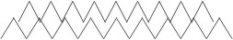
So that no matter what it is — you can think of it in terms of these teeth ... do they fit or do they not — supposing we take all these people who are in this room, who at the moment, maybe assumed to be interested in certain aspects of this subject. If they are interested in the same aspect, they must be using the same frequency.
Sometimes in a spiritualist circle you get a request that everybody sits round, and lets the finger of the hand ... say the little finger ... touches the thumb of the next person. All sit in a circle, and then all concentrate on one thing. Well, the purpose of doing that is to persuade the mind to beat in unison. Because when you’ve got unity, you have power. If you’ve got unity in your own being, you’ve got power. Whereas if you have too many purposes which cannot be logically related, then your power, although it is there, is dispersed in various directions, and does not appear as effective power, because it lacks unity.
[comment from the audience] I begin to see the idea now: that if you’re using up energy and at a certain frequency you’re going to require to take out of the food to replace that food at that frequency, is that correct?
Yes. Well, it will be shown scientifically, that if a man eats exactly the same food ... supposing we say to a man, here’s some mashed potato and we mash them all up to give a more or less homogeneous consistency. And then we divide them arbitrarily in half and say, now I want you to eat this half today, and I’m going to tell you funny stories while you eat it, and then we are going to take the excrement and measure the chemistry in it. and tomorrow you are going to at the other half, and we’re going to tell you horrible stories — not funny stories — and we’ll do the same thing, and it will then be shown by resonance that the man has taken something out of the one that he hasn’t taken out of the other.
This is going on all the time. This is why you can’t get the same diet to work for different people in the same way. This is why you can’t get the same drug. Which will give you, say ...
Well, let’s take penicillin ... it’s the wonderdrug of the journalists, yet its percentage of successes, which is a statistical statement, is such, I think about four years ago it was about fifteen percent of immediate success. This depends on the chemistry of the person that takes it. Giving a drug, giving any kind of treatment whatever where you introduce bodies from outside for assimilation, must take into consideration the type of the person that’s going to receive it ... his chemical type.
Now if you get a book like Culpeper’s Herbal: the medicine of his day was one thing, but he was a rather unusual fellow, and he liked the old-fashioned way. Like Paracelsus did in many ways. In fact Paracelsus invented this modern method of injecting metals into people, for certain resonance reasons. No two people can assimilate the same substance in the same way. The same person cannot assimilate the same medicine in the same way in two separate acts.
[comment from the audience] There can never be a complete accuracy of measurement, then.

Why an Egg Becomes a Human Being
That is why it is said to be now a statistical science. The 18th century dream that there was a definite number of material particles which, as they said were fortuitously running about and producing accidentally a universe, and their velocities and directions being known, you should be able to write the history of the universe forwards and backwards. That was a dream. It’s no correspondence at all with fact. They had never at that time seen atoms walking about, and colliding, and fortuitously getting together to make a frog or something. It was an assumption, a kind of dream ... because the mind of man is always looking for a final explanation, which if he gets it, he thinks he can stop and fold his arms, and that will be the end of it. But the universe isn’t like that. The universe is fundamentally a continuum of power. And because it is a continuum, a straight line, these things which science counts — because science is based on measurement, and statistical measurement of that — these things can never tell you what’s going on down here.
The invention of an infinitesimal calculus is an attempt to deal with smaller and smaller and smaller distances between here, but it can’t deal with nothing. There’s an attempt in mathematics to deal with what are called infinite qualities. They borrowed a Hebrew letter, Aleph, and by using the term Aleph Nur, which means a number when added multiplied or divided by itself to make precisely what it was the first time, namely zero, this is an attempt to get down to this substratum. Most people think it is meaningless, but it isn’t. It’s an attempt to discover why this baseline can produce these ripples. [28:59]
Why does an egg become a human being? You look inside it with a microscope, all you can see is some little strings with knobs on. In the old days they used to think that inside an egg was a little man waiting to have his dinner and grow big. It isn’t true. Inside there are some little weird granules. But somehow they are the vehicle whereby a force outside them, namely the macrocosmic force, presses into that egg and produces a man out of it. Somehow the man isn’t in the egg. He’s outside the egg, but he gets into the egg by pressing on it, and producing modulations which fundamentally are frequencies.
You take, say, the high bridge nose of the Jews as a race: that high-bridgeness there is a product of haughtiness of spirit, of thinking high. Each nation has a definite psychological tendency which produces a physical structure. Because the modeller of form is first, feeling: first feeling, then the function, then the ratification of the function in material.
So that we can say about diseases in general, they begin with feeling slightly off colour. If the person becomes hypnotised by that, or begins to think it’s useful to dodge some issue, then he starts working upon this feeling, and gradually he alters his substance, and produces malfunctioning. If he produces his disturbance of function over a long time, he can make an organic breakdown. An organic breakdown doesn’t just start like that ... it starts by some functional disorder, which starts by some feeling disorientation to begin with. So that the more we can control and elevate the feeling and make it more positive, the more unity there will appear in the physical body. The whole point in yoga terms is to become eka citta ... have a one-pointed mind. Just have one aim and subordinate everything else to that. What contradicts it has to go. [31:22]

Hexonic Field
Now, Khen mentioned the zodiac and while we’re talking about assimilation, we can deal with that. This circle cuts itself spontaneously into the right number. Now if we bisect the angles between these, there’s our six pointer. That fits exactly. And we bisect these angles and produce our twelve divisions. [32:00]
This is really a device which is fundamentally a new way of dealing with the macrocosmos, the big universe itself, and reducing it down to the level where it is useful to men.
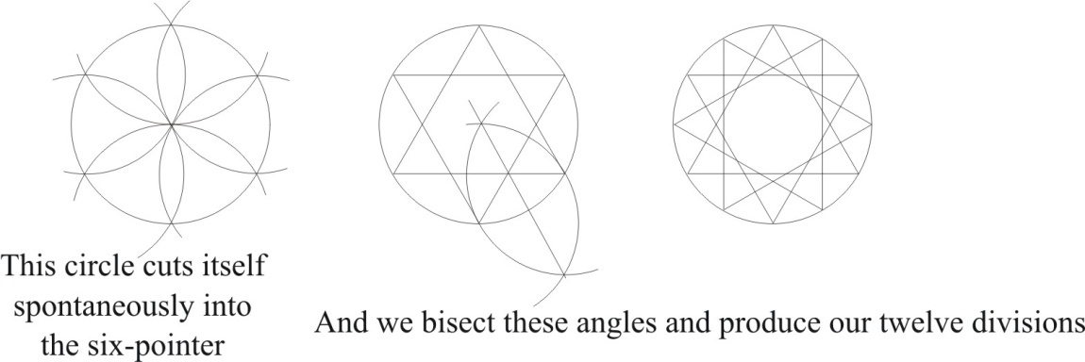

We draw one little circle and another, and another, and another for ease of analysis.

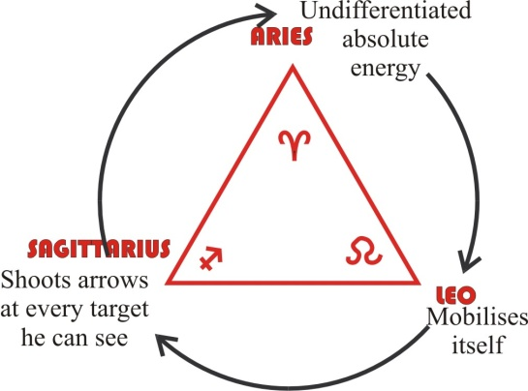
Fire triad
We draw one circle and we put in it a triangle that way, and we’ll write on it the sign of the Ram, Leo, and Sagittarius there. And you see the Ram is like a V, you probably know it. Now that is a so-called fire triad taken out, and actually refers to the nervous system of the human being ... the being’s nervous energy.

Air triad
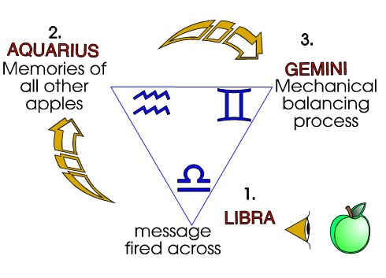
We invert that one and we put this triad, in and this is at the bottom Libra, and there Aquarius, and here Gemini. Now that’s our air triad which has to do with intellect, ideas and the respiratory apparatus: the breathing apparatus in your body. Breathing is very closely linked with thinking, very closely linked with judgement. You know that when you start judging events your breathing alters. If you decide that something is very, very bad and should be stopped, you find that your breathing begins to reflect your judgement. The Greek word for lungs is phren, which means mind. So they knew that there was a very close relation between thinking and breathing. And of course you can fire ideas at people and make them very excited, so that their breathing accelerates and they get palpitations. And yet you’ve only spoken to them. It shows the power of judgement over the breathing apparatus, particularly.

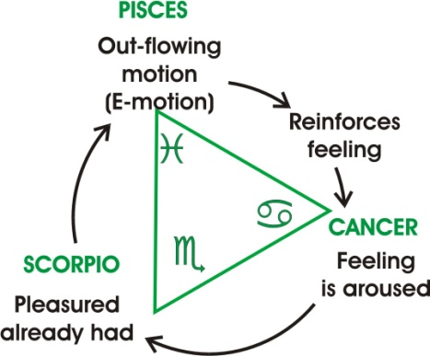
Water triad
Now we have here the water triad. That’s a triangle there with Cancer there, I’d better write this in full ... write 69 lying on its side, and that’s the sign of Caner; Scorpio down here, which is an M with an arrow on its tail; and then the sign of Pisces up there which is two semi-circles back to back.

Earth triad
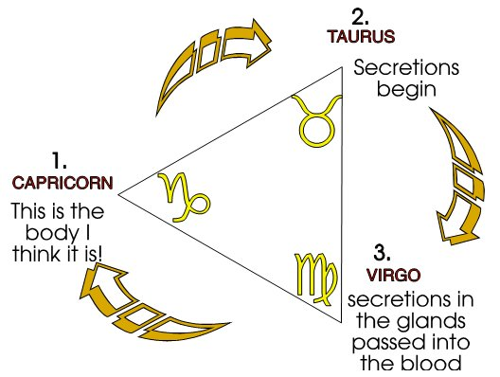
And then over here the final triad, Capricorn which is the sign of the Ram, plus the sign of Taurus ... Taurus is the sign of the Grecian thing I won’t draw. A loop. And Virgo is like an M, with the same loop added to it. I’ll just show you those, they’re a bit difficult. The sign of the Ram is like that, the sign of Taurus is like that. If we add Taurus here, to the Ram, it’s the sign of the Goat, Capricorn. I’ll explain why in a moment. [35:25]
There’s Taurus on its own ... we do a letter M, and then we put the sign of Taurus on it at the side. So in these three earth signs we are using the sign of Taurus three times, and that’s because that Taurus means to turn. Tor ... you see? That’s Rota, you see?
All matter is rotation of power. So when we are talking about the matter of your body we are talking about rotations of power. And therefore Taurus is turning things, you can spell that T.A.U. if you like. Or this is the Hebrew way of spelling it ... one way is Greek, if you spell it with an O [TOR] there; it’s Latin if you spell it with a U [TUR], and an A.U. there [TAURUS]. But the fundamental concept is T.R., which is the rota concept. [36:22]
So in the case of the earth sign, it’s to do with your physical body which manifests in the ... specifically in the bone structures, which are the nearest things to the mineral world, aren’t they? They’re the parts that when you get hold of a living human being and boil him until the flesh falls off, it’s something that’s still there ... that’s the bone, and that’s the really earth part of you. The rest of the stuff is, if you get a living man and heat him up, you’ll drive off the most volatile substances first. Then you’ll find various sediments chemically afterwards. All those added together are the earth substances of the body.
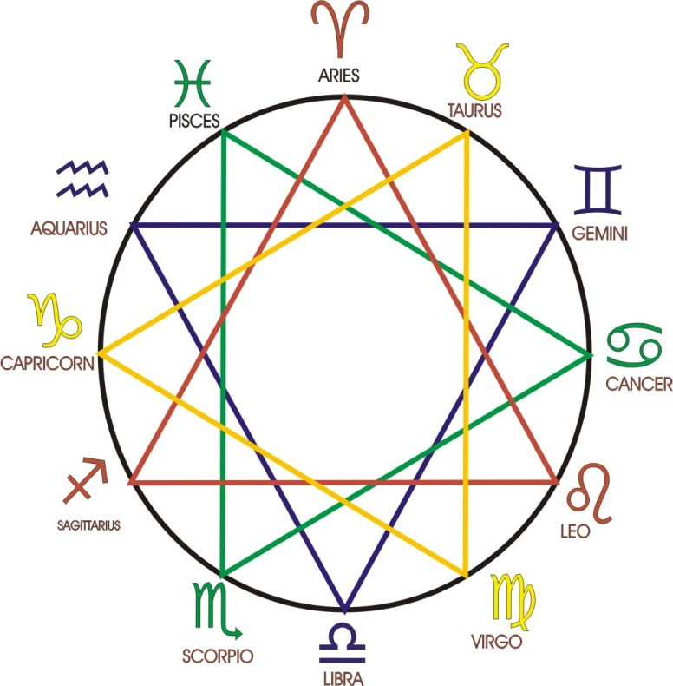
Now we’ll consider what they are. I’m going to put ... I’ll put the sign of the Ram in here for a moment. It should have been at the top. We’ll call that twelve o’clock. Then it goes round. Taurus, Gemini, Cancer, Leo, Virgo, Libra, Scorpio, Sagittarius, Capricorn, Aquarius, Pisces. Now I want you to think about this as a psychosomatic device. It tells you something about your mind and something about your body at the same time. [37:49]
When we come to consider the earth signs, that’s Capricorn, Taurus and Virgo, we can see very clearly what it means. This means assimilation, absorption, this Capricornian, the goat, is the being that has a ‘go at’ anything. You know that the symbol of the goat in the Old Testament is that person that throws himself into the situation and gets into trouble and therefore we talk about the scapegoat; a being that pays the price of other people’s carefulness in dangerous situations. There’s always one that can’t quite control himself and rushes forward first. And he is the one who is blamed, although everybody wanted to do the same thing. So this fellow who must have a ‘go at’ is called the goat.
And you know that the goats in general are not herded in the plains like sheep; they jump on the mountain tops. So that when it says the separating of the sheep and the goats, in the Revelation, it means separating those independent spirits that are always trying to do it on their own, from the massed spirits, called sheep. And where the goats have to go and where the sheep have to go is not necessarily a bad thing. The goats ... where the goats go that’s where they like to go. It is called hell to sheep, because the sheep like to get together. But the goats like to be independent. This is why Jacob Boehme says that the angels call the good, good — but the devils call the bad, good. So this is your primary absorption of matter. So a person born with a stress on there is really pitched in this necessity of absorbing matter through food.
And this sign [Taurus] means secretion: it has to do with the glandular system. The food that you have absorbed, you now hide it in certain centres in the body: glands of internal secretion. And you store it there and you let a bit of it out every now and then, it goes round the body.
And this one [Virgo] has to do with the circulation of the food. So that’s three processes: taking the food in, hiding the food in particular parts of the body, at the glandular system, and then circulating it to produce a balanced whole.
Remember we said last week that the chemistry in different parts of the human body ... the blood is not the same. The chemistry of the blood in the brain is not the same as the chemistry of the blood in your thigh muscle. Because each part of the body has some substance being manufacture and been poured into it at that part, so there’s high saturation of a certain chemical from a gland. And far away there’s less saturation of that, and something else is the dominant influence. So that the same chemical injected into one part of the body of the same man will not produce the same effect if you inject it into another part of the same man ... because he’s chemically different in different places.
I mentioned Culpeper before: he said it is no good knowing the right remedy unless you’ve got the right man to give it to, and it’s time. And when he said it’s time, he meant to say that there’s a definite relation in resonance between something that most people would tend to scoff at, but not modern scientists: they’re a bit cautious now ... namely that certain plants have definite relationships with certain planets. They were said anciently to be under the dominion of Mars, of Venus and so on. We know that all vegetable life has very, very close statistical relationship with the planet Venus. We know that the coffee in Brazil is largely determined by the Venusian cycle, and we know that the moon itself has a profound effect on germination. This statistically, which is the same thing as saying scientifically. [42:09]
And the scientists therefore are today considerably less dogmatic about this. And he said, if a planet is ruling a certain plant, when you take that plant and abstract from it a certain chemical and give it to a man who is antipathetic to that planet, it won’t help him ... it will annoy him. We talk about man as being — say, in ancient terms, we might have said — a man is choleric ... is a man that tends to fly into bad tempers, he’s an angry man, and so on. They had four types of men, and those four types are still valid and they’re involved in here as we will see: the first, the absorption taking in; the storing or secretion in particular places; then the rotation or circulation of those to maintain harmony of the body. That is for the physical things. We’ll come back to them again in a minute. [43:12]

Water Triad
Now we take the water signs, so-called, which have to do with all the fluids in your body ... all the fluid substances. And these are peculiarly related to your feeling. Just like the bones are a lever system related to your motor activities, so the water signs are related to the fluids in your body.
And when we start with Cancer, it means the whole of the fluids in your body.
When we talk about Scorpio, it means particulars.
And when we talk about Pisces it means — like Virgo meant — the circulation again; the relating factor.
So a person with this stress has a diffused feeling awareness ... the Cancer type. The Scorpio type has gathered his feeling together, and he’s a very zealous man. Zeal is his essential characteristic. And the Pisces type is an emotional man: he’s whizzing it round, tends to fly out. There’s a certain amount of unity in Scorpio, but it manifests as zeal and drive. There’s a lot of disunity emotionally in Pisces; it tends to spit itself out in many, many diverse ways. But it’s all to do with the fluids of the body, and with the life of feeling. So that’s at the psyche. These signs [earth] are like the gross physical body, this [water] is like the soul life, the feeling life ...

[.... break in recording]

Air Triad
Then we come to the air signs. Libra means perception.
Just like we said taking in gross matter there [earth], taking in fluids in general [water], we now are saying taking in sense data. First we must perceive. When we’ve perceived then we unify them all in the memory. So that Aquarius, the so-called water carrier, water is plasticity; it is the form retainer.
First perceive, then remember, then evaluate. So Gemini means judgement or evaluation. That’s why we’ve got this two pillars ... the right and left hand of the Solomonic temple.
Whole perception, seeing as much as you can; storing it up in the memory; and judging from it. And that is the intellectual triad, and has to do with your breathing apparatus. As a matter of fact, if you try deliberately to perceive a lot of things — it doesn’t matter what they are — if you just took the contents of that table, and tried to go round them, just seeing them as quickly as you could, you’d find your breathing had accelerated ... merely to try to do it, although they are not particularly exciting things there, I don’t think. There aren’t any funny knobbles there. Nevertheless if you actually tried to force yourself just to see them, you will start accelerating your breathing process. And that’s very closely linked with your heart, which is the centre of your circulation system.

Fire Triad
Now when we come to this triad we get nervous energy as a whole, which would give a great belief in capacity, a very quick mind, and tending to dominate or hoping to dominate the situation, because they feel that they have the nervous energy to do so. But that’s only the general feeling of it ... not the particular.
When we come into Leo, it has become gathered together into a ball, and therefore we say that Leo is the peculiar sign of wilfulness. It is the sign of the will.
And then we come here to that which balances these two. This is the individuated will [Leo], and that is the general [Aries]. And this one goes in between both [Sagittarius]. So this one alternates between the undifferentiated nervous energy and the unified, or volitional nervous energy. So that’s shortly an explanation of the different parts.

We’ll go through them again now, and look at the logic of it and see how useful it is for us if we can start off with a certain characteristic, because this wheel was specially devised as a method of dealing with people with certain temperaments.
Supposing we say here is a person born in the sign of Gemini, we know therefore that he tends — I’m ignoring his heredity ...

[... break in recording]

... either/or with them, and there’s no end to it. The only way you can help that kind of person is to choose something they haven’t thought of, and rush them into it ... which is the opposite sign. Now the reply to every kind of behaviour is simply to play the opposite kind of behaviour.
Supposing we take a person the sign of Pisces which is emotional activity: that is emotional activity. And straight opposite to it is Virgo. Now the Virgoic type is solid, feels itself to be fairly reliable. It’s sure that it’s the most reliable kind of being there is, and in certain ways it is. And it has such a solid stable centre in it that when emotional people are about, if a Virgo enters, it appears to be a centre of security. [49:14]
So the correct reply to an emotional person is not to join in, and start pulling your hair out by handfuls, but to go all Virgoic with yourself, settle down, and be very, very solid and think that you’re made of matter. And thereby you contradict that emotional contagion. We could go around the whole circle but it would take rather a long time to do it. I’d rather go back and explain the logic of this process.

Cardinal Signs
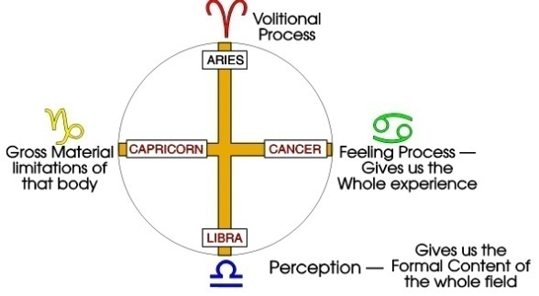
First of all, all the energy in the universe, before creation, we may consider as a continuum. And it is not synthetic, because it has not yet been analysed. And we will call that the undifferentiated whole. So there’s an undifferentiated nervous energy before it enters into a human being. So we can refer to that, the nervous energy, the kind of vibration that appears in a human being as nervous energy, is a definite frequency. And we call that a Cardinal sign, and put C for Cardinal. If we draw the George Cross on here, like this, those are the Cardinal Signs:
Undifferentiated nervous energy, the sign of the ram: undifferentiated feeling, Cancer: undifferentiated perception, Libra: undifferentiated absorption of food, Capricorn. That’s all undifferentiated, and that is prior to creation.
But the moment that that force enters into a finite organism like a human being, then it is no longer undifferentiated. It’s like pumping air into a balloon. The air may be outside, undifferentiated, you pump it into the balloon, and straight away if we draw the balloon inside there and draw the molecules of air that you pumped in, they’re rushing about and colliding with each other, and hitting on the inside of the skin and bouncing back. So that straight away they haven’t got that absolutely free motion that they had outside. They are now conditioned by the fact of existing. This means to say that every force that gets inside a finite being, like a human being, like a stimulus ... the light stimulus goes in your eye, goes in certain brain cells but comes to a term inside the end of a nervous line, and it sets up a beat and then the ripple starts all the way back again. So that in the unified state —that is, the energy entered into a finite system — we pass then to the signs called fixed. [52:08]
And I’ll put here the top sign there, the Ram is undifferentiated, the opposite sign here was Libra, that’s undifferentiated, Cancer is the undifferentiated, and Capricorn ... there’s the George Cross.

Fixed Signs
Now if we go clockwise, round one stage, we come to Leo ... that is the first differentiation of it. And it is called a fixed sign because the energy has now got itself fixed up in a body. Perception, passing into a finite system, becomes memory. That is, every perception of light goes in, produces a modification in my brain, and my brain is never the same again. It has now been modified, and that modification is memory ... so that the undifferentiated perception becomes memory when it enters a closed system like a human being.
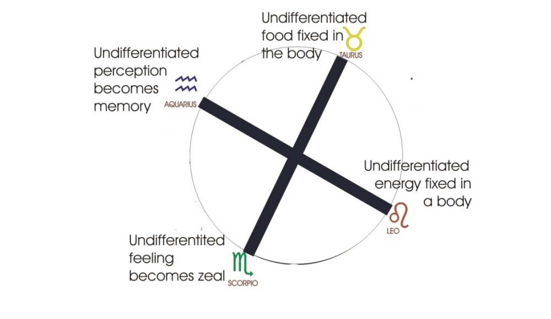
The undifferentiated feeling, when it enters a closed system becomes zeal. As if we were to pump water into a balloon — this is the water triad — and pump it and pump it and pump it, at a certain point there will be a weak place in the skin of the balloon, and it will burst there, and the water will shoot out. And that is the tendency of these feelings signs. When the feeling builds up to a certain level something must happen, and in the case of the Scorpio stressed person, their whole life is driven from within by feeling.
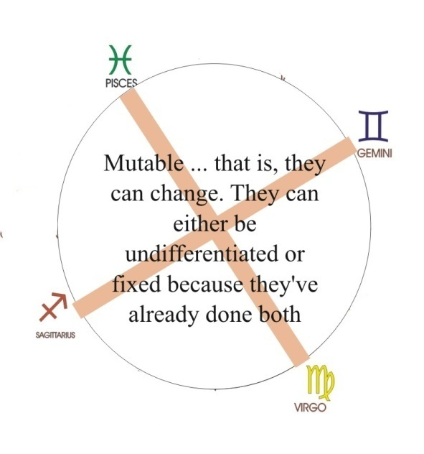
So that is then the fixed sign: Scorpio. And Taurus is the fixed sign for the earth. Remember, we take the undifferentiated food, put it in, break it down and then hide in glandular structures for use for distribution later.

Mutable Signs
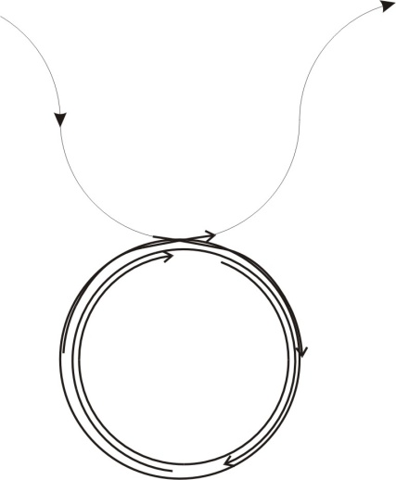
The first signs we call the undifferentiated or cardinal. The second ones we call fixed. And the third ones we call mutable, that is, they can change, they can either be undifferentiated or fixed because they’ve already done both. This has to do with reincarnation. If you’ve done a bit of that, and you’ve done a bit of that, then you can rock between them, and say, well, today I’m wilful, tomorrow I’m reasonable, and so on. Whereas, it’s very hard for these beings to be reasonable or undifferentiated, because they’ve only just gained their unity. So we’ll find that people stressed Leo are men of will, they’re wonderful pioneers, they get things done. But they really cannot rest, they cannot not-do-things. Things must be done, and they must be done by them. So we have to see the logic of this: that whatever it is that exists, must first exist prior to creation, which is its Cardinal’s hinge, it is upon that that everything hinges, like a stonehinge [sic]. And then it must enter into a closed system, whereupon it reverberates inside the system. And then it must burst out of the system again to regain its freedom.
So those are logically the three things. Energy coming in ... my pencil is refusing to co-operate [an aside] ... energy swings in from infinity, turns round — that’s the sign of Taurus — presses into its centre and then shoots out again. That completes the whole process, doesn’t it?
Solar energy comes into a plant, and by means of the chlorophyll in its leaves, it synthesises certain elements in the atmosphere using the sunlight as its primary energy. And after a time leaves come shooting out, fruits come shooting out and then it throws its seeds about ... scatter. [56:26]
So there is the logic. First, undifferentiated non-creative, then the creative, packing in of more and more energy, and finally the out-throw. And it’s very, very important to realise that in any situation whatever, for any kind of being — every finite being, every animal, every vegetable, every human being — is in a situation where forces are coming at him, piling into his organism, and will wind up inside until they’ve made such a pressure that they will come out ... unless he understands how to control them. [57:01]

Sexual urges
Now in the case of sexual urges, we know it’s perfectly obvious. Certain forces come into the body — they’re not individual forces, they’ve no regard whatever for individuals — they come into the body, they are determined to procreate. They periodically build up, they build up all the time, but they periodically release ... so they have to start building again. The energy comes in, piles itself up until the chemical messengers from those centres, going all over the body keep saying, go on, go on, time to release this lot of this, new inhabitants of the earth. And therefore the process called ejaculation or out-shouting must occur unless some method is devised of turning them in and transforming their frequency onto another level, which it is possible to do.
Psychologically that’s called sublimation. A man wants to do various naughtinesses, instead of which he decides to build the Sydney single expansion bridge. Now that can be done with it. It’s possible to create a work of art with the very, very same energy lifted to another level. But it has to be understood that you are dealing with infinite energy coming into a finite system, and it will shoot out in some form of symptom ... unless you understand how to change its phase.
So we can say that from the moment a child is born, energies are piling in through its food: solar radiation, cosmic radiations of various types. And they are forcing that child to grow. The child cannot refuse to grow at that level. It must grow because energy is coming in and packing it on the inside, and it will grow to the term for its type of being. And then energies start shooting out. And when a stimulus comes from outside and hits on an energy storage, the energy storage tends to react and throw more out. So a person may be practising self-control for a few days, and think, I’m doing very, very well, and suddenly somebody says what is called, the wrong word. And then quite suddenly it’s apparent that that self control was merely a bottling process. [59:27]

Assimilation at a higher level
Now it says in the book of words, no man can be continent except god wills. Continent means contained. It means you cannot, as a finite system, contain all those energies, unless God allows you to. And that can only be if you do with it what He wants you to do.
There is a method of doing it. That is to say, you can take the same energy that would fire at a particular target and deliberately think of the Macrocosmic being instead — which is equivalent to doing something that god wants you to do — and then you can contain the energy; it actually changes its frequency. You can then assimilate it at a higher level. And that which was merely a physical urge is then transmuted onto a higher ideational and emotional level. It will actually solve problems for you, the same energy that would get you into trouble can get you out, providing you shift your attention from the particular onto the universal.
God is concerned with reminding all creatures that they are derived from the universal, and trying to persuade them to behave as if there were only one whole being with many little children internal to it, like the seeds in a pomegranate. You know the temple of Solomon had its pillars crowned with pomegranates to symbolise that, because a pomegranate is full of seeds, and it’s a kind of diagram of the universe.
[comment from Khen] 365, according to John’s paper ... every one. [laughter] I’ve been waiting to tell you that.
One for every day of the year. There should be a quarter one somewhere. Anyhow, we consider this as a diagram of the four systems in the body — we have four organic systems in the body — physically, and also as a psychological device.

Physical
Physically, it means there is nervous energy [fire], there is breathing [air], there is feeling in the fluids [water], and there is absorption of food [earth].

Psychological
Psychologically it means there’s a very definite relationship between wilfulness and nervous disorders, because this nervous energy is that energy which becomes will when it enters into a finite being. So that people that tend to be wilful are the same people that tend to be neurotic. [01:02:10]
Now if we take the opposite of fire — that’s water — the water people in general, with the exception of Scorpio that is ruled by Mars, they are adaptable, and they do not tend to neurosis. What they tend to is something quite different: they tend to enjoy themselves and not be too particular about what are called this world’s moral consideration. They tend to be hedonist, to enjoy life. They say that life is for pleasure and for the avoidance of pain, and, if we can get on very, very nicely together, it’s good enough for us ... you can keep your air sign theory.
Now the air sign type in general hasn’t got that kind of feeling, but prefers a process of judging everything, evaluating everything perpetually, and therefore tends to lack feeling. But if you remember, Plato said, feeling is the unity principle in your body, and thinking is the disunity principle. It is thinking that breaks you up: it’s analytic. It is feeling One that will renew your wholeness. So it’s very important to see the difference. [01:03:30]

Psychothymia
Now in the case of the earth kind, we can see an illustration of what psychologically is called psychothymia, where we divide people into two kinds: schizophrenics, and cycloids.
The air sign intellectual tends to split up into subsidiary personalities ... it’s called schizophrenia. The Earth sign tends to be alternately depressed and elated, but it keeps always his own personality. It is always Maggie Mumps who is depressed, you see, and elated and depressed and elated. Now if we take the extreme case of this, the insane people who are cycloid, they tend to commit suicide after a depression has just finished ... never in it. Because when they’re thoroughly depressed they can’t do anything about it. But if they’ve been depressed and then they’ve been elated and then they’ve been depressed and elated in a continuous cycle, they get fed up of returning to a depression that they’re just escaping. So when they come out of a depression they get enough energy to commit suicide before they have time to get to the peak of elation and become depressed again. So there’s a definite period for the cycloid type when we have to watch them very, very carefully because they tend to do away with themselves ... not in the depth of a depression when most people would think, but when they are coming out of it. [1:05:00]

Earth: Cycloid (Bi-polar) control
In Boehme’s terms it would be a warning to all earth signs to avoid depression. And the way to avoid depression is very simple, mechanically: never allow yourself to be elated and you can never be depressed. You see, it’s again this waveform. If you allow yourself to go — there’s your median line — if you allow yourself to go up, that is, you push the string up there, it must fly down again ... so that this is the way to conquer depression. Because in depression you can do nothing at all except sit and be depressed. You wait until you tend to be elated and you pull down that elation, knowing that if you manage to pull it down you cannot be any lower the median line in your depression than you allowed yourself to be exalted above it. In Bible terms, the mountains shall be brought low and the valleys shall be exalted. Such symbolic expressions are psychologically significant in this way.
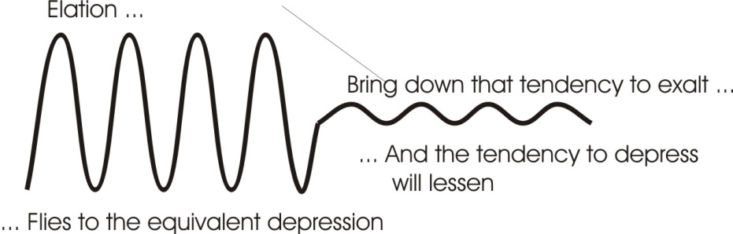
So in dealing with an earth stressed person — a cycloid, manic depressive type — the important thing is to teach them not to be exalted. They feel fine, why shouldn’t I feel fine, I’ve been depressed for so long? The answer is, that is why! If you do not pull yourself down when you are exalted, you must fly to the equivalent depth to the height you’ve allowed yourself to be exalted.
And if they practice ... lots of people I know that were very cycloid in temperament in this manner have completely cured themselves. The ideal is to get that tendency-to-exalt hardly to move over the median line, so that it can’t go below it ... you then get an even keel of life ... you’ve got self control. And you know that if you get excited and flip up ... pull yourself down. And you know that if you’ve allowed yourself up, and managed to pull yourself down, you will be pleased that you’ve done it. So that when you become depressed later, you will be equipped in your memory with the knowledge that next time you’re elated you can pull yourself down a bit more, and the depression will reduce.
So the characteristics of those people are: they are pitched in the physical body ... they tend to be cycloid in behaviour, all totally depressed and elated, the cure is pull down the elation and then the depression cannot occur because of that physical fact.

Water: Pleasure-Loving
The water signs tend to be rather easy going and pleasure loving. They’re the most pleasant people in the world to get on with ... for other people in general. They’re not always the best people for themselves, because it isn’t always possible in this world to enjoy yourself all the time ... for that is their campaign.

Air: Schizophrenes and the link factor
The air signs tend to split, because of their analytical processes, into many little subsidiary entities ... so-called split personalities. You can see the mechanics of that very simply in this sense. Supposing you study arithmetic, and then you leave it alone and then study foreign languages, then you leave that alone and study music, and you leave that alone and decide you’re going to the pictures for relaxation, during which time you eat chocolate and bananas and so on, and then you come out and decide that it’s time you went the pace, so you go and get drunk. And you do all these different activities and you never find the common factor in them all.
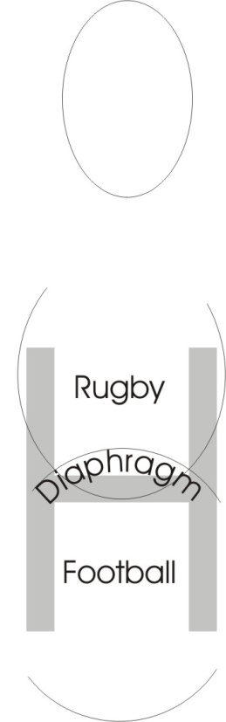
Now if you don’t find the link factor between these different activities, what you are really doing is engramming on your brain substance knowledges of certain fields of activity that are quite discrete ... they’ve nothing to do with the other activities. So there’s no link factor, and then when the nervous energy plays through those parts, it operates so that a man one moment is a very, very rational being — that’s because he’s practiced being logical for a time — and then during the next period, he isn’t being rational at all because the energy now has moved. It can’t stay always in the same place in the brain ... it must move. When it moves to another place then the fellow thinks, oh I think I’ll do a little bit of music practice now. And half way through that the energy moves to another zone, it thinks, I’ll go to the pictures instead.
This is caused by the movement of energies through the different zones in the brain. And you know each zone in the brain has a specific function to do with the actions of the body. So the important thing for dealing with the schizophrenic type is to give him the link factors that tie together all the different activities.

Ball Games
A man goes to a football match, another man hates football and likes cricket. You say to both of them, after all it’s a ball game. And you start telling them that they’ve got eleven in both. Eleven cricketers, eleven footballers. Why eleven? Why is a cricket pitch twice eleven long? Why are there three stumps? ... and so on. All these games are symbolical. They’re ball games. And all the ball games can be linked together as games which are really metaphors of activities of the will: because ball means will. B-all, means the whole: ball. Boll, with an O in, is the Greek form of the Latin V.O.L. ... volition. This is the boll: the circle. Energy comes in and turns round: that’s boll. This one is called Vul as in Vulcan ... the gentleman that hides underneath volcanoes, and hammers. This is Vul, and this is Vol. That is individuated volition.
So that when we talk about ball games we are talking about will games. And the whole object is to pass that ball through an arch of some kind, isn’t it? So in this sense, this represents the initiative power. Freud would have said, oh well, it’s just a male symbol, and the goalpost is a female symbol. In the case of rugby we use a letter H because rugby is only for decent fellows to play, isn’t it? Now can you see symbolically why in rugby they have an H goalpost instead of what is in effect a khet [Hebrew letter].
Well it’s the sign of spirit. Now supposing you take, this is the diaphragm. These games were made by beings long ago to train their children. There’s your diaphragm in the H, you see, and the footballer kicks underneath it all the time. But the rugby man who’s training to be a gentleman, he has to get the ball over the bar, doesn’t he? He must keep the will up. [01:12:12]
Now this is a method of linking for the sake of these schizy-type people ... linking together what these ball games are about ... they’re all symbolic. It’s not accidental that they have in a certain game for a certain class of people a certain number of players. It isn’t accidental that the ball has to be kicked over in rugby and kicked under for ordinary folk.
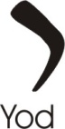
And the more you can think about ball games in that way — that the ball equals will, and is a masculine sign and the goal itself is a feminine sign — spirit itself is feminine prior to creation, because the positing is the first masculine, because Latin macula means a spot. We put an ‘s’ in it ... ma-s-cula. You see, that is the same as a masculine sign. Men are the original spots or blots on the escutcheon of spirit, you see? They’re throw in ... that is like the Hebrew letters yod which you would draw just like that. That’s a Hebrew yod, which is our jot in English, that Christ refers to. Not one jot or tittle shall pass away. There is the goal, you see? That’s Het, hedge, limit. This yod is the drawing of a hand, like that, and it means creative power, and it means the positor. Posit is that making-of-the-point. Po...Sit. A Po is power, Sit means you put your power down, let it Sit. So this yod or jot, the Greek iota, is the jot or tittle that cannot pass away ‘til all is fulfilled, because as long as things exist there must be positing of power. And as long as there is positing of power, then nothing can pass away. And nothing is going to pass away until everything has fulfilled its purpose, and therefore not one jot can go away until all is fulfilled. It’s just a question of the logic of it.
Now, are there any particular questions you’d like to ask about any aspects of the zodiac that might help to clarify any particular issues? [1:14:46]
[Member of the audience (X)] Well, I find that I’ve got most of the other symptoms of behaviour patterns that you give to the birth signs that aren’t particularly my own.
In what way?
[X] Well, I find I’m little bit of the one time I didn’t have ...getting very late and up in the air ... the other earth sign of changeability, starting to do something .. and deciding to do something else ... I think I’ve had the lot, in fact.
Well now this is a diagram of a human being, isn’t it? And a human being has these four parts inside him. We’ve analysed them out and dealt with them separately, but to deal with the human being we must put them all back together and synthesis the whole man. You’re a Pisces type aren’t you?
[X] Yes.
That means you’ve got a primary stress there. But that primary stress, being an emotional stress, has tended to link you to all the others, hasn’t it?
[X] Yes.
You see that? So because of that stress, in a real sense your mind is very quick internally, and you attach yourself to a lot of things, don’t you, and have done, emotionally? So we must remember that the whole man has all these things inside him. And the difference between one man and other as regards this wheel is stress only. That is to say, you are not merely one of those, you are all of these. There is always eleven of those subordinated to one unless a stimulus comes outside you see? Supposing we stimulate your Gemini faculty and ask you how long is a piece of string? You’ve got to think about it haven’t you? That takes you out of Pisces for the time being and stress the Gemini. You see that in you? Because you’ve got them all.

Natural Equilibration
Now, if we found an emotional being to act upon you, you would understand what he was doing, wouldn’t you? But because you are looking for wholeness you may not like him. In fact very often the people we are most like, are the people we like least. Because they haven’t anything to give us. Now, the funny thing about this is, very often people marry someone who is on the opposite side of the wheel. And when they have babies, they frequently bisect the angles between them. This is an attempt on the part of nature to equilibrate all the time.
Supposing all the giants married giants, and all the small people married smaller people. We would have two races wouldn’t we ... the very big and the very little? What we find is that tall people are fond of little round people, you see, and fat people are fond of thin people, and dark people like fair people.
This is a device of nature’s to guarantee that the human race manages to remain human. Otherwise it wouldn’t be a race at all, it would be a multiplicity of different species, wouldn’t it? [01:18:03]
So we have to remind ourselves that this is only a stress, and then we must add to it this: you are also not only born at a particular time of the year, but you were born of certain parents. So you have your biological inheritance as well as your birth position to consider. Also you have the fact that you’re born in a certain country and there’s a certain tradition acting upon you. And you’re born on the earth, aren’t you? ... not on Venus or on Mars. Your specific gravity wouldn’t be the same if you’d been born on Saturn as it is now. You see that?
So first we must consider all these different influences. First of all you derive from the infinite spirit — which is called the Godhead — then you are whipped into the Macrocomic sphere, and then you are driven through the sidereal sphere, through the solar sphere, through the planetary sphere into the earth. You’ve already passed a lot of influences on the way, haven’t you? Then you get into a certain country on earth at a certain historic period on earth with a certain tradition, in a certain family with a certain biological heritage, and on top of that in a certain house of the zodiac.
[Khen Ratcliffe] Just ain’t no hope for you ... [laughter from the audience]
You see that you must handle it very, very carefully. Most people say, oh, well, we know of him, he’s a fish, cross him off. You see, he’s emotional. Now that’s foolish, because the character of the external stimulus
[Another member of the audience] I say it of myself sometimes.
Everybody says it at sometime in their life. Subject to this number of influences which you have to remember — they’re all valuable you know. It’s the same as if you are studying anatomy. You have to study the different structures, you see, start with the skeleton and then you hang onto it various major muscle forms and subsidiaries and so on — say artistically — and to draw a figure of a human being in action you have to remember an awful lot of things to avoid mistakes. And when you are trying to deal with a human being, remember first he belongs to the absolute spirit, then he came into the universe, he’s subjected to astral or sidereal star forces — cosmic energies — then solar energies, planetary energies, earth energies, national energies, particular family biological, and then the time process on top of that, and then external stimulation coming from outside to complicate the matter. [01:20:39]
If you make allowances for them all, you can be very accurate, but if you ignore them all except one, namely the particular time you walked in, it’s surprising how close you can get to it.
For instance if you take even the century we are born in: we are born in the 20th century, the first part of it, and the 19th century inertia is riding over us still. We still believe in atoms ... by inertia. Atoms are a fiction. We still believe in electrons. They’re another fiction. A man like Schrodinger says, well their logically inconsistent with themselves. Perhaps they are just wavicles ... you see he takes the word particle and cuts the part off and keeps the icle and then tags a wave on to it and says it’s a wavicle, because is behaves like a wave and like a particle. This is an attempt to put together contradictories to explain something that’s inherently contradictory. And they’re all myths in any case. In that sense the whole of science is a myth. But it’s a convenient myth.
... if I tell you that Prometheus stole fire from heaven for which the gods got very annoyed and sent him a wife named Pandora. But Prometheus means forethought in Greek. So he wouldn’t have that wife, he said, “not for me, thank you. If the gods have sent me a present after I’ve stolen fire it must be no good.” So he refused it. [1:22:12]
But he had a brother called Epimetheus, which means after-thought. So he married her and then all the troubles of the world started. That is a mystic statement, it’s myth, it is valuable. It says, “forethought can dodge a certain amount of trouble but it gets you into another kind of trouble”. Because Prometheus was bound to a rock and then an eagle came and tore out his liver every day, and in the night time he renewed it. But the eagle came back and tore it out again the next day ... because he was a man of forethought.
Now if we go into the world of business where men are fore-thinking all the time, they are Promethean men. And we find that liver trouble is one of their chief troubles, because fore-thinking has to do with the liver. And when you are fore-thinking, you are really annoying yourself in a variety of ways, and sewing all sorts of fears in yourself.
And the eagle is the symbol of the intellect. So it is your intellectual activity that’s biting at you ... that Promethean activity.

The Planetary Symbols
[Khen] How about Liver ’pool’ in that situation? [01:23:18]
This is an amazing thing you see, we go into Manchester and all the buses are red. We come here and they are all a funny kind of greeny-blue aren’t they? The same colour that you see on copper. And the same as the lamp standards, aren’t they? Now copper is a metal sacred to the goddess Venus ... the goddess of eroticism. And the liver is very closely connected to that activity. It’s part of the geodetic revelation. Who persuades the corporation to paint their lampposts and buses in the appropriate colour of Venus? Does the Lord Mayor know about it? [01:23:58]
[Charlie Blythe] They were red at one time.
Who persuaded them to change them?
[Charlie Blythe] I don’t know.
You know Mars and Venus are opposite?
[Charlie Blythe] Yes.
Did we do the planets in their pairs? Have we done that?
[Charlie Blythe] No.
Have we a bit of spare paper? [looking through the scroll of paper he uses for the presentation of the talk]
These are a part of the planetary influences but they are very simple to learn, and very, very useful. And they’re very, very good ... [????]

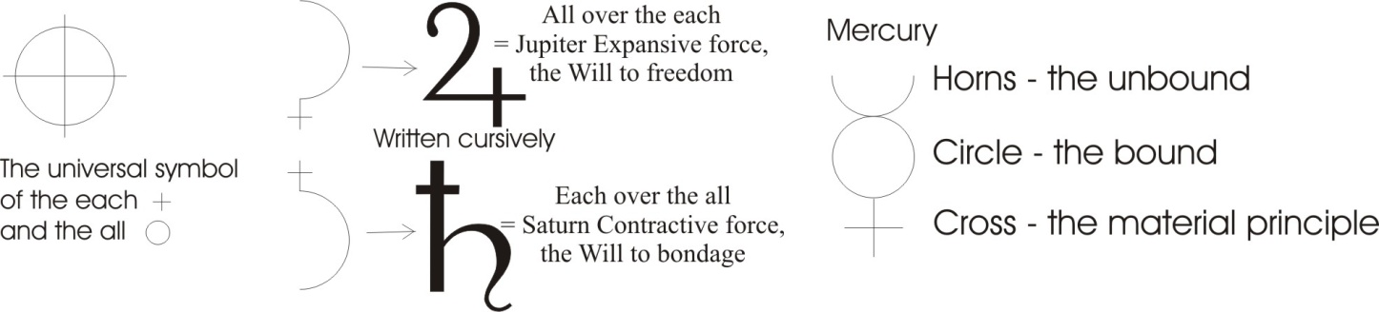

We take a circle and say that represents all there is. We draw it again and put a cross in it to represent each there is. And then we say we like to represent two different concepts out of this, so we’ll cut the circle in half like that, and take the cross out and put it at the top, and put it at the bottom. And we will then make a quick cursive sign like this ... and like this. Now that is the sign of Saturn, as a planet; that is the sign of Jupiter. When the cross is over the semi-circle is means time over eternity, or contraction more than expansion. When this semi-circle is over the cross it means the expansion is dominating the contraction.
Saturn means contraction. Jupiter means expansion. That’s one pair. [1:25:47]
We’ll just do them again. Saturn: time over eternity, or contraction over expansion [Saturn], expansion over time [Jupiter]. That’s one pair. Saturn, Sat is being ... and the urn thereof, the urn that contains being. The idea is that when the contraction principle in the universe dominates, you have made an urn of being. But when the expansion dominates you have made Ju is God, piter - Father ... Ju-piter. That’s God the Father, because the expanded condition is prior to the contracted. Remember the uncreated state of energy is prior to the created state. So Jupiter is older than Saturn.
Saturn is called Chronos by the Greeks, isn’t it? Time. Time is a word emit ... throw out ... backwards, because it depends entirely on the emission of energy. The time process depends on energy emission.
Saturn Chronos time is the same as Satan the devil ... is in opposition with God the Father. But they are both half circles of a whole, which is represented in Christ. And the sign for Christ is the sign for Hermes, Mercury. There we are the horns, symbolising the unbounded, the circle symbolising the bound, and the material principle, the cross, crucifixion. So that represents the horns of your power on your head, this represents the feeling of your chest and that represents the fixation in the sexual energy in the lower body. So there’s your three-part man; and that is Mercury.
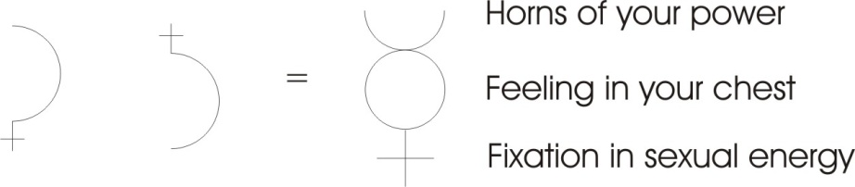
So if we like to say it, we can write an equation that Saturn and Jupiter equals Mercury. We can if we want just go like this [draws on the white paper]. And that is a legitimate equation in that sense. Now Newton borrowed it from Jacob Boehme and said forces in opposition — contraction and expansion — produce rotation. This Mercury is Mer-cury, to run round. Running round. There’s the Mer in the Mer-sey. Mercury means to run round, and the running round is always caused by a contraction and an expansion together. So contraction/expansion = rotation. That’s a pair, and this is an odd one. We’ll see why this is odd, it hasn’t got one opposite to it.

[a break here ... moving onto assimilation 2]

Part 2
We have another pair now: Venus, circle with a cross below ... which means that the soulish substance — the fluidity of it — is superior to the bone or material fixation of it. That is the matter part, this is the soul. That’s Venus, therefore she’s concerned with feeling. That is passive ... funny way to spell passive [said as an aside] ... circle with an arrow flying out is Mars, and that means active.
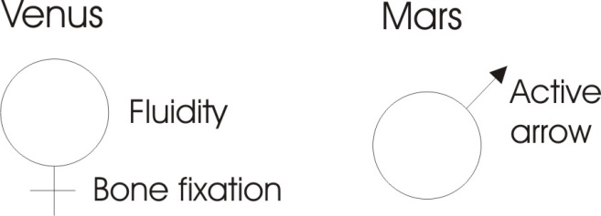
We’re in the very merry month of Mars at the moment and therefore the forces in the earth are becoming active and tending to throw their little shoots, with red ends on them waiting to grow. These two are a pair of passive/active. It’s a method of analysing our universe.
And we have another pair, the moon which means body itself, and the sun ... Moon or lunar, and Sun or sol. Now this means body [moon] and that means force [sun]. Or that means will [sun] and that means body [moon]. We can call it body and force or matter and force.
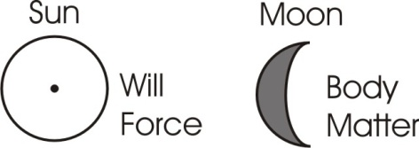
[Khen Ratcliffe] What’s the difference between the passive Venus, and the body of the Moon?
Well here we are considering the fact that it doesn’t do anything other than receive [Venus], and here we are considering that it exists and occupies space [Moon]. Thus the moon aspect of that is that it exists, and occupies a definite amount of space. The Venus aspect of it is that it won’t move unless we push it. The Venus and the Sun differ [appears to change this sentence] ... the Mars and the Sun differ in this way: Mars is always active, it’s always flying out when a certain amount of energy has gone in to it, you see? But this [Sun] symbolises the very concept of force, quite independently of whether it has poured itself into something or not.
So we now have three pairs and an odd one, and the odd one is the sign of the Messiah. Now when god is said to create, he creates in six days, and then rests on the seventh day. Now the seventh day for the Jews, and the seventh day for non-Jews, is not the same day. The Christians use the Lord’s day, Sunday, because it means illuminated: enlightened. The Jews use Saturn’s Day because it means material cover. Now essentially the Yiddisher type has his book, which says, obey that thy days may be long in the land which the Lord thy God giveth thee. In other words it’s fundamentally materialistic. So Saturn is their favourite day. And Christians are supposed to be wanting to become enlightened, so Sunday is their favourite day.
But the favourite day for other folk who know one or two tricks, is Mercury’s Day: Mercury or Wednesday ... the quick fellow’s day. And the quick fellow doesn’t have a materialistic outlook, and is not particularly wanting enlightenment as such. He’s quite satisfied with the material situation as it is, and that some people want enlightenment, because he’s going to balance all of these processes. He doesn’t want to be passive, he doesn’t want to be active ... he wants to be both when he wants to be them. He doesn’t want to be conditioned: inertic, passive. He doesn’t want to live by liking things passively. He doesn’t want to push things about, he doesn’t particularly want to be a material body — hello Dear [an aside to a new arrival] — he doesn’t particularly want to be a force. He wants to balance the whole of possibilities.
[.... break in recording]

The Seven Days of the Week
[Let’s take?] ... the days of the week and look at them. We’ve not got them in the order that they occur in English here, that is Sunday, Monday, Mars is Tuesday, Tiwez is the old Norse god of War. Venus is Friday, the old Friga’s day ... fruit Day or payday. Mercury is Wednesday. Jupiter is Thor’s Day or Thursday ... the hammer’s day. And Saturn is Saturday. And if you look at the logic of it you can see just why it is that people go making merry on Saturn’s day ... the Saturnalia or whoopee time of the ancients.
You start your day in a moony state in the working week after you’ve had a rest in your illuminated state on Sunday. Sunday is supposed to be devoted to illuminating yourself ... remembering the Lord on that Day. On Monday you’re supposed to start counting again ... go back to business. The moon is the counter. Having counted you’re supposed to make war on all your rivals in the business world, on Mars day. On Mercury’s day, you’re supposed to be well into the business field because Mercury is the patron saint of businessmen, Rollensteins, vagabonds and leg-pullers. And on Thursday, it’s getting late in the week so you have to hammer it to get your quota. And Friday, you get paid ... that’s fruit day. Saturn’s day you make whoopee.
Sunday | Sun | Devoted to illuminating yourself... remembering the Lord on that Day.  Sit down and evaluate your position. That’s your Sunday.
Monday | Moon | Moony state in the working week, start counting, going back to business. Moon is the counter. When you’ve found out where you are, start the next day counting, to see whether you’ve got the wherewithal.
Tuesday | Mars, Tiwez, the Norse god of war | Make war on all your rivals in the business world, on Mars’ day.  Launch forth, and aggress against the world, to further your purpose.
Wednesday | Mercury | Well into the business field. Mercury is the patron saint of businessmen, Rollensteins, vagabonds and leg-pullers. Mitwoch, you should be really spinning it, rotating with mercurial speed.
Thursday | Thor’s Day | Getting late so you have to hammer it to get your quota.
Friday | Venus, Friga’s day | Fruit Day or payday
Saturday | Saturn | Making merry on Saturn’s day. Saturnalia ... whoopee time of the ancients
Table 1

And that is the order in which your weekly round is generally conducted. And the funny thing is, it’s conducted practically over the western hemisphere in the same way, and with very little modification in other countries. In other words, there’s an inherent logic about it.
Sometime in your life you should sit down and evaluate your position. That’s your Sunday. When you’ve found out where you’re up to you should then start the next day counting, to see whether you’ve got the wherewithal. On the next day you launch forth, and you aggress against the world to further your purpose. On the middle day, the Mitwoch of the Germans, you should be really spinning it, rotating with mercurial speed, really getting about like a traveller with fourteen different zones up and down the country. Thursday it’s getting a little late, your quota has not been ...
[break in recording ...]
... once you apply them all, you’ll have a very good evaluation of the situation, won’t you?
[question from the audience] What happens to the loss of time, when we get the leap year every four years. Does that alter in any way...?
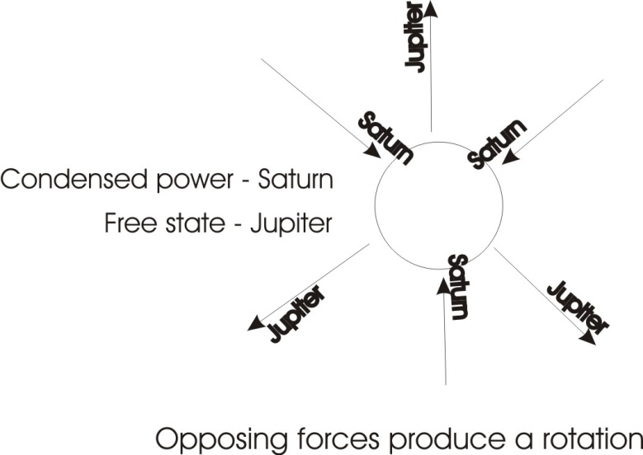
It doesn’t affect this because the amount of error that occurs through using a year that isn’t quite right is infinitesimal as far as an individual man is concerned. It is periodically corrected. You remember on one occasion eleven days disappeared from the calendar, and the poor people — who didn’t know that those eleven days hadn’t really been stolen from time, they’d just altered the calendar — took a lot of bricks and started throwing them down Whitehall and everywhere they could, demanding back their stolen days. They actually thought they’d had days stolen.

Contraction Expansion Rotation
Now all of this, which might look complicated, isn’t, if you see the underlying logic of it. There must necessarily be — to create — a contraction. And what existed before the contraction is a state which, after the contraction, you could call expansion. Couldn’t you? Before you contract, you don’t call that the expanded state, you might call it extended if you want, but expansion and contraction are logically opposite ideas which presuppose each other. Before contraction there is that which is expanded. Expanded is prior, and is therefore called Jupiter God the Father. It then contracts onto a point and that’s the devil, Saturn. And this contraction or self will is the same thing as ideation, individual value. And you have to balance the expansion of the Absolute and the individuatedness of Saturn. That is, you have to be yourself and remember there are other beings as well. See the logic and then restore the whole thing to this diagram and it becomes simple. You’ve got contraction, expansion and rotation ... those are quite simple, aren’t they?
Then, passive and active. That’s passive pleasure, active desire. The Venus type is a blonde lady with not much energy, with fingers pressed right back and can touch the wrist with them, and she lives for pleasure. If you find one of this pure type, be surprised.
The Mars type of man has red hair, red skin and a tremendously zealous nature, and he never waits, he goes bang for the target. You can find a lot of pure types of those actually ... more than the others.
The moon aspect simply means the body as a material structure, and the sun as a force acting upon it.

So that’s quite simple really, isn’t it? Contraction/Expansion produce Rotation.
That rotation considered internally may be viewed as passive [Venus].
And considered as squirting energy out is active [Mars].
Considered as occupying space we call it a body [Moon],
Considered as its original force, Jupiter, we call it a force, the sun.

Four Systems in three phases in the Body
So really those are not very complicated are they? And we can reduce the twelve signs of the Zodiac down to four systems in your body: your physical matter represented by the bones; fluids in your body, your blood, etc.; the air in your body; and the nervous energy in your body ... just four systems.
In three phases: the undifferentiated before it gets in your body; the differentiated and unified when it gets in the body; and then the alternation between the two, the mutableness of the third state. So that the top state is like an absolute positive. Then the contraction of it which makes unity is a negative, and the third state alternates, is neutral, it goes Absolute ... particular.

Thinking about Things
You find if you try to think, you have to think about a thing. But if you try to think about a thing, you will have to leave it. Supposing I decide to think about that pencil; thinking about it is saying what is in it. I say, what is it ... well it’s graphite in the middle ... what’s graphite? ... immediately I have to leave the pencil to think about it. That’s why we say, about ... ab-out ... away-from it. It’s graphite in a ... because it’s fairly easy to break. If we get a piece of wood, what’s wood? Trees. A piece of I think that’s a piece of Czechoslovakian pine or something. Now every time we try to think about a thing, we have to leave it and think about something else.
And if we see the logic of that we will never try to think about a thing without thinking about other things. Because if we think, well, what is wood?, well it’s trees, what are trees? They’re kinds of beings that somehow are created by the action of the sun on air, water and earth, aren’t they? Somehow a force enters into the earth, and drags up various chemicals and combines them with water and air, and that’s a tree. So already it becomes a cosmic proposition to examine the pencil. And whatever it is, we should always force ourselves back to the universal origin in order to understand what it is.

Will Power
If we think inside our body, what is that Absolute cause of all things, force, what is it in the body? It is will-power. So there’s a definite relation between the will power of a man and the Jupiter or cosmic creative force in the universe. But you cannot get at it as long as the rota, the inertia, the habit of you is using up all your energy. If you’re in the groove, if you’re a dead man, you can’t get the energy out of the groove to use it for another purpose.
So there’s a very simple test of whether you have got willpower or not: simply take something that you habitually do ... and don’t. Take something that you always do, and don’t do it for a week. If you manage it you can say, yes, I have will power. If you forget about it, you can say I haven’t got will power yet. But know that if you get it, you have got the same essence with Jupiter ... that is, with God the Father. That is, with the cosmic, original spirit.
[Khen] Could you equate the six-foldness with the twelve-foldness that you spoke about at the beginning? You drew the first six which we’ve spoken about with the five sense organs, could you show how the twelve arise in there?
Yes, well first we’ll take this out — the Mercury — because it’s the balance of all others. And then we consider the contractive side is the part that produces matter, isn’t it? So this Saturn is related specifically to the bones. This is why this thing the skull, which is bony, we say it’s a Saturnine compaction. All the bone parts are Saturnine. All the airy parts are Jupiter, the expansion, which is your lungs expand, don’t they? The expansion tendency which sucks in the air, is your Jupiter function. This Venus is fluid, and so is the moon, but this is the passive aspect of it [Moon] and this one is the spatial occupancy of it [Venus]. So both those two belong to the fluids in the body.
And Mars and the Sun belong to the nervous energy in the body. You see? So it’s not really a complicated thing when you see the internal relations of them. They’ve been spread out in this way to enable you to analyse a situation.
You see a man with a certain kind of body, and his head may belong to a slightly different category. You find a man with the coloration of a Latin, and the features of a Slav. Well you would say straight away his ancestry is mixed. We find some high yellow negresses that look exactly like Jews, because once upon a time there was a medial type, the Shem type, from which there appeared a Japhetic or intellectual, and a Hamitic or sensual. If we breed back the terms together again, we find that we are getting the middle that we started with. You find a tremendously Jewish look about the high yellow negresses in America. In fact you could easily mistake them for Jews, because they are really the product of breeding back into the middle line from which they merge.
The thing is to see the fundamental simple line and then all this stuff isn’t complicated at all. There would be no bodies in the word if there weren’t contraction. So Saturn is the very principle of materiality. And then immediately we see why it says in the Bible, the whole world is in the grip of the devil. That is, all matter whatever is a product of covetousness, grab. God the Father is expansion, and is therefore always at war with Saturn.
But Jesus Christ the messiah is called the mediator. And he tempers the severity of god who wants to break up the devil’s works by explaining why it is necessary. So Christ mediates between God and the Devil. The sin in man is apologised for, because it is the sin in man that keeps him separate. Sin means separation. If all men lost all separation — which would be the same as all sinfulness — the whole universe would suddenly splurge, and there’d be nothing left. And there’s no value in that absolute splurge, therefore a certain amount of devilishness is necessary.
Sometimes you find little boys running about and mothers will say, they’re proper little devils those boys, and it means that they are initiating something and separating something, and fiddling about and interfering. It isn’t necessarily a bad thing. Actually the only good is the whole ... the mercurial resolution of all these oppositions. [18:36]
[Khen] Can we equate that with that six-fold division we had a few weeks ago? Where we saw the universe first as a whole, and we divided it, didn’t we into what we termed spirituality and materiality, so there’s a dualism, the plurality. Could you put that on for everybody?
No I wouldn’t do that, because that is a totally different frame of reference. It’s a totally different frame of reference.
[Khen] There is an equation ...
There is an equation.
[Khen] But it would only mix things up at the moment.
... it would at the moment. The best thing to do is to familiarise yourself with the internal logic of this thing, and to see that in this sign — Mercury — we have a diagram of a man where he has pinned his sexual energies. He has his whole feeling, and he remembers his dual origin. Those horns up there symbolise that he’s rooted in duality: the devil and God the Father. William Blake says, the people on earth worship the Devil under the name of Jehovah. And they don’t know it. Why? Because Jehovah God is a creator. But a creator is a finiter. And we don’t want finiting: we want freedom. Why do we want freedom? ... because we haven’t got it. If we had it we’d want to be finited. The essential thing is to see that the Saturn/Jupiter opposition is no more than the split of a prime whole. All/Each split, the triumph of each over all, and of all over each.
Where all triumphs over each, it’s Jupiter.
Where an each triumphs over all, it is Saturn.
So we say that Hitler was the devil because he triumphed over the German people; he subjugated them to his will. Now if they’d have subjugated him, we might have called it the tyranny of a bureaucracy, or something like that. But it’s very, very difficult to equate the many with a particular devil, because the mass itself seems to be its own justification, and its own law. The herd makes the rules for the herd, and it always defines an individual who doesn’t conform with herd law, as a devil.
Thus the Pharisees said of Christ, he has a devil, because he’s fiddling about with the Pharisaic Law. We must put him on the cross where he belongs; the sign of the devil ... nail him up. So they really want him pinned on the cross like Moses pinned the serpent up on the cross in the desert. It simply means cross fixation.
If that malcontent or dissatisfied fellow, the fellow who doesn’t like our rules, can be caught by us, we’ll nail him onto the thing that he signifies; namely irritant form within the body politic. The Sanscrit word, the only word in Sanscrit for Will is Icheha. Ich, the English word, itch ... irritant. [21:49]
You see, you get a welfare state and some people think it’s an ill-fare state, and start dodging. Now the government will always define the dodgers as naughty men, but the dodgers will always define the government as a wicked, tyrannical bureaucracy. And the question is, who wins? The winner does the defining. And it’s very, very important to realise that what we are dealing with is a whole ... and continuously re-synthesise this.
You see, there is a man who has his awareness, consciously, that he’s rooted in Saturn and Jupiter, in grab and let go ... it’s as simple as that: grab, let go.
Supposing a man grabs, and gets his penny. Sometimes you get a little boy’s got a penny. It’s in his hand.
And you say, What have you got in your hand?
He says, Penny.
Where are you going with it?
Nowhere!
Why?
My penny!
But pennies are to spend.
He looks very suspiciously at me. You take him to a shop and you say, give this boy something for a penny.
And he looks at his penny like that and he won’t let go of it.
And you say, But it’s currency. It’s supposed to run about. You’ve got to let go, otherwise it’s useless. [23:03]
Now the boy has to learn that he can’t get the value of the penny without opening his hand and letting somebody take the penny and giving him something for it. It’s this thing ... grab ... and let go. And the important thing is, what are you going to grab and what are you going to let go? If you grab the wrong thing, you find you’ve let go of the other thing. And it’s the ability consciously to grab the right thing at the right time, and let go of the right thing to let go of, which you would call the wrong thing to hold ... also at the right time. And then you’ve resolved this difference. [23:39]

Fallen and Unfallen Man
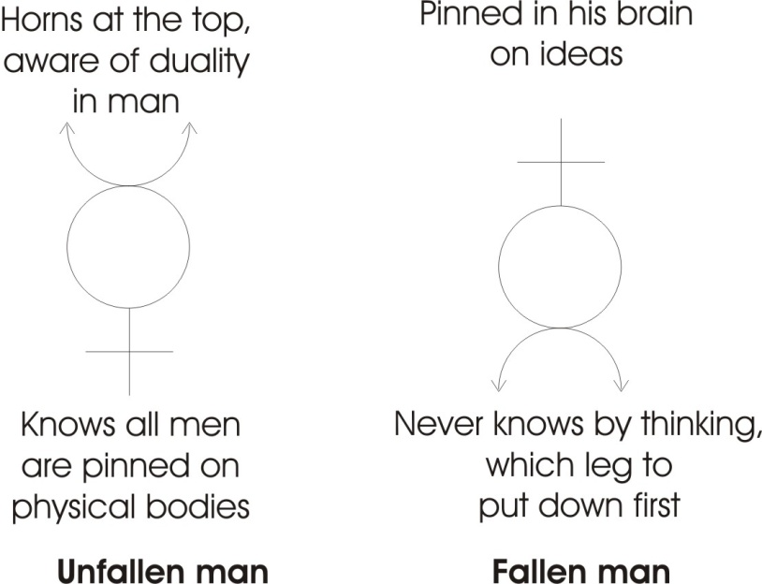
And we call this the unfallen man; his horns are at the top. He’s aware of the fundamental duality in man, that grab and let-go is his origin. And he has in his feeling compassion for all beings, and he knows that all beings are crucified on their physical bodies. So he thinks in terms of a dialectical process: the identity of opposites. He feels compassion for the whole thing, and he knows that he is pinned on a physical body, and so is every other body. That’s called the unfallen man. Now we’ll draw him in his fallen state. Now, he’s pinned in his brain on ideas. He’s now an intellectualist. He thinks that he can solve the universe in terms of thinking, and the logical thinking cannot solve it, because logical thinking says that contraction and expansion are opposites, mutually exclusive, and nothing to do with each other.
Logically, putting-in and taking-out are opposite aren’t they?
Paralogically, beyond logically, dialectically, both processes are going on simultaneously in the universe. Energy is pouring in and energy is going out in the same moment. The Atlantic cable that takes a message to America down its core is returning a current on the outer sides of the cover, isn’t it? There must be circulation. Something is going down there, something is coming back at the same time. Now we call that paralogical thinking. And the man that thinks only logically, we call him an intellectualist — remember I.S.T. means he’s crucified — he thinks wholly, but now he’s walking on two legs, you see. That is to say, he’s alternating as he goes along. One of his legs is the thinking leg, and the other leg is the feeling leg. And he never knows, by thinking, which leg to put down first.
We talk about getting up in the morning and putting your right leg down first. And some people are not quite sure whether you should put the left leg down first. Now in India where they have systematised all of this they say, when you get up in the morning, put down on the floor one of your legs. If you’re a Brahmin, put down your left leg in public ... if you’re in secret, put the right leg down. Now it means — the right leg means — Will, going wilfully. Left leg means going with circumspection, or looking round about, to see what’s cooking. So when you are going through life, you have to look all the time, but if you’ve only got a thinker, a logical thinker, you do not know whether it is time to be wilful or just think. When you are dealing with a person, you can’t think whether to be wilful or not at the moment with him, can you? It’s just impossible. You’re almost always invariably out of phase with him. You might try wilfulness and he may hit back ... you might try thinking but he’s sucking a lollipop at the time, he’s not in his intellectual centre, so he can’t respond. [27:04]
So this is the fallen man who is an intellectualist. That’s like a diagram of a scientist. The legs of him are embedded, if you like, in the material world. And he doesn’t know quite what to do about that because he’s a thinking man, and therefore he has to formulate a mathematical analysis of the world based on statistical survey, and he can never deal with an individual. He can only deal with large numbers of things simultaneously. But the unfallen man is aware that he’s rooted in grab-and-let-go, aware that the physical bodies of all beings are pinned, and his feeling is of compassion.
So this fellow’s feeling here, is a whole feeling split by this. His thought process goes down there, and — this is likely too long — part of it says it’s time to think, part of it says it’s time to be wilful. But he can never have enough data by thinking. But on the other hand if you remember this, you can deal with the situation much better, because somebody’s absolutely adamant about something, you know in principle that he’s very, very soft about precisely that thing, otherwise he wouldn’t hammer it so hard. If he’s a man who’s absolutely secure about a thing he doesn’t need to hammer it.

Tolerance and Guilt
So this fellow — the mercurial man — if he comes up against a very dogmatic person, he knows mush is hiding under him. On the other hand if he comes up against a man apparently mushy, he knows that if he pushes that man and takes his mush off him, he’ll suddenly contract into a stone and grab, and fight. So you find that apparently tolerant people, when you start trying to find out the limit of their tolerance, they’re quite clear that it’s so far and no farther. [29:10]
In a recent description, a historical one, it said — in about the early 17th century — a group of intolerants fleeing from intolerance, went to America to establish some more intolerance. Now we know what they are talking about ... the Virginians ... they early settlers there. They could not stand the situation in England, because the government was squeezing them. But the government was squeezing them because they wanted to squeeze other people, and they wanted such people in America ... to form the basis of a government. So they had to squeeze the people that wanted to squeeze, so that they’d fly away like orange pips between the fingers, and then rush off into another country and start doing the same thing with whatever beings were there. And they always do it in the name of the thing they are guilty of.

Paralogical Thinking
So in the dialectical thinking, the paralogical thinking, whatever a person is, remind yourself that he’s also the opposite at the same moment. And state it to yourself. When you become fairly sensitive you can state it to him, too. And he knows it, he might suddenly start grinning and say, oh well, and let go of it. In this method [empirical] you can’t do it. If you try to think, you’ll be statistical, and you don’t know enough about that man with that colour and that height to be able to predict his reaction.
But you do know that all men are everything simultaneously. If whatever he says he is, maybe he is, but he’s also a lot of other things as well ... quite opposite to the things he just said. And the more that you can see that everything springs out of grab-and-let-go, because it’s grab and let go together produce rotation which establishes being. It’s that establishment that gives this passive aspect and the body aspect. And it’s the fact that the in-pouring of the energy into it makes it squirt out like Mars, and gives a force manifestation. So the more you can think about that, the more you will find that it’s only an extension of that diagram of the cross in the circle, which is tremendously easy to handle once you’ve analysed it and then re-synthesised it together. See if you can equate these with the different signs of the Zodiac, and later on if you like for instance if you look in Genesis 49, you’ll find the blessings of Jacob to his sons, and you will there find the characteristics of each of the twelve groups ... the kind of people they are and what kind of things happen to them. [32:00]

[ ... break in recording ... ]

To remind yourself, put your mnemonics down on bits of postcard or something, pin them about the place where you know what they are, you know what they represent. If you put them down symbolically like this, you know what they are ... nobody else does.

Topographical Psychological Diagrams
[from the audience] A good thing like decorating your room with ...
Yes, yes. A lot of my friends have got a special room where the wall is donned with symbols. And whichever way they look, they get a stimulus to do work. I did a very big one of the geometric relation of all the people I knew on the one wall. Quite a large wall, quite plain wall, it’s about as high as that and possibly a bit more.
And everybody who came in and looked at this thing was made ill. All it was, was a geometric relationship of all the people that I knew. And they were all furious about it, but the funny thing was that each person said I like this one but I don’t like those. And they always picked out the ones that represented themselves for liking. They could feel this discordancy. The whole thing was built up with the compasses from the relations between those people. And done in appropriate colours, you see. So they had their natural colour sympathies there. But they didn’t like it. None of them liked it. They only liked a little bit of it. It’s just like real human beings. [33:53]
[Charlie Blythe] Did this become a big circular pattern on the wall?
It was made entirely of circles but they weren’t concentric.
[C.B.] No I mean were they like cells around a central one?
That’s right,
[C.B.] You would be the central one?
No, no, I didn’t put myself in it.
[C.B.] This was to represent the relationship between you and these other people, I take it.
Right. To represent the relationship that those people had with each other.
[C.B.] Oh, I see. But it would be hard to find the centre one then.
Well everybody thought they knew what was central to them. And they all disagreed about what was central. They all disagreed about their favourite colours, they all disagreed about which circles should go with which circles, which should touch each other, which should intersect, and at what angle. That’s one of those topographical psychological diagrams, only done completely with the compasses. Nothing freehand at all.
[C.B.] Well, it must have given a result something like a modern art example.
Well some people who didn’t know what it was, thought it was modern art. They thought it was a mural painting of modern man.

More on Elation Depression
[C.B.] You know, earlier you said that in the case of a person who becomes very elated and then very depressed, they shouldn’t allow themselves to become too elated ... hold themselves down?
Yes
Well if they succeed and hold themselves down on the mean line, doesn’t life become drab then? There are no lights and shades?
Quite the opposite. That’s what they’re always afraid of. It’s because they’re afraid of that median line that they allow themselves to become elated. You see, they’ve got the wrong conception of that median line; that median line is tremendously vital. It’s vibrating like this ... it’s not static. [36:08]
It tries to bounce up, you pull it down. And the funny thing is, every time you pull it down, you are pleased with your ability to do it, because you know fundamentally the only thing that pleases a man is the ability to do what he wills. Nothing else. So Nietzsche could say the only cause of sorrow in a man is the realisation of personal impotence. And the only cause of joy in a man is realisation that he can will. Nietzsche said that for man joy is I will, for a woman, joy is, he will. That’s a statement about active/passive, isn’t it?
[C.B.] So that the blacks and whites are not lost?
No.
[C.B.] They’d be seen better.
Yes. Well that certain negro was campaigning to remove the colour bar. He said if you play a tune on the white notes with no black notes, or a tune on the black notes with no white notes, it’s not as good as a tune played on both. A gentleman called [Agri ?] ... “are grey”.
[Khen, Chuckling] ... of course.
That, they print it in all their negro propaganda.

The Fruit in Eden
[Woman’s voice] Gene do you remember once saying a pomegranate was ... did you say the fruit of the Garden of Eden? Do you remember?
Well, you know that the name of the fruit is not given. When some people say it’s an apple, some other people say it’s a tomato. You see the whole thing about the tomato is it’s like a pomegranate, in Europe, isn’t it? The strawberry is used in heraldry for the same idea, only the strawberry’s got the seeds on the outside. Simply means this idea of plurality.
If you take a cut through an apple you get this shape, don’t you? ... with your seeds in here. You get this threat of duality don’t you, in the section of it? In the case of a strawberry, the seeds are on the outside. The tomato’s are on the inside. And the pomegranate is the oriental equivalent. The pomegranate is used in the orient, and the fig is used for the same reason ... because it’s full of seeds. The idea is plurality in unity.
A-dam means don’t-separate. And when He has created Adam it means whole, but it was found when he was whole he was like a circle. He was no good to himself. So it says, God said it is not good for man to be al-one ... all one. So he decided to take out from him the volitional aspect and leave him with the intellectual aspect. Namely, he took out a part, call it woman, making it dark because she’s full of secrets, and then the serpent comes along ... that’s the stimulus, stimulates the will, the will runs along and takes the intellect with it. Therefore it says he went first to the woman.
Hitler did the same thing in Germany. He talked to women first, knowing once he’d got the women on his side, they go home to hubby and say, that Hitler’s a fine fellow, get thee into the party ... see?
[C.B.] Well, the words used in the Bible there, as you just quoted them just now, might suggest that God made a mistake when he made man all one, and then he made a correction when he made women.
Now this is what the emergent evolutionists say. But mis-take means to take one thing for another, that you didn’t intend, doesn’t it?
[C.B.] Yes.
And it couldn’t be that, because when Adam was made he was the first ... there wasn’t another to take amiss for him.
[C.B.] No, I meant, well, in error then.
Well error means running away.
[C.B. ... sounding defeated] I’ll have to find another word. [laughing]

Good Better Best
You’ll have to find another idea, because you see first of all we have undifferentiated energy, no creation whatever. Then we create. There’s the zone of creation. Now, that’s good. God saw everything that he had made on the first day, and it was good. That didn’t stop him working on the second day, did it? There is good, better and best, isn’t there? Now this is good, that’s good, better is bet torah, put a law in it, bet torah means house of the law. So we set this rotation band going inside. This cuts it into the twelve zones that we mentioned before. That’s called better. But best means pure being established. We put a cross in it. B.S.T. Best Spirit Fixed. So that’s three stages:
Good, that’s just like in the substance.
Better, putting a law in it.
Best, pinning it, formally. That’s the state.
Now, on each occasion it says, and God saw it was good. Now when this, he works so far because the will only works as far as it wants to, and it doesn’t work any farther. So at first it works like that, and it has made itself a ball, that’s a fine ball. He thought, hmmm I’ll start cutting it up now, like this. That’s good division, you see. Well, I think I’ll get it all nicely turning like this, get the whole thing fixed. It’s good, each stage of it. So if a man is doing a painting, first he gets a decent piece of paper, he says that’s good paper, just like the earth. Then he does some primary geometrical structures for the composition. That’s good fundamental composition. Then he puts particular forms within it. Those are good. When those are all drawn then he puts colour on top of it. They’re all good in their own level.
So he doesn’t make a mistake. Not in error. First he makes a whole being and then the whole being which is free spirit might undertake to create from itself. But it didn’t. It wasn’t under constraint but went to sleep like a spinning top. So He says, alright, it’s a good piece of spinning top work, that ... we’ll have a bit of something else as well, so he gave it another prod. He took a bit out and thus established a polar relationship. [43:57]
[C.B.] Does this mean that when God started to make the universe that He foresaw what the result would be ... or He didn’t know, he was doing it to see what the result would be?
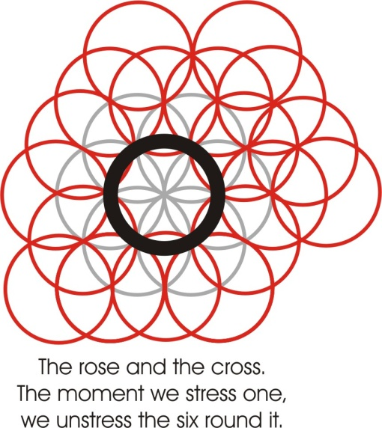
No, he knows. Like this. You see, first of all, all motion ... supposing I say this white paper represents spirit, but you can’t see the way it’s behaving, it’s not static, it’s highly dynamic and therefore it’s full of motions wiggling about like this. We call it chaos don’t we? [44:32]
[C.B.] Yes.
But that chaos is full of all conceivable motions, isn’t it? If I stress one of them — there’s one you see — I begin to abstract a form. If I like to stress another one, like this, there’s another form, a bit like Snozzle Durante, we put an eye in it, and hair on. This is only a question of stressing what already exists. For which reason it is said that God foresaw the world before it was made, and then when he spins like this, he makes inside there and in this rotating activity, again the overlapping of intersection of forces inferred here makes the possibility of special stresses like this, doesn’t it?
The moment you stress what is, there appears an emergent, an individual, but nothing new. There is no new thing under the sun, but there are new ways of stressing things. So the God, the Absolute Spirit, foresaw in himself everything that could possibly be created, and then he stressed some of it ... and that was creation. And he stresses internally, continuously, new stresses, and the appearance of new stresses we call evolution. But nothing can be stressed that doesn’t exist. [46:34]
This means that for every individual man there is an eternal form. Actually, a man exists as a baby forever, and as a child, as a youth, as a man, as grown old, as dying, forever, in all his phases. When he has stressed them all alternately, then he understands himself. Then he holds the whole concept of himself as born, dead and in between, and that is his being. Christ says every man goes into his own place and his works follow him. Because death is only the removal of a certain kind of stress, and the putting on of another kind of stress. This is why Paul says really there is no death in the sense in which people imagine. There’s no annihilation of whatever is. Whatever is, can never cease to be. Whatever is not can never come to be. For all you can do is stress it, which really means activate the will in that place a little more.

Poltergeist
A poltergeist phenomenon exists. No scientist today would deny it. A vase picks itself up and is flung against a wall. Why? It’s only power, stressed in a certain way. Maybe there’s a little girl there and she’s not allowed to throw vases about, and she wishes she could. And she goes into a sort of stupor with herself, and gathers her energy together, takes it over to the vase, because fundamentally she’s identical with it, and putting her frequency by sympathy of feeling at the same number as the vase, she suddenly displaces it ... she’s altered the stress. Those things can happen only because the universe is fundamentally force ... energy.

No Mistakes for God
There isn’t anything that isn’t made of force. When force rotates it’s matter, when it translates without rotating we call it a force, a cause. So there aren’t any mistakes for god. We can make mistakes as like putting your hand in this pocket for a pen and bringing out one. It’s an Indian ink pen, I unscrew it, and start writing and suddenly ink runs all over the paper. Why? ... because it won’t write unless it’s full. If it gets half full it starts spilling. It’s a fault of the pen design. The manufacturers know about it. They can’t cure it and they warn you about it: Keep it full. If you allow it to get half full, it starts leaking. That’s because it’s got a special kind of feed. It’s the only pen that will take Indian ink. But if I forgot, and thought I had filled it when I hadn’t and decided to write on my knee, I’d make a mess. Now that’s a mistake. You take one thing amiss for another. [49:24]
[Charlie Blythe] When I used the word mistake, what I meant was, didn’t god foresee when he was making man that it would be necessary for there to be woman as well? Did he wait until afterwards and then see that it was necessary?

Lilith
Woman was in man, in Adam, before she was taken out. Adam was made in the image of God, male and female: that is, a hermaphroditic structure. He could have operated on himself if he had willed ... he was a free being, but he didn’t will to. This is why it is said in tradition that he had a wife before Eve, whose name was Lilith. And because he had Lilith he refused to work. Do you know what Lilith means? [50:07]
[C.B.] No. ... oh, Lilith? Yes.
Lilith yes. Lilith was his wife before Eve was taken out of him. Lilith was Eve inside him, and it meant to say he was getting sensual pleasures inside himself by playing with his own will and intellect instead of expressing it. Lilith means to play with oneself.
Now there’s a lot of people, a lot of people today that are Lilith ridden in that sense. In magical parlance we’d say that they’ve got a succubus. That is, somehow they managed to use that energy but they never do anything. Actually, they are doing it inside. They’ve got this peculiar faculty of sensually pleasing themselves and tittilating their imagination with their own will ... and it’s called Lilith. Very naughty girl, Lilith. And when god saw what Adam was doing he say, Oh, I’ll take Lilith out, change the name from to-play to develop. Ava or Eva — Eve — means to develop. You see, when it is called woman, you see, and she was called woman because she was taken out of man. Because this wo-man means out-man. Pinch off him his sensual, volitional side, and leave his intellect where it is. And then the Will will get into trouble when the stimulus comes, and drag the intellect with it, and he’ll have to do something. [51:44]
Now there’s many a person that gets trapped by internal sensuality like that. You can pick them out very, very easily. They’ve got dreamy eyes and a certain amount of introversion, and they never make anything on the outside. A lot of people think they are very quiet. But they’ve got a universe inside and all of it fun and games, and they’re Lilith-ridden.
[C.B. It’s got to do with Leeth, that, I suppose?
Hmm. Sleep, pleasant dreams, it’s a piscatorial tendency. But it stops work, you know ... stops development, because you can actually construct inside yourself a wonderful, fantastic and delightful universe, without ever getting related to any reality outside yourself.
[C.B.] So it’s almost like the taking of drugs then?
Actually the people that take opium are going into contact with Lilith by an artificial method. You see, they can’t concentrate sufficiently like some people born in certain positions can do naturally. Some fellows can sit down and have an opium dream without the slightest effort, without opium. As you know the name of opium in Latin is papa-vera, and it means the father as a sexual symbol and the mother, playing about in the imagination. And it’s that internal process.

Alistair Crowley
Actually that naughty old boy Alistair Crowley recommended it as a pastime for certain of his female followers. When they were not physically very attractive, he taught them this method. You see, if they were physically attractive he taught them another method. But for those who wanted to learn, he taught them this method. That is, how to imagine themselves as man-woman internally, and have a relationship with themselves. The result was that they lost all external initiative. And thereupon he took their chequebooks, put them in their hands, put a pen in, and said, write: pay Alistair Crowley, and they wrote and he went away, came back and gave them another lesson. And they thought it was worth it. [54:18]
Some of the old ladies that I know who were members of the organisation of, you know, the ‘Dawn’ thing, and the Women of the Trees, both of which he initiated in London — although there was a rival claim in Germany for certain aspects of the Golden Dawn — some of those women at sixty and seventy, who were still interested in sexual activity to the point that they would be prepared to learn that technique and pay for it ... and it was just encouraging fantasy. And they were becoming more and more and more passive, more and more subject to his will, because he taught them how to twist.
[C.B.] Easy way to make money.
Well it’s easy, but the question is, do you like the kind of job that it is?
[C.B.] No.
One of the easiest things in the world. All you’ve got to do is just hire yourself to Maida Vale, put a sign on the door and do it ... the sport he taught. You’ll get immediate buyers.
[another voice, (Z)] To overcome that one, you need actually the correct stimulus, don’t you?
Yes, external stimulus, and application on concrete things. Take any concrete thing like that and universalise it. Try and find out its source. No matter what it is, use the external, because if you don’t, you’re locked up in yourself in a fantastic world, and the end of it is that you become depleted of energy. [55:55]
The best method is to take concrete material things like that and deliberately trace their source in the material world, right through to the particular end, to the earth origins, their cosmic origins, back to force ... and then start on another one. The Buddhists used simply a piece of clay, and say, find anybody with a certain type of expression in the eye, and put a piece of clay in his hand and say “meditate on that ... it is clay”.
And he has to think about it.
What am I supposed to do about clay?
Well, what is clay? Earth.
What is earth? Well, earth, according to the astronomical theories was once upon a time liquid ... not solid. Before that it was a gas, before that it was incandescent ... a body of light. So somehow that dark clay is only light, made dark.
How has it become made dark? By compaction. Too much grab. Too little grab, you’ve got an ocean of light with nothing in it. Too much grab, you’ve got darkness. Somewhere between in that vibration — the Mercurial resolution — you have light/dark, chiaroscuro, the great relation, the possibility of real value.
You get a picture on white paper and paint it in white paint; it’s a good picture, but you can’t see it. That’s what god used to do before creation. He painted with light on light. And the devil said, well, I’m painting black on black, just to be awkward. So Mercury said, well I’ll paint it black on white and white on black, and resolve it. So the Mercury man is a fellow that knows the rooting of everything in this opposition, and utilises it.
[C.B.] That means the Mercury man can change his view point from one side to the other.
Mmm.
[C.B.] It ...that’s what it really means isn’t it — changes his viewpoint.
Yes. Oh, yes. You see, there’s a very old Chinese saying which says: If you knew the truth, the real truth, and you knew it only in one way, it wouldn’t help you except in one condition, in one time and place. So you’ve got to know the truth from every conceivable angle. You’ve got to get elasticity, otherwise you’re useless.
Really, a technical expert cannot resolve the most elementary problem because he lacks the external stimulus of apparatus that he’s used to. If you give him a piece of cotton and sealing wax, if he were able to get down off his high horse, he could arrange that thing in such a way to get a similar effect. But he doesn’t remember that ... because he’s too technically trained in one direction. Come off that horse and get another horse, get all the horses there are and ride them all.
[Z] Who said ... if we did it properly once it’s sufficient but if we do it umpteen times, it’s because we’ve not been doing it properly ... we’re learning how to do it?
Well it isn’t so much that. You can do it once properly, and immediately afterwards you will discover you’re back in your ordinary physical consciousness, because of the fact of the mass inertia of your previous thought. You’ve done it quite correctly, but you cannot maintain it unless you transmute the body. By special efforts, you can get a flash, and you can see the whole truth. And then a few seconds afterwards you can’t be quite sure that you’ve seen it. But you know that you’ve seen it and somehow it’s not a bright as it was. It’s simply the fact that the body has got to be reconditioned and made fine enough to receive that light, all the time instead of by special effort.

Cosmic Cycles
[Khen] What happens when it lasts a matter of days? Say this particular time of the year which is building up to a period at Easter, when it becomes just after illumination which might last quite a length of time.
Well there again the external environment is conspiring to give it to you. It’s not your world. You see, the environment is giving it to you. That’s the tide that takes the flood that leads on to fortune. But the point is, can you restate that condition when it’s not in style? Easter is the ‘Yest’ time, the uprising time. It’s easy to be optimistic in the spring. Everything is conspiring with you. Can you be optimistic in the winter? [01:01:09]
[From a lady in the audience] I’ll just say that didn’t Shakespeare talk about the winter of discontent?
Yes. Now is the winter of our discontent made glorious summer ... this is again dialectical thinking. You take your bow and see broiled duck, this Chinese gentleman, don’t you? The thing is, you can go too far. Actually that bowl is broiled duck potentially, if you are a good shot and there’s a duck about and it’s the season of ducks. Otherwise you’re wasting your time with the bow, aren’t you? [01:01:46]
So the point is to get the instrument that you have, and look for the right time, and work while it is light, like working on the concept of the resurrection at Easter time, you see? Work while it is light means work when nature is conspiring with you, because at first the winter will come when you cannot work so optimistically, because it’s miserable weather. But after a time you gain the ability to work when it is dark, when there isn’t a man. Because it says the night comes when no man can work.
That intellectual fellow, the upside down man, can’t work except in the right situation. But the man with the horns, the dialectical horns, can, because he says, if winter comes can spring be far behind? ... because he understands the cycle of events. So when he sees a snow landscape, he sees seeds underneath the snow, hiding and warmed, protected by the snow. So he looks underneath the superficial darkness to those potentials hidden. And he knows by the law of cyclical activity, that because winter is here, and no thing can persist, therefore there must be non-winter following. So Spring must come, the martial force must shoot out.
A lot of energies are poured into the earth in summer aren’t they? In autumn the earth is full of energies, and then they hide in the seeds, don’t they? The fruits have fallen off the trees, seeds are in the ground, the snow covers them up. They’re underneath, they’re waiting for the stimulus from outside that’s going to hit them again when Mars, the ram sign comes in ... the energy comes from the cosmos, the solar forces come banging into those seeds. The melting snows swell the jackets, the energy goes inside, bursts, and a shoot comes out.
It’s the John Barleycorn cycle which is another example of the messianic Winter crucifixion, and resurrection in the Spring. The whole thing is a cosmic cycle. The agricultural corn cycle is borrowed from the cosmic cycle. Some anthropologists think it’s the other way round. They think that man first made the corn cycle and then thought cosmically about it. Cosmos existed before the corn cycle.

Maya
[Khen] What is the best way to get back into that state. Having experienced it a number of times ... particularly a period like Easter, and then to find yourself I suppose in a state of fall again and not understanding it.
Well the best thing is, when you’re in it to watch like mad what kind of feeling you’ve got, and observe it so cleanly that you can remember the feeling, so that later when you’ve gone out of it you have a memory that you had a feeling of a definite type. [01:04:53]

The World Soul
[Khen] I tell you the effect that it had on me when I’d done it, and that is that I know I can get back into it, but inertia says, ‘well, it’ll do tomorrow’. I can remember it, and then if I make a big effort to do it, I find that I’ve got to make an even greater effort than the one I thought necessary. And it can be done, but at that particular period it’s easier to do it. That’s the way I’ve experienced it.
Well remember that there is a force in the universe, that compression force, the centripetal force, pressing onto the centre and trying to persuade you to generate physically. And that is your physical mass inertia. What it wants you to do is have a lot of physical babies.
There’s another force, but it’s of a totally different frequency, calling out those people who are ready to come out. But at this period of macrocosmic history, the forces are still going in, because the object of the world soul is to generate a plurality of free beings so that they can have relations of a very high order. But you can’t have a plurality of free beings without having a large number of bodies to serve as vehicles for training. And those bodies have got to be made. And free beings don’t like tying themselves down.
Therefore there is a structure of the universe called Maya, the grand illusion, which makes everything in Spring look slightly different. You see ... there’s a halo put round things. It’s a trick inside the nervous system, you see. Thereupon people are tricked into generating the physical bodies which will serve as vehicles of experience for souls to become free.
Now there’s got to be a very definite number of such bodies made. Over a cycle of years somebody’s got to make them. If you see the light by special effort, well then the forces that want you to make physical bodies will try to pull you down again. And they’ll say, well the light’s always there, why have it today? And they’ll have wonderful explanations about why you shouldn’t bother to go back into the light, because it is eternal. It’s always there.

St Augustine
St. Augustine expressed it in his autobiography, by saying a prayer, Oh Lord deliver me from the concupiscence of the flesh ... but not today. Now he writes those words in his autobiography. And he was a great psychologist and Self-searcher, and it was a genuine payer. He was fed up with that generation cycle. You know they’re saying three ‘B’s of St. Augustine represent his life story — three ‘B’s — born bothered and bishoped. You see?

Prodigality
It’s the same as St. Francis. St. Francis became a great saint because first of all he’d been a great sinner. If you do enough naughtiness, you begin to become convinced that it’s not worth it, whereas the people that never do it are never sure whether it is not worth it. That’s the meaning of the prodigal son. But if you say that to some people, they say, oh, I’m going to be a prodigal then, if that’s so! But they’re using your words as an excuse for weakness. They can’t do it. And then the first time they get into trouble they come and they say to you, it’s your fault, you told me to do so-and-so. [01:08:34]
I can give you an actual concrete example of one evening in a group like this, I made a general statement about the prodigal son, a quite general statement, that prodigality was not a bad thing in itself, and that for many people it accelerated their development because they could give things up quicker than they would otherwise give it up. But this was always a matter for an individual to solve. You see?
And about six months later a fellow come to me and he said, do you know that you are responsible for my girlfriend? She’s going to have a baby!
I said, why?
He said, because of that stuff you said about the prodigal son. You see? And he was quite annoyed about it ... and he was very sincere. He thought he’d been led up the spout by encouraging prodigality. And I said to him, most of the prodigals I know are very, very careful to not get that kind of result. But he actually was very, very annoyed with me for mentioning the prodigal.
[Khen] It accelerates something, certainly.
Mm.
[Khen, chuckling]A new being.
Well it actually accelerated him wonderfully ... and his wife. It accelerated him into marriage, a thing he would never have done otherwise.
[C.B.] That’s what you would call an object lesson.
Oh yes. A very objectionable lesson. But it did him good in the end, you know. I mean the end up to now ... not the final end.
[C.B., departing] Will you excuse me, now?
Yes of course.
[C.B.] I’ve got to push off. Good night.

[Z] We were talking about the benefit derived [....sundry farewells made...] Christ taught us this thing you see, that we have to behave as though we are receiving it or have got it, you see. Now this particular force centre of things like you have, if you hadn’t actually experienced that, it’s something you can’t visualise, isn’t it? How can you actually use that particular method to obtain ... to help obtain help to obtain anything?

Exercise — Stopping Thought
Well, first of all you cannot see that unless you’ve managed to stop thinking for a period. You see, the thing that stops people from getting at that light, which is eternal and permanently there — we’re in it actually, it’s another frequency — is fantasy and ideation. That means to say, you’ve got all the formulations in your mind. All formulations of feeling and idea, are the things that block you. So that the precondition of seeing it, is first of all you must eliminate from the mind, ideas. That’s why yoga is a suppression of vrittis, of mental modifications.
That’s the Patanjali definition. It’s still the only valid definition there is: Stop the mind working at lower levels and the top levels will be seen, because they’re there.
Now the obstacle, the chief obstacle to this, is falling asleep ... falling asleep. It isn’t a question of stopping the mind thinking, and falling asleep. You’ve got to stop the mind thinking, and remain awake. The tendency is to fall asleep. In order to practice it, you take a stream of thought — no matter what it is — and you deliberately try to stop one thought getting away from you, and stop the next associated thought coming in. And you’ve got a space between the two. Try and increase the space. [01:12:20]
We used the example of a horse and a cart. There’s a horse and cart there, and a man comes, unharnesses the horse and takes the cart away. When the cart has being taken away by the man, the horse runs away leaving a space. Now you try to hold that space, just hold it blank. But you’re terribly alert and you’ll feel ideas trying to get in ... don’t let them. Keep that space. If something comes into that space, start again. Put your horse and your cart back.
[Z] But the point is I can to an extent achieve it with a picture form, but then there’s the talk and the words going on.
It’s all ideation. Talking is also ideation.
[Z] I’ll tell you what has happened, I’ve actually got to the state of unconsciousness, and come back out of it, and found out that that talking — it’s only a guess — it seems to have continually gone on all the time even though I wasn’t there. Now whether it’s actually started again when ...
No, it’s going on all the time.
[Z] You leave it and you come back and it’s going on ...
Everything’s goes on all the time, because everything that exists is eternal. What you are doing is changing your phase. When you can’t hear it you’ve gone out of its frequency range. That’s all. But it’s still talking there.
Do you know, every word you have ever heard in your life is sounding on its own all the time? And every sentence which is a combination of words is also sounding because all the words that constitute your vocabulary are vibrating all the time.
[Z] As one.
Yes as one whole.
[Z] According to the particular opening you make within yourself that’s what you would see, actually ...?
Mmm. What you do is stress a thing, and it’s your feeling that determines what you will stress. [01:14:07]
Not a thing you like, something you dislike. The thing you like you tend to move towards; the thing you dislike, you tend to be afraid of ... and it presents itself.
But talking is still ideation, it’s still formal presentation.
[Z] We have to take the sentence and widen the .... words at the same time.
That’s right. It’s the kind of exercise that we start with ... you do it now, you see. I will say to you a series of numbers and you mustn’t say the last one that would logically follow. Mm? So I say twice three are ...
[Z] It’s hard to say whether you’ve done it or not. It’s ready to jump in. I’m not actually ...
Did you manage to keep it out?
[Z] No, I can’t say that. There’s a tendency sometimes, I find it hard to say whether I said it or not. Quite often I find myself stressing it in the throat, you see.
Now that kind of laryngeal reflex ...
[Z] But I don’t know if it was there it the mind or not.
... it’s a question of levels, you see. When we talk about prayer, there are three levels of prayer:
Audial prayer, audible prayer where you can hear the words coming out of your mouth.
Inaudible prayer where you can feel the reflex in your larynx.
And silent prayer, which is still a form, but there’s no reflex here, and there’s no sound out of your mouth, but you can hear the form of it in the mind. But there’s no physical reflex, it’s a different level; it’s a different frequency.
Then if you take the meaning of that prayer and contract all the words together and retain the significance, without serial expression, that’s the fourth kind.
[Z] Oh yes, I know what you mean, yes.
That’s taking significance instead of serial expression.
[Z] So I say happiness and just feel happiness, with no particular word.
That’s right, you identify with the significance of the term.
Now see if you can do this again. We will recite the alphabet. Don’t you hear the next letter when I stop. A. B. C. D. E. ... did you manage to suppress it? [01:16:35]
[Z] No, it came up ... a pattern
You see, you should be able to stop it so that you don’t know what’s coming next. Otherwise it’s still inertia ... it’s still mechanics.
[Z] It’s happening without my intention when it came up ...
Oh, it’s quite mechanical, it wasn’t your intent. Your intent could be the opposite, but it would still come up unless you are tremendously alert. Don’t let the final word come in this: Rule Britannia, Britannia rules the ...
[Z] I said monkey instead then. [laughing]
You said monkey ... that’s a device, you see? But did you notice that the monkey that you inserted was a jumping monkey, like the wave motion? What you did is abstract the jumping from the wave and turn it into a monkey to avoid the word wave. That’s still mechanical association of ideas ... see?
Now this is an exercise you can do on yourself, and you can do on each other as an exercise. And really try. Prepare yourself, because if you get prepared and get a pal to try you out, you can gain this ability to chop it, and you just don’t know the alphabet any more.
The M.O. at Strangeways Prison, Manchester, has a wife, and I was talking to him one night, we were having super with him, and he said, my wife a yoga, you know.
And I said, is she really?
He said, yes, she’s terribly good at it, she’s read all about it. She’s very, very good at it.
So I said to her, have you done that exercise of emptying your mind?
And she said, yes, which one?
So I said, the one about the horse and the cart where you let the horse run away when the man takes the cart away, and there’s nothing there.
She said, what is it?
I said, see if you can do it.
And he interrupted and said, of course she can do it. She’s practised yoga.
I said, well, we’ll see if she can. I said, now imagine a horse and cart and a man comes and he unharnesses the horse, takes the cart away, and suddenly the horse runs off. There’s a space there. Can you do that?
And she went, Oh, she said, there’s a man behind the cart!
You see? It gave her a terrific shock. It would have given him a shock too, if he’d have seen this man wasn’t him. See? It was another man, a threatening figure, one of the many convicts that she’d noticed that he had to deal with. Because being a convict is not necessarily being so witty that you’re positively horrible to look at, you know. Some of them are quite good looking. And the threat of violence is there. So he was behind the cart waiting until hubby had gone away to MO see.
[Z] He was actually in prison in the talk?
Mmm. If you do that exercise with each other, you can go ahead very, very quickly. It’s hard to work on your own. Get somebody to say something with a natural, logical sequence, and you try and chop it so that you just don’t know it. And don’t try and put a monkey there ... that’s still mechanical association of ideas. [01:20:12]
[Z] I suppose I’ve got to follow you all the way? Each letter?
Yes.
[Z] But the point I find this: you’re saying ...A.B.C.D. Now you’re going a certain speed, where I can’t tell where I’m actually presupposing or not, by the time you’ve done your next letter you see ... I might be ... ’m not even prepared for it ...
Well you mustn’t hear anything before the beginning of the exercise. There must be nothing in your mind except the things that I said, and when I stop, you must stop thinking.
[Z] That would be a good thing to get up and over here ...
Oh, yes. The lower and more forward your consciousness, the less you can do it, because there’s an awful lot of associative mechanism down here on the mental ideas. It works tremendously quickly.
[Another voice from the audience (W)] You know in the ‘word association’ exercise ... can you start to get used to it and able to carry on for longer?
Oh, yes.
[W] I seem to notice that.

Words
Yes. A very god exercise with words is this: you know every word is built of primary letters and all the primary letters co-exist eternally as forms ... so that every word in every language, is merely an out-built, an expression, pressing out, of a fundamental geometry of the universe which exists simultaneously. That means that all the words in all languages are related together in a very definite manner. So when you look at a word, see if you can see another word inside it, take it out, and know that if it’s in it’s got a logical relationship to that word.
Let’s take the word word. Inside the word word is a word wor, W.O.R. as in worship. You know, worship ... it has a very definite relation, because you can’t worship without words. If you look up this prime root — this W.R. root — it means a power, differentiating, illuminating its parts. And it is also O.R.D. which it the root of order, and you can’t make order without words. There’s also O.R., which is gold, isn’t it?
[W] Gold?
Gold! Or ... means gold. And gold is the same thing as will. Gold is the symbol of willpower. So inside the word there is a principle of order, a principle of worship, and a principle of will. And the will is hidden in between. Will is hidden in the middle. That means that every word you’ve got really conceals in it a will. That means it tells you, if you analyse it, there’s something you can do.

Cat
Take a short word like cat. What does it mean? What is a cat at? What is a pussycat? The Greek word cat means fix. The pussycat is so called because it sits in fixed attitudes, and when it moves it suddenly takes the whole of its concentration from one place and puts it on another ... and it fixes its attention. Have you noticed that? It’s called cat because it fixes itself.
Now this fixing is the same thing as cutting off, isn’t it? Take the vowel out and the K.T. sound is the fundamental concept ... cut. The cat does that. It forgets all about you when it sees something down there.
Some people think that cats are very queer. The Egyptians thought they were sacred, because a cat can be looking at you, and you give it milk and then suddenly it goes ... [makes some kind of cat-like expression to which there is laughter] ... it stares in mid air and people go ... [makes another expression] .. that cat has seen something. It’s a frequency that human beings don’t see. It really has! It’s got a totally different gamut of vibration — in its awareness — to a human being.

Animal Awareness
You know that when the big earthquakes occurred in South America a few years ago, two days before it blew up, the animals migrated. They all left. And the human beings were saying, why are all the animals running about, the stupid things ... what are they being excited about? First day, all the animals cleared off, and towards the second day end all the birds flew. That’s funny isn’t it, the birds went after the runners? You see? [01:25:09]
You see? They were all saying, oh, aren’t animals funny. Suddenly there was a big bang and the whole place was buried in a few hours. Now who told the animals?
The fact is that the forces in the earth that were ready to blow up were beating at very, very high frequencies. And the animals could feel that terrible proximity of an explosion. It was real. They didn’t see the future. They saw the present condition of imminence; terrible vibration in the earth and in the ether where all these inter-magnetic forces in the earth that were crushing the strata underneath. They could feel this emanating. They thought, I think it’s time to go ... and they went.
[W] They just reacted ...
They just went, that reaction is the same thing as intelligence as far as the animals were concerned. Providing they are in their natural habitat, its survival value is perfect.
But human beings upside down, thinking statistically said, can’t possibly blow up, you know, because statistically it hasn’t blown up before. Statistically, says, times plus times to one that it will never happen again. And it hasn’t happened at all yet. Statistics ignores that there’s always a first time.
There was a magnificent film of the Mexican one; did you see it? They managed to get on the spot with cameras, and a mountain was thrown up in a few hours. A colossal amount ... three thousand feet, wasn’t it? It just grew like this, and a village disappeared and everybody was rushing off in all directions, and after it had been put up in a few hours, the geologists said, we shall have to modify some of our time scale about the formation of the earth’s crust. You know, they have some wonderful ideas of how long it takes to raise a mountain range, 3000 feet high. It takes a long time, about four hours I think it threw itself up in its major mass. They were surprised ... so they wrote it down in the book: Modification of Statistical Survey.

~~~ End ~~~

Matthew 25:32/33 And before him shall be gathered all nations: and he shall separate them one from another, as a shepherd divideth his sheep from the goats: And he shall set the sheep on his right hand, but the goats on the left.
Confessions of St. Augustine http://www.sacred-texts.com/chr/augconf/aug10.htm
Eze 32:5 And I will lay thy flesh upon the mountains, and fill the valleys with thy height.
Mat 5:18 For verily I say unto you, Till heaven and earth pass, one jot or one tittle shall in no wise pass from the law, till all be fulfilled.
http://paul-brown.suite101.com/william-blakes-the-ghost-of-abel-a339074
John 10:20 And many of them said, He hath a devil, and is mad; why hear ye him?
Ecclesiastes 1:9 The thing that hath been, it is that which shall be; and that which is done is that which shall be done: and there is no new thing under the sun.
Revelation 14:13 And I heard a voice from heaven saying unto me, Write, Blessed are the dead which die in the Lord from henceforth: Yea, saith the Spirit, that they may rest from their labours; and their works do follow them.
John 9:4 I must work the works of him that sent me, while it is day: the night cometh, when no man can work.
http://www.quotationspage.com/quotes/Percy_Bysshe_Shelley/

