Becoming
A talk given by Eugene Halliday, transcribed by,
and with arbitrary headings by John Bailey.
The drawings and tables aren’t originals, and all editor’s notes are in square brackets.
In many instances remarks are indistinct or blotted out by an audience cough.

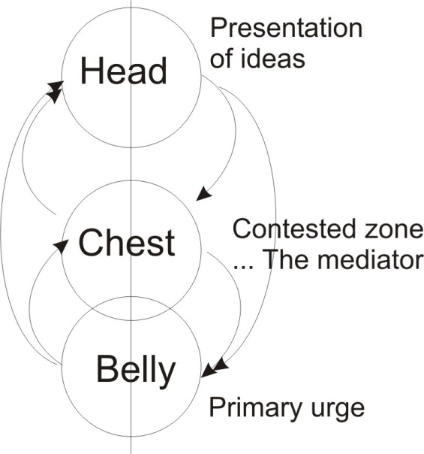
A question about emotion cropped up: is it correct to understand its function as a mediating principle between urge and ideation? ... and please clarify how it comes to be strongly stressed in a high percentage of people.

We’d better draw this to keep control over it. Here’s our three centres again. Down here we have a primary urge; and up here we have ideation, presentation of ideas; and in between the two, we have a contested zone where idea and urge conflict. The question is, is it correct to say that this is the mediator between these two states. The answer is yes. Our feeling state is a mediating state between the idea and the urge. But to understand why it is, we will have to refer back to the trinity aspects we did on the last two occasions.
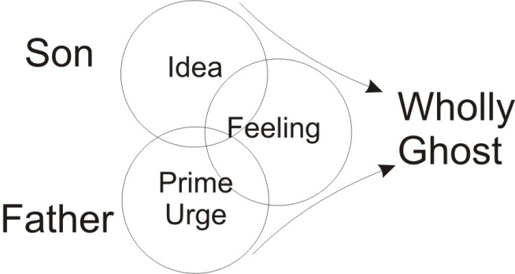
The prime urge is equivalent to the Father in the trinity; and the idea up here is equivalent to the Son; and the emotion, which we can picture coming out at right angles to the two — the egressing of the feeling — is called the Holy Ghost ... the Holy ghost because it is Wholly, with a ‘w’, and it is a ghost or semblance of appearance of the form and the power. The urge, we can see is outside the cosmos, coming in to make the first idea. So the Father principle outside the macrocosmos, the Son itself, and the continuously egressing spirit that shoots out to posit the world ... you could imagine another sphere sticking out here, and that’s the world we live. And this sphere must be posited inside this one, functionally. But we don’t want to obscure the diagram, so we are going to leave the material world that we know out of this picture, and nevertheless know that it is a product of a force shot out from the Absolute Energy, and its first circumscription which is the Cosmic Logos or Son ... the Word of God.
And we then consider the dialectical relations between the two. The energy outside cosmos is called No Thing: it is not a thing ... the Ayn Soph of the Hebrews. It is not a thing and the macrocosmos is a thing ... the biggest thing. There’s No Thing and there is Thing. But to thing is to bind, to circumscribe, to limit.
The No Thing is absolutely unlimited ... the thing is limited. We represent the Father by the sign of Jupiter, and the thing, we will represent by the sign of Saturn. You remember we had before the dual aspects of Saturn as creator, the urn of being, Sat, Satan, who is creating and therefore finiting ... and the Son, who is manifesting. All manifestation presupposes finiting, and between the non-manifest No Thing and the thing, there is a necessity for a resolution between the two.
Now if we condense the thing to its maximum condensation — we would draw a black circle to represent it — the blackness is simply the self-interference, the self-overshadowing of the absolute light stretched to infinity. But the absolute light, prior to creation, is called an equable light. It has no flash in it, it has no radiation, it is simply an equable light distributed infinitely, and as infinitely distributed it is not itself valuable. To make value we must make a difference.

Becoming
So we have the Absolutely Free ... the Father, making for itself a dialectical opposite, the totally bound, and therefore we have non-being and being: non-existence ... existence. And the existent, if it is allowed to stay so, is death; it is a permanent death. And the Absolutely Free is a no thing with no value, no manifestation. So we have to find a resolution between non-being and being.
And the name of the word between non-being and being, which resolves it is ... becoming. [4:19]
The word becoming means ceasing to be and coming to be other than it was. So the word becoming covers a concept of being and not being simultaneously. If we go back to the Heraclitian dialectical process which Hegel borrowed, and then Carl Marx borrowed again, we find that the principle of dialectics is a conflict between an Absolute Substance – or as the Marxists would say, a universal material — and a form of it, condensed. And there’s a continuous dialectical conflict going on between the form which is condensed, and that around it which is not condensed. So there’s a necessity for a resolution between the being that is, and the being that might be, and the non-being. The non-being an the being together act upon each other and produce becoming.
So the whole manifest universe is then a process of becoming. And because of this it means that whatever we are now, we are in process of not being. So that even the Marxist would say we are simultaneously ourselves and not ourselves.
There is something we recognise about ourselves, and in the act of recognition we prove it to be memory, namely a past state, continuing with us into the present whereby we know that we exist as individuals ... and something growing in us that is new.
And this resolves the conflict between the absolutely free and the bound. The state of becoming is a transition between an eternal death and an absolute non-manifestation. And the process of unbecoming bound is becoming free.
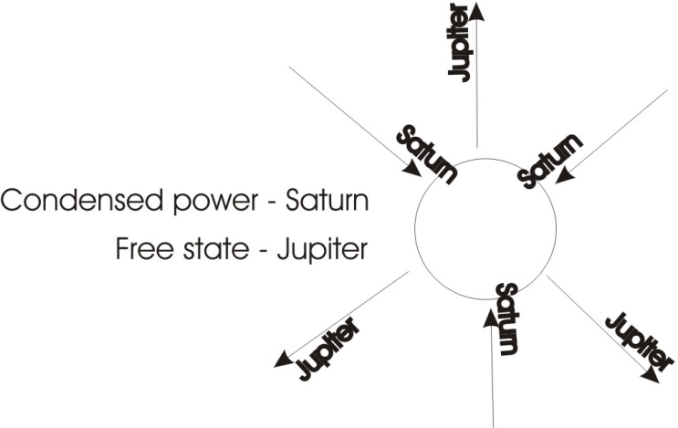
So if we talk about the material world as death ... under a law of rotation absolute so that it cannot escape out of itself, we can call that the footstool of the father. The Father principle is Now, conceived to be resting with his feet, His pedestal, and He’s going up into freedom.
Now there is nothing in the condensed power — which is represented by Saturn — other than that which was in the Jupiteran state, the free. The free power condenses itself, and on condensation receives another name. The name is the function expressed.
So the free, the Jupiter, becomes the Saturn — the Saturnine impression — simply by contracting itself. And what it has contracted is nothing other than itself. So that it is an overshadowing of itself by itself. Now, prior to this rotation band appearing, there is absolutely no interference whatever in the Absolute Power, and therefore the Absolute Power cannot be considered as static.
So there is a kind of motion in it. But it is an equable motion, the colour of it — the nearest we can say to it visually — is that it is a very, very dark blue, like indigo with a slight greenish cast. All the seers who describe it, and when you experience it, agree that the colour of the abyss — the abyss is the Father Ab; the Yes, positive, affirmative — the colour of it prior to the condensation is blue ... a very, very deep blue. It is the colour of the quintessence in the alchemical terminology. Now when it presses onto a centre it receives the name of Saturn, and in so doing it has darkened itself more as it presses on its centre, and becomes black. Black ... the lack in black means that it now lacks the freedom, the power, and in so doing it has induced in itself an awareness of a restriction, but it didn’t want the restriction as such. What it wanted to do was manifest.
So the absolutely free urge ... that’s down here in this diagram ... that urge, has to climb to a centre, going up to the metropolis. You go up to the metropolis, so we climb to the centre from the perimeter, and the prime urge in so doing is precipitating a hard shell which is in the human being a skull. We said before that wherever there is a bone in your body, it’s Saturn triumphing. And we know that because the power cannot go into the dead centre, right in the middle of the hardest thing is the softest thing. So trapped inside the Saturnine impression is Jupiter. And it is this Jupiter that is going to flash and break out when we increase the contraction of the Saturnine Will. That means that we must concentrate very, very hard before we can strike a light.
Now in bringing this compression to be ... in the same way if I compress my hand and grip very, very hard I become more aware that I have a hand if I can hurt myself. And the whole purpose of the primary contraction is to become aware of self. So the Saturnine impression is the ground of individual existence ... the ground of the egoic consciousness. So it is immediately placed in opposition to the Father. The individual ego centre of every created being is immediately in opposition to the Father. And yet it is itself the Son. This is why the mediaeval alchemist said that the son is the counter-stroke to the father. The son in a very, very special significance is the prodigal son that later on becomes the Messiah, but in order to become the Messiah, he first must go very, very black to the n^{th} degree. He must go fully to the term of blackness.
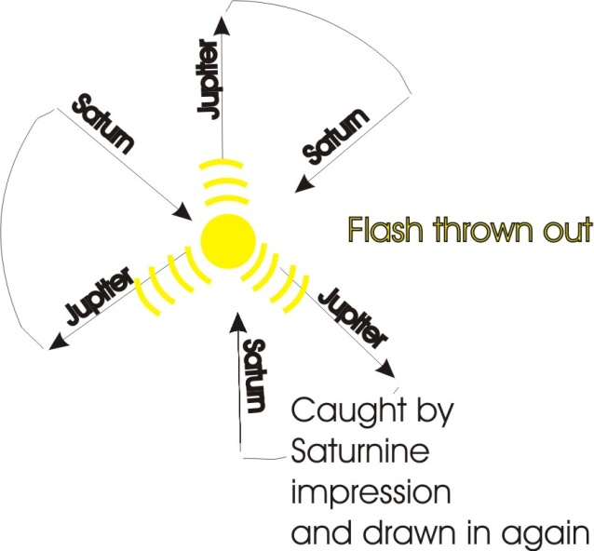
Now, when this power, condensing in, contracts to the limit so that no further contraction is possible, and the power from outside is still pressing in because the Father is determined to manifest, then as the energy is piled into this finite system, it follows that it must burst out again. Now, the bursting out from that centre is the Holy Ghost. It is that bursting out which we see at the objective level in a human being, in the egressing of nervous impulsations from the brain down the spinal column. [13:37]
Imagine a drift of very, very, very high frequency energy, into a physical body centre, piling up inside it, and pushing outwards to the perimeter of the being until it breaks it. And at the point of break there is a flash of light from the centre — it’s identical in process with lightning in the sky — that light then flashes to the limit and, as it would go to infinity and be lost — you may remember that Gurdjieff talks about this diminishing of the Absolute prior to the reciprocal feeding device — the light which flashed out would flash to infinity and be wasted if it were not caught again by the Saturnine impression, and turned back. So then we get the energy flashing out, trying to get out, and being caught and brought in again. This then illuminates the whole being.
Now this process of the light traversing and illuminating all the turbulence inside is called the light of god and it is then at this point that the whole sphere is then the Messiah. In this state — in the black state — it is Satan, it is the Luciferan being that has revolted, willed back to this centre, and then tried to aggress as the pressure comes in and builds up, it tries to flash out and when it tries to flash too far it is immediately caught in again.

Three and Four Nails of The Cross
So we have a very peculiar relation between the devil, the contractive principle that produces egotism, and yet without which no existence could be ... and the same thing carried to its term, with the addition of Father energy, or further energy, if you prefer it, the Father energy coming in, blowing it out, exploding it, and then the light being caught in, the whole sphere incandesces. And in the process of that incandescing, the whole being changes its mood. In the black mood it is dominated by four processes, usually referred to as harshness, sourness, bitterness and heat. If we looked at its simplest form, this is the difference between the three nails and four nails of the cross in certain churches.

- If we take the primary contraction and the rubbing as it rotates in the dark, and the breaking of that thing into little bits which we call the bitterness, then we have the astringent contraction, form 1,
- the turning of the wheel which generates the heat, that’s heat, is form 2,
- and the rubbing which has caused that heat ... that’s 3 forms.
Those are the three nails of the cross.

Now if we change the terms to astringency be made harsh, and the whole substantial being is made sour by the contraction and the rotation within it, and the attempt to escape from the painfulness of the contraction makes it bitter, and the rubbing makes the heat. So it’s only by the addition of sourness in there that we say four nails instead of three.
And pride, covetousness, envy, anger, are the psychological aspects of those four nails.

The Messianic Light Body
We can actually see this kind of chemistry generated in people, according to the degree of stress in them of this egotism. When they are very, very egotistic their understanding goes out completely, they become very, very dark. When Christ says that the light of the body is the eye, and the light is dark, how great is the darkness. Then he says, if the light be single, the whole body is full of light. Single means unity ... united. Only when the light flies round so very, very quickly, flashing from the centre and caught in at the edge and brought back, then the eye is single. Then the whole body is full of light, and that is the Messianic body.
Now it can only be got in the one way. We must concentrate: if we don’t concentrate we cannot exist. If, when we find a pinch of pain we try to escape, the escaping is already a process of unbecoming. It’s a regressive movement back into the No-Thing. So we have to face the pain of existence and drive in, because until we’ve driven in hard enough into the painful situation, we cannot incandesce and produce this Messianic light body.

The Free and the Domed
Now, in between this state of the complete blackness of the contraction — which is dry and hard and granular, and there is no feeling in it, no feeling life — between that and the No-thing, the Father free. I don’t say free-dome because this is dome and this is free. We mustn’t pursue free because that’s non-being, we mustn’t pursue dome because that’s not free. We have to pursue free-dome which means the Absolute determination. We must take the free and dome it. The free is our will. Our body is our dome, which we have willed. Each one of us has willed a body, which releases god from all responsibility for our naughtiness ... as we’ll see later. [19:35]

The Generation of Oil — the Messianic Flash Point
Now when the contraction goes to a certain degree of tension, it actually starts to sweat. This is the kind of sweat that Christ is giving out in Gethsemane, and you cannot do it except by act of Will. Sentimentality doesn’t do it. It’s no good being sentimental at a pussy-cat, it will not do it. The only way that you can get the kind of sweat that Christ sweats in Gethsemane is by act of Will. You have to contract. If you actually contract your hand very, very hard you’ll make it perspire. When that pressure inside becomes very, very great, it actually breaks down with the heat the little particles that were previously dry, to melt. And that makes a water here, and that water is the feeling life, and that water is an essential of the light that is going to shine.
Now all the water needs is a little bit more freedom for the generation of an oil in it. But it can’t get that oil in the water unless the contraction is increased. So when the contraction has produced the dry granularness, and the attempt to get away from the sting of it produces a flight to the perimeter, and it’s immediately caught back in because yet it is dark, then it begins to melt and in the melt is the promise of freedom. So it drives more and more furiously into the centre. It’s trying to reach flash point, and in the process it is sweating. [21:24]
You’ll find alchemical references to this horrible, black, sweating process, where a stone will sweat if you put it under pressure; put it under enough pressure, it will incandesce. Christ is saying the same thing when he said if these people do not cry out in affirmation of this light, the very stones would cry out. [21:45]
Human beings are already stones that have learned to cry out. They are material beings made in the Saturnine impression, and through a series of condensations and painful evolutions they have reached flash point to a certain degree. But the average person’s flash is what is called a twinkle, a funkeln, and it comes and goes ... a little bright idea and then it’s gone. The thing is to make that little bright idea a continuous ... a one light.
If the eye is single the whole body is full of light. The eye itself must be a unity. Kierkegaard wrote a book which recently is receiving attention from some theologians, called Purity of Heart, or One Will. They are interchangeable terms: the one Will.
You must have one Will. When you press inwards if the pain makes you change your mind you’ve got two wills, and it then tries to fly away to get relief. If you allow yourself the relief you’ll return to the football match, and so on. And if you don’t allow yourself relief and you drive in again, you’ll go darker and darker and darker into hell, into hot, bitter, astringent state, and you’ll find this chemistry comes in your organism when you do it. But if you keep on driving in, the hard granular precipitates within it which are produced by terror — whence terra, the earth is derived — they begin to liquefy, and then you see the promise, even in the dark, the liquefaction, you then drive harder onto the centre and incandesce. The light then shines through that liquid, and the light beginning to circulate through it, turns that water into a different kind of water. Here the water is sour. Here the water is sweet and has an oil in it. [23:55]
Now that oil is an essential of the life process in all organic beings. If the oil content drops, which it does by an increase of egotism, then the person starts becoming sour in the chemistry, and they are already going down to death. Once the water has become illuminated and has got its oleos content, an oil is identical with the psychological value experienced in love, then there is a free circulation of the light continuously, and the messianic body is born, and that is the true feeling life. And it is called the end of nature, the warmherzigkeit, the warm-heartedness of the being of god.
That is the aim ... to reach flashpoint and to make the flash continuously turn back through the whole organism, and thus illuminate or make unific the whole being. Then you have a feeling life which is mediating between the free Father and the bound in its devilish, Saturnine aspect ... and the feeling life grows out of it. [25:12]
There could be no feeling life at all if there weren’t a primary contraction, Saturnine and devilish, which is initiated by god the Father as creator. And yet, if that Saturnine impression is not sufficient to gain flashpoint — through fear of pain — but prefers egotism, but dodges the pain, it remains what we call a petty-egotist ... it isn’t a big egotist, it hasn’t got the grip, the concentration to find out about itself, so it just has a general idea that it’s selfish without a lot of energy.
Now the little egotist without much energy can never reach flashpoint, and therefore he cannot un-become his egotistical level. He can never become a unity being with the light, with the one light running through it. Therefore he can never become a son of God. And the funny thing about the Bible: it’s often quoted by people saying, Oh, god has promised so-and-so ... wonderful things to everybody. The Bible does not say so at all; it does not promise to everybody. A lot of sentimentalists say it does, but it doesn’t. It promises only to those who overcome ... and it says they are few.
This means that any statement that everybody is going to be saved and given this equable light as a free gift, is unvisible. Furthermore there isn’t a religion in the world that says that people that make no effort are going to get it: whether we take Hinduism, Buddhism, Taoism or anything else, there must be in the man a Will to get that light and he must concentrate and drag everything into his centre. He must introvert and feed himself with data. Ideas are food for one part of the organism, emotional relations are food from another, oranges and lemons are food at another, and so on. We have to drag in the energy at all levels that we can into this body of ours, which is the tomb, and we must bury ourselves and stay there three days. One day prime urge; pleasures and pains; the idea born out of it; and then back to the big resolution ... the light flying round. [27:29]

The Quickness of Mercury
And the feeling life is then continuously rotating through the whole being. Its speed is so great that for all practical purposes it is simultaneous. We could define practical simultaneity as this: if you can complete your psychic and mental processes quickly enough so that an external stimulus receives an adequate response, then for practical purposes your processes are simultaneous. [28:13]
You must be able to be so quick — this is the Mercurial self, generated in this quick flight of the light back to your whole being ... that’s your mercurial, messianic self — so quick must be that, that when a stimulus comes to you, you have caught the stimulus, whipped it through your whole being, and had time to react adequately; whereas if your process is slow, you are then called in biblical parlance, dead. The stimulus comes produces a reaction and your mental process might be tottering about here, and already the response has gone out.
So to become quick you must first concentrate. You must be a super-egotist before you can strike a light. That is the prodigal son. If you don’t have the energy to do it, well, it will just not happen to you, because it can only be got in one way.
There is nothing in the universe that isn’t made in exactly the same way. There’s energy drifting into dark spaces in the interstellar regions. That energy piles up and makes a dark star. And one day it piles up hard enough and it flashes and we have a nova. Suddenly there’s a new star, but it isn’t a new star, it’s an old star incandesced. And there’s been untold millions of years’ drifting in of energy to that point. The same thing must go on for a planet, for the seed of a plant, of an animal, of a human being ... there is only one process.
This process is always the same. We have to start with the Saturnine impression. There must immediately be a reaction, a flight away from it, and that flight away must never be allowed to succeed in getting away. It must be caught by the Saturnine impression, whipped in again. And then as it rotates that is Mercury.
So the devil and God the Father beget the Son between them. You see the relation of the Messiah to the devil in the temptation. The devil tempts the Messiah to keep contracted and never allow the flash out. And the Messiah says to the devil, alright I’m going to join you, I’m going to press in too, because you see my Father is going to put energy into you and will have to crack at some point. The Messiah doesn’t run away from temptation, he goes with the devil in the granular desert, in the dry places, and he insists on pressing in to see what the devil has got to tempt him with. All the time he is drawing on energy in himself from the father. So the devil is defeated on his own territory by willing into the temptation consciously, actively ... instead of unconsciously and passively. [31:23]
So there is a very simple process, and we’ll just restate that the primary urge of the Father, the totality of ideas is the Son, these are derived from the macrocosmic vibrations, and between the two is the feeling — which is centred in the individual here — that the whole field of it is outside, and includes ideation and urge because it is the Absolute field. And an ordinary man is not aware of the field because he hasn’t finished yet being subject to the urge and the negative aspect of the idea ... which is to avoid pain. We cannot become field conscious here, we dare not become field conscious, unless we have first urged, suffered pain, avoided a pleasure, so that the energy of the urge climbs through the negative side and becomes ideation.
We cannot think on the pleasure side. We think on the pain side, and out of the thinking of the pain side comes this rotation. And yet at the individual level, the mere negation produced by contemplating the pain, would stop you from pressing yourself. It would stop you going back to the urge. [32:49]

Two-centre Beings
In many, many cases, particularly in the twentieth century, we find a terrible negativity in people, where sexual energies have driven them into situations, but have given them painful experiences. They don’t want to experience it again, so they cut off from it completely and pretend they are two-centre beings: that is they have ideas, and they have feelings, but they have no urges. These are the dilettante funerary comic Italian operettas and things, where they have ... a ... program notes, whereby they know what it is they are appreciating, and a sentimental flutter in the presence of some very pleasant bit of Lehar or something. But urge down here is unknown to them, and they don’t want to know about it. They have a rule about it: nothing below the diaphragm is mentioned ... or below the table top, if you like. And they put the elbows on the table and they stuff food in their mouth and talk merrily and sentimentalise, and what falls down there they don’t know about. And they are not allowed to know about that. And yet if they don’t know about that, they can never incandesce, and they must remain forever this sentimental intellectualist rubbish.
So the feeling life for them is not the mediator. It is simply a kind of leakage of undigested ideas. They are the ones that will stroke the pussycat, and do in this department all sorts of petty little aspish things that belong really in the dark. They are sour and bitter, but they haven’t got the urge to concentrate on the sourness and bitterness. They can’t really be harsh ... they haven’t got that much energy.
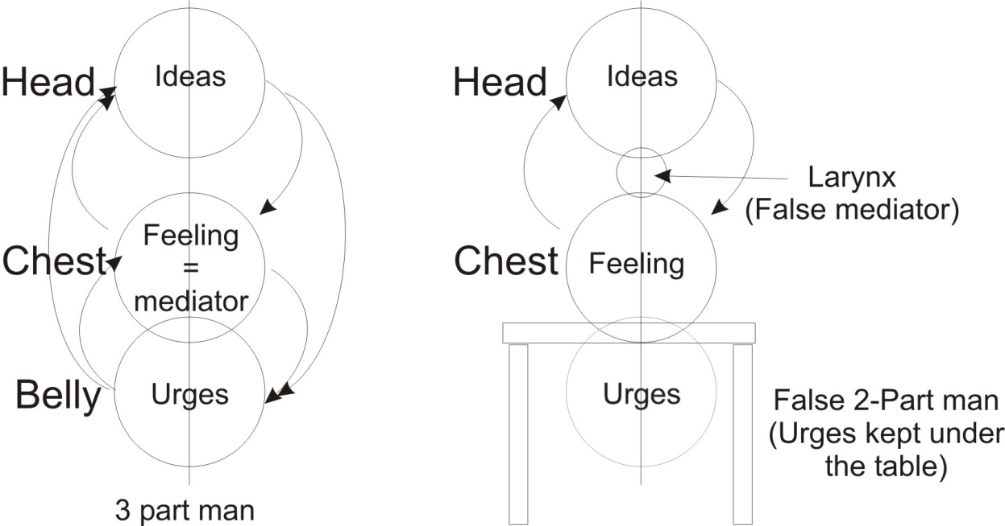
And yet harshness with oneself is a necessity of incandescence. You can’t strike a light until you are harsh with yourself. These people are not strong enough to be harsh with themselves, or even with anybody else. So they have a sentimental religion which wouldn’t contemplate the deeds that are done in the name of big business, because nothing under the table — which is the appetite — is mentioned. So for them, the feeling is not a mediator ... it is a sort of leakage. And the mediator for them is in the larynx. And it’s there in speech, in talk, that their mediation is. And the talk is their escape. As long as the word between the feeling and the idea can escape ... then they will not know that there is a problem.
But if you once stop them from expressing their little petty opinions, then they become overheated, they become aware that what it was that was trying to express itself on the tongue over dinner is really come from here [the belly]. And therefore if you try to stop one of these aesthetic-heart-appreciators-with-a-dilettante-brain from expressing his opinion, he will become dark and become aware that there’s an urge which he said must not be mentioned. Therefore he won’t like you because you’ve reminded him that he’s got another centre. And he will go away.
If sufficient energy is possessed and he drives on to the centre — which in this type he won’t — he will incandesce. Now is that clear about the feeling relations between the idea and the urge? [36:50]
Have we any special questions on that relation?
[Voice (Z) from the audience] When you talk about reacting negatively, I take it to mean we don’t lose control
Yes.
[Z] The adequate reaction, in terms of your equilibrium ...
Yes, in the broadest sense, equilibrium is the term that would be used by ... the psychosomatologist would use that word. It isn’t really a matter of keeping your balance, it is also a matter of introducing a new determinant to change the situation. The fully adequate response lifts the situation onto another level; it doesn’t merely maintain the status quo.
[Khen Ratcliffe] You said you’d say something about the fact that the individual had willed himself ‘body’, released god from the responsibility.
Yes, it’s a very, very important point because a lot of people say, we hear them every day, that if god really existed he wouldn’t have allowed this world to be made the way it has been made. And it’s used as an argument by atheists and all sorts of other people, and so we might as well look at it.
This paper represents the Absolute consciousness. Its quality is the same throughout, so that whatever it can do in any part of it, it can do in all parts of it. So if we postulate that any single part, the part where I put my finger, has the power to contract itself, then we must assert that any other part has the same power.
Now, let us try to be quite clear about the logic of this. Any part whatever of it has the same power. But prior to creation its power can only be to contract ... to produce a change. It must contra-act. In its free, extended, affable extension, there is No Thing there. A thing is a contraction. Absolutely throughout infinity there are an infinite number of contraction points that can be made. That’s the first point.
The second point is that when a contraction is made it is made at that point ... not at another. And only that point — that zone where it is — can be responsible for the contraction there made. So the contraction of the paper there is directly the responsibility of the paper there; and here, and here; there are three centres in infinity. This centre’s responsibility is for itself, this one for itself, this for itself.

And as many centres can appear as there is space for. We must remember this, because when we come to look at the distance between the earth and the moon, we’ll see why there isn’t another moon between the earth and the moon.
If I now try to draw another centre in between here (), of contraction, you see immediately that I’ve reduced the zone in between that can be used by further contractions. So there’s a limiting factor. The moment within space some contraction points are made, no matter how far apart they may be, between them a finite distance has been produced. If you want to look at the logic of the finite divisibility of space, you can read David Hume; he does it very well in his work. But between any two points the space is finite, so it will only admit of a finite number of other spaces ... but there’s an infinite number outside. Each zone is responsible for the contract...
.... break in recording ...
... author of its own being.
Now it’s essential to understand this if you want to understand modern existentialism ... because modern existentialism is just about this problem. [41:14]
Every being makes itself, because every centre has precipitated itself where it is, and no centre can precipitate another centre where it is not ... because a force acts only where it is. There is no action at a distance. There is only action where the thing is. The sun doesn’t act at a distance, the earth is inside the solar system, and the energies of the sun which cause the planets to rotate round the sun are right up to the limit of the solar system ... that’s why they can act on the planets. The sun — the body that we see in the sky — is not acting on the earth. But the light where the earth is, is acting on the earth. And that light is a modality of the solar substance considered as one being, like that unity light that we made out of that mercurial system on the other diagram.
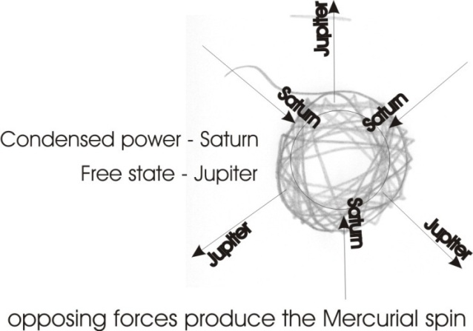
So each being, then, generates a Saturnine compression, a Jupiteran flight to escape, a dragging back of the Saturnine impression ... the creation of a mercurial wheel. Each being is therefore actually self-generated in eternity.
Now the white paper represents the Absolute, and that Absolute as a three-fold spiritual power, is called eternity. The ‘tern’ is trinity [e-tern-ity]; you know that’s just another form of trinity. So it’s the trinity and the E is the letter aitch; it’s the Hé-trinity.
Eternity simply is that which is prior to creation, and which itself is the necessary ground of creation, and it is a three-fold spirit: three-fold because it contracts, it expands and it rotates. Those are its three things. The Father, and the Son, [and] the flight from the centre. And you see that in this diagram, the Saturn, the devil, is the creator ... this is the one that whips it in — posits it. The other force tries to escape, to get out ... that’s the egressing spirit. And the whole thing turns as a wheel, and that’s the Messianic Mercurial Logos.

Egotism and Anger
Now every being that exists is such a wheel, such a sphere, grounded in three primary forms of activity.

Egotism ... that is, centripetal pressures
The attempt to escape pain.
The dragging in, because it’s losing in the escape its egotism
... with the generation of a rotating wheel.

Now this rotating wheel, prior to incandescence is felt, is experienced, as anxiety. The word anger, the ang, the angst is ‘against’. If you look at that ang to yourself it’s exactly the experience that you get at the local level.
You have a primary energy ... A
the motion thereof ... N
and G, the blockage or closure.
ANG

Now that dark bit in the centre is G. In the middle of it is a tiny bit of light I haven’t bothered to draw, and the N is the flight of the motion, and the A-R is the primary fire, which is the Father. So ANG is the origin of being. If you read Kierkegaard or Heidegger or any of the existentialists, you will find them saying the universe is rooted, the individual is rooted in the universe, in Zorge und Angst. This is this terrible anxious turbulation; the whole of nature groaneth and travaileth to be delivered from vanity. It’s called a house of death. It’s called the devil’s charnel house. Every being is made like that, and is grounded in it: primary egotism, the attempt to escape the results of egotism, to deny karma — nice thing to deny — and the resolution of it ... the turbulation. And that turbulation generates, in the friction of the wheel, the heat which is called the hellish fire. [45:45]
The whole process of this as a turning being — I’ll simplify it so you will see, it’s going like this all the time — it’s called a worm, or the old serpent. And when it says in the bible, their worm dieth not, it means this primary egotistical will to exist, which because it is rooted in fire, AR, is eternal and can never be destroyed. Nothing can destroy it.
That can be destroyed which is composite, but the Absolute Fire in not composite. Therefore this same thing when it turns in to make ANG — not ANG-ER, a later development — the ANG is the self-overshadowing in the blackness: that is the terrible blockage of that energy. And then it shakes with terror at the pain; that is the ER at the end of ANGER. Anger is a whole process. When somebody doesn’t like that which you see, if they become very, very angry, the R in angry is the shake you see in them, and it’s produced by the chemistry of egotism.
So if a person is being very, very egotistic and you hit them with good insults, you will notice a change of colour. If you’re quick and snatch them by the hand and smell it you will smell the chemistry, and you will see this violent shaking. It is that shaking that is called the bitterness in the wheel. That is the bitterness that Christ experienced on the cross, because this is the process of the crucifixion. [47:23]

Luciferan Grab
So the individual is primarily a fire, an appetite, which grabs and digs itself a grav or grave, and it goes inside it, and it’s determined not to let go of its own existence. And when any bit of it tries to fly away, it catches and tries to bring it in. Now you’ll see why there are hierarchies of angels in a moment, because if I start drawing all these poor little individuals in, the paper will get very, very black. But you’ll see that as the space between any two is finite, we can only get in the interspaces, smaller ones, can’t we? And they won’t have so much energy, so that they will not be able to bring themselves to face the pain and flash. So they won’t be able to incandesce.
Now all those little beings that can’t incandesce are referred to in the bible as the sheep. They haven’t got the energy to do it. So what they have to do is take their orders from these centres which have the energy. And such centres are called thrown spirits; Lucifer was such. And all the ones round about him he kept trying to escape, and extending his Saturnine grab, and trying to involve others all round him. But because he’s a finite being there’s a limit — because there’s infinite space outside — so there’s a limit to how much a given centre of Saturnine impression can grab. What this particular Luciferan being will grab is all the world that we know as material. That means everything whatever that the scientists can deal with is Luciferan. He has grabbed and produced that material. That means to say that cosmic dust in outer space is all within that Luciferan thing. The whole world lies in the grip of the devil.
If we go right to the limit of the stars, we find that the astronomers know that the stars are distributed as if on the skin of a balloon, and that is the limit of the Luciferan grab. That skin is called the firmament in Genesis, it is that which is the doming of the finite material world that we can see. And beyond it are infinities of other concepts, to which we shouldn’t even apply the word existent. But they are figures, and contain what to us are potentialities of existence; as actualities at very, very high frequencies. [50:17]
So we’re only concerned here at the moment in the generation of individuals, and the demonstration that every individual is responsible for himself.
Now when throughout the whole of space these contraction points made themselves, some of them — because there’s no control of one by another one — some of them actually willed to drag others in. Thus, of Lucifer, it is said he in his proud wake dragged down one third of the angelic host. Now when he did so, all he had done was put a superstress on what already existed; a potentiality of contraction. And whatever the possibilities were, in him, he actualised. But he did not actualise anything whatever that wasn’t already in him. And God did not — that is to say this Being Absolute — did not have responsibility for the superstress placed there by that, because only that zone is responsible for what it does.
So prior to creation, we all existed as potential superstresses and we were trying to come to be. Some of us were very, very irritant in the body of God, so He put us in a process called the curse. Cursive means a running. As we tried to grab, He ran away. But as we were finite we couldn’t reach out as far as He could run, and that produced the firmament: that balloon on which the stars rotate. Within it there, we are in the curse — we go round and round and round the Zodiac, cursing or coursing round it, and all the time grabbing with our own centres and causing everything that happens to us.
So we are the arbiters [EH pronounces it ‘are biters’] of our own lives, and we create our own lives as we go along, and we are still absolutely dependent on God the Father. He still has the whip hand, is infinite. And if we want to escape this terrible turbulation, and the three nails of the cross, we can only do so by understanding them before we give them up. We can’t give it up until we understand what it is. So we have to find out what it is by being it, one hundred per cent. Then we can give it up and not return to it. When we give it up, it is only a proof that we have struck a light and understood the process. Then there is space in us.
When the space comes in us, when the bitterness of the failure — because failure always produces bitterness — when that bitterness causes a scattering of the particles in us, in the interspaces, light comes. And because it comes in when we break and not before, and it comes in freely — because we can’t drag it in — it is called grace, it is a free gift from the Father. The generative power, when the wheel breaks, which it does in its turbulence, then the energy comes in through the breaks as grace. And if it weren’t for that energy piling in, none of us could ever get the energy to incandesce.
In the same way the earth itself is shrinking. It once upon a time was very cold; just a little gathering of cosmic dust. It is getting warmer. Energy is piling into it, and the Saturnine impression is grabbing at it and packing it tighter and tighter, and in a definite number of years it must incandesce. So the end of the terrestrial globe is a burst of fire ... by which time its inhabitants, that is those who have struck a light in themselves, like Noah did at the time of the flood, will have left and gone to the moon. By which time the distance between the moon and the earth will have increased.
I mention the distance between the earth and the moon ... you can see that in a space where we let this represent the earth and this one the moon, the distance between the earth and the moon there is so small, that if any cosmic dust comes in here and there is a Saturnine impression trying to make it into a planet, it must rotate either round the moon or round the earth. Either one or the other ... it can’t stand still, it must rotate. And the moment it goes out of the equilibration point between the earth and the moon, and goes either round the moon or round the earth it must fall onto the earth, or onto the moon.
That means there isn’t sufficient space between the earth and the moon for a sub-moon to develop. It must fall onto one or the other. But when the moon has drifted away in the expansion of the universe, and the space is sufficient, then a little attendant moon will go round the present moon, the earth will incandesce and be a sun. Those bright inhabitants will have flown to the moon, and they will tell their children that they were Sons of the Sun exactly as you find in the origin of the ruling families of Egypt and India, and so on. They were all Horus children; they were sons of the sun.
This process is eternal. There is always a Saturnine impression, the production of an earth, the pulling by that earth of particles towards it, the creation round it of anti-pulls, which become moon centres for it, the incandescence of the earth centre so that it becomes a sun after the drifting away. Further precipitations making further moons and so on, through infinite space, world without end, amen. [56:19]
So we see that every individual is responsible for himself whether he knows it or not. He does have an ability to respond in it. But although he has responsibility for himself, there are degrees of responsibility; there are degrees of the ability to respond to the stimulus. And responsibility is the passive aspect of response-ability, the active aspect. So we become response-able when we become conscious and active. We are held responsible by powers over, we become respons-able when we become conscious. And as we increase pressures, we are increasing knowledge. And as Solomon tells you, he who increases knowledge increases sorrow. We are driving this in, but the sorrow, the Zorge and the Angst, are the preconditions of the flash of light. So there’s going to be no Messiah unless there’s a devil. So if the Luciferan revolt had not occurred there would have been no necessity for the generation of the light of the messiah. There is only the one process.
So as we are gaining experience and packing it in, and the more painful it is, the better to us, and we make ourselves internally conscious ... we are adding knowledge and increasing sorrow, and we should be glad to do it, because that sorrow [stressing the Rs] is the row of teeth whereby we analyse more and more and more. Out of the eater — the Father — came the meat. The Me At, the egotism. And then it devours that. And when it incandesces and shines out, the Father is getting the food of light. Now that is called ... the light substance is the body of Christ, as he says we must eat if we want eternal life. And the fluid that it is generated in, is called his blood.
There is a real dynamic significance therefore in the body and blood of Christ. It is not a metaphor, it is not a symbol. It’s a fact, that the light which means that linkage power in the icht, it’s the linkage power that makes the whole process a unity. It can’t occur until the contraction has reached a stage of trying to escape, shaking in its ang until it can make ang-er, and where the ‘R’ breaks out it is bitter and where the bitterness is, then the water runs in between ... the grace, the grease. Then the light in the condensation, in the water, flashes out, and the whole process is completed. And that makes the immortal body, the body of light.
Light cannot degenerate, so when we’ve generated the light, it is then an eternal body, a vehicle of light, which is then the possession of the primary energy, the ‘R’ which generated this Saturnine impression itself, wherefore we say that the letter A, Ahhhhh ... precedes the letter O.
Now if I put the dot in there, there’s the German word, Auge, A.U.G., now that is a human eye. The Egyptian version of it is slightly different. We’ll put a curl on it here to remind you of a spiral that God the Father had to make, to make the eye. The whole universe is an eye and every sub-vortex within it is an eye. So every existential being is an eye [an I]. And there is a big eye, the macrocosmic eye, which is God. And He must win because everything is internal to him. He has the power of the surgeon. He can if he wishes cut off energy to any given being who won’t behave. [1:00:28]
Now you can see the meaning from this of the talents. And to him that hath, unto him shall be given. Let’s look at the little tiny contraction that occurs in between there. There is no space for it to develop. It can’t reach flash point. It therefore hasn’t got much. So even that which it has, is taken away from it by this other big centre. Now this sounds terrible to people that have not, because they think it’s unjust. But justice means what God does. The J. U. in justice is the J. U. in Jehovah. It is what God does and God as a very sensible, intelligent force, to produce value
- must precipitate centres,
- must grind them in under the name of Saturn, the Devil,
- must turbulate them as a hellish being,
- must incandesce as the Messiah,
- must send its efflux spirit through the whole process continuously as the holy spirit
- and he must continuously endeavour to make converts. This is what he does.
This is the one and only process. [1:01:47]
So you see we are all responsible. If we don’t want to have our little talent taken away from us, it won’t matter if we lose it absolutely, because that would simply mean that we would remain in potentiality between two other beings that had actualised themselves. If ever they got tired, we’d get another opportunity. Most of them don’t get tired.
But if we do want to develop ourselves in the life that we have, there is only one way to do it, and that is by pressing onto the centre of our being. We cannot do it by extroversion. We cannot do it by external watching of the world. We can do it by taking what happens outside and forcing it inside and demanding to know our own reaction to it. And the deeper we can push it, and the hotter we can make ourselves with it, the more hellish we feel, the better, because the whole process is the one only process of generating the light.
To drive in, to accept the pain of finite existence, that when you feel a flight from the centre to escape, to drag it in again and make yourself face the thing you don’t want to face. It’s this continuous re-facing of oneself in one’s own centre. Because every time we fail, there’s a special mechanism, the Freudian censor if you like, that covers up the failure immediately. It’s the buffer king ... covers up the failure. And pretends well, we’re still nice folk really, and sets up a facade concept so that no energy can get through the facade and dig into the root centre where the incandescence must occur. [1:03:34]
Now is that quite clear? That the responsibility for us is on ourselves, that although god exists, God the Father is infinite, his responsibility is infinite, namely unmeasurable. But our responsibility is measurable. And it depends on our consciousness and activity ... how much respons-ability we have. We are called responsible by other people who are more strong than we are, who define that you are responsible. That it is -ible not -able means the being is considered as passive. So when you go into a court you are held to be responsible. He defines you. Whereas really, you are not respons-able, but only –ible. That is, your responsibility is defined for you by other people outside you. Whereas respons-ability means that you yourself are aware of the extent of your own power and understanding.
Is that fairly clear now?
[Z] This process of development that you’re speaking of is the only one that’s real, isn’t it?
There is no other.
[Z] What is the nature of the process that is normally understood, say, the process that people consider has taken place between the way in which primitive peoples exist and the way in which today’s society exists. What kind of process is that? What I’m asking is: is there any difference between an integrated man of the Egyptian era, say, and an integrated man of this period?
None at all.
[Z] None whatever ... there can’t be can there, because they can only get to the same place.
If you were to, say, examine the existent sculptured portraits of the monarchs of the early period of history, look at Julius Caesar’s face and compare it with Montgomery’s face and so on ... you will not find a better integration or better character in the modern equivalent in any field ... and you cannot.
Furthermore the percentage of great men in any period is about the same ... because it has to do with these ????? centres. How many major contractions can occur in a definite amount of space ... see? How many can you get into it? [01:06:06]
As soon as a big man appears, and a thousand miles away another big man appears, straight away not so big men can appear in between. So it means there’s going to be a real fight. If you want to stage a revolution, it means terrific energy must be used to convert the followers of your predecessors, who already have the authority. So that Marxists run about terrifically, because they haven’t got the power. So they have to make terrific wide-scale propaganda to try to overthrow the powers that already exist. It implies terrific energy expenditure, and dialectically it requires the assistance of the man you’re trying to overthrow, which is why a communist representative is allowed in the English parliament.
[Z] Then what is the nature of this other development that people talk about, such as the ordinary conditioned people? There is a difference isn’t there, in the way in which the things that people have to play at against what they have in another period. What kind of a change is that?
About psychological development?
[Z] Well, you could describe it ... yes ...
There’s no such thing as development in that sense. Don’t use the word normal; normal means the optimum for a being. For the average being there is no development. He doesn’t integrate, he goes from his childhood imposed upon, he’s no idea what integration means, he doesn’t work upon himself, and he dies as ignorant as he was when he was twelve ... of essential psychological integration.
So there’s no such thing as the evolution of the average. The two words exclude each other. Evolution is always of an individual who has made more self-analysis, driven himself onto his own centre and been tremendously harsh with himself. He has to point the accusing finger at himself and be very, very accurate. Not stupid negative scruples — the crime of scrupulosity in Roman Catholicism, accusing yourself of a million petty things, which psychologically is to avoid the one big thing that you’re really guilty of.
So let’s abandon the idea that 10,000 years ago the average person was evolving more slowly than the average person today. Neither of them evolved at all. They are imposed upon from outside. You cannot evolve passively. You can only do it actively, which means consciously.
[Y] Mr. Halliday, is it true that evolving information was perhaps more on the surface during past civilisation than it is today?
No. No, it’s frequently stated so, but it isn’t true.
[Y] It is not true?
Because if you remember it appears so to us if we are interested enough, if you go into the BM [British Museum] or somewhere and look at manuscripts which are now available, and to make an error of thought and think those manuscripts were available to people.
[Y] I see, yes. They were not available.
They weren’t. They were not available. In fact the manuscripts in the Rylands Library in Manchester now, some of which are very interesting, are available, with a veil on it, because certainly no ordinary member of the public dare, and I mean this literally, dare go in and ask to look at a book, even if they knew what the title was. Because they’ve got a funny idea that the Rylands Library is a special library. They won’t go in the British Museum, into the reading room. There’s so much red tape, it’s enough to frighten you to death. You’ve got to have clean hands and all sorts of things. [chuckle in the audience]
Now, in the times, say, when Gnostic literature was current, people weren’t reading it. It wasn’t for them ... it was for scholars. So it always had a very, very limited ... er, ‘sale’ if you like. And it can’t have anything other than that, because as we’ve said, between centres, there’s only a finite amount of space, with only finite possibilities of contraction.
Christ is talking about this all the time, and the sentimentalists ignore it and pretend He’s not. He’s a very, very nice fellow; he’s meek and mild, etc., etc. Of course he is ... the light is meek and mild. But that doesn’t mean that he’s not true, and true is the same as being absolutely rigid about essentials. And when he says, that if a man should ill-treat one of these little children, better for him that a millstone be hanged round his neck, he’s not kidding ... he means it, and he knows which millstone he’s referring to. He knows the biological relationship; he knows the forces pressing in to make those children, and he knows the same forces and what they will do to somebody who does something to that prolific pressing itself into manifestation. He knows the big millstone that will grind them. His parables have a concrete significance, and all of it is very, very tough stuff.

Doubting Thomas
You know the recent Gospel of Thomas, where Thomas is taken aside by Christ and told three words and coming back to the disciples, and they say, what were the three words that Christ told you?
And he said, if I were to tell you, you would take up stones, and stone me ... and then you would be consumed with fire ... so they didn’t want to know [01:12:00].
Now that’s a real test, that Thomas’ had the nerve to put his finger in the hole of God’s hand, you see. If — just imagine for a moment — supposing it hadn’t have been God and Thomas had put his fingers on, and it was only grease paint painted on ... it would have been a horrible showdown. But imagine the colossal concentration and courage of Thomas, to say if this is God, he is true; if He is true He understands why I’m putting my finger in the holes in his hands ... and I’ll do it. And the others were terrified that anybody dared put a finger in the hand of God.
Christ was GOD! My Lord and my God, says Thomas. He had the nerve to do it and therefore he has a quiet snigger when he says to his fellows, if I told you, you’d stone me. And fire would come and consume you up. And there’s not one of them with the nerve to say, well tell me and let the fire consume me ... because it was a symbolic statement. The fire was the fire of the incandescence which they would have had if they had the courage to say to Thomas, well tell me, and I risk the fire. If there’d have been one courageous man there, he would have taken Thomas to one side and said, I know you don’t want to tell, me but tell me, and let the fire me. And Thomas would have said, shake hands, you too are poking a finger in the hole.
Christ called it taking the kingdom of heaven by violence, by terrific courage and effort of will, and it can be done ... but not to the wishy-washy.
Last night a young couple were doing an exercise on the Saturnine impression ... a special exercise he was set. He’s not heavily built at all, and in it he developed such terrific contractive power, such a grip that he was amazed at his own power ... and about half past one he went. And I thought, I wonder who’ll be the fellow he has to grip today with that. Because he found some strange thing in himself he’d never had before. Now he knows what concentration means. He actually knew the function of the devil, and that when the devil said, if I didn’t do what I’m doing nobody could exist, and God would have nothing to worship him. Because I, said Satan, am the principle of Grab, of egotism, and without those petty egos there are no worshipers. He understood that, and today he had a sudden impulse, and he got hold of a fellow a couple of stones heavier than he, quite unexpected this impulse came up on him and he grabbed hold of this fellow, much to his amazement and they had a terrific wrestling bout. The fellow was physically too heavy for him, put him down, but he gave him a terrific shock.
This fellow had always had an idea that this one was a little bit not very, very strong, and he felt superior to him, and the psychic power developed in this exercise was so great that it frightened him. It gave him a new view, that from somewhere inside this fellow — an actor, who you wouldn’t expect to be very strong — came a terrific grip like death. It frightened him. He had to fight like mad to maintain a balance. [1:15:34]
Now that kind of thing is a new experience. Doors can be opened. Forces that came through you, and they are easy to open the door for, can so work on your body that they could tear your body to bits. They can crack bones with the internal muscular tensions. And everybody has those forces. Usually they manifest only in the insane, where a tiny little crazy man will throw round three or four policemen all over the place. Naturally there’s a certain amount of strain on the organism, because it hasn’t worked up to it. But the limiting factor for the power of a ....

[... break in the recording ...]

[Khen] .... would you say that anything like dystrophy with the resultant of the opposite to that, where they seem to just go out to water and flesh?
It can be considered so, but it can also be considered that many tiny points are doing it simultaneously.
[Khen]Letting go?
No, a holding on. They are disintegrating it. Supposing we get a multiplicity of little wills, they can pinch all the energy that should be unifying the being, and disperse it ... this is what happens in the case of corruption. Let’s take an ordinary ... a man dies and his body is there. Bacteria invade it. Each one of those is a little compression point. And it proceeds to disintegrate that body by integrating it into a multiplicity of centres. This is why Christ always says to those people, be thou made whole. There’s a terrific amount of energy dispersed over many, many centres. Psychologically, it’s schizophrenia. Physically, it is an actual dissolution, through the energy that should be unifying the body being played over a lot of discrete, un-integrated ideas, with their attendant emotions which are also disintegrated.
[Khen] In a child then this becomes the resultant of parental and ancestral ...
Yes. In general you could lay it at the door of two main forces: the ancestral ones not making integrated efforts, and on special occasions the celestial forces as when a person born in a certain situation on the wheel has a very, very bad opportunity.
For instance all people born in the sign of Aries at the zenith have a hard job first to accept any limitation whatever. Every birth position has a specific problem to solve, quite independent of the ancestral problem. So when Christ is asked, which man sinned this one or his parents that he was born blind? And he says, neither, that the words of god might be made manifest. That is a special case there of a force coming in from outside to cause it from the Father principle ... not that the individual parents referred to by the questioner, are respons-able, or –ible ... they’re not. They weren’t response-able, and he wasn’t defining them as responsible, but the whole ancestral line backward had been refusing to see something.
People often refuse to hear things. Volitional deafness occurs. A person may be perfectly intact and not want to hear ... sometimes only one person’s voice. It’s not unusual for a man to be tone deaf to his wife.
[Khen] Would such a state enable the soul of that child to hear something which the ancestors had refused to hear and produced that. Would there be value in that particular state?
Now we’re getting abstract. We’d have to take a particular concrete case. And evaluate it, otherwise we’re going to write an interminable number of possibilities, aren’t we?
[Khen] Mmmm. Yes, I can see that.
In a given case we can evaluate the case in terms of all the forces acting there.
[Khen] In general then, the value we say would be to those people observing the case who themselves are not ....
Yes, yes.
[Khen] So the other value would have to be necessarily be individual then?
Yes. The value of a congenital idiot to itself is very, very little. It’s almost like a vegetative process, non-reflexive. But that, to another person with some faculty to observe, is an object lesson and a spur to its own evolution ...
[Khen] Yes.
... and the creation of a thankfulness that he has gone beyond that or avoided that. It can create in him another spur to evolve, but not unless he’s got a certain amount of light already.
[Khen] And the congenital idiot of course could not get anything.
No benefit. Having no concepts of his own condition, the congenital idiot cannot suffer in the same way that people who can think imagine that he suffers.

Mystery of Father Son and Holy Spirit
[Khen] Apparently, these dystrophes don’t suffer in that fashion. It is the people that come to see them that feel sorry for them. The Rotarians that pat them on the bonce [on the head] and say, here’s some sweets, and have a good time at Blackpool. The children themselves apparently can make jokes about this behaviour. As though they ... although they even see those around them dying from it, and not living to a very great age, they just are only concerned with that moment that they’re in.
They have no concept, comparable to that of an ordinary person, to evaluate their condition. Jacob Boehme said of the ordinary man in the street, that he knows no more about the new man, the regenerated man in Christ — he knows no more about that new birth, that new man — than a cow knows about a new barn door ... and he meant it. If you put a new barn door and a cow is standing looking at it, it hasn’t got a concept of door, or of newness. It may go, it’s green, but if it doesn’t smell like food, that’s the end of it.
So it’s the same way to the multitude of lip titular Christians that their concept of the new birth begins and ends with the two words: new, birth. What it means, they’ve no idea. They stare at the word ... nothing happens. And so they say it’s an article of faith. Nothing happens ... it’s tremendously important to realise this. Terms are presented to them, and nothing happens. Recently it was said by one divine gentleman, that it’s time, in self-defence, that we taught our Christian children not only what to confess, but how to understand what they confess ... to understand it, not only to confess it. [01:23:15]

We are reading God the Father the Son and the Holy Ghost.
What does it mean?
We don’t know. It’s a mystery.
What is a mystery?
Mmmm ... we just don’t know what a mystery is. So we define three terms with no referents.
So they are like a cow looking at a new barn door. Father has got to mean something — it means Will, Primary will. Son has got to mean the mind generated by that Will ... the totality of formal content, the absolute ideational content made by that will. The out-flowing energies that are going to make the actual world, is the Holy Spirit.
Those are the three referents.
If you realise that, you know that where you’ve got Will, if you can get hold of it, you’ve got God the Father — where you’ve got real understanding, you’ve got God the Son — and where something comes out of your will and your understanding, flowing out energy, you’ve got the Holy Spirit.
If you’ve got the Father without the Son, he’s going to be very, very annoyed, because the Father without the Son is a fire specialising in being very, very angry because He’s got no Son. The Son is the light which has generated in the compression. So He must first go to hell for three days in order to get a Son.
And when the Son comes on earth, he must go to hell to echo the Father’s process. And after three days He will be resurrected.
There’s a definite significance for every term in every major religion, and it has a real concrete significance of actual value. It is not a mystery in their sense of the term. But the real meaning of the word mystery is the story, the tora, the law of the ‘my’ which is the primary appetite. The mystery is my story. It is the story of an appetite that had nothing to bite at, so it bit itself, and hurt itself at a depth being. And then it discovered that by continuously biting itself it got to know itself very well, and that if it bit itself in specific ways it could spread out the pain over a large area, and then the pain, it could give a new term of the sting of sense.

Sense Pain
The sense life is entirely made of pain. If I look into that light, immediately feel a pain in my eye, I’m over-stimulated. If I close my iris in time, I won’t be over-stimulated and the pain will be negligible, I can ignore it ... but it’s there. Our five senses are five modes of being hurt. We’ve got five kinds of holes drilled into us, for receiving five kinds of interference, and all interference is painful. But I can accomplish it by dispersing it quickly over my being.
And the same with an insult: if I can take the energy of the insult and rapidly see what it means and disperse it by association of ideas throughout my being, then the in-sult the in-jump of the energy has been captivated by me and adds to me. And the insulter, receiving no reaction, has lost some energy. There’s a mechanical principle underlying all these psychological things.
There’s a method of gaining life all the time out of other people’s attempts to kill you. Because people do attempt to kill you, in little ways, little bitings, little criticisms, little slurs, rude things said when you are not there, and half-nice things said when you are ... they are all little attempts of little petty egos to kill you in bits ... because they daren’t kill you wholly, because they are afraid of the police.
So if you know that fact, and know that every stimulus is energy, and you take every little attack, every slur, every bite, and you whip it inside and say, this is energy, thank you very, very much, very kind of you, and you know what you’re doing — it’s energy you are taking in — then you can understand what is said by John: I must decrease while he increases.

- The lower intellect — John the Baptist, the intellect looking into the material world — will be getting smaller and smaller and smaller,
- while the higher intellect — the Absolute Logos of the Christ — is increasing.

You are taking energy from the outside world, twirling it round, and because it’s an insult it makes you hot, but you are not going to retaliate. You’re going to keep it ... and the hotter, the better. You turn it inside, it incandesces and gives a light to you. You must be very careful, because if you don’t, and you inhibit the retaliation today, if you see him in three years time it’ll come out again ... because it’s been waiting.
And if you know that and say, well it’s never going to come out ... I’m going to be on guard, and the next time you see him you remember the incident, because it remembers itself, because it is a sceptre, self-made, and it was insulted in you ... it was a sub-ent. And it will speak and tell him. But it’s not your policy to let it speak, because if it does you’ll lose its value.
You shut it up and then it’s your ...

~~~ end ~~~

Luke 15:11
Mat 6:23 But if thine eye be evil, thy whole body shall be full of darkness. If therefore the light that is in thee be darkness, how great is that darkness! Luk 11:34 The light of the body is the eye: therefore when thine eye is single, thy whole body also is full of light; but when thine eye is evil, thy body also is full of darkness.
Luk 19:40 And he answered and said unto them, I tell you that, if these should hold their peace, the stones would immediately cry out.
Matthew 6:22
Mark: chapter 9 verses 44-48
Eugene refers to Grimm’s Law ... in the European languages the B becomes a V
Ecclesiastes 1:18 For in much wisdom is much grief: and he that increaseth knowledge increaseth sorrow.
Judges 14:14 And he said unto them, Out of the eater came forth meat, and out of the strong came forth sweetness. And they could not in three days expound the riddle.
Revelation 2:7 He that hath an ear, let him hear what the Spirit saith unto the churches; To him that overcometh will I give to eat of the tree of life, which is in the midst of the paradise of God.
Mat 13:12 For whosoever hath, to him shall be given, and he shall have more abundance: but whosoever hath not, from him shall be taken away even that he hath.
Matthew 18:6 But whoso shall offend one of these little ones which believe in me, it were better for him that a millstone were hanged about his neck, and that he were drowned in the depth of the sea. Mark 9:42 And whosoever shall offend one of these little ones that believe in me, it is better for him that a millstone were hanged about his neck, and he were cast into the sea. Luke 17:2 It were better for him that a millstone were hanged about his neck, and he cast into the sea, than that he should offend one of these little ones.
John 5:6 When Jesus saw him lie, and knew that he had been now a long time in that case, he saith unto him, Wilt thou be made whole? [The take up thy bed and walk story]
John 9:2 And his disciples asked him, saying, Master, who did sin, this man, or his parents, that he was born blind?
A term also used by Jacob Boehme.
John 3:30 He must increase, but I must decrease.

