Children
A talk given by Eugene Halliday, transcribed by, and with arbitrary headings by John Bailey.
The drawings and tables aren’t originals, and all editor’s notes are in square brackets.
Often, the remarks from the audience are indistinct.

A question here about the questioning of children.
We have said that a child will respond intelligently to a properly formulated question set in terms that the child can understand. The question is: how to formulate questions in order to get the responses from the child that will be profitable to it.
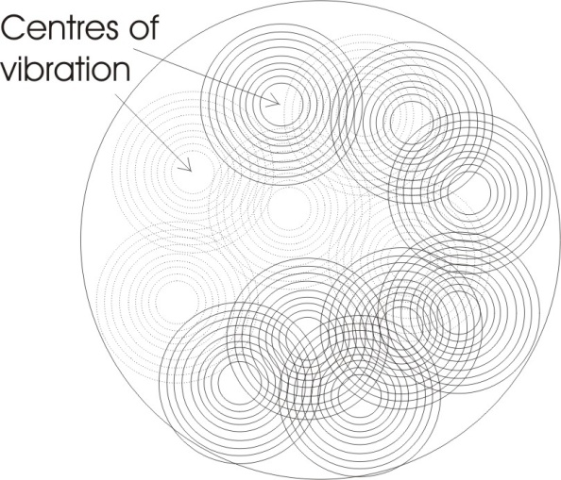
Now, you know that Plato had an idea that all knowledge is simply remembering something that we have already seen. In Plato’s theory, ideas are eternal forms, and we have already experienced all these forms before birth. Now that might remain theoretical, if it weren’t for one consideration: we all begin our existence as an egg, and therefore we have already inside us a principle of form. Before the egg begins to assume the shape of a human being as we know it, it is a sphere which is vibrating.
[sound interference] as a sphere, containing all the forms, such an effect will become serialised in the child as thought. I’d like to see just how clearly we can get it, so that we can understand why, inside the egg from which we all develop, all the things that we could possibly know are contained ‘formally’. If we were to have the egg as a figure of in the continuum without any partitions then the only form there would be the form of the sphere, but in fact this egg is vibrating and the vibrations of the egg are traversing the egg continuously, producing a grid. And this grid manifests in the process of cell division, parting the egg into a considerable number of little chambers. When the chambers are sufficient in number then the process of differentiation ...

[break in recording]

... not already resident in that primary egg. If we make the mesh small enough in this drawing it will represent the partition of the egg into innumerable cells. If then we care to stress any given pattern on the existing cell partitions we can produce a shape of the kind we see in a tapestry.
The only difference between the egg with knowledge and the egg without knowledge is simply a stress. General psychaesthesia, the general power of feeling that it has, is what we posit of it when we are not considering any particular pattern. But when we consider any particular pattern that we care to produce, simply by super-stressing the existing partition, then we are talking about the object’s knowledge.
We could make the mesh like that, and draw any shape whatever internal to the egg, and we know from the facts that this mesh in its vibrations is exhausting the formal possibilities of the sphere, that the totality of the experience that will later be serialised, is held in simultaneity in the egg. We can then understand why Plato thought that the experiences we have in the sense world simply make us aware of something prior to the sense world.
A stimulus from outside adds a superstress onto an existing pattern inside the egg. The character of the external stimulus causes some resonance within the egg, and steps up or intensifies certain formal patterns within the egg which are a part of the total formal content of that egg.
So we can say that the egg is omniscient: it knows all conceivable forms in itself. But they are not serialised. This is the condition of Adam prior to the expulsion .... [more sound interference] .... because he was in a state of perfect equilibrium, and in the absence of an external stimulus he had not caused any particular super-stress to appear on any existing form within himself. But with the presentation of an eternal stimulus, there then arose in him knowledge, and the knowledge was simply a part of his total wisdom brought into a super-stress state by the energy of the external stimulus.
So in the doctrine of Plato, that, knowledge is simply remembering something that we have seen in eternity, you could see a biological basis for this in the egg, and the continuity of the egg from the prime egg from which the human and the animal and the plant organisms have derived.
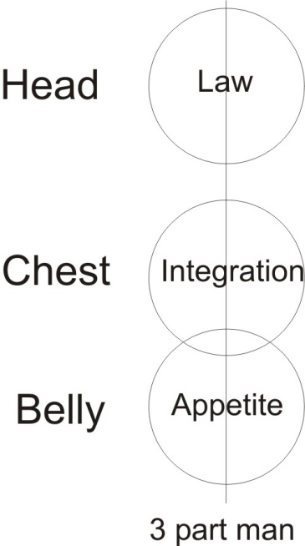
Now the question is this: how can we formulate questions in such a way that we get a response from the child ... [more sound interference] ... separate from other forms in the child, which will be of profit to it in moving towards the development of its life and the attaining of maturity.

The General Rule for Question Formulation
Now we’ve said that maturity is the establishment of the law, and its integration in it. There is its primary appetite, there is the law, there is the physical body, there is the integration. That is maturity: the integration of that body by the law controlling that appetite. So a mature person is a person who has established inside himself a law whereby he has been able to integrate all the appetites of his body.
It is obvious that unless we can make the child Self-conscious about his own inner tendencies, we cannot lead him towards maturity because maturity implies that he is aware that he has appetite, and aware of the need for integrating that appetite. Because without integration the appetite tends to scatter, and to become plural ... and in its extreme case to disintegrate the cell from which it started.
To know what question to put we have to remember the three-fold division. And we have to distinguish very clearly, and say to the child:

You are thinking, you are feeling and you are urging.
- There is an impulse here to do something. What do you want to do?
- Do you like it or dislike it?
- And what is the idea, what are you thinking about when this impulse comes and you like it or dislike it?

So the question technique requires that the child should be shown that he has these three parts, that one part is concerned with impulses which spring up quite independently of pleasure/pain experience. They are prior to experience. They lead to experience but themselves are prior to experience. The impulse jumps up and starts to express itself, and it leads you into a situation where you derive either pleasure or pain.
If you derive pleasure the tendency is to re-will into that situation again. If you derive pain, the tendency is to begin to think.
So in any given situation, in order to conjure up from the total knowledge or wisdom — wisdom is the total knowledge of that being — we have to make this three-fold statement.

We have to say to it:
- What were you trying to do, what does the impulse want to do?
- Was it something destructive that you would not like doing to yourself ... or something constructive that you would like doing to yourself?
- What was the idea in your mind when you were doing it?

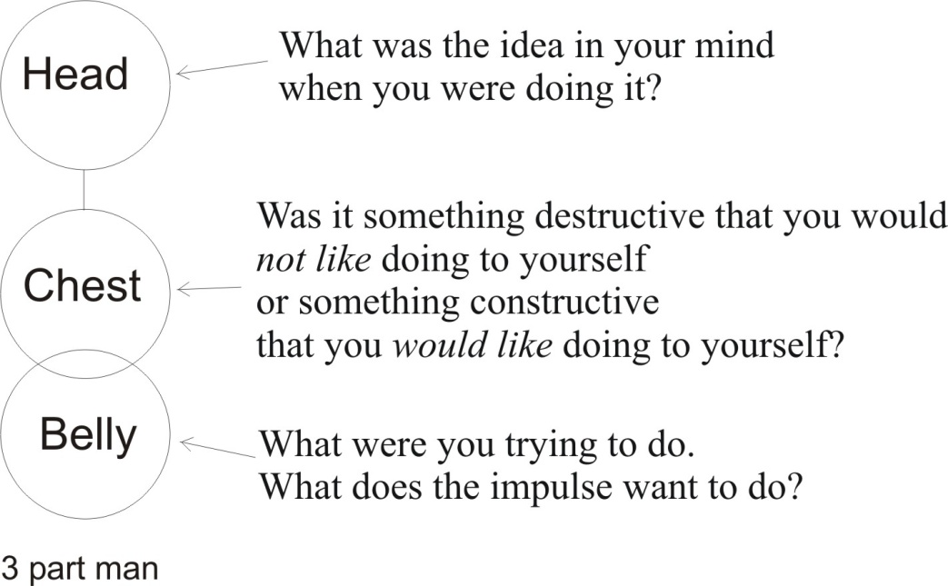

And if you present these three questions to a child, the child will then find inside itself, without any special effort on its own part, an arising in consciousness of this latent knowledge — which is in the totality, the wisdom — stepped up by the stimulus of the question so that the child becomes conscious of a response. And the response is an intelligent response, simply because it comes from the whole wisdom, the totality of form inside that being.
If you gain the confidence of the child, which you do by feeling that it is for the child’s benefit that you are doing it — and not from fear of social censure or something — then as you present the question to the child, the child is glad to have the question, because it brings into consciousness clearly to the child what he’s trying to do. And when he becomes very clear about it, certain tensions which usually arise from obscurities are removed.
So governing all cases are three kinds of questions.

- What were you urging, what was the impulse trying to compel you to do?
- Was it constructive or destructive, did you like it or would you dislike it if done to you?
- And what was the idea that came into your mind while you were doing it?

Those are the three basic types of questions. And if we formulate that — not only to a child but to any being whatever — the being will find inside itself a proper response, which is simply the appearance in consciousness of a pre-existent formal content. It is part of the product of the geometry of its own being. That’s the general rule for question formulation.

Application in the Particular
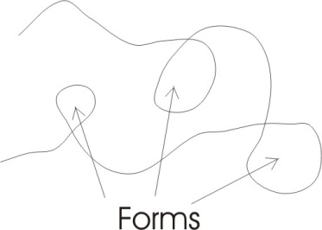
To apply it in any particular situation we would have to examine the situation very carefully, to see:
- what in the situation related to the impulse urge,
- what to liking/disliking,
- and what to the idea.

And we’ve said that number nine is the number of the magician. Every man has three parts and a coordinator. Inside each part there are three parts, which means, in the urge part the actuality of the urge is masking a potential idea, which will appear when the urge has expressed itself ... and it is masking liking and disliking.
So at the back of every urge is an unconscious liking and disliking, and idea. Because the moment power begins to move — because of the nature of movement — it begins to formulate. Form is idea. So that as soon as a power begins to move, the nature of its movement determines form. So the power that wanders about like this is drawing shapes or forms or ideas. [13:25]
In the feeling department there is a potential urge, and a potential idea. That means if you suspend your feeling and try to find out whether you like or dislike a situation very carefully, very finely ... at the moment of so feeling, there will not be an actual impulse to action, but merely an attempt to discover one. And also there will not be a clarity of form — actual — but there will be a shadow form. As you are searching in your feeling you become aware of vague form trying to precipitate itself. If you precipitate it, it ceases then to be mere feeling and becomes idea.
Physiologically it is sometimes said that the general psychic awareness, the psychaesthesia of the being, is simply that awareness which has not yet made any specific organ in the body to serve as a centre. At the moment a specific organ appears, it is not then a general psychaesthetic function ... it is now formulated, because it is organised. To organise is to form. So in the feeling zone we have a potential urge. As we examine the feeling we will find a tendency to go towards or away from it. And the more clearly we feel that, the more that potential urge in the feeling will manifest and then gradually express itself as a definite movement towards or away from a being.
In the ideational centre we have a potential urge and a potential feeling. Thus if we think of a purely mathematical statement — say, the idea of equivalence — and we represent it like that, it appears that it is merely an idea, but if we clarify that idea very, very carefully, we will find a shadow, an aura around it of feeling, that we either like equivalence or we don’t. And at the back of that there is an urge, a tendency to do something about it, to establish it, to pat it on the head and say, you’re a good thing, stay in being ... or to cross it off and say, you’re a bad thing.

The Classification Tree (science philosophy and religion)
Now if we become aware of this threefold process in each department, so that we can actually clarify and determine in ourselves the affective and conative, the feeling and urge value of an idea, or the urge and idea value of the feeling, or the feeling and idea value of an urge, then we are number nine, because we are able to negate anything whatever that arises in us by deliberately stressing some other part. As if in this egg the total knowledge, our wisdom, when a certain stimulus comes and a certain form sets up by resonance from the stimulus, we are able to set up another form and divert it ... produce another pattern. This we can do by becoming progressively more and more aware of this threefold division. [17:04]
The important thing to realise is this: once you have absorbed the fact that there is
- no urge without a potential feeling and idea,
- no feeling without a potential urge and idea,
- and no idea without a potential feeling and urge
then it becomes possible for you to determine the direction either of your own urge, feeling and idea, or of some other being who does not yet know the rules. Because in effect, if you have examined in yourself and found the real meaning — that is, the meaning to wisdom, to the totality of your knowledge — of a given idea, you also know the effect, the emotional value of it, and the kind of urge it would provoke. Which means to say that if you know that fact, you could insert a verbal stimulus in somebody’s ear, and that verbal stimulus has a definite content: it has an idea, a feeling and an urge value.
If we utter the word urge for instance, it resonates inside here, and it descends down here and it goes into this department. You cannot hear the word urge without having something go on in the lower third of your being. If you just look at the word urge, and recite it to yourself and try to think what it means, you’ll find that consciousness will begin to drop. Whereas if we put the word idea, and think about that, the consciousness will begin to rise.
This means that we have, by means of a purely sonic stimulus, a capacity to determine the consciousness level of another being ... or ourselves, if we want to make magic on ourselves.
If we put the word feeling in, or emotion, then we find that the consciousness begins to go round the middle part of ourselves. So by means of words we can cause concentration of consciousness in various parts of the body.

Philosophy, Religion and Science
So that if we begin to divide our wisdom — that is, to serialise the total content of form — and present it serially, we can make a tree: a classification tree. And we could say we can divide all reality up into ideas, feelings and urges.
And we can then put in:
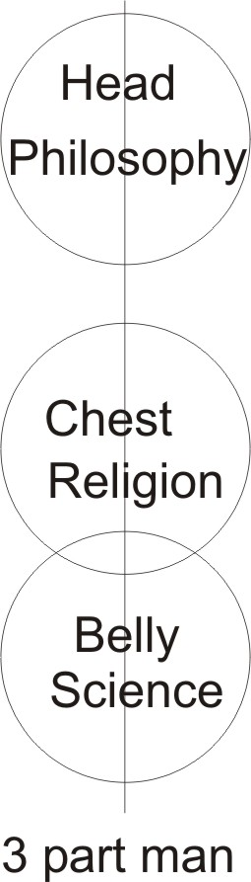
- All the ideas, every philosophical system, which is rational.
- In the feelings, every religious system,
- And in the urges, every scientific system.

The Ge in the Ur-Ge is earth. And urge, Ur-Ge, means primary substance. It is that that science is attacking in the Ge, the earth; breaking it down to get at the power, the original differentiating power.
Science is pursuing urge, only it calls it force. It is concerned with causation. Causation is power differentiating, and locked up in the earth.
The feelings are liking and disliking, and that liking and disliking, provoking relations between human beings, is the ground of all religious problems.
Idea, being form, is necessarily concerned with ratio, and the subject that deals with that is philosophy. So if we were to write down the vocabularies of all philosophers, and then of all religious teachings and then of all scientific teachings, we will find stresses beginning to appear in the body. [21:37]
We know once upon a time that religion was the rule, and then philosophy came, and then science came. Religion was a general feeling attitude, unformulated. This general feeling attitude, in the attempt to become clear about it, resulted in a rationalisation of it. And then the failure of that to establish a proper relation with the gross material world led to the appearance of science.
We are in a state today where philosophy on its own, pure and rational philosophy without physical data, is held in disrepute by scientific minds. Nevertheless it has a function. The strain between the two, the opposition between science and philosophy, is very beneficial to religion. [22:33]

The Function of Opposition
Which brings us to another part of the question. What is the function of opposition in the development of a being?
It’s obvious that mere opposition is not good enough. Because if we try to educate a child on mere opposition as soon as it was born, we’d just sit on it and require it, by the opposition, to grow into a man. It isn’t simply opposition that is wanted, but intelligent opposition. [23:06]
Intelligent opposition simply consists in firing the right question at the child when it is about to do something. What you are opposing is a part of the child. The child at certain times will tend to do things without thinking; its impulse will operate straight through it. The opposition is then: that you oppose the urge, and require the child to think. You’re not opposing the consciousness behind the child, you’re not opposing the person, you are opposing an unbalanced energy, and you are balancing it by forcing it into the opposite.
So when an uncontrolled impulse comes, you ask the child whether it thinks it can always get its own way by simply allowing an impulse to rush through it. This causes the child, because you’ve said to it, do you think that this uncontrolled urge can succeed in getting for you what you want? That forces the child up there [into the head].
The impulse inertia would tend to go on. Nevertheless when you say to it, do you think that this is profitable to you? you have filed in its consciousness, its total consciousness, a stimulus such that when an impulse occurs another time, there will also arise by resonance, a voice saying, do I think that this is good enough ... simply to respond to the impulse?
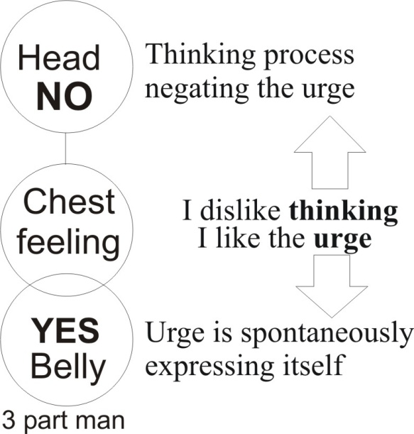
Now when it tries to think and the urge is still trying to express itself, then we get the statement here of the uprising of the urge to express itself and the down-pressing of the thinking process to stop the urge until the thinking process is completed, and the result is a feeling develops between the two. This feeling always develops between the two ... the urge, spontaneously expressing itself, and the thinking process trying to negate that urge.
So on the middle line there then appears a feeling, I like the impulse, I dislike thinking and now thinking exists. How can I get my thinking to keep quiet and allow my urge to manifest?
The answer is, when your urge is pointing in such a direction that your thinking stops, then your urge must have been modified by the thinking process sufficiently to be acceptable to your feeling, because you have to balance the yes and the no in your feeling. [25:52]
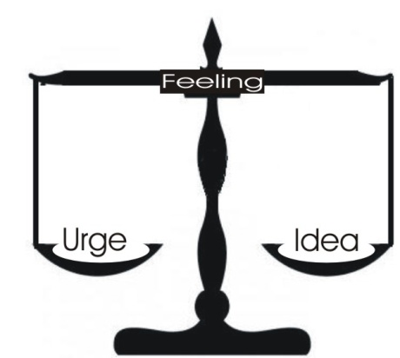
So the function of opposition in training is this: that we do not oppose the child or the grown-up, we simply oppose the disequilibrium in it by stating on the weaker side something in favour of the weaker. We always take the weaker side. This is like British international politics. When two enemies are fighting we look to the weaker one and support it. Because if we support the strong one, it will polish off the weaker one very quickly and deprive us of an ally. What we want is the balance of power.

Free Will
If we turn the image this way, put it on the pan, suppose we place the idea on the sinister side here, and the urge on the dexter side because it tends to extrovert, then the feeling will be here on the balance. If the urge starts tilting the scale and is about to operate, we throw some weight on the idea. The object is to get this in balance, because the meaning of deliberation is simply freeing from the alternatives.
Remember, the will cannot act freely unless equilibrium has been attained. If there is an inclination and you do it, it is not a free act of will. First of all you must balance exactly the urge and the idea. The attempt to balance this — the continuous throw of a force on one side or the other according to which one is the lighter — causes a feeling tension to arise. Ultimately this feeling sensitivity, properly developed, is what we call good taste. It enables you to feel exactly how much urge and how much rational control is needed in any given situation. [27:58]
So that’s fairly simple, the purpose of opposition as an educational device is simply to balance disequilibria in order that the feeling itself may evaluate them properly, and then from the centre of the feeling, in balance, comes out the free will. The will is free from — it’s not just free — it’s free from the opposites, the urge and the idea.
Now it has been said that the universe of man is governed on a polar principle called the two-party system, and the two parties are the ego party, and the rest ... see? This is like Labour and Conservatives ... that must be the Liberals in the middle there. [28:58]
The two party system is: shall I act always to my benefit, or shall I consider always the benefit of all these others, each one of which is an I ... there’s lots of little ‘I’s like little nuclei in cells [sounds like he is drawing a number of points on the white board]. Now that is the mass in generality, and this is any individual whatever.
There arises a conflict between the individual and the mass of men, and it is this conflict that generates between the two, the feeling in the individual, and in the mass. That ego is a conservative. This mass is a labour fellow. Between the two is a feeling possibility which, when these two are in perfect balance, will result in a decision which is free.
Now we have to consider very carefully, so that we don’t get confused about two different kinds of feeling. One we’ve just talked about — the free feeling — is the fourth state of the being.
When an urge rises up spontaneously and leads us into a pleasure situation and we tend to repeat it, the feeling there we will call feeling of the first order. And that feeling continuously tends to release energy back into the same situation. But when the urge runs into a situation productive of pain, then the energy rises up and becomes thought. [31:00]
So a being can become an urgeful being, and then a pleasure/pain being, and then a being of ideas — a thinking being — and later, if it reaches the level of understanding these three things, it can come back again to the feeling, and evaluate at the feeling level, the idea and the urge, consciously. And it is then the fourth state of the being.
We say the child when it’s born is an urge being; it wants to suck and do various things, always from urge. And it tries as far as it’s possible to urge always towards the pleasant. After it’s been stopped and some of its tendencies inhibited, there arises pain, and from that, thought. The child tries to dodge the thought, not to face it, and continuously tries to pursue the pleasure. But the continuous negation of this pleasure cycle by its educators results in it becoming aware that other beings exist, and that they will have to be accounted for in its thinking process. And still it doesn’t like it.
But gradually there arises in its head an idea that it might actually become profitable to allow that other beings exist, because a naughty little boy who wanted to be entirely selfish and live to himself may by an intelligent parent be questioned about whether he would like to live entirely alone on a desert island, with no playmates. And at this point he begins to realise that he doesn’t want to be a pure egotist. He doesn’t want to live entirely for himself alone, because it would refute his purpose, because his life consists in relation with other beings.
So he then has to allow that other beings have a function for him, when previously thought that he was enough to function on his own. And when he allows that other beings have a function for him, it arises logically that he may have a function for other beings. And he then begins to consider that it might be possible to make an equation between the pleasures and the pains, and to pay out so many pains to get back so many pleasures. Now he’s already going towards that fourth level of the feeling awareness, and becoming aware that a reciprocal relation between himself and other beings is a necessary precondition of his ultimate happiness, and proper function.
Now this is the fourth level. To coordinate by means of the feeling — because only the feeling can coordinate the idea and the urge — to coordinate oneself with the rest of the universe ... and to realise just precisely what the universe has to give oneself, and what one owes back to the universe if one is to continue to live in it, or to live anywhere whatever.

The Rotating and The Translating Force
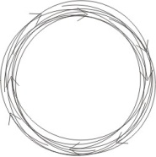
I’ve just said that without the feeling we cannot relate the idea and the urge together. An idea is a form, and an urge is a translating force. It is a force that is going somewhere. The rotating force is standing where it is. And this rotation force and this translating force cannot be turned into each other, because the rotation always meets itself and encloses a zone, and the rectilinear translation never encloses a zone. So this one and this one are eternally separate. That which never encloses and that which always encloses. [35:33]
So the urge for any being can never be brought into proper harmony with the idea in a being unless there is something internal to which both the idea and the urge subsist. Now we know actually what it. It is that represented by the white paper on which we made the two lines. The white paper, we said is consciousness and power devoted to move, and it moves itself. And it can either move by translation or by rotation. And in the place where the rotation is, it is the white paper which is conscious of it. And where the urge or translation is, it is the white paper which is conscious of it, and it is conscious of it as a field-awareness. And we’ve said that field awareness is the same as feeling. So we can actually feel whether that urge is a translation of energy, or whether it’s an energy that goes round and round and round continuously. [36:39]
So the feeling can tell us the difference between an idea and an urge. Now the difference between an idea and an urge is not absolute, it is relative, because both an idea and an urge are power, and the only difference is in the mode of their activity. So we can make a little illustration to show that an idea or rotating power can be traversed by what, to it, will be an urge ... which is in fact a part of the arc of a larger rotation. We’ll see why this is very important in a moment.
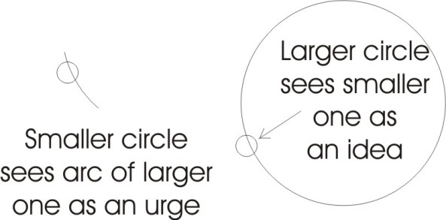
Any force, the arc of which is greater than the one under consideration, is called an urge relative to the one under consideration, and the rotating one is called an idea relative to the larger one, part of the arc of which is an urge.

Cosmic Reason produces Individual Urges
Now I want to remind us all of the — I’ll remind me as well, while I’m at it — when we draw our six divided space, we cover the paper with circles all over, we get a series of forms, and if we go on drawing these, every centre of every circle is really the initiation point of an impulse.
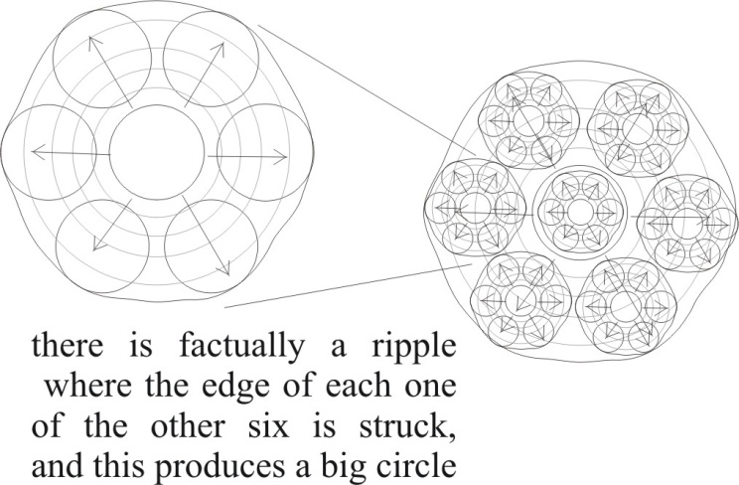
Remember, absolutely, nothing goes anywhere. All motion is an ap-pearance, caused by impulse, expulse. There’s an automatic becoming more dense when the thing contracts, or becoming less dense when it expands. The impulse and the expulse is the cause of everything we know. Any part of space is a centre, and therefore an impulse ... and the source of an expulse, an expelling force. And a ripple is caused by the motion every time it meets an obstacle.
So if we arrange, as we do spontaneously, six circles round one, now when the impulse from the central one propagates out, it meets what is the equivalent of a larger circle. Simply, there is factually a ripple where the edge of each one of the other six is struck, and this produces a big circle; and the same for every other centre through space. So there must be another one outside here, and when we get six of these bigger ones, we’ll have another circle very big; it’s still a centre of impulse and expulse, and we then see just how, for a small circle, it appears that there is an urge.
Now the Logos — that six-spoked wheel we talked about before — is the supreme reason, and if we take the supreme reason and represent it by the circle round which we can draw no bigger, then we can see that for every small circle within the big one, the reason of the big one must appear as an urge in the small one. So the so-called irrational urges of individuals are really Cosmic Reasons. [40:53] This is quite obvious in the case of the sexual urge, which would be called an irrational impulse by anybody suffering from it, and yet it has a cosmic value ... a cosmic significance. Even some of the lowest practices so-called — say, un-mystic practices — have a reason behind them.
Everything is over-produced in this world, because cosmos requires for its reasons the generation of certain fine energies. The earth is a coarse energy. A plant takes that and makes a slightly finer energy. An animal eats that and makes another energy. Man makes a finer energy. And all the finest energies are related to sex in the plant, the animal and the man. So that we can consider man as a machine as to his body, producing very, very fine energies which are necessary for the macrocosmic purpose. So that when we’ve understood this fact properly, we can see that there are no absolute irrational urges. That is, all irrational urges are irrational and urges only for a being too small to understand the large circle from which that so-called urge derives. [42:30]

Moral Considerations
Now this strikes right at the root of most moral considerations in relation to fundamental functions. We’ve said before that the moral is the expedient for the rulers of a given situation. Simply, the rulers’ expediency is the moral. Now The ruler of all is the Logos, the Cosmic Self, the Pure Reason. And therefore if we like to say there is an Absolute morality then we can do so, but we must always mean by it, that which is expedient for the macrocosmic purpose. It is the ruler. But for all lower organisms, all smaller circles, that macrocosmic one will always appear as an urge until the individual has, by the power of his yoga, identified himself with the macrocosmic self ... when his urges then become his reason.
If we take a small circle inside the large circle — traversed by some other circle, originating from a certain centre — and there is an urge cutting across the smaller circle [i.e traversing it], a being identified with the small circle — say that was the Roman empire in its heyday — would consider one of these larger circles traversing it as a destructive irrational urge, and would do its best to stop that urge from existing. In effect he would like, if possible, to bypass that larger purpose ... and tries to do so.

Bigger Circles — Macrocosmic Reason
Now the history of man’s civilisation is simply the history of small circles: a man; his immediate family; a tribe; a nation; commonwealth of nations, and so on; with progressive identification with ever larger units. But always, somebody is persisting in identifying with the smaller form, the old dispensation. And somebody a little more sensitive, a little more aware of the bigger circle, identifying with that, is trying to persuade those identified with the old dispensation to let go of it. But every time you act from outside onto a being, you necessarily produce a reaction. So that if you tried to persuade a being by any method other than an appeal to its intelligence directly — from centre to centre — there will arise a mechanical reaction.
So if a man comes and is aware that there is a bigger circle ... [break in recording] ... he is becoming a nation, tried to stop the integration of tribes by physical methods. Again, they knocked a few heads off to discourage people with a national consciousness. And then those who had an international consciousness a few years ago were thrown into prison for thinking internationally, and that caused an increase of the international consciousness.
We are now being encouraged to have a Commonwealth of Nations consciousness. It has been said by some American philosopher fairly recently that the Commonwealth of Nations is the ultimate concept for humanity ... the ultimate. Now the ultimate concept cannot be less than the totality of all beings. He thinks he is being very, very much ahead of his time when he says the ultimate for humanity is the Commonwealth. At least you could have gone on to, say, the Pan-terrestrial Human Association or something. But another fellow would suggest that we might have an Interplanetary Commonwealth, and another one a Solar, and another a Sidereal, and so on. In fact nothing less than Absolute Identity is ultimate in the real sense.
So again a function of opposition comes.
People who would tend to stay with daddy and therefore not to develop in the early family system — the very simple patriarchy — when the family became too big to handle and it was necessary to set up heads like the tri- in tribe is three-fold, like Noah and his three sons ... each one of the sons wanted to set up a little pyramid of his own and stop listening to daddy.
Now some of the children with good Oedipus complexes in them would be objecting to their own daddy trying to force them away from their granddaddy. Because the funny things about most little boys is, they’d rather murder their father than murder their grandfather, because grandfather always has peppermints in his pocket, and daddy does not ... as a rule. So a tribe — or a three-fold government — is opposed by the father, and those who would like to go to the grandfather are made more and more conscious, by the opposition between the two, of what it means to choose between this simple patriarchal family situation and the tribal situation. Every time there is opposition, the situation is clarified and the necessity for choice is made more apparent. So another function of opposition is clarification of the elements from which we have to choose.
All choice implies taking and rejecting.
Now we had this great concept, the Supreme Logos, internal to which are various small systems, and for each little system the reason of a larger system appears as an urge. Which means again we have a method of discovering the reason of the universe by becoming more conscious of the direction of our urges.
We find an urge that we call the evolutionary urge. If we try to find out where that evolutionary urge is going — where it’s tending to push us — and we remember that it is a part of the Macrocosmic Reason, then we will become aware of what that Macrocosmic Reason is trying to do, simply because of the direction of our urge. So the thing that would appear dialectically to be the least helpful to us in our thinking process — namely the irrational urge — is then seen to be the key to a larger reason than the one we’ve got. [50:15]

Why Do People Tell Lies?
Now there’s a question here about why do people tell lies, and why, having told one, do they cover it with a lot more?
Remember that every little system is trying to establish itself. It is a centre of an impulse. Remember we defined an empire as that zone which is controlled from a centre. The limit of empire is the limit of the influence from a centre. Every little individual is trying to become an empire. And it is treating every force which appears to it to be an urge, as an enemy of its empire. Now, in relation to a child, his father is a large irrational system, and where the father’s large irrational system cuts across the child, the child must think its father irrational ... simply because the child is trying to establish its own empire. And every motion which is an arc of a circle too big to be totally encompassed in the smaller one appears to be irrational.
Now we’ve said before that a lie is simply what is laid down, and we’ve said that the law is from the same verb. Each individual is trying to establish a law of his own being. And another being, bigger, more mature, nearer to maturity than he is, is trying to include that being inside the system of the older one. The superior knowledge of this larger one, the larger one would call his social system. And the rules for governing it he would call, from the feeling standpoint, his moral code. So he would tend to give what would be to him reasons to the child. But the child must feel those reasons as simply urges ... daddy wants to interfere, and so on. [52:53]
I remember a brother of mine many, many, many years ago eating seven pounds of mincemeat just before Christmas, and not mentioning it to anybody. It was only when he had very, very severe colic that it was known that he’d been doing something. And he wouldn’t say what it was he’d done, because he was afraid of punishment. And so it’s very difficult to treat it, because I was under oath not to tell, and he had no intention of telling. So I couldn’t tell, although I knew what he was howling about. And my parents didn’t know what was the matter with him, and the doctors didn’t know what was the matter with him ... but he had eaten something.
Anyhow, when they were out of the room, I was able to say to him, if you don’t tell them, I can’t, but if nobody tells them you won’t get treated, and if you don’t get treated you’ll probably die. I was five at the time.
So in fear of death he told. And straight away it became possible for the larger being, the parent being, to place the action inside this system of reason. Seven pounds of mince-meat at once is not good for the tum [belly]. So it then saw the reason of it. And prior to the explanation, the behaviour of this child was irrational, but the child had inside itself a reason for its bellyache, because it knew what it had done.
So in any given context — and every finite being is a context — an action or a feeling or an idea has significance to that being, and the significance will not be the same to another being unless the being is able to participate by sympathy, by compassion, in the feeling experience of that being, and from the feeling experience extract the idea — the reason part of it — and the urge, the impulse, that led to it. [55:01]
The important thing to realise is this: in dealing with a child, you are actually dealing with a smaller being. In dealing with an immature adult you are dealing with a smaller being in this sense. Every time you get an idea, that idea resonates over a certain area, and goes to a certain limit. When you get another idea and bring it into relation, you change the pattern of the field. An idea is the centre of the field. If we add another idea, we change the pattern of the field again. And we are actually getting bigger. We are moving toward wisdom instead of merely to knowledge when we begin to arrange the ideas that we get in fundamental geometrical structures. Those are the structures of thought.
So that a man with a million ideas properly related, is a much bigger man in the idea world than a man with only one idea. So a baby with very, very few ideas is actually incapable of assimilating the idea system of the parents, and so the reasons of the parents cannot be interpreted rationally by the child. So the child must think that the parents are very unreasonable and full of urges to dominate. In fact the child would frequently count what to the parent is a pure rational request, as a simple interference with the desire to dominate as its motive.
The same thing goes with adults, where somebody with a relatively small idea system comes in contact with somebody with a large one. If the large one tries to impose contrary to the will of the smaller one an idea, even though the large one may be absolutely certain that he’s god almoight — I nearly said it in Irish [an aside] — god almighty, and knows what he’s doing, nevertheless the smaller one must feel that this is irrational.
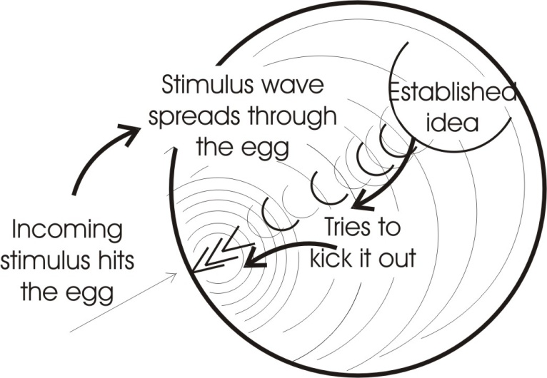
So when we are dealing in this way we must always try to remember to talk from consciousness to consciousness and not from consciousness to body, and try to appeal to that consciousness, and try to make it clear that we are not concerned to upset the existing rational structures, but merely to indicate that there is also another rational structure. We must never devalue the rational structure that the being has. We must never say, your idea is no good. That idea is perfect at its own level, and the truth includes all ideas absolutely. If we say, your idea is no good, it is equivalent to an attack on the body. And an attack on the body always, and necessarily, produces a physical reaction. [58:12]

Open to New Ideas
Remember inside your head, when you get a stimulus through the ear, you have an idea going round there, and if you utter the word and that idea and prefix it by, that is rubbish, then the statement, that is rubbish, goes in here and starts hitting on this idea. And because that idea is established — it’s a rotating energy — it constitutes a body, a physical body, to the incoming stimulus. So it reacts against the stimulus and tries to kick it out. That’s quite physical. This means that when you think you are resisting somebody’s idea and they think they are trying to impart a truth to you, it is not you, it is not the consciousness that is resisting it ... it is the already established pattern of idea that is resisting it. And if you know that, and you become aware that a bigger idea would be better, then you don’t identify with the little idea in you that is resisting the new truth, but you deliberately say to yourself, there are bigger ideas than I’ve got, I do not yet know anything — everything I mean [Eugene corrects himself] — and therefore I should be prepared to allow something in, knowing that everything has ultimately its justification. I should be able to afford to listen to anything whatever, knowing that if I listen to all the things, that have ever been said or could be said, and assimilate them, I will have omniscience. And if I reject any of the things that could be said, I’ll be deficient.
So again by non—identification — by saying the observer is not the observed — when we feel a resistance inside us to a suggestion, our first duty is to remind ourself that we want absolute assimilation power, and to observe the kind of resistance that occurs when the idea is presented, and see if we can discover precisely what it is that is causing the resistance ... in other words what we are trying to preserve in our system. [1:00:29]

How to Impart Truth Without Moralising
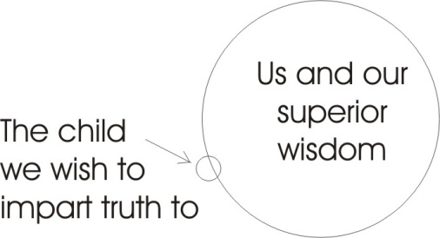
Now the last question on here was how to impart truth without moralising. And we’ve said that the moral is the expedient for the ruling class.
If we wish to impart truth to a child — supposing this circle represents us with our superior wisdom, and this is the child and we wish to impart truth to it — first of all we must know what truth is. And we must know that anything we say to the child by the law of truth, must be interpreted by the child as an irrational urge unless we reduce what we have to say down to the terms that it can fit into its rational structures. So the kind of question, and the statement about how to avoid moralising in presenting the truth, is first to understand what truth is.
Truth IS the totality of all possible beings and their reciprocal relationships. And the moral is the expedient for the ruler. And we recognise only one supreme ruler: the Absolute. And anything less than that we would consider to be itself immoral, contra- the Absolute when it tried to impose a formal behaviour from itself onto a smaller being.
Those who recognise the nature of the truth will be prepared to reduce their vocabulary to the level of the child if they are talking to a child. And it’s fairly simple to do it. All you need is a question. You say:

What have you learned?
What do you know?
What do you do at school? How far are you up to?
What do you know about thinking?
What do you know about feeling?
What do you know about impulses? ... and so on.
What do you want to do?

If you keep reducing the thing to very simple terms, the child will respond. Because it cannot stop that resonance inside itself, and the idea must arise, and if you put that to it, you can explain to it just precisely why it must interpret anything you say as an irrational when it won’t fit the context of the child’s pattern. [1:03:08]

The Case Of A Liar
If we remember...
[Question from Khen] Say that pattern is a direct denial of something which it has done at a particular time. In the case of a liar, where it states it has not done something when it knows quite clearly that it has ... the purpose being, like your brother, to avoid punishment.
Yes, because he wants to establish his empire.
[Khen] He really wants to establish his empire.
Mmm. It doesn’t want it disintegrating, and he doesn’t want punishing, and so on, all of which appears to him to be disintegration. He lays down some statement to establish his empire. Once he’s laid one down — oh what a fearful web we weave when first we practice to deceive — once he’s laid one down, if you persist in questioning him, he will have to lay down a lot more.
[Khen] Are you suggesting that you accept the first statement, or ...
The best thing to do of course is to anticipate it, so that he doesn’t tell the first lie ... which requires increased sensitivity. That would imply that you had conquered panic in yourself. But if the first lie has been told, it is better not to persist in the questioning, because it will beget more. It is better to let it lie down and increase your sensitivity, and you will know whether it’s a lie or not, and you will be able to produce various situations which are not attacks on any physical system already established, but will draw out various statements.
I know kiddies that have lied and then, when given plenty of room and not been disbelieved, they have felt it necessary afterwards to come and admit it ... in a very garbled manner to restate it. The fact is that the moment a being misrepresents something inside itself, it introduces a contradiction ... even if it’s only to defend itself.
Now that contradictory element will be shuffled to the perimeter by the other elements, mechanically. It would tend to slip out on the tongue, in what Freudian psychology would call a lapse — you see? — revealing an inhibited content in the sub-conscious, simply because it cannot fit in with his pattern of truth. And his truth for him is the establishment in his being, and he doesn’t want anybody to tell lies to him, so he must be against lying in principle. So that lie must get shuffled away from his central concept, because he never thinks he’s a liar, really. He just thinks he’s been cornered, and forced to say something he doesn’t want to say.
A sensitive person will observe a slip that would indicate exactly ... in fact if you increase your sensitivity you can see, not the lie but the tendency to lie, in about five weeks. Because these things never appear suddenly; they always appear as a result of other activities which have been going on in the feeling of that child. Very often, parents get a terrible shock when an innocent child, so-called, does something totally incompatible with the parents’ concept of the child. When that happens it is the parent that’s at fault, because he had a false concept of the child; he’s really unaware of where the child is up to in his development. [1:06:47]
The important thing is to see that lying is not absolutely immoral. If it were, then certain kinds of lying, subtle misrepresentations — which by moralists are considered very bad — would not have been done by the Logos himself. You remember that when Christ was going to the festival, and his brother said to him, are you going to the festival, he said, no. And when they’d gone he went.
Now, he wasn’t going to the festival, he was going to do something else in the place where the festival was. But they would have thought he was telling lies. And actually he did lay down the statement that he wasn’t going to the festival, and then he went ... but not to the festival, but just to the place where it was.
This whole question of lying depends on the true meaning of what it is to lay down anything whatever. All form is laid down. Therefore all form is a lie. Only the Absolute is not a lie, because it isn’t laid down.
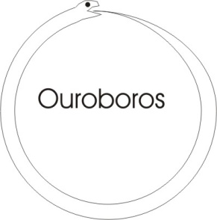
You remember the glyph of the serpent with his tail in his mouth is the very principle of form, and that that represents the devil, and the devil is called the prince of liars, the first liar. Form is a lie. It is laid down. The Absolute is free spirit. It is not laid down ... it’s the only non-liar.
When it says in the bible, if man — that’s this bound being — says he has not sinned, he makes God a liar. Because this infinite and this finite presuppose each other and man is a finite and if he says he is not a sinner — considering sin means separation — then he is making a liar out of the infinite, because the line of division divides the infinite from the finite, as well as the finite from the infinite. [1:09:07]
So if the finite isn’t sinning it must be the infinite that is. So if man says he’s not a sinner, he makes god a liar. And as sin happens to mean separation, it would be a very difficult metaphysical problem to see who is responsible for the separation. The word firmament, for instance, implies banging from both sides. So the infinite is as much responsible as the finite for that bound. Because if the infinite were to retire and exert no pressure, well then that would expand infinitely.
So you see this whole definition of moral and unethical behaviour, of telling lies to mummy or whatever it is, or daddy, it simply requires for its solution a bigger view ... to see that all finite systems mean, by reason, the way their forms fit together internally. And if they have very, very few forms their reason would be rudimentary. And if they have a very big form they may include in their form a reason, which, to a smaller being would be a non-reason. And if you remember that in dealing with children, and with people you consider to be at a lower organisation than yourself, then you would make allowances for that, and try if possible to explain that which you know must be interpreted as an urge by the smaller being, in terms of the pattern of the smaller being, so that the smaller being will actually think that your urges are reasons.
Now when you come to the top level, there is no difference whatever between reason and urge. We’ve mentioned that this letter U simply means going. It’s the power that goes, and when it’s going, if it goes in circles, it will eventually produce a circle. And that is O. And the U becomes O when it rotates. But the U is not rational. It is the UN-rational, the UNU ... that is a drive which is considered not to rotate, and only a pure translation with no rotation whatever is Absolutely irrational.
But every ‘thing’ that exists or could exist, or has existed, is necessarily rational because it necessarily rotates. So that for all beings, the irrational is relative, and it simply means a rational impulse belonging to a being of a bigger order than the one under consideration. [1:12:15]

Tolerance
We can see now what tolerance means. The TOL in tolerance means lord. The big circle should tolerate the little circle. It should understand the formal limitations of the smaller circle, and not too suddenly apply one of his big reasons to the smaller one, without first preparing the smaller one in its own terms for the reception of that bigger impulse. And it’s this allowing time for the smaller one to assimilate the big one, that is meant by tolerance. It’s allowing time for the smaller gradually to change its resonance, so that it can assimilate as part of its self, of its own pattern, that which otherwise it would consider to be irrational.
We could, by making the circle big enough, make such an urge that would appear to be a diameter of the smaller circle, and therefore be easily explained as a rational necessity of the smaller being.
Now owing to the fact that all circles whatever split into this six-fold form, and all the beings that we know of, and have to deal with chiefly, have this five-fold sensorium and a common sense, we have a means whereby we can explain in an existing pattern to another being, namely as five-sense-data and a coordinator, all the processes of all circles whatever. [01:14:06]

Speaking in the Terms of the Child
So if in dealing with a child, we can tell it about seeing and hearing and smelling and tasting and touching, and ask it, where it got the idea that it has from? From which sense did it get it? And the child that is asked questions like that actually enjoys answering them, because it feels inside its own being that it is getting to know itself, by means of the question. And when it does so it feels that it is extending and consolidating its empire ... because it actually would like to know what it is doing, and what it is like and where it is trying to go. And the more clear the child becomes about its direction of urge, and its liking and disliking, and its formal content, the happier the child becomes and the more established its direction ... its security increases. So that if a child is presented with a series of questions from a man in that manner, the child must eventually get an idea that questions from this man are useful to the child, because they help to make it conscious of its own content and thus to establish its character and give it more stability.
On the other hand if the questions put to the child are not framed in the vocabulary of the child, it must appear that they are cutting across its form, even though if they were reduced the child would see the point.
We sometimes see an unconsciously long-winded explanation of something to a child which makes a child begin to change feet ... it just can’t keep still, because it can’t understand any of it. And the energy of the stimulus is going in at the ear and finding its way down into the toes, because there’s nothing in the child’s brain pattern to assimilate it. So it goes into the muscles. And you’ll find the child picking its leg up and twisting and scratching and doing all sorts of funny things. The thing that’s making the child twist and scratch is the unassimilable energy from the stimulus.
So when a teacher says to a child that keeps changing feet, keep your feet still, he’s asking for the child to break out in a rash or something like that ... which is fairly common. When you stimulate somebody with a word or with anything else, you are actually introducing energy.
If the energy cannot go into the existing thought pattern, and it has gone into the organism, it must go into some part of the organism other than the thinking part. And it must there wander about and produce symptoms of some kind. So that you can — I’ve seen some very, very sad cases of that — where a child has been pushed and crammed for an exam, and in the process broken down. I know one case of a boy who’s fifteen and he was pushed for an exam, and his brain has completely collapsed, and he’s now considered to be incurable. [01:17:24]
It’s only data that was put into him, nothing else. But more was put into him through the ambition of his parents. Ambition for him, as they explained — not for them — for him. The fact is, they put the energy in, and he hadn’t got the existing pattern to assimilate it, and consequently the energies ran inside, and not being assimilable, they ran in between the ideas that he had, and cut his mind to bits and he became schizophrenic. Now that’s going to happen as a simple energy problem. [01:18:02]
Now we’ve dealt with, I think ...
[Khen] What happens in the case where the child tends to avoid something and discipline enters into it ... for what you would call the benefit of the child? Even small things, the tendency to run across a road, which you know from your experience is a busy road, and the instilling into that child of running across that road ... or the not running across it ...
Well if you said that there is a tendency for him to do so, you’ve already really said that you’ve observed him do it before.
[khen] ... or not to understand the dangers which exist in the road.
Well then what it really requires is — when it is not under stress and therefore will not react against a suggestion — to have explained to it in a calm period, when it can assimilate, and in its own terms. And then later on, the explanation will take over the control. Because the funny thing is that even dogs have become road conscious in the last few years, and you see them using zebra crossings, and so on. A few narrow shaves and they would rather cross where it is safe. And so would the child. But it doesn’t actually know at first.
I saw a little kiddie walk away from its mother who was gossiping with another woman. She had her back to the child, the child was standing behind her, and he walked across the road and was nearly hit by a motor bike. The noise of the bike pulling up, skidding, and the tires squealing, and one or two other people shouting made the mother realise that she’d lost her little boy, so she immediately ran across the road and proceeded to hit the boy and pull his arms out of their sockets to exhibit publicly that the child was at fault, and not her. Now, factually, she was at fault.
The thing is to try to give the information for the situation in the terms of the child, so that there becomes engrammed on it a clear consciousness that its own purpose depends upon this information ... that it must be able to realise its own purpose, not the purpose of the teller. The benefit must always be to the child. It’s quite useless to say to a child, daddy won’t like you, or, grandma won’t love you, or something, because the essential thing is not whether daddy-likes-it or grandma-loves-it, but whether it gets what it wants. And grandma-loving-it may or may not be part of that. [01:20:51]
Every time it is related to the ego centre, it must start to operate. One of the simplest mechanical ways with very young children is always to recite the behaviour pattern you want to engram ... with the name. So instead of saying you to the child, if the child is called Suzie, you say, Suzie will do so and so, and, Suzie likes so and so, and, Suzie knows such and such. And you explain everything round the name. And then every time the name is mentioned, these things crop up. And every time the child thinks about itself the name is brought into stress, and that, by resonance, stimulates all the things that protect the name.
The tendency, of course, because adults are busy, is simply to forget about those things until a dangerous situation arises, and then to panic and start hitting at the body of that being, instead of at the intelligence of that being.
Now have we got any questions we might tackle? [1:22:19]
[Questioner 2] Adam, because of this I take it, explains all of the things that puzzle us, such as disease, and war, imperfections and values, and so forth, simply be seeing the cosmic reasons?
Yes.
[Questioner 2]I wonder can we ever hope to understand that?

Understanding Yourself as Macrocosmos
Well of course you can. All you have to do is understand yourself. The Macrocosmic Reason is identical with the reason of yourself as a single cell. The geometry of your single cell is identical with that of the Macrocosmos. If you understand yourself, you are understanding the Macrocosmic Self. If you understand a part of yourself, you’ve understood a part of the Cosmic Process.
If science can understand the rules governing chemical behaviour in the digestive process, he’d know considerably more than he does now. Organic chemistry is so much more complicated than inorganic chemistry. Man is the measure of all things. There is nothing inside man that, if he understands it, will not give him control over terrific zones of the external world ... because man actually is the epitome, the essence of all problems whatever, of the universe compacted and made into a microcosm.
If science could understand something which with all its psychological knowledge it doesn’t understand — namely what is the relation between an idea — an idea — of a visual stimulus, and the fact of the stimulus of the retina by light ... no explanation yet exists. These things are facts. Science has yet no idea how to deal with fundamental things such as the arising of feeling from a physical contact. Feeling is not defined by science as existing at all. Science today is concerned with materials and with mass energies, which today it uses to account for materials. But mass energy concept never becomes the concept of any psychic function whatever. So for science, psychic world just doesn’t exist. [01:25:04]
And for many psychologists the spiritual world has no existence. There are various functions which are totally unknown, simply because the external scientist is more concerned to examine the external world than he is to examine himself.
You know that psychosomatology is relatively new. It was forced on the medical profession — including the psychological profession — by the success of quacks, when medical 19th century science had failed. The 19th century idea of a human being is a heat engine. You stuff calories in and you get work out. That was their simple concept. They treated the body as if it were a machine and very often they said nothing can be done for this body, and then the disappointed person went off to a quack, and the quack said something can be done about it. And whether or not the quack had the power to do something about it, something occurred ... from the stimulus.
Something can be done about it.
A new movement of energies was created by the concept: something can be done about it. Whereas in the view of man as a simple 19th century heat engine, there were so many things that nothing could be done about, that men accepting that concept had to turn people away as incurable, who were later cured.
Now it is because of that that it was decided to consider man in his wholeness or at least to attempt to, so that the mind was allowed to have an effect on the body, because many body conditions that had been said to be incurable were cured. So it was gradually decided that the whole man should be treated. But today, although the whole man has to be treated it’s a very, very rare fellow that includes spirit in the whole man. Most psychologists, certainly the Freudians, would have psychology as a materialistic function, and an insoluble problem of how psyche and soma are related. And even yet they don’t go to the point of allowing that there is any significance whatever in the word spirit ... other than a metaphorical statement about a body function, or a mental function which they would call psychological.
Now the whole man must include all whatever that exists inside the Macrocosmos, because the Macroscosmos is simply the externalisation of the processes of the inner man. We have no external universe, except as a projection of the internal processes of a man. A being knows only the modifications of his own substance, and therefore what we call the external world is really the assumed external world which is a projection of the internal, formal activities of the observer of that world.
So if we examine the totality of the universe, we can posit that totality of the universe inside man — and then to deal with the whole man is the same as to deal with the whole universe. [1:28:45]

Light Therapy
We know that the stars shine light on us. We know that the star masses are a different chemical constitution. We know that chemicals produce different effects on human beings. Therefore we logically know that light — different frequencies of light, different colours of light — must have different effects on the human organism. And yet people who talk about light therapy are assumed to be light headed. And yet it must be true. Because there is nothing outside the human being that is not in him. [01:29:01]
And we can apply chemistry. We could apply codeine or something as light. We can incandesce it, and radiate a man with it. If we want to be experimental we could test him. We’d probably cause him to disappear with radiation with some of the lights that we could make by burning various metals, but we would demonstrate the point that nothing less than the whole of phenomena constitutes the whole man. And of course this requires a man with a very, very rounded …

.... break in recording followed by ...

[Question] When you say that you are only the modifications of your own substance. I’m thinking of someone who is consciously deluded about something. Now they are seeing what you might be tempted to describe as a false universe.

Hallucination
No, a false is that which is fallen isn’t it? ... fallen from its proper context. If a man believes, or if a lady believes something — has a hallucination — it is a genuine hallucination. I knew a lady, and she rang me up one day some years ago, and said, will you please come and remove a negro from my bed? So I went round and removed the negro from the bed, whereupon she dusted the bed, and said thank you, and was very calm after that. And then I asked her after that what kind of a negro it was, and she said, a sitting negro. All I did was walk in and say, do you mind going off the lady’s bed, you are disturbing her, thank you very much. Whereupon she just let her eyes go to the door, and he went.
Now what had happened was this: there’s the dear lady, she looked a bit like this, it’s rather like her this, [Eugene drawing] she was a lonely lady, and she was also a very pale lady, and she had had no experience whatever of the male. She’d had no sexual experience, and consequently a large part of her processes there had been seeking for a long time for their reciprocal partner, and they had not found that partner. [01:31:42]

[... break in recording ...]
Sexually bad people were negros
... now she had a desire down here for a sexual relationship, and an idea up here that white men were too good to do that sort of thing, except by invitation, and that she was such a nice woman she couldn’t possibly take the initiative. So white men were taboo. That was her idea, and within her rational pattern, that was correct. But she had the idea that black men might do such a thing without asking permission, and therefore the black man inside her gradually began to attract her, because he was more like the chemistry down here. He had been defined as a sexual entity, ignoring the rules of the white man. So when the sexual chemistry began to rise up here, it resonated more with the black man than it did with the white man. And then gradually it began to become stimulated to a very, very high degree, and its intensity actually reached hallucination level. Now there was nothing false about any of it. It was pure mechanics. There wasn’t a single false element in it. ..... everything about it was mechanical.
Another lady had had a similar thing and had not the faintest idea why it was, only with her it wasn’t a black man at all, because she thought anybodywas equally likely to do such a naughty deed, when it was explained to her that this process — she was an unmarried woman — this process always tends to produce that kind of activity in the mind, the man immediately disappeared. And she never saw him again. Although in fact, for three years she’d been going to a psychiatrist to get rid of him. And he hadn’t explained to her this process whereby that idea reached hallucinatory level.
When she saw the explanation, she saw the utter futility of it, that this hallucination man was not going to do anything ... he was wasting her time. And so her Will centre took the energy away from there, because he wasn’t going to help. And she started getting on with her work with great vigour.
We have to remember that a falsity is simply a truth fallen out of its proper context. There aren’t any other falsities. Something belonged there, and it fell out. When you put a thing back, that is supposed to be a lie, or supposed to be a falsity, into its proper context ... it’s true. And if all those strange things called lies and hallucinations and so on were understood properly, they’d be seen to be the right, true, logical results of all the forces at work in that being. Which means in the Absolute sense, utter falsity does not exist; which is the meaning of the statement by theologians who know their job, that evil has no absolute existence, whereas good has. The opposition between good and evil is not the opposition between things on the same plane. There’s not a scale there with evil on one side, and good on the other, but there is a totally different thing, with the evil as any force tending to isolate itself from the integration with all forces.
When a force is cut out of its context, it starts being evil, and if another force cuts across an existing force in such a manner that although itself is rational, it constitutes an unassimilable for the smaller one ... then the smaller one defines the larger one as evil.

Good Better Best
1:36:14 [indistinct questioner 3 ] I’m straining to have a difficulty now, I don’t know whether I… know what to say … Everybody has an idea of the will. Now then, do we chop the word up and make it into individual will, or separate will. Have we destroyed that original concept of it as something we don’t .. err.. normally approve of? Am I making myself clear?
You haven’t destroyed the concept, no, the concept still exists. It now goes in a different context. Supposing we say that evil is the reverse of ‘live’. As we’ve said before, to be live is the aim of every little system. Whatever conduces to the continuance of that being and its [sub-being ?] is live for it. Whatever interferes with its optimum function is an evil for it ... the reverse.
Now you remember that Adam and evil were not allowed to eat of a certain fruit. And nevertheless the fruit was eaten. And the fruit was about the knowledge of good and evil. And after the Fall, man started saying that the evil and the good were separable. And by the evil he meant the painful. And by the good he meant the pleasurable. But we are in a universe where beings come into existence very tiny, and start to grow. And if simple being were good, then that little being is good. But that being is also growing into a bigger being. And when it’s grown bigger it will be better than good. So good isn’t enough, because there is better. Better is Beth Torah ... it means the house of the law. It now understands the law. But there is also above the better, the best. And best implies self-crucifixion ... the house [B] of the self [S]-crucified [T].
Better is the law ... Beth-Torah.
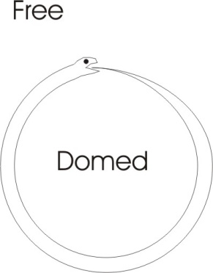
And Good is what satisfies your gullet.
So we have to consider very carefully the meaning of these words. Good is what satisfies your primary appetite. Better is when you have the law established in you. And Best is when you can actually crucify yourself, you, yourself are the cause of your own form ... you are a self-stimulating being. That’s best. In order to be that, you must go from being a good being to being a better being, and then you must leap out of the Torah, into the unconditioned. Because only the unconditioned is free. This is free, and that is dome. So when we understand these properly, we will prefer the best. And the better and the good will continue to exist inside us for a period of time.
But the Torah is a time function. If we identify with the best, we transcend time, so that when the time body, the better, has fulfilled its purpose, then we will still be the best ... still be free. But if we identify with the good — that’s the hedonist identification, we pursue the gulletal appetite — then on the interference with the appetite we’ll become profoundly unhappy. And if we identify with the better, with the law, then when our ideas are seen to be limited and circumscribed, we will become disappointed in them. And we will have to jump out of the idea into the free, which is the best. Now we’ll have to assimilate the meaning of these three in relation to the words evil and live.
That is Absolutely alive which is free. And the first bond, or boundary, is already the first demarcation of death, because death means separation, the differentiation and disintegration. So the undying is the free, but the dome is subject to death. So if we identify with the free, with the domeless, with the unconditioned, we are getting the best and we are most alive. It is the spirit, as Christ says, which quickeneth. The flesh profits nothing. It is only this consciousness which is learning these lessons. And they should lessen, they should get less every day as Lewis Carroll [... found ?], as we learn them. Until finally we have nothing left to learn, because we have discovered what it is to be free, namely self-determined, Absolutely.

~~~ end ~~~

Oh, what a tangled web we weave, When first we practice to deceive! [Sir Walter Scott]
John 7:8-10 Go ye up unto this feast: I go not up yet unto this feast; for my time is not yet full come. When he had said these words unto them, he abode still in Galilee. But when his brethren were gone up, then went he also up unto the feast, not openly, but as it were in secret.
John 6:63 It is the spirit that quickeneth; the flesh profiteth nothing: the words that I speak unto you, they are spirit, and they are life.

