Classical Romantic
Transcribed by J. Bailey (2005)
With diagrams and arbitrary headings by J. Bailey
Editor’s comments are in square brackets [ ].

Romans
We’ll start with the classical romantic, I think — and work round euphemistically later.
Now, the first thing is to define the word classic and the word romantic. And the first thing to observe is that the word romance is really derived from the word Roman ... and Roman itself to the Romans meant one thing, and to non-Romans meant another thing. Now actually, the word Roman means ruling man, the man that assays to rule an empire.
So if we were to… I think I’ll start up here and work down the left shall we? [an aside, referring the white paper which he draws on to illustrate his talks] The letter R itself is the letter for kings, for rulers, because it means to differentiate. And if we don’t differentiate we cannot see formal differences. If we don’t see the difference between one thing and another, we can’t begin to put them into classes ... and if we don’t classify things, we can’t control them.
So the first thing that the Romans are doing, as ruling men, is to be classic ... that is to say, they are going to classify the world. And they proceeded to do so in fact, by sending out parties looking for other civilisations, determining to invade them, and eventually to make them pay taxes. To which end, they made roads and other essentials of intercommunication of peoples.
One of the rabbis said on one occasion, The Romans are a marvellous people. They have made roads, and market places, and baths.
And another other rabbi said, Yes, the roads are for them to come along. The markets are for putting the prostitutes in; the baths are for their coming clean after the fact; and the whole thing is designed for their own ends.

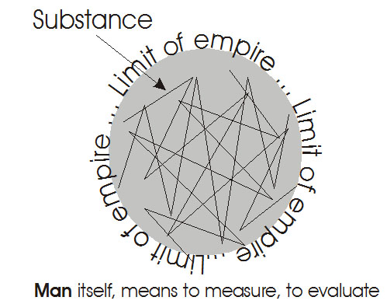
Roman Empire
So if we look at R as the symbol of differentiation — we try to pronounce the letter R like a good Scotsman might — you see that it causes the tongue to vibrate. And when the tongue vibrates it is giving you the feeling of differentiation. In fact, if you vibrate on a sufficiently sensitive plane, with a fine powder on it, it will actually differentiate that powder. And the form that the powder is shaken into is determined by the pitch of the note that you utter.
So we let R equal differentiation power, and we’ll use the O as circumscription. So if we wish to do, we can draw a circle ... we’ve got a little wandering Jewish board tonight [another aside]. Inside it we’re going to differentiate. I’ve put the lines wiggly inside the circle, to remind you of the vibrations of the letter R. This circle represents the limit of empire. The M in empire represents the substance that the imperialist is concerned with. The differentiations are differentiations of cultures which any would-be ruling people must study before they can take full advantage of the subject people.
Man itself means to measure, to evaluate. So the Ro-man means a man or an evaluating being, who is determined to differentiate the possibilities of a circumscribed zone. You notice that the word empire, if you look it up in a dictionary, is related to the word piracy. And piracy is pi-ratio again.
There’s our centre and we just go round the circle with pi, in the earth now-and-now, instead of by-and-by. The limit to which our authority goes is called the limit of empire, and it is initially built by piracy ... that is, by men running out and raiding the perimeter of their own zone, and then subjecting peoples all here [in the substance] to law.

Payment of Taxes
You remember we said that the word Italia — Italy, is made out of a reversal, Ital of Lati, the Latins. Now Lati actually means the flat of the sword. And you’ll find in the bible and in other references, that some people were put to the flat of the sword and some to the edge of the sword. But the big ruling men, the Latins, or flat-of-the-sword men, didn’t like putting people to the edge of the sword because you could only do it once, and they wouldn’t pay taxes afterwards. Whereas, if you put them to the flat, it makes a lot of noise and frightens them considerably ... and still leaves them intact to pay the taxes.
So we see that the Roman is determined to rule, and in order to rule he must go out, he must differentiate. And he must then proceed to order people to pay taxes. And to this end he must not interfere too much with the tribal systems of the people he conquers, because the unity principle of a tribe, if broken, would also dissolve the instrument whereby he could tax them. So the essence of good imperialism is that, when you go out from your centre and raid another country, you should get hold of the rulers of that country, keep them in power, so that you then have a particular person whom you can make responsible for the payment of the taxes.
So in fact, we find that the Romans were not particularly bothered about the ideology of any of the peoples that they conquered. They were only concerned with taxation. Therefore they had no real philosophy of their own, or religion of their own. Everything was borrowed by them later: philosophy from the Greeks, and religion from various sources; Egyptian and Central Eastern.
So the word romance came to mean fictive. We find the word Roman is the continental word, meaning a novel or fiction. And the reason was, as the Roman was only interested in the material results of his survey of the territory he didn’t really care what he believed or what he said, as long as he had this comeback of material taxes. And so gradually it became apparent to other people that the Romans would say and do anything whatever ... to keep the taxes flowing in. So that if a Roman defined something, they would then say, Oh, that is a romantic statement, meaning, it isn’t true — it’s just something said for taxation purposes ... in other words it’s what today we will call romantic.
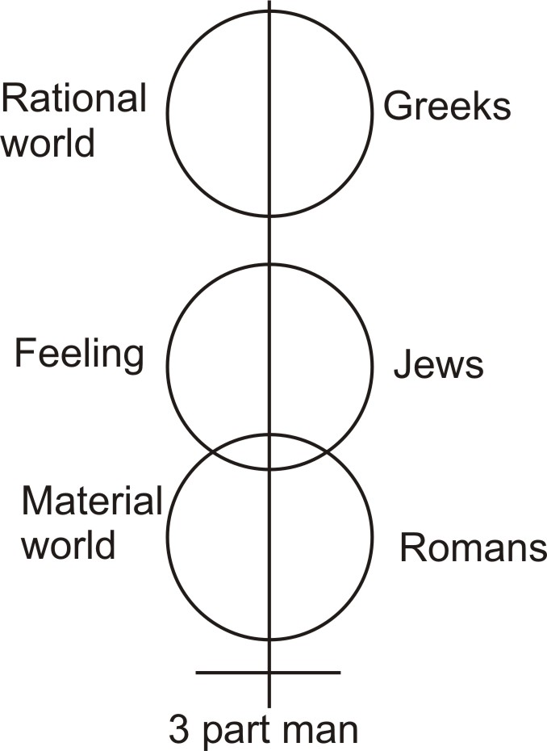
Now, if we don’t see the differences between different nations — that is, if we don’t classify nations in different ways — we cannot really set up and support the governments inside that are going to pay taxes. And this method of seeing the differences, and segregating the type of activity of different peoples, is what we call classification. [08:22]
So the classic mode is really the mode of pure classes.
The romantic mode is the mode of fiction.
And yet the two are so interrelated that one passes insensibly into the other.
So if we look at the classic Greek as an example, we find that their temples are purely geometrical in structure. They are classic. They stand as types of structure. And yet we find that this classic structure has come out of a highly emotional people. Their emotionalism needed this antithesis of cold, classic, geometrical proportion, to serve as the stable base for their other side of nature, the emotional side ... whereas with a rigidly logical people, with only one thing in their heads, namely the material outcome of the situation; they really needed the romantic mode of expression. That is, they would like, because of their internal hardness, to have its antithesis, namely romantic expressions ... non-classic statements. So we can find these are like two parts of a human being.
So again, we’ll put the human being, and we’re going to do a funny thing here.
We’ll put the Romans down here, and we’ll put the Jews in the middle where they belong. We’ll put the Greeks in the head, and this is a good working division of the relation of the three.
The Romans are concerned with the material world,
the Greeks are concerned with the rational world,
and the Jews are concerned with all that goes on in feeling. And it is their job to relate these two facts which are really opposites. And one of them, this one [belly], is the objectification of the formal content of this one [head].

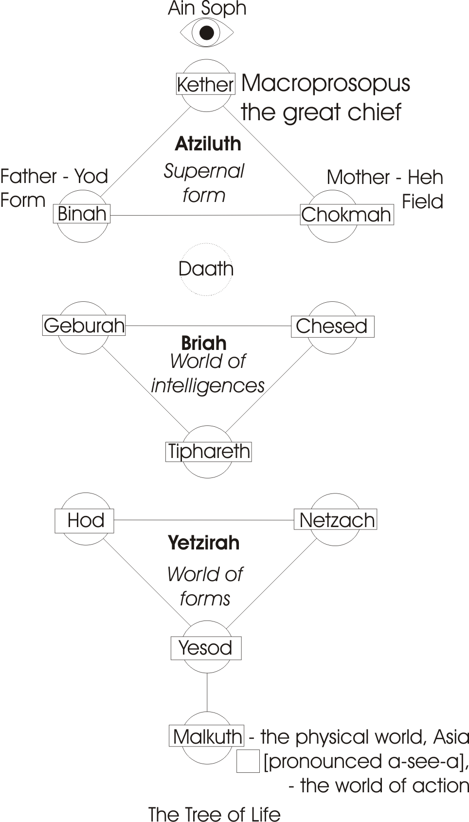
Qabalistic Analysis
We’ll now take a Jewish analysis, Qabalistic ... separated it out, so that it doesn’t wander. At the top here — I’ll write the English for it — is the Ain Soph. It’s coming down and moving there [paper rustling].
Now this word Ain is Hebrew, equivalent to nothing, and it’s also equivalent to the eye. In fact the Saxon plural ain for eyes is really the same significance. The observer is never observed, so consciousness itself never becomes a form, and therefore consciousness is as a nothing. It is not a thing. So this Ain signifies the limitlessness of consciousness itself, and the Soph is the same as the Sophia wisdom. So Ain Soph means the limitless wisdom of the supreme not thing, which contains all conceivable form. So that is entirely beyond differentiation. It is simply a top-level concept, relating together two totally different concepts ... the concept of nothing, Ain, and the concept of all forms whatever, the Soph. So the Ain Soph signifies the dialectical opposition of all beings, lifted to its highest intellectual level.
Now, in order to consider being at all, we have to start below that, and we start with the thing called the crown Kether in the Qabalah. This is the crown above which there is no thing, but the Absolute Wisdom is hidden in that no thing. And it appears in this crown, and this crown is called — we’ve had it before — Big Head, White Head, Macroprosopus ... the Great Chief. And he polarises himself as father, and as mother of the universe. And that completes the top triad.
Now, we have the Yod over there, and the Heh there, of Jehovah. This is the form, this is the field, that is the father principle, positing energy, this is the mother principle, receptive energy. And this contains all that there is, which may later manifest below — and all that is hidden in there [Ain Soph], is here [in the supernal triangle] expressed and polarised for consideration. Remember, we’re not actually doing anything at all with the Ain Soph. What we are doing something with at the moment, is our own minds. We are arranging, classifying concepts, in order to be able to show just precisely what it means to be romantic — because if our concepts correspond with reality, we shall call them classic concepts. And if they correspond with nothing whatever — they’re entirely fictive — we can call them romantic concepts.
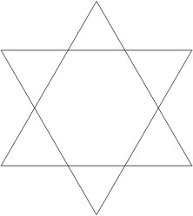
Now, we said before that the heaven world, that’s that world [supernal], reflects itself in matter in an upside down sense. You remember when we did the shield and the six-pointed star, the two triangles interlaced, we did separate them out, and say that one of them was the reflection of the other, upside down. So in here we now have another triad, and this has a special name [see the diagram]. [14:50]
This one is called Atziluth, the region of supernal forms.
This one is called Briah, the world of intelligences.
And then there’s another one, it’s still this way up, which called the world Yetzirah.
So this is the container of intelligences and forms in unity, this is the world of intelligences, this is the world of forms, and then down here — we’ll represent it with a square — is the world, as we know it. Now this diagram — it looks like a Christmas tree with baubles on it — is called in Qabalah the Sephirotic tree, the tree of the Sephiroth. Now Sephiroths plural, or Sephira, which is the same word as the English word sphere, se phi ra sephera, you can see, remove the vowels and you’ve got Ess Phe Ra, s-phe-re. So Sephiroths is referring to these wheels, which are the baubles on this tree, which is the tree of life that stands in the middle of Eden as the super concept to which we refer. [16:10]
Now you remember that in yoga we had an Absolute, and then we had a polarisation as Puruşa Prakriti, as Observer and Observed. It is corresponding with this father/mother relationship in some degree, where Prakriti, the substantial principle is the mother, and this would then be the observer. And yet we remember that we are observing the diagram, so really we’re out of it. But we’re positing ourselves in there as initiative energy, and this is receptive substance. And these three then reflect themselves down here in the world of intelligences, of forms, and finally Malkuth the material world ... which is called Asia [pronounced A-see-ah], the world of action. But action there means specifically, separated action, because all this is fundamentally power, and power is continuously on the move. So there’s nothing static in power, but the K in action, the sound of K which we represent with a C in English, signifies this separation out.
But actually we move in impulses. If we make a smooth gesture with the arm, and then photograph it, and then show it in slow motion on a screen, you will actually see that there are little impulses in the movement, and this is the meaning of this K ... it’s an impulsive world. Our actions are separable, and observable in separation at the gross material level.
So, this world down here is like the gross material centre of a series of magnetic fields ... magnetic only by analogy, the magnetic field itself would correspond roughly with this formative one. And beyond that there is another one, the sphere of intelligence, and beyond that this celestial sphere.
Now, in yoga parlance we said we had a gross body, a subtle body and a causal body.
- There is the gross body [Malkuth]
- here’s the subtle, which we said was full of form, ideas [Yezirah]
- here is the causal one, the intelligences which initiate [Briah]
- and this is the divine one [Atziluth].
So everything above that line is really not individual at all, but everything below that line can be considered as individual. And we then see the meaning of the hermetic statement, as above, so below. There is nothing below, except a reflection of the possibilities of the Ain Soph, of the inimitable wisdom, polarising itself, and then the intelligent aspect of those things mobilising themselves, forming themselves, and finally by absorption of gross matter, objectifying themselves at the gross material level.
Now when we’ve made that tree, we’ve really classified the universe in a convenient way. If the classification corresponds with reality, then it is opposite to the concept of romanticism, where it does not correspond. Now we find in fact in history a continuous interplay between this romantic principle, in the sense of fiction ... and the classic, in the sense of eternal form. [19:49]

Logos and Ratio
Now the essential thing about the classic for a European mind to consider, is that it corresponds roughly with the Platonic sphere of ideas. When we talk about classic thought, or classic education, we’re talking about, really, a heritage of the Greeks as thinkers, rational. And if you remember the top concept of the Greeks was the concept of the logos, the logos has the log in it — and it was that original log which was a tree rolling along, which gave birth to
- the wheel,
- the lever,
- friction,
- fire,
- and reason.
So out of the one concept, there came the ratio of all things.
Now we can show, even scientifically, that the concept of the logos is valid for experimental purposes as a control idea, that everything which exists in the world, is actually circumscribed, as a finite. And that therefore, there is a ratio of its parts to its wholeness and this we would call its internal logic value, or the inherent logic of it. So that all that we can reduce fundamentally to geometrical structures which are inherent in the universe, we call classic. And in opposition, we will call romantic all those distortions of such proportions which frees the feeling side of the nature, or the part of the nature that doesn’t want to be bothered with universal reason. [21:34]

Stoics
To see the difference, we can examine the Stoics as philosophers. The Stoics believed that the universe was logical, and they believed that a logical man must behave properly. And therefore, they themselves tried to conform with the logical principle of the universe, and they became tremendously strong as individuals. In fact, at the time of the appearance of Christianity, we find the Romans have been over to Greece and overthrown it, they’ve been out into Egypt, into the middle-east, and we find stoic Greek philosophers serving as tutors in Roman families.
Now stoicism could never have become a popular religion because it required a hardness in its practitioner. The man must be logical, and he must deliberately make his life conform to the inherent logic of the universe. So it quite obviously was a religion only for individuals with great strength. So that it was never a serious threat to Christianity, which does not require anything whatever from an individual ... other than faith.
We find, in fact, that when the Romans want an integrating religion for a disintegrating civilisation, they cannot do better than find a religion that imposes nothing in the way of effort or study requirement on the participant in it, but a simple act of faith. Only believe and it shall be. So it was a very convenient religion — this doesn’t invalidate its fundamental truth — it was a very convenient religion for a ruling people. Whereas the ideal of the stoics would have been quite incapable of unifying large numbers of people.
So the individual stoics became very, very hard. And they made their lives very, very rational. So that, in a sense, a real Stoic was like a piece of logic on earth — he believed in a kind of logical determinism. And the whole of his life, he forced into a logical pattern. And that kind of man — we could call him a classic man if we wanted to — he contains in himself embodied geometry. Something like the concept in Roman Catholicism in convents, of a nun called a living roux, who has so been conditioned in her reflexes that she constitutes merely a machine which reacts to stimuli in a preordained pattern ... in this case imposed from above by authorities terrestrial, and in the case of the stoics, imposed on the stoics by their concept of logic.
So in opposition to them were other people who said, Well, even though logic is what it is, nevertheless it is only a human product. Now this isn’t true, it isn’t only a human product. It pre-exists humanity. The circle, the sphere, pre-exists all that we call ‘organic beings today on earth.’ Nevertheless there were men who said, Really, man is the centre, man is the measure of all things. And therefore, really, he can make his own rules, because it is for man to decide whether something is or is not logical. The man who said that got into trouble in ways quite other than the way the stoics did. But in fact, we find a continuous conflict going on, between:
- The men who believe the universe is essentially reasonable, and who try to conform with that reason
- And the other men, the wilful men down here, who believe that that reason is a construct of a wilful being.
Now we know that if we push any idea whatever to its conclusion, it will turn into its opposite. So we know that if we take the Greek idea of the pure Logos, we will find that that Logos has — as in the case of this Qabalistic diagram here — produced a world of supernal form, of celestial form, pre-existing the world as we know it, and has imposed itself by the Absolute Will, through ideas, into matter.
So we place at the top — above the form of the Greeks, above that Logos — we will place the Absolute Will ... which is the same Will that the Romans pretend to embody in their divine emperors. So we see now, if we put down here Will as a principle, and Reason as a principle, we see that the opposition between the two is unbridgeable, in the sense that we cannot rub one of them out. [26:43]
There is reason in the universe, and there is also Will in the universe. And between the two are jammed the Jews in the body. And they are an emotional, feeling people, who’ve been jammed between reason and wilfulness, have tried to resolve the problems of that relationship. And we find that the people called the Jews have, in fact, been pushed by these two other forces, and made to leave their own centre and wander about getting two kinds of experience.
If we look at the history of the Jews in the Old Testament, we find them pushed from one country to another. And from being a simple little tribe with a tribal divinity, they were forced by their experiences and by their captivities to absorb ideas from other nations ... and these ideas being of two kinds, rational ideas, and ideas of power, of Will. And they gradually assimilate the concept of the Will in their relations with these ruling people, and the concept of reason with the others, and they fuse it together in feeling. And then they do not express it in the way either of those two terms can. [28:09]

Classic / Romantic Migration
So in a man we will say the reason in his head is Greek. And we know what happened to the Greeks: they were defeated by the Romans. So we can say that the Greeks inside you must also be defeated by the Romans. Well, we know that in the heart here is the centre of the blood system, and that this is circulating through the body, and going into the Roman lands, and then carving into the Greek lands, and continuously carrying with it certain chemicals which influence every part of the body.
So that if we examine the chemistry of the body in the Roman land, and the chemistry of the body in the Greek land, it isn’t the same chemistry. In other words, this blood inside a human individual is playing a similar role to the role of the Jews as a people in the human race. Just as the Jews wandered about and came into contact with other people, so the blood wanders about in the body and certain organs’ internal secretions change the quality of it, so that when it travels back to where it was, it is no longer the same thing that it was when it left, and it is modifying it. In the same way, the Jews collected ideas from all over the world, and were dispersed in order to collect them, and then they gathered them together again. And in their gathering together of those ideas, they then had to take the end result of their wanderings, and present it back to the world as a world view ... in the same way that the blood is the equilibrating factor in the body, by collecting these chemicals and then distributing them throughout the body. [29:55]
Those chemical messengers, those hormones and so on, are entirely Yiddish in this sense. In fact we can say that the wandering Jew, is that wandering blood stream. And we know that the nervous system itself is largely Greek ... that is to say, it is concerned with imposing form onto the whole being. And we know that the blood is the medium of the feeling life, which is Jewish, and we know that the impulses of aggression, material, come from down below in the Roman land. So we have a good, balanced analogy between the parts of the human body, and those three types of people. No matter where we go, we will always find a tendency to be stressed in a given nation, either here, here or here. And if we were to write down all the names of the peoples in the Old Testament, and then trace them through as far as we can into modern times, we will find that the people derived from their progenitors in the bible are still manifesting the same characteristic that they did then.
For instance we know that after the fall of Troy, there was a migration of those peoples. Those peoples moved away from Troy, and they appear in Italy later, in southern Italy. And we find some of them appearing in Europe. And we find that Paris — who was a fellow who ran away with Helen if you remember — is also the name of the capitol city of the people in Europe, namely the French, who pretend to be reasonable. In other words, these French people today are the manifestation, the objectification, of the Greek spirit of reason. And we find that each biological type is carrying inside itself the chemistry of its own world view, and that by inter-marriages, these different world views are mingled, and eventually produce some kind of being with a capacity for understanding many nations.
So we have this simple opposition between the purely rational, corresponding with geometrical principles which are quite rigid. A triangle has three sides ... that is a logical statement. It has three angles inside ... three the other side if we want. It encloses a zone. The logic of that is one thing. But if we wish to be romantic about it, we can talk about something which is not really a triangle, and call it a triangle. So if we like to say this triangle will now be applied in this situation — that’s Tom, that’s Dick and that’s Harry, although really this is Tom, that’s Dick and that’s Harry. Tom, Dick and Harry — we could call them, if we wished, the three points of the triangle. We could call them if we wish — they’re peculiar fellows — an example of the eternal triangle in a love affair.
Now as we are moving away from the purely geometrical significance, we are moving away from its classic value, its classification value, and it’s becoming vaguer in its application. And as it becomes less and less rigidly logical, it reaches a point at which we decide to call it romantic ... that is, it’s becoming fictive, that is, that the application is becoming more and more tenuous, more and more difficult to apply. [33:37]
So I think that will do for the rough outline of the opposition between the classic and the romantic. If we simply equate the romantic with the fictive, roman is still German and French for this fictive concept. The word for a novel in Germany is roman, and even in Italian, romanza has exactly the same value, but it implies fictiveness ... non-rigid, non-logical geometrical structure.
So when we come to consider this diagram here, we can consider it from one point of view as a purely classic diagram, when we see its underlying geometry. There is a triad here, there is its reflection below, there is a movement of that thing to further objectification, and then finally the concreting of it on the gross earth. And that is entirely a classic diagram.
Here is all that is in the celestial or supernal world, here is its first inversion in matter, appearing as embodied intelligences, the world of Briah — B. R. I. A. H.
And then those embodied intelligences, proceed to formulate themselves in the world called Yetzirah. It is those intelligences who formulate themselves internally in the same way that an intelligent egg puts the divisions, the walls, inside itself before it develops into an embryo. And it is that same form which then, by absorbing gross matter, turns itself into a grossly objectified being. So that is a purely classic concept.
Now, if we were to get a manuscript of a couple of hundred years ago with this tree drawn in it, we would find it not expressed in general in its purely classic form, but we will find a drawing of a man in here with lots of whiskers, and the statement that his name is Mr. Whitehead. It actually says his name, Mr. Whitehead in here, you see. And on this side there’s a drawing of another man in the costume of the period, and written on top is father. And in here there’s a drawing of a lady of the period, with the appropriate neckline, and she’s called mother.
This is Abba, this is Aima ... that’s father, that’s mother.
And in each one of these we find a particular concept, with a pretty picture on it, and we find connecting lines running down, across all of these things ... and they run into each other. And then on top of it here, we find a figure of a man, with his arms holding those two, his body coming down here, standing on this, and we find right in the bottom is a picture of another girl, who is called the Heh in exile, the final Heh of the name Jehovah, and it symbolises the spirit which has now got itself embodied at the gross material level. And all the humanising of this diagram is romantic, because it really diverts us from the fundamental true geometry upon which it is based. So that if you were to see that diagram as it stands, you wouldn’t tend to be diverted into a consideration of merely human relations by it. But if you saw this one, with pretty pictures drawn into each circle, you could easily be misled into thinking that it had something to do with human beings as such.
But it has not. [37:42]
The diagram has to do with universal form, in its totality and prime unity, and then the selection — I shall draw that supernal triangle in the middle like this, and say — Imagine that inside there, there are waves reflecting from each side. Then we will find that inside there, there are triangles. And each one of those small triangles is now down here, a separate entity called an intelligence. In the same way if we were to draw a circle, and let it vibrate from its centre, it would be covered in ripples very quickly. And as we’ve actually seen in our bowl of water experiments, in certain periodicities it will break up into little wheels, or into little six pointed figures of impulsations. That it has six impulses to each wheel is the original of the word existence — ex-istere, out of six. So if we take one of those little triangles and draw it inside here, we can call it one of the intelligences considered in separation, which in the supernal, celestial triangle, is considered simultaneously with the others. So in this one all triangles are considered in their essential unity, and in this one they are considered as separate intelligences [world of intelligences triangle]. In this one they are considered as separate formative beings, where the intelligences are beginning to form themselves inside [world of forms triangle], and in this one, they have absorbed matter, and are now what we know them to be ... gross material beings [Malkuth]. And this is true, whether they are animal or vegetable or human. [39:42]

Absorption of Matter - The Fall of Adam
Now this gross material world is the world that we don’t really have an essential relation with, ultimately. We know that we have the power to take material food and to pack it into a little egg, and develop that egg into an embryo, and that into a human being. And we know, we’ve done this entirely by pushing matter into it from outside, which does not essentially belong to it — which means that the gross material that we eat is not really our own essence. And therefore, we are in relation, in fact, on earth, with a principle, the material principle, that’s really nothing to do with us.
Now, the fall of Adam refers to the point where this formative triangle, where Adam’s made, was brought into contact with the gross material world, and the gross material world stimulated this triad, so that it then began to absorb matter. Now prior to The Fall, Adam was not a gross material being. Adam was really a being in the world of forms, in the subtle world. He was a being similar to the beings you experience in the dream world, similar to the beings that spiritualist mediums contact. He lived in this world, and because of the stimulus value of the material world, he began to absorb it, and it is this material world that is called, in the Genesis story, the serpent, which beguiled Eve. [41:25]
Now if we remember that Eve is the substantial aspect, that’s the mother principle, there’s Adam, that’s Adam Supernal the Divine Adam, Adam Kadmon. This is the substantial aspect. We know that it is through the substantial side of ourselves that we are subject to stimuli, that there is a linkage between our mental life, and the quality of the stimulus that comes to us, and therefore we know that it will be through the substantial side of our nature that we are subjected to the temptation ... and through which we fall: whereas the other side of our nature, which has to do with our reason, is not so easily stimulated in the absence of a material body.
So the first thing that happens is the stimulation of the substantial, lower part of this triangle, which represents the material, the matrix aspect of our total being. Therefore the serpent nature, the gross material stimulus, stimulated Eve first, and then spreading through the substance, came up here into the world of formations and reasons, to the point where the intelligence — where this triad touches this one — the intelligence itself became interested in the quality of the stimulus, and then began to Will down to see what is going on. Now it is this Will into material experience that is the cause of what we call The Fall. Because once it has gone into there, its understanding which in this world is the pure reflection of the celestial, is now tainted with the vibrations that come from below. So instead of him seeing the pure geometry, which is reflected in this top level individual being from this celestial, he now has become a romantic ... that is to say, his fundamental geometry has become distorted by the quality of the vibrations from below. [43:40]
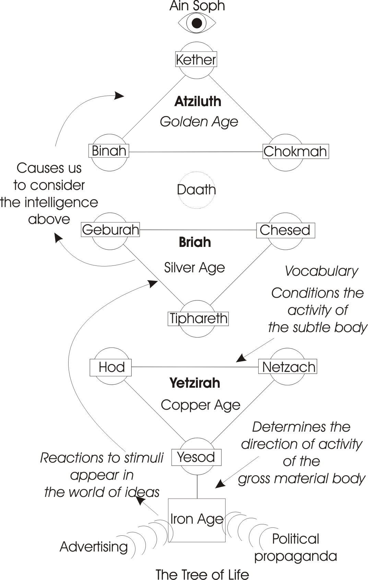
We know, as a matter of fact, that if a man is being quite reasonable, and we assail him with various perfumes, and different things to eat and drink and so on, the actual stimuli from these substances can so change the quality of his thought processes, that his reason is covered over with a kind of movement, a vibration in his body. So that he is turned from a classic, reflecting being, to a romantic, earth directed being.
So, in general, we had this statement romance = fiction, that the classic refers to fundamental geometry, that it works all through history in a battle between the two, because man is actually between the two worlds.
- We had the world of absolute form, in its unanalysed unity.
- We had the world individuated here for each being, but still reflecting that celestial reason,
- And we had the gross material world below, stimulating this lower triad of the forms which appear in the subtle world as ideas.
And if we look at the four ages, in all the myths and archaic references, we can see:
- The golden age,
- The silver age,
- The copper age and
- The iron age.
And we are in the age now where material stimuli hitting upon us condition our thought processes. You know that when you try to think, you think with ideas, and with words tied to ideas. So that your vocabulary and the things they represent actually condition the mode of activity of your subtle body, that is your idea body, and that’s flowing into the gross material body, and determining the direction of activity of the physical body.
So there is the problem left for us. This evening we try to climb up to consider this celestial one, and we have a gross body which is useful to us, because by means of it we can demonstrate what we are talking about.
This is a gross material piece of black chalk. By means of it I’ve made a gross material diagram on gross material paper, but the significance we’re imparting to that gross material, is not gross material. The first level, above the gross matter of the chalk, is the form. I put down there the letter ‘S’ to symbolise the stimulus nature — ‘S’ for stimulus. And that stimulus causes reactions from below, from the gross material world, to appear in this world of ideas of the individual. So that man’s ideas are being conditioned by external stimuli. We know it — and at the same time we don’t know it.
- We know it, because advertising goes on, and political propaganda goes on.
- But we don’t know it because we don’t really realise that this is going on to the point of defending ourselves against it.
Now, this form down here, participates in some way with the nature of the gross material world, and mediates between the intelligence world and the gross matter. And therefore, it is through this form that we can begin to order the reactions that occur inside the mind as idea-bearer; because even romanticism, if ordered, will give birth to classicism. If we get an untruth, and show in what way it is untrue, it becomes a means of truth. So that if we find a perfectly nonsensical statement, and we feel the clang when it is presented to us, that it clangs in us somewhere as false, means that we have truth inside ourselves to serve as a standard. So it doesn’t matter how romantic somebody becomes, the more romantic they become, the more they will refute themselves, and when the refutation is complete, we then are able to discard the fantasy, and to say, What is the principle, which belongs in this world, which gave birth to all the fantasy?
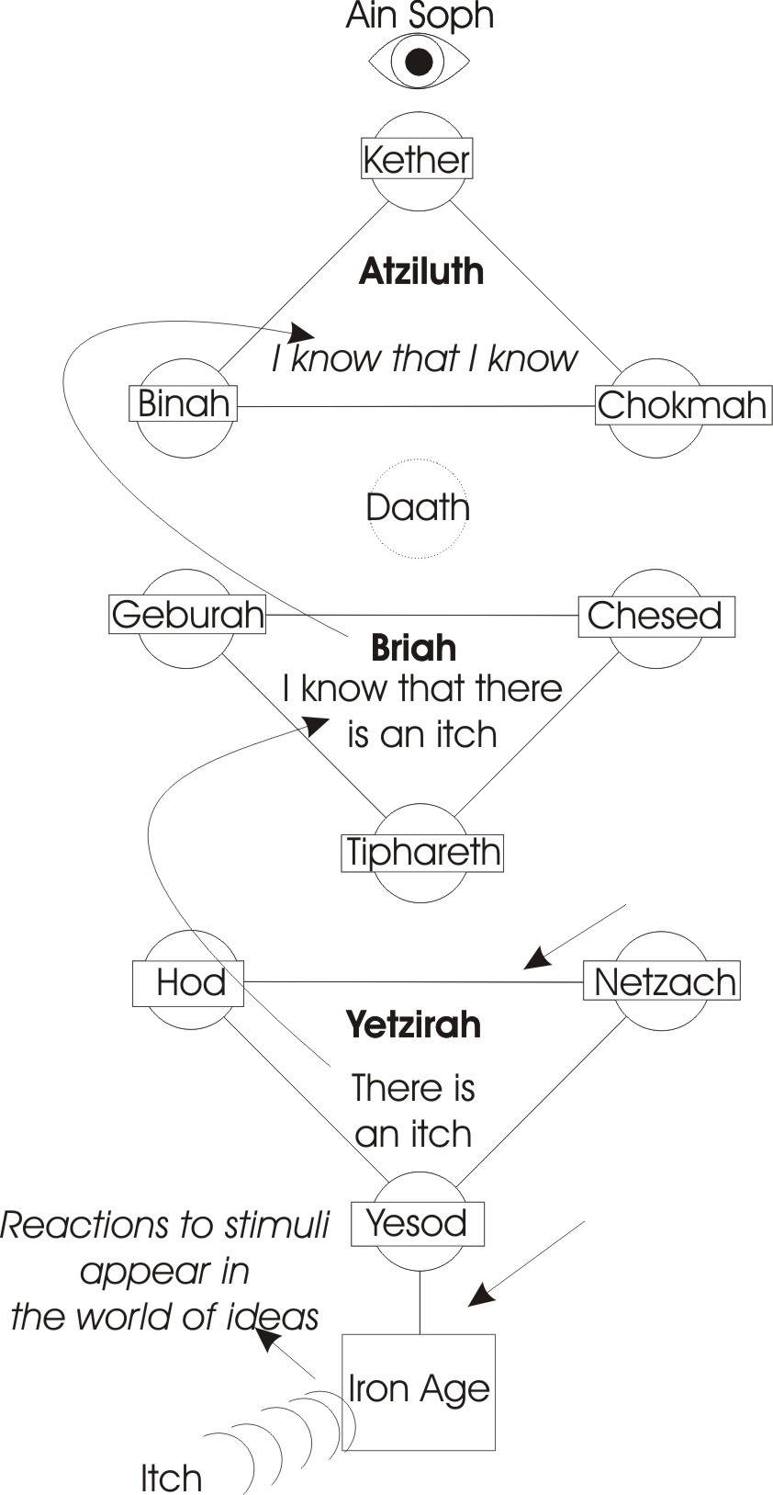
If we remember the test line, qui bono — to whom the good — if somebody comes with a romantic statement, we say to ourselves, who is going to get the benefit of this statement. And we then proceed to analyse the statement in terms of who gets the benefit. And then we can sort out what is romantic in it, and what is classic. The classic is the eternal geometrical form, the romantic is this private, terrestrial influence and purpose. [49:05]

Reflexive Self-consciousness
So it is in this world, in the world of ideas, that it is possible for us to turn ourselves away from the gross material body, and to consider the intelligence above. It is this process that we call Reflexive Self-consciousness.
A stimulus comes to you in the physical body. It may be just an itch on the back of your hand. It’s good enough. You then say to yourself, I know that there is an itch on the back of my hand, and then, I know that I know. When you say, I know that I know, you are going like this: here’s your intelligence,
There is an itch, on the back of my hand, you’ve defined itch in this world.
And then, I know there is an itch.
And then, I know that I know there is an itch.
So you’ve actually carried back your intelligence to itself. And it is this ability to bring consciousness back to itself that we call reflexion with an X not with a C.T. Remember the difference. Reflect, and reflex.
  - Reflect is when a light hits a surface like a mirror and bounces off,
  - And reflex is when it bends back on itself.
So it isn’t reflecting we want, because that is superficial. It is reflexion, a bending back of the Consciousness upon itself. If we can just, even for a little minute, turn 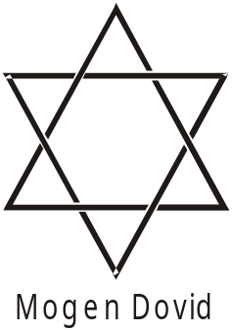consciousness onto itself, so that it becomes its own object as a finite, then we have released ourselves from the tyranny of ideas, and from the stimulus of the gross material world. It is then only one jump to turn round and look into that Absolute Mirror. That is the great wisdom mirror, which contains all the forms, and all the inventions, and the props of all the best plays that are going to be written in the future. So if you can actually turn round onto it, you’re bound to get a good idea. But you can’t turn and look at that until you first turn away from that, reduce the stimulus to an idea, and then turn the idea back onto consciousness, and then state to yourself, know that I know. Then in that state I know that I know, you remember the fundamental absolute geometry of all beings, and hold it. And at that moment the whole body and soul and spirit becomes unified. And it is in such a state that it is said, one can see in the supernal mirror. It is this that is signified by the Cosmic Mary, the assumed Mary, of Catholicism, which is the mirror of forms, in which this abyssal being, the Ain Soph, reflects itself to show the Absolute Potentialities of All Being whatever.
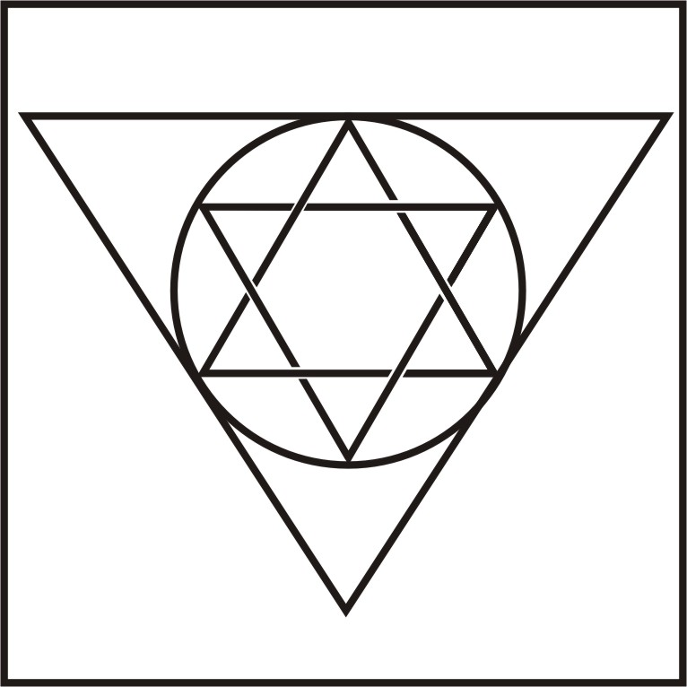
So that diagram is simply an extension of the two interlaced triangles of the Mogen Dovid, of this David’s Shield. And we can remind ourselves, when we look at those two interlaced triangles, of this one. We can, if we like, draw a circle round that, and we have two triangles and another one here round it with a circle to bind them together, and we can put a square round that, and that square now symbolises the gross material body. So if we then write that upon a card, and look at it and then ask ourselves while we are looking at it, How much of consciousness is at the moment being determined by my gross material condition?

Pain and Pleasure
Supposing I was sitting on a pin. There is pain in the physical body. But actually the concept of the merely material is not a concept which you can apply the term perceiver of pain. Pain is a subjective statement. Pain doesn’t belong in matter at all. It belongs in sentiency, in the field. And this is why such things as anaesthesia can occur in mental disorders: that no matter how much you may stimulate the gross material body, nevertheless the owner of that body may say, I can’t feel anything.
You say, Well, you’re not well, you’re mentally disordered, because you should feel something because everybody does when we do this. And statistics say you aught to feel it.
But if he’s withdrawn from the gross material body, you could burn it, you could cut it up, and he wouldn’t feel anything about it — simply because he would not be identified with it.
So, as we saw before, the fact that we insert this matter into us by eating, shows that it does not essentially belong to us, and therefore we shan’t be surprised to see that the physical body as matter is not the thing that feels the pain ... it is simply the thing that serves as the point of reaction to a stimulus, which if we identify with, then we shall define it as painful. [54:39]
And pain means a point of negation. Remember that ‘ain’ there, symbolises negation, nothingness. Pain itself means point of negation, that point in which we say, No, I don’t want it. So the same situation exactly can be pleasurable to one person and painful to another, because people are so constituted that some things are very delightful to them which would be very painful to other people. And that man would define the situation as pain only if he was refusing it from the centre of his being. And the same situation exactly he would not define as pain, if he were accepting it ... because pain means to refuse.
So we’ll find in the case of masochistic and sadistic people, that they are actually enjoying things which other people call painful. So that somebody would say, He is a sadist, he’s experiencing pleasure out of pain. But really it isn’t pain to him, it’s pleasure. His sensorium is reacting in a certain way, and by his mode of looking at it he’s deriving pleasure. Thus he can actually derived pleasure, even from inflicting on his own body stimuli that in another state of consciousness he would not inflict. And therefore he doesn’t define them as painful to him, though it looks like it to other people.

The Body of Light
So our tree of life, this is the tree standing in the centre of the Garden of Eden, and remember we said, Eden is the same thing as no judgement, beyond judgement, and we are going to put that tree inside it. So we’re drawing a line to symbolise the wall of Eden, and then we’re going to put the tree inside it. Now, there’s the tree, and it’s said that when Adam had eaten of this fruit in response to the stimulus from below, he then knew he was naked. You see, prior to that time, he was living in this world [Yetzirah], and his body was actually so suffused with light, that you couldn’t see it in the sense that you could see this gross material body. His centres of power, his genitalia, were just centres of light. This has something to do with mysterious use of the euphemistic proud. All centres of generation in the body are actually broadcasting energies which, to a camera sensitive to those vibrations, would be registered as light. So that all the centres of generation in the pre-fall Adam were simply zones from which energy flew out as masses of light, and nothing could be seen because he was clothed in light. You find this reference to ‘clothed with the sun’ in the Revelation, and so on. Clothed with light, because the energies were not blocked by the opaque matter, but were actually coming out of the body.
I’ve actually seen myself men in certain conditions of excitement, where the energies from inside have been conjured out by magical ritual, and then their bodies have glowed until you couldn’t see the forms of the physical body, so that the energy coming out is coming out too strongly for you to be able to focus on the gross matter in the middle of it.
So at that level Adam, prior to the Fall, was clothed in light. But when he ate of that gross material world, the light died down in him, that is, he’d actually lowered his frequency. He then had a gross material body that was opaque, and he could see all the poor fallen degenerated centres that had previously been given giving out energy, now shrunk down to material things, and looking rather horrid ... certainly not classic in form. But he then became ashamed of himself, and hid himself, and God is represented in that myth as coming and saying to him, What have you done? And he blames the woman. And the woman blames the serpent, the stimulus situation. The situation of the serpent, the stimulus situation, is then cursed, and from that moment, he is thrown out, Adam is thrown out of the Garden of Eden, out of the land of non-judgement. And the tree of life which is in the midst of it, which could release him from all this condition, is closed to him until the consummation of days.
He’s now got to go out into the world and dig in gross material world. It’s said, With the sweat of thy brow shall eat bread. Before that time, he didn’t need to dig, because he was actually receiving the same energy — that we have to get out of digging, and food and so on — from direct cosmic radiation. We were simply being fed by light. Light is still the stuff we feed on, only we get it the hard way.

The Tree of Life
So he then went out and began to dig in material world and he’s been digging right up to now, and he’s still at it. Meanwhile inside the land of no-judgement is the tree of life. And round here it is said, at the gates thereof, there is an angel with a fiery sword. And that fiery sword is turning in all directions to keep Adam from the tree of life. Now if we remember, turning in all directions is another way of talking about a sphere, isn’t it? It really means a sphere of influence, of energy in the body, there is in the body a spinal axis, and along that axis there are zones of influence. And inside certain energy centres in the body, the tree of life is still there. There’s actually a little part in the brain that’s called the tree of life, and it is related at that level, we will call that in the physical economy, the supernal level. And there’s a little arrow ?????? with the tree of life up there. And there are connections there with different parts of the… [1:01:06]

[break in recording]

….of the word or ordering principle.
So it tells us that if we penetrate beyond all partial judgements into the centre of dialectical principle — because not to judge is the same thing as to judge contraries all the time, to say the high is low, the near is far, the principle of Zen — to call everything in terms of opposites, is to force the mind back into the primary unity, which it was in before it polarised itself as good and bad. Because remember that the tree of good and evil was the one he was told not to eat. And good and evil means to say, This thing is good, it is not bad. That’s Aristotelian logic. It should be said of anything whatever, This thing is good/bad, bad/good. Because it is:

- in relation to something it’s perfectly good,
- in relation to something else, it’s bad,
- in relation to that to which it is good in one time, it’s going to be bad at another time.

And at different levels of the same being, at the same moment it’s good and bad. So we can get a certain chemical, and you say, this is good for removing symptom of a certain disease. So you inject it, and that symptom disappears, and another one appears in another part of the body. It is a side product of the chemical that’s been injected. And so by such methods, symptoms can be forced to change, and every time the symptom changes, you can write down, Cured of that [laughter from the audience]. And when that occurs, the symptom in changing its form is still precisely what it was in this world ... namely a power capable of polarising itself in any way whatever. So that even a bacterium, if we examine it very carefully, find what it doesn’t like, get ICI to make it, and then squirt it on it, and keep squirting it on it ... constant stimulation is no stimulation. The supernal correspondent of that bacterium will make itself a modified form. So that DDT won’t affect the insects that it was designed for, and so on. So that today, even the threat that malaria might come back.
They’re doing terrible things, you see ... they hit back. They hit back, because all forms exist forever in eternity, and they will continuously re-invade all territories as fast as man pushes them out. So, in the land of Eden, in the land of no judgement, if we assert that there is no good or bad, of which we can assert absolutely, This is good and this is bad. So we transcend that kind of thinking, and we say, We refuse to use concepts of good and bad in relation to finites, Absolutely. We can still say that a screwdriver is better than a hammer for driving a screw, but, we’ve said, For what and under what conditions it is good. We’ve not made the statement, The screwdriver’s a good thing, because in actual fact, we could show that historically it’s been in many cases, very, very bad.
I remember Tom Slaughter once murdered a man with a tent peg, and knocking it in his ear. So we could prove from that that tent pegs, like flick knives, should be made illegal. 1:04:55

Now, have we any particular questions? Has that dealt with the classic and romantic?

There’s one thing we can say about that. You know, take the eighteenth century, the Age of Enlightenment — the Aufklären kunst ermunst, when they were clearly using this up. What they do for the time being, the reasonable men who writes a complete philosophy, like Leibnitz or Spinoza or somebody, they deliberately ignore the capacity that human beings have for telling lies, and for mocking the thing up. So they produce a perfectly sound, logical system, of a world that could exist if it weren’t for all the people that are stopping it. And then they get upset because these people will persist in interfering in it.
So every time the men set up a philosophical system which is absolutely complete, like the system of Spinoza, which is perfect — you couldn’t write a better and more unific system, than Spinoza’s — and after all said and done in the very same period, and this is always so, right in the middle of them, is this terrible romantic activity going on. And people are running about say in the period of William Blake, seeing fairies and painting them in oils. We get the school of William Blake and Samuel Palmer and so on in a period when they’re concerned, like Blake was with the geometry of this structure, nevertheless feeling that that geometry is driven by Absolute Will, and that that Absolute Will can bend that triangle and fold it any way it wants, and is doing so. [1:06:42]
So we find in the very same period when people are trying to build perfectly self-consistent systems of philosophy, other people called artists are rushing about saying they’ve just seen a fairy in the dell. Or William Blake himself has looked at a fairy’s wedding on one occasion, and he’s looked at grains of sand, and found every one of them is a little man ... and that, right in the middle of a period giving birth to rational systems.
So, if we remember that a being has an inside and an out we can write, if we like, inside there classic, and outside there romantic. So, we can say of another being, if he’s classic on the outside ... he’s romantic on the inside. So we can actually say of any given being who exhibits a characteristic on the outside, that because of the nature of polarity he is exactly the contrary on the inside.
For instance all the classic scholars I know, I know quite a few, they’re all homosexuals, and pro-Greek, and highly fantastic. And they’re very nice fellows, but the whole of their external is concerned with quotations from the Greek classics, from the great Greek playwrights, and so on. And they’re absolutely fantastic on the inside. And on the other hand, I know nice, some businessmen, who are very romantic on the outside, and hard as nails on the inside. We find pillars of Christian Romanticism, in big business full of schemes for benefitting the poor. And inside they’re busy getting the capitol so they can help them. And it’s this dialectical relationship is necessary because a being is polarised. And you cannot express your totality at once, because that would void your internal.
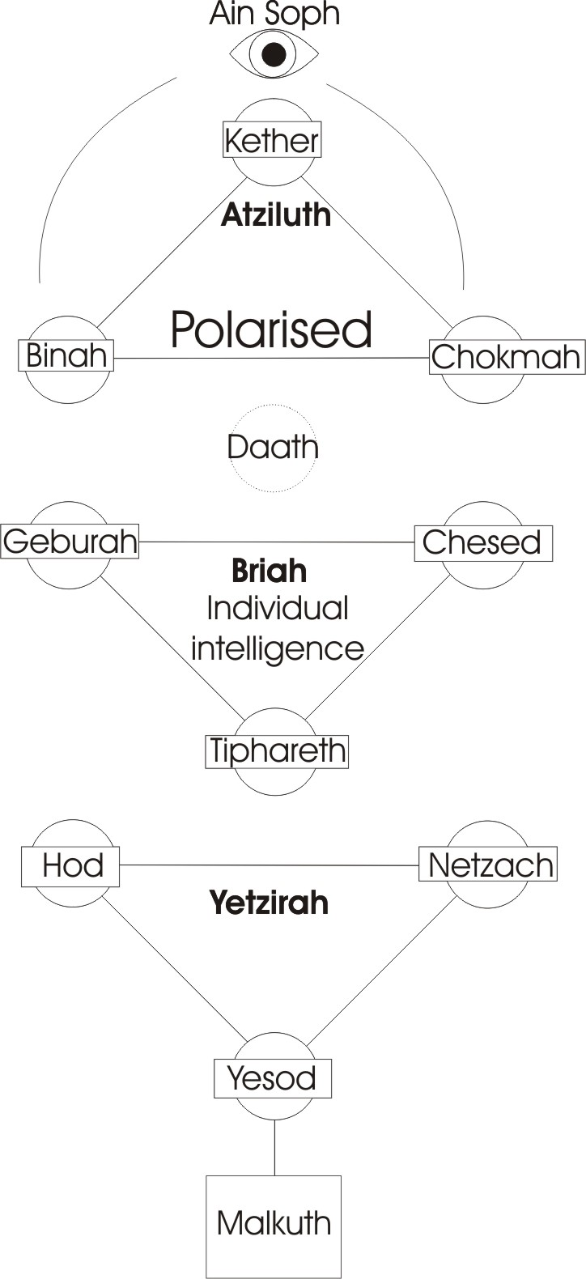
It’s a very good thing to try as an experiment. It’s a dangerous experiment, so you should go in a room where there’s no furniture, and no other people. And you then try to express, in action, whatever occurs to you. Best to pad the walls [laughter from the audience] …first. Because you will then find that so many of the impulses in you contradict themselves and would destroy you, that you would give them up. And on the other hand, if you then tried to conform to the principle of reason exactly another thing would happen to you, and you’d that you’d have to give that up. Because absolute Ain-Sophery here, this inimitable wisdom, appears here in polar relation, and then in the individual intelligence there is no possibility whatever for an existent individual to escape polarity. So that what he’s doing on the outside, at that precise moment he’s not doing on the inside ... which is the meaning of this Eden function and what Adam should not have done. When he defined the thing as taboo as bad, not to be done on the outside, he had thereby created a fantasy about it on the inside ... which is the basis of all modern psychology.
- The prim person is a hotbed of fantasy on the inside.
- And that fantastic person on the outside, is struggling like mad to get hold of a principle on the inside.
So in fact we find, running about in society men that are quite unreliable externally, they won’t do this and they won’t do that, and yet they are the men that are apparently, according to themselves and their inner belief, searching for the truth. And this internal search for the truth makes them externally, totally unreliable. And on the other hand the man that applies himself to the gross material truth, and gets on with it on the outside, becomes progressively more fantastic on the inside.
Samuel Butler’s Way of All Flesh is an example of a tower of respectability who feels safe because he’s carried all his principle to the outside, and then he comes in contact with a little piece of fantasy and that stimulates him, and then the internal fantasy springs from his hidden centre, goes right through the being, and destroys him.
So if we remember this necessary polar relation of ourselves, we will stop this kind of self-condemnation that goes on, and the condemnation of others follows automatically, for condemning themselves and condemning others.
Now you see the dialectical thing is this: if you see the essential polar relation, you will have to condemn condemning ... in yourself. And at the same time, this condemnation must be stopped. Because whatever you do, you are always doing the opposite. The thing that you do consciously is immediately inverted unconsciously.
We’ve said before, that if we take this as the type of an egg and then subdivide it, then every little subdivision is exactly the same substance as the original, and as the original was itself a vehicle of intelligence, so is every little cell. And each little cell, wherever there’s a membrane in the body separating that part of that body from another, we have a subsidiary intelligence, an entity with its own purpose, and it will fight and argue with the rest of the body.
So if we make a decision down there to be good: supposing that represents sexual behaviour and a man decides to be good, there, well, the chemistry of that relation through this Yiddisher wanderer here, is carried all through the body. So a strange situation is developed there, and the chemistry of the rest of the body is changed, so other parts of the body are saying, We’re not getting any of that situation that we used to have, that we thought was essential to our well-being. So they start sending crazy messages down, and the result is the thing he is trying to do becomes impossible, or if he tries to stop doing something, it becomes inevitable. The mere fact that he defines it is to make it an enemy.
Eden means don’t define it. [1:13:10]
All the troubles of the world are caused by somebody defining it. Therefore in the Golden Age, this one, in the supernal world, it says in the Tao Teh King, in the golden age, people spontaneously did what should have been done, but, after that, there was a degeneration. This has to do with the time process. Then the men began to make rules about what should be done. Now, that’s the first division, rational, saying we are going to make rules about what ought to be done. That’s the Silver Age.
Then they said, Now we’ve made the rules, we must join those things together, that we think ought to be together. That’s the Copper Age, copulation age, where things are joined together by arbitrary decisions from above.
And then, as there was resistance from other beings to these things being joined together, we entered into the Iron Age. We took out the sword and started sloshing everyone that disagreed with our definition.
And yet the whole man can only be regained by completely abandoning all that type of definition, and asserting our Absolute prior unity behind all polarities.
[Khen Ratcliffe] Why, in the Golden Age, would they consider it beneficial to reflect in the Silver Age, when I assume that in going from the Golden Age into the Silver Age, they must have seen a benefit in reflecting back on it…..
Well, consider this very carefully: that this is simultaneous and eternal, all of it.
- That Golden Age exists now. There is a level of our being where we are actually Edenic, and don’t make such stupid statements.
- And underneath it, there is a Silver Age, a period where we do think and define.
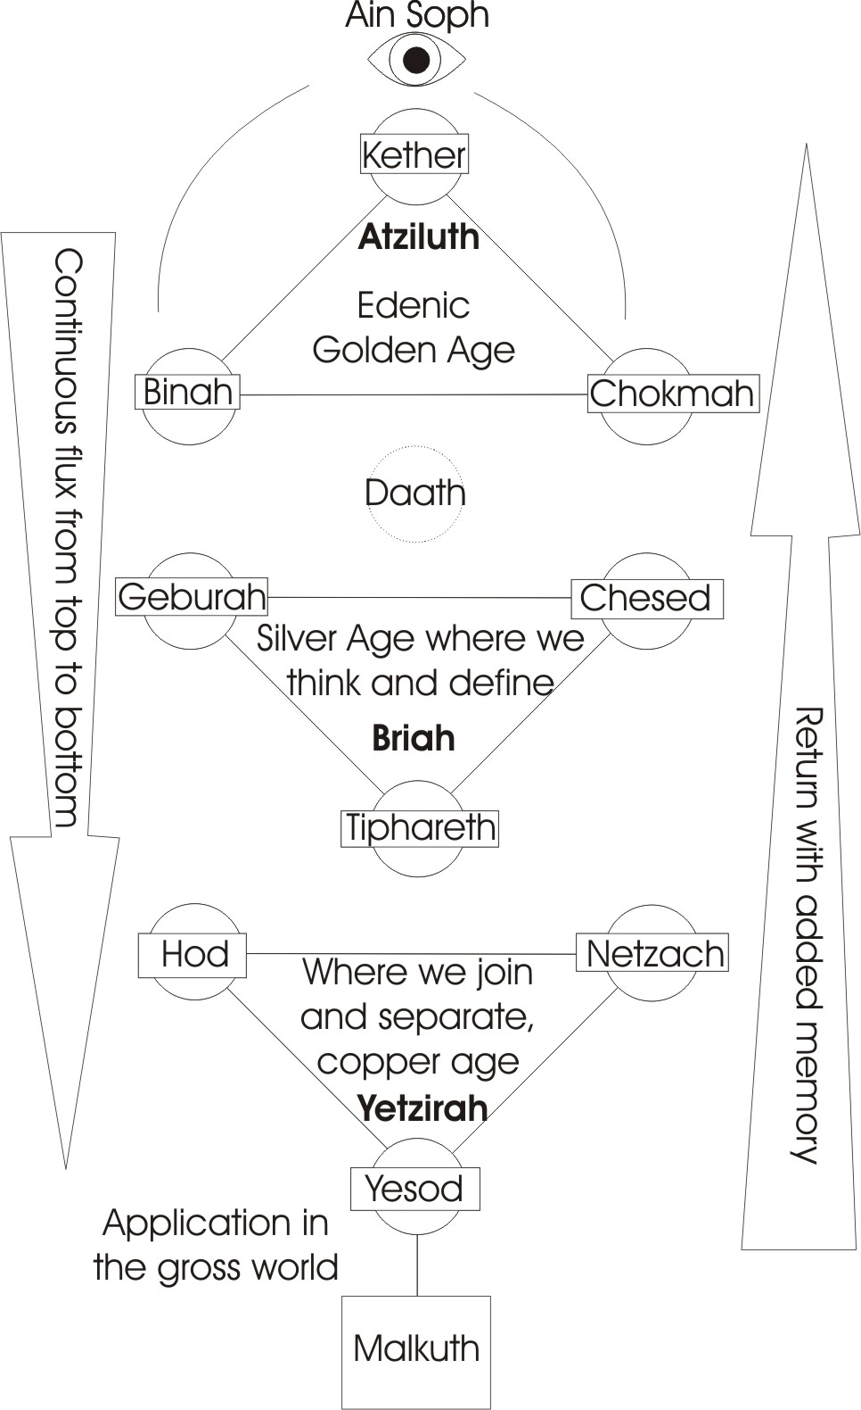
- And underneath that state where we want to join things together, and separate them ... though God hasn’t done, we do.
- And then the application in the gross world.
And because the whole is one, yet is all power, and the essential nature of power is to move, there is a continuous flux from top to bottom. So, the very nature of power itself is to pass from this spontaneous non-judgement state, through the state of judgement, divisions, executions, and then back again.
With the added memory.
With the added memory. So that it is said that these four Yugas, these four great ages, follow each other in eternal succession.
Seeing them serially is what would create the problem, of course.
Seeing serially creates the problem, why did they do it? Because they see the inherent nature of power and they realise there’s nothing but power, is this: the static concept cannot be applied to it. Therefore it is continuously changing through phases. Each phase appears in the historic process as a Zeitgeist, a spirit of the time which determines exactly what people in general are going to do. And because it determines in general what people are going to do, it follows that it is also possible that some few can do the contrary.
It is possible for us in this room for instance to consider the real meaning of this, because millions of people are not interested ... simply because of that. And it is for this reason that we should never descend into the Dan land, and we should stay in the Eden land. So we shouldn’t try to make millions of people see this point of view, although we know it’s true. So that you wouldn’t make an odious comparison, and say, All the people that are working on the idea I am working on are good people. The others are stupid.
Rather, you say what it says in the Tao, Fools are the instruments whereby the wise perfect themselves. So thereby you’re not glad that there are so many millions of people working in the other direction. You’re just recognizing that they are, and because of that you are moving in the contrary direction ... because of polar fact. You know how, say, an electric cable under the sea, and a current goes in one direction through the core, and in another direction through the case. It’s the same with a ray of light from the sun actually ... it’s polarised, so the inside and outside of it are opposite.
If we like to call for the moment the core of it positive, then the other part would be negative. And we would imagine that if masses of people were going along that way, a few can go down the core that way ... simply because the many are going along. And if we remember that a charge distributes itself evenly over a surface, so that if we get a sphere and charge it, the charge will disperse itself over the whole surface of the sphere and there will then be nothing inside it. In the same way, the mass of the thing is a guarantee that not that is on the inside.
So we transcend all the good/evil significances of ordinary speech in it. And we’re not delighted and crowing over the fact that millions of people are going in the contrary direction, we simply recognise that it is so, and then get on with our own work, which depends on the fact that they are going the other way.
[Indistinct question]
Yes. [?? 1:18:14]
What is it in the nature of experience, what happens because of the nature of experience, that you want to go back?
It’s simply that you’ve been repulsed by events. Remember that if you always got your own way, you would never reflect.
It isn’t the fact that we don’t always get our own way and make us want to go back?
Oh yes. That’s the guarantee. That’s why it is said that god has eternity to wait in, so he doesn’t care how many times we hit our head against the wall. Eventually we do what we call repenting, and he was there all the time. It’s not for his sake that we repent. His unity is unbroken. It’s our heads that get broken.
Now whilst we’re affirming things to be good or bad, you can’t reach that state, that Edenic state …
Yes.
Now if we’ve learned that this experience we’ve had isn’t very good for us, we don’t like it, is that impulse sufficient to take us back?
No. You stress one side, and you make a mistake. What you have to define is that all the ideas that wanted to force you back, you thought were bad things. You now know that they are good things, because they are forcing you back. But they were bad things. Boehme handles it by saying that the devil’s called the bad good, and the angel’s called the good, good. You’re in a period — you’re driving out from your centre into the material world, you’re really doing bad things that are good for you — because they’ll send you back. And you must assert both of these, and yet see that tube, with a force going in the opposite direction.
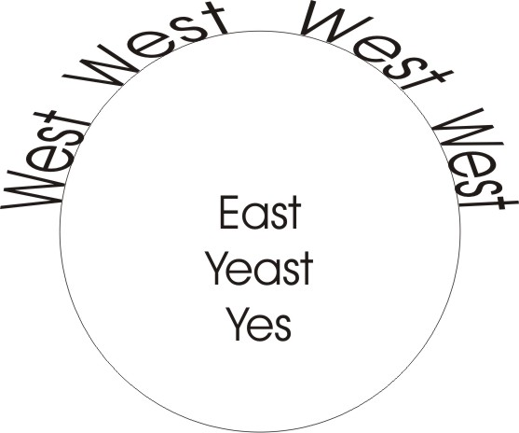
When you go into material world you are going into slavery, because you are becoming more and more subject to stimulus from outside and you’re losing your autonomy. And yet, if you don’t get a good knock on the head when you do drive out, you will never turn back. So as Boehme says, the worst is as good as the best. A good bang on the head can make you think.

The East
Why is the word celestial used for the east as well as for the higher things?
Well, remember there are two kinds of east — the geographical east, which is a romantic concept really, in our sense, and the heavenly east or the mystic east, which is the inside of a being. So if we take a little sphere and we write E for East in its centre, because that east is yeast or eerie to arise, the east, yes, and the west is all the way round it — it is the perimeter. Now it’s very important because this is the reality, the other is a romantic thing. The east is nowhere on the Earth is it? It’s simply a globe, geographically. But the centre of a being, that’s the nucleus in an egg.
From which the power is pushing out is the east, the yeast, the ‘yes’, the point of arising, the orient, the mystical Zion, the Eden, and so on.

The Pi Law Stone
It is said for instance in Jewish mysticism, that when a man doesn’t have any children at all, he will have to reincarnate and come back and have another try. But if he wants to go to heaven he must take care, that when he dies he is in Palestine. Now Palestine is the Pi Law Stone. It means he must have a very, very clear sense of the geometry, the classic mode, at death. [1:23:01]
Supposing you remember at the point of death, supposing you were seventy, and you’d had nothing to do with any beautiful girl since you were seventeen. And you remembered one suddenly at the moment of death ... and then died. Where do you think you’d go? To the land of pure geometry? [laughter from the audience]. No, you wouldn’t. You’d bounce right back in a horrible situation, the identical time and place with your first birth ... not another one. This is the horrible thing about the eternal recurrence: you can actually die and reincarnate back at the same point — because all is eternal — and relive exactly the same life you did before, just to get a look at that girl. And if you don’t control that death memory, you’ll always do it.
This is why it was said that when Nietzsche examined the nature of the eternal recurrence it helped to unseat his mind, because it was obviously stupid to go and repeat the same life, not another one, not in the common sense of reincarnating and having another try in another life, but actually to go back into the same life to reincarnate at the same historic period because it exists eternally, and to do the same stupid thing again and again and again. And in order to avoid it, you must get dying in Palestine.
You must, at the point of death, Pi Law Stone yourself. That is to say, you must put in your mind the pure geometry of the sphere, and say, No matter what world it is, no matter what beings there are, they are all no more than this law expressed, and it is this law I affirm, and hang onto it like mad. And if anybody comes to comfort you with a hot water bottle at that moment, well, try to keep your mind on your Pi Law Stone. Because that way you see the principle, and you will dodge that crazy experience that you’ll otherwise relate to. It’s a terrible concept, eternal recurrence, viewed like that.
A true one, is it?
Yes. When Nietzsche saw it, it gave him a terrible fright, and he immediately went to work to try to devise a method whereby you could dodge that stupid recurrence, and set yourself such a target that it didn’t worry you in the slightest if you did the same life every time. And you would then affirm it.
In other words the whole object is to live such a life that at the end of it you can say, this is the one that I will do again. And until you reach the target, that is, Pi Law Stone, you’d better keep changing your object. And if you think that Palestine is called what it is because of its significance geodetically, and those people who drove into there, and then were dispersed from it, and have been gathered back together in it now. And now somebody’s got to come with a hammer, and beat on that stone very, very hard in the not far distant future so that they’ll really know what they went out for, and came back to ... because that’s going to complete the cycle.
They’ve really got to fight for that stone. If you, when you see anything in the news, try as an exercise to ask yourself, Which side of this battle am I on, if any? Can I extricate myself from the judgements involved?
It’s a fact that the Arabic Republic are doing so-and-so and so-and-so. Those Arabs are nomads. Arab is the same letters as Hebrew actually, anagrammed round. These Hebrews are Eber, crosses over ... they go over, out of slop, into form. The Arabs keep dodging form. The result is that other peoples are formed before them, and then finally they realise that the Earth is quite small, that deserts shrink on their aeroplane invasions, and that they will have to settle down. But it’s late. And so they scramble to try to make a social structure, to try to make a nation that can become the very thing they’ve never wanted to be ... an integral unit. And this again is dialectics. Whereas the people that wanted to make that unit were dispersed throughout the world. And even today, the few who have gone back can’t persuade the others to go back. So that the Zion, if Zion is like a temple of God, namely with man, is dispersed throughout the world. Not all Jews will go back to Palestine, because now there are eleven among all the other nations. You get the eleven in the parable, you put it in the fire, and afterwards you come and look for it ... it’s all over the place.
The Indian image of it is salt, where the father says to his son, Take this salt, taste it, now put it in the water. Leave it for a bit and come back. Now taste the water at the top. Salty. Taste it at the bottom, it’s salty. The salt has gone all the way through. That salt means savvy, consciousness ... the sting of sense. And it has been dispersed through all nations, simply because one block-headed, stiff-necked, arrogant crew were driven by their own internal necessities to look for a God of Armies, a God of Victories who would fight for them.
And he has.
And in the process, he’s scattered them about so they can get their experiences to come back, and again give out the law from a centre, on a new level. Meanwhile, they’ve left in all the other parts of the world their representatives, to assimilate and take the message. But the important thing is to realise that as an existent being you cannot escape polarity, and therefore whatever you are doing on the outside, know that the contrary is being done on the inside. And watch it and become aware of it. So you don’t get any false concept in yourself when you do an external act, and say Oh, I’m a decent bloke, I just gave tuppence to that fellow, because you have internally the exact opposite ... you were robbing him.
Get that rule. To see this polar relation inside and out, above and below, all the time, is to drive yourself backwards from the material world…..
[Break in recording]
….there is an utility in the exercise, yes.
Is it valuable to do that?
Oh yes. Providing you pick a decent idea. If it’s a particular idea with a particular concept of good and evil attached to it, you’ll precipitate yourself into a particular situation that will refute you.
So immediately we get hold of an idea…
…it will invert unless the idea itself is an idea of a pair of opposites which can’t invert. Your best idea is, when you go to bed at night, assert this absolute polarisation of the infinite in the finite, and suspend judgement. Say, Eden is where I’d like to be, and deliberately put yourself in that state of non-judgement. Now that’s a hard exercise to do, because when you go to bed at night the usual thing is that the mind starts judging all the day’s events and the people that have been in it ... saying rude things about most of them. You know about that do you? [this said soto voce as an aside]
Yes. [with a chuckle]
Yes. Remember that all judgements of the order that the lower mind makes are purely mechanical. So it’s bound to be against a painful physical situation as such, and for pleasure as such. So it’s bound to praise all those beings that think that they’re nice beings who’ll be associated with pleasurable situations, and to condemn all those beings that have been associated with painful ones.
Lots of little boys at school say, When I’m big enough, I’m going to bop that fellow who’s teaching me, because he’s been a source of pain. He’s required that little boy to do something that the little boy didn’t want to do ... even if it was only spell a word correctly. In the same way that a child is almost ambivalent in its will towards its parents, it needs them for nourishment and protection and it hates them because they impose on it. They even make it bring coal up or something like that ... when it’s trying to play. These things add up. So there’s always this ambiguousness, in the attitude towards the parents, of a child.
[Khen] The opposition of those ideas, can merely be used or could be used as the justification for prodigality, couldn’t it? You might say, alright, I’m misbehaving externally but right idea is going on internally.
Well, the man that tried to use it in that sense, would have been saying only half of the truth, wouldn’t he. If he actually said to himself, I’ll use the idea, he would not have said at the same moment, I will not use the idea. You have to say this pair of opposites in order to push yourself beyond the stimulus.
[Khen] You still have your reaction to the stimulus ...
Yes. The statement itself is purely reactive.

Pride
[Khen] What happens with proud?
Yes. What happens with proud. Well, proud is one of the words for which we could say the synonym tumescent is an equivalent, couldn’t we? And that means packed with energy. And proud behaviour is really the behaviour of a being when the energy inside has come to the point where it must act or he will burst.
[Khen] Mm.
You could see the application in various fields.
[Khen] Yes …yes.
There’s a drift of energy to a centre from the field, and it packs in the centre until something has got to happen. You hear this statement clinically, over and over again, of psychological cases and so on, they said, Something must happen. They’re really talking about an eternal drift of energy towards certain centres. And those centres then become loaded. They are finite centres and they can’t take any more of it ... and yet more is coming in and in. They start to hit out somewhere. It’s the same principle as lightning in the sky, piling up, it charges until it must drive. So that the behaviour of a person who is like that, is simply evidence that certain centres in him — they’re usually sexual centres — are piling up energy, and that he feels actually endangered unless he expresses it.
[Khen] When those energies are piling up ,that would be equivalent to the time of darkness that Paul talks about. It would be difficult would it, to work in that particular period? That is, to work against the final precipitation of his energies as…
Yes. Well,
[Khen] …I’m talking now, psychologically...
Yes, psychologically it is recommended when you feel that build up, to go and do something useful with it ... before it’s got time to strike.
[Khen] Like trying to work out your thing last week…
Yes, or make a new gramophone table or something. Certainly to use the energies up.
[Charley Blythe] You’re giving a different meaning to the word ‘proud’ to the common meaning.
Well you give me the common meaning.
[Charley Blythe] The common meaning, say, is that when someone thinks that he’s a pretty good person. He thinks himself as a good person.
Do you mean, morally?
[Charley Blythe] Yeah. He likes other people to know. He likes to show other people that he thinks he’s a good person. Isn’t that pride?
Do you mean morally on that? Because you find pride of muscle, pride of reason, pride of aesthetic sensitivity. I was taught by my father that the three mini kinds of pride,
- pride of muscle which is fairly easy to cure with a hammer,
- pride of reason which is a bit harder to cure, it takes longer, because you have to disprove it with logic,
- and pride of the heart, which is very hard to cure because it’s impervious to being hit with physical force, and it’s impervious to reasons, so it can only reform itself from the inside.
But in all cases, it means, I have more of it than you have. Whether it’s energy at the physical level in muscle, or of reason, or of feelings ... pride feelings. A surcharge of energy is the idea.
[Charley Blythe] We generally in appearances, say that that man’s proud, don’t we?
Yes we mean it’s considered he has got more of something than we have.
[Charley Blythe] Yes.
It’s this more that’s the idea in tumescence. Fullness, surcharge, whether surcharge of moral qualities, or of mutton-headed muscularity, or whatever it is, it’s a surcharge that we’re talking about.
Some people, apparently, have said, Proud about nothing, but they’re still proud because they feel an inherent value in themselves, and have not the faintest idea that they do. But they can feel it. And it means that energy is in a certain centre going like that. When they feel it, there’s a lull. I’ve got somebody with me, because there’s that feeling there. You say what is it? Well, I don’t know. Well it’s not curable if you can’t define it. You have to wait for that fellow to explode in the situation and then something taps him.

Lucifer
[Charley Blythe] They say pride always comes before a fall.
Before a fall, the fall of energy from this centre. It’s got to build up the lightning bolt and then it falls. The reference is to Lucifer isn’t it?...
[Charley Blythe] Yes.
…who is the highest and favourite angel of the creator. He’s the most powerful. He’s defined as the brightest of the lot. He’s absolutely packed with energies, light and power. And it’s because he’s surcharged, he thinks, I must give ... to these inferior beings. Now if he gives, he will diminish as a finite, won’t he?
Mm.
So he’s really dependent on an infinite influx before he can give infinitely.
[Charley Blythe] Yes.
So, the statement, he commits the sin of pride, pride is there defined as a dividing fire. All the energies in him twirl round, and he says, I am the greatest. I will gather to me all the energies of infinity, and then I will distribute them to the angelic host, and they will know that I am god. But really, infinity is god. So it’s the first statement of idolatry, isn’t it? Yet it depends on a surcharge of power inside yourself. All the ones that are very far away from his level, worship him. The ones that were nearly at his level, envied him.

Humility
[Charley Blythe] Well, what would be the opposite of pride, then?
Humility.
Is meek the opposite of pride?
One of its aspects, yes. Humility is the opposite ... thus the word humus, earth. Earth, remember, you are earth. Thus thou art, and unto dust thou shall return. Humus, the earth, humility. Because when this super-being — the Luciferan being — didn’t look at infinity as his source of energy, but considered it was in himself, then, if the myth corresponds with the process in himself, it was because he was surcharged with energy more than any other being, that made him say, I, am giving light to these beings ... and to discount infinity. And immediately after that he grabbed at power.
And you know when you grab at air with your hands it goes out through your fingers. And in the same way it is said that as he grabbed then the whole world stood in the curse. That is, as he grabbed like that, spirit, which air symbolises, simply disappeared between his brothers. So he found he grabbed himself ... and that meant the gross material world.
Now it’s on the basis of the gross material world that we stand in our humility. And that is the thing to remind us. We have a gross body. Let the proud man make that gross body behave first. Because now it’s been appended to him until he can absolutely control it he has no justification whatever for pretending to be merely of celestial origin.
[Charley Blythe] What about two men who are proud — and they have the same concept of each other?
Owing to the inequality of finites, one of them is prouder than the other.
[Charley Blythe] You have cases of men due really to pride, challenge each other to the duel. And each one might be as proud as the other, and thinks he’s better than the other?...
Mm. They have occasionally shot each other dead, haven’t they?
[Charley Blythe] Yes.
But not always in the same spot.
[Another audience member X] You did say that you get an opposite to humble, actually. You said that if we’re one thing outwardly, we’re another thing inwardly, you see.
That’s right.
[X] Now if we’re humble outwardly, does that mean to say that we’re proud inwardly?
Oh, yes.
[X] And if we’re proud outwardly we’re humble inwardly?
Oh, yes.
[X] Are we aware of this situation. Is this the way you mean it?
You’ve got to become aware of it.
[X] You’ve got to become aware of it?
Yes. When you become aware of it, you release yourself from the pairs of opposites.
[Khen] What about ‘proud flesh’ externally, in the medical sense, where there is a contraction of flesh? Is there an internal state, opposite to that, in the physical body?
In that zone?
[Khen] Yes.
The zone itself has a field, which is exactly doing the opposite to that physical thing.
[Khen] So, would it be possible…
…do you mean that….
[Khen] …can I continue? Would it be possible within that physical field to contact the inner causal field and reverse the situation, or at least equate, balance the situation so that you could disperse the pain or what we would term the proud flesh?
Oh, yes.
[Charlie Blythe] If we must all become the opposites by becoming aware of them, how do we reconcile that with having been told that we must be, what was the word, be in humility? How can we reconcile humility with overcoming opposites?
Humility overcoming the opposites?
[Charlie Blythe] We’re told that we must be humble.
By whom?
[Charlie Blythe] Um… well I used the wrong word there? Um. I’m not sure now which word I should use.
Well they will have conditioned your whole thought process.
[Charlie Blythe] I’m trying to think of the sense of the word.
One is the Logos Christ. And the other is the government.
[Charlie Blythe] The other is what?
The government.
[Charlie Blythe] No, I wasn’t thinking of any meaning, the government like, actually, um,
[Khen Ratcliffe] How about the negative sense ... not-proud?
[Charlie Blythe] Well that’s the opposite of proud, isn’t it — not proud? By becoming aware what we must get away from?
It’s not a true opposite ... simply to negate a thing. It just scrubs it out of your mind, it means nothing, that.
[Charlie Blythe] I’d better leave this for the time being, until I get it sorted out.
Well, remember, the term you use to start thinking about it, is going to condition what you think.
[Charlie Blythe] Yes, well I’ll sort it out and I’ll ask you another time.
[X] I’ve noticed that occasionally when I speak to you, a certain amount of discomfort there. Now could say, I feel a little bit ashamed for some reason, it could have been because unconsciously there are things which are quite shameless calling you names, you see.
Yes that’s right. Yes.
[X] I’ve come aware of what those things are as I find them..
Yes. A young fellow, about three years ago, was in a similar state to that, and he couldn’t bring himself to do anything about it. And he was getting so tense internally, you know, through driving on this, that I watched a little bit. And after he’d had a few bad nights I said to him, I want you to do an exercise faithfully, will you do it?
And he said, Yes.
I said, Will you promised to do it and not to modify what comes into your mind?
And he said, Will it help?
And I said, Yes.
I said, Now go into your room, get a lot of paper, and write down whatever comes into your mind about me, and then show it to me.
Now he wrote down more rude words on five pieces of paper in small handwriting, than he knew he knew. And it started with my name, and then it said what I was. And everything he’d ever heard in the whole of his life that was rude about any being whatever that offended him, I am.
[X] I can remember a couple of names I used from a night before.[laughter]
Well, this young fellow….
[X] Not that it’s anything you’ve done against me…,
No, no ... it’s just a focal point. If you remember this polarity ... it follows, if I am doing you any good, I must be the devil.
It’s only two days ago that a fellow, nearly my age, came to me and said, I think I can now formulate something about my relation to you. He said, I’ve got a group of sub-ents in me, who say, ‘always do what he says, and listen very carefully to the advice, and make it go wrong and then you can blame him’.
Now that was a clear analysis. [1:47:46]
In actual fact, anybody who’s honest with himself, will find filthy expressions and dirty statements, about every person in their lives that have given them any benefit whatever ... for a very simple reason. In principle, the ego believes it should be able to benefit itself, doesn’t it? So really, any good coming to it from outside is an imposition. Because it says, Well I could have thought of that, and then I could have actually done it, and then I could be telling him.
[X] Well I don’t feel like that.
You may not. Because there are phases. That doesn’t mean to say you won’t.
[X] But does that mean I will?
Oh no. It may be that you’ve already done it. You might not even have noticed it. You might have already done it about somebody else ... because I’m not the only trouble. I’m just a stimulus in the situation. I could become objectified in somebody’s mind as the celestial cesspool — you know, a sort of pile of rubbish — quite easily. This is what psychologists call transference, in any case. But whatever the problem is, it gradually accretes to a centre, and it then turned into a rotten tomato and flung at some person. It is really an accident that a person gets hit with it. In fact, most of the quarrels that go on in families, and in marriage relations, and so on, are no more than this tumescence, this build-up, this proudness of energy compacting itself, suddenly letting fly at anything ... even the cat. Anything can be its object. But the thing tends to be its object that comes to an idea that you would have come to in any case yourself later.
[Khen utters an indistinct comment]
Yes.
[Y] Every mortal thing that you’ve said refers back to the affection for the opposite, that targets everything as the opposite.
Yes.
[Charlie Blythe] I can’t see.
[X] It’s your own intellectual pride that there’s somebody who’s intelligent, ……
That four-letter word means what men have, isn’t it? You know, for a man to take anything from a man at all, is terrible ... in principle. It’s like a woman listening to another woman. It’s just not done. Only in the case of man, it’s even more ….????
There’s a fundamental drive in a man that says, given the time and the opportunities, I could do it. Yet in fact, many men have been so busy being something else that they haven’t got round to it. It’s a matter of no importance whatever, because we all co-exist in absolute simultaneity in there.

[Charlie Blythe] What it seems to me though, is that someone is able to help you in some way, that you, you, if you like, call him a devil….

That simply means that you are not in contact — at the moment of saying it — at this moment. With that part of yourself it automatically says things about it. It merely means that there are unconscious parts of your mind where those things are going on, that you don’t know about.
[q4] So you must have had special advantages.
[Charlie Blythe] You might be being told something in front of other people who you would like to think that you knew it all already. You might be willing to, then.
You can resent being told it in private. Only, it wouldn’t become manifest to you, because the stimulus situation would have provoked the egotism. It would just sink. There is always the fear underneath that maybe, someday, he might just stand up and say, I told you that.
I was once introduced to some people, after a pupil of mine had been coming to me for fifteen years, and he’d been going and lecturing in a certain place, and one occasion he introduced me, through no merit of his own, to an accident, to this group of people on an evening when a lecture was being given, and he didn’t know what to do about it.
And he said to me, I suppose I ought to go through with this.
And I said, Of course.
And he started, and went on, and about three quarters of the way through, stopped dead.
And he said, I’d like Mr. Halliday to finish this lecture.
And his ears were burning, and he felt terrible. And he couldn’t carry on, and he turned round and he was flat out. So I finished it. And afterwards the president of this organisation said to me, I can tell where you got your knowledge from ….you see?
And as he said this, this poor fellow had become absolutely incapable of saying anything about it. He just froze like that. He didn’t know what I was going to say, and I said nothing. And when we got outside and we drove off, he was absolutely silent. And do you know, he became like dead ???????? for about six months on account of that. He just couldn’t talk to me, he didn’t phone me, he didn’t come to see me, he didn’t do anything, because he felt that he should have said, at that moment, it’s the other way round. And he was really making himself ill when I spoke to him about it.
And I said, Don’t forget, in there, nobody teaches anybody. It is all co-existent, simultaneous.
Like it says in the book, In that day, no man shall teach any man of god for all know him.
It’s only an action in the time that a word comes out of one mouth rather than another, because in actual fact, the word that comes out of my mind is determined by you ... not by me. Because if you don’t develop in a certain way from your own centre, then no demand is made and if no demand is made, I can’t move. And that’s true with everybody.
A woman can’t feed a child unless there is a child to feed. See? Nietzsche’s idea of the sun borrowed ... [the recording trails off here]

~~~~~~~~~ End ~~~~~~~~~~~

Compare with Chladni figures http://www.youtube.com/watch?v=n-tYVjngvyo
1 Corinthians_13:12 For now we see through a glass darkly; but then face to face: now I know in part; but then shall I know even as also I am known.
Rev 12:1 And there appeared a great wonder in heaven; a woman clothed with the sun, and the moon under her feet, and upon her head a crown of twelve stars:
Gen 3:19 In the sweat of thy face shalt thou eat bread, till thou return unto the ground; for out of it wast thou taken: for dust thou art, and unto dust shalt thou return.
Satya Yuga (Golden Age), Treta Yuga (Silver Age), Dwapara Yuga (Copper Age), Kali Yuga (the Dark Age)
Eber, mentioned in the Genesis 10 and 11, was a great-grandson of Noah's son Shem and the father of Peleg and Joktan. He was an ancestor of Abraham and hence of the Israelites.
1Co_4:5 Therefore judge nothing before the time, until the Lord come, who both will bring to light the hidden things of darkness, and will make manifest the counsels of the hearts: and then shall every man have praise of God.
1John 2:27 But the anointing which ye have received of him abideth in you, and ye need not that any man teach you: but as the same anointing teacheth you of all things, and is truth, and is no lie, and even as it hath taught you, ye shall abide in him.

