Feeling
Transcribed with diagrams and arbitrary headings by John Bailey, March 2010.
The editor’s additional comments are in square brackets[ ].

~~~~~~~~~~~~~~~~~

[tail end of a question from Khen] ... regarding the autonomous nervous system with that particular questoin.

[Another questioner] A question about feeling and intellection. And I wondered if feeling could be associated with the autonomic nervous system, and intellection with the cerebro-spinal nerves.

In general, yes. You could equate them.

Now, there’s a question here about the middle one ... let’s have a look.

We’ve got two kinds of feelings: liking and disliking. Yet when we are told to examine our feelings, the examples given are, “Am I feeling pleased, compassionate, self-indulgent, etc.” Are these qualifications of like and dislike, and if so are they not then formalisations? If they are, is it still permissible to use the term ‘feeling’ rather than ‘idea, form?’
At what point does feeling become form?

Feel and Fiel -D
This is a tremendously important question, because the creative process of the universe and of art depends on a clear understanding of this. Let’s make the equation here:
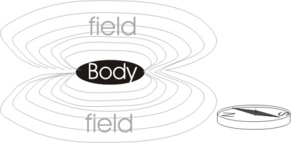
Feeling = Field Consciousness.
This Feel here [in feeling] and this Fiel [in field] are exactly the same word originally. The ‘D’ at the end here means the limit of the field. If we allow this paper to represent in its whiteness feeling potential, and we extend the paper in imagination infinitely, we would then have an infinite feel without a ‘D’ on it. But when we take a field we have to define the field as finite so far as detection instruments are concerned. So if we take an electrical definition of field – there is a body and the Field is defined as that zone in which the presence of the body can be detected by a sensitive instrument. So obviously this depends on the degree of sensitivity of the instrument. If you have a very insensitive instrument, the Fiel—D the D would be written here we could say. There’s the field, and the instrument would have to be so close.
Supposing this is a magnet and this is a magnetic needle. You’d have to bring it to within a certain distance of the magnetised body before the needle would register. If you took it too far away, you would find that you were unable to detect the presence of that magnetic body. But it might be that the needle was suspended on a bearing with a great mount of friction, and therefore couldn’t orientate itself to the magnetic body because it was impeded by the friction. If you remove the friction, lessen it, you can move the needle farther out and it will show the response. If you reduced the friction to nil theoretically, then you can move it an infinite distance and it would still respond. So that the ‘D’ in fielD actually means the detectable limit – the limit of detection of the magnetic flux which is going on.
Now we’ve said before that every body sending out an impulse wave, an expulse wave, has round it six others, which — we’ve got six here [drawing them on the white paper] — which, as it reaches them, they react onto it and limit it. So that the limiting factor for any given centre is always the centres round it. We could cover this paper with dots — let each one represent a vibration centre — all the others round it would represent limiting factors, and they would be represented by the ‘D.’
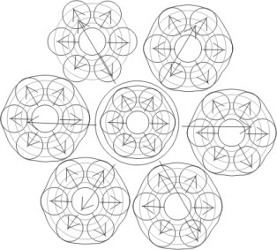
If you contract a muscle very tightly, with your eyes closed you can feel the form of your hand. If you begin to relax it, the formal content becomes vague. If you relax it completely and put it down, you can’t tell the shape of it. So the relation of feeling to idea is the relation of a non-contracted field — which we would call feeling itself — to a contraction within it.
Now we’re going to see — we might be able to do it actually on a piece of paper — if I take this piece of paper and I don’t alter its proportion at all, but I flex it and bend it backwards and forwards in a wave form in a long the piece of paper, without a fold in the middle it can be a little bit more rhythmical. When I do that to it, I’m not altering the amount of paper in it by flexing it, and in so doing I’m bringing parts of the paper close together, and those parts are experienced in the feeling as zones of contraction ... contra-action. Contraction means contra-action.
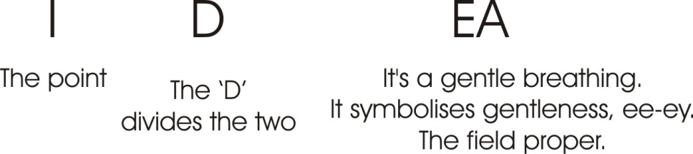
So there is an extended field. If we imagine it extended infinitely, the tensions in it to be equal, the feeling is of no thing, no thing, the negating of thing. If I want to make a thing in it I must cause it to act on itself ... contra-action. The moment I do this with it — this is a typical impulse-expulse image — when I pull it in, the tighter I pull it, the clearer becomes the definition of the feeling, and the more it is justified to use the word idea. So if I open it, it becomes vaguer. If I open it completely, it will be an undefinable feeling. If I close it, and make it very compacted, it will become a gross material particle.

Idea and the Letter D
Now let’s look at the ‘D’ again – which always means division. Ea [pronounced yay] means affirmation. E-A [pronounced ee-ey], this letter E is the fifth letter in English. In Hebrew the fifth letter is H. This [E-A] is really a soft H ... it’s a gentle breathing. It symbolises gentleness, E-A. This [I] is the point. This [EA] is the field proper. The ‘D’ divides the two – I-D-EA. Now Ea is an old form of Earth or Substance. You can see it in the word earth, Ea-roth, Ea-rota.
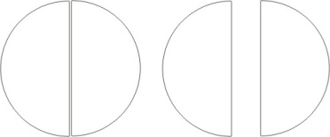
This is the field activity. This is the point. I — H – Field [A] activity. With a D. Actually if we put this ‘D’ here it spells exactly Yahudah [I, Y and J are interchangeable], Judah, and the Judah is precisely the one who divides himself off from the rest of humanity in order to do certain work, to function as a divider, and a representative of an idea of separativity, circumscription, circumcision. D is a semi-circle. There’s the whole thing. Take them out, trhey used to take them out like this [if we divide the complete circle in two by a line down the middle, we have two ‘D’s back to back] and that is dead. D-D, dead, the thing is divided, disintegrated. We use one of them nowadays, this one, because we write in this direction. It still symbolises division, and I-E-A without D means ‘the centres [I] in fields [E] activated [A].’
And just as we said of this piece of paper, we make a centre by simply folding it. This is why we say that the universe is a complex: com-with, plex-folds – with-folds. When we fold it we bring into being, and we circumscribe. Every idea is divided from another idea by the fact of circumscription.
So the difference between feeling and idea is the difference between — and this is relative — the difference between the degree of division that you can introduce into it.
How sensitive are you? To one man a thing is an idea, and to another man the same thing is a vague feeling. Because he cannot make himself sensitive enough to find the edge of that field, he thinks that that is a vague feeling. To one man art is feeling, and to another man who knows the meaning of the word art it is a science. Art is the same as articulation – joining, conjoining things.

Feeling and Idea Exercise
So to move feeling into idea, either you must move towards increasing sensitivity — you must make your feeling more sensitive — or you must move towards greater contraction.
I put my hand there, and either I feel more carefully to get its shape: and then I can, by extreme sensitivity feel my hand as warm, and I can actually feel draughts of air between my fingers.

Just open your fingers and feel very carefully and you will feel vortical movement of air between your fingers. Your fingers are warm. They are acting on the air and the air is spinning between them. You can feel it. And that’s increasing your sensitivity. If you don’t want to increase your sensitivity, contract your hand as hard as you like, and then instead of become feeling-sensitive, you have become idea-sensitive. You know as an idea that your hand is clenched, you are able to feel the form of it without becoming sensitive.

So a man may not be aware that you are annoyed with him until your hand, closed, bangs on his eyeball. And then, without increase of sensitivity of feeling, he becomes aware that you are annoyed. If you can increase your field awareness you can actually detect that somebody is annoyed with you before they know it. Before they know it. They’re not even sensitive to the causes in themselves, and then if you liked you could release a contra-feeling to balance the enmity that was about to spring out.
So there are two ways. You can either move towards increased feeling, or you can move towards greater contraction. If you move towards greater contraction you are becoming a hammer man, and if you move this way [toward feeling], you are becoming what is really meant by sage, SA-GE. The sage is a spiritually active — that’s [sa] the reference to his divinity — earth being. GE is the Greek for ‘earth.’ Sa-Ge, sage, means this spiritual activity that’s increased sensitivity.
Now in fact if you increase your sensitivity, you can feel all round your body, the air going like this [turbulating]. If you extend that feeling you can feel everybody in the room to be little heat centres, with air spinning round them. If you increase your sensitivity further you will discover that there are other levels also spinning, electric levels that cause the air to spin and the body to be hot. [13:05]
So there are various levels. When we talk about the ‘fiel’ without the ‘D,’ we’re talking about this infinite sentiency – sentiency means feeling. When we talk about fiel-D – we are talking about a limiting factor upon it, which is always introduced by some contracting element. The limiting factor, lim, is the same as ‘line,’ the line round it — if you don’t enclose it, it opens and becomes exposed to infinity. If you do close it, well then it becomes finited idea.

Love and Hate
So if you want to move towards idea, you contra-act, you contract. For instance, if you want to define, that is, to turn a feeling into an idea, then find the opposite of it. Suppose you want to define ‘Love’ ... well, we define the opposite is ‘Hate.’ We have to define functionally — in terms of action of the field — what is the difference. We must say, “What does a person do under the feeling of love, and what is the opposite of that? What do they do when they hate?” We can say “Love is the feeling which somebody has when they intend to work for the development of the potentialities of a being.”
Work for the development of [L] the potentialities ... the ove – the egg.
Now hate is exactly the opposite. It’s when you decide that you are going to pin by power — Ha means power — and you will crucify [T] that being and stop it developing.
We can make an equation that love is ‘Spirit working towards an end, developing successfully.’ And hate is love deprived of its object by something, and determined to immobilise the object that’s depriving it. So it is said in the Bible of God, “I have loved Jacob and hated Esau”.
Now ‘Jacob’ means ‘mild man.’ Ya-cob means affirmation of the secret mildness ... being mild on purpose, not weak. Mild on purpose – Yacob.
And Esau was a ‘hairy man’ who rushed about bashing everything he could, and the Divinity who likes lubrication in his engines so that they don’t seize up isn’t very fond of hairy men, because they’re always spoiling the potential development. So therefore he says, “I have loved Jacob the mild man – I have hated Esau the hairy man.” And hate simply means this power shall be crucified ... fixed. ‘T’ means this crucifixion element.
So we must practise these two modes, because by contra-action we become aware. When we talk about contraction, we tend to think of a circle getting smaller and smaller. But when we are thinking about it we are using the intellect, and you will find about your intellect that it cannot work except with a pair of ideas. If you try to think of the whole of that circle [indicating the diagram of a circle] with your intellect, you will find you start running round it. The intellect tends to precipitate ... to point. So the dot on the ‘I’ in intellect means that. Intellection is this point analysis. You measure forms in terms of points: so many points to the line, so many lines to the plane, and so on. So if you look at one side of that circle and put a definition on it, the tendency — if I write ‘hate’ there — is to run through the centre and write ‘love’ opposite to it. And the mind jumps about.

Circle Exercise
Actually, I will draw a circle round there, and try, with your conscious mind — that’s egoic mind — and that is always rational mind. The egoic mind is always pinning itself and then trying to relate.So egoic consciousness and rationality go together.
Look at that circle and see if you can see it whole. See whether you can hold all of it without moving your consciousness, or whether your consciousness doesn’t tend to pin itself and then run round.
Now is there anyone here that can actually look at it without the mind running round?
The tendency is for the intellect to go like that and pin on it. So if you are egoically conscious as an individual, your mind tends to focus and then con-centration — that means with-centre — you run round it and say, “that is a circle because I started there, went round it, came back to the same place. So I know that I’ve circumscribed a zone, because I have returned.”
Now the intellect therefore is pinning itself to points. And is always pinning itself, running round and then jumping across, which is its short way of proving a circle. If it went round like that with blinkers on — supposing we get a horse and put blinkers on, and let that horse run merrily round there with blinkers on, it would not know it had been round a circle. So the intellect, to make sure of it, once it’s rapidly gone round, keeps going like this.
I’ll draw you another circle now. Look at it very, very carefully and see whether your mind — does it keep going across once it’s decided it’s a circle. Once you’ve decided it’s a circle, doesn’t your mind keep jumping across? Doesn’t it require an effort of will to force the mind back on to that circle and keep going round?
You see the two ways of determining?
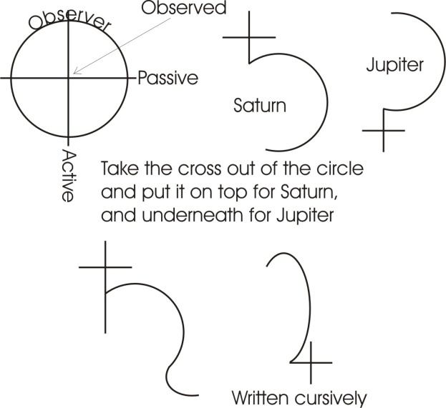
Yourself in blinkers, you go around, come back to the same point. How do you know it’s the same point? The answer is, you jump out of the circle, quickly go like this, and say, “Yes, that is where I’ve been.” So we say there’s an essential dichotomy in the intellect. The intellect always cuts itself into two. This is its tendency.

A Master Concept
The intellect can tell us that by its nature it is dualistic, and it can tell us therefore that by building up our percepts, finding out what is similar in them, and building concepts with them, and then building the concepts higher and higher into super concepts, until we have got finally a master concept which is one idea that contains all.
There is an idea [the cross in the circle] which contains all the ideas that we can possibly discuss in this or any other universe, because it contains the idea of limitation, circumscription, of activity and passivity, and their relations. That’s been a point at the intersection of the active and passive. This is the Observer, this is the observed, this is the active, this is the passive. This is the subject, this is the predicate.
In all universes this is a superglyph. This is the master concept and therefore we find this kind of thing built up as a globe, the orb that the queen holds. This itself is a glyph of the three-fold man, and while we are on the subject, we can now do a little bit of the planetary significances that we touched on before, and our superconcept is this [circle]: that represents the concept of limitation. It excludes the Infinite and includes the finite. So the circle, which is the vowel ‘O’, tells us we have excluded the Infinite, because we want to talk, and talk is necessarily finited. So now we confine — con-fine: with limits, with ends — our attention — a physical tension of force produces psychological tension, you can’t have one without the other — make a tension of consciousness within this circle, and then begin to consider within any finite situation, something is being acted upon – something is acting upon it. [22:20]
Now this super glyph can be cut into two, and we’ll cut it like this. There’s one, and here’s the other one. We have repeated the diameter of the horizontal in order to split it for analytical purposes, and we are going to say that this one [Saturn] is going to represent the force which causes creation and this one [Jupiter] is the one that liberates from creation. And then we are going to alter the form of it a little, take this T out here, put it up here [top of the glyph for Saturn], and this one put it down there [bottom of the glyph for Jupiter]. And we’re going to make the cursive form of this, because it needs to be written very carefully, nicely formed in this way, and then to make it quick, to write the cross we put there and the circle starting there. And that is Saturn. And this one is made like that, and that is Jupiter.
Now we’ve said that Saturn is the creative force, and you know that Saturn is equated with the Devil. And the Devil is, funnily enough, God himself. I’ll give you the spelling of it in Hobbes’ Leviathan: divel, which sounds like an Irish [???] because this [div] is the name of God, and this [dieu] is the name of god, but it means ‘The Creative God.’ This form El is the form Elohim we see in the Bible is translated often as God. When it says ‘God created,’ it is referring to this El function because this [E] is the field and this [L] is the work that he did. ‘Field labours’, that means. Div is this same principle of division. D: divide. I: point. V: development.

Create
So to divide — that working being which divides — is the devil. Div is Sanscrit for God. The V is changed into U, Deu, and into O [Deo] the same God, the creative God. William Blake, when he discovered this said, “Everyone is worshipping the Devil under the name of Jehovah.” What he meant to say was, creation is necessarily arking – kra is cra, is to create. You know what we said about ... the T is crucifixion.
Look at the word eat in there [create], and you’ll see what Gurdjieff meant by the Reciprocal Feeding of things. To create is to lock, to differentiate, to make food, so that every being, vibrating, vibrates every other being. Now food is only vibration. It doesn’t do anything else to you. If you put inside yourself a certain amount of food, it merely vibrates your cells and imparts to them a motion they were tending to lose. So when you are assimilating food, you are really assimilating motion packets ... quanta of motion.
So create means to lock up in order to eat. There again is the Ea ... the primary substance. And the creator, in being a locker-upper is playing the devil again. Gurdjieff once said, “If people knew the exact position of themselves in the universe, they would all commit suicide – and of course they can’t possibly know that. It is a funny kind of saying, they can’t possibly know their exact position until they won’t commit suicide.
Most people are food, unconscious, for other beings. There’s hierarchy of beings, and some people are conscious food, and don’t mind being eaten. When Christ says, “Except you eat my flesh and drink my blood you shall not enter the kingdom.” He was talking about that. He says exactly this, “When you move, you vibrate my tissue – and adding motion to my tissue is feeding me. And if I can get a lot of people to move me, then they are all feeding me. But they won’t do that unless I feed them. So I’ll have to step up my vibrations, and then theirs will step up, and then there’ll be a reciprocal feeding. The Japanese would call that the mutual inter-penetration of beings — gigimuge — the running round and round like this. The running round and round and round of all motions in a perpetual stimulation of all beings ... and that is food. There’s a relation between Food and Faith, in the F-D function, because that is food for you in which you have faith, regardless of what it is.
That is why, funnily enough, you get fashions in medicine. A medicine is produced, people have faith in it. It acts upon them. Then after a time the good old chemical combines are producing new ones, and suddenly – as Paul said about the Greeks – they only wanted to know something new. Is there new remedy? When the new remedy comes, the faith is put onto that, and the old remedy begins to fail, because what is food to you is simply what you respond to, what you assimilate. And what you assimilate depends on yourself. It depends entirely on your own will - you must Will to assimilate. Christ says, “Believing, ye shall receive. Ask, and believing ye shall receive.”
If you don’t believe, you don’t start the motion which is essential to assimilation. A certain substance is given to somebody, and you suggest that substance is noxious, and then make them swallow it. Then they’ll show you some unpleasant symptoms, because everything in them is against it.
So there is a very close relation between this creation function, the eating in it, the food, the faith, the ‘fid,’ fidelity, and so on. All these roots are very, very closely interwoven. [29:20]

Sat-Chit-Ananda
So this function of Saturn – Sat means being. And the Urn of Being is the whole universe itself. The macrocosmic Sphere is the Urn of Sat. If we look in Indian metaphysics, we find the Sat-Chit-Ananda ... it means Being, Consciousness and Uninterrupted Motion. They frequently translate ananda as bliss, but it’s not the best way of thinking about it, because it’s a psychological word which has not been translated into its true function.
Ananda literally means a process like a serpent running along, and when it comes to a barrier it goes through it. This ‘An’ is a serpent running, and he runs along, he runs along ... this is the archaic way of expressing something. So in Polynesian languages, if you want a man to go away, you don’t just say, “Go,” because he’ll just move about two inches. You say, “Go, go, go, go, go, go, go” until he’s out of hearing. In those days it was the An-An-An-An continuity principle. That’s why the letter N here occurs in the term I-N-G in English, and the E-N-D, the A-N-T in French, German and so on. The “N” function means continuous motion. So this [Ananda] is going along, going along – barrier – still going along. So Ananda means this transcendent motion.
So as a function it means this motion that transcends all limitations. So [if] a barrier is put you flow through it. That’s lovely, that’s bliss. Of course it is. But you have to understand that bliss is this capacity for going through everything as if it didn’t exist, following your will
The function chit is Consciousness itself. We see what it is – it is the closing of the field on a point ... cross situation. Mutual stimulation, the active and the passive, and at the point there is the chit or ‘consciousness.’
Chitta means mind. It is the modern Italian word for city, borrowed out of that and refers to this. This is the city – the mind. Jerusalem is the City of Peace ... Shalom – peace. And the mind made peaceful by understanding this process is a city with all its streets laid out in logical form radiating from a master concept. So that when you look at it you feel at peace, because you know where everything is, and you are not bothered at all about anything getting out of control. [32:30]

Saturn and Jupiter
Sat-Urn means the ‘urn of being.’ Sa Turn. And this mean the spiritual activity turning. The ‘urn of being’ is simply made by the rotation ... a turn of spirit breathing. ‘SA’ is this Sanscrit for breathing – spiritual activity.
HAMSA – the name of the swan as the infinite graceful bird which migrates. It’s white, pure, floating on the sea of infinity ... it’s a Hamsa.
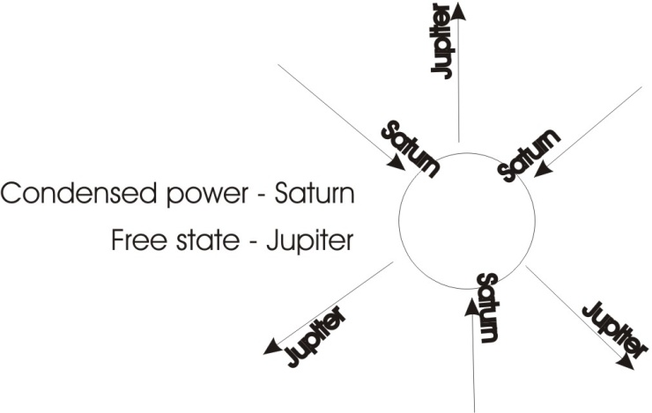
H – Spirit.
M – substance
[HA] – breathing, spiritual activity.
And the spiritual activity, turning, makes the Macrocosmos. Saturn, Sat-Urn. And that is equated with the devil, because there’s a limiting factor in it. And the other glyph means that which goes the other way to the limitation.
So we now represent the limiting function like that [by three arrows converging on point and the contrary function of it as three arrows pointing away from the point], and the contrary function like that [three arrows moving away from a point]. Saturn is precipitating on a point and Jupiter is moving away from a point. The point is brought into being by the contra-action from our conceptual sphere ... be it ever so far. And the escape from it is represented by Jupiter.
Now there’s a dialectical twist here. Jupiter is Diu-Piter, which means ‘the Father, God’, Piter – Pater. But there is a joke in it, because this fellow, this Sanscrit for your-Father-ancestor, we just change the form of the vowel to get the Latin Pater there. ‘Diu’ becomes J-U, Jupiter. God the Father is obviously the Generator. Now we put them both together and say when the force is going to the perimeter, we shall call it Jupiter, and then when the same force is returning to the centre we shall call it Saturn.
So all the centripetal movements are Saturnine, and all the centrifugal movements are Jupiteran. So there’s a movement towards freedom symbolised by Jupiter, and towards bondage, symbolised by Saturn.
Now you know that the planet Saturn has bands round it. It is therefore used to symbolise the principle of bondage. And apart from the few little bodies that are not really to be taken into account because they are difficult to detect, as far as the naked eye is concerned — well trained and in good trim — Saturn is the outermost of the solar system, and symbolises that power which binds.
Now Jupiter is a very big and expanding planet and symbolises this expansive power. And the planetary significances and correspondences, they are not meaningless. They are not even accidental. There is a real relation, because those planets are in the conditions representing the functions that these symbols stand for. So there is the principle of bondage, circumscription, Saturn.
Now Saturn is the generator of time – Kronos/Saturn ... Time. There is no time other than that produced by beings rotating, and measuring these rotations against reference points. The fingers of a clock travel round and they come to 12 o’clock, and 12 again. And they keep going round. And while the fingers on the clock are going round, the Earth is going round on its axis. And while that’s going round it’s travelling round the sun. And while the Sun is receiving the attentions of the earth, the sun is travelling round another centre, and time is simply the measuring of these rotations against each other.
So there is clock time, terrestrial time, solar time, sidereal time. There is a time as big as any rotation you can find and as small as any rotation you can find. There is time inside the atom, because even an electron has spin on it ... it is turning. When the science comes to the ultimate gross material particle, it will have a unit of gross material time which he can add up to find out the real relation between subatomic time, terrestrial time, solar, sidereal ... and so on. And it’s all a simple function of circles added together, which can be struck inside each other with a pair of compasses, quite logically, from a big circle.
So Saturn symbolises all that people in general believe to be bad for them. That is, limitation, bondage, imposition, circumscription – they’re all ‘bad’ things. And the expansion is what people imagine is a good thing. But if you keep expanding indefinitely and never contract, you will simply become tremendously vague.
Now these temperaments in people manifest — I am using ‘temperament’ in the sense of balance — between too much contraction and too much expansion there is a happy balance of forces and this depends on the level of your evolution. And this brings us to the symbol of the Messiah, where Saturn and Jupiter put together are represented by Mercury. The reason is that the force pressing onto the centre and the force pressing away from the centre produce rotation. [39:05]
So we can again represent this process. I put three in here to stabilise it because two tend to wobble about. And we put that down and say that represents ????.
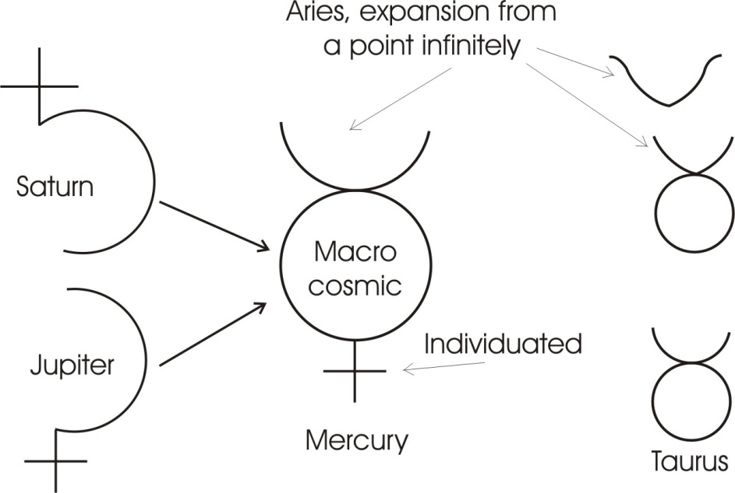
Newton, reading this stuff in Boehme, formulated his laws of motion. Action, contra-action together ... action, reaction, produce rotation. Rotation is a product of two motions ... a centripetal and centrifugal motion. So this [Mercurial] glyph is the glyph of the fellow who can balance the creative force or limiting force, and the salvation force. So he’s the Son of Man and the Son of God.
That’s [The top part of the glyph] the sign Taurus in the Zodiac, is made with the sign of the Ram and the sign of the limiting or circumscibing force. And we just go round that quickly, and that’s Taurus.
Aries, the Ram is the letter V. V symbolises this expansion from a point, infinitely. We have to circumscribe it to make it work. So the top part there means the infinite. This [the circle in the middle] means the whole or macrocosmic, and this [the cross at the bottom] means the individuated. Whilst the cross symbolises the Individuated.
So we’ll put it at three levels there:
- The Spirit non-circumscribed. [Aries curve at the top]
- Spirit’s first circumscription, macrocosmic, the circle. [Circle in the middle]
- And the cross, the physical body. [The cross down below]
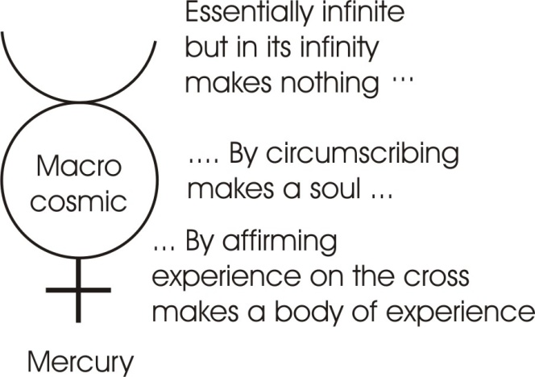
Spirit, Soul, Body. And this is the glyph that belongs to the Messiah. Mercury is the Roman version of the Greek Hermes, the Egyptian Thoth and the Hebrew Messiah. He is the man who knows when to squeeze and when to let go. He has two keys — the Key of Binding ... the Key of Loosing — and he gives these keys to anybody who studies just precisely what is the real meaning of contraction and expansion, and what it does for us in terms of self-conscious creation of Spirit which is essentially infinite, but in its infinity makes nothing, but by its circumscription makes a soul, and by the affirmation of experience in the cross produces a body a of experience, which body, then folded into the soul, is seen to be portended in the Infinite Spirit. [42:05]
Infinite Spirit contains all these little crosses in their Absoluteness. But in their Absoluteness we can’t get the relation out at the individual level. So we have to take upon ourselves an individual form, each one of us — which is our physical body — and by means of experience in that body we can inform the soul, and show the soul the potential of spirit. And the three stages would then represent:
- The non-fallen man: and that is why you will see on old Astrological charts of the human body the mark of the Ram in the forehead. Aries rules the head ... that’s spirit.
- In the chest is the soul.
- And down here [belly] is the principle of form, sex – the lady or passive, and the gentleman or active.
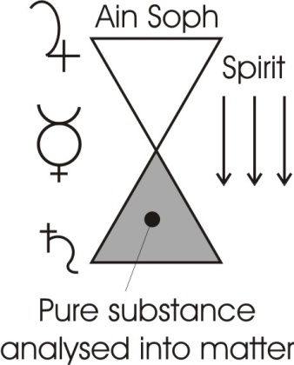
So here is the three-fold man again made into a glyph, and this glyph is the sign of Mercury. And the planet Mercury symbolised by this is actually peculiar in its orbit. It’s very, very variable. It rushes around, wobbles about, and behaves in a manner similar to a ball of quicksilver when you let it loose on the table top and tap it. It runs about, it will break into little bits and they’ll all run off on their own. So that it symbolises this quickness ... the Mercurial nature.
Now Christ was always talking about this ... the ‘quick’ and the ‘dead’. The dead are those people who are divided internally against themselves. And the internal opposition between their sub-ents, their parts out of harmony, in continuous conflict – a house divided against itself shall not stand.
And the ‘quick’ side of you is the side that can see — it is tremendously alert — what will happen if you allow a certain division to take place, and if it’s a bad thing to inhibit it before it has time to start rolling and become inertic. So this glyph symbolises exactly the opposite of the word dead. It is the quick. This is the Quick Man that Gurdjieff talks about. The Quick Man is the man that understands that in Spirit all that may appear in manifestation already eternally is. But that Spirit needs reciprocal centres in order to reflect its own activity back upon itself.
Now I’m going to draw two triangles to show what goes on. It looks like a Roman 10 [X], doesn’t it? It might be that it’s an hourglass. This [upper line] represents the level of the Supreme Spirit, and the whole of this [upper] triangle represents Spirit — that is its absoluteness — and beyond here is the Ain Soph of the Hebrews in the Kabala. The Kabalistic Ain means ‘not,’ and Soph means ‘wisdom.’ And this not means negate all that is below ...ignore it. And when you’ve ignored it all, then you will be wise in a most peculiar sense. But you can’t ignore it until you know what it is. Ignorant people do not ignore the Truth – they are just totally unaware of it.
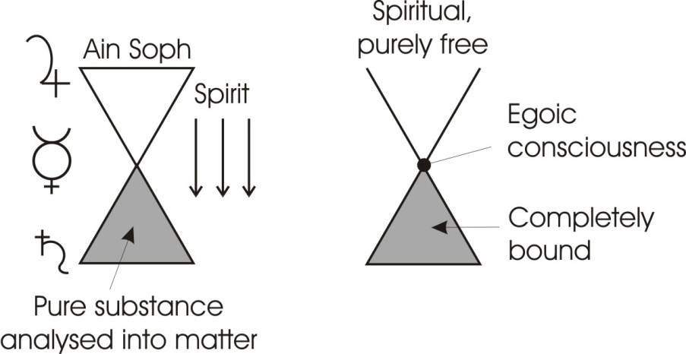
Down here [in the lower triangle] the exact opposite of the Absolute Spirit is the concept of Pure Substance. And this concept of pure substance is analysed into various types of matter, producing an atomic scale. These produce compounds, molecules which build up into various substances which produce bodies, and eventually they produce an individual.
The top level of that individual here [the point in the diagram where the two triangles meet] is the Egoic Consciousness. Now that Egoic-consciousness is the point of reciprocal relation between the substantial or mass-inertic aspect of the Absolute, and the Spiritual, or pure free ... you can’t even say state. If you say state you are talking already about what is bound. The ‘T’s in it stop it. Sta is the root Stand. Now we mustn’t use the concept there, so we say, “this is the purely free.” This [bottom triangle] is the completely bound. Here [the centre between] is the point of reciprocation between the purely free and the completely bound. So we write Saturn down there and Jupiter there [at the top], and here [in the centre] we write our dear little friend Mercury, to show who it is. [47:20]
Now there at the point of the Self – we’ll stop using the Latin Ego for the moment, because the hard G in it simply proves that the Romans were materialists. They thought, I am a gross material being [– ego]. That’s why actually they lost power, because the I is not a gross material being, it’s an Observer, and that part of it is the Self.
We will spell it like this [cel(l)f] – to remind us what it is. It is a cell in which is resident a force [F]. If we put it self, the sel means salt, which is the principle of contraction, which comes from down here. The highest point of the contracted being is this Self. And above it are the horns, which point up to infinity. And below it is the cross that belongs to the matter. And this Absolute, being infinite, has absolutely no value whatever, because value depends upon the significance of the letter V, which symbolises seeds divided [visualise the branchings of twigs on a tree ... ed]. We can’t get value unless we compare. There are no values other than those arising from comparisons, and so the concept of value requires duality. But in infinity there is no duality, and therefore there is a need for precipitating a principle of duality. And the principle precipitated is the substance, which is then carved up into fundamental matters. And then these fundamental matters are added together to make complex molecules, finally organic beings and ultimately, if we’re lucky, reflexive self-conscious beings called ‘human.’
Not just man ... man means counter, evaluator. Hu-man means spiritually-aware counter.
At that point it is possible to direct the whole course of evolution in different way.
All down here [bottom triangle] is being acted upon by the Infinite Spirit to make a Substance, which is a primary vibration. And then the intersection points of the overlappings of these vibrations become primary entities – very, very fine, finer than ones now known to the physicists. They then add up to the gross material elements we find in the atomic scale. They then add up — those fine ones are called Tanmattras in the Indian metaphysics — they add up to the Rutas, the gross material elements, which we find in the atomic scale. They add up into molecules, and they build up various compounds until they get an organic being, but it’s all being conducted in general, without regard for any single individual, except in so far as he is a step nearer reflexive self-consciousness.
That means that if there’s a ... 20,000 million people on earth, and two of them are moving towards reflexive self-conscious awareness of their origin, the Universal Spirit will wipe out the whole lot if necessary to preserve that two, because it needs these centres of reciprocal relation.
Now this is a terrible idea, because it means in fact that most people are disregarded because they are not moving towards reflexive self-consciousness. But it’s a marvellous idea, because it says, if you can say to yourself, I prefer to become a reciprocal point for the Absolute, a reflexive self-conscious being, you know immediately that the Infinite will preserve you. It will do everything it can, because you are a centre moving towards the ability to reflect back to the Absolute and say, You are, I am. You have said, I am and you are, and I am saying, I am and you are. This completes the reciprocal relation between the Absolute and the relative.
So we can see the tremendous value of the centre here – the Feeling life. There [in the belly] is your urge, your conation, your physical reactions. Here’s [in the chest] your Feeling, and here [in the head] is your thinking. [52:20]
Now there’s a low kind of thinking called mechanical thinking, which is simply the reaction of the mind to the stimulation of your five senses. There’s another kind that has to do with deliberate dealing with high concepts derived from our primary glyph. Now these are two different kinds of influence – one from outside, which is entirely mechanical and produces mechanical thoughts, and reduces you to the level always of material particles. And the Infinite has no regard for those infinite particles except in so far they sub-serve the movement towards the creation of reflexive self-conscious beings. So we have to be aware that it is in here, in the feeling, that we can resolve the relation between the bound relative and the Infinite ... the Absolute.
Here then, in the Feeling Zone, in the Soul, it is possible to judge a relation between a particular sense-datum and an Absolute Idea in the Plato sense.
The man who, instead of reacting to an idea — we must draw a Fallen Man now. Then we’ll understand what I’m talking about. I’m going to draw a man like this ... that is the inversion of this [the Mercurial Man with his ‘horns’ in the air]. This is the Egyptian hieroglyph for the letter ‘H.’ It is the eighth letter. ‘H’ and ‘eight’ are the same word. This one has got his tails, his free horns, below, and this one above.
Now you know that Saint Peter was crucified upside down for certain symbolic reasons. Here is the reason. This is a cord twisted three times, the Thrice-twisted Cord of Hermes, who is Mercury, who is the Messiah.
- This symbolises the three-fold man and his Infinite origin.
- This one says that this man knows that he comes from a spiritual source.
- This one says that the man is driven by sexual urges.
These things go down in that diagram. Let’s draw this one up here. The same with this one. That’s two men there, one rooted in matter, and the other rooted in Spirit. Now the man that reacts always to the sex stimulus is being acted upon generically. That is to say, there’s only a general action on him – there’s no care for him as an individual. He’s merely a doorway to a seed, which might be a reflexive self-conscious being in another generation. So all the men that respond to the stimulus that comes [down] here are stressed down here. A stimulus comes – a seed is made, and the seed comes out again and has another try. If we get hit hard enough and often enough, the vibrations of the blows we receive produce form.
There’s a being, there’s a stimulus, there’s the form inside, the reaction. If we get hit hard enough and often enough our form becomes quite complex. And eventually we discover we’ve got all the form of Infinity in us. And then we say, Alright, now I’m not going to react at that level, I’m going to be considerate. This is an immediate reaction. This one said, let me feel very carefully whether I like what’s going to happen to me. Let’s call this one a one-brained being ... stimulus ... reaction. Here’s a two-brain being, you go up and you feel whether you like it before you let it out. And then, when you’ve felt and become very, very sensitive, you become aware of a type of situation. And types belong up here [in the head]. After a certain number of repetitions you say, oh, yes, now I know why the Brahmin priest is not allowed to marry a red-headed woman. They are hard to control. So you go up there and you write up there, red headed women are not for priests to marry.
Up here you write all the principles, and those principles are eternally in Spirit. And so you are gradually becoming aware. And as you become aware of these principles you are transcending. But at the level of evolution of man who’s trying to evolve today, who can’t jump into that immediately, he can only do it by telling himself honestly whether he likes or dislikes a given stimulus. He must be honest. He must tell himself without any ambiguity, without any fluff, exactly as Christ requires him to do. He must say “Yes” and he must say, “No.” All else comes of the devil. If he won’t make his mind up between yes and no about any given thing, he’ll fluff about, and in so doing he will begin to disintegrate.
Now the rule is, that to every properly formulated question, the answer is either Yes or No. So if you can’t get the answer Yes or No, you haven’t formulated your question properly. In order to do it you must break the situation down quite a lot. [58:19]

[Reading out another question] There’s a little thing here ... this question of feelings of towards like and dislike: “Am I feeling pleased, compassionate, self-indulgent, etc.? How do I rely on those of liking and disliking?”

Compassion
We have to analyse them. Now if you feel very, very lazy, and don’t want to work on yourself and would like the result of somebody else’s work, you can read Spinoza’s analysis of all these things. He worked it out quite well. How simple ‘liking’ — a feeling — plus a certain idea, and the situation, added together equals compassion. How many elements are there? There is a feeling in compassion. [Com-passion = ] and with and suffering. With suffering. Somebody is suffering. I am with them in my feeling. That is compassion.
So here is one fellow, here’s another fellow. This fellow is on the cross, this fellow isn’t. This fellow looks at that fellow, and the vibrations of this man are going out like this, and if you’re very sensitive, you can feel the cross in yourself that really is centred in that man. If you then say, “Alright, I expose myself to this feeling.” And then I say, “What would I do if I were in that position ... what would I like done to me in that position?” And then you proceed to do it, and your compassion becomes effectual.
So it’s still liking. “I like to do something for that man, because he’s in a position which, when I feel it in myself, I will dislike.” So we can then cut the thing down and always find like and dislike. No matter how complex the situation, we will always find a relation in it that will break down and tell us exactly what it is. And then we can give to each part of it, on analysis, a simple Yes, and a simple No.
“I wouldn’t like to be crucified like him. Here is the shadow of it. I wouldn’t like it to get more intense. Already it upsets me, and I am not actually in the position. The mere idea that I might be in the position makes me shrink. I would not like to be in that position. And because I know — or at a lower level, simply believe — that the whole Universe is somehow related together, and if I refuse to help him, at some point in the future it might happen to me. If it happens to me and I’ve refused to help him, I am not logically justified in expecting somebody to help me. Therefore, I must give an unqualified YES to aiding him, because I give an unqualified NO to myself not being aided in the same situation.”

Advaita ... the Non-dual
Now if you persist in that kind of analysis with the most complicated feelings you will find you’ve still got two feelings plus an idea situation. Break down the situation, look at it, analyse the functional relationship between the entities in it, and you can then cut it down to a liking and disliking. And if you remember, the Supreme represented by the Aries sign, or the ‘V’ at the top of the Mercury figure, symbolises the Non-dual. This is going to infinity. And in infinity there is no difference whatever between any of us. And that same infinity, that non-differentiation — the Advaita, the non-dual analysis of Shankara is dealing with this — the same Infinity precipitates the finite and particular, a series of such, all precipitated from the same Infinity. And it is trying to lift them up to the level where they are aware of it. But because the supreme value to the Infinite is beings that are aware of it, it by its nature cannot have regard for them as individuals if they are struggling away from that process. It’s not that it arbitrarily interferes with them to punish them. It doesn’t. They punish themselves by running away from it. [1:03:00]
I’m going to do another version of this diagram. Let the centre represent a seed. Let this [perimeter] represent a limit, and to give an evolutionary period of time let this [radius] represent a direction. This SEED — S-D, Spirit Dividing; this Seed, this SAMA; English word same, Sanscrit sam; seed ... Spirit Substantiating, Spirit Dividing. When a seed exists there are forces in it trying to differentiate. And to differentiate is to make differences. So a man is very busy making sperms, and they’re all different. So that if he has 10,000 children they will all be different. Being different, they will be functionally adapted to different environments in different ways. So consequently when the seed is differentiating, some of that seed’s differentiated parts will point in this direction. They’ll all split up – if you keep on having children you will find they are all different — and they’ll all go on differentiating. And out of all those directions, only one of them is going back to the Absolute, and half of them are going away from it.
Now let’s call this the line that evolves towards non-dual consciousness. And we can see immediately from the nature of the seed, the seed differentiating, produces human beings that are moving in all different directions.
And yet the supreme value to the Infinite is to gain some reciprocal centres that become aware of it. So only this line is important individually to the Infinite. So along this line is the line of the Messiah. There is Ab-Ra-Ham. That is the Father who is the differentiating power of the substance. Abram. The Father Ab, the Son Ra, the Ghost Ham ... Ab-Ra-Ham. Along that line, Abraham, Isaac, Jacob and so on, up here, David, and eventually the Messiah, who is the perfectly reflexive self-conscious being, the type that we have to become. And yet all the beings on earth are differentiated, which means literally that millions of people are not going along that line ... from the inherent differences of the egg.

Monism
Now next to it are the Kings of the World, who are not going towards the Non-dual, but they don’t want to go down here into slavery, so they go towards Monism. This is the non-dual over here.
“I and my Father are one,” says Christ, “And you’ll be one with each other, as I am one with you and we are one in him.” It’s a non-dual statement.
The next thing to it is monism. There’s another one, this one over here. We’ll call this a spiritual monism, and that a material monism. Both are hierarchical. One gives rise to the church, with all its authority, with the Pope on the top ... a terrestrial figure. And the other gives rise to Marxism, a hierarchy of material powers. They are power pursuers. They are monists. They believe in a hierarchy, but they put the top brick on the pyramid, and there never was a top ...

[... break in recording.]

... special way, like a suit to fit the wool. And that process of caring is always tending towards differentiation because it is not going towards the non-dual absolute relation.
If we go down here into the opposite of this non-dualism the perfect dualism of the opposition between matter and spirit. Those people believe that Spirit is one thing and matter is another.
We can place all round here [the outside of the diagram] various processes which work out into different philosophies. This would tie up with another diagram we did a year or so ago, and you could then build your philosophical systems in it. At the moment, the essential thing is to realise that either you are on that line or not, biologically. That is, there is a seed tendency in you, or not, to want to deal with every being absolutely, instead of relatively. That is to say, there is no difference whatever between myself and yourselves — there aren’t selves, there isn’t even self — it is Super Self. And all these little bodies are precipitates within it, and they all have to be treated in exactly the same way. There can be no taking advantage of anybody whatever if you are on that line. And if you have any tendency in you to wish to get power in order to take advantage of any other beings, that tendency doesn’t belong on that line.
That looks very much as if we’re moving towards Calvinism if we’re not careful ... or towards the chosen people concept. But we are saved from this by a fundamental fact. Spirit is not made of discrete parts. It is absolutely continuous, and therefore it is in no sense to be separated. So if there is any spirit in you at all — and there must be, otherwise you cannot subsist — then it follows that you have all these tendencies in you. And therefore there is in every being a line, which, if developed, will lead to the non-dual consciousness. But unfortunately — we will now represent this middle line — unfortunately, everybody below this line [on the diagram] is suffering from mass-inertia, and doesn’t understand that there is such a possibility. And everybody above that line — except this particular direction — believes in authority over the masses for their sake, because they have no order, so they’ll have to be taken care of. So we set up a monistic view. We will deliberately teach that a God exists, whose eye is on the sparrow, and I know he watches me, and I am his representative ... two dollars please! [laughter from audience]
This process goes on with the Marxists on the one side, and the right wing church hierarchists on the other. They believe in Spirit, because they know they’ve got something that these people haven’t got. They don’t want to take the final step to say that matter is only a mode of operation of Spirit. And so even those perfectly stupid beings are spiritual beings, veiled by inertia.
Now the chemistry of all parts of space is the same, and spirit is not differentiated. Therefore, we are all of us, each one of us, centres of Absoluteness. And all our differences are the products of stimulations which have given rise in us to sub-ents ... to subsidiary entities which are represented by these lines [diagram]. Which means that we have a sub-ent that’s going to God, only he is a Super Sub-ent. And we have some other sub-ents that are very, very ready to be helpful, and push everybody about, and keep them in order. And we have lots of others that say, “Oh, what the hell, I’m going to bed now....” [more laughter]
So let every one of these lines [diagram] represent a sub-ent tendency, and we will find that we have a certain sub-ent in us which actually contemplates this Non-dual, this absolute preparedness to treat every being as if it were a precipitate of the One Being that this sub-ent knows it is. Then you have a concept in you — a conceptual being — that is a non-dualist, the highest metaphysics ever produced, considered by the Indian priests too high to give to the masses, because the masses were too low to receive it. And you cannot bring it down – you cannot go to a football crowd and start talking to then about the Advaita of Shankara – they just won’t know what you’re talking about. It takes quite a lot of work before you can understand what non-dualism means as opposed to monism.
In Monism you have a concept which requires circumscription ... call it God. Alright, that’s God – and there is the archbishop – there is the King. There is a little difference of opinion between the King and the Archbishop about which one is on the side nearest to the power of God. So they hold a little agreement called the Divine Right of Kings by the Grace of Archbishops. And then inside here, nations and peoples and so on. And so they say, “You obey the king, because God has said — through Paul — ‘Be ye subject to the powers that be.’” And they are monists ... they like God to exist. Because as Comte said, the Positivist, “even if religion doesn’t exist as a truth, it ought to exist as a social necessity for unity.” If God doesn’t exist we will have to invent him, because people need him. That’s that God – that’s Monism.
The Advaitists say, “Alright, that’s God. He exists, yes. There is a macrocosmos. There is a microcosmic limit — rub it out. We are not interested ... that’s spirit ... that’s spirit, spirit, spirit, spirit ... all is spirit. And all bodies, all universes are functions of spirit, and nothing else. And we prefer to consider everybody as a function of spirit, because we feel better that way. Because then we are relating our Cells all the time to ourSelf.” If you can get that response out of a person that means they are one with you in the idea and in the understanding, you feel better than if you don’t.
So the Advaitist says, “Alright, we will get this. We will ignore all forms as valid in their own right, consider them as functional modalities of spirit ... and it is the spirit we are interested in. You can have your God. You can have your divine King, with archbishop’s blessing, and you can have your subject masses, but we assert that they are all modal operations of a hierarchical system set up by the Infinite for its own purpose of producing reciprocal centres to become self-aware at both ends – that is, Absolutely and relatively.” [1:15:10]
The Rabbis say, “Infinity is both ends”... and it’s a good image ... because if there is the earth [diagram] you can move towards the earth that way, centre, but you can also move away from it like that. And you can move away from it infinitely. So here’s one end, and there’s the other end. Because if you move away infinitely, you should be able at infinity to move back to the earth infinitely. So the Rabbis say, “Infinity both ends.”
So in the same way, non-dualisitically, we say that body of my dear friend Khen, and this body, and all the other bodies in the room are simply little vibrations in the Absolute. And to pretend that one set of vibrations is more valuable than the others is confusion. Because in realistic fact, if you gave Khen a smack with a steam-hammer such as to disperse the motions of his body so that he would no longer be recognisable, you could not have destroyed one tiniest bit of the motion which had been compounded as Khen. And consequently Khen would have been dispersed, but he would be still vibrating in the Absolute and those vibrations must go to a term, and they must come back onto the gentleman that wielded the hammer. That is a Law. Every impulse goes to a limit and comes back. This is the doctrine of Karma ... that a desire released differentiates itself, goes to the term, and returns to the point of initiation. This has to be accepted as a necessity of a universe at all, a One-turn, a Uni-verse. [1:16:58]
And so here, this diagram, which is the two and seventy jarring sects confuted by the vine, as Omar has it – is two and seventy because it’s the signs of the Zodiac split in a certain way. You get six and twelve, and functionally together and get seventy-two jarring sects. There are also seventy-two jarring sub-ents in your body, because man is a microcosm ... he is a universe in little. There is nothing outside man that is not in him, and if there were it would be a waste of time, because he couldn’t know about it.
So we look at this diagram, and in order to evolve quickly, we must say to ourselves at any given moment of the day, “I have an impulse in me. Is it an impulse that is based on my non-dual concept that what I am doing is myself, to me?” That there are no other selves, plural – there are only other bodies in the Self. So if I gained reflexive self-consciousness awareness, and Khen gains it, we won’t have two selves talking to each other at the top. We will simply be aware down below that we are absolutely one above. We keep our duality of body, because that’s the basis of value-relation ... to keep the duality of body. But we know that at the top level we are identical, not just two chummy souls.
Now, we test ourselves in any given situation by saying, “Is this a non-dual sub-ent speaking, or not?” Now most times when we listen we’ll find it is not. We will find down here there’s a gentleman called — what’s he called? — Pally. He’s always been pally for the wrong reason, this fellow. He is always splitting. He likes to posit seeds of power all over the place, and he has no regard whatever for the recipient. He is just getting rid. He doesn’t want a personal relation at all. As a matter of fact, concrete example exist, of this, in Ritzes [ballrooms] in various towns, where a certain type of young man goes at eleven o’clock when it’s about to stop. He doesn’t go for the evening’s dancing. He goes at eleven o’clock and it’s letting out time, and he watches the girls to see which girls are in what moods, and offers to take them home. And he actually says, “And I didn’t even have to pay for it at the beginning.” This is this kind of fellow. He exists. He’s part of the process.
In Pope’s Essay on Man, whatever is, is right at its own level. He’s doing something. He’s fulfilling a long felt want at a certain level. And there’s a sub-ent in every man that would do that kind deed very often, as long as it had the strength, and even sometimes when it hasn’t. And that sub-ent has to be recognised ... it’s the exact opposite of this other one. This one is positing dualities all over the place. We have to learn to recognise every sub-ent we’ve got, and we can only do so with our test one. This is the one we want. The nearest thing we will get to it for some time — this very high monistic fellow who believes in Non-dualism as an ideal for tomorrow — meanwhile we are getting on with the acquisition of power, and helping these unfortunates down here to be put safely in jail for their own good, and so on.
When we find that we’re getting egoistic power impulses, we know that we are not very far off the non-dual concept. Because we are beginning to affirm the monistic analysis – a hierarchy with ourselves as King, Self-blessed by Self-priest, and we will establish a hierarchy. We know then we are being monistic. And we know then that all that’s left to do is to rub out that boundary, and affirm exactly the same for every other being who is just as perfect as ourselves. He too shall set up a hierarchy in which I shall be a sheep, and my wool shall be picked. In fact I must sell him a pair of scissors to cut my wool with. This kind of reciprocal relation brings us nearer and nearer to this non-dual analysis. This is the one that Christ is on. This is the one that the Best sub-ent, in its real sense, is on. [1:21:51]

Good Better Best
Good, Better and Best – so there are three stages. Good is always very nice but there is better and best.

- Now, GOOD belongs to the gullet, the GOO-lit, this department [the belly].
- BETTER is the house of Law – beth tora [Head].
- And BEST belongs in here. That’s the feeling. The -ES- is pure being – and that being is this feeling-awareness which embraces this.

This is the diagram of fallen man, who thinks there [in the head], has urges there [belly], but can be saved by refining his feeling [chest] to examine his ideas in the light of this non-dual process.
- So the Good is there [belly] – that is in us.
- The better is the good idea.
- The Best is simply to be in feeling, sensitive to the whole process. [1:23:07]
So we come back to this necessity for feeling; and that feeling contractions create ideas; that an expanded idea will give rise to a feeling; that if you analyse very, very carefully all the ideas you’ve got – and all the complex feelings, you will come down to very, very simple forms of liking and disliking.
Let’s now have a look at a few bodies now [Diag.]
- Here is a body which simply absorbs food. That’s the belly body.
- Here is a body which is aware of liking and disliking food [Chest].
- And here is another body [head] which thinks about the kind of food that it likes and dislikes.
That’s a three-bodied being. Now remember that matter is simply a modal operation of Spirit, and then that is a three-brained being. BRAIN is B – house, RA – ruling activity, IN.
B-ra-in ... ‘the house of ruling activity in.’
So here in the head you have a special brain for thinking and collating all the processes in it. Here [in the feeling] you have another brain, and down here you have another brain [belly]. Those are three brains or ruling centres. Now the theosophists and others, various systems, have complicated this and produced weird and wonderful assortments of bodies. We’re going to make it very, very simple and then see how the differences arise from the simple version. [1:25:00]

Causal Gross and Subtle Bodies
This one [belly] is concerned with the gross assimilation of food.
This one [head] is concerned with the subtle idea.
This one [chest] is concerned with the Causal, which is Feeling.
This is very funny because we always get this causal one coming in the middle. Because the Field — we said the D was a limit — starts from a centre, spreads out to a limit, which limit is determined by other centres. Really, it goes through, and all these processes are in a Super Field which extends infinitely. The control factor comes from this [feeling] centre, because we won’t think unless we feel like thinking. We won’t eat our dindins [childish version of dinner] unless we feel like eating them. And so it is in this Feeling process that the cause of our actions rises.
So the Causal body is the Feeling body; the Subtle body is the Idea body; and the Gross is your actual material body which you get by dropping particles of external terrestrial matter down a hole in your face, whereupon they are di-gested, or cut into bits, altered a little, put into fluids, raised up and made to circulate. And after they have gone up and down a bit, they collect at the bottom in little seeds here for future performances.
Now because the Gross body and the Subtle body are what they are, to link them you must have feeling. But the Gross level is entirely urgeful. The Psychologist would call that Conation. That ‘con’ was once a rude word. It means rushing into holes — this urge — always running into cul-de-sacs, and it’s never negative. It’s a funny thing about this energy: it is either asleep, or if it wakes up, it is always positive. It never says, “No.” This energy, this sexual drive, either sees the thing is worth going at, or it goes to sleep. It can’t wake up and be bothered to say, “No.” If it wakes up, it has said, “Yes.” So that’s an entire positive urge down there.
And the opposite of it is a pure negative. Now the Buddhists said that the Brain, the mind, was the organ of fear. This urge drives you into situations. The situations are roughly that shape, it dashes in and bangs up there, and finds it can’t get through and retires for a fresh try. When it finally gets fed up with the results, the reverberations here have produced subtle changes, called ideas, which are up there [in the head] and they are recorded as things that won’t work ... things you can’t get away with. So the brain is full of wonderful things you can’t get away with, that you have tried. So it is a negation function.
And in the middle, here, is the pos/neg, the Yes and the No in the Feeling. But these differences were potential in the field. So the Field is the causal one which has, by feeling awareness, mobilised itself as urge. Will is mobilised Feeling. We use the word will when we talk about the point of initiation ... when the Field which is balanced, suddenly mobilises itself. At the point of mobilisation it is called will.
So the field — which is balanced in a certain way — disturbs its balance in order to create. That produces this Urge. The Urge rushes into experience reaction. The reaction of the environment produces thought. So there is the cause.
Now between this feeling and this Urge there is the creation of another body. There’s your navel: below the navel are certain functions. Above the navel and up to the solar plexus there, say up to the diaphragm roughly, there are functions. The Greeks call this the Epitum here. This is the Red Dragon. You will notice that between the navel and there, there’s a certain function to do with anger. If you feel very carefully, when you are annoyed you will feel a process going on between the navel and the solar plexus. This is this brain here, and the top part of the urge is becoming aware of itself. The bottom part of that urge just is unconscious. It just rushes. It has no idea of pleasures or pains. It can actually rush at a wall with its head and bang its head repeatedly, and it has no pleasures and pains. If an ordinary person goes into this state and he’s examined by a doctor, he will be assumed to be a pathological case, because ordinary people respond with pains in such situations.
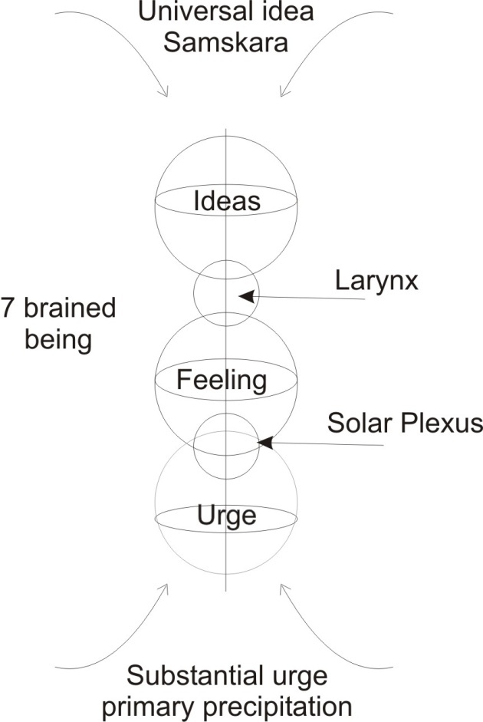
But this lower element of the drive doesn’t – it just goes at it. It keeps going at it in order to get sensitivity. So if ever you find a person banging his head against the wall, don’t be sorry for him because it’s his method of learning how to become sensitive. It means he’s reached a pitch where his only way to sensitivity is to beat his head on the wall. That’s the level at which he stands. And at that point, if you substitute for the brick wall a padded wall, he will hit harder and harder and harder, and you’ll have to make the pad softer and softer and softer. And it’s really a fight between your concept and his.
Now, the lower feeling here is concerned with this Urge. And the higher feeling is concerned with the lower idea. So we have here another brain, and this one we’ll say is situated with the larynx as a centre. You know how tremendously emotional the larynx is. You can see all sorts of funny activities going on. And the thyroid gland are closely linked to the emotional life that is. But it is the emotional life linked to the ideas, as opposed to the emotions linked to the urge.
We’ve now got a five-brained-being. Now the average man doesn’t know that he has five brains ... he doesn’t even know he’s got three brains. And a good intellectualist thinks he’s got three brains, and thinks he’s got the top when he’s an intellectual. And really it’s quite a low order compared with the kind of activity that can go on in here and here. And even those are low compared with the activities that go on above there and below there.
This individuated urge — which is unconscious — is a particularisation of the substantial urge, Primary Precipitation of the Infinite. And the opposite end of it — the idea individuated, particularised, the individual idea — is the lower part of the Absolute Idea.
So now we’ve got seven brains.
To climb from one to the other, you have to become aware. Everybody starts like a baby – they rush at the situation ... they get knocked. That knocking causes reverberations up to his conscious limit. It writes things in his brain substance, and then the reciprocal relation between I want and thou canst not have — as Daddy said — produces feelings in the child of, I love my din-din, I hate my Daddy, and so on. On the other hand, I love my Daddy on a Saturday because I get a penny, and I hate him the rest of the week because he gives me nothing. A Psychologist would be aware of this ambivalence in the child. The child always loves everybody who gives him his own way, and he hates everybody else. And this is the level of the gross reaction, producing the most rudimentary thought. And the feeling analysis of the child is such that the child grows with his wants ... and the negation of his wants. [1:34:14]
So if we can become aware here of the feeling about the urges, we are learning about another brain that we don’t usually know about. By brain I’m talking about a zone, a house of ruling activity, internally. And these centres actually have vibrations here, very peculiar ones, which are not quite like the gross ones, not quite like the conscious feelings of the individual, but they allow you to feel what your urge is trying to do. And the same way here, the feeling about what your ideas are trying to do puts you into these centres.
And the idea individuated, related to the Absolute Idea, puts you into this centre. So the top of your head is a point, the Samskara, the thousand petalled Lotus. That is the one point at which the individuated idea becomes related to the Absolute.
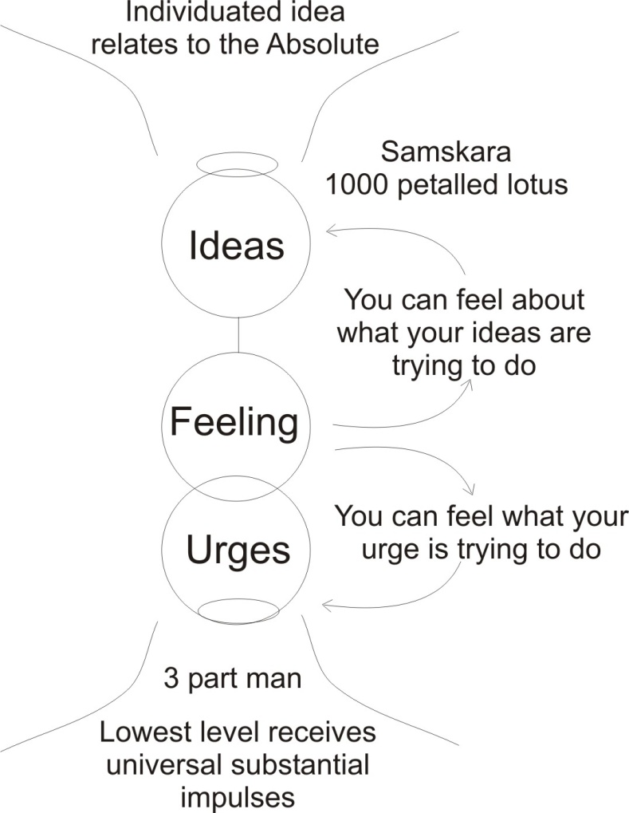
Right down here, at the lowest sexual level, is the part of yourself that is receiving universal, substantial impulses, which don’t even become pleasurable or painful. The physical sex act itself is so inter-woven with pleasure/pain that they cannot be sorted out at that level. The intensity of the pleasure and the pain is identical, and it cannot be sorted out. That belongs to the lowest part, because the substantial urge is coming in and enjoying itself ... but the individual is being subjected to it and knows it. The pain is the individual’s. The pleasure is the Universal substance getting its own way. So when a man feels that urge working in him — say, at the point of ejaculation — he feels somehow that he’s been taken advantage of by somebody. And he was – the Universal Substance. The pain is his. The pleasure is the Universal Substance’s. If he participates in the pleasure of it at all, consciously, it must be because he says, “I’m doing a universal job.” And he is ... at that level.
Now in that diagram you can see the whole mode of conscious evolution. You know that you have gross urges.
Say, you’ll have your dinner one day very happily, and another day you won’t feel like it. [1:36:45] Right. So you’ve an urge to get your din-din. But feel just why that urge is there now. Say, “Well I’ll have it in five minutes ... or ten.” If you said this to the average man in an office who is used to having lunch at a certain hour – “Wait ten minutes” – immediately, his digestive juices go whishhhh and he gets terrible indigestion ... because he’s a machine ... a digestive machine. And if you say, “wait a minute,” he will feel awful, and all kinds of funny processes will arrive here in this part, and around here on the solar plexus he’ll become very perturbed, and he’ll think he is going to lose the whole world. And then he’ll begin to get annoyed with you.
And the comfort mechanism in the average person is so strong, that rather than admit that he is a slave to such a rhythm, pseudo-reasons are fabricated and send energies up here looking for little ideas to support why he should be regular. All those are mechanical processes. If you want to find out just who you are, you must break such things — if it’s only by five minutes — because in that process of breaking the rhythm you can feel what you are up against.
When you’ve broken down the relation between feeling and urge, by not allowing an urge to operate for a few minutes, then go up here and take your feeling and try to feel what an idea signifies in terms of liking and disliking. Every idea that you have, you like it or you dislike it ... in its totality, and in its parts. And the amount of liking and disliking is entirely a mathematical problem. If it’s a complex idea, every element in it you must say either Yes or No to. There may be fifteen yesses and twenty five noes, and you will be slightly ambiguous. You will say, “Oh, I don’t really much care for that one.” But if you analyse it down to its fundamental elements, you will says, “yes,” “yes,” “no,” “no” to different parts.
So that when you’re feeling I like and I dislike particular ideas, you are creating this centre. You can’t create it any other way than by feeling why you like ideas and dislike them, and breaking the idea down to get down to the fundamental liking and disliking. [1:39:22]
When you’ve got those two functioning, then you can really turn back on this [belly centre] and see it for what it is – a Universal, substantial reproductive energy coming through the individual organism to make more seeds. Don’t try at that level to chop it ... because you can’t at that level. But just see that there is definitely a non-individual tendency. You can see why — because everybody’s got it. So it isn’t merely individual; it’s a universal thing. It isn’t clever – everybody does it.
And then you go up to this end [the head] and look at the individual idea and the Absolute Idea, and when this one [the head] becomes clarified, this one [urge] becomes more under control spontaneously. You can never control that [lower] one on its own field, because when you put your mind down there, the whole of your energy slips down the body, goes into the substance, and increases the seed output. When you go up here [head] and consider the idea, the same energy there [belly] is translated up here [head], changes frequency, and becomes the supreme organ of thought ... of ideas related to the Absolute.
So there is your process. First, be quite sure that you know what a gross urge is, and then about what an idea is – like a triangle, a square, and a particular idea like a chair, telephone, and so on. Then go back and see if you can feel your urge, then see if you can feel your idea, until you can really do those things consciously. Then go back onto the sexual one, so that when it operates — it could be in little tendencies or big — when it operates, just say, “Yes, it is not mine, it is something working through me,” and make yourself quite sure that it isn’t yours as an individual, it is something working through you. And make no attempt to control it from the individual end, because if you do you’ll get reactions that will surprise you. All you’ll do is feed more energy that was up here into the substance and increase seed output.
What you do is, when you’ve become quite aware that that is so, you just say, It is so! Then you go back up here and look at the individuated idea of the Absolute, and try to see all the individuals as particularisations of the Absolute Idea. And gradually the energy will stop going into the substance, and build up here, this spiritual awareness. The energy then drifts slowly up here. Never try to force it from the individual end, because if you do it will hit back at you much harder than you could possibly imagine, because you are dealing there with a force down here [belly] which is justified by this one [head]. This one [higher one] precipitates this one [the lower one] and jams man between the two to force him to evolve onto reflexive self-conscious level. And it can only do it by increasing seed output until an organism is created which becomes aware of the problem. When the organism exists which is aware of the problem, then the energy can begin to rise up, and will do so spontaneously without individual effort.
So there’s a seven brained being for you.
Go back to the three. Realise that the mechanical part of thinking, here — the messages in the five senses — can’t help you to escape from the external world, because it’s fed always from the external world. The only thing that helps you to escape that is the consideration of the beth influences, the introvert ideas derived from the absolute vibration in the upper part of the mind. If you put the consciousness high up in the brain generally, there, and when commanding, you centre between the eyebrows, but you keep it high so the lowest point of it is between your eyebrows – you will find that this gradually here forms an awareness ... even over the head. At certain levels of it you will actually find, if you put your hand there, there is an aura of heat all round the head. That can vibrate to the point of becoming visual and make one of those lovely saints’ halos. It becomes quite visible and flashes about when it’s starting. Before then, it becomes very, very hot ... not subjectively, objectively. There’s a real heat over there that anyone other person can come, put their hand near it and they will feel that heat.
It’s funny how the whole thing develops out of the Logos concept ... quite spontaneously. So that there’s no effort required once the concept is there. It works, and you have to let it work. The moment you start from the 5-sense end — the sense data — and dictate to that master concept, it shuts up. It won’t have anything to do with external dictatorship. It just stops. And if you allow it, it just flows out and makes a pure exposition of its own function.
It does it in any brain where the 5-sense contribution is suspended.

[break in recording]

... the relation between your feeling and your urge, and universal urge. The relationship between your thought and feeling, and your feeling and universal thought. It’s always this feeling that’s got to be shifted about. As soon as you get a feeling and go like that, you’ll find the limit existent. That’s a definition. If you refine your feeling it slips out, and you find another definition: spheres, one within the other. They have definite edges, and those edges can only be found by feeling. That’s the meaning of the Taoist statement: If you can be a man — that means a counter — and yet remain a woman — that means a feeler. So you have to extend your field all the time and yet be clear enough — not vaguely feeling — clear enough to know what you felt. And when you can verbalise what you felt, then you’re a man/woman. That’s the divine Androgyne. And then you are entitled to wear the badge of Mercury on your lapel.
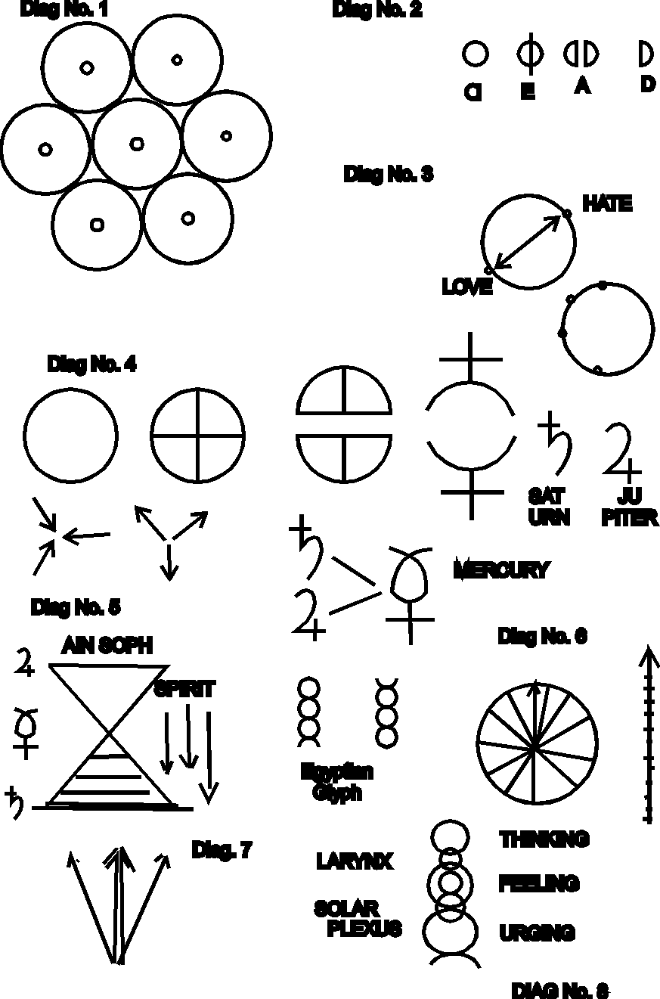

Malachi 1:2-3 I have loved you, saith the LORD. Yet ye say, Wherein hast thou loved us? Was not Esau Jacob's brother? saith the LORD: yet I loved Jacob, And I hated Esau, and laid his mountains and his heritage waste for the dragons of the wilderness.
Mat 21:22 And all things, whatsoever ye shall ask in prayer, believing, ye shall receive.

