Hierarchy.
A talk given by Eugene Halliday
Contents:
Hierarchy. 2
Environing Forces. 2
Irritability of Protoplasm. 3
Taxism and Tropism 4
Particularised Response V. Transparency to Stimulus. 5
Ignorance – Wilful Disregard 6
The Yogi 6
The Fool. 6
Fate and Destiny. 6
Freud, Hegel and Schopenhauer. 7
Nietszche 8
Hierarchy Inside a Man. 8
Protoplasm and Environment. 9
East-West: Subjectivity-Objectivity. 9
The History of Influence. 11
Marxism. 12
The Natural Hierarch. 13

Hierarchy.
A talk given by Eugene Halliday, transcribed by,
and with arbitrary headings by John Bailey.
The drawings and tables aren’t originals,
and all editor’s notes are in square brackets [ ].

We have a very nice question here. Somebody has been thinking hard.
Considering the mechanism of social hierarchy, the analogy has been made with the behaviour of lumps of coal in a bucket, where it could be observed that on shaking the bucket, large lumps of coal rose to the surface due to the smaller pieces falling down. This poses the question as to why some people are large lumps and others, small chips. This could lead to a fatalistic conclusion. What is the true position?
It’s a very good question, actually, because it does indicate that some thought has been going on about the dynamics of hierarchy. When we shake the bucket of coal, the reason the big pieces come to the top is because, although the forces of gravity are acting downwards through the space where the coal is, when we shake it, we introduce a lateral movement. We tend to throw the pieces of coal outwards, and this frees them from their immediate contact with each-other. And in the free, relatively free state, spaces are created between the lumps. And as gravity is still acting on the whole lot, the smaller pieces are taken to the bottom. They fall through the spaces that are too small for the big pieces to small through ... fall through. [audience laughter 1:27]
The question wants to know why some are big and some are small, and whether there is some fatalism in this.

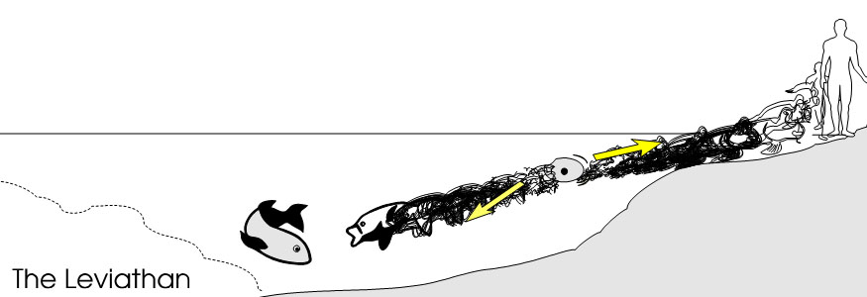

Environing Forces.
Supposing we change the image here. This bucket is now, if you like, a pond. Accept that this bucket has been changed in shape ... it’s a bit like a lavatory bowl now. Now, the water on the Dexter side here is shallower than it is on the sinister side. If we start by positing a primary mono-cell, that’s in the water — like an amoeba swimming about — that monocell, as it divides in order to duplicate itself, is gradually going to fill the space inside this body of water which is of different depths on the right and left. So that as it is moving towards the sinister side it is moving into deep water, and we might think in the evolutionary sense it is turned into beings that can swim about in deep water. It is turning into fish-like creatures. [02:45]
But as it’s moving towards the shallow part, it is moving towards the land. It is learning to adapt itself to a life on the edge of the sea. And we find that on the edge of the sea actually, they develop a kind of life midway between the land animals and the deep water fish, and out of these gradually appeared some little beings that crawled out of the sea onto the land. Those of you who remember the little records of the fish in the nuclear experiments somewhere in the Pacific, after being duly radiated, instead of going into the sea they came out of the sea, ran about on the land and started climbing trees. This presumably from some change in the elements inside the nucleus of the cells in these fish.
The point is, that as the environment itself is unequal, and the reaction to the environment is stored up inside the beings, those beings that move towards the land are going to develop by adjusting themselves progressively, until eventually they become land animals ... and eventually bipeds. And down here is the great leviathan, living in the deep water. [4:08]
Now it’s obvious here that there is no question of fatalism at all. The life, striving in all of these life forms, is identical. They all have the same life. What they don’t have is the same environment.
So now we have to decide, simplify it considerably ... supposing we have an egg here, and this egg divides itself and becomes two eggs. The two halves start to move away from each other, and now one has gone into shallower water and the other into deeper water. There’s nothing whatever to stop either of them deciding to change their direction ... for the one in the shallow water to go towards the deep water, or the one in the deep water to go towards the shallow water. They are not fatalistically determined to do so. What is certain is that when they do move in a given direction, they will be subjected to a certain environment which they have not examined before they’ve gone into it.
So those that moved towards the deep water and became deep water fish are responsible for having done so. They have freely swum in that direction. And the other parts of the same egg have freely swum in the direction of shallower water. So we see no fatalism about this, because they were initially free to swim in either direction. But once they have swum in a given direction, they have exposed themselves to different environing forces. [5:43]

Irritability of Protoplasm.
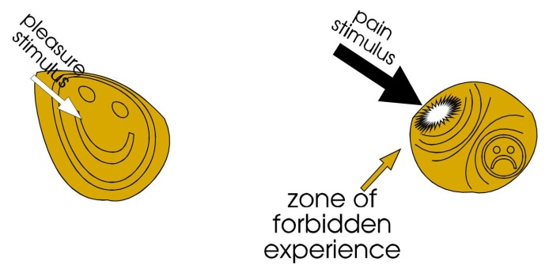
Now, let’s go back to our definition of the essential quality of protoplasm. You’ll remember it ... it’s called irritability. Now, irritability is no more than the tendency of the protoplasm to respond to an energy input called a stimulus and to retain within itself the energy input, and modify itself with that energy, and retain this modification and use it in order to react to future occasions of stimulation. So if we say here is a monocell, here is an energy input called a stimulus. The stimulus energy goes inside that cell and consequently the cell is changed. It cannot be the same after the stimulus as it was before it. It has involved the energy into itself. [6:43]
Now, if the energy comes in at a certain rate, it goes in very, very easily and the monocell here lets it in gladly because it energises it, and enables it to act more efficiently. If the energy input is very, very strong, it may be too strong for the given cell to assimilate safely, and it starts to break down. Now, as soon as it feels itself breaking down, the energy of the cell moves back onto the centre of excessive stimulation, and tries to stop that energy spreading. And it makes for itself, in the process, a zone of forbidden experience. This is how, psychologically, we inhibit unpleasant things.
Here is the stimulus. There is the energy of response coming to meet it.
Where two forces cross, intersect, oppose each other, there is a rotation.
So the stimulus energy comes from outside. The going-to-meet-from-the-centre energy comes from inside. The two together fuse, rotate and create an experiential zone. Now, all fundamental predispositions of action are built up in this way. There is no overruling force — a god or other intelligence — ordering about any particular being in any particular direction from the beginning. [8:20]

Taxism and Tropism
The essential quality of the cell — of the protoplasm — is that it moves in a direction which when we used ourselves as guinea pigs and test it, is towards pleasure and away from pain. This means, towards that which will increase our being, and away from that which will destroy our being. It is customary amongst the biologists to talk about taxism. A taxism is a tendency to move towards or away from a stimulus according to whether the stimulus energy is assimilable or not. If the energy input is pleasant and increases the performance of the being, it is called a positive taxism. And if the energy input is too great for assimilation, and begins to break down the tissue, it is called a negative taxism.
From this very rudimentary beginning it is possible to build up a complete explanation of the behaviour of a complicated being like a human being. But in the case of animals the word taxism is used. But in the case of plants the word tropism is used. [9:40]
Tax of course is the same thing in taxi and is from a word meaning motion. The trop in tropism is tropain, to turn. When you see a sun-flower turning as the sun is travelling through the sky or the earth is rotating on its axis, this is called tropistic behaviour.
And there are a series of very simple terms to aid the mind to think about these things very clearly. Thus we would call a plant that moves toward the light — towards sunlight, specifically —positively heliotropic. Some say heliotropic [pronounced hell- instead of heel- ]. Now to grow towards the sun is a heliotropic action. To grow towards the darkness — away from the sun — could be stated in two ways. When the root of a plant grows down into the earth it could be called positively geotropic. It is turning towards the earth. As the earth is generally damp when roots are moving towards it, and it is pursuing moisture, it could be called positively hydrotropic, moving towards dampness. If it is moving away from the sun, we would call it negatively heliotropic. Certain types of leaves will turn their sides away from the sunlight. [11:13]
So if we use the two terms we could see a very simple illustration of them in a human being. The human being’s head, fixed on the spine, has a pair of ears on the side — except van Goch — and there’s a muscle going from the ear on the side of the head forwards to fasten onto the clavicle. And this muscle is a muscle which helps to turn the head. And the peculiar thing is that the message from the right eye crosses over in the brain and goes down into the opposite side of the neck muscles, which then shorten and turn the head. [11:53]
So if I look at a person with my left eye and that person is interesting, the message goes from the left eye to the opposite side of the neck, shortens that muscle and turns the head. Now, as a turning movement it is tropistic. I might turn and look at a beautiful thing, because a stimulus has hit one eye and gone straight through to the opposite muscle, and shortened it and turned the head. These muscles on the side of the neck rotate the head simply by shortening, which reduces the distance between the ear and the point of attachment on the clavicle.
Any turning moment of interest could be called tropistic behaviour. But if you get up and start running towards the desirable object, that would be called taxic response. Now, using only the terms taxic and tropistic response, it is possible to explain the behaviour of any being, no matter how complicated it is. But the essential thing about it is to realise that all beings whatsoever are simply modalities or functions of Absolute Sentient Power. [13:00]
If we remember, we used the illustration of the paper. When the paper moves, we are saying the paper represents the Absolute Sentient Power. The movement of it is a self-movement. We must conceive the paper as waving itself. And because it is a continuum, whatever quality we assert in any given zone of the paper, we must assert in every other zone. So if I arbitrarily draw a line down one part and put my finger behind it and tap it, we must attribute to the paper the power to vibrate in that place in that zone. If I draw another zone over here, we must attribute to that part there also in that zone the ability to produce a vibration from itself.
So within the theory of the continuum of force, we have to posit that because it is a continuum, it is throughout itself absolutely identical, dynamically. Which means that any part of the infinite continuum can vibrate in any way whatsoever. It also means that no part has the power to dictate the motion of another part. [14:12]

TAP---TAP---TAP | TAP------TAP------TAP | TAP-TAP-TAP... TAP-TAP-TAP... TAP-TAP-TAP

So if we now simplify this. I’ve drawn three zones there.
1. [in the first] I tap that one, one..two..three.. that’s one every half second.
2. In the second, one and two and three ... that’s one every second.
3. Supposing we have triplets here ... giving nine little beats in a second.
Now, we have to posit that one of these can vibrate itself at one-per-second, another at two-per-second, another at nine-per-second ... if it so wills to do it. The one that is vibrating at one per sec. is responsible for itself because in the zone where it is vibrating nothing determines it except itself.
Now, this means that every being is ultimately self determined. So there’s no question here of any fatalistic overruling of any being by any other being whatsoever. Every being is self-determinant from its absolute origin. Because when we draw these arbitrary circles on the paper to represent these zones, we have to remember that the lines we have placed on here are merely lines convenient for us. And the being that we have there surrounded, might vibrate in that way, but it might decide to concentrate its vibrations on the north-west corner, and another one on the south-east corner, and therefore produce subsidiary zones within itself, but each subsidiary zone is again responsible for itself within its own locus. [15:53]
Now, although each one is responsible for initiating its own motion, and no centre can be forced by another centre to do anything it doesn’t want to do, yet because it is a continuum, the vibration from any one centre travels through that continuum and is experiencable in any other parts of the continuum. Which means that although A and B and C are free to initiate motions, they are not free to stop other centres initiating other motions. And because it is a continuum, they cannot stop other beings interfering with them. So if B decides to start banging about, and A thinks it’s awful, C might decide to be cunning about it and remove itself to another place. But the behaviour of each one is its own, and its response to the behaviour of the others is also its own. [16:58]
If B decides to vibrate very violently, almost to obscure the vibration of A and C, this doesn’t mean that B has the absolute victory, because both A and C are zones of the same continuum and therefore if they will, they can start rattling too. This means that any baby is free to cry when being smacked. It may not be free to stop the parents smacking it but it is free to bawl loud enough to make them stop, or stuff the keyholes up so the neighbours can’t hear. It has a reply.
Now, we can see then that every centre is the master of its own motion as initiating it, but has no control over the motions of another being. But it has got the possibility of the control of its own response to the motion of another being. We see here that there is no room whatever for the naive concept of fatalism as compelling you to do something absolutely, so that you have no redress against it. [18:08]

Particularised Response V. Transparency to Stimulus.
Now let’s see actually what happens, and why in a given case one being shouts and another does not shout when being beaten. If we remember that the stimulus coming to any given being conditions that being's response because it takes the energy in and responds to it — there is a going-to-meet from the centre of that being to the incoming energy, and the generation of a pattern caused by the two energies — every time an energy input is received and gone-to-meet by the inner energies, a zone is created within that being, and the two energies pattern themselves in a specific way. Now, if the being had not gone to meet this energy but deliberately made itself absolutely quiescent, then the stimulus energy would have gone straight through it, and would have had no effect. It is only the going-to-meet that causes this complex kind of behaviour pattern that we call a memory pattern.
The ideal of the Yogi, the sage, the mystic and so on, is absolute transparency to the stimulus situation. Sometimes husbands try to gain this stage by becoming volitionally deaf. And the amusing fact is that it is possible to tune out the vibrations of the beloved’s voice and still hear other people that are more interesting. The psyche, being also a continuum based on the Absolute continuum, can adjust itself in an infinity of different ways simultaneously. So the psyche can give itself a little message, do not listen to voices whose harmonics are based on C above the mean. [20:03]

Ignorance – Wilful Disregard
Now, when it does so it has given itself a tuning device, and it has also in so doing, made itself ignorant. Remember, ignorance is wilful disregard. It has set up a pattern inside itself, I don’t want to hear X. So here’s X. X comes, and this little going-to-meet has said, when I start going to meet I will curl away from it, so that it can go through. The wife’s voice can go through to the infinite. But because he has defined it as the wife’s voice he was not listening to, he has made himself a little conditioned image of a not-listenable-to. And this one is a particularised response.

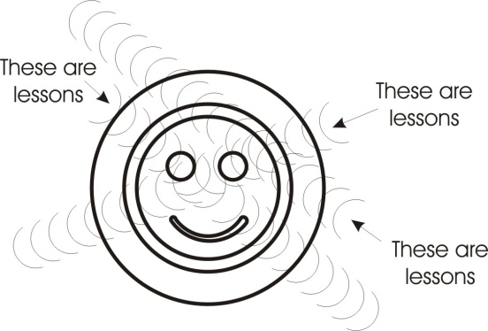
The Yogi
This isn’t quite what the yogi is talking about.
He says you should be transparent to everything whatever that happens, and as it is going through, observe it. Don’t refuse it. To refuse it is to condition yourself with it. But if you take anything whatever that comes to you, then as it is passing through you, you merely observe that it is going through. You don’t respond and you don’t reject. You merely observe the passage of this, the ghost train of impulses, through your station. [21:22]

The Fool.
We can see here that we actually have a power of withholding a response — inhibiting a response, burying a response — or simply being absolutely transparent to a stimulus, being aware of what it means and making no comment as it goes through.
In the Tarot symbolism, the card, there called the Fool, refers specifically to this type of activity. The fool is the man who doesn’t know what he knows. He hasn’t learnt the lessons he’s learned. He has observed them going through and heard people saying, these are lessons. He can recall that this is a lesson — according to the definition of other people — but he has not himself given himself to the concept that this will lessen [lesson] anything.
He has merely said, there are motions going through my substance. [22:18]

Fate and Destiny.
Now, when we shake the bucket of coal, the analogy is: when we have a French revolution or a Russian revolution, for a time what actually happens is this: every being that exists has loaded itself with its own responses — and I’ve marked them here as circles of various sizes — and we can say that one person, this very large person here, has willed to have as many experiences as he could do, so that when something has happened, as soon as a situation has arisen he has gone to meet it. And with every new stimulus he’s gone to meet it and he has filled himself up with experiences inside himself. This man knows an awful lot about an awful lot of things. [23:12]
But another little fellow might have said to himself, I don’t want to experience anything. He may be either transparent, or he may be opaque. He might have made himself able to knock every stimulus away from himself without taking it in. Now, it is the totality of the individual responses in each person that constitutes the destiny of that person. We will distinguish between fate and destiny in a very simple way.

Destiny — | is where you are going from within.
and Fate — | is what happens to you from without.

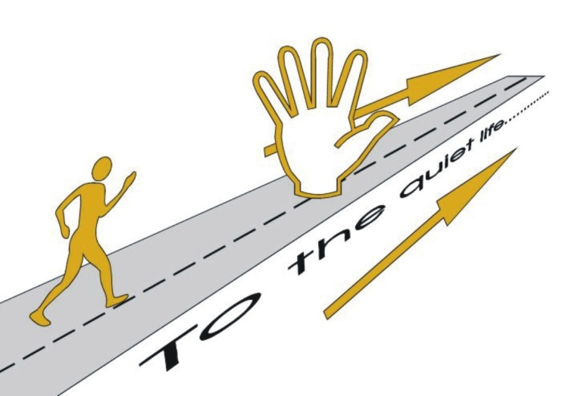
There’s a peculiar relation between the two because if we take this little fellow who decided he was going to have a quiet life by avoiding rough experiences ... his destiny is a quiet life. But while he is moving towards his destiny, this big fellow here is vibrating in an unassimilable manner. And therefore he is being pushed away progressively by the energy of the big fellow, away from this marvellous social association, to the periphery of manifestation. So in pursuing the quiet life as his destiny, he has exposed himself to the fate of being pushed away from violent men. He has nobody to blame or praise for this other than himself. [24:38]
The thing that happens to him is his fate. It’s the automatic result of his destiny which he has chosen.
Some people are so confused that some thinkers declare they have no destiny at all but only fate. That means to say that they are so inconsistent in where they are going, they have so many different directions, that they are practically stabilised in space by their own internal contradictions. And then whatever is happening to them is happening without their permission and therefore all they have is fate and no destiny ... in practise. Really they have too many little destinies and not one big enough destiny to subordinate the smaller destinies in the hierarchy. [25:22]
So we see here that to think in terms of fate — to believe that there is a fate that can push us around whether we like it or not — would only be self-hypnosis. It could only be an imposition upon ourselves. We would begin to behave as if there were a fate. But really, in believing this we would have chosen an idea, and imposed this idea upon the universe and upon ourselves, and paid the consequences of our own definition.
Anybody who really embraces the concept of an absolute determinism or fatalism is simply paralysing his own free initiative by his own efforts. [26:02]

Freud, Hegel and Schopenhauer.
Those philosophers who have bothered to insist that determinism, fatalism, is truer than the other view, the idea of free will, have generally been pessimistic fellows — men like Schopenhauer, and Freud and so on, men who believed that you could do nothing about it — they were really talking about themselves and putting a false interpretation upon it.
You may remember that Schopenhauer’s pessimism became deeper when he discovered that he hadn’t the ability to steal students away from the lectures that Hegel was giving. Hegel was more interesting in his lectures to people than Schopenhauer was, and when Schopenhauer realised that he couldn’t steal Hegel’s thunder, then he decided to write a pessimistic philosophy to justify the result. But in so doing he imposed upon himself. He was a contradiction in many ways. He was also a great woman-hater who spent a tremendous amount of time with women because he hated them. This kind of contradiction inside him was simply the measure of his own decision to interpret his defeat.
Freud’s own pessimism arose from the particular theory that he adopted in the first place; that the function of life is the pleasure pursuit, that the pleasure function is at the basis of everything, and that he could see that you couldn’t get pleasure unalloyed. You couldn’t always get your own pleasurable way. And he couldn’t conceive of a situation in which you could. And instead of finding another meaning than pleasure to life, he just said quite simply, the purpose of life is pleasure and you can’t get it, therefore you might as well be a pessimist.
He could have said, because pleasure cannot always be got, it must be meaningful to live without it, or to find an alternative motivation than pleasure. But he didn’t do that. [28:04]

Nietszche
Nietszche, thinking about the same problem beforehand, had decided that because consciousness requires a differential stimulus to develop itself, it would be far better to learn to transcend whatever level of performance had previously been given, and to make the purpose of life simply the will to overcome any difficulty. Once the mind has conceived a specific direction of development, it has imposed upon itself a scheme and consequently it goes the whole hog in doing so, and reaps the fate imposed by itself in choosing its own destiny. [28:47]

Hierarchy Inside a Man.
Now, while we are on the subject of the hierarchy, I’d like to deal particularly with the hierarchy inside a man. Most people don’t like this hierarchy idea because they think, I am not at the top, therefore I hope the hierarchical concept is not true. I’ve had a considerable number of debates recently with one or two strong-minded men who think that the world should not have any big people in it. Only this morning I was informed that the Grecian situation could be solved very, very easily by killing the blue-blooded gentleman responsible and removing the problem. The same of course with our queen, who is known by everybody to be useless in any case. So why not get rid of all those symbols of the hierarchy?
Now, to me, this is unrealistic — to talk in terms of getting rid of them, without getting rid of them. To talk in terms of getting rid of them and then get rid of them, that, I would call realism.
Some of you might have heard an interesting little talk that president Johnson gave on the TV last week. He was telling a story against himself, and therefore for himself like all statesmen stories. And he said he was arguing with some very big American businessmen on one occasion, and he wasn’t getting very far. So he get very, very forceful and said to his biggest opponent, Go to hell.
There was a burst of applause about this and he thought, Well, that’s very, very good. So afterwards, on the way out he said to an old solicitor friend of his who used to give him good advice, Did you like the speech?
And he said, Come and see me tomorrow and I will tell you.
And when he went to see him the next day this old advisor said, The only thing I have against what you said is this: you said something to somebody that you couldn’t make him do. You said ‘Go to Hell’. And you haven’t the power to compel him to go to hell and he might not like you. Therefore, don’t tell people to do things that you can’t compel them to do. Now that’s very, very realistic.
This man then said to me that he believed that I was really a secret Conservative, and that I was a very wicked, wily serpent, working for the right by pretending to be left. He said all that my sympathies showed to him was that I was a secret hater of the little lumps of coal at the bottom of the bucket. [31:26]
I said that I had remembered as a child I used to back the fire with those because they kept it in all night. But just to rub it in I quoted Lao Tse’s statement that the people are straw dogs fit for burning and this clinched it for him, of course. And then I said that he had really misrepresented me completely, because I have as much lack of sympathy for the right — if I have any lack of sympathy for anything — as I have for the left or the centre. Actually, of course, I’ve got equal sympathy for both of them, because I know exactly what it’s like to be trodden on having had an older brother. And I know what it’s like to tread on somebody, having had three sisters. [32:07]

Protoplasm and Environment.
Now, if we appreciate this: that our sympathy must be — through the continuum of the Absolute Being — Absolute Sympathy. So he then required me to say what I meant by agreeing that queens and kings now living should not be immediately executed.
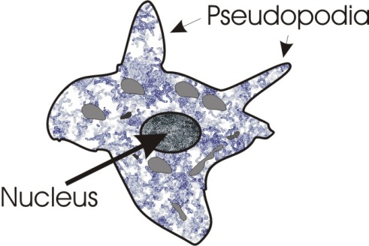
So I said, well, imagine the primary protoplasm of the human race. And like an amoeba it pushes out pseudopodia and each little pseudopod that it pushes out is going somewhere. And the peculiar thing about this creature is that every little prolongation of that protoplasm is responsible for itself. The movement of this little finger here pointing south-west, and the movement of the other one, pointing north-east, each one is responsible for itself, not for the other one, although it’s one being. It is the same for the continuum. I said, now the human protoplasm has historically spread out in this way and after a period of time it has divided itself and moved away and grown itself new little extensions. And in each extension of itself it has encountered a new environment. And some of the environments were richer than others in stimulus value. [33:33]
Thus it’s better to live in Europe to acquire a large amount of knowledge, rather than in the Gobi Desert. It’s just as simple as that. Some of those beings chose to move north, south, east or west. They went into different environments, and they got the product of their responses. Imagine the people in the Euphrates Valley at the time of the building of the Tower of Babel/Babble. Some of them, when they multiplied moved over towards Europe. Some moved off to China. Some towards India. Some into Africa. Some along the Mediterranean, and so on. As they moved along in these different fields, they came across different environments. And they responded to the environments. So that if we look at the situation of the terrain in Greece and look at those mountains and little valleys and broken-up islands and so on, we can see quite easily why the Greeks were an individuated people. Rather like the Scots were in their secluded mountain valley situations. We can quite easily see that a nomadic people in the desert where there was nowhere worth staying really very long, and each little oasis had only a small amount of water, and you couldn’t stay in that place with your camels and sheep and so on too long, and you would have to move. The environment dictated the behaviours of these different peoples. No mysterious fate did this. [35:11]
The simple spreading out of life itself in its sub-divisions — north, south, east and west — led all these extensions of the same life into different environmental stimulus situations, and resulted in all the different kinds of people we know today. So there is there no question of a rigid, deterministic view of the world. Fatalism in the old naive sense is false. Life spreads out, encounters its various environments, and progressively produces, in differing environments, different results.
The peculiar thing is, that the environmental effect of living in a desert has its own peculiar virtues. It causes the imagination to function, thus providing mirages and things, to let you believe that the world is in a sense capable of illusion. Those who’ve actually seen a mirage, even on our motoring roads, can be aware of how really convincing water-that-isn’t-there can be. A thirsty man in the desert looking for water, and bending down and getting a mouthful of sand, could quite easily develop a theory that the universe has illusions in it at well as facts. [26:25]
And consequently the nomadic peoples, the Arabs, show in their thought, in their poetry, their art, this awareness that certain things are illusory.

East-West: Subjectivity-Objectivity.
Now, if we go into Europe — Europe means the best form, best form obviously for developing a many sided character — we find the terrain there is not, except in the extreme north, very given to breeding illusions. Rather it’s given to breeding preoccupation with changing a changeable environment ... actually to act upon a material situation that is objectively present. So we find the European mind develops within that environment in an objective manner. It developed in a way dictated by the environment, by the objective reality of it, and men in Europe built houses, architecture, art and the theory of life out of their practicality, and became of course the ancestors of those men that dropped that very objective bomb that conscience is still bothered about today. [37:36]
Now, if we look at the spread out into Europe we find that the terrain in Europe actually does encourage this kind of objectivity. And we find when we go the other way towards the east, the environment conduces towards another kind of virtue called subjectivity.
If we go into Persia and India, we find new kind of way of thinking and feeling. If we go into India to a certain historical period, we will find that far from being objective, they are highly subjective in the sense that they believe the observer — the subject, who is observing these things — must be connected with the ultimate power of things. So the metaphysical systems of India which gave rise to the Yoga schools were really concerned with the development of the subject himself ... not with the change of the environment. In India, after the monsoons, if you built yourself a little road, if you don’t go out very quickly and start mowing it, it will disappear. And therefore there’s a sort of continuous battle against the jungle. [38:42]
Those of you who tried to go native in the jungle in your morning suit like true Englishmen will know that it’s very, very hard to stay English in the kind of environment where everything is growing all the time. In some equatorial countries, and in the far east, the things grow so quickly that it is practically impossible to mow the lawn without employing an army of men continuously to do it.
So we see here that fate and destiny are just two sides of one coin. When that amoeba split, when those people in Babylon decided to move out simply because they were increasing in number, those who moved into Europe were moving towards an objective and scientific mode of thinking. Those who moved towards Africa and Arabia, and so on, became nomadic peoples — because of the terrain — and developed a very peculiar kind of psychology of their own. Those who moved further still into India, into a highly luxurious vegetation country, developed a peculiar kind of subjective appreciation of their own. Those who moved into China developed another view of the world.
But it is all the same life.
Now, supposing we found an amoeba that has wondered about from itself so much that it didn’t notice that one of those little fingers that it pushed out belonged to itself, and started fighting for a piece of food that was near to both of those little pseudopodia.
Now this actually happens.
If we drop — let’s think about the most obvious concrete example of this — in the south of England a few years ago, a calf was born with two heads. And this calf was quite small, it only lived a short time. When its food was put before it, both heads tried to eat it. And they sent messages to the body to get hold of that food. And this poor little calf was shaking violently because one head was sending a message, get it. The other head was sending a message, get it. And the strain upon its organism was too great and it died. They took very, very great care of it as far as they could but factually it had two groups of senses with no sense. It simply sent messages to get what it wanted and head was talking like head, and other head was talking like other head. Each head sent messages out of head and these went into body, about which head knew nothing. And body suffered the consequences of the battle.
Now in the same way, some people — people like, say, Aleister Crowley for instance — recommended that every time you made a mistake you ought to cut yourself with a razor blade to teach yourself a lesson. Actually it’s very, very efficient. But when you do so, what you’re really doing is frightening some of your cells as if they were little school kiddies that wouldn’t learn a lesson. [42:00]
So when we’ve been discussing this particular view of hierarchy, the hierarchy is simply the automatic result of one life spreading out in many directions and subjecting itself to many different environments. In discussing this it became perfectly clear that certain races, certain families and certain individuals within families, become more informed by their more complex environments than do their brothers, sisters, and uncles and so on. And in the process — because we have to assert of any given being in any zone of a continuum what we have to assert of any other being — in the process if this being got twelve marks for being clever, and this only got three marks, the message from the 12-being, vibrating through space, being received by the being with three, that being with three said, Why haven’t I got twelve? This is called jealousy. Now the reason it hasn’t got twelve is because when it chose initially to move, it moved in the wrong direction. That was all. It didn’t know it was the wrong direction. But then the other one didn’t know it was the right direction. It’s just the fortunes of war.
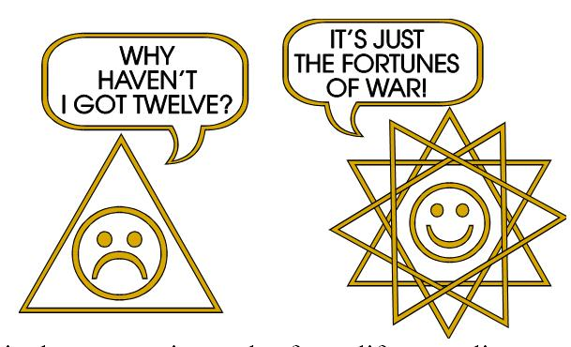
But in the process of getting this greater complexity, the 12-being factually has the power to push around the 3-being. Now the 3-being who just complains about this and does nothing about it, is merely imposing upon himself a concept of injustice, which if he examined it fundamentally he would have to give up. For the 3-being to complain about the 12-being, and not to do something to get the other nine for itself, is just an expression of the futility of ignorance. It is ignoring the source of the information that the 12-being has. The 12-being has that information because he has been in a sufficient number of environments.
Well, said the fellow talking to me this morning, That’s very, very nice, but it means to say that that Greek fellow that had it suppressed that he was a Greek, and was really a German anyway, and who persuaded the newspapers at the time not to give away who he was — that’s Prince Philip — really wants kicking out.
Just because his ancestors through the fortunes of environment became 12-beings — 12 meaning governmental perfection — just because of that accident, he is now in a position where he can about and do a little trip for £3,000 to play polo. And another being who is only a 3-being has to do his courting underneath the arches at the back of the police station. [45:08]
Now, he would say, This is unjust, because this 12-being is getting the benefit of environmental actions of his ancestors, and this one is only getting the results of the rotten environmental reactions of his ancestors. But what he’s doing is not observing that this 12-being, by the continuity of protoplasm, is simply actually the extended finger of that primary choice that the ancestors made ... that primary choice of any given person. If a man decides that he will have a child and send that child to Oxford rather than to Hulme Grammar, in so doing he has made a choice and he’s conditioned the protoplasm in his own being. And that conditioning is going to appear in that child. Maybe that child will reverse it afterwards and send his child first to Oxford when he’s five and then to Hulme Grammar later, and then to Borstal ... to be a governor.
Now, whatever the thing is, we gain on the roundabout and we lose on the swings, if anybody is complaining about injustice they have only one remedy. And that is to study the sources historically of the power of the other pseudopod. That false foot of the divinity there must be studied.
Now what do these power men actually know that the un-power men don’t know? There’s only one answer to that. They know how to play silly tricks on people that don’t know. So supposing we studied The Hidden Persuaders and a series of other popular works, we would at least get an inkling that TV advertisers have one or two tricks up their sleeves that actually dupe a lot of people to think that the soap powders on the market are not made by the same firm, but are rivals. [47:11]

The History of Influence.
Now, if we want to improve our situation instead of wailing about injustice, we must study the history of influence. We must go back. And we find that very, very simply defined a long time ago, in the Book of the Dead there’s a nice little thing that looks like this, there, on the top of a column or a temple, and some funny things ... they might be feathers. And in between them there’s a thing there called a cobra. Sometimes they put eyes on it to fool you. And this is the original Law of Persuasion. They actually colour this thing green to make quite sure you think it’s a snake.
Now, the feather means intellect. And this cobra means conation ... primary drive, urge.
And in this Book of the Dead and in fact in all great religious ritualistic symbols, there’s a very, very simply principle laid down. Carl Marx put it in a very simple way. He says, The reality of force is conation. It’s that funny fellow down below who does the driving. That funny fellow is rather cunning because although he doesn’t believe in anything other than violence, he has become convinced that violence without technique might fail in its object. So every time he has banged his head against a wall, every time this irresistible force has met an immovable object, he makes a mental note of it and it goes up the spinal column and lodges in the brain as a little idea of what you can’t do.
So if you get a straight pin, put it in the back of a piece of hardboard and hit it hard with a hammer, it is probable that you won’t get it to go through with your first blow without bending the pin. It’s not inconceivable. And therefore this mysterious philosopher down below says it’s no good, that we will have to learn how to do things. Technology.
And this is a dialectical fact. The men who know that violence is the initial way of creation will have to learn non-violence, because only non-violence gives you the technique. There was an interesting little program on for kiddies the other day, called brute force and finesse. Needless to say the Germans were illustrating most of the compressive forces. [50:04]
Here we have the very, very ancient thing of classes of people.
  - Belly people.
  - Sentimentalists who believe that the heart is important.
  - Rationalists who believe that the head is important.
  - And an unknown force that no philosopher has ever mentioned.
You can find them talking about the 3-fold division. You find Plato doing it, Pythagoras doing it. Anybody who’s making a social system talks about the 3-fold division of man. But they don’t keep on reminding you that these three are no good in separation.

Marxism.
Now, when Hegel came along, he said, Let us imagine the Absolute objectifying itself as pure reason, and appearing in the universe as the best quality Prussian gentleman.
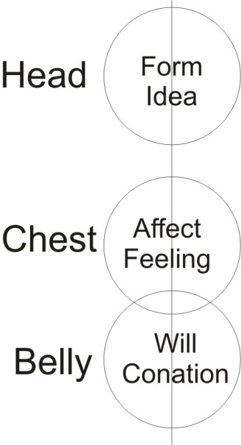
Carl Marx took this same concept and said, This is sheer wilfulness disguising itself as words. So he says the reality of the world is the violence, and the moral or ethical superstructure in the head is merely an excuse for violence. So that from the Marxist point of view they define truth as whatever subserves the revolution, including if necessary even bits of truth like mathematics and geometry, and so on. But it must subserve the overthrow of the powers that are, and the substitution of other powers for them. Now it is quite obvious that in this 3-fold being, to say that any one of those three is absolutely basic, is false. [51:48]
The Marxists taught this in their special literatures for the leaders of the CP [Union of Soviet Socialist Republics] but they did not point out that the reality of all those implies a field force which has differentiated itself in three different ways.
1. Every force has a form. And that form we call idea in the mind.
2. Every form has a definite amount of energy in it that you can call will, and psychologists call conation.
3. And every form, idea or amount of energy, is felt by a living being ... psychology calls that affect, the feeling.
Now through this feeling centre comes emotion, and emotion means energy going out to express itself [E-Motion, energy motion]. So here is a being with already a hierarchy in it. But the top of the hierarchy is invisible. Your head is visible, your chest is visible, your belly is visible. Your spinal cord is invisible, but the field force that has precipitated these divisions and still controls them is invisible.

The Natural Hierarch.
So at the top of every hierarchy there is an invisible power. This invisible power, science cannot put its finger on, because science has committed itself to using a method of measuring. Things that can be measured are not invisible. The mode of measuring is by the behaviour of certain instruments placed in the field of power. These instruments have to be seen in their responses.
Now considering further about the hierarchy, any man who exists and walks about on his feet is exhibiting that he is a natural hierarch ... whether he admits it or not. When a man decides to go a long walk because he is interested in seeing something — I think London is the best place for doing this, it does it quicker than anywhere else — it makes you aware of how hard pavements are.
Now, the soles of your feet are full of living cells, and those cells can hurt through you walking on them. And the message goes up, right up the body to the brain, saying, feet are aching.
But this fellow at the top will send the message, Keep walking, I haven’t lost interest yet. And this is a fact. Inside the body a certain groups of cells get badly treated through continuous hypertension, and the cells react against it by dividing and dividing and dividing, and eventually they separate themselves from the orders from the brain.
The brain is saying, Worry, worry, worry, worry.
And at a certain critical point they [the separated cells] say, No thank you, and they surround themselves with a field of force and now they are quite free from the dictatorship of the brain.
But the brain is still acting stupidly. It trots off to the doctor and says, What’s this?.
And this doctor says, That is a cancer. All that’s happened is that these cells have got fed up with this silly fellow in the brain worrying them with his problems.
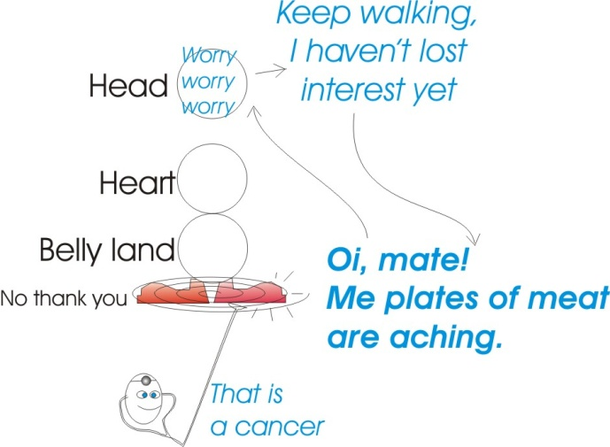
Now Every kind of reaction in the body illustrates hierarchy in this way. If you run very, very hard, you make your heart beat. Not that your heart wanted to beat ... but you have decided to run. If you bite your nails down to the quick ‘til they are sore they send you a message, but it doesn’t stop you biting the next nail if you are a nail-biter. So everywhere there’s this evidence of hierarchy and a supreme lack of consideration in individual beings for the living cells in their own organism.[55:47]
God once said to Jonah, Why are you so concerned about a simple plant, wanting to save it, and you’re not concerned about the people of Nineveh?
We can say the same thing about people who don’t believe in hierarchy. Why are you so concerned to speak against the hierarchical dictatorship of some individuals over some other individuals when you are not speaking against the same dictatorship of your brain cells over the rest of your body?
The same rule holds good. If you can’t be just to your own organism, it is unfair to complain about injustice when Mr. Wilson turns out to be not left wing. Whatever the situation is, factually there can be no order without an orderer, and without somebody subjected to orders. The whole universe is an orderly system. There are different levels of force, different intensities. There is a hierarchy of powers. If you must go to the equator, you can keep your hat on. You mustn’t expect the sun to stop because you are silly. You have to adjust yourself to the reality of a hierarchy in the universe, as you require the soles of your feet to adjust to your determination to see the latest exhibition. [57:05]
So we can say shortly, There is no fate whatever dictating to human beings or any other beings absolutely what is going to happen to them from outside. What happens to them outside is the natural result of what they have determined to be, their own purpose, their own destiny on the inside. The thing that makes the man big and the other man small — the big piece of coal and the little piece of coal — is quite simply that the big man has had more experiences and involved them into himself and committed them to memory. And the little man has been dodging experiences.
When there is a civil revolution a lot of people get out of the way. Some people don’t get out of the way and they get hit on the head and carted off to jail. You’ve seen this latest insurrection over the colour problem in the USA. Factually, people were taken away from Africa some years ago without their permission. They were sold to the men who took them away by some of their own brothers. It wasn’t that just white people went out and grabbed black people. No. White people went out and traded with Arabs who traded with other black people who had stolen some more black people. Then they carted them off to the USA. And then after a time these black ones grew up, and through the sheer propaganda, careless talk of the USA government about freedom and democracy and individual rights, some of this began to seep into these dark fellows as referring to them. So the USA is now reaping the benefit of its propaganda. To justify what it had been doing. [58:57]
It is no good pretending that this is fate. The men who were captured weren’t very alert. The men that captured them were a little more alert. The men that bought them without the trouble of catching them were even more alert. Like other great men in the past, when you’ve had a series of victories, if you’re not careful, you can start resting on your laurels and then you get into trouble. When those white people had removed a sufficient number of these dark people from their homes, and given them new homes and conditioned them in a certain way, they were not anticipating the multiplication of these darks to a point where they would be a social problem. That point has now arrived. This isn’t fate. This is the automatic result of the conflict of life with itself.
If we just realise this fact and don’t waste any energy complaining about anything whatever. If we don’t like something, immediately say to ourselves, How has the man about whom people are tending to complain attained this position?
Study the method, if you want to do it.
If you don’t want to do it, don’t complain, and don’t bother about it.
If you do want to do it, study the method whereby he acquired that power.
Don’t complain that you are about 6,000 years behind him in learning.
Intensive study of the principles can make that time up. There are short outline handbooks of how to do it. Usually they have a title like, How to Make Friends and Influence People. If you are serious in trying to acquire the art, it can be acquired in a very short space of time.
Because the rule is that,

What has been haphazardly acquired over a few thousand years can by very concisely acquired over a few thousand minutes, where the will and the direction of the intelligence is really established.

~~~~~~~~~~~~ END ~~~~~~~~~~~~

http://www.bbc.co.uk/programmes/p003c3jk
http://en.wikipedia.org/wiki/Sternocleidomastoid_muscle
Heaven and earth are ruthless, and treat the myriad creatures as straw dogs; the sage is ruthless, and treats the people as straw dogs. Is not the space between heaven and earth like a bellows? It is empty without being exhausted: The more it works the more comes out. Much speech leads inevitably to silence. Better to hold fast to the void.
Written by Vance Packard, who discusses how modern advertising attempts to control our thoughts and desires in order to make us buy the products it produces
Possibly ‘visible’ is more correct here ... visible in the respect that when a body is dissected it can be clearly seen?
Harold Wilson, sixties Prime Minister.
Self-help book, written by Dale Carnegie and first published in 1936

