Contents

Demi-urge 2
Power and the Trinity 4
Necessity and Essence 4
Value 5
Orthodoxy and Heresy 7
Sameness and Differentiation, Potentiality and Actuality 8
Lucifer as a Person 8
Satchitananda 9
Person 9
God and the Devil 10
Devil as Serpent 11
Boehme / Newton 11
Penetrate to the Meaning of Words 13
Socrates 13
Joseph 14
The Story of Joseph 15
Carl Jung 16
Insanity 19
Anger 19
Self-Honesty 21
Hypnotic Suggestion 22
Time 23
Abstract Time and Biological Time 23
Ancestral Perception 24
Incarnation 25
Sleep 26
Forms of Power 27

Lucifer (281 & 282)

Transcribed by J. Bailey (January 2001)

With intuited diagrams and arbitrary headings by J. Bailey

Square brackets [ ] contain transcriber’s notes.

Demi-urge
Q. I just said that I’ve fallen out a bit with Lucifer. I can’t ... after what you’ve told us over the last few weeks, it doesn’t seem that he’s necessary at all, because we’re either moving inwards or outwards. We are either moving to the perimeter where we have the saw teeth, or we are moving to the centre where there are no saw teeth. If I call the perimeter with the saw teeth Lucifer, are we adding something to it that’s unnecessary? I’m either moving inwards or outwards. I don’t need Lucifer. That’s the thing I’ve been thinking of lately.
Well, that’s the primal metaphysical truth, you don’t need him.
Supposing you had a pocketful of money ... then you wouldn’t need any money, would you? If you had a stomach full of food, you wouldn’t need any food. And because you’ve got a perimeter with teeth on, you don’t need one. Because needing implies lack, doesn’t it? Now, if we didn’t have him, we wouldn’t need him. If he were a non-existential being absolutely, he’d be a fiction.
Q. That’s what he looks like to me.
A fiction?
Q. Mm.
Well, many philosophers have charged him with being a fiction. And he is a fiction. But first you have to define fiction. When you talk about necessary and so on, you must define it. Necessity has something to do with essence, hasn’t it ?
Q. Yes. Well, I also mentioned that in the Bible it said ‘God created the world’ ... the universe. Now if I take that to be the physical universe, the material of the universe, the earth and the planets and so forth, how can they be Lucifer? If God created Lucifer, and then he became the material world, it’s a sort of second-hand creation, isn’t it?
Second-hand is the word that the Gnostics and various other philosophers have used of it. They use the word demi-urge for the Creator, which is second-hand ... the half-worker. Because he only makes half of it: namely the gross material half. The thoughts you are having are valid thoughts, and very ancient ones philosophically.
Q. Well it looks to me as though … it’s like looking at a stick, really. It’s one end or the other.
If you cut one end off, you’ve still got two ends, haven’t you?
Q. Yes, but I don’t have to have a third idea, when there are only two.
And what are the two?
Q. Well, one is the in, and the other is the out. One is the centre and one’s the perimeter.
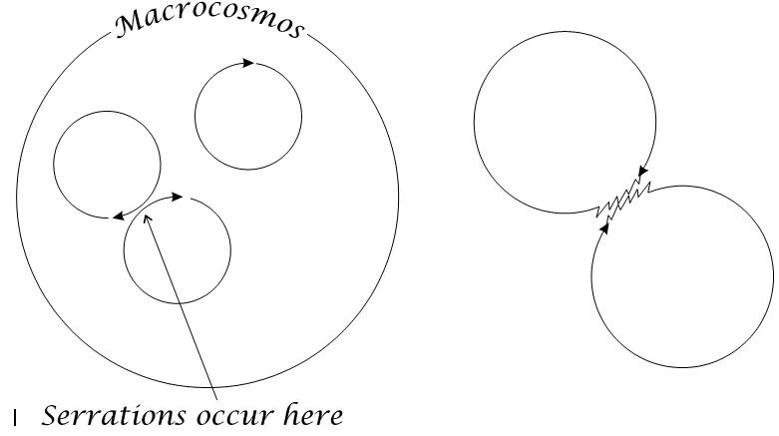
Here’s the Universe itself, and it’s caused by a force, or energy — Spirit — rotating, isn’t it? And that is the limit. This circle represents the Great Universe, than which there is no bigger. Now, obviously this one has no teeth on the outside. Aristotle calls that one the Motionless Mover. It’s motionless because there’s nothing outside it to relate its motion to. So that all relative motion is inside it. So if we draw three circles inside here, we can see the possibility of relative motion of these three, can’t we?
We can also see a very strange thing. Supposing that is the direction of rotation of those three circles, it follows that where one, you see, meets that one, they’re kicking against each other, aren’t they?
Q. Yes.
And it’s there, where the kick is, that these serrations occur, isn’t it? They can’t occur here, on the outside of the Macrocosmos. They must occur on any being inside the Macrocosmos. The Great Universe doesn’t have any on the outside, but it has them on the inside here, and it’s because of the pulsation of that Great sphere that these internal spheres rotate. You know that if you got a ball inside your fingers, and rapidly go like this with your fingers, then the ball will start to rotate, won’t it? Because you cannot get those pressures internally and externally exactly equal. And the inequality will kick the ball, and it will begin to rotate.
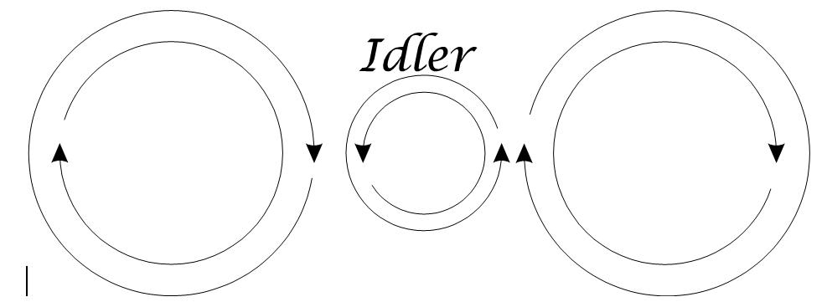
Now we’ll call this Big One the motionless mover, because there’s nothing relative to it outside, to measure its motion, if it had any. And also it doesn’t have to turn to make these things rotate, it can just pulse. And then all the spheres inside rotate.
Now let’s take two of these out to simplify this. Supposing we say there’s the direction of motion. They’re both going the same way. Then at this point [where they touch] they will kick against each other, won’t they? So they must drive each other apart. And funnily enough, if you get two such, and they drive each other apart — the direction of rotation is like that, look — so that imagine this is the surface view of water, and these two vortices, one there and one there, this one must be kicking the water here this way, mustn’t it, and turning it backwards, mustn’t it? And the one there must be kicking it that way, and therefore spinning it the same way. Now that’s the same thing that an engineer calls an idler, isn’t it? Now that idler is necessary.
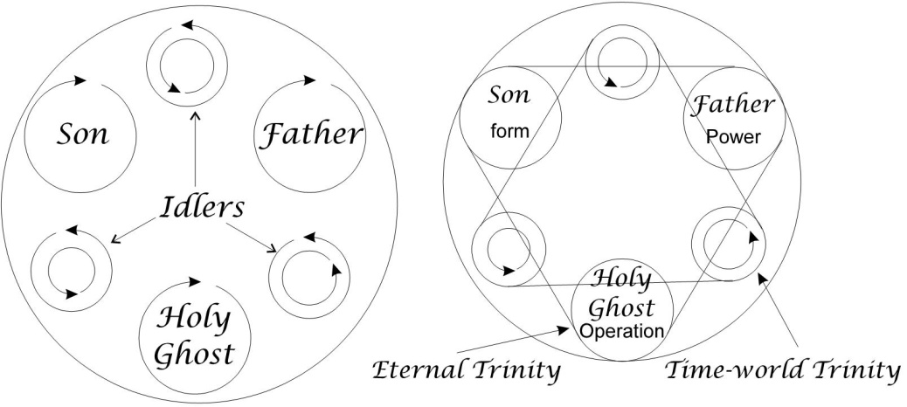
This is a very important concept. These two, because they are going the same way round, must kick against each other, and once they’ve separated they start an idling process between them, in universal substance. And actually this is the same thing: in between the volition and the ideation, we’ve got on idler, here, which is actually kicked round in the opposite direction, and serves as the balancer, and the spacer which enables the other two to rotate in the same way. [7:32]
Now, in this case, we’ve got three hierarchies of angels. Angels and Angles are the same. These are the three great hierarchies of God. And again, they kick against each other, so they must push against each other and introduce idlers. So we’ll cut that down, and that, and put one [idler] in here, and cut that one down, and then we get our six circles inside one, don’t we? [08:02]

Power and the Trinity
Now if that one belongs to that one, then those three are idlers, aren’t they? We’ll mark them off. Now supposing we take God the Father, and the Son, and the Holy Ghost — like we’ve said before, the Power, the Form and the Operation — between those two [Father and Son], those two [Father and Holy Ghost], and those two [Son and Holy Ghost] there must be an idler. Now this Trinity belongs in Eternity, and this one is the Time World. And opposite to the Father is this concept of the Luciferan figure, which makes it possible for the Son of Man — that is, Incarnated Christ — to appear. [08:55]
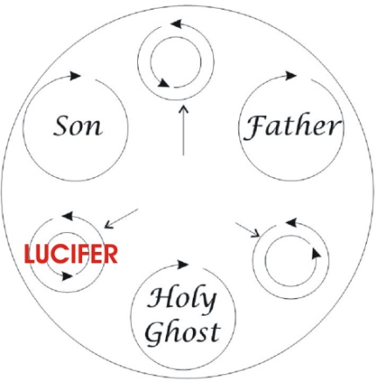
Now, let’s just think about that diagram a moment, and realise that the mere fact that we can make a relation presupposes a triangle. To make a relation we have two terms, two objects, and something in common with both of them, don’t we?
Q. Yes.
And we can’t have a relation without that ... two separate things, with something that they have between them, in common. So if we would say in this case that God the Father is Power, the Son is Power, and the Ghost is Power. That is power initiating [Father], that is power rotating [Son] and therefore forming, this is power arranging the rotating forms [Holy Ghost].

[ | God the Father is power — | power initiating. | ]
 | The Son is power — | power rotating and therefore forming.
 | The Ghost is power — | power arranging the rotating forms.

So the relating factor there, the substantial concept, would be power. And we can’t have a relation without two terms. And there must be something there between them. If we take the subject and the predicate, we always have a verb in between, which in Logic is called the Copula, the Joiner. We can’t say ‘S-P’ ... it isn’t a statement. We must say, ‘S is P’, or ‘S is not P’, when is-not can be linked together, or is not-P. Some logicians prefer to say, ‘S is not-P’, in some cases, and some prefer to say ‘S is-not P’. But we can’t do it without this copula. And this copula is some form of the verb to be. Because being, substantial being, is the ground of all our statement. Something must exist in order for us to speak about it. [10:54]

Necessity and Essence
Now let’s have a look at this question of the necessity of anything whatever. If we take a triangle, we can say that it necessarily has three sides, can’t we?
Q. Yes.
And everybody popularly would use the word necessary to mean that. But if you remove from a thing what constitutes that thing’s essence, you have removed that which is necessary for its existence. So if you remove the rational part of a human being — take out his brain for instance, fillet him, take his nervous system away — you wouldn’t call him a human being any more, would you?
Q. No.
There’s something essential there. If the essential is there, then that Being is there. And if it is taken away, it isn’t that Being, it’s another one.
So necessary has to do with essence. In fact, we could make it into two words. You see that esse is part of the verb to be, isn’t it? It is the same as essence, you see. Ness ... now, that’s not ceasing, isn’t it? ... arising. [12:26]
Ne — | Not
Cess — | Ceasing
Ary — | Arising

So the necessary is that which cannot cease. If it does cease, it isn’t that being any more. If you get an egg before it’s broken, and it has a certain shape, and then you break the shell, take it out, make it into an omelette, well then it’s not egg-shaped any more, is it? ... if by egg-shaped you mean the shape like this ... more or less elliptical shape. [12:56]
So the ESSENCE of a thing is that which, if it ceases, the thing itself will cease. Is that clear?
Q. Yes.

Value
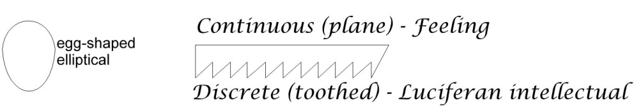
Now we’ll consider just precisely what this serration business is. And then we can see whether, if we remove it, we will remove all that we call value. We’ll draw the saw-teeth again, and the plane back to the saw. We can count here [teeth of the saw drawing], and here we can’t [continuous edge of the saw drawing]. Now the essence of this [lower] side is that it is toothed. The essence of this [upper] side is that it is plane. That’s discrete [toothed] ... that’s continuous [plane].
Now let’s look at the concept of value. The letter ‘V’ is a snake’s tongue or a plant, splitting. You see? When we talk about value, we’re talking about something you can get something out of. If we talk about utilitarian value, the value of this thing [the pencil] is that it makes that mark. It is there; I drag it along the paper; a black mark appears. That black mark is being got out of this pencil, hasn’t it? So we say that its capacity for making black marks is in it ... we know actually that it is its substance that we’ve scraped on to the paper, isn’t it? The value of that thing is precisely its substance, which has certain qualities.
Now we draw two ‘V’s [inverted], put a beam across, put two pans in the bottom, and we’ve got the symbol of value, haven’t we? Evaluator ... scale.
Now the scale is so-called because if you want to be really fine, scrupulous as we say, weigh it with the scales of a fish — they are very light. And you know that all the early trade of the world was in terms of very expensive things. Kings used to send precious stones, gold, marvellous perfumes, and they weighed it with the scales of a fish. That’s being really scrupulous, isn’t it?
So here we have the symbol of Value, and the symbol of Time, ‘T’, and it’s on this basis that we weigh all that we consider worthy of our attention. And the idea here is that there are discrete things, because we cannot evaluate unless we’ve got two ... can we? There must be discretion in order to have value. There’s no value in this thing here ... remove all the teeth, and this is useless. Remove all differences whatever, and the whole universe has disappeared. [16:39]
Now we’ve said that the necessary is that which does not cease, and if we can show that something cannot cease, we have shown that that thing is an eternal necessity.
Now value means this weighing process and implies a duality of objects, and a common point which joins them ... their substantial origin. So if we call this side of the saw Lucifer [toothed side] or the intellectual side, we can see, if we write intellect on there, we can write down here, feeling, can’t we? We mustn’t even call it volition at this point, because volition, will, is the point of initiation of a change ... and there is no change in the continuous. We can call it feeling, we can call it sentiency, field-awareness, but we must not call it anything suggesting for a moment, value. Value implies a difference.
So the Value side is here...the differential side [toothed]. Is that clear?
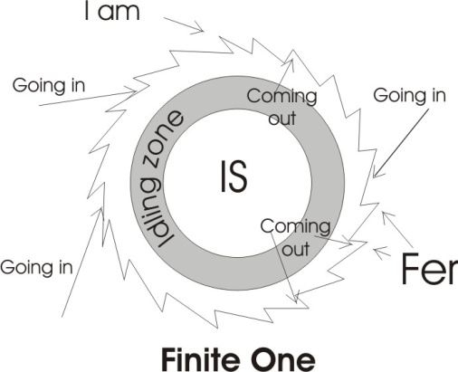
Q. Yes.
Now, let’s draw our circle, as we did before, and this is a finite one within the Universe, and therefore this perimeter is serrated, like a circular saw. Inside him he has the Immanent Spirit, this Is-ness, this Eternality, and here is the part where he is stimulated by other externals. And your thought was that maybe this is not necessary, because there is going in and coming out, all the way round isn’t it? [18:42]
Q. Not that that was not necessary, but I thought it was not necessary to call it Lucifer. I’m not trying to lose the saw teeth, I’m trying to lose Lucifer.
Let’s have a look very carefully what Lucifer is.
Light, fire.
Luci-fer is Light-fire
Already there’s a dual-aspected being there. This Fer is the same as those teeth. This Luc is the same as that Is. This is the great secret about the devil: that the devil and God are fundamentally identical. Because this is the centre [IS] from which arises the Light which radiates ... that’s the LUCI. And those teeth there are the FER, or Friction ... the zone where another one touches it. So really, Lucifer refers to the whole process.
Now, historically we are up against the fact that when it was known that Lucifer was the whole process, it was the peculiar possession of a few people who were ruling society. And in order to make other people obey them, they had to hide the fact that it’s all the same whether you go in or out, as long as you are exercising your Light and your Fire or energy. You cannot get people to obey you passively, if you first educate them to believe that there’s an inner principle of Intelligence and Energy in themselves that has no need of external direction. [20:41]
Can you see that?
Q. Yes.
This Lucifer, we can write if you like the Lux, the light, and the fire, or Fer – which is the same as the I am there — between the two, you see, is this idling zone.
Between the light and the fire — Consciousness and Energy — the Universe itself rotates.
Q. I can see that as a principle.
That is the meaning of this name. We mustn’t throw away a name and retain the meaning of the name, and then think we’ve got rid of something. This ancient name of him is one of the names conferred on the same Being.
Another one of course, is Beelzebub, which means Lord of the Flies. Because all the petty irritations along there [saw teeth] considered as little ineffectua1 stimuli, are called flies, and he is the Lord of those because he’s the Lord of all stimulation whatever. Friedrich Nietzsche borrows this idea, when he talks about the flies in the market place. Meaning that wherever people are exchanging goods they irritate each other all the time ... and to no real being-value. They haggle and bargain when they know already that the price is going down. You see? That’s flies in the market-place. They’re not wasps or bees; they don’t sting each other. They just threaten each other, and both sides know that the other is only threatening and cannot do anything about it. [22:33]
So that kind of thing, that process of petty irritations, is called Beelzebub.

Zebub itself is an onomatopoeic word, just copying the noise of a lot of flies.
And Beel, Baal, simply means, itself, the house of that worker.
As a matter of fact the word Alba is ba-alb turned round. The Baal in the Euphrates Valley is the Alba of this island, Perfidious Albion ... and still the name for Scotland in the Celtic language is Alba, white. White means balance.

Another of these titles is Satan, isn’t it? And Satan means the serpent, the cross on which he’s fixed, and the continuity principle, N, which means continuity.

[ | S —  T —  N — | the serpent,  the cross on which he is fixed,  the continuity principle (‘n’ means continuity). | Self  Crucified  One | ]

And this is the Self-crucified-one, because he does it on himself.

Orthodoxy and Heresy
Now every organised state, every national state, every church state, in order to maintain its position as dispenser of doctrine, or dispenser of orders, must teach everybody their dependence on the government — either of the earthly government or the spiritual government — must teach dependence. It therefore must define that any person who crucifies himself on his own idea is a Heretic. Heretic actually means ... it’s a Greek word which in its root means I think for myself. [24:28]
Now Orthodoxy is: Doxa is opinion, Ortha is that tura root again ... means right [the combination of R and T]. It simply means the Law. Ortho-dox means opinion-right, the right opinion.
Now what is an opinion? If I want to build a big church, then I will say those opinions are valid and orthodox which put one bit on another until the height I require, because fundamentally the cause is in Will. Somebody’s willing to build something. And they must define Satan and Lucifer and Beelzebub — and any one of the other thousands of titles of that self-sufficient fellow — as a nuisance and a devil. Remember what we’ve said before, that that word DEVIL - DEV-IL, if we look in Hobbes’ Leviathan, we will find him spelling it this way:- Div-el. And the Irish still say Divel for devil. It isn’t just an Irish accent, it is DIV-EL. In the eighteenth century it was written that way.
Now DIV is God. And this [EL] is God. EL is the same as EL/AL. and this [DIV] is the root to see, divide ... videre, to see. This is divide root, the tooth side. This [Div] is the see root, which you can’t do unless there are things to be seen, belonging on the toothed side. And this [El] is the link side here. So that’s [the plane’s] the continuity principle, and that’s [the toothed’s] the discrete principle.
So the Devil/Divel is God. This is why the Rabbis said to Christ, when he was tearing their orthodoxy to bits, Ah, he has the Devil. Now we know that if we go into Persia and Northern India, we find exactly the same word there, Div, div, Sanscrit, that’s Persian. And they are adjacent countries, and they are taught by the government there, that Div means bad, and they are taught it means good. So the people on the perimeter there — when they meet each other — these people will say, those people over there openly admit that they worship Div. And these people would say those people over there would say, what we worship is bad. And it was the ancient method of keeping people round the centres of commerce ... what we call today the direction of labour. [27:19]

Sameness and Differentiation, Potentiality and Actuality
The Egyptians used to teach that the Earth was flat. The Indians did the same. Usually, a big ring of mountains round it. And if you still had enough courage to go over those, there was nothing on the other side. It was a bottomless abyss. And if you didn’t care about abysses, down below there was a monster, Python waiting to swallow you. The Indians made it very difficult for you, because they put the world like a disk, mountains round it, put it on the back of an elephant, made the elephant stand on a tortoise, the tortoise was swimming in an infinite ocean. You might as well stay where you are. It was their method of directing labour. So whatever we do, we have to accept this: there’s no value unless we see the discrete, the differential. And yet we can’t see it except in a background of sameness.
There must be a difference, and there must be something same underneath. The same is zama: seed, the source, the potential. So this is the ‘potential’ side down there... potentiality. And at the top here is actuality. So you see, all our actuality is on our outside. And our potentiality is tucked on the inside. What we do is take some of our potentials and actualise them, and then, using the actuality we find ourselves presented with further stimuli, which are in fact incoming energies, and we take them in and stow them in our potential department, until we’re ready to come out again. [29:00]
Now we’ve said the necessary is that which does not cease. If a thing can cease, it is not absolutely necessary. Now the nature of this says that there is a logical relation between the toothed and the non-toothed — between the serrated side of the saw and the plane side — because if we didn’t have that substantial piece of metal there, both of those would be meaningless. So they are two aspects of substance. The one, the continuous, plane aspect’, valueless ... and the value side, the tooth side. And we see those values against this plane background.
Thus the protective colouring in animals, say the dappling of fawns or something, against similar patterns in light and shade in the undergrowth, makes it impossible to see it. So we need a plain background to see the differences. Both are necessary. If all plain, we can’t see plain. We wouldn’t even exist, because we are already differentiated.
So what all men call Value rests on those two:-
- A fundamental sameness, which is the substantial ground,
- And an actual differentiation, which is the value that we seek.
And it doesn’t matter if we call it Lucifer or Satan or Beelzebub, or a variety of names. There are lots of names in different languages, but they are all meanings gathered together in the simple fact that we are talking always about this Sameness of the Universe, our source, which is essentially identical ... and the Differential side of our nature that makes it possible to have a conversation. For if we weren’t differentiated, we couldn’t have a conversation. There is no conversation in the continuum.
So we mustn’t think that we’ve done anything if we throw away a term that means exactly the right thing. What we ought to do is understand the term. [31:36]

Lucifer as a Person
Q. What you’ve shown me now I could follow and say that is logical. But to talk of Lucifer as a ...
... a person? Let’s consider that.
Q. I can see all the reason of that and what was meant by it, but when I’ve got to think of Lucifer as a being who [... this and further comments are indistinct]
It depends how you read Genesis. It says, In the beginning the Earth was without form, and void, doesn’t it?
Q. The Universe must be Lucifer.
That’s what the bible says — The whole world is in the grip of the Devil.’ Created means locked up. You’ve forgotten that the KRA root, in create, is ARC. Now God did not arc nothing. He didn’t lock nothing up. He locked something up.
Q. Yes but He made the Universe. He didn’t create another person or another being, and say, “You can do it if you like”.
You know that you’re indulging in abstract thinking, and you don’t even notice it. Because the Universe itself is a modal operation inside Absolute Sentiency. The essential attributes of the Absolute are these:
- It must Be, musn’t it?
- And it must See ... which is Consciousness; we call it Awareness. It must be Aware.
- And it must move, have Motion. Yes? It must be aware of its own motion, mustn’t it?
Q. Yes.

Satchitananda
Now we cannot deny one of these three to it. If we put the Sanscrit word in, Satchitananda
Sat — Being
Chit — Awareness
Ananda — Which actually means a serpent running along, is the Motion.
Those are the three. And you must not suddenly remove one. [34:49]

Now let this paper again — the white paper — represent the Absolute, of three aspects. So that the Absolute is being aware of the motion which it itself is doing. Is that clear?
Q. Yes
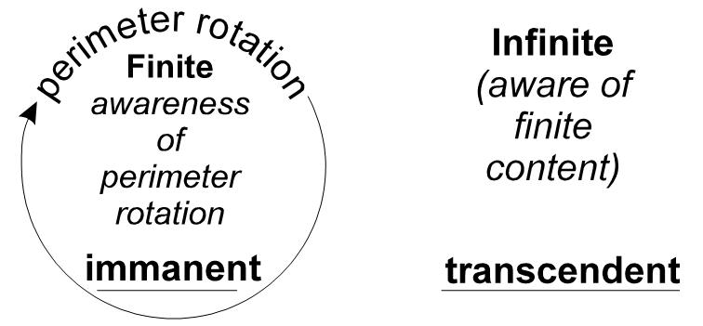
And when we make a circle, like this... we haven’t touched that inside, have we? So that’s still being aware of its own motion, isn’t it? So it must be aware of its perimeter rotation, mustn’t it? This must be aware that there’s something there; this must be aware that there’s something there. This one is aware that it is finite. This one is aware that it is infinite with a finite in it.

Person
Right, now the Pira-Son, or Rotating-sonic-system, has these three aspects. It is aware of its own motion, which is precisely what a person does. A person is not a fellow with legs and arms. A person is simply a being who is aware of his own motion.
Remember Grenfell of Labrador, in a little book on physiology for children he wrote, said that a man in India, involved in a railway crash, who lost both his legs and arms, was considered by his family no longer to be a person. So they came and took all his furniture away. So he then brought legal action against them. And Grenfell says, when he was in the court he could still say he was he, in spite of the fact that he had no legs and arms. Therefore he was still essentially human. And the court ordered the return of all the things. He could still say he was he. He was a being, and he was aware of his own motion or action. Now that is the definition of a Person. [36:54]
Now it is quite abstract thinking to suddenly remove — like a physical scientist does — this Sentiency, this awareness of the Absolute Substance. The Universe itself is a Sentiency-Being, with modifications inside it, some of which we call thought, some which we call feeling, some which we call physical bodies … these things [here EH taps – the table maybe?]. But we only know a physical body by its resistance, by being aware that we can’t get through something when we try. The physical universe is a system of resistances inside an Awareness-Being ... isn’t it?
Q. Yes.
So the Universe itself is a person, because it fulfils the definition. It is a sentient being, moving, aware of its own motion, and knowing that it is. All this it feels, and it feels the sum-total formal content its own being. That’s a Person. This is why Christ, before the appearance in the time-process, is still called a Person, the Second Person of the Trinity. [38:16]
You see, the Cosmic Christ is not less, but more, of a Person than a finite man is, because to become more of a person is simply to become more aware. Awake, for morning in the bowl of night has flung the stone that puts the stars to flight [Omar Khayyam’s ‘Rubáiyát’]. That awake is the command right through every religion. Wake Up. Become aware of what motions are in your being.
When you know yourself, you are increasing in your personal being. You’re becoming more and more of a person the more you know about yourself. So Christ Logos, the Universal Being, is actually the fullest personality. He’s not vague. We’re vague. He’s not vague. He has, internal to him, in his awareness, every thought that we’ve got as individuals. He’s got the thoughts of all people, not only today existent, but all the people who have lived and died and had memories. Those are his. And all the people who may come to be, now resident in the germ-plasm of existent human beings, all those thoughts and the memories in the plasm are also his. And he knows it. He is a Person. [39:48]

God and the Devil
Now that same Person, from two different points of view, is God and the Devil. He’s a Devil to all opinionated orthodox system-makers, because he breaks them down ultimately. But he also builds them up, because they’re convenient at a certain period.
You see, when the Roman Empire fell flat, the Goths came in and knocked it down ... there was no unity principle. And there was absolutely no authority to take its place other than the Christian Church at that time. It was a baby, and because there was no authority, a man like Augustine, who was a tremendously ambitious and powerful man, intelligent and ambitious — Luci and Fer — he moved in and began to define the City of God and the City of the Opposition.
And it was simply this: that there was no authority there ... there was chaos among human beings, and therefore a necessity. Something must come to be, in Time. Because it is an eternal fact that the serrated and the continuous are both logically presupposed in each other. [41:10]
Therefore the Church became valid at that moment, as a unifying principle. And it remained valid up to the time that other centres had enough co-ordination to rule themselves. And then the Roman hierarchical structures became invalid. The great revolt started.
And the Spirit bloweth where it listeth [John 3:8]. That blew into Luther. And it blew into Henry [the 8th]. You see? That Spirit blows into a form and animates it. And then it leaves it.
Supposing somebody comes along and you give him a lupin seed. And you say, There’s a lupin in there.
And he says, Goody goody, I love lupins. And he puts it in a drawer. He says, I’ve got a lupin.
You say, Well, it doesn’t look like one, does it?
But it is one you know, it’s potentially the most beautiful lupin there ever was.
I will put it in the garden. No, I am going to leave it there.
Now, God says, I don’t like that fellow. He ought to put it in the garden and grow.
The man says, Please Sir, if I put it in the garden it will grow and then will wither.
And God says, Everything has to wither. If you don’t put that seed out of that dark door and put it in the garden and let it grow, I personally will disintegrate it with cosmic radiation. I’ll have a go at it, I’ll knock it to bits, I’ll let moth and dust get at it. Corruption will get at it because you are not using it. [Matthew 6:19].
So we’ve got to see this whole system as within this Great Being which is God and the Devil.
It’s the God, the good, the Supreme Good to all beings who are prepared to let go of a thing when its utility is finished.
It is the Devil to all the people who want to hang on to a thing when its time has gone. [43:04]

Devil as Serpent
Q. In the case of Adam and Eve in the Garden of Eden, when Eve was tempted by the Serpent, the serpent was Satan or the devil,or Lucifer.
Yes
Q. But, it’s not literally a serpent. Because the thing that tempted them was the fact that they liked the saw teeth edge.
That is the Ser [as in ser-pent], that is the Serration. Ser-Pent, the serrated thought. You see, when Christ says, be careful how you take the words in that Book, those words are Spirit, and they are Life, properly understood. That thing that goes on the ground that we call a serpent, that is a particularised serpent. *The Universal Serpent is just as conscious as all serpents together. And that wiggling, like this, is the basis of the saw-teeth. And we call that thing a serpent because it goes like this... like those teeth. And it’s possible to count the wiggles in him. Whereas if you straighten him out you can only say, one, you see. And it’s a Sentient Being.
And the Universal Being is a Serpent too. The oldest image of God that we’ve got is a Serpent with his tail in his mouth, biting himself, and saying, I’ve been bitten, and biting back, you see. And that’s the rotation of the stimulation in the Universe. Really, that’s all that’s got to be learned: is that every individual, without knowing it, is his own serpent, bites himself in the tail and complains ... in other words, self-stimulation is going on through fantasy*. [45:00 repeats from The Universal Serpent ... to 46:06]
A man thinks, and he may think that Johnny so-and-so said a rude word to me last week, and I should get my own back on him. He may think so. He is stimulating himself. He will get the results of his own self-stimulation. As he sows, so is he going to reap.
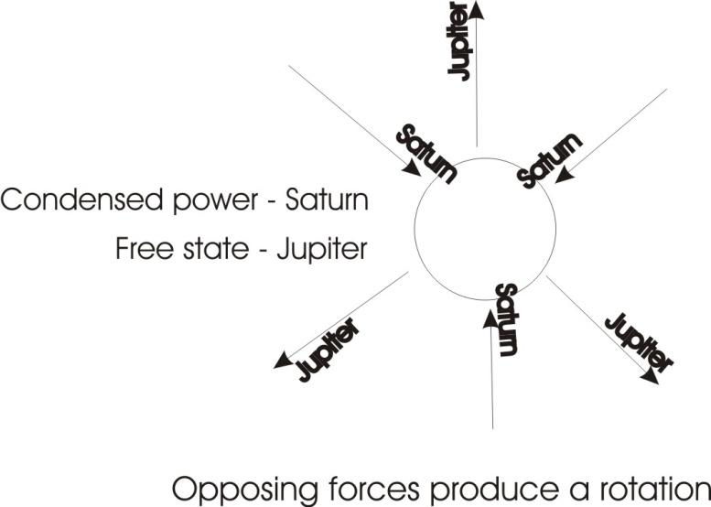
You know, one of our best thinkers, one of our most insulted modern thinkers, probably one of the most misunderstood Frenchmen of modern times said, It is no good trying to simplify the truth so that the football crowd will like it. What we’ve got to do is to find the people who would like to hear the Truth as it is. Don’t throw the terms away ... the terms are valid. [46:58]

Boehme / Newton
When we talk about Saturn and Jupiter, they are valid terms. They need understanding. They don’t want throwing away. There’s nothing you can put in their place. Well, supposing you say, Saturn only means contraction, and Jupiter only means expansion. That isn’t true.
Saturn means a will to contract ... it’s Sentiency. To pretend that it’s merely Contraction is abstract thinking, because there is no contraction in the Universe other than this Willing towards Centres. And Saturn means also this sentient covetousness, this pressing on centres. Jupiter means the Will to Move Away from Centres ... to expand. So if we say it is merely — as Isaac Newton said — Expansion and Contraction, that’s abstract thinking ... it isn’t really concretely true. [47:52]
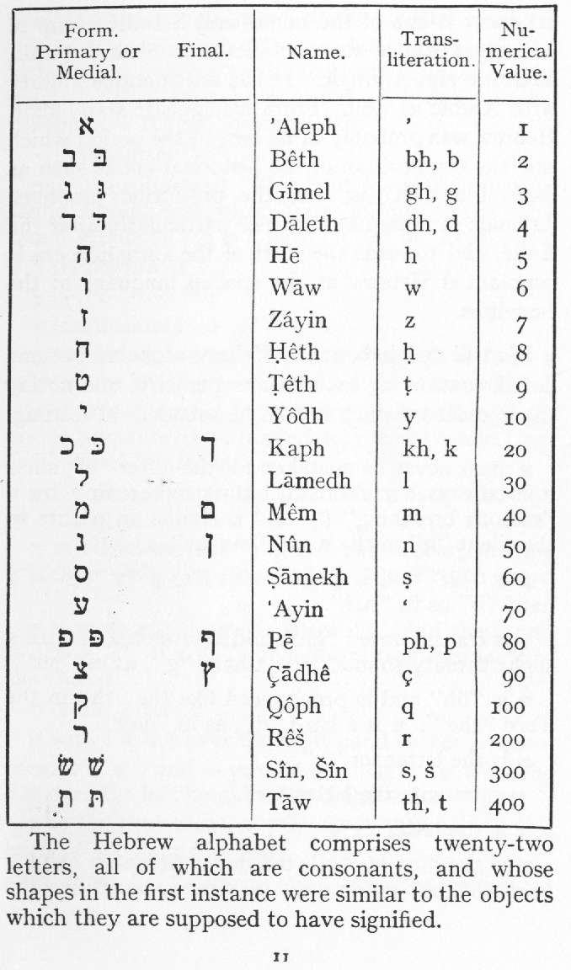
Newton took the thought out of Jacob Boehme’s words, that Contraction and Expansion in opposition produce Rotation. Now, when Jacob Boehme is using those terms, he talks abut the contraction, about the Compunction, and in the same sentence about the Anger, and the furious covetousness of Saturn. Now, Newton did not disbelieve that, but he knew that he was living in a period when it would not be acceptable. It would be anachronistic to talk about the Will of Universal Substance contracting. So he said, I will take out the Contraction, and use that alone, and the Expansion and use that alone, and the Rotation and use that alone, and say that Rotation is the product of Contraction and Expansion. In other words, that Jupiter and Saturn, God and the Devil produce Mercury or the Son between them ... Rotation. [48:54]
Now, Isaac Newton did that, and his notebooks exist in which he made notes from Jacob Boehme. And this infuriates many of the scientists, because they say, he must have had a silly side as well as a clear side. Bernard Shaw once made a stupid statement about him, when he said that, he’s obviously mad. He was trying to translate the Book of Joshua into Mathematics, so he must have been insane. Actually it’s shot through with mathematical formulae.
Q. The book of Joshua?
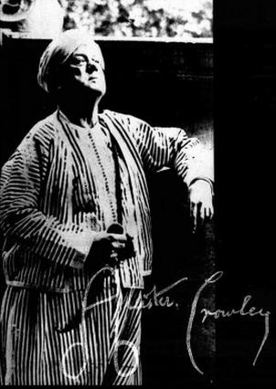
Mm. You see, if you remember that the Hebrews had no way of counting other than the letters of the alphabet. If they wrote the letter A, which is an Aleph like that, looks something like an A, something like an N ... and the letter B which is like that. Now, A plus B equals C, in English. The third letter in Hebrew is G. That is the same letter, lock. But the other one, because the Hebrews as a people were grossly materialistic, they said, we’ll have gross matter there, ‘G’, and their sign for it is that. So Aleph plus Beth equals Gimmel. One plus two equals three.
But Aleph and Beth mean AB [abba], the Father, the title of God. The first in the house. Beth is Hebrew for a house. The first aleph in the house is a camel. Now Aleph means an Ox, the principle of acceptance. If you don’t accept circumscription you will never become a self-subsistent being. One plus two equals three. Now our three, written like that ... you see this partition. There’s our three points of the relation. And, if we go like this… we see a kind of archaic candlestick ... that’s one, three. The three in the one, the Trinity. And, if you look at it very carefully, and we’ll draw it a little more like this… and put the end on it, this should be the male organ ... the one-three, the one which is really three.
Alistair Crowley thought, Well, my name begins Alistair, so I’ll write it like that ... That’s how he used to sign all his documents, because he knew perfectly well that the Universe itself has two aspects, here ... Potential and an Actuator. You see, there’s a difference between the left and the right content. One is loaded with form, one is loaded with Will as a stress. This is an ovipositor, if you like, that’s simply a mode of positing eggs into a bed, isn’t it? And they are kept here, and they differ on this side than this, like the Teeth and the Continuous, or like boys and girls. And that is the old symbol which appears here, in the Trinity, which is A+B=C .
Now the first converts to Christianity were Jews. And they were converted because of a very simple thing. They were taught that the Lord thy God is one God. They believed that God was only one. And Christianity said that God was three-in-one. And the Jews said, No, God is merely one, which is to say just continuous without any difference. And the early Jews were converted — those who were really knowledgeable — by simply telling them, Aleph plus Beth equals Gimmel. That is, AB, the Father, is a Camel, because the camel is by the symbol of its hump self-sufficient. It maintains itself in the desert. In the vast Infinite there is a Camel, the Universe. The camel is so-called, not because it’s got legs, but because it’s got a hump ... because it stores things. [53:35]

Penetrate to the Meaning of Words
You see, what we have to do is to penetrate to the meaning of the words that have come down to us traditionally, get right down to it. Don’t throw out the baby with the bath-water. Get hold of the real meaning of the word, and don’t eliminate it. And you shouldn’t eliminate it because of this reason: you have to think in terms of form. You can either think visually, or you can think audially with words. Whichever you do, you are thinking in terms of form, because the words you employ are merely quickly said visual images, which once upon a time were drawings of actual objects. The Alphabet derives from a hieratic, hieroglyphic background.
So you have to think either with words or visual images. So to throw one away is to throw away a tool of thought. And we mustn’t omit to remind ourselves all the time that the Universe itself is a one turn inside Infinite Sentiency. There’s a substantial awareness there that knows everything that is going on inside it. When it says, God is not mocked, it means this: every little finite being is inside this Infinite Ocean of Awareness, this eternal-moving-awareness-being. So that if you do something that it doesn’t like, you can’t win. And it’s not in a hurry — it just shuffles you into your next lesson. Because it’s got plenty of other people who need precisely the kind of lesson that you’ll give to them while they are giving you one. [55:27]
If you’re a man that moves out of a job because he’s uncomfortable there, and doesn’t like so-and-so, and goes to another job, he finds another kind of thing that he annoys, and annoys him. There’s nowhere where you can move negatively — that is, in an attempt to get away from fact — without precipitating yourself into an equivalent disguise.
You see this idea of God and the Devil, remember the word Devil is simply the word God with a nasty aroma around it put there by the Church, because they cannot make an organised body if they teach people independence. Autonomous centres don’t go to church. They ARE a church. The Temple of God is with Man. Every Christian, that is, every one who understands the real relations of the Cross in the Circle, is himself a priest. And he has the power, if he understands it, to bind and loose. That is, to tie up and to define, and to un-define. And it means tying people up if they don’t know. Because in fact you can define an idea for somebody, and if they don’t know how to get out of it, your definition will bind them. And they can be circumscribed with their own idea, and you can undo it, whether they like it or not. [56:55]

Socrates
When Socrates went about, stinging the slow-moving horse of the Greek state into motion, the government didn’t like it. The young men did, they loved it, but the government didn’t like it. And so they said, If you go on undefining our definitions like this, there’ll be no state left. So they asked him to drink the hemlock. Which was the same thing as drink the shut-up. Because the H and the M, and the LOCK, signified the Spirit and the Matter. So really, Socrates was letting the cat out of the bag.
Remember what happened when he went to the Delphic Oracle, and the Oracle said to him, You are the man in Greece who knows the most. You are the wisest man in Greece.
And he said, That’s very strange. The Oracle cannot tell a lie, and I don’t know anything. And then he thought, Well, I do know this, that I know nothing. Maybe that’s more than other people know.
So he went on to a politician, and said, Are you a politician?
And the man said, Yes.
Well, do you know about politics? said he.
And the man began to tell him.
Socrates cross-questioned him, because he knew ‘S’ and ‘P’ just don’t fit, and that every P is taken out of S and can’t be put back again without some mysterious thing in S — namely S — that is not in P. So the Predicates, no matter how many you make, can never exhaust the Subject. So he just exhausted them. And they, being finite, couldn’t go on infinitely, and if they could have done he would have stood there listening, delighted. And so they flew into a temper.
Now, after he’d annoyed the chief leaders, he then said to them, Apparently the Oracle was right, I know more than you do, because I know I don’t know, and you don’t. [58:45]
So they then decided, We’ll have to put him on the spot. But he was seventy before they finally nailed him. And in his own words, he couldn’t possibly go and walk to another country, because he would have to start talking there, so he might as well drink the hemlock here.
You see, if we get these universal symbols right, this H is the aspirate letter, isn’t it? It’s just simply, breath. What is it? It’s the least solid thing that we have that we can get hold of in our body, isn’t it? And yet strangely enough, if we cut it off, we die. If we take the most solid part, our bone, saw a nice thigh bone off, you see, we don’t die, we can leave it off. Cut the breath off, that very fine, subtle substance, and we die. So that ‘H’, the aspirate, represents that fine, subtle essential in us. And we find, in fact, that in the Universe, the most subtle is the most important, and the most gross is the least important ... for intelligent people. And for unintelligent people ... the opposite. [1:00:03]

Joseph
The more the stress is on the gross world, the less intelligence there is in a person. Francis Williams and some other journalistic experts, talking to a brainy fellow who’d made a few million pounds, and they were greedy to get at it. But he wasn’t interested in money.
And when they said to him, It must have been the first hundred thousand pounds that was difficult to make, how did you do that? Surely that was harder than the other?
And he said, No, it was just as easy.
And they couldn’t get out of him the secret. And the real secret was that he wasn’t interested in money, he was only interested in power. Power makes money ... it isn’t money that makes power. The nouveau riche who tried to climb into the aristocracy with money never got there, because there’s something more than that coinage that’s dug out of the ground: namely the fellow who fabricated — a fellow named Joseph — who fabricated the concept of coinage as a means of tying up other peoples’ power by forcing them into the intellect, a counting department, out of the will. If you train people to count, then you can tie up their volition in worry processes. You see, the pure man of will goes about in a free state. Before civilisation exists, he does what he wants.
Another man wants to build a pyramid, and he goes to this wild man, and says, Build a pyramid.
And he says, What for?
Well, it’s a monument.
To what?
To my importance.
Oh. And he goes away. He’s no good, you see.
So what he has to do is to get some fairly young ones, and teach them that there is a method of counting, and you teach them all about the teeth, but you don’t tell them that those teeth belong to the back-of-the-saw, because if you push the back of the saw right up, mentally, you will find that the teeth are on the back of the saw. Where does the back of the saw start?
So then you start teaching the three ‘R’s, or three wreckers, which Luther inserted instead of the great dogma of the Church, and that throws the child into intellectual centres, and the intellectual centre is a negative controlling centre on the Will. So you set up a series of forms ... today we call it conditioning their reflexes. You set a series of forms in their minds, such that their Will can not operate without first filtering through the trained system. Then you can say to them, Now boys, forward, we’re going to build a new bridge. And they respond, as they’ve been conditioned.

The Story of Joseph
This is an actual historical process. It was fabricated. The biblical story of the fabricator is the story of Joseph. Remember what Joseph did? When Joseph goes to Egypt, every Egyptian at that time owned his own patch of land. And he said to Pharaoh, These fellows here, you know, they’re no good to you. They are independent. Each man has got his own bit of land. And every year the Nile flooded, and then every man marked out his own land. And sometimes there was a bit of a fight.
So Joseph said, I’ve got an idea whereby we can take all their land off them, and get them to work for us. But it will take a bit of time. And he outlined the idea to Pharaoh.
And Pharaoh said, That’s very good. As from today’s date let every man bow to you as if you were me.
So when Joseph went out in a chariot, they said, He is the fellow like Pharaoh. He was really Pharaoh’s left-hand man. Now what he did was this: a very, very simple trick, He said,
According to the Chaldean astrology — handed down to him from his ancestors — the whole Universe itself is cyclic, and there must come times of dearth and times of plenty in the harvest. So what we will do is wait for a time of plenty, and then people will be so delighted and so careless, we will impose a tax of corn. And then we’ll collect the corn. And they won’t mind because there’s plenty. They throw it away. And we’ll store it. And we will wait for a time of dearth.
So he built big granaries, and then when there was plenty, those fat kine, they stored all the grain in the granaries, and the people didn’t care, there was plenty of it.
But he knew the Cyclic Law. So at the end of the cycle of plenty, dearth came in, and Egypt became the granary of a starving world. And when the people said, We have no corn to make bread.
Joseph said, Well, you bring me your cattle, and I will give you some corn. So he got the cattle.
And the dearth went on.
The next year, they were still short of corn. So he said, Alright, now you give me your land and your labour, and I will give you corn. And so they had to agree.
And then the moment the land was officially his — that is to say, they had agreed — he moved all the people from the south to the north, and all the people from the north to the south … [1:05:49]
..break in recording

… so the whole thing was beautifully balanced and Joseph was highly rewarded for that. And as a matter of fact, Joseph is still one of the chief study figures if you do a history of economy, you see, because he actually fabricated this whole system of land-stealing, coinage fabrication. You know, they still print in Irish coinage a pig and a hen, and a so on. In the old days they used to print corn on it, you see, and the great password — the Shibboleth as we’d say, meaning plenty — is this sheaf of corn. And that corn — sometimes we say somebody’s being corny — and that is a survivor from the same thing. [1:06:35]
In the Church you have a screen behind which certain mysteries go on. In the German language you have a word harfen, to harp: secondary meaning, to screen the corn. Now, corn and the corner of the room are related, because corn in a one-roomed dwelling, used to be kept in the corner. And the corner was called corner because they put the corn in it. And then, they used to put a harp over it. If anybody came to borrow corn, your wife started playing the harp, you see. What did you say? […laughter…] Can you let me have the corn? I can’t hear you for this harp... Hence, harfen — to screen the corn.
Now, this whole technique is traditional — it has been handed down, and is still used in propaganda, and of course advertising is riddled with it. It touches you on fundamentals. And if you are not on guard, you are triggered off by a million memories you know nothing about. [1:07:37]

Carl Jung
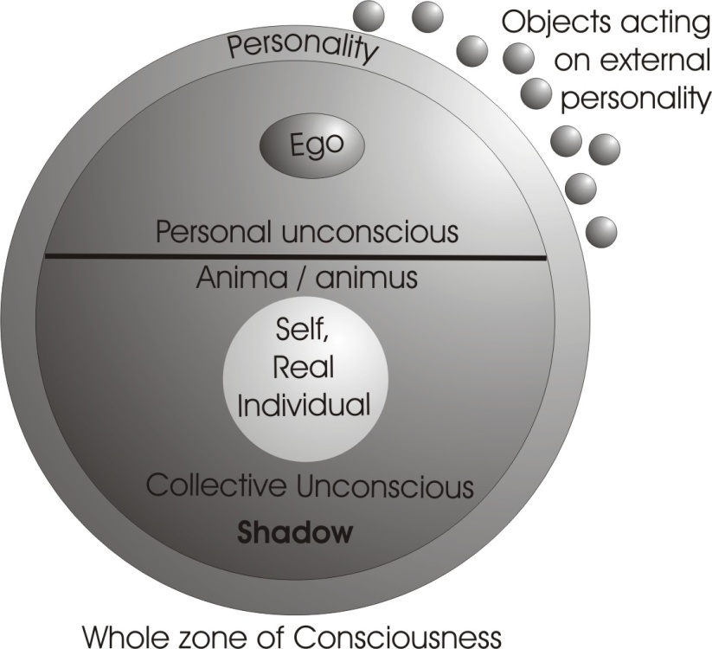
Now I have brought a little diagram which had a wonderful adventure — it blew out of the car and went into a puddle in Liverpool and has since been dried out — to show you the analysis of a man, Carl Jung, and to show how this analysis obscures as much as it reveals.
Now this is the diagram actually used by Carl Jung in his own analysis. And it is an abstraction from another one that he would rather not publish, because if he did he would have to confess the source. And in altering it he made it worse.
This big circle represents the whole of your Psyche or Soul. He cuts it in half, slightly more than half way, and shades the bottom half dark, except for this hole in the middle, which he names the Individual, the Real Individual. Whatever you are, really, is inside, lit, only you can’t get at it, says he.
Now, this top part, here is the conscious part of your Mind, and the outer band, here is your Personality, and these little circles represent objects which act upon your external Personality. This is the whole zone of the consciousness, and consciously you have a thing, the ego centre. That ego itself is simply that to which you refer when you say ‘I’. And funnily enough, a thing that Jung himself didn’t realise, it isn’t the same thing for two minutes together, because it’s only a complex of conscious ideas, which change all the time. But he took it as a fairly stable thing. And it is the reference point when you say “I” in consciousness. [1:09:54]
Now, remembering our H-M opposition — this Spirit, Light, Consciousness — matter, dark, inertia — he cuts the circle in half and calls the whole of this part the Unconscious. And yet he knows that this is like a water-body reflecting the elements above it. So that for every element above it, there’s one below it. And he translates certain archaic terms and gives them new names, which don’t help, and rather obscure the real meaning.
The Ego’s Shadow — he actually calls it the Shadow — in the unconscious is, in his terms, that aspect of yourself which you see in dream as a little, diminutive version of yourself. Sometimes obsessed by great weights — you might have an idea that you were very, very little in a dream — that is your Shadow Self, it is the reflex of your conscious egoic self.
Here is a band across the middle of your personal unconscious, and the whole of the rest of this is the collective unconscious. [1:11:08]
Now, this external personality here is, as far as he’s concerned, simply the adaptation mechanism to your environment ... reaction to objects and people who have stimulated you. This is your personal opinion of yourself, the ideas you’ve integrated that you like about yourself, and down there are the ideas that you don’t like about yourself. This one says, I am a really good guy, always keep my temper except under great provocation. And this one says, I am a petty irritable little twerp, and don’t want to admit it.
This, which is neither conscious nor unconscious from the point of view of the egoic centre, or from the shadow, is not discussed other than to say, it is your individuality. Now, that personality there, band, shows you all the different ways you have of relating to other people. And its opposite down here he calls the anima or the animus.
Now, anima is Latin for soul, and animus is another thing except that this one [animus] is male, this one [anima] is female. Now the idea of Adam-and-Eve, Adam and Eve, Consciousness and Substance, appears in this diagram, and he says — borrowing it from the Bible and various other archaic religions — that every human being is a hermaphrodite, is male and female. And therefore, if a man in consciousness exists, a being who says I am a man, then unconsciously he is a woman. And if it’s a woman who says I am a woman on the surface, she is a man. So she has ... a woman would have an animus inside her, that is a masculine side to her nature ... and a man has an anima. Now the source he gives for these two is the cause of a recent book he wrote about God which got a very good hammering from the theologians and critics, because it showed that it wasn’t his real subject. His understanding wasn’t big enough to deal with this. [1:13:29]
A collective unconscious, for him, is simply the totality of all your ancestral experiences from the primal substance, the protoplasm ... say, from the level of the amoeba upwards. So that every state of being — living being — is engrammed inside your physical tissue, and all those impressions are called the collective unconscious. Your personal unconscious, that which belongs to you, is simply that which the ego doesn’t like to know about and has pushed down in here, and which he daren’t let anybody outside know about. So he pushed it down in here.

So your Personal Unconscious is the zone of the things
you don’t want to be known outside about you,
and that you don’t want to know about yourself.
But the Collective one is the totality of all the things,
all the predilections, the desires, the ambitions of all your ancestors.
And in the anima is the collective experience of all the men, your forebears, your male ancestors, the collective experience of woman, making a kind of Rider Haggard She figure. | And in the woman there is a collective being,  the animus, which represents  the totality of the experience  of your female ancestors, of males.

So actually we see an analysis which is very similar to the great religions about this male/femaleness, only we see that it has certain elements that are not as well expressed as can be done in a diagram slightly different.
So this means to say that inside every man there’s a tendency to prefer one type of woman to another. And that preference for blondes or redheads or brunettes or short legs or long legs, is not much to do with that individual. It has to do with the totality of his ancestors’ experience of women.
So the anima in a man and the animus in a woman has a dual aspect, because every wife or every husband has two aspects. One thing, say a man to a woman, is being tied to her by affection, and being a breadwinner. And the other is, he’s always trying to get away from that restraint, and also he sometimes tries to dominate the situation.
And a woman doesn’t marry a man in order that he should rule her. So she has a double image inside her from all her female ancestors, of males as experienced by those female ancestors, and all this image is surcharged with highly delightful characteristics and very horrible characteristics. They are the tyrannical man and the perfect subjugated lover in the same figure. And the same thing with the anima, which is the perfect angel of a wife and an absolute harridan, nagging, naughty old singing horse, Xanthippe. [1:17:00]
So these dots down here, which correspond with the external objects for the individual, correspond with the objects that the ancestors have seen, and which have produced in your substance — in the germ plasm handed down to you — images, just like the objects outside produce ideas in your consciousness. So that diagram is his way of looking at it. And yet it cuts the thing like this… and it doesn’t show us what we’ll see in this [next] diagram.
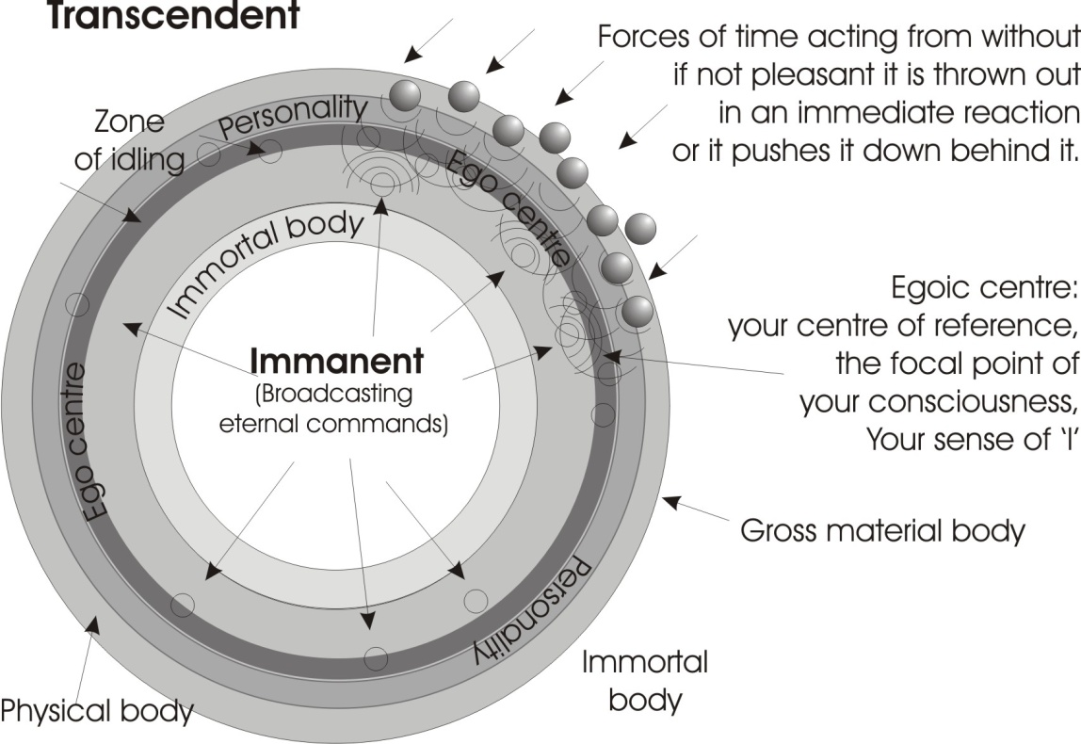
If we take this, there’s your material gross body ... we will make it fairly dark on the edge. Nice thick edge. There’s your physical body. There’s that exhausted centre of spirit, the Immanent Spirit, which he’s marked as the individual, which is really a misuse of the term. And between that untouched paper there and there… there is no difference in quality or essence. The difference is that that is inside this circle, and that is out. So we’ll say this is immanent, that’s Transcendent. There’s your physical body which receives stimuli. Those stimuli produce ripples, and this Centre is broadcasting Light or eternal commands. And between the two there arises a zone of idling. And the Egoic Centre appears here, only we must draw it as a circle — that is your centre of reference, the focal point of your consciousness, your sense of ‘I’ — and that centre is simply the resultant of forces from within, from eternity, and forces from time outside.
Now, what comes in is assimilated to this, if it is pleasant to it. And if it is not pleasant, it is either thrown out in an immediate reaction — you are told to go to blazes — or if that consciousness there, the egoic consciousness, dare not kick against the stimulus openly and doesn’t like it, it pushes it down behind it. So this is the zone of repressions, apparently. That’s this one, see? Now of all the stuff that is pushed down there, some of it is not liked by your internal Spirit, so it pushes it back. And you develop another idler, here. This always occurs. There’s always something sending something down, something sending it back, and the generation of an idler between, which would be another circle.
Now, round here there is a body which we can call the immortal. He’s [Jung has] written individual there. Really this is the immortal body, the truly individuated immortal body, round that Immanent Spirit. And that is the body that has to be perfected. So if the egoic centre throws something down there, represses it because it doesn’t like it, the Immanent Spirit may like it very much for integrating into this body. So it retains it in that body. And that one [egoic] doesn’t know about it. So you’re preparing an immortal body very often unconsciously.
Now at the same time, certain demands are made from outside by stimuli, requiring you to behave in a certain way. And you feel the call, you will arrive at work at 7.00 o’clock tomorrow morning, or something. Now, you respond to that in certain ways, and you send a behaviour pattern into your physical body zone, and you back it up here with a little zone which represents the personality in this diagram. Again it goes all the way round, I won’t bother to draw it. This band is your personality zone which you express to please external beings. And yet you don’t like it. So you just push it that way. You don’t push any of that stuff backwards. But there are some other behaviours that you’d like to keep for yourself that you don’t express. And there are also some behaviours you haven’t found out yet whether they are worth you keeping, or whether they’re only good for a façade. So you have a zone there of testing, a testing zone for ideas that may be fit to assimilate into your egoic consciousness or may be only for façade purposes, like being polite to the boss. [1:22:18]
The Ego Centre itself has exactly the same thing: it rejects certain things, and those things are refused by the Immanent Spirit. So we get a series of circles all the way round, and the stimuli are all round this being, and this diagram then becomes arbitrary. And it’s much simpler to think about the relation between your Immanent Spirit, which is always pushing up, welling up from inside spontaneously, and knows more about anything than you could possibly learn by this external stimulation. And yet, the fact is that that external stimulus exists. So there is friction ... there are other beings here with teeth, biting you, stimulating you.

Insanity
And of all the stimuli, some of them are acceptable to make an immortal body, and some are not. Those that are rejected are thrown up to be expressed. But the ego centre dare not express some of them, so it pushes them back. So you have this zone between your immortal individuality and your egoic centre. And between that zone [immortal] and this one [egoic] there is a testing zone, where the ego itself is continuously re-presented with ideas that it has repressed in the past but they keep bobbing back again, because the Immanent Spirit won’t have them. So it keeps throwing them up.
Now it’s this stuff that’s thrown up from below that’s persistently pushed back, that is re-thrown up, that produces what we call insanity. You see, insanity means un-wholeness. Sanity is wholeness and nothing else.
If, for certain external-situation values this egoic centre pushes back certain tendencies, like the tendency to express yourself freely, well, this [Immanent spirit] says, I’m only interested in expressing myself freely. So it pushes them back. The ego is terrified of some of the things that occur to it to say ... say in an English court of law. So it tries to push them back. [01:24:27]
So there then is developed below the leve1 of the ego, but external to the Immanent Spirit, a zone of terrible compression of energy, and this zone is the zone that the psychologists are trying to get at. It’s full of elements that your Immanent Spirit won’t have anything to do with — because they are only external bendings of the knee — and your egoic centre dare not express because it would lose its job ... or its girlfriend or something.
So if you compare this rough sketch with this one, you’ll see that that is actually a superior diagram to this one [Jung’s], because it gives you the dynamics of the internal/external relation. And in fact practically all modern psychology denies that that Immanent Spirit is aware of itself. They can’t deal with it, because if they allow it to exist, it is the same as that. If that is Being Awareness, Sentiency ... so is that. And if that is so, then no egoic purpose can triumph. But the zone of ambition is not down there [immanent spirit]. The zone of ambition is here [egoic centre], so all individual ambitions cannot afford to believe that Immanent Spirit and Transcendent Spirit are in contact, and that the ultimate battle goes always to this [egoic centre].
So that this whole zone here, which we call the zone of the Law, the Tora in the body, the turbulence of the spirit, the zone of the groaning and travailing to be delivered ... all that is a zone in which we can never win, no matter how hard we try, if our purpose is other than the one that Immanent Spirit/Transcendent Spirit has. [1:26:25]

Anger
Now have we got any questions that we might deal with arising out of it?
Q. You spoke last week of intuition and the psyche. I take it that that intuitional force is flowing from the immanent centre.
Yes.
Q. These things that we are speaking of such as the ego. You said that in between talking you did not think. Is that a stilling of all that part?
All this stands still. Until you train yourself, all this is turbulating like this. It is going like this all the time so that one idea is chasing another one.
Q. Now that has a very close relation to what you were telling us about … the fool has it?
Yes. You see, the gaining of that stillness is the same thing as becoming a fool, consciously, because when that turbulence is going on, it’s very clever. It’s that that thinks exactly what to say that will wound so-and-so, because he wounded me last week. That Mercurial quickness that allows you to defend yourself immediately ... that’s all turbulence. Boehme’s word for that is Turba, the turbining process.
Now this is very important. He defines — in the German language it is ??? [words are indistinct] — but he defines this relation internally in such a way that he says, This is the Devil’s zone. Not that ... not that. This is the devil’s zone. The whole world lies in the grip of the Devil. Every finite, every gross material body is in the grip of the Devil. And he says, The Devil and his authority extend no farther than anger. ... no farther than anger. Now if you look at the word anger we’ll see why he said it. [1:28:58]
The German word for it, if you like, is angst, and it really means fear. Now anger never occurs unless you’re afraid. It is evidence of fear. It is also evidence ... you see -ger, this -ger at the end is the same ger- in German, you know. Ger means your earth [G] is breaking up [R]. [1:29:24]
AN — | This is your serpentine nature, your cleverness.
GE — | This is your gross body.
R — | This is your disintegration tendency. [1:32:51]
So people shake with anger. And they actually disintegrate their organism with anger if it persists.

[1:29:39 ... repetition of a section of the talk here from the heading ‘Anger’]
[1:32:56]
With suppressed anger you can produce every organic disease you care to think of ... because every disease is located in the psyche, in relation with certain ideas; and every idea with a function; and every function with an organ, specialised. So if you are angry about a certain subject, you act upon a certain organ ... and it begins to disintegrate. This is why Christ says, Be not angry with one another. This anger is simply the contraction of this zone — egotism you see, this ego centre — grabs on to the whole body to use it, and then it thinks very rapidly how to defend itself and what to say, and what to do. Then the whole of the nervous energy flies around the body very, very rapidly and you feel your temperature going up. And very frequently while you are doing that, you’re going pale on the outside, because all the blood is diving into the muscles, ready to hit out. Going pale is not a sign that you are not going to do something ... it is a sign that your blood, your energies, are internalised into motor departments to hit out. [1:34:03]
So this turba, or turbining process here, when it is going very, very fast, he calls it the Mar-cury, not Mer-cury. When he calls it Mer-cury that means it’s gentle. When he calls it Mar-cury it’s going to mar everything ... break-it-all-up. Mars. If we can stop this process, then this light which is issuing, shines [see immanent spirit in the diagram]. And when he said that the Devil’s authority extends only as far as anger, he meant to say that you contract yourself, and stress your gross body, and tighten yourself up and make your nervous fluids fly around your body, and animate your brain tracts so that you can get plenty of ideas to hit the enemy. Then you are in the realm of disintegration, which is devilish, the div or dividing function. Then you are no god to yourself. You are destroying your unity.
So that if in fact you can relax and understand that when you are angry, you are doing yourself a profound dis-service, and relax, and say, it isn’t worth murdering myself. Because anger is murder, actually murder. If you are angry a little bit, you’ve murdered a little bit of your tissue. [1:35:29]

Self-Honesty
Q: One of the things that I was having difficulty with when I was thinking about this idea of psyching and intuition. When you were talking about a fool ... he plays about. Wasn’t that something to do with finding out his purpose ... the purpose of immanent spirit ... and when you still yourself, when you are speaking, are you doing the same thing, are you just letting it come through without any…
... without any criticism at all. You risk the consequences.
Q. That’s what I mean, you’ve got to just let it come, you don’t have to…
You mustn’t consider anything. If you consider it, then you’re not being what you should be ... open.
Q. You are just saying what comes then, aren’t you? You’re not issuing it, really.
You see, remember this zone behind the ego is a repressed zone of rubbish that’s been rejected from there [Immanent Spirit]. Do you know that’s the first stuff that starts coming up? Long before you get a pure intuition, you get a lot of rubbish, repressed stuff.
Q. Which is fantasy.
... which is fantasy. If you express that, it will say some very strange things.
Q. But you’ve got to get it out.
But you have got to get it out.
Q. That’s what I’m after, yes.
You’ve got to get it out.
Q. Is that the way to deal with it? To get it out?
Yes. What you have to do is ... the simplest way to do it without annoying other people, is this: you just start being honest with yourself. As simple as that. Start being honest with yourself.
Somebody comes along and they say, Hello. How do you do? Nice to meet you.
And instead of you saying, nice to meet you, if it isn’t, you don’t. You deliberately look round for something else, and say, Well, it’s a blue sky today ... if it is. You see that? You divert yourself and your energy out of the mechanical process, and you determine you will be perfectly honest, you don’t have to injure anybody outside. The stuff will then begin to appear in your mind. And you will begin to understand what it means to be SIN – CERE ... that is, to ‘CRA’, to break off all the rubbish from you. This ‘SIN’ is separation. You’ve to take the crust, the care, the hard shell that surrounds you, and get rid of it. You can’t do it without internal honesty. And you don’t have to let anybody else externally know what you’re doing. [1:38:08]
A man says to you, How do you do. Nice day.
And you don’t look at him and say, And I don’t like your face either. That is a thing that occurs to you. That isn’t an intuition. That’s a repressed judgement that previously you dare not allow yourself even to think about, because it might show on your face. Now, you allow it to appear. You just watch it, and say, That was a repressed element. See? Meanwhile you are saying, There is a lovely pied wagtail going over the road at the moment, avoiding that Rolls Royce ... if there is one. And you don’t fabricate things in order to make comments. You just see what is and make a true comment. [1:38:44]
Q. It’s got to come out by talking?
Well, you talk to yourself internally. You don’t have to talk to anybody else. But they will require that you say something, won’t they?
Q. Mm.
If you just look at them when they say, how do you do, lovely day, isn’t it? and you go ... ... ... and start meditating on the processes in your mind, they will say, you’re not all there, and you won’t be all there ... where they are.

Hypnotic Suggestion
Q. There was something else that I was having a bit of baother with as well, and that was the ... em ... that when you talked about helping someone that was ill or something like that, you said you could actually give them a helpful stimulus. Well, one of the things I wondered about was, for what period, only for the period that you’re in contact with them, or whether you could you continue that?
Well do you know anything about hypnotic suggestion ... post-hypnotic suggestion? [1:39:58]
Q. No.
You can hypnotise a person and you can say to that person, in three years’ time to this day, at precisely this time, you will suddenly say, ‘I must buy myself a red handkerchief’. You see. And then you say to that person under hypnosis, when you wake up you will not remember anything about this suggestion, but you will execute the command. Wake him up, and he doesn’t know anything about it.
At that precise moment in three years’ time, he will suddenly speak. Because what you have done is, you’ve stressed something that was eternal, namely it was always possible for him to say that, wasn’t it? He just selected one of his possibilities and stressed it. So it’s continuously working.
So in the same way, you can continuously help somebody ... if you wish. You can allot a stress, if you want. You can say, I hereby allot stress XPR — whatever it is — on so and so, for ever. You see, and that stresses it permanently. If you say, I will help him for five minutes, you have defined the limit.
Q. Yes, I was trying to get the idea of the faith or the flow of energy into the pattern that you have laid down, the concept that you’ve got, and this living in the NOW idea where each new situation you are meeting on the instant it would appear to me that when you’ve passed from the presence of that person you are meeting a new criterion yyou’ve forgotten about that one and cease to operate the faith of how the enrgies flow into that particular concept that you had during the period that you were with the person.
Well, there’s a very funny thing, you see. If you stop this turbining process, you do not forget it, and you do not specifically remember it. It is all of it simultaneously available. The concept of forgetting and remembering is dualistic. It belongs in this [egoic?] process… Forgetting is just departing from one zone in the organism. Certain functions are in certain parts of the subtle body, which is linked with your gross brain. If you damage certain parts of the brain, certain functions are made impossible — although they exist in the subtle body — because you haven’t got a mediator through the gross nervous system. They’re still there, and it would apparently be that the process was going on and you couldn’t express it. [1:42:37]
In the same way, at the gross level you may remember something. You come across it, there it is. It is an intersection in your brain. An energy plays over it and it lights up. And then having gone over it, it passes, and you’ve forgotten about it. After a certain revolution it’s re-stimulated ... anniversaries, Christmas, and so on, Christmas shopping, Easter. These things are in your tissue now. They remember themselves, according to cyclic law.

Time
Q. How would the time factor work in the case you gave us then where you say ‘you will buy a red handkerchief in three years’ time? How would it be regulated to 3 years?
Well, because a fellow has a calendar inside him. You stress something that exists. You know, there’s a very funny thing called biological time. Biological time this means that that every living being has got a pulse in it, and it can get you up at any hour of the morning you want to get up. You can say before you go to sleep, I am going on my holidays tomorrow, and I’ve a train to catch. I don’t need to fight myself like I have to do when I’m going to work. I’m going to wake up at 4:30 smart like that. And at 4:30 you wake. Why: because you’ve got a clock in you. There’s a clock. This biological clock is very funny, because in certain conditions when you’re a bit feverish, it goes a bit quick. When you’re depressed it goes a bit slow. But the means for the year is related to certain solar impulses. The number of breaths you breathe in and out in a year is related to the available energy in the solar system. If you breathe very, very fast on purpose, you’ll have to breathe slower later. [1:44:27]

Abstract Time and Biological Time
Q. Well, it’s biologically that the time is changing its aspect?
Oh, yes. You see, you’ve got two kinds of time - Abstract Time, which we measure on the face of a clock, and Biological Time, which lets things grow. Time is a being, it’s not an abstraction. If you put a seed in the ground it changes. On the Monday and the Tuesday and the Wednesday and so on, it isn’t the same shape. It’s not just 12 o’clock Monday, 12 o’clock Tuesday and the seed’s the same. It has altered. Processes are taking place in this biological time. Time is really a living process. Be careful you don’t forget that fundamental sentiency which feels the necessity for this impulsation. And it’s this impulsation that creates time and produces formal modifications through time. [1:45:19]
Europe tends to think of time as an abstraction. Oh, it’s just Time. What’s Time? Time is a real substantial being, evolving. Saturn-Chronos is Time ... you see, Saturn and Chronos are the same. And Time eats the children that it gives birth to. That is to say that Time gives birth to a seed, to a flower... and it corrupts and becomes manure. And that real being eats that same manure to make another flower. It is not an abstract being, it’s a real being. There aren’t any beings other than real beings.
You see, the whole mind has been so badly educated, deliberately, that you cannot think except in abstract terms ... unless you work very hard on yourself. And when you think truly, concretely, and absolutely, then there is no external authority for you ... doesn’t matter who it is. Because you’ve got that same light ... the light that lights every man that comes into the world is there, and is equally valid in everyone. It doesn’t matter whether it’s Hitler or Mussolini or the Queen Mother or whatever it is, if it says, I command you, so-and-so, you say — even a Quaker would say — There’s an inner light: I don’t have to take any notice of you. And as you become more concrete and aware that sentiency is the background of the whole universe, you can call on it on the inside. But you have been trained to be afraid, trained to panic when you see a uniform, trained to panic when you hear the trumpets blow in the high court, trained to panic when you see that wig and that serious face and the gouty leg and so on. It’s all conditioning your reflexes, this training process. And you must release yourself from that by real concrete thinking.
Purna is the Sanskrit term for the Universal Concrete Whole ... not the abstract whole. And that concrete whole has everything you could possibly imagine in it, simultaneously, all the time. [1:47:40]
Q. I’ve seen that post-hypnotic experiment. And also read of the degrees of depth of hypnosis. Can you tell me on the diagram what they work on?
Well, of course the deepest hypnosis can’t go farther than the limit of your individuality. It can’t go into there, [Immanent Spirit] because that is Absolute Wakefulness. You can’t hypnotise spirit. You see, hypnosis is only a method of putting to sleep. That is, rotating energy in a zone so that it can’t escape. Hypnosis is the Greek for sleep, and all that you do is, you fix the attention so that the available energy goes round and round and round and round. It can’t break out and make an association. If it could break out, it would wake up ... hence the fixation of the gaze. If you look at an object just slightly higher than your normal vision, you’ll quickly tire the eye, and it will tend to droop. If you add to it verbal suggestions — and there are other techniques too — then that person is mono-ideistic ... you’ve really put one idea and stuck consciousness going round it like that, and it can’t break out. It’s fascinated. And it can’t go deeper than your individuality. Now it’s going on in advertising and propaganda in minute degrees all the time. People are being fixated — as they call it these days — on an idea, which then becomes determinant. [1:49:17]
Q. It makes it appear very mechanical when you see it done. The last I saw was, a certain piece of music was played and a man in the audience would stand up and shout out.
That’s right, yes. Well, you know, really there’s hardly any limit to the number of people you can hypnotise simultaneously. You see? As a matter of fact, some of the things that can be done ... I did a series of demonstrations on one occasion, where different members were allowed, at their own request, to travel mentally, as they called it — some of them called it Astral Travel because they were Theosophists — to places, to see if they could see what was there. And they described exactly the contents of places which were verified by other people in the audience, and they themselves were delighted. Because instead of letting them not know what was going on, they were brought forward into their so-called waking state — which is really a sleeping state — very gradually, so they managed to retain the memory of what they had seen.
And it profoundly altered their attitude to their existence. Because they discovered a funny thing — that there is no reality distant. Distinct is two touchings ... to distinguish is to put two fingers instead of one, like that. And in the concrete whole, which is fundamentally a continuum, there is no near or far. It is all simultaneous. So there’s no travelling, really. There is merely a shift of attention, a-tension. Just like you can contract that [your hand], or contract your toe or something ... how do you do it? You shift your attention, and there then occurs a physical tension in the body, correspondent with the psychological attention. [1:51:20]

Ancestral Perception
Q. The continuum would be Jung’s collective cnconscious, wouldn’t it?
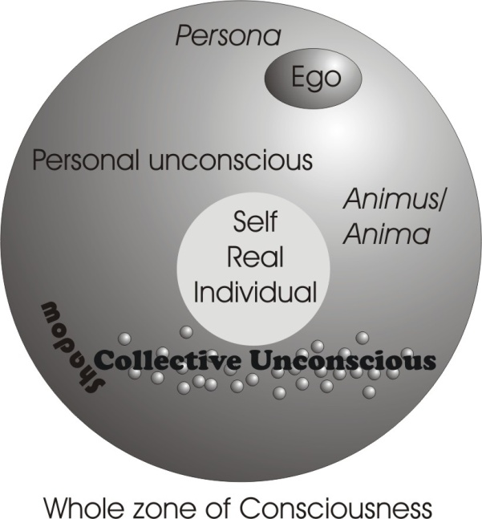
No. His collective unconscious is far smaller than that, because this includes the Absolute and it includes the Absolute as this three-fold, Being-Awareness-Motion. And if Jung had have seen that properly, he would not have written what in effect was an atheistic book. And he wouldn’t have been so depressed by his own idea. Freud never got near it, you know ... and therefore he was profoundly pessimistic. And Jung differs from Freud only really on one major aspect ... and that was this concept of whether psychic energy, the libido, which is simply the word Love disguised, lib-, lob-, lov-. Libido or psychic force for Jung is general, it runs through everything ... and for Freud is merely sexual. That’s really their fundamental difference. So when he said it was general, he’d already invoked the collective unconscious, which Freud denied. But it was still a Collective.
Now collective is still made of parts, isn’t it? It isn’t the Continuous Absolute. It is a collective. We’ve still got in that diagram those little dots down here the elements of the collective — not the continuous — unconscious.
So it’s a concept added up from percepts of your ancestors, isn’t it? It isn’t Absolute Awareness that he started with. It’s your biological predecessors’ experience, involved into your germ-plasm. Now it happens to be true that that experience is involved into your germ-plasm, but that isn’t the ground of it. The ground of it is Absolute. It’s far bigger than any collective.
Q. That ancestral perception is still very limited, isn’t it ?
Oh, very, very much. He wouldn’t allow, for instance, that a person could have in his unconscious the psychic content of a living lizard — say a Komodo dragon — which lives now. That couldn’t be in your unconscious, because your ancestors didn’t experience that one. Now in actual fact we can contact it, because it’s within the Absolute Sentience and we can pick it up, find out what it’s like, where it is. It’s possible, if you were to pervert yourself, to find out where all the treasure in the world is hidden, and go and dig it up. You’d have to be very quiet, because you’ld have to cough up most of it to the government. [audience laughter, 1:54:20] You see?

Incarnation
Q. It’s valid then that you could recover a former incarnation.?
You can recover whatever you have, Absolutely. Because what you call previous incarnations are only previous stresses. And they’re still there, only less intense. They’re with you. Actually they are marked on you. Your whole form is marked with your experiences. All you do is stress something you already have. You can’t stress what you don’t have. You can’t ring a bell you’ve not got.
Q. This may be an absurd thing to say, but, could you be one of your own ancestors, actually?
Oh yes. This is one of the biggest things you have got to be careful about. Because you might behave in a certain way — very, very badly — and then give birth to or father some children, and then later on you may be yourself the recipient of your own naughtiness by being born in your own line. Now, the only way you can avoid that is not to have any children at all. And then you might get stuck in a cousin’s line, or something like that ... who’s worse than you are.
Q. In another re-incarnation, would you have a choice? Would you be able to say, “Well I didn’t like that family last time, I’ll go for another one this time?
Well that depends entirely on reflexive self-consciousness. You obviously have no choice unless you are aware of your being. It’s this becoming aware of the content of your being. No being can know anything other than its own substantial modifications. Can you see that?
Q. Mm.
So you have to become aware of your content, now. You don’t know it, but there are millions of images derived from before this gross material world was precipitated, inside you, only they are dominated by the external stimulus at the moment, to which you are paying attention.
If you ignore the conversation and introvert, you’ll start going back. Ideas will still be there. Ignore those and go back. Ignore that and go back. You will come to the very substratum of your being, namely Absolute Truth. To do it, you must stop this external reaction, this curiosity that kills the cat. Cat is Greek ... [interruption from the audience] Yes?
Q. I personally can’t see the necessity of reincarnation when you have an ancestral memory. It’s the one thing I get bogged down on, is this re-incarnation. I can’t actually accept it.
Well, it depends how you understand it, you see. When you say “I”, you are not referring to the same group of ideas every time. You know that, don’t you, because sometimes you are in a good mood, sometimes you’re not in a good mood. And you say, I am in a good mood, and, I am in a bad mood, it’s not the same “I”. Now the Consciousness as such is Absolute. That awareness belongs to no body. Bodies belong to it. Bodies are internal to consciousness. [1:57:36]
Now incarnation is simply stressing in a body. Actually, you don’t know what is incarnate in you, now. You don’t know how many things are incarnate in you now, because different things incarnate in you from moment to moment ... that is, they embody themselves in your actions. Now, until you can gather yourself together and integrate yourself so that your individuality is indestructible, you cannot consciously take over the body. But it’s actually possible for an integrated person to incarnate in another person’s body, so that he’s using two bodies at the same time. Actually, this happens sometimes when a very strong-willed person persuades a weaker-willed person to do something that he shouldn’t do at all. And it’s the incarnation of the strong will into the weaker body.
You see, incarnation itself requires very, very careful thinking about. It isn’t a slap-happy idea that you have a formulated soul that knows what it’s doing, that at death goes out and looks for another body. There not one person in a thousand that has any possibility, never mind actuality, of integrating themselves to the point where they could choose where to go. People don’t choose where to go as it is in their physical body on earth. They are reacting all the time to suggestions from outside.
So to understand incarnation and reincarnation, first of all you have to get hold of that integrated centre, which is the only thing that can be said to re-incarnate. You see, if you look at the parents of some children you see factually characteristics in the children that are in the parents. You can only say that those characteristics have reincarnated in the children. Can’t you? That’s the whole meaning of heredity: that there’s reincarnation of character, re-embodiment. Those bodies will be finished with: the character will persist, it has re-incarnated. But Reflexive Self-Conscious reincarnation is the rarest thing in the world. [1:59:54]

Sleep
Q. That’s what I was referring to.
Yes, I know. People often get puzzled about that, but really, until you are reflexively self-conscious, to talk about reincarnating yourself is meaningless. First you’ve got to gather yourself together and be sure that you are you. How many people can know that they are themselves in the middle of deep sleep? Not many. And yet as a matter of fact, the state of deep sleep, at its very deepest, corresponds with that [Immanent Spirit]. That is to say, in the very, very deepest sleep, you are omniscient. And when you begin to move from the depths forwards into the dream ... that’s fantasy. And as you move through that, the fantasy becomes the fixed and you call it waking up. The fixed fantasy is the external, material world.
Q. How far removed is the trance state?
A considerable way, if you are talking about the trance that’s induced by a hypnotic technique, because in sleep you are not mono-ideistic, you are not tied to an idea as you are in a trance. You see TRANCE itself tells you — it is TOR-ance — you’re locked up. Now, in this very, very deep sleep state, you are not locked up. There’s this transcendence here ... you’re face to face with the Absolute there. That’s why you cannot remember it. You cannot remember it because it isn’t finite. All you can re-member — make again a member of your waking consciousness — is form. So that the greater significance there is in a dream, the harder it is to re-member it ... because it’s wide. It’s not defined down to particulars.
Q. There’ss a strange point there. If in very deep sleep we are closest to that centre, and yet in the sense that we’re mechanical, and we’ve got to wake up in order to get to that centre, we seem to be going in two opposite ways to get to the same place.
Well you are, actually. You see, first of all you’ve got to see that external world objectively. Because you remember that when you see a thing — there’s your eye, there’s an object, there’s a brain centre, there’s the ocular centre at the back of your head. Some light shines on this [object], goes in the eye, carries a motion along a nerve to the ocular centre, and registers the object. Now if you could stop there, all you’d see is a prime percept — you could not say, that is a box. In other words you would not re-cognise it. But up here [in the head] you have the type box, Plato’s ideal box. Some people think it’s just a lot of boxes you’ve have seen before. But whatever it is, it is a box. It contains square boxes, tall boxes, long boxes, round boxes, and so on. That after-motion there, which appears as box is fired up there and stimulates its correspondent up there, and then a reaction starts back, and goes like this … so that what you see out there is not the box that is there. It is that box plus all the associations of your higher memory centres. They are then projected out and cover that box up. [2:03:30]

Forms of Power
Q. I’m trying to absorb these ideas. We know there’s great energy locked in that. This is an energy system, this rotating sphere. What sort of energies are there? Are they the same order of energy or are they as powerful, less powerful?
They’re the most powerful. They’re absolutely powerful. The first determination is universal power, and if you reduced that down to a very, very low level, you have got the ‘H’ bomb ... because the ‘H’ bomb is still gross. And the gross is the most inertic, the least powerful of the whole system. Science hasn’t finished. Science is going to frighten itself to death yet, because there are forces that it knows nothing about, far different from the electronic level, nothing to do with what is called physical size. And already some of the most advanced scientists are aware that there’s a real danger of breaking out of the material world into another world of a totally different order, where the physical laws no longer hold. And that other world is far superior in power, and it is the source of our ideas. And it is those ideas that push around those little brain cells, that pushed around, push the muscles, that push various external metals and so on and produce an ‘H’ bomb. You see, that which is most scorned is the most valuable ... namely the invisible.
Q. You know you spoke of fission and fusion in the idea process?
Yes.
Q. You could liberate very great energies that way, couldn’t you?
Oh, yes. The whole universe is such an energy structure. In ultrasonics now, they are learning a very strange thing: that the hardest thing they can find, and the toughest thing they can find, caves in on the stimulus of sound. And yet sound is what? ... the same order of stuff as the human voice, only raised up octaves higher and higher and higher. And at the top level frequency it is so powerful that it can totally destroy the grossest matter and leave no dust, and there is no audible noise at the human level. There will be no sweeping up in some war in the future, when they have perfected the ultrasonic techniques. There will be just a general dispersal of the parts of the bodies of the armies.
Q. Even at that, the sonic band is low, isn’t it?
The sonic band is very low. You see, even light today is not considered the top speed. It’s only considered the top speed for the material universe. And they are already frightened that they are likely to tumble through another kind of barrier like the sound barrier, in the light barrier ... because there really is such a barrier. And very strange things happen when they break that. [2:06:54]
Q. Which barrier?
The light barrier. I mean, to accelerate a body up to 186,000 miles per second is to stop it being a gross material body ... and it’s then light. You could say it’s a photonic body. In order to exist at that speed it must be light. That is the top speed for the gross material universe. But it isn’t the top conceptual speed.
Q. I’m trying to think about these ideas. You begin to see that all the powers are there , but they are locked ... is that right?
Yes. Well, you see, the historic evolution of the world, the slow, bit-by-bit exposure of knowledge, goes hand in hand with a certain development of the brain and nervous system in the human being, because he’s not allowed to have more power than he is really ready to assimilate. And therefore it depends on the evolution of consciousness in him how much power is going to be made available for him.
With another kind of power, you could say to the moon, remove yourself ... you are 340,000 miles away, well, double it. I want your periodicity changing. And it would move. And that movement would not be a shock. It would be spontaneous. Such are the powers that exist. And gross material powers are terribly crude. [2:08:26] ***
You see, supposing you take the lowest level of — say in medicine a surgical operation on a bone — the bone breaks, you can’t have anything much grosser than that. You put it together. Then what happens to make it heal? You put the ends together and the cells start working. Why? If you say, I’ll take some cells out and examine them, and you heat them up, you heat them and you do all sorts of things with them, put them under a microscope. You don’t come nearer to its intelligence. All you discover by that technique — which is ‘S-P’ technique, subject-predicate technique — is that that thing is made of what you call chemicals which are made of electrical charges, which are at this very moment becoming waves of probability in space-time. And what’s the meaning of a wave of probability in space-time deliberately knitting a broken bone? It is an abstract idea. That wave of probability is an actual wave, not a wave of probability. It’s a wave of actuality, and it is intelligent. And the centre of a person there may actually send a message to break that bone in a so-called accident ... for the individual’s good.
Supposing a man is profoundly egotistic, and he’s leading the whole organism into trouble, and he is digging to get power, and this thing here has another purpose. So it sends a message up saying, it’s about time you fell down stairs, you know. So he falls, and then when he’s fallen down, instead of repenting he says, everything’s against me. I’ll start again. Where’s my crutch? You see?
The message comes up through the cells, don’t heal. Don’t heal. Go on annoying him. You cannot defeat that centre. That centre costs the insurance companies more money than any thing else. What the insurance companies call accident proneness is really internally willed. This egotistic bias is causing fantastic errors. And therefore the only way you can avoid that sort of stuff is find out what that really wants you to do, and do it. [2:10:36 - gap to – 2:12:43]
[Q] Can you help me to try to understand this idea? Suppose somebody came here. People have talents in a certain directions. Suppose a man came here, not particularly a sound man, but he happened to have a talent in that direction. He that, “now that idea of fission and fusion of ideas, that’s what I’ve been looking for, I can use that.” And he can. He has an ability in that direction. What is the likely result of this?
Well first of all it’s not correct, if you are referring to his individuality, to say that he can. What it implies is that he has already been led to a point where the ideas in his individuality can assimilate those new ideas ... not he can. Those ideas are forms. Now he hasn’t yet got Reflexive Self Consciousness, has he? Which is the only real meaning of ‘He’ doing things. This is why Gurdjieff kept hammering at Ouspensky and others, you can’t do anything, because you’re identified with your individuality. Your individuality is form, and form and form can do nothing except be form.
Decision isn’t form ... it’s free spirit. So in effect, if he saw that idea, it would simply mean that some stimuli in the past ancestrally, and on him individually, had so informed him, that these new ideas fitted like little cog-wheels into the formal pattern, there, and that might move him towards a higher level where he could be nearer to Reflexive Self Consciousness. But if he made the mistake of saying as an individual, these are good ideas, I will use them, he will fail.
What he ought to say is something quite different. He should say, if these ideas are any use to the Universal Purpose, let them fit into their appropriate places. I’ll leave them”. You see? Then they go, as Christ would say, into their own place. Whereas people are always trying to put them into another place, like Humpty Dumpty misusing terms.
Q. That is where the private purpose for instance could defeat ...
Oh, yes. If there is a private purpose sometimes it is followed with success for a period because it is useful to educate some other beings from the point of view of the universal purpose. When that is finished it is removed. The apparent success of Hitler depended on the disintegration of Germany, didn’t it? No Versailles Treaty, no German disintegration, no Hitler. That didn’t mean he was there permanently. He was there to produce a type of unity ... then his work was finished. He identified with the situation and then he tried to retain the situation…

Break in recording

… they are going to going to build up virtually a moral dictatorship. Now anybody who wants to realise that and says, all right, I am going to go moral for the period. I shall write moral articles or I shall do this. And then that will reach a peak and it will go up to twelve o’clock and after twelve o’clock it’s going to start falling. He should get off at eleven o’clock. It’s all that alertness, like Joseph to the cycle. Alert means all work, doesn’t it? Jump off 11 o’clock to every 6 o’clock.
Q. The text, “My Father works and I work”. Is that it?
That’s right. You’ve got to make the two simultaneously, you see. This is the Father. I work. My Father works ... I work. When Christ says, if I judge from myself — this thing — my judgement is not right. But if I judge from him who sent me, my judgement is right. And then he says that very funny thing. I do not judge, but if I do judge, my judgement is righteous because two establish it. And I am one and He is one who sent me. [2:16:44]
But some people think that he’s being a bit cheeky there because they are saying, He has fabricated God the Father. He’s given himself an external authority, which he is the authority for. He says, ‘God the Father exists and is right. And He has sent me, therefore you must listen to me.’ But really, it’s a metaphysic fact. If we analyse the nature of the Absolutely Free we find that Free Power, Sentiency, either does nothing, or something. If it does something, it conditions itself, and it deals with the conditions. God so loved the world that he has to give something to it. What did he give? His only begotten Son. That is, the Light of his Consciousness to put inside it, to rule it. That’s either/or. If he doesn’t make a system of circumscription, he hasn’t made a world, and there’s no value. If he does, he’s made a finite structure needing a light, so he puts a light in it.
Q. One of the things that’s occurred to me is that if you’re going to get your tail in your mouth, just turning your own power back on itself, and then you’re going to get your sex energy and transfer it to a different place, you’re going to be a terrific power pack, quietly, aren’t you? Are you going to get the necessary problems for you to require power?
Of course you are. You move to where that power can be utilised.
Q. You’re still going to get your tasks…
Oh, yes. You needn’t worry if you get that. They’ll be found for you.
Q. So I can see that you couldn’t possibly present a private purpose to that kind of force because it’s too great, isn't’it?
Of course it is.
Q. That’s the stuff that’s all flowing through you and out normally isn’t it?
Yes.
Q. And I can see that it will crack you up if you’ve nothing to use it on.
Yes. Well, it’s the force flowing through people. When you look at the people you say, they are incontinent, because they can’t stop it. But if they didn’t try to stop it, and honestly want to sub-serve its purpose, it will find them something to do with the energy that’s there. And it will be much easier than the other job that he was doing with such difficulty. It will be a higher job and an easier job. The higher you go, the easier the job you get.[2:18:17]
Think of God’s job. He just going like that… all the time.
[laughter]
No problem, is it?
Q. It must get harder, the higher you go.
It isn’t true, you see. If you study — say a child learning the elements of arithmetic — it has a terrible time. And once you’ve absorbed those you begin to understand a bit what it’s about. It becomes easy, doesn’t it? The first time you do algebra it’s terrible. After a bit you get used to it.
Q. But is it not very hard to do what takes very great responsibility?
Ah. A very great responsibility. But there is an awareness of that responsibility such that you don’t abuse it. You don’t even have to fight yourself to keep your mouth shut about certain essential secrets.
You see, once you’ve defined a point as a location without dimensions and understood it, you’ve understood the whole of geometry, because it’s simply an extension of that ... isn’t it?

You know, when you think about throwing a word away ... think about it very carefully. What you are throwing away are letters of the alphabet. They have a meaning. Before you throw a word away or think it’s not necessary, find out exactly what it means. If you can’t do the literal significances at first, at least get down to the roots.
The moment you see ‘Luci-fer’ — they usually call him the light-bearer, you know ... a loose translation. Well you know that that lux is Latin for light. There’s another word for light in Latin, lumo: that means smoky light. And his name isn’t Lumofer, it’s Lucifer. So he is not the smoky light when he’s called Lucifer. And his name was Lucifer before that fall, veil, pall, covering over of that essential secret. Therefore Christ says, Oh Lucifer, how art thou fallen. [Isaiah 14:12] Satan says self-crucified [S = self, T = crucified]. And Lucifer is his title before that peculiar process of covering over. [2:22:11]
It’s actually the most fascinating subject in the universe ... namely the identity of polar opposites. How is it that God the Father has his main characteristic given in the Old Testament as a devouring fire? You see? He’s an angry, jealous God. What does that mean? It’s exactly the same definition as the Devil. And gradually this definition of God gets cleaned up as He goes through the Bible. Why? Because people are evolving. First of all they have to behave like devils, and then when their blood gets a bit cooler they define God again. You have to define God continuously, you see ... newly, according to your level of being.
Q. When you described Him as ‘fire’, doesn’t that mean that if you break the law, you’ve got to face terrible consequences?
Yes. But that law was generated by it, through it. You can’t have this turbulation without heat. And you can’t have light without incandescing matter. And you can’t have matter without this primary grab. The first letter of God’s name, the Yod or Jot, Iota, is simply that [grasping]. You see, because if he didn’t gather the Absolute and make a point in it, like that — and then compress it and grind it — it wouldn’t incandesce and become light.
Genesis says, Let there be light [Genesis 1:3], which means that there wasn’t any. The earth — that’s the substance of the universe — was without form, and void. Darkness was upon the face of the deep and then He says, Let there be light, and He crushed the substance, like that… and that’s a diagram of that Iota, God’s fist.
Q. Well that was what Lucifer did, wasn’t it?
This God, as creator, is Lucifer. William Blake, when he saw that, he suddenly broke down a verse and said, Everybody on earth is worshipping the Devil under the name Jehovah, and they don’t notice it. Because the Creator is He who does that [grabs], you see? … always.
You get a piece of clay. Do you ask the clay if you go like that to it? Who’s the potter, pray, and who the pot? You see? So you say, Alright, the clay is my substance. That hand is clay, and this clay hand models that other clay. Does the pot complain when I model it? Let it complain. I have the hand to model the pot. Not the pot: me. Nevertheless I am constrained by the deficiencies of the material to make a pot. You see? There’s a reciprocal relation there.
God the Father is the Devil, because the Devil is the divider, and to create is to divide. If I create two: there’s one and there’s another. So they’re divided. They’re two grabs. You see, GRAB is the German word for Grave. Change the ‘b’ to ‘v’ [grave] ... that’s death. Hitler was called Schickelgruber, he was a present from the dead, sent from the grave …
If you can see this essential identity, that that which was open, Jupiter, and that which is closed are the same, essentially. And when it was closed and produced this plurality by closing in various places, we say that’s the Devil’s work. But those people who know that both are identical, deliberately tell people not to do this. Don’t hang on to your taxes, when you get a demand ... pay up. Remember the truth is mighty and shall prevail. Make your record correct. They’re on the collecting end.
Q. Well, the names ‘Jupiter’ and ‘Saturn’ ... were they used in this sense first, or were they applied to the planets first and then borrowed for this use?
They were first used in that sense, and borrowed to apply to the planets. You see, the planets are used because of a certain relationship to the earth. If you make the Earth central to the system, and then put rings round it, you see, there’s a definite relation between the Earth and the planets. If we look at the Ptolemaic System of the universe. [2:26:48]
Q. One thing that struck me the other day was, that the planet Saturn is the one with rings round it. And was Saturn chosen because the rings show bondage, and Jupiter the free one?
That’s right. Yes. And you notice the names of the other ones outside, supposedly unknown to the ancients — in spite of the fact that very often they said that there were seven and two, seven planets and two others, namely the sun and the moon, which make nine. And the names of the other fellows outside are the names of abyssal things — Heaven, Uranus, Pluto ... which is that Pi Lot or abyssal distance around the whole process. They don’t name those things accidentally. They search the deepest mythic traditions.
Q. What about Neptune?
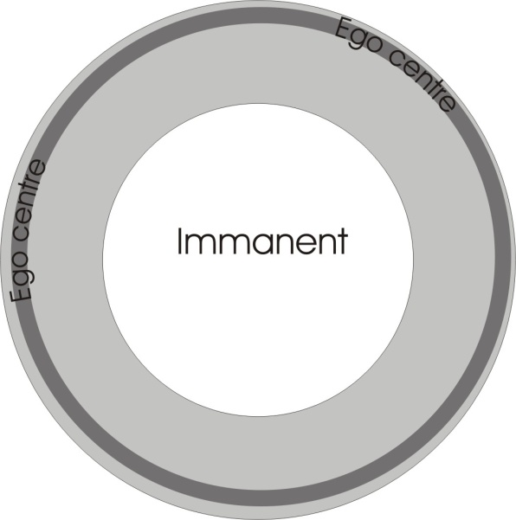
That means the Ruler of the Universal Ocean doesn’t it? Beyond that there’s nothing, is there?
Q. So that the names were used before they were applied to planets?
These names which existed and were applied to the recently discovered planets — when I say recent I mean in the last couple of hundred years, you see — those names are in all the ancient myths. They’ve taken them from the Greek, but they existed in the Babylonian and Indian, and so on.
Those names refer to this: Neptune is the Great Ruler of the Sea. He has a tri-dent, or three-teeth, doesn’t he? ... and so this being-awareness-motion, the Universal Ocean. In that Universal Ocean there appears a great Pi LawT, the great Pi-Lutor, who pollutes the Absolute, doesn’t he? In the first Macule, the first dark spot, it’s called the Great Interjection, magically ... the appearance of a formed system. And then that grinding itself round in a process from which we get the word crater, this great mixing bowl. That great grind set its edges on fire and that was heaven, light, a big band of light. And then that light radiated inside, going like this all the time… produced all the systems within it. And if you remember that diagram we did of the zones, here from that one to that, and work out the opposition between them, it’s a very good exercise. [2:29:40]
Put your physical body there ... that’s gross matter.
Put the hole in the middle for the Immanent Spirit.
Put your first individuation, the egoic centre, your relation with external beings there… and work out how many buffers you need between there [perimeter] and there [Immanent Spirit], and see if you don’t come to the number nine for the lot.
Q. I was wondering how many that would limit to, because we could always make them smaller and put another in betweeen, even if you arrived at nine, you could say, Well I’ll make these smaller and put more in between.
That happens. But we try to put a body in between the Moon and the Earth — a planet — do you know what would happen to it?
Q. Yes it would upset balance.
If the distance between the moon and the earth doesn’t alter, it will fall either onto the moon or the earth ... because of the disequilibrium of their cycles. It cannot stay there. In order for it to stay there, the Moon must retire first.
The Universe is expanding to make room for more moons, by which time, you see, that [moon] would be an Earth, and this [Earth] will be a sun, having incandesced. It has to move out. So if there are more bodies appearing in the solar system, the solar system would disintegrate and become a series of solar systems.
Q. The same must apply to all the names of the elements, then?
Oh, yes. It isn’t accidental that the elemental scale is made up of a series of octaves. You’ve got thirteen octaves in the atomic scale, haven’t you? In the natural atomic scale, ignoring isotopes and other ….. [obscured by a cough] , you have thirteen sevens plus one, haven’t you? Now the same notes in music are related at audio frequencies to the vibrations of those atoms.
Q. There’s a clue in the names, is there?
Oh, yes. Every one of them has the correct name. Their positions in the atomic scale are tremendously important because actually you’ve got a key of what you ought to work on next in that.
It’s such a big subject and yet it’s as simple as that diagram. And once you’ve understood that relation of the centre to the perimeter, and the fact that energy flowing from a centre goes so far then turns back, and that is your Pi Law, and the amount of energy gives you the Hé Law.
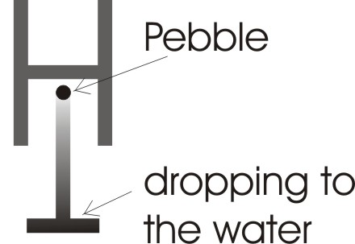
So that the Hé Law and the Pi-Ratio Function together:
- The height from which you drop the stone is the force, the ‘H’ value.
- The distance of the height of the ripples that result is your Pi Ratio function.
So you can analyse the whole system in terms of those two ratios ... power and space. The funny thing is that ideas are charged with power. There’s a natural relationship between ideas, such that the word dog has more power in it than the word mouse. [2:33:04]
Q. In the same way that elephant would have more power in it than dog?
Not because of the size of it. But actually because of the meaning of it, it has. You see, ele-phant itself is God[El] reasoning[Ph] and establishing[Nt]. The elephant is wise, because it is actually a precipitate of a certain kind of understanding. And that’s what has caused its nose to become so long and grew a finger on the end of it. You know how sensitive an elephant’s trunk is? Now that nose is the organ of discrimination, and elephants, in spite of their large bodies, are tremendously sensitive. In fact they are so sensitive that they were put in an elephant’s body to stop their gallop a bit. You see, this is a polar opposition. If you became one-sided, you would not be a whole being, because you’d be delighted with success in one field — and you would never develop your wholeness.

~~~~~~~~~~~~ End ~~~~~~~~~~~~~

John 6:63 It is the spirit that quickeneth; the flesh profiteth nothing: the words that I speak unto you, they are spirit, and they are life.
Genesis 41:4-7 And the ill favoured and leanfleshed kine did eat up the seven well favoured and fat kine. So Pharaoh awoke. And he slept and dreamed the second time: and, behold, seven ears of corn came up upon one stalk, rank and good. And, behold, seven thin ears and blasted with the east wind sprung up after them. And the seven thin ears devoured the seven rank and full ears. And Pharaoh awoke, and, behold, it was a dream.
Wife to Socrates
John 8:15/16 Ye judge after the flesh; I judge no man. And yet if I judge, my judgment is true: for I am not alone, but I and the Father that sent me.
John 3:16 For God so loved the world, that he gave his only begotten Son, that whosoever believeth in him should not perish, but have everlasting life.

