Contents

Making Things Operative (239) 1

Ideation — Cognition. 1

Feeling — Affection. 1

Conation. 2

Modern Psychological View. 3

Space 3

Zones of Rotation 4

Cell Division. 5

Wave Formation and Nodal Points. 5

God the Object of Worship for a Worshipper. 5

God Pure Act. 5

Inequality of Finites. 7

The Election of Grace 7

Karl Marx - quality is an emergent of quantity. 8

Spirituality 8

Constantine. 9

Ideas. 9

Geometry and Mathematics. 10

The Mobilisation of Ideas. 10

Hammering Ideas to Bits. 11

The Other End of The Point. 12

Operators and Things (active and passive). 12

Troughs and Crests. 14

Continuity of Protoplasm. 16

Acquiring Power. 17

Making the idea operative 17

# Making Things Operative (239)

It was pointed out the last time I was here that it is possible to learn a lot of theory without this theory ever becoming operative in the organism. So tonight we’re going to talk about something we have referred to before, but in a little more detail ... how to *make* things operative.

## Ideation — Cognition.

And we’ll have to go back to our primary diagram, and look at the human organism in dynamic terms. If we were to use the orthodox psychological terminology, the function of the brain — particularly of the fore-brain — is what they call ***cognition,*** but we prefer to call it ***ideation,*** because the idea in cognition is the idea of seeing things together, and it is quite possible to present in the mind a series of disco-ordinated ideas, and this could be called ideation without cognition. It’s possible to ideate, to present ideas in the mind, without comprehending what they mean. Each idea can appear in the mind, become fixated or displaced by another idea, without any real comprehension of the relation. So for this process in the head, to keep it quite basic, we will use the word ***ideation***, and mean the presentation of ideas, whether singly or in groups, serially or simultaneously.

## Feeling — Affection.

The term used in psychology for the feeling life is ***affection.*** You know that popularly this means being fond of something. But it also in psychology means the contrary, to dislike something. When they refer to the affect, they are referring to the way a stimulus affects the organism in terms of liking and disliking ... and therefore the affective process we can give a plus and a minus value.

**Plus — means ‘I like it’.**

**Minus — means ‘I don’t like it’.**

## Conation.

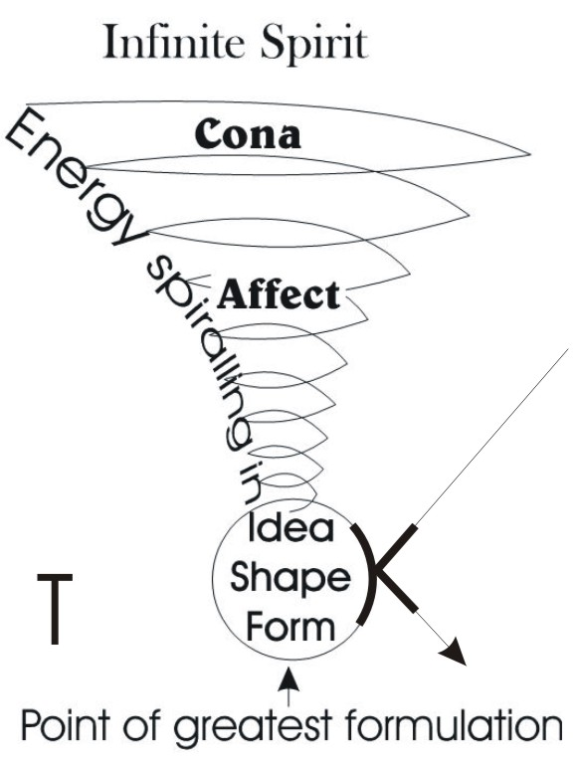The function below the diaphragm, the psychologists call ***conation,*** and conation means basic drive ... absolutely basic life urge. It can appear in a differentiated form as sexual urge in man and woman, but the sexual urge as polarised is already merely a secondary behaviour of the primary, conative drive. Conative drive is simply life energy, pushing itself away from where it is, in some direction which is not yet determined by idea. [03:03]

If we look at the word *cone*, and we draw a cone, and we draw it dynamically — energy spiralling in and converging to a point — that is the meaning of conation. But right at the tip of this point here, where it can condense no further ... that is an idea. Remember ***idea*** is a Greek word for ***form***, borrowed through the Latin. The Latin word *forma*, form, is the word used to translate the word ***idea***. The Anglo-Saxon word ***shape*** has the same meaning. It simply means the circumscribing or limiting of an energy, until you can actually locate it formally ... determine its shape. So we can talk about the idea of a triangle, which is a Greek word expressing the shape of a triangle, or the form of a triangle. Shape, form, idea are synonyms for this purpose.

Conation is driving along, and progressively condensing towards an idea. And this conation comes from the Infinite and winds itself in. It is a self-inwinding process. And if we write at one end conation, Cona, we should really technically put the ‘T’ at this end where it reaches its formal conclusion.

You know that an ion is a charged atom, which it is either positive or negative. It could be a negative ion with an overbalance of negative charges, or it could be a positive one with an overbalance of positive charges. But the ‘ion’ at the end means the progressive motion of a nuclear — an orbital — system. [05:01]

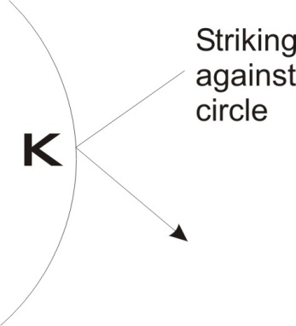**N – means continuity of motion.**

The Cona process has exactly the same meaning as the Gyna process or *woman* process. You know in gynaecology you are concerned with woman. This is a word for woman borrowed from the Greek. In *Arthur’s Bride*, the Lady *Guinevere* means *true woman* and this same word has been, by sound shift, turned into *cona*. So that fundamentally the *cona* function means the kind of movement that is tending to converge, tending to objectify, tending to formulate, but has not yet done so.

Let’s try to make this slightly different.

We’ve come from infinity and we wind in, tightening as we go, until we come to the term of tightening. Now if we like to write up here *spirit*, before it begins to wind in, as we are coming in to the cone form, and progressively condensing, we are becoming tighter and tighter ... more and more restricted, more and more formulated. And at the point of greatest formulation we have an idea. [6:27]

At the top we have pure spirit, exactly the same thing as the Godhead in theology. And when it begins to wind in, we have a feminine aspect ... the beginning of the closure. And at this point we could write, where the closure occurs, here ... let’s make this a complete circle. We could say that where this line of Free Spirit strikes against and bounces off this closed circle, we have written the letter **K,** and this **K** means to close, to strike, to inhibit.

The letter **O** is here. The letter **K** is there. So this is K.O. and N. means continuity of motion, so as this progressive in-spiralling occurs we must keep writing K. O. K. O. on all levels and write in **N** for the continuity of the process.

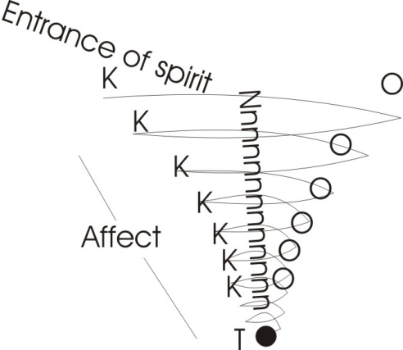Now, midway between the idea and the initial entrance of spirit into the approximation to a closure ... that is the affected process. We can write ***affect*** in the middle of this cone. So we’ll write the Kona here. I’ll spell it with a K this time ... it’s the same letter actually. And as it is coming in towards here we write that final **T** on the end, and then the little circle with a dot in it for the idea itself as a point of precipitated energy and an orbital function around it.

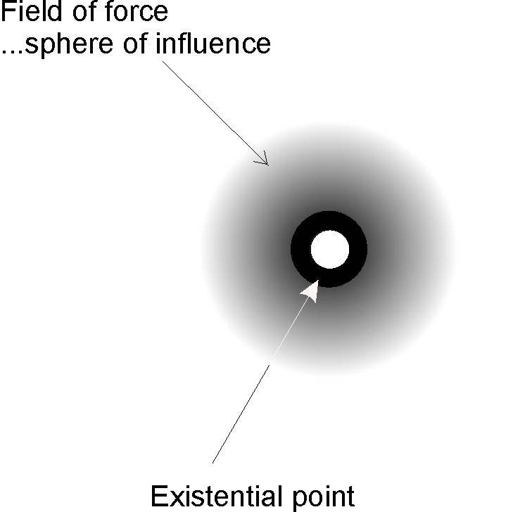Every point, every existential point in the universe is surrounded by a field of force. That field is defined as a zone of influence.

Every form influences every other form, to some degree. [8:28]

## Modern Psychological View.

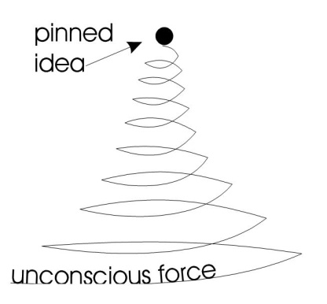Now, supposing we deliberately invert this for a moment and talk about the unconscious, the sub-conscious, the nearly unconscious — but not quite — feeling process, and then gradually the formulation of an idea. We can write at the top, we’ve got a pinned idea. We’ve inverted the diagram. It’s still valid, except that it takes on somewhat of a modem psychological significance.

In modern psychology they have tried valiantly to get rid of the idea of spirit, because it implies a superior intelligence to that of the individual psychologists who are formulating the theory.

And as they tend not to like superior intelligences, they would rather invert the image and represent the life force as an unconscious force, gradually climbing up from a homogeneous state, progressively by condensation, to an individuated state which differentiates itself from any other similar conative processes. [09:39]

## Space

Now if we consider this very carefully, we have abstracted just one conative being from an infinity of such beings. An infinity of possible beings subsists in the infinite power of the universal source ... the Absolute. That infinity, that power, can produce this conative process anywhere it likes. In other words, the qualities that we attribute to any part of space, we must logically allow for any other part of space. Space itself, as everybody knows, is not a material body. It is that in which material bodies subsist. [10:28]

|  |  |  |  |
| --- | --- | --- | --- |
| **[** | **SPACE: S —** | **SPIRITUAL FORCE, UNDULATION (sine wave)** | **]** |
| **P —** | **POSIT, POINT OF INITIATION (of any centre whatever)** |
| **ACE —** | **AITCH, ACHE (infinite spirit)** |

letter pSo if we write our word *space* down, and examine it a moment, and cut it, we find that it is made of *ace* which of course is the symbol ‘H’ (aitch). We see it in the French word for ‘H’, *Ache*, which of course is the English word *ache*. And the idea of the ace function is the idea of spirit, as infinite. But when we put the letter ‘P’ in, we posit that there is something within that space relative to which we can conceive space as non-being. A force, a spiritual force ‘S’, has posited itself within infinite spirit.

We’ll change the diagram a little bit and we’ll write ‘P’ for posit here — that might be the finger of God or it might be a paramour pointing downwards — but all around this ‘P’, or place, or posited being, there is an infinity of spirit which is represented by the ACE. In a pack of cards we have ace high and ace low.

**Ace high** theologically corresponds with the Absolute Godhead ... superior to the king.

**Ace low** counts as the primary particle in the universe ... the first precipitate of that spirit.

**ACE LOW ... is immanent in manifest being** *[in posited form****].***

**and ACE HIGH ...** is **transcendent absolutely** *[Infinite Field].*

So this same word *aitch* has two significances. It is the infinite field, ace high. It is also the immanent energy in any posited form. So if you like to take the first letters of spirit, S and P, the reason we do so is because the S means an undulation, and the motion of the sphere can be analysed out like a sine wave, and considered as an undulation. This same function is going across all these concentric ripples to posit that P.

If you drop a pebble on the surface of water, that water itself will behave in this rippling manner. We saw some large iron girders with ripples on them on the way up tonight. How they got in is a mystery but they were very well done. [13:00]

The essential of this undulation is that by its very nature an undulation in the infinite continuum always produces points of precipitation, because this undulation, going through, is continuously stimulating the whole field and causing a process of feed-back, a back motive force ... a back-EMF if you like. As soon as we discharge energy from a point, the field always reacts back on to the point from which the motion is initiated. So we’ll write the letter ‘P’ for the point of initiation, for the positing of any centre whatever.

## intersecting forcesZones of Rotation

So the whole field is considered as ‘H’ or ace or spirit, and the product of the motion, the Absolute motion of this field at any point whatever throughout space is the positing — through the self-interference of this motion pattern — the positing of a point. We’ve said before, if you charge two forces across each other, at the point of intersection here, they rotate. If we say let that represent one pencil, and that is another pencil, you hold them up, put the tips together and push hard, you will find it extremely difficult — if you use a lot of force, practically impossible — to stop those pencils spinning round each-other.

Try to get two pencils, put the ends together, and press them and keep them in line. You will find it is very difficult, and in the same way as the difficulty is for a human being, so it is for the Absolute.

The reason is quite simple: that when you release energy from your nervous system, the energy is quantised, and therefore it is always too much or too little to balance exactly ... so it vibrates. And you can’t stop this vibration, and therefore the tendency is for the pencils, when you press them, to displace themselves and skid off. And once the motion has started in a rotating manner, the inertia of it tends to continue. So if you tried to press the pencil ends together, press hard ... they slip. If you try to line them up they tend to slip again and in the opposition you develop a rotation. [15:27]

So within the Absolute field, any intersecting forces develop a zone of rotation.

Now let’s go back to our cone diagram again. The Infinite field represented by the paper represents ‘H’. We borrow the word *paper* from an Egyptian word, which means, *your father is reasonable*, anglicised as papyrus [Pa-Py-Rus]. And the idea is, you can always trust Spirit. And this you can certainly do providing that the spirit you are trusting is Absolute. And if ever the spirit that you are trusting is finited, then you are better to distrust it ... that is to have two kinds of trust, one from the will and one from the understanding.

So here we are with this reappearance of the cone again. From the Infinite, the energy winds in. This winding now is an abstraction out of the total function of Infinite Power. Once it has begun to turn in, it feels, in the turning-in, itself to come to consciousness of its own process — progressively sharper and sharper — until when it gets right down to its limiting closure it has become completely aware of itself. Now, you know that in Zen-Japanese Buddhism — or is it Zen-Buddhist Japanesism? I’m not quite sure which way round it is — the basic idea is, *what is my original face before I appeared in the time process?* [1]

Let’s see just what this means. [17:10]

## Cell Division.

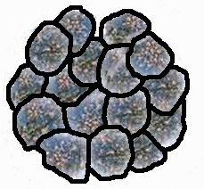When we study embryology, we start studying from the point of fertilisation of an ovum. Now the ovum is a potential, and we know that it will look something like its mother when it develops, but it doesn’t develop without a starter. The starter is the male sperm. When this egg has been produced and fertilised, then it does various peculiar things. The first thing it does is start to partition itself. And it goes on with this process of partitioning until it is like a little cluster of eggs. Yet in fact we know that this cluster of eggs is one egg which has introduced partitioning, like a seaside landlady into a relatively small house.

And in this process of pluralisation there has arisen a new possibility, which in the simple state of the undivided cell remains a mere potential. When the cells have been pluralised in this way, then we can take any given group of them, and develop that group of cells by shielding it from the other groups and progressively folding it in various ways. This is the way the brain is made. Remember, the cells in the brain are just sub-divisions of the original cell. All the cell sub-divisions are simply the original cell.

So there is no basic difference between the cell that makes the underside of your sole and the cell that makes your brain, the cell that makes your heart, your kidneys, your spleen, whatever else you have secretly kept back from your neighbours. It is the same cell, specialised. Now we want to see why this has occurred. [19:01]

## Wave Formation and Nodal Points.

Let’s look at this cone thing from another aspect. If we were to do the coning in this manner, to a limiting point, get fed up with the point and wind it out again, we see that we can actually begin to construct this wave formation again.

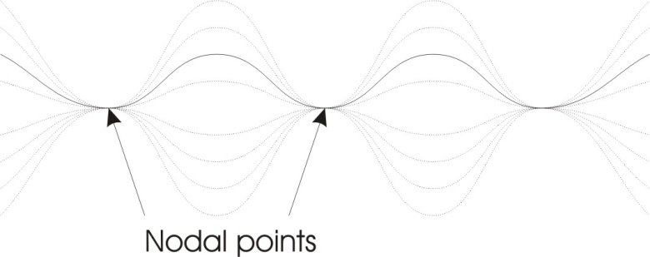And the point where the idea is, in a wave system, we call a nodal point. Now a nodal point is the same thing as going into the land of Nod. It’s where you go to sleep. If we were to get a vibrating string, the point which is called *nodal* is the point where the string does not move. You get a violin string and pluck it, you’ll find it swings about. And it swings in various manners like this, and it swings back. At every point where the string is not moving up or down — not, node for not, ‘t’ to ‘d’ — not moving up or down, we call that a nodal point, and nothing is happening there. It is the still centre round which this swing can occur. [20:07]

## God the Object of Worship for a Worshipper.

Now the Infinite Power has infinite form within itself *actually*. We have to be very careful about this, because when we talk about God we are talking about the object of worship for a worshipper. So if we let the worshipper be enlightened about the nature of God — and he discovers that God, as a function of the continuum, is not other than his own self, fully understood — then at this point, this God ceases to be worshipped by this worshipper, because he has identified himself with it. So he no longer views this God objectively outside himself but he denies the apparent duality as reality and asserts his own identity with it.

## God Pure Act.

Now, the whole continuum represented by the paper is pure motion. It is not a potentiality in the sense that it might be used by electronic engineers or by physicists or other people. Potentiality as non-actuality is a myth. But it is a convenient term. We could say that this room is full of potentially running-about beings, because they are not running about at the moment. [21:29]

So whatever we are not actually doing we could say is a potential. But owing to the fact that at a certain level of our being we have an image in the mind — which is dynamic and not static — of ourselves running about, at the level of the image of running about, the psyche is running about. And if it didn’t run this image of running about permanently in the mind, we couldn’t get up and run about in the temporal world.

So theologians define God as PURE ACT. And when they say this they are already on the edge of talking about the Godhead rather than the God that is an object of worship. Mohammed said something which is translated — mis-translated — *there is no God but Allah*. The original says, *There is no divinity but the divinity*, which is a bit tautological. But what it is saying is,

*“The Absolute, the Infinite Motion, which is the only worshippable in the sense of highest value, is not other than that worshipper. And if the worshipper realises that his own motion of his own intelligence extended to infinity is this very divinity that he’s talking about, he will see that when he talks about value, he is talking about transcendence”.*

If you think about your physical body as a physical body located in space and finited and limited, you will have no great regard for it. But if you think about the intelligence which you believe is packed inside it, waiting for the opportunity to express itself, then you can have a very high concept of yourself. And because you may be not be actually doing it at the moment, you may say, *It is only a potential*. But at its own level it is not a potential, it is a pure actuality. So we will define this Infinite Power as an Absolute Motion, a PURE ACT. And when they call it the Actus Purus, we should take the C.T. out of it and view it as A.U., that is energy going along, and the C.T., the ‘cat’ in it, is simply where those energies intersect. [23:57]

**When we use the word AC-T —** w**e are implying that we have applied a force [A] to a resistance [C]. When we put the T on it as well — we fix it and establish it, and crucify it and we say, *do not change.*[2]**

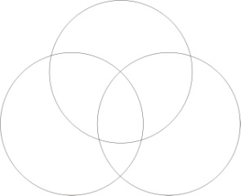So in the word AC-T we take ‘A’ — primary energy — and lock it upon itself and nail it down so that it cannot get rid of its form. It is an AC-T. When it is said that God is the Actus Purus, the pure act, it is really incorrect to translate it at all. And it is incorrect to think about it as a terminated or determined activity. If we say it is a pure ‘A’ — that is, the first letter of the alphabet, the Aleph of the Hebrews or the Alpha of the Greeks — we are saying it is a force that, by rotating from the infinite and going out again, creates a finited zone and that finited zone is cut — that is, locked up and fixed by its being — and separated from any other such finited zone that might appear in existence. [25:13]

The Absolute is factually infinitely modalising itself. Now, it is an Infinite Pure Motion. When we say it’s Infinite Pure Motion we mean to say it can change itself. It has no inertia, no mass resistance other than itself. It is absolutely free. It is a continuously self­-mobilising, Absolute force. [25:55]

And if we consider it at that level, then we have to say, *Let us disregard for the time being the fact that we are here in this room ... that we are created or locked up*. In the infinite motion all conceivable forms are there. If we were to draw this ... remember Michaelangelo’s favourite Mason’s mark, the three circles, which is also the symbol of the Trinity in Christianity. You know that if we get the compasses we can get any intersection point, same radius for this, and we can start drawing circles wherever we can find an intersecting point. So we can always draw another circle. Just take an intersection point and use it as the centre of another circle. In this way we can cover the paper with this non-arbitrary system of ripples.

Now without bothering to get the right place *[on the scroll of paper that he uses],* I’ll put a few more in to make quite sure that we have an idea of the intersections of these rippling systems.

The reason we can put these in is because the Infinite Power, this Sentient Power, the power that feels itself, is by its very nature motion, and therefore it is condensing and expanding itself. It is contracting and expanding alternately on every point so that throughout the whole of infinity there is factually a mesh. We write the word mesh in there; it’s an important word because it’s the base of the objective self, me.

M – is the substance.

E — is the field energy within that substance.

M is the negative or passive aspect, and E is there the field energy active aspect of the same thing.

The S.H. at the end is a word meaning to issue, come out.

## Inequality of Finites.

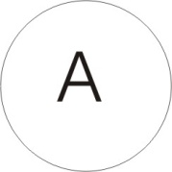Imagine this to be a diagram of a plane of water that has been hit with pebbles all over so that it is full of ripples. Now, if all these ripples were exactly at the same tension and periodicity it would simply be like a fisherman’s net, extended through infinity in three dimensions. But to imply that the pressures placed upon all of the circles are identical would be to imply that there is an overriding control over them ... which is not so. Because the only thing about this continuum of power is that it is self-mobilising. Nothing constrains it to move, other than itself. [28:32]

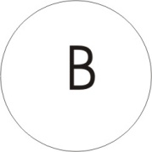So the particular circle here represented must be seen as condensing upon its own centre by its own will. And another circle over here condenses on its own centre by its own will. And this centre ‘A’ does not consult centre ‘B’ about what it is doing. And we cannot conceive the necessity within the infinite of ‘A’ dictating to ‘B’, or even of a larger circle dictating to both of them within themselves. Even if the larger circle contracted on its own centre — like a genuine leader of a large organisation, assembly or church — we could not in fact stop locally the concentration of that fundamentally identical Sentient Power on its own centre. Therefore a large organisation like the church, in spite of all its dogmatic formulation, cannot stop differences of opinion within the cardinals and other levels in the hierarchy. [29:35]

Now, if we look at this mesh as exactly equal all we can say about it is that it would not be terribly interesting. But if we remember that this mesh has no overall control to compel any given circles to remain at the same pressure or vibrational rate, the same intensity or periodicity of any other centre, then we will have to say that this infinite field is an individuating, a particularising, a differentiating field. It doesn’t cut the field, which is a continuum and therefore impossible, other than functionally. It merely actualises zones in itself in a different way.[30:17]

## The Election of Grace

Now, there’s a concept of the Election of Grace in all major religions. And it says that some beings are, from before time, chosen for salvation. And it becomes meaningful at its own level if we consider it within this field.

Now, if we select any given one of these circles — and remember it is self-determinant and therefore not under the dominion of another circle — it can choose its own periodic frequency and intensity. We will place on this one a heavy thick line and call that a super-stress on an existential form within the infinite motion. Now, likewise we could take any given zone and super-stress it, and it doesn’t matter what the shape of the thing is, whatever shape we select to super-stress within this infinite, it is already in the infinite as an actualisation of pure motion.

**“There is** **no new thing under the sun”[3]** means that every existential being — mineral vegetable, animal, man, human, spiritual, whatever that being is — it is an eternal fact within the pure actuality of the Infinite. So that whatever is going to become of this being is already there, wrapped up in pure actuality inside itself.

## Karl Marx - quality is an emergent of quantity.

Now in our cone diagram, we did a certain analysis of one of these things. If we now like to start a cone, from one of these circles, we can wind it in. There is the tip of the cone and that is the point of clearest ideation, clearest formulation. Now, if we like to make a perspective of another one we can deliberately take it from itself and make itself a nice little sharp point there. You can see here that we can alter the angle of one of these primary spheres of motion, and in altering the angle alter the significant relationship of the two beings. Here is another one, we’ll draw it with the cone going another way. Karl Marx said that quality is an emergent of quantity. It’s a near enough truth to fool a lot of people ... but it isn’t quite true. If we take three points we can arrange them on a line. We could arrange them touching each other to make the line more 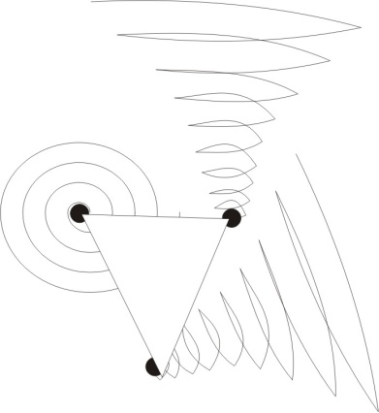obvious. But we can also arrange the same three in the form of a triangle and so when we talk about quantity as that which is the basis of quality, we are leaving out the essential of the quality, namely the formal arrangement*.*

Now when we consider the infinite motion, we have to say that this infinite motion contains within itself all conceivable forms whatever. And as quality implies formulation of quantised energy, and the formulation is already within the pure actuality of the infinite, then we have to say there are qualities already there before we actually super-stress them. We can say the qualitative differences between temporal individuals are already eternal actualities in the infinite. This means that every human being is already eternally himself before he gets into the time process.

Now. Back to our cone fellow again. And we’ll start from the ground up. This is a being who believes that he comes from the earth and he has to work very hard how to think. Now, you can see from this diagram that progressively as his basic conative drive, his urge, condenses itself he loses his relative vagueness and he finishes up with a very clear idea. [34:48]

## Spirituality

Now, in the middle ages, the church was aware of a very peculiar thing. And this was a thing that had started in the early Christian church as in other religions it had started in the corresponding phase. That as people were taught that their father — that is God — a spiritual force, could animate them, could lift them out of the identification with the material of their body and illuminate them ... as this became a possibility by the simple mentioning of the possibility, so people began to do funny things. It says in the Bible they began to speak in tongues and every listener heard in his own language[4].

Now as long as people were comprehending the meaning say, of Christ’s words, *I and my Father are one and all beings have this same source power, and if you, an individual being go to my Father, you shall do greater works than this relatively simple demonstration that I have done in Palestine*. Now a lot of people believed Him. But as soon as they believed Him, they began to feel for what God wanted them to do. If you read in the Acts of the Apostles, you will find that they are getting funny messages from the Spirit, *go to such a town, go to such a country*[5]. And these people always followed the message. So if somebody said, *You will now go to Zanzibar*, he would out and go to Zanzibar and he wouldn’t want to know what he was going to do when he got there. He would accept the message and go. Now, it’s quite obvious that if this kind of thing is going to happen, you cannot make an organisation and guarantee its formal continuance. [36:40]

So as soon as Christ has made His message clear that people could become self-determinant in this way, then the powers established of time had to pull up their socks — which had fallen down through loss of weight through licentious behaviour — and decide what to do about it. The first thing they used to do was kill a few people. It wasn’t only Christ who was crucified, actually, there were people crucified after him for saying the same thing. And the powers that be, the powers of the state, first persecuted the men who started spiritualising themselves and taking their messages directly from God rather than from the emperor. After persecuting them for some hundreds of years they discovered that it didn’t stop them. The more they persecuted them, the more they realised that they’d got something worth being persecuted for. [37:42]

## Constantine.

And at a certain critical time, a very smart fellow who killed Christianity, a fellow called Constantine, let’s make it all constant and one. Let’s unify the empire. Said *the only thing to do is stop persecuting these so-and-so free beings and I will become one of them. And then I can give the orders.*

So he became a pseudo-convert to Christianity and then proceeded to organise the whole process of training. And then we find that the spirituality of the early church — this is true in the Muslim faith, the Hindu faith as well as in the Christian faith — the spiritual awareness of these people was captivated by the monarch developing an idea.

He said, *I saw a cross from the sky and the letters ‘IHSV’ were written there*. These are the letters composing the name of Jesus. And he translated them as meaning, *If you will accept me, then you will get the better of the people*. So he accepted this doctrine and then they all looked to him. In other words, he imposed an idea on them.

## Ideas.

Now we said that an *idea* means acondensed energy pushed to the term of clarity. So if you look in your mind, you will find a peculiar thing about it. You notice in this word idea, if you take the D out, you’ll have a vowel structure I.E.A., which is the same basis as the word ‘Jehovah’. God is represented, not the god of the objective worshipper, but the God of the Absolute is represented as God. And if you leave out the D, then we have a pure motion. And if you put the D back in, you divide it. [39:37]

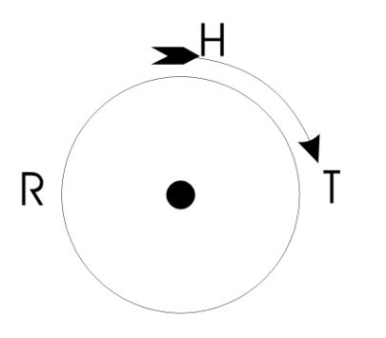And you know that there’s a nice charming goddess called Ea, and this goddess represents **the absolute field energy, the Infinite field of energy. Ea means field energy ... the Infinite field energy itself. And this, with a positive point within it — the letter I — and a D, is divided.**

|  |  |
| --- | --- |
|  |  |
| **I —** | **Positive point.** |
| **D —** | **Division - divides the field of motion** |
| **EA —** | **Infinite field energy** |

This ‘EA’, with a posited point within it, the letter ‘I’, and a ‘D’, is divided.

Now if we take any given zone in this Infinite and spin it round, the spin demarks it. You could say it is *EA*. First we’ll make a centre with a dot in it and we spin it round and on the edge of the spin we will write R.T. with an H. The H means the power that drives it round and the R.T. means Rota. So we read the word *Earth* from this ... the primary field rotation, the earth. It means the field energy, locally spun and in the local spinning, individuated, finited and established. [40:52]

Now when we talk about ideas, we are talking about that which by its very nature is cut off, condensed into the field. This field is infinite and when you wind in and clarify the idea perfectly, then you have immobilised in the idea a definite amount of energy. When we were drawing the cone we said, *let’s write ‘CONA’ at the bottom, and we can write affection in the middle and ideation at the tip*. If we look at the idea, we find that all the energy that was conative drive, progressively becoming feeling-aware of itself and then condensing as idea, all this conative drive has become immobilised in the idea. So where we get a purely logical idea, an idea defined in the logical sense of a term — a logical term means the end. When you are talking philosophically, you don’t just talk about words, you talk about terms, and a term is a word defined rigidly with a usage which you must not abandon — when we use the word *term*, we are implying in this word a threefold subtantialisation. Threefold because there is a conative drive, an affect or feeling awareness, and the condensation is form. Now let’s reduce this to its ***extreme*** value.

## triangle circle squareGeometry and Mathematics.

In logic and mathematics, we have to say that a given symbol shall be used during a given operation in a definite manner. We are not allowed to alter the meaning of the term in the middle of the argument without mentioning it.

Now in this sense, if I say, *consider this triangle as triangle*, or *consider this square as square*, *consider this circle as circle*, when we look at these things, all that we have as a response in our mind as idea, is simply a form. We have no emotive orientation towards it. We neither like nor dislike these things. Let’s try it now with something even more abstract ... mathematics.

If I write **1,2,3,4** and we examine it very, very carefully.

And I write **286** and **439.**

You would find it extremely difficult to pin your affective or emotional response difference.

How do you feel about **286** as opposed to **439?** It is extremely difficult to say.

How do you feel about the number **2** as opposed to the number **3**?

How do you feel about **2x2** as opposed to **4**?

You find it extremely difficult to find an affected response to a mathematical symbol. So that mathematics, a very, very abstract system, is almost divorced from an affect response. That is, you don’t like or dislike **1,2,3,4**. You recognise that **1,2,3,4** is a system of symbols for various operations. Now if we were to split this **2** into **1,1,** you would get a different feeling than if we split 3 into **1 , 1 , 1.** By arranging them into a different form, a new quality arises. So in this sense geometry is less abstract than mathematics.

##### Geometry is approximating to the concrete motions of the continuum of energy. But at the mathematical level, you can have an idea with practically no affect ... that is, with no liking or disliking. [45:04]

Let’s go back again. There is our idea, here is the infinite winding in and becoming conative drive. In the middle the affect, and right at the top the idea. In the process of conation trying to find out what to do, it condenses itself. As the restriction increases, it feelingly becomes aware of itself more and more. At the spiritual level here, it has nothing of what we call at our level, *feeling of liking and disliking*.

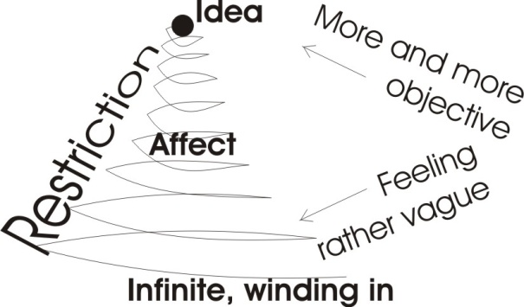Feeling arises as restriction increases. And if we carry the restriction to its exact term, a peculiar thing happens. We suddenly become aware that we know a definite form. And the affect disappears. Because we can always handle a definite form ... we can put it down and we can take it up. So we are not scared of an objective known fact. The idea, thoroughly understood, has no affect for us. Now remember, we are talking about how to realise operatively certain theories that we have discussed.

Here is an idea. That idea might be the idea of absolute non-duality. The implications are that all the beings in this room are not plural at all. They are simply vortical centres of an absolute motion. They have no individuality of their own and their apparent individuality is no more than that condensed in them by an act of attention. Simply because we attend to our individual bodies, we are limited by our attention. Nothing else. All limitation is self-imposed. [46:52]

## The Mobilisation of Ideas.

Now, what are we going to do about it? Here we have a perfect, simple idea. But the idea has no affect. That is, it does not mobilise us to like or dislike ... of itself. Our affect here, our liking and disliking in this middle zone, has two aspects. One is on the condensing side, a feeling that it is getting more and more objective and on the conative side, the non-condensed side, it feels rather vague and wishes that it knew what it was doing. So the feeling life of the psyche has two aspects, two functions.

1. One is to feel vaguely about a lot of possibilities.
2. And the other one is to try to condense, to move up the cone, to find a specific possibility.

Now, the only way we can mobilise that idea is to discover the affect that condensed into it. An idea carried to its term of definition is immobilised. It is energy condensed onto its final point, its least spatial occupancy. And you cannot see in the idea the amount of energy which has gone into it, because you have pursued that idea to get clarity, and clarity is the same thing as non-emotion.

Now, if you add up all the theoretical ideas out of all your experiences, all you finish up with is a dead system of mathematical statements. All the truth that we discover as form finishes up in a mathematical analysis. [48:40]

## Hammering Ideas to Bits.

So we find fellows like Alfred North Whitehead making an equation for universal evolutionary processes. And at a certain point in his life he could see that this form had killed itself in the process of clarification. But being a very intelligent man he said, *well, it was a human being that developed this idea, that discovered it, and before he knew it he was mobilised to look for it. Now that he has found it, the amount of energy he used in developing it must be hidden inside it. So how can we get it out again?*

Now to do this, to turn the idea of a reflexive process into actuality, we have to locate the idea and proceed to hammer it to bits again to reverse the process. We know what will happen. When we start cutting into the idea we will discover that we will feel things about the idea.

Let’s take an example of a very abstract idea, the abstract idea of zero.

The idea of ZERO is nothing, surrounded by a line so that you’ll know where to look for it.

And if we look at it and say, *is it any good for us?,* and then begin to think — that is, to ideate — about it, we observe straight away that we actually drew it by going round.

So we can say to ourselves, *well, why did we bother to go round? We could have used the same length of line with a bit of pi-eyed behaviour and discover that we can draw a line of the same length without circumscribing anything*.

But in the act of circumscribing, we have produced an apparent isolation of the zone within it. And beyond it there is an infinity of possibilities which we did not represent. So we can then feel inside ourselves, *well if I go round this line continuously, I shan’t get very wise. I know that it will get blacker and blacker and at a certain point I could anticipate that if I keep doing this, the thing will just finish up black and then I can say, “interest exhausted”*. [50:57]

So I can discover that it has within the idea a certain amount of energy. It has a feeling of circumscription, a feeling of limitation, a feeling of including a space, finite ... and of excluding the infinite.

We can then say, *well, looking at it, I could finite my feeling and consider what to draw on the inside*. Like a first year art student, I will try to fold a beautiful lady into this space — and that shows that you have to bend the elbow to get the head round — and then it starts to look a bit pre-Raphaelitish in the window. You start filling it up with interest. And if you fill it up with more interest still, you finish up like a lot of drawings do, with the ultimate consummation of modern art, a black dot, worth £80,000. You can find a buyer provided you explain what has gone into it. [52:03]

Those of you who saw the film *Mondo Cane* will remember that a certain artist, to a musical accompaniment, painted blue pictures by letting nude models blue themselves all over and then they were pressed onto the canvas. Millionaires bought the patterns that resulted. Anything can be sold.

And of course, as soon as we start talking like this, we are introducing an affective response into what is fundamentally an idea. We know perfectly well that the curve on a leaf is part of a certain series of numbers, a simple summation count. We know that a sunflower has a long curve and a short curve in the arrangement of its seeds, and we know if we calculate a certain number we count on the short curve, say thirty-four, we know that there will be fifty-five on the long curve. And we know that this particular series of numbers runs absolutely throughout every natural process from a spiral nebula down to a piece of privet.

When we begin to look upon this form and enter into it again and carve it and look at its implications, the condensation of that point is undone again. [53:24]

## The pointThe Other End of The Point.

Let’s see what we do.

A point is the least mark we can make on the paper. Let’s consider the symbolism of the point. And we might say, *there’s a dot on the paper now. Mmmm, not very interesting*.

Let’s see what the Rabbis in the Kabbalah did with the point.

They said, *well, before we made the point on the paper there was nothing to observe*.

And the least thing we could make or the paper is a point. *If we had a passing fly to help, we wouldn’t need the pencil*. When we have posited the point then we have something towards which consciousness converges. So then we begin to feel a sort of focusing. In case anybody doesn’t think that he focuses we’ll put little arrowheads that say, *focus on this point*. This causes an affective drift.

We can either think, *that’s rather interesting ... because the arrows wouldn’t point if it weren’t*, and we will examine the point. Or we could say, *I wonder where the arrows came from? —* you see *—* and find the other end of the point. But in any case when we start thinking about the implications of the form, we create an affective response. When we get our affect response in the middle here, what we are doing is taking a condensed idea, the product of many frustrations, and we are dissembling, taking its energies apart again and driving it back down the cone. If we push it a little further than the feeling, we become very mobilised about it.

Let’s see if we can do it with another symbol to show how we can make operative a concept.

M — Substance in its passive plasticity.

T — Penetrating force.

Here is the letter ‘M’. It could be. It might be. Or maybe it’s not a letter ‘M’. Maybe it is a fish. It might be the mouth of a fish. It might be short for the word ‘maw’, M.A.W. Nevertheless it is the letter M. Let us use that for any substance which has had a force applied to it, and in the process has bent.

And let us say that M equals substance in its passive plasticity.

Let’s take a letter ‘T’. Now we know as a matter of history that this letter ‘T’ derives from early representations of a male organ. That is to say, if we draw the letter ‘T’ with a short horizontal line it will begin to approximate to a very ancient symbol. Let’s put the ‘T’ here on top of the ‘M’. We’ll consider a moment what it means. The ‘M’ means a passive substance, which has been penetrated by a force. Now what happens to our affect? [56:34]

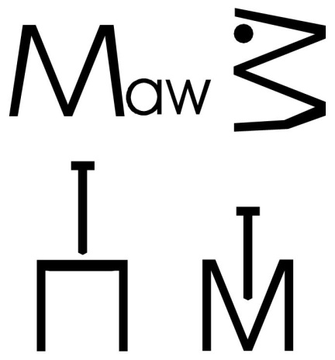Do we feel quite the same as when we said how do you feel about the number **5002**, and the number **5OO2.43**?

It’s difficult to find a strong affect from the mathematical one. But from the geometrical one there appears to be an affective resonance.

Now, this ‘T’ is sometimes called a crutch in heraldry. It simply means any form of energy pressing into another energy which is relatively passive. The two together constitute time - ‘T.M.’ or ‘M.T.’, meat or the objective presence, or mutation ... changeability. Here is the plain substance, prior to a force penetrating it. That is represented in art by simply drawing a horizontal line. If we want to make a picture which is peaceful, we make a picture with lots of horizontal lines in it. We’ll put horizontal clouds in it. Then we get a peaceful effect. So we use this horizontal to represent the passivity of substance at rest. And then we use the vertical to represent a force coming at right angles to this substance, impinging upon it and distorting it. As it presses it down, it rises up the other side and we have this form of the ‘M’. And this means that if we feel for it we can begin to see, in association with the hierarchical structure that we saw within the mesh, that something can be used here. [58:28]

## Operators and Things (active and passive).

If we remember that the infinite motion contains all conceivable temporal possibilities in eternal simultaneous actuality, then we can see that any given circle and any other circle may have a different super-stress. So that within the consideration of the circles in the mesh as such, we could see, observe, a hierarchy of super-stressing. Some are more energetic and more condensed than others. This means to say that a very, very compacted one could rush along and pass straight through a less compacted one.

And this means that any being can evaluate itself in two ways:

1. **It can evaluate itself as the horizontal line ... that is, a being that could be penetrated by another being, a being that could be pushed about by another being.**
2. **Or it could identity itself with the vertical, and say it is a being that could stand on its own, retain its own dignity, or push about other passive beings.**

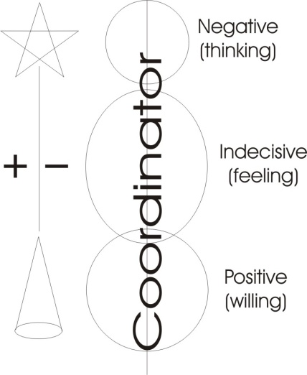So as soon as we begin to consider the basic meaning of the vertical and the horizontal, we discover an affect ... that is, an emotive response. [59:56]

Any human being at any given moment is either active or passive to some level of being.

And because the being is a precipitate of a continuum force, the being’s response is infinite at any cross-section of time. So that if a being were intellectually active — that is, criticising what is being said — it would not follow that he wasn’t being emotionally passive at the same moment, or conatively neutral. He could be, at different levels of his being, positive, negative and indecisive about the same fact simultaneously.

So when a being decides to evaluate himself in his three separate functions and his co-­ordinator, he can begin to watch himself. And when something is being said to him, he can take the formal content of it, think about the idea, define it. He can deliberately feel whether he likes it or dislikes it, and according to the degree of dislike or like he can release a definite amount of conative force to it. [1:01:11]

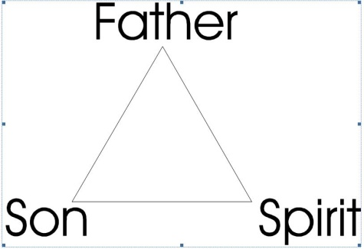Now this diagram, then — if we just equate it with our head, our chest and belly — becomes affectively charged. Here is the meaning of the exaltation of the will. We look upon a symbol, which is a merely geometrical thing. In the Vatican there is a triangle. This triangle represents the Father, the Son and the Spirit. And if you don’t know that, you might think it’s a piece of processed cheese[6]. But if you know that it represents the Father, the Son and the Spirit, you might think to yourself, *well, which is which?*, and start feeling, *Well what’s this passive one down there? Is that the Spirit?*

The dogma says that the spirit proceeds equally out of the Father and the Son. This is very difficult to recognise in this diagram, because there is no proceeding equally out of the Father and Son here unless we say perhaps Father on one side, Son on the other and Holy Spirit on the other. Then we could think that the Father and the Son precipitate the spirit between them. And that would be like a flat earth diagram.

Look at it in this way, the Father is the energy, the Son is the form and the Holy Spirit is the function. What does this means in relation to us, affectively? If we know that all religions derive from an Absolute religion and that the Absolute religion does not allow the authority of a finite being over another finite being, other than that authority which he can actually exercise. That is, he recognises only actualauthority, not theoretical or potential authority. [1:03:12]

So if we say, alright: let’s take the word for Jesus. Jesus isthe son. He represents the Father and he sends the Holy Spirit. What does thismean to us? The Son is the logos, the second person, the rational, formal Self. The Father is the amount of energy he’s conated there. And the Holy Spirit is affective.

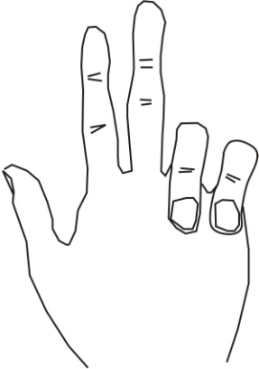Supposing we know what this means and along comes some high dignitary of the church and says, *you must obey me because I have made a funny sign*, a manual of power. And he makes his thumb go up like that, puts two fingers up and folds two down. And he says, *because I have made this sign, you must obey me*.

And you look at the sign and you say, *yes, well that one means conation, that’s intellection or ideation, and this one is affection. So all you are saying to me is that you know about your three parts of your being, your three functions. And as I know about them too, I return the sign*.

So then he says, *Oh, well, don’t tell the people. Let’s have a cup of coffee*.

Now this actually happens. It has been done experimentally and they become very nice, and they will even buy you a very strong Turkish coffee, Turkish because it’s on the border between Asia and Europe, it is full of grounds and they pay for it in threepenny bits.[1:4:49]

The important thing is here to realise, when the Absolute motion — which cannot cease because it is itself what it is, cannot get rid of itself — it has to decide whether it will simply remain in an eternal chaos, or do something about it.

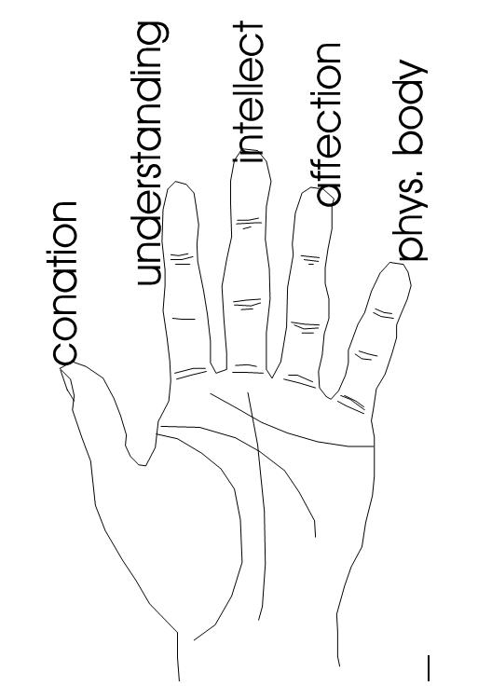Now Saint Paul said he had a doctrine of strong meat. And this doctrine he said, *You’re not fit to bear it* — not you people, the people that he was talking to — and *therefore,* he, said *I’ll give you a drink of milk instead*.

The substance [M] of ilk ... means to say if you know somebody, you feel at home. And if it’s strange, it will frighten you.

Let’s look at what the Absolute does. I wave the paper to represent it and I draw a line to represent this wave. Now, as soon as we consider this waveform, we observe something that is quite obvious. I’ll sharpen it up for you a bit, to make it more obvious.[1:05:59]

## Troughs and Crests.

At the tip of this wave there is a crest. And down here is a trough ... the ‘slough of despond’ if you like.

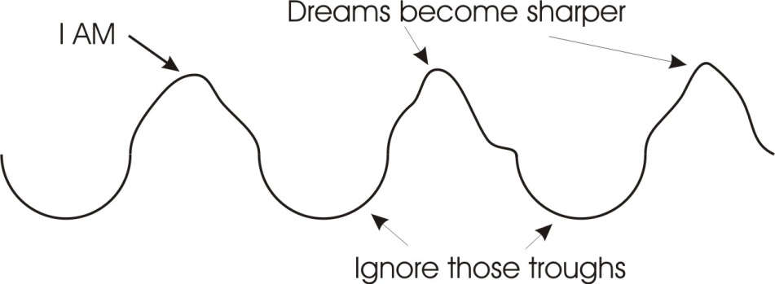From the very nature of undulation, from the very nature of waveforms, from the very nature of crossings-over of forces, there is a point of least motion and a point of greatest swing. There is a point of formulation — a nodal point — and a point of dynamic searching in between nodal points. Now remember that it is the non-dual Infinite Absolute power, which feels itself.

1. Now prior to this method of condensing itself into formed crests, we must think about it as a chaotic movement with no determinant direction and because it is sentient, it is feeling rather vague. Remember, the being knows only the motions of its own self. So that prior to making the wave crest it has no sharp awareness at all. As it makes no crests at all and just goes into the state *Pralaya*, the state of equilibration, it has no objective content and it’s equivalent to being in a very deep sleep and nothing has happened.

2. When it begins to modulate itself slightly, it is like dreaming vague dreams.

3. And when the waves rise higher like this, then the dreams become sharper. And if you can persuade the waves to rise up and make sharp crests, the ideas become so sharp that you wake up. [1:07:55]

So this state in which you are aware of discrete ideas is your daytime, waking, ordinary state. The state that most physical scientists, through their lack of comprehension of what is underneath it, **think** is the most important. They are trying to construct a universe out of wave crests ... and ignore the troughs.

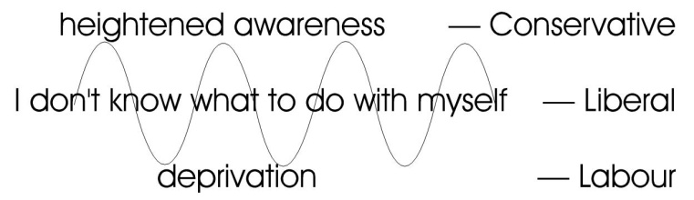Now let’s look what happens.

If the energy of this sentient power piles up to a crest, it discovers something inside itself, namely the sensation of individual being. It feels, *I AM* at the point where this crest is raised. So wherever there is this undulation there is a series of crests, but simultaneously the place between crests has a double pull.

So down in the trough there is a sensation of strain.

Stress on the crest, strain in the trough.

Now this strain is felt as two-way strain, and therefore an anxiety, *I don’t know what to do with myself*, says the middle part of this trough. *Shall I go up here or shall I go up here?* But the middle part of this trough cannot go both ways. The energy of this middle can start travelling up, but in so doing, it’s continuously exhausting the centre of the trough and as it’s drifting towards the sensation of individual being, of objective accomplishment, simultaneously, not later, it is depriving the space between crests.

So if we say there is a sensation of heightened awareness of individual value within the crest, simultaneously in the trough between the crests that same sentient power is feeling deprived and robbed.

Now we said before that in drawing the mesh the whole thing is full of circles. And these are all self-precipitated. Where some of these circles have precipitated themselves into the super-stress we might call *crest*, they have stolen energy from a trough zone. So in the trough here, the circles — remember these circles go through the whole of space — they [circles] are feeling deprived. So in the trough between any two crests, so there is a zone of deprivation feeling. [1:10:34]

Supposing we write down here, Labour Party, Liberal Party, Conservative Party. You see the political implications of this. Those who have got themselves crests in heraldry, you see, have done so simply by stealing field energy ... appropriating field power to their own purposes. In so doing they have dragged from the trough land some energy towards themselves, but only some of their energy is precipitated in the crests. And some of the other that’s dragged with them is only Liberal,it isn’t Conservative. It is just moving away from the low Labour trough towards that crest.

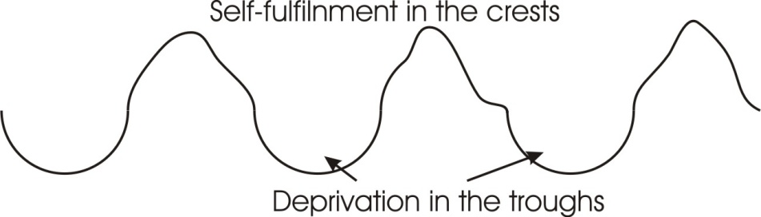Now, existentially it is impossible to avoid this fact. That wherever there is undulation, there is wave cresting — same base, CRA - to create — here it is gathering together. And there is exhaustion or deprivation in the intervening troughs. Now the total field here, in any given zone, is aware of the deprivation in the trough, and of the self-fulfilment in the crest. So the field knows both of these two. And because the field is self­ mobilising it says to itself, *why do I have to suffer the sensation of deprivation from the trough in the field, when the crest is there?* By a process of identification, namely precipitation of energy from the field into the crest, the field says, *I prefer the crest to the trough*. So the field feeds the crest with further energy. This now creates a greater disparity than before, and the result is the creation of a band here round the crest, and there is a hiatus created between the trough and the crest. [1:12:54]

Now here you have your three-party politics again.

By deliberately not looking at the deprivation caused by this cresting process, the leaders of the world who have accumulated the field power, manage by identification with their power deliberately not to contemplate the deprivation in the trough. So they don’t have to think about that fellow, who can tell it by the smell from Bath and Wells, because they have the power to concentrate on what they’ve got.

Now this is strong meat doctrine that Saint Paul was talking about[7]. We have said that this field is self-mobilised. No part of that field can be blamed for the function of another part. Every part is its own self-function, self-precipitated. It is its own destiny. Whatever it is, whatever it has become, it has become it by its own personal condensation.

Then there is no legitimate ground for complaint for the circles in the trough that they are not crests. They can and do complain. But they have no legitimate ground for complaint, and likewise there is no legitimate claim to boast about in the crest, other than the fact of accomplishment.

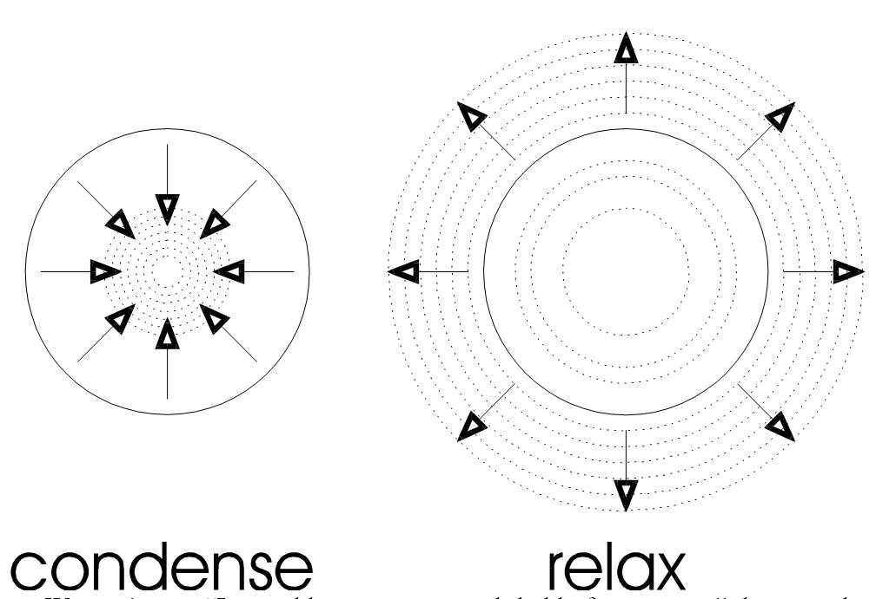When Karl Marx — who was in the middle part here, with the university education that lifted him slightly out of the trough, but not born with a silver spoon in his mouth — when he looked upon this diagram — he actually uses this triangular diagram in the beginning of *Das Kapitas* — he said, *The only thing that’s put those crest fellows there is the actualisation of power, they have seized power. And then they have used this silver — silver means talking: you’ll remember, silence is golden and talking is silver — they have used this silver to make ethical systems to persuade the trough beings to be happy in their poverty of spirit*.

## Continuity of Protoplasm.

So here is a realistic statement of the actual dynamics of the universe. Every being within that mesh is stressed in a peculiar way by itself — and you can wiggle your edges if you like, and make yourself any shape you like as a human being — no matter how you wiggle your edges you will remain what you were as a pure, actualised, geometrisation. You yourself have imposed on you progressively.

Now the protoplasm of any existential human being living today is simply the growing tip of an ancestral line. That is, we can’t say, *let us blame mummy and daddy for our state*, because the protoplasm that is doing the blaming is a portion of the mother and father. This egg cell, this sperm cell, are simply bits of the parent. So if the child blames the parents it is simply the protoplasm that was the parents blaming itself for behaving so badly in the parental phase.

All we have to do is recognise that we are self-precipitated from the eternal. Certain beings seize power simply because there is no superior control. This one thought, *I wonder what it’s like to condense quite a bit?* One here thought*, “I wonder what it’s like to relax?* But the one that condensed most gained sufficient energy to drive straight through the other one. Call this the fortunes of war if you like. But fortune means strength in unity in any case. [1:17:04]

The one that gained this unity, when it later split by cell division, made two such beings. And those beings carried the cytoplasmic records of their own self in the continuity of the protoplasm. And they carried on doing in the next generation what they had been doing in the previous generation, namely appropriating power and driving holes through all other being that were not doing it, and simultaneously fabricating a verbal structure to discourage those people that had not started by seizing power from ever desiring to seize it.

Now, what are we going to do about it?

This is a fact: a couple of years ago, a Conservative MP said, *We are not bothered about Labour leaders. We can corrupt them by giving them a middle class house which relative to their mentality is equivalent to a palace*. If you read the history of the Labour leaders you will find that they are all corrupted progressively on the way up, some rather quicker than others. Bevin was a little quicker corrupted than Bevan and therefore lasted longer.

When you see this process as an inevitable process within the Absolute Power, then it becomes possible for you to say to yourself, *Here is a mass of protoplasm. It takes a little bit of itself, and pushes it out and makes another being, ingests some food for further energy, expands itself, takes a little bit throws it out and makes another being, expands itself with food, takes a little bit, throws it out and makes* ***another*** *being*.

Now it’s always the same protoplasm plus food. So any existentially living person now is simply a bit of protoplasm that was original protoplasm right back ... using *protoplasm* in its dynamic sense not merely material or chemical structures on earth, the plasm or moderable substance of Absolute Power itself. So it is like a twig growing along. Right on the end of that twig there’s a little tip, a growing tip. There’s a little cap at the end of that tip that is receiving power. It’s like a little reverse radar-telescope. It takes power from the Absolute and draws it in and keeps growing. And that growing tip is you as an individual, now. And the sap in that tree is simply the *sapiens,* the awareness of your ancestors. [1:19:41]

## Acquiring Power.

Now, at a certain point it becomes possible for you to say, *Well, if that fellow has crested itself very well over there, then my ancestors might have done it if it had occurred to them. It didn’t occur to them otherwise I wouldn’t be in the trough. But there’s no reason why it shouldn’t occur to me now, if I am sufficiently alert*. And then this man has to make a decision. *Will I become what Christ calls ‘quick’, or will I remain**‘dead’?*

Every man here has to make his own decision. Once he’s seen the truth of the whole universal power and its inevitability, its impossibility of escaping itself, then his destiny becomes a matter of his own concern. When he’s got the idea then he must cut into this idea to discover its affected bias. Every idea, even a mathematical one, analysed, will reveal an affected bias. Out of this affected bias you will like or dislike a certain course of activity. When you have decided the degree with which you dislike or like your present level from trough to crest, then you can decide conatively to drive a new idea, a new form of activity.

Nothing constrains us other than this fact: we are self-limited by our primary conation, the thing that placed a super-stress upon our sphere in the eternal. We are further condensed, by liking and disliking what happens to us. We are further condensed in the frustrating process to get an idea. And when we have analysed the idea and rediscovered the hidden affective charge in it, then we can push it further back to its source in conation.

When we do this process and turn all our ideas into affects and all the affects into conated drive, then we cease to be trough beings only, or crest beings only, but we affirm the whole field of crest, trough, crest, trough, infinitely. [1:21:56]

We don’t have to steal more energy and give it to Mister Wilson[8] to represent us. We can say that we could crest on our own if we wished, we don’t have to support your particular crest, or we could cut straight across your crest. We could circumscribe it in a way that you won’t like, by not feeding it. We can take the energy away from that crest and condense it in a trough with a new idea called ‘passive non-co-operation’, which is what Ghandi was doing in India when the British were there. And we see here that there is a doctrine of ‘strong meat’. You remember we’ve had this before. You can always reconsider an absolute truth in an infinity of ways.

The riddle of Samson, *Out of the eater came forth meat. Out of the strength, sweetness*.[9]

The eater, absolutely, is our old friend the field energy, self crucified, and the field, differentiating from the point of crucifixion ... that is the eater. When these forces intersect, the energy spins, and that zone of spin is the objective ‘ME’. And the objective M.E., and the energy [E] on the T is meat.

Every being is himself self-precipitated. His own appetite has created himself as an objective piece of food for its own fulfilment.

Nobody imposes the diet on anybody other than the being himself.

When we fully realise this, we can take all our ideas, discover the effect of these ideas upon other beings and discover the affect, the emotional charge hidden in the idea. And having discovered how much we like and dislike the content of the idea, then we can apply ourconative or drive energies to operate them.

25 to 5 ... somewhere. [1.24.47]

## Making the idea operative

*Eugene, having done this, you must become vaguely uneasy in the end, because ... [Indistinct question from the audience.]*

E.H.: Not at all, because you have crested yourself, and you have pinpointed every formal possibility for yourself. See it as a restraint upon your own will, and see that in the fact of the precipitation of the idea you have immobilised yourself. And see that the uneasiness prior to the immobilising — the uneasiness of conation and affection — is unsatisfactory. And by associating both of these together simultaneously, you retain an absolute determination, in which you can deliberately be trough or crest at will, simultaneously or alternately; alternately by super stressing one and depressing the other ... and then reversing them. You can at least be satisfied if you understand that it is inevitable that you have to do it. And Spinoza said that, *If you see that something is absolutely inevitable you cannot grieve about it*.

If you know that Wilson gets a headache through representing the people, then you can decide whether you are to have a headache. If you know that if you don’t have a headache you might have another kind of headache through not representing the people, then you can decide whether not to. And you can represent, misrepresent, not represent simultaneously on different levels of your being. So when you are simultaneously doing all of these things, then you are back again in the absolute awareness plus the memory of the temporal process by which you arrived at it. [1:26:73]

You don’t have to do anything. You develop yourself deliberately, consciously, but you can only operate the idea by discovering the affect, the like/dislike within the idea. And then when you get an idea, to become operative is the next logical step. But if you retain the idea without operating it because you yourself don’t know the idea has to be operated, you might think you should have attained something by retaining the idea and not by the operation. In which case all you’ve done is condense yourself onto a point.

If you don’t return back to your conation as well, and retain the point, you’ll find yourself trapped*.* Shiva in the Indian system symbolises this ability to connate into a point, to ideate in the third eye, and has done this completely to immobilise the universe. If you do either of these without doing the other one, you are liable to suffer, that is to be passive in relation to the thing you haven’t done which promises you something you haven’t had. If you are merely conative and never ideative, say like the female *as such —* I don’t mean like emancipated women artists, but the female as such is — she is conative without ideation, and she thinks vaguely that there might be something that might be good for her if only she knew what it was, which is a not nice feeling of indeterminacy. And if you become a professor of logic, in one of the chairs of death, you might be able to talk very, very precisely, and to say precisely what the equation for happiness is, and not actually have any conative drive. So perhaps like Schopenhauer you might be having such a seat in logic, and discover that more students are attending your rival Hegel than are attending you, and you are not very comforted in your position. [1.28.49]

To do both of these simultaneously and to have the ability to alter the super stress, to become at one moment perfectly logical, and in the other moment perfectly non-logical, conative, and the other one which has the affect between them, and looks both ways simultaneously like Janus[10]. To be indeterminate, to know what not to do and to know what to do is the same thing as being the fool in the Tarot pack, and the Sage in the same pack. One side of the crest is pantherium. It is all animals. Inside the human being it is a fact: we have representatives of the mineral world in our skeletal system, the vegetable world in our digestive processes [1.29.34]

1. *In zen, this is a classic koan, a form on which the initiate is asked to meditate in order to exhaust the thinking mind. Master Eno’s question to the monk Myo is usually put as* 'what was your original face before even your parents were born?'
2. ‘A’ is Absolute motion.

   ‘C’, when pronounced as a ‘K’ sound is a locking at the back of the throat which proves a resistance to the movement of air from the lungs.

   ‘T’ Christ pinned Himself on the Tau cross, the true meaning of his existence.
3. Ecclesiastes 1:9
4. For example, Acts 2:4, Acts 2:11
5. Acts 11:12, Acts 21:4
6. Dairylea Cheese Spread was popular at the time of this talk.
7. Hebrews_5:12 For when for the time ye ought to be teachers, ye have need that one teach you again which *be* the first principles of the oracles of God; and are become such as have need of milk, and not of strong meat.

   Hebrews_5:14 But strong meat belongeth to them that are of full age, *even* those who by reason of use have their senses exercised to discern both good and evil.
8. At the time of this talk, Harold Wilson was prime minister.
9. Judges 14.14
10. Janus is the Roman [god](http://en.wikipedia.org/wiki/List_of_Roman_deities) of doorways, portals beginnings and transitions. He is represented as a two faced male and he looks to the future and to the past. The month of January is named after him.