Non – Seriality a Talk by Eugene Halliday

Précis
Eugene summarises the talk himself [at 22 min 40] as –
‘We are talking about how to break down the serialisation which acts slower than our immediate awareness. If we don’t break down this serial thought in the mind - because the serial process occupies more time than the immediate necessities of the moment.- the serial mind must always be behind the reaction time’.’ [ . . ] ‘ reaction time is slow, and this reaction time gets slower and slower the more energy that is involved in the five sense processes inside’. The ideas of Freud and Jung relative to this are discussed, [21 min 16], Maximum Entropy [40 min 22] and the dualism of involving any idea of external causation of the universe. [46 min]. Then in answering a question [51 min 16] he discusses sub-entities and their integration into the whole being and the achievement of ‘transparency’ at [54 min 32] to the end of the talk.

Transcript .
[All comments by the transcriber are in square brackets. All the diagrams are the surmising of the transcriber- as they were not recorded at the time of the talk as far as I know. The time points are all reckoned off the MP3 player and are added for ease of reference.
In this talk Eugene refers to someone being ‘still’ [catatonic] since 1946, for 17 years - dating the talk at 1963 [ 32min 39]. The recording of the talk begins with indistinct voices – and this transcript starts with a hazard at the opening question. Transcript A R August 2013]

[Question from one of the audience] – . . . It was that, effectually, we have to work from the conceptual apparatus that we have, and this appears to be slower than the emotional apparatus. In other words if we get involved in a situation that we conceptually decide we can do something about beforehand, but it already precipitates itself before the concept can get a hold of it. And I was wondering, what was the method of attacking it, to stop it.

E. H. – Let’s do a drawing of our three part man again. And we know that when a nervous impulse goes from the brain to produce a voluntary act, that it takes a measureable length of time to get the message down the spinal nerves and into – say – the leg. This amount of time taken, a portion of a second, is very, very slow compared with the reaction speed in certain, life preservative instinctive responses. We know that we have a method of response, far quicker than this process of voluntary, individuated transmission of a nervous impulse.

You know that if you put your finger on a hot plate, without being aware of it, you will be aware that you are burned, and of an attempt to get away from it. But it has taken a certain length of time for the message to get from the finger to the brain centre and from the brain centre back to the finger, so there is a delay and the finger is burned. If you had an immediate response, through the field, that would not occur. And that only occurs when you are abstracted in certain ways and therefore out of the situation. In the situation, with your feeling appreciation of it, you would function much quicker.

Now when we are talking about the evolution of man, we are talking about the various stages at which his will functions – levels of being. When a baby is born most of its reflexes are from the mouth and down the food tube, and from the nostrils to the lungs. We will say that the one from the mouth to the food tube is the first one, because we find that the baby spends quite a lot of his time with his eyes closed and not taking much notice of things said to it. And its sensations, around the mouth, are to it of primary importance.
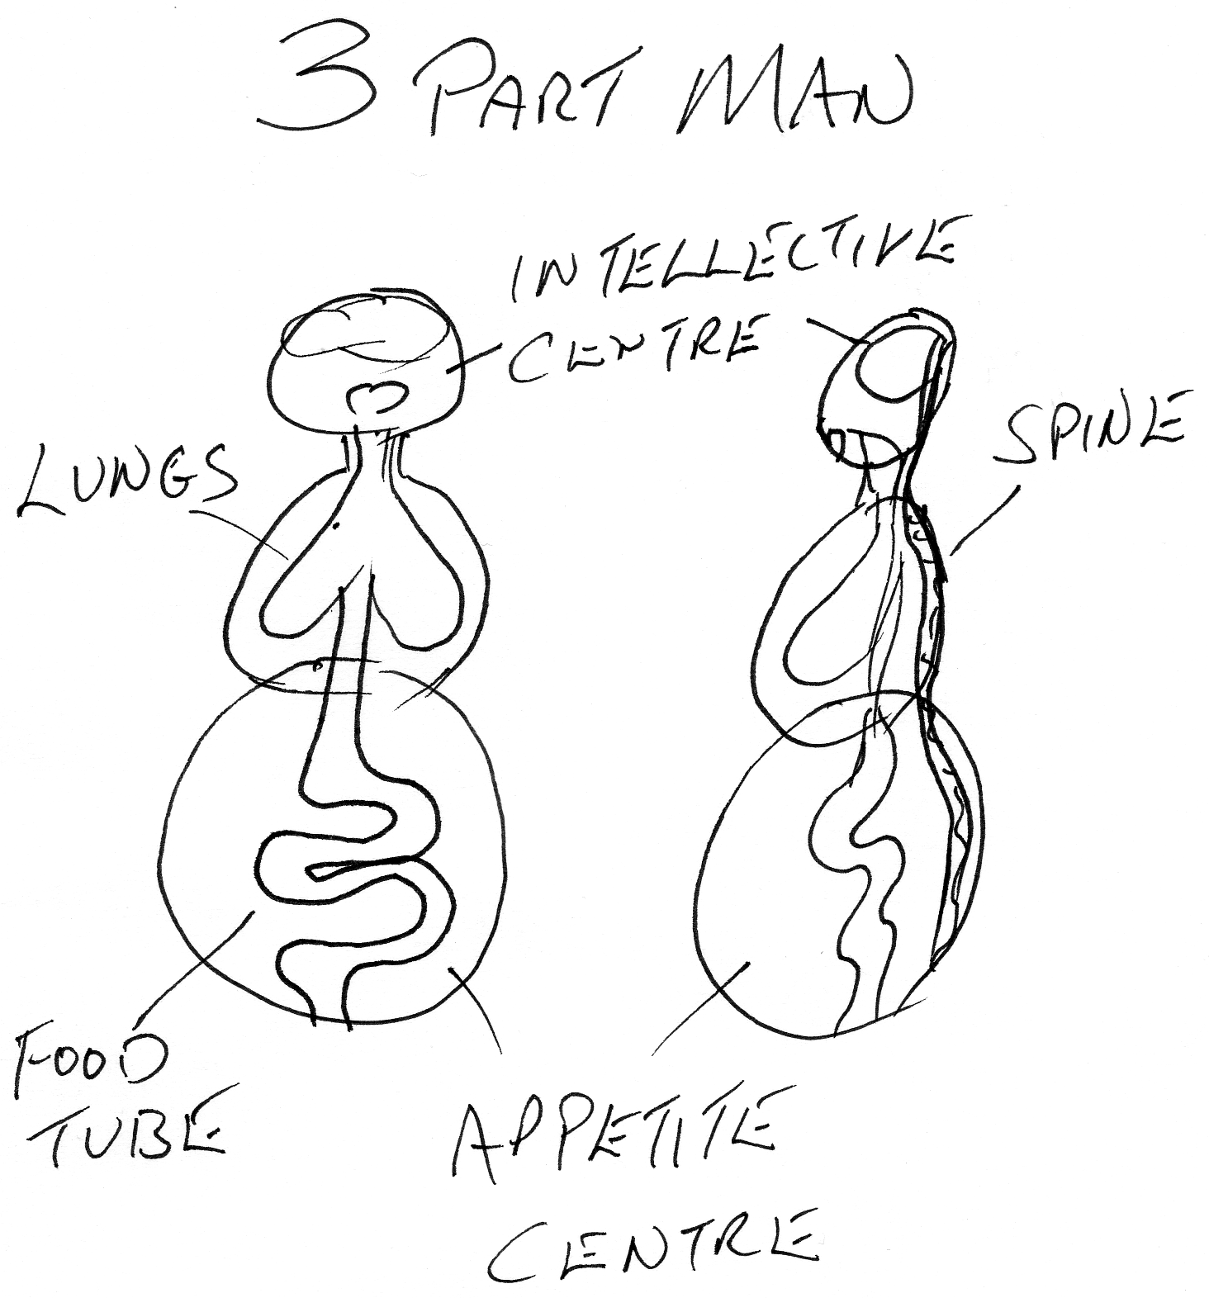

Now later on when through repeated stimuli through the ears certain forms are put into the mind, they are verbalised forms, and the verbalised forms put through the ear have a certain length of nerve track to go down, which takes time. And the immediacy of response has disappeared. Now as it grows older, a greater number of words are put in and the act of deciding becomes progressively more and more complicated. So that when you come to think through serially, the situation needing a decision, if you take all the elements of the decision and individually, consciously serialise them, and then try to evaluate them you will take up a considerable amount of time. And fail to solve it. [4 min 14]

You notice in the devil book, that it is said there, ‘Count all or count not at all’, because when you start the serialising process of counting all the elements in the situation, if you don’t count them all the ones you have left out will undo you, and invalidate your solution. If you do count them all, serially, you are going to take an awful long time. So unless there is another mode of response, as the speed of the stimuli coming to you is greater than the speed of your thought process is to evaluating them, your reaction time will always be behind the fact. And this is the matter of experience of people in daily living.

They find that they have done things and said things, which, if they had been able to inhibit them, they would not have done or said. And in this ‘saying’, they are committed into relations that they don’t want. That is because an immediate stimulus comes in and runs down into the appetite centres which are more immediate than the intellective ones. So that if someone shouts at you suddenly, violently, you will tend to jump and get out of the way – before thinking about it.

As soon as you begin to think about the thing you interfere with it, slow down your reaction time, and the new stimulus is upon you before you have had enough time to evaluate the old one. A very simple illustration is that if you try to go downstairs, consciously, individually, serialising the movement of the muscles in your legs as you put your feet on the stairs. You will find that, if you try to run down, doing that you will fall down. That is because, once the body is on the move, gravity is carrying you down and you are moving very, very quickly and you literally haven’t got time to get the data filed in here. [referring to diagram. 6 min 15] And run through all the necessary data for the given act of going downstairs; and then send it down to the legs in the appropriate order. You are already down.

The same thing, done a little bit more safely is to run up stairs instead of down because then you don’t fall very far. So you find the same thing, if you try to run up stairs with individual serial thought , that you will simply interfere with your process and it won’t function properly.

Now the problem is this, as the organism can respond immediately, from field awareness or the total organic reaction of field awareness, and the stimulus come frequently through the field. If the man has an ‘inertic tendency’ to think serially through the process then his analysis of the situation will never be in step with the actual situation. Which means he is always living behind himself, and he is always finding himself committed into a situation that no longer exists.

How to get out of this process? If the serialisation takes time – time is actually a rotation of forces. It takes time to go round a cycle, which has been defined by the initial term, the term you start with and all its’ implications’ which have to be ‘explicated’. Remember as soon as you have a governing concept you have a word, and that word contains implications. And to serialise the meaning of the word is to explicate those implications. And it occurs in time. And if you do this serially you will never act correctly, you will always be anachronistic; just behind the time of the situation.

So first of all you have to learn how to dissociate from this serialising process unless you have the governing concept that the observer is not the observed. You can’t state it too often to yourself. Let the paper represent the pure consciousness of spirit. Spirit is power and sentiency. It is power that is able by rotating to embody itself, and it feels the mode of its own action. So: its action, its embodiment, and its awareness are not three separate substances; they are three aspects of the one fact of ‘sentient power’.

To understand the trinity of Christianity, or the three body doctrine of the Buddhists, requires us to remember this simple fact which we illustrate by saying that the paper is the power/sentiency itself – the sentient power. It knows nothing other than itself because no ‘being’, and no ‘non-being’ either can ever understand, or experience, anything other than the modifications of itself. [ 9 min 32]

So if this paper, this sentient power does nothing it experiences nothing. And if it waves, it experiences waving. Now if we imagine we roll the paper up like the piece at the top here, we make ourselves – here’s the perspective of it [drawing on the board] – we make ourselves a roll of paper. We have ‘involved’ by rolling the paper round certain experiences which the power sentience – the sentient power knows of itself that it has rolled itself up. Involved itself. Whatever rolls there are on the inside of that roll can only be experienced in the peculiar relationship in the rolled up state.

If we write on the outside ‘A’, then go round one turn and write below it ‘B’. Then go round another turn and write below that ‘C’, then if we look straight through there, we identify with successive layers we will see ‘A – B – C ‘in the same time space. But if we pull the roll out, to extend it, we will see A, B and C period. Now this ‘involved state’, the in-willed state is what is meant by the word ‘same’. And this ‘same’ same spelling in modern German ‘same’ [the German word ‘ SAME’, pronounced zama, but spelt as English ‘same’ means seed] – ‘seed state’ – implies a spiritual [S] – energy [A] - substantialising itself [M] - in a field [E]; it is a field substance energy of spirit, which is sentient power. It has turned itself around, put into seed, that which it is in simple extention.
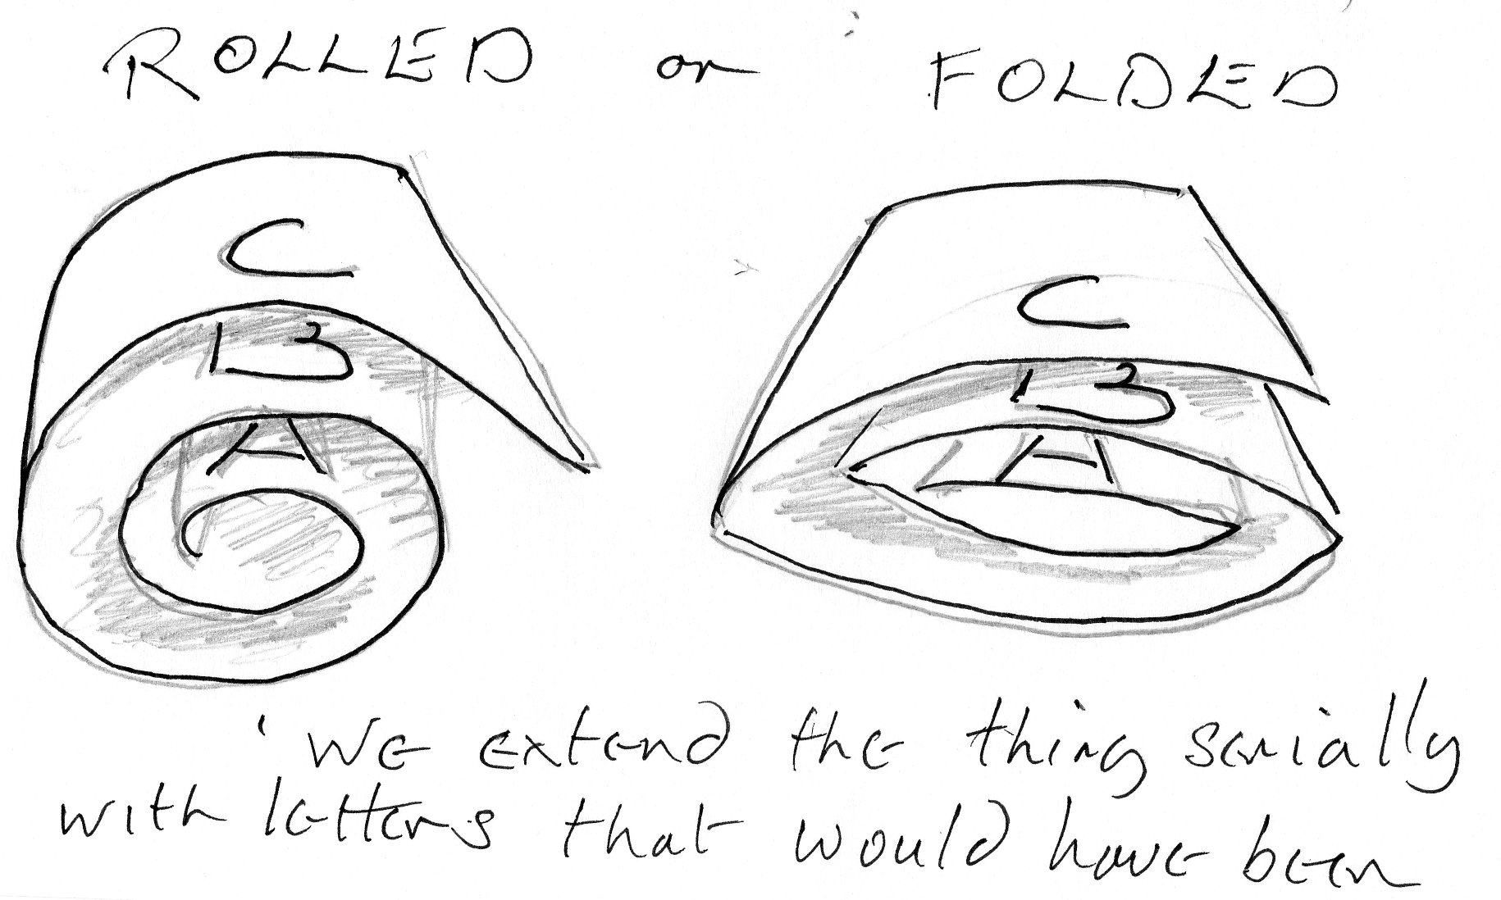

So there is nothing ‘involved’ that cannot be ‘evolved’ – turned out. Complication means ‘with folds’ – if we imagine we fold the paper backwards and forwards like this, then we have exactly the same problem. We have a simple piece of paper, when we pull it out – ‘sim-ple’, same ply – seed folded and if we extend the thing serially, with letters which would have been vertically above each other on the folded paper – we put them after each other in time.
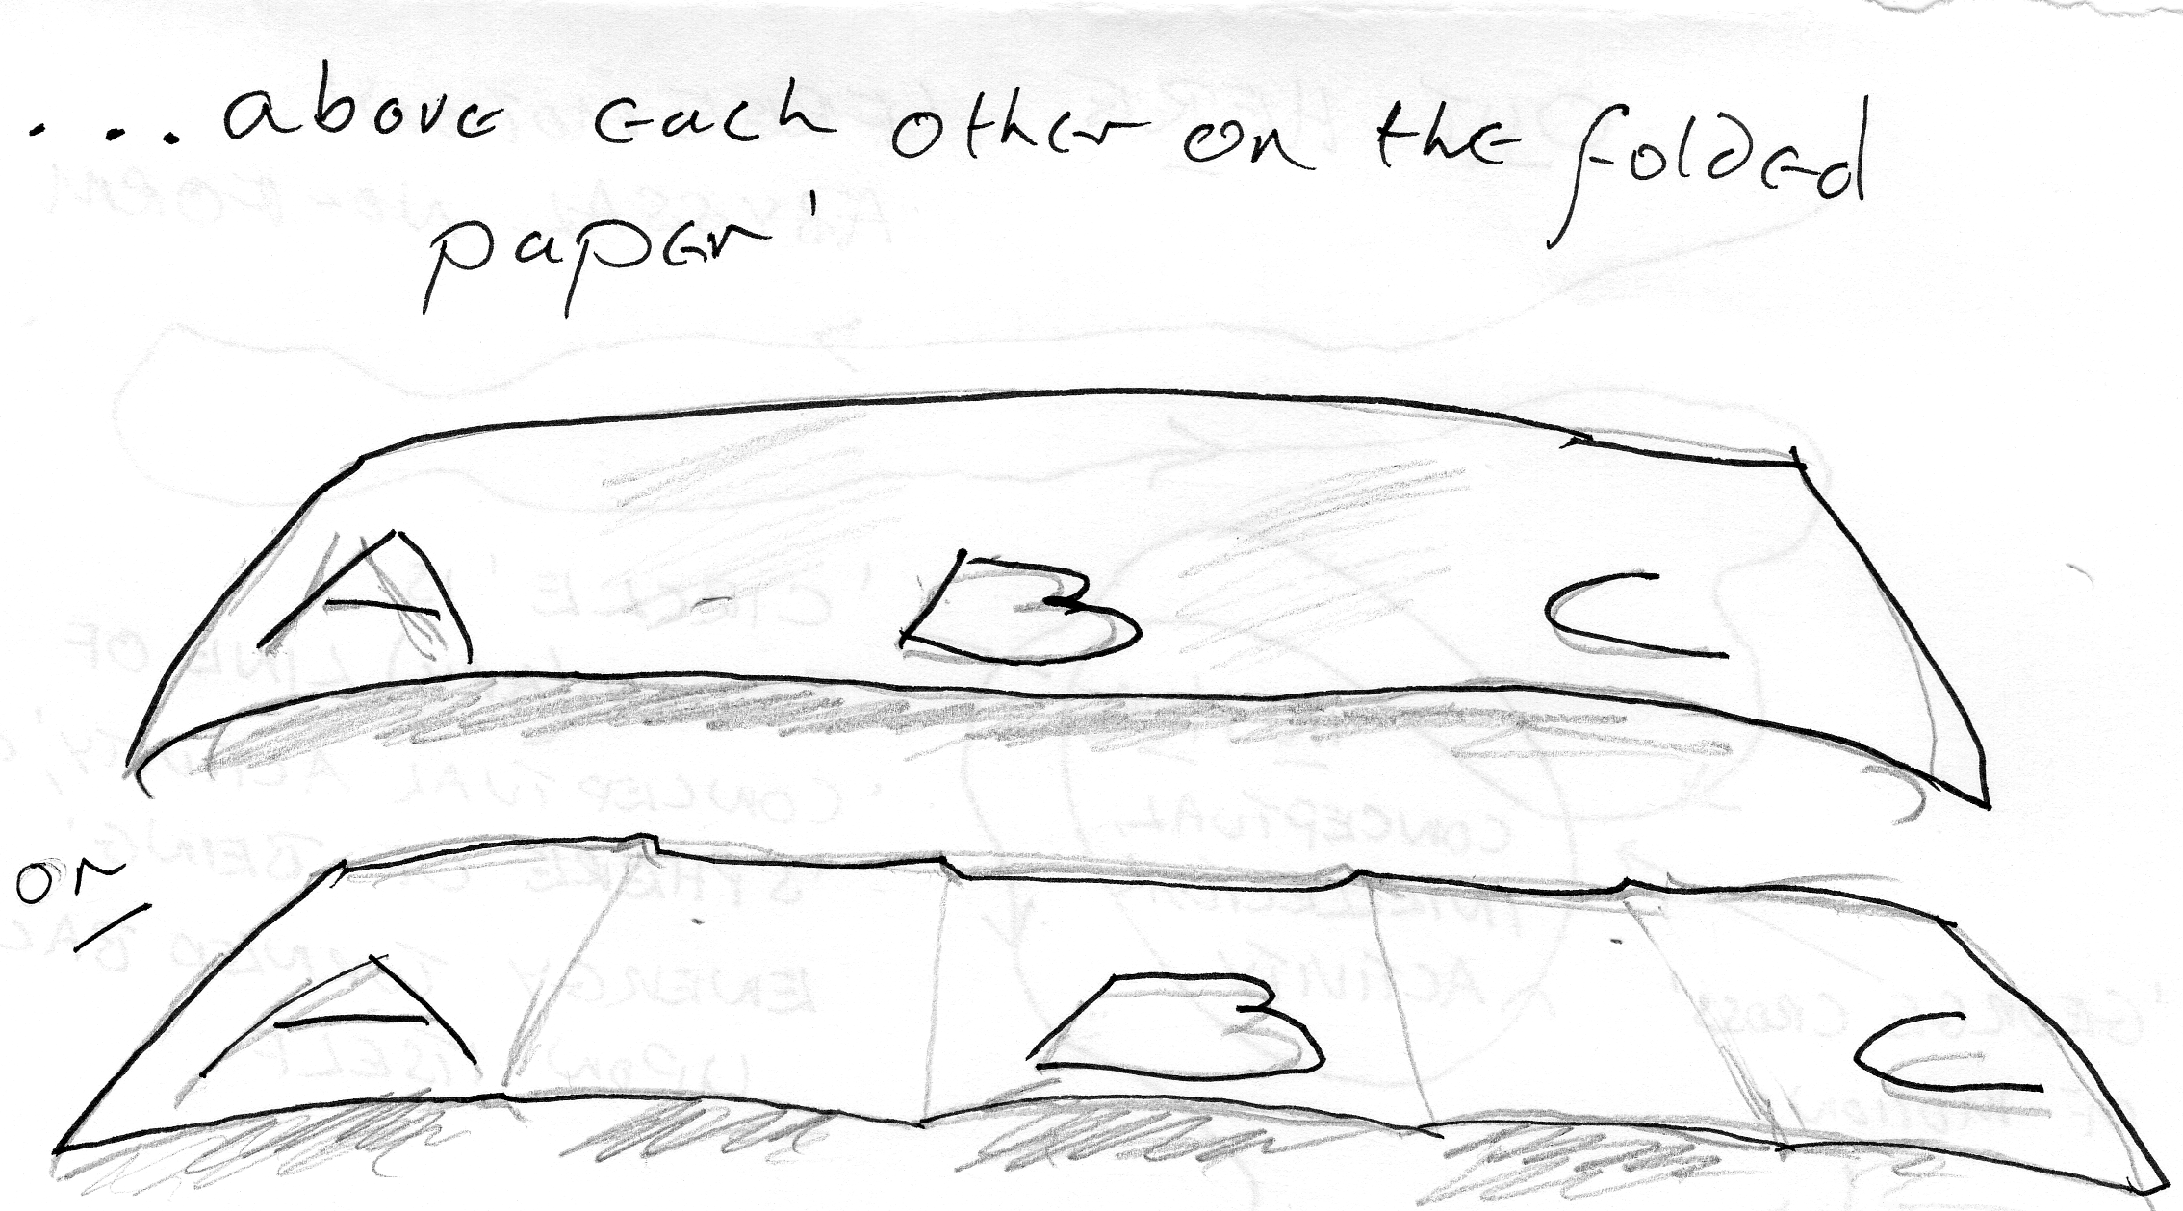

So we can experience, simultaneously, different levels of being. And by ‘levels of being’, we what mean is ’folds of being’; by simply learning to focus through the field, instead of being dictated to by contingents – the external stimulus. [12 min 28]

There are two beings, the perimeters of which are in contact. As they impinge on each other they disturb each other’s substance. There’s an empty hole in the middle that can’t be disturbed, the immanent spirit.

Now the spirit as we know it comes from outside if focused upon, must cause an externalisation of consciousness – it forces the consciousness onto the perimeter of the being. Now the perimeter of the being is the part of it that has no understanding whatever. Observe that at the point of contact, these two beings are in the least possible contact, and therefore in the physical relation – shown by these two circles touching each other there is the least possible kind of relation for any two beings. If you want to increase relationship therefore you must discover something totally different. From the centre of the being ‘emanating ‘is the power sentient. Because it’s coming out, spreading out centripetally, spherically; centrifugally from the point of view of a being observing it flying out from the centre, it is coming out and in so doing, because of the overlapping of the contingent stimulus from outside you have a progressive veiling of the inner, creative, sentient power. The nearer you get to the perimeter the more disturbance there is from the contingent stimulus. [14 min 06]
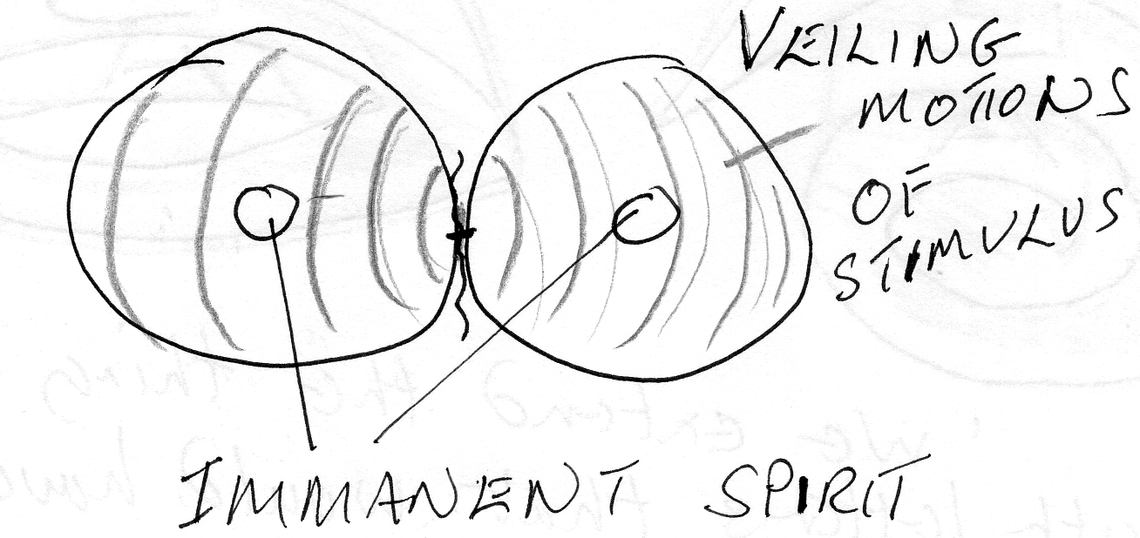

If you go into your centre there, the contingent stimulus cannot touch you at all. You are an immanent spirit. If you get just outside that bound the contingent spirit reaches you though it is less intense on the inside than on the outside.
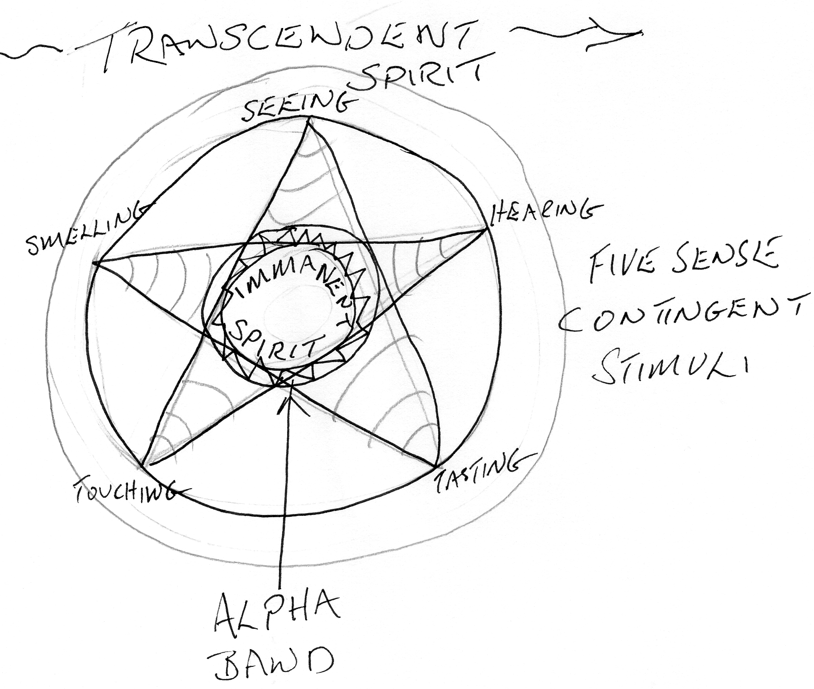
Now let’s make a slightly larger diagram for a moment. . . This is a being, immanent spirit internal, transcendent spirit outside it. Here’s a contingent stimulus from [lost word unclear at 14 min 36]

Now that, being outside, constitutes a promise and a threat simultaneously. It promises a relationship that might be valuable and the threat of a stimulus that might impose on you and stop you developing your own immanent spirit. So we have a stimulus, contingent coming in with an immanent, creative spirit pressing out. Between the two here we can draw a band and say, ‘On this band the two are equal.’

Below this band immanent spirit is victorious over the incoming stimulus. And above that band the contingent stimulus is triumphant. Now this alpha band here we can place the five senses. Where the five senses reach there is dominion for the contingent stimulus. And inside here is dominion for the immanent spirit. But at a certain level, we can call it half way between, without finding out what halfway means, whatever it means dynamically not from terms of so many inches. When the power from inside balances the power from outside, there is a zone where the contingent stimuli of the five senses can be observed and drawn into relation with the immanent spirits creative movement. This is the zone where an artist stands when he is controlling his pencil or paintbrush. [16 min 15]

He has his creative spirit coming out, and he keeps his eye on his paper so that he can see what he is doing. If he is copying somebody else’s paper work then the external stimulus is determining what he does. But if he is looking on the underside of this band and he sees what creative spirit is trying to do and he allows his hand to obey the immanent spirit instead of the external stimulus. This is the difference between artistic creation and copying.

Now you know that we have relations with other beings, and we’ll call these, if you like, social relations, and as all beings in a contingent stimulus situation are surrounded by other beings, which promise and threaten simultaneously. It follows that some of the activity of this inside spirit might be unacceptable to socialised beings on the outside. This stuff that is coming up that is not acceptable to society, the social being, that is the external being, will send forces to stop it coming up.

So we have a special zone, down here, where the social pressures meet the creative spirit and try to stop it spreading out. So that, everything that is created in an individual and appears to be anti-social will be repressed by the conceptualised social energies. Which are the energies of social concepts. They will spin round and stop this creativity working. [18 min 09]

Now all these are different speeds. The one that serialises is the level of the five sense stimuli and as you go progressively inwards you become progressively less and less serial, and more and more simultaneous in your awareness. It is possible to go inside and to cut off successive layers of the outside; so that, in the process of going in, you become less and less aware of the external world. This is the method of ‘quietism’. This is not the best method because it actually leaves you immobilised, perhaps in a room or in a desert or a forest and then the ants might come and build a nest around you.

Ideally you should be absolutely aware, not just internally aware. The quietist mystic, who forgets about his body – forgets he has one – when he contemplates the creativity of immanent spirit as it bubbles up, is not doing all he might do, because he might be watching his physical body as well. And the absolute is aware of all these things. So in absolute identification he has actually got identification with the gross material body as well as with the creative spirit on the inside.

When we’re talking in psychological terms, orthodox psychology, what they call the subconscious is not as deep as the one that we have just demonstrated. The Freudian subconscious doesn’t deal with the creativity of the immanent spirit spreading out and being stopped by the social consciousness. He deals only with biological forces, which can not go any deeper than this particular band, where the social forces impinge on individual forces which are themselves in their totality, social. So that in that psychological analysis there is no difference between the social conscience and the collective individual consciences. [20 min 27]

We have a group of individuals, each one of which is essentially pleasure seeking in that analysis. There is no deeper principle, no creativity, but simply this pursuit of pleasure, through beings - who are supposed to be in this theory - pleasure driven. So there is no social law, other than the law that ‘pleasure seeking beings will stop other pleasure seeking beings from getting their pleasures, if they interfere with the pleasures of the others’. Now this is essentially a very, very simple analysis and allows for no creativity at all. Thus in the Freudian analysis an architect, building the Empire State Building, is simply a man sexually thwarted who is trying to make the biggest phallic demonstration he can.

Now obviously such an analysis is materialistic, and quite external, and the whole of the Freudian position is based on analysis of five sense data. Now Jung - Carl Jung - allowed that there is another zone, deeper than the individual that he calls the ‘Collective Unconscious’. But this, for him, is still only the collective unconscious of the ancestors of the individual. so in a very peculiar sense it is still a biological proposition, and an empirical proposition because he is dealing with individual human beings and their individual human ancestors. He has seen that the protoplasm of these human beings is the same protoplasm, and that somehow the experience of this protoplasm can be contacted and handed down and makes things up in the form of dreams or fantasy drawings but he is not seeing inside this biological fact another fact – the fact of the essential creativity of this absolute.

So really, in his fairly recent work on God, he has produced a book that treats the concept of God in a way unacceptable to many theologians because it’s really a biological concept he’s got and not a spiritual one.
[22 min33]
Now we are talking about how to break down the serialisation which acts slower than our immediate awareness. If we don’t break down this serial thought in the mind - because the serial process occupies more time than the immediate necessities of the moment.- the serial process must always be behind the reaction time. Like a man who is always getting a black eye because he’s a bit slow in putting his arm up. He can see it coming, but it takes time to get the message down the arm. Or, a man driving a car with no road sense: he drives along, when he sees a car: he sees a woman leave the pavement, and he doesn’t add up – car, woman crossing pavement, change of behaviour in the car in front. And by the time he’s at the back of the car, the car has stopped and he’s hit the number plate. His reaction time is slow, and this reaction time gets slower and slower the more energy that is involved in the five sense processes inside.

So we find that men as they are getting older and older and more reminiscent, are getting slower and slower in their reaction times in physically dangerous situations.. So we see the obscuring effect of the five sense serialising activities.

Now how to break it. First we have to say, ‘The observer is not the observed. That is to say that the paper is not the waving of the paper. Now this is a very important thing, particularly in Zen Buddhism, where the awareness of the abrupt school, the sudden school of Zen – which is identical with the European mystics who understood the same thing – says that, ‘Although the paper is not the motion of the paper there is no motion of the paper other than the paper moving.. If you identify with the paper you can keep still. If you identify with the motion you can’t keep still. You can if you are moving. ‘

If you are identified with the motion, you have no power to do anything at all; no choice. You are simply identified and you are moving. If you are identified with the paper and remember to define it, ‘The paper equals sentient power’; which is initiative, feeling itself, it can increase and decrease the amount of movement it has. So in that sense there is no difference absolutely between the paper and the movement of the paper - because the movement of the paper is the paper moving. [25 min 15]

So when one monk asked a Zen master, ‘What is the Tao’. He said, ‘Eating when one is hungry is Tao. Drinking when one is thirsty.’ The monk should reply, ’But everybody is already doing this.’ To which the master would reply, ‘They’re not doing it like I am doing it, because they don’t know they are doing it and I do’. You see they are reacting to an external stimulus, but on the inside there is an immanent spirit which tells you, before the external stimulus hits you, that you are hungry. You’ll probably be first at the table, too bad. The person who is externally determined, from five sense stimuli, he has to wait for the stimulus to come.

So he doesn’t know he is hungry until he sees a poster of a meal - ’Feed’, but he is. But he is so preoccupied with some other external stimulus, that he is unaware that his body is hungry. So he is acting when the external stimulus makes him act. Whereas the person who is identifying with the piece of paper, it’s essential self nature, and is aware of all the motions which he is making – he is making them – he’s not waiting for an external to make them for him, he is making them. He is aware that the energy level, the amount of motion in his self nature, is dropping below that which he requires for his next function. [26 min 53]

And his next function does not mean temporally, serially, but it means the next one ontologically – immediately below the folded piece of paper which it sees through. That is ‘A’ and that is ‘B’, and that is ‘C’. He sees them simultaneously as you can see through two pieces of cellophane the letters A, B ,and C. Now on each piece of paper you look through and see A, B and C, at once. You separate them and you have to take three seconds to do it.

This simultaneity has a job to do see. He has energy ‘A’, he now has energy ‘B’. He needs energy ‘C’. He sees that simultaneously. He doesn’t need an external stimulus to tell him that his energy level is a little lower than needed for his next job; the next job ontologically, not temporally.

When he sees this he immediately goes and starts eating or whatever else he wants to do. He is doing it deliberately and from inside and therefore with initiative, he is not waiting for the stimulus. The average man, in a relation with a woman for instance, would find, in practice, that he never thinks about a girl until the’ I.T.V.‘ad, or a poster in the street tells him to think about it. He ‘s too occupied with something else – a bit of radio or a motorbike engine.

Until the stimulus come he doesn’t know about it, and he is so battered by stimuli from outside that he has no awareness of the immanent spirit inside him has been very busy making sperms and that those are now ready, characterised for fertilising somebody. He doesn’t know that. And meanwhile they’re moving. [aside referring to a diagram]’ That’s like a cross section of a testicle’. They are moving, and in this case they are moving, they move to shoot out. And at the point of maturity they are going to get a way out, somehow.

The man who depends upon the external stimulus does not know that they are about to come out. That it’s their time to come out. And therefore when the stimulus hits him he gets a shock . The thing responds mechanically and he has no control over it. So he cannot choose the target. It might be that he finds he’s taken out a very strange girl, that in a more balanced condition he wouldn’t have taken. [29 min15]

If he had been aware of the whole field non-serially he would have known exactly how they were developing and whether they were ready for out, and whether they would prefer one target to another. And he would find that target from immanent spiritual activity. And he would not accept a substitute target inferior to the one envisaged by the immanent spirit. So in the very, very same act there are two exactly opposite modes of response to it: , one determined by an external stimulus, and one by the free, creative activity.

We have to break the serialising process, simply because it depends on the original five sense stimuli which follow each other, and in their continuous following can never be added up. So that serially we can never have enough data to deal with anything adequately. So the man who tries to understand his girl by cross questioning her, will never catch up with the large number of data it would need to compute. Because according to her principle of T.W.T. or ‘That was then’ , she has made some more data since she opened her mouth, and gave him the last information.

So unless he feels right through the whole field, and gets hold of her state of being, he does not know what to do - which accounts for him being so often repulsed.

In this non-serial awareness, [aside] ‘We were talking about it in the car coming up actually’, two opposites ways, here is one man and here is another man. There’s a pointer pointing there, and here’s a pointing there. We have here a case of a man who has been battered so hard by a certain order of stimulus, that the whole of his being, substantially, is vibrating with that stimulus. He knows only one thing - he is mono-ideoistic. And he is a catatonic, he is completely fixed, he cannot move, he is a banana. He cannot evaluate a banana because he is a banana. [31 min 28]

To evaluate a thing one has to have a letter ‘B’. One must place ‘banana’ over there, and the concept of fruits of various kinds over here; with a governing concept – ‘Fruit’. And we must have an eye there, and we must look along there and along there and make the connection. That is his mode of evaluation. But if the stimulus comes so strong at him that it throws his substance continuously into the same form – ‘continuous stimulation is equal to no stimulation’ – he knows only the banana therefore he knows nothing; not even the banana.

He cannot evaluate it because he can’t let go of it to look at the other thing, and he has to evaluate it again. So his mono-ideothism is non-serial because he is just a banana. And his being is going - ’Banana’. Like the Chinese mountain that is a mountain because it is just meditating – ‘mountain’. Such a man, I know one who’s been – 1946, yes in 1946 – he’s been seventeen years ‘still’, stuck in the same condition. And they haven’t managed to knock him out with every treatment they have. [32 min 39]

And he didn’t understand what he was being, he was being it. And to be totally identified with anything whatever is to be incapable of evaluating the thing with which one is identified. So to evaluate one has to break identification, for there is one mode - the negative mode of non-serialised thought. That is to say ‘thought captured by a powerful stimulus. The being saturated with the stimulus; so that there is no room for any other stimulus whatever. And therefore one is being that thing and therefore has no energy left over to separate it to evaluate it. It’s a very low level kind of existence. The condition of a man, who’s private ‘hell’ consisted in being locked up, in what is in effect to him non-being, because it is simply being one undifferentiated form.

Now in the other case we have a man who is fully aware of the polarity of being; of the paradoxical nature of yes and no, of idea and will. He knows that if he stops the external stimulus from dominating him, and deliberately shifts his attention from that which is serialising, and gets hold of the feeling of his being, he will simultaneously feel every process of his body; simply because they are going on simultaneously. He is not feeling ‘together’ things that are ‘serial’. He is simultaneously experiencing what is simultaneous.

We can demonstrate this in various ways. One of the ways is to show a person that what he calls his ‘past’ existence is still present in his body and to determine it. In the same way we can show that what a person will call ‘his future’ is already in his substance. And if he doesn’t have the appropriate stimuli to knock him off it, he will fill full, fulfil the destiny of his own substance. But if we insert an new stimulus in we can alter his life, in ten, or twenty, or thirty or forty years, by inserting a new determinant in now, which alters the configuration which has a logical end in twenty years hence.

In this kind of non-serial thought we have a person, who instead of being completely focussed on one form is focussed on no form whatever. He is ‘paper’ identified – he is not identified with the motions but with the paper. Now this paper is moving [sounds of him waving a sheet of paper] and you can see that in practise you don’t have to watch the motion, you have the power to watch the paper without the motion. [35 min 32]

If I wave the paper and you look at the paper as paper you will find that the content of your mind is different, from if I ask you to watch the edge of the paper waving. Watch the edge of the paper waving and you can then identify with the motion. Now take it off the edge – which is a definition – and put it onto the paper, and say, ‘This is just paper, the waving of the paper is irrelevant it is just paper’. Now the movement of the paper is now peripheral. It is still there, you are aware that it’s still moving. You are not identified with it, therefore you are free from it.

So you see that in fact you can do two things. You can identify with the paper when it is moving, without identifying with the motion. You can be aware the motion exists, without it determining your actions. Simultaneously, being aware of the motion, you can be aware that the paper, as such, is unchanged; that nothing is lost. You can then say the paper is power, the sentient power of the absolute. And the motions thereof that we observe as the created universe are simply motions of it.

We can do exactly the same exercise. We can centre ourselves on our ‘power senses’ - our sentient power in ourselves. We can still wave our hands, and we can ‘feel’ our field, while we are waving our hands. It is quite different from waving our hands and concentrating on them, which is a very good exercise. If there are a lot of brave men in the audience they can do it now. Let’s wave our hands, like this. And put the eye on the hand and see what happens to the sensations in the mind while you’re trying to follow it.

Do it slowly first so that you can follow it. Then increase the speed and you will find that the attempt to follow it does funny things with your mind. Now keep it waving, and instead of thinking about the movement, think about the feeling of the hand. Now the movement of it lapses from consciousness, but you have a definite substantial feeling that the hand is still there. And this is a fact that we have such power.

We can feel the hand and we are not confused by the motion. And we can focus of the motion and forget the hand and become confused. And this is an observed fact. And it is exactly this that we do with this sentient power. We can get hold of sentient power, and it doesn’t matter how madly the universe gyrates - [prounounced standardly as ‘J’yrates], ‘G’yrates [emphasising the G] I prefer - and every focus on the ‘g’yrations of it of it – and try to keep up with them – we become very dizzy; very confused. But if we just remember that this is sentient power vibrating itself, and we get hold of the power, we can see what it is doing and we are not confused. [38 min 33]

We have no doubt when we are waving the hand that the hand is waving. And we understand it very well by just feeling the hand’s substance. We don’t get any more information by trying to follow the hand’s motion – we get less, because we get confused. In the tag, ‘Let go and let God’, is simply the direction, let go of the conscious individual – or the individuated conscious attempt to keep up with the motions of the universe – and ‘Let God’, that is to say ‘the absolute self’, which is this paper moving these things, do what it will. It will always do better than the confused individual will do with the same data.

So as far as the technique of getting off the level of serial thought to the higher level is concerned, first we say, ‘The observer is not the observed’. We decide what we mean by it, the paper is not the motion of the paper, but the motion is of the paper. But actually we can identify with the paper when it is moving, and we are not confused, or with the motion of the paper, or forget the paper and then we become confused. So we identify with the sentient power, we break identification with the motion but the motion does not thereby cease. [40 min 01]

Now the attempt to make it cease is one of the greatest stupidities that pseudo-mystics have ever done. If we try to stop creation absolutely, to level all things, to produce this maximum entropy of being, we produce nothing. If we actually take the mind waves here, and hammer them down flat – we’d have to hammer them from both sides to do so successfully. If we hammer them flat, when we have succeeded, and we can do it, what we have got is precisely nothing except self created stupor. Now this self-created stupor has often been mistaken by people, and this is how the Quietists came to be condemned, because misunderstood Quietism means hammer your mind into a flat plain and don’t let it move. Now it can be done, but if you do it you’ll be no wiser when you’ve done it. Except for one element, you will realise that you can make yourself consciously stupid.

Now the other fact we have to accept is the fact that, this paper is not matter inert, it is power and its essential nature is motion. So that if we don’t interfere with it, it will create; it is creation. But if we still the mind, by which we mean the external, five sense stimulated substance, we will become aware that this power is actually still creating. We feel its motions but we know that they are not motions of contingent stimuli. They are – one of the concepts of Indian philosophy, of Pralaya – the great equilibrium into which things go – is seen to be an abstract idea. If there ever was an ‘equilibrium’, there never could have been an ‘overthrower’. To overthrow an equilibrium, you need an external force to act upon it.

There is no external force in infinity, therefore, if there ever had been an infinite equilibrium there could never have been any creation; there is a creation, therefore there has never have been an infinite equilibrium.

Factually we have to accept that when the contingently stimulated individual comes across a cessation of the contingent stimulus, if he is extraverted he thinks that everything has stopped because the external stimulus has stopped. And he then runs about looking for another contingent being to stimulate him. But if he knows more about his next visit, or if instead of running away he decides to go into a room on his own to find out what he was running towards, if he has that much self-control and he says, ‘I won’t go to the pub tonight and jollify myself. I will sit at home and allow to arise in my consciousness all the purposes for going there’. If he can make himself sit in the chair all the impulses that wanted him to go, seeking that external stimulus, will re-stimulate all the memories of the previous contingent situations in which he has enjoyed himself. And he will discover that he was driven by a previous external stimulus to find the equivalent again in the external world.

Such kinds of external determination, is a slavery of the material order. If there has been an equilibrium, of the 19th Century pattern, where atoms had ever been stabilised in the field – and there were nothing other than atoms – then nothing could ever disturb them. They could not disturb themselves and therefore there could never have been a creation. One of the problems of ‘science’ – so called, is the problem of ‘entropy’. All the motions in the universe, which is seen at the material level, if they strike against each other, being motions of bodies – there is always some energy lost in the collision – and the bodies slow down. This admits to an ultimate term to such action called ‘maximum entropy’ where they have collided with each other so often that they have now slowed down to the term. In other words they are quite stationary.

Now if they were ever stationary in the past – they couldn’t move. And as they are supposed to be moving towards that entropy, or equilibrium, in the future, when they get there they won’t be able to move either. [44 min 55]

Now anything that has an end has a beginning. [short gap or silence in the recording] One of the problems of time, so called, is the problem of entropy. All the motions in the universe, that you see, at the material level, if they strike against each other, being motions of bodies there is always some energy loss in the collision and the bodies slow down. This admits of an ultimate term of such action called – ‘maximum entropy’ – where they collide with each other so often that they’ve now slowed down to the term. In other words they are quite stationary. Now if they were ever stationary in the past they couldn’t move. And as they are supposed to be moving towards that entropy, or equilibrium, in the future when they get there they won’t be able to move either.

Now anything that has an end has a beginning, so if ‘maximum entropy’ is true, if there is an equilibrium to which things tend, when it is reached, there can be no more creation after it. For if that were to be an end, there must have been a beginning. And the beginning and the end would be in equilibrium and the original beginning must be disturbed by some force from outside, because it cannot be disturbed any other way. And therefore there must have been a time when there was equilibrium in the force external to it, to disturb it – for they are in motion.

If we don’t take this to the maximum entropy term and make the equilibrium again creation stops. But if we have conceptually been forced to let an external force in on the first occasion, we have no reason to stop it on the second occasion. We then have a concept ‘dualistic’ – an infinite lump [? 46 min 40] of matter, disturbed by a force non-material. This dualism resulted from naïve materialism.

Now today we don’t have this we say that matter is simply the behaviour of force, that there is a unity of the force- although we would say a non-dual field which is a higher concept – that this force is a self moving field that has the power to wave itself. As if this paper is endowed with a power called ‘either waving or not waving’. But the difference between waving and not waving is in the meaning of the word ‘not’. [47 min 23]

If we say that a piece of string, going along without knots is non-creative, but it is going along. And if it makes knots as it goes along then it is creative.

Then we see that the difference between creating and not creating is the difference of the word ‘knot’. Now this ‘knot’ [not ?] also means ‘to suffer’ – another bad English word related to the German word spelt in the same way, meaning – suffering, passivity, and in the highest sense to be deprived of ones absoluteness. If there are any knots [nots ?] in us, it means that there are negations in us. So those negations are simply negations of the sentient power rotating round itself at that point. There is no reason whatever, why we should be knotted [notted ?] other than this – wherever there’s a knot there’s a reason.
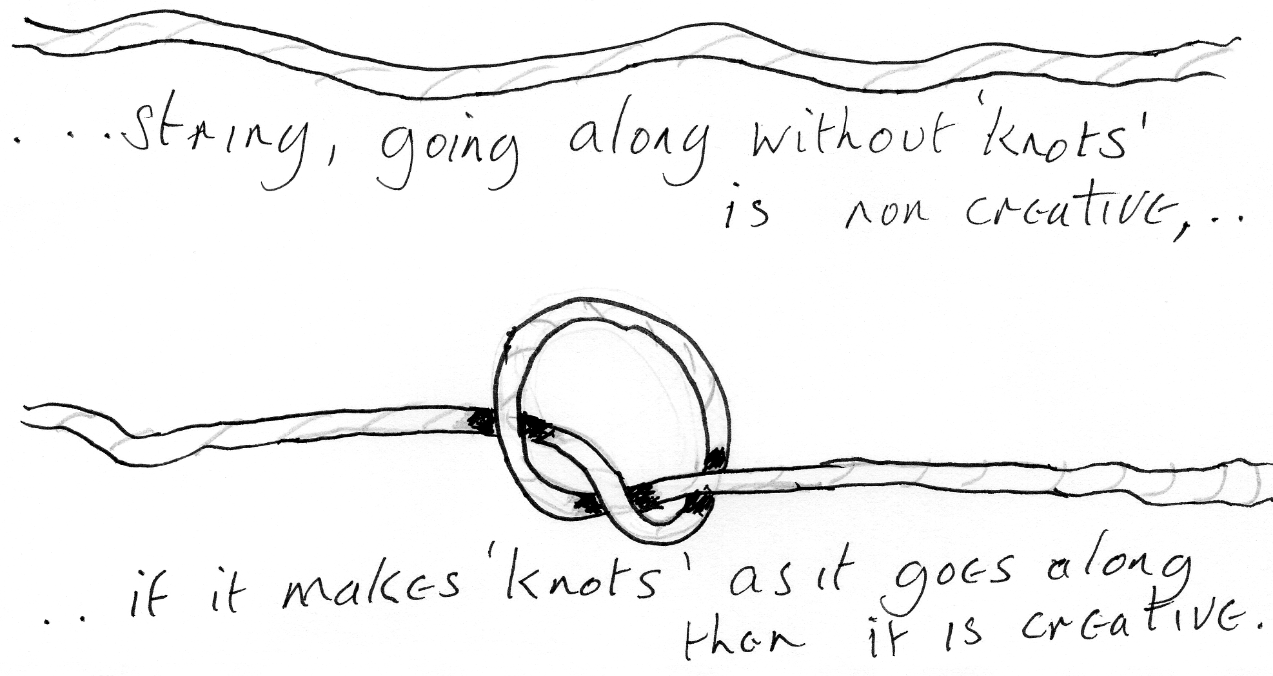

But it is a rotation of this sentient power, self-knotting, that is self rationalising because the rationality depends on the cycle; and it is that ‘cycle’ which is the ‘knot’. So there is no rationality other than ‘knot’ or negation. So if there is a reason for ‘knot’ it is simply the ‘knot’ being looked at rationally. And if there is a negation at all, considered rationally it can only be the self-tying of the absolute power.

Now this self-tying goes on literally, and the being can identify with any rotation point or ‘knot’ , and he can by effort of will, initially, confine himself into that ‘knot’. And he then goes round in that private eternal recurrence. He is suffering; and he is denied of his absoluteness. If he makes this extra strong he puts a ‘K’ in front of the ‘N’ which symbolises the application of a force against a resistance to keep it there.
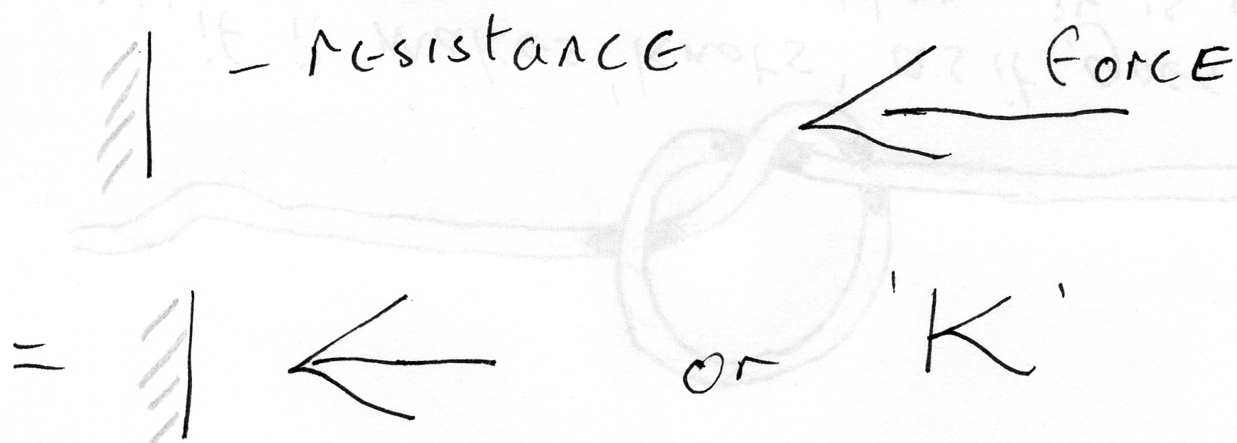

There is no negation, no knotting, no keeping, no slavery, no bondage other than the bondage of self to self; that the slave is the master self-enslaved; that this paper is the sentient power, that when it waves it has the power to feel its waving more that its ‘paperness’; and it has the power to feel its paperness more than its waving. If it feels its paperness more than its waving it’s a sage. If it feels the waving more than the paper, it is an ordinary man. For that is the only difference.

To feel the paperness is to be field conscious throughout. To look with your eye on the movement of the edge, is to serialise consciousness and to catch ones self up and to bind ones self with the form of the presentation and to forget ones own sentient power. Which is not different in any way from ones own will.

[Question from one of the audience] – Before you go could I ask you just to give one specific example in the terms of your analysis here? . . . Very often a situation occurs, some behaviour pattern, from somebody outside. And I find that I’m able to grasp my reaction to the behaviour pattern and inhibit an annoyance behaviour from myself. Then, two seconds later, if this behaviour continues, I find that I’ve fallen back, despite the fact that I’ve previously sorted it. [51 min 16]

E. H. – Yes - and the chief cause of that is that the mere fact you are practicing the 'inhibition exercise’ means that it has not yet become fully yourself. You are still partially identified with the motion, this is why you say that you are ‘trying’ to inhibit it. Now the moment you succeed with inhibiting it, a sub-ent. [usual E.H. abbreviation for ‘subsidiary entity’] called ‘self opinion or J T or whatever you like, rises up, rubs his hand and says, ’I have just succeeded‘. Now that is so much energy rubbed off the individuating process. And you’ll find if you analyse yourself at that moment, that always occurs. Until you don’t need to inhibit - because you are not identified - that will happen.

You will inhibit, you will succeed – if you are lucky – and having succeeded a voice will rise in you and say, ‘I have succeeded at that exercise’. But this voice takes energy off the exercise. Every voice in here inside you is not nothing, it’s energy. And it is part of your total energy.

[Same questioner continues] – So why do you get the annoyed reaction if you’ve just conceptually inhibited it? [52 min 33]

E. H. – Well when you inhibit, you see, you have a certain amount of – there’s a stimulus there contingent – part locally inhibiting comes from inside here - sends out a message over here ’Inhibit’. Now when you start doing a bit the energy that is spinning around here you have to drive against it, and locate it; because it’s threatening to overwhelm you. Now, as soon as you close it, it starts to rotate, and it is held in by your pressure. And as soon as you have got it held in, it immediately feels to you, ‘I can let go of it now’ because it’s now held in.

Immediately you let go of it, because it’s now held in, straight away you get a sub-ent. or a series of sub-ent.s round here who say, ‘We’ve just successfully completed an exercise’. At that moment the energy that was pressing against it to defeat it, goes back into these self conceptualising sub-ent.s, and immediately this wall is pushed further into your being.
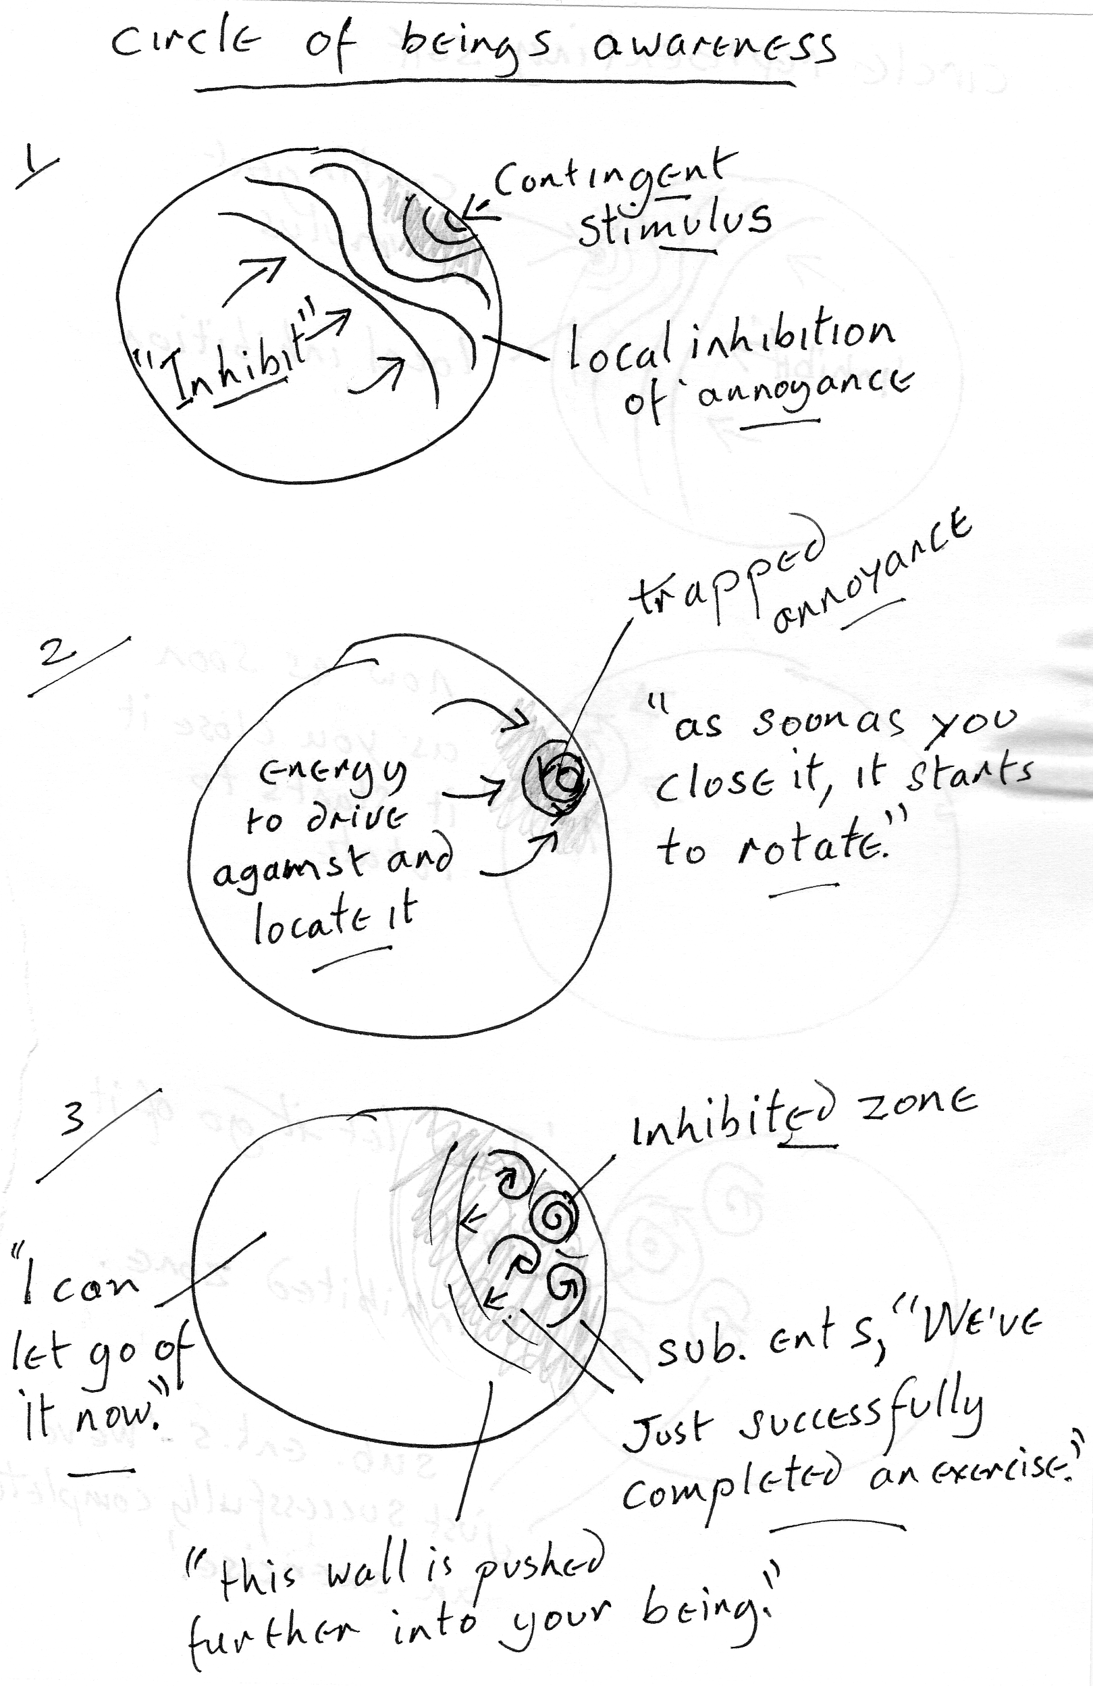

And its inner formal content – namely the nature of that stimulus- now spreads and floods the sub-ent.s that were just enjoying themselves. And it is the original annoyance that you inhibited that is doing it. It is not another one, because that annoyance is only a definite amount of motion characterised in a definite way.

Now the correct way is, of course, is not easy to do in the first instance. First you have to try to inhibit, but if you remember – ‘ the observer is not the observed,’ you will not bother to inhibit but you will dissociate, and you will allow the energy of the attack to go through you. There’s no time to locate it and hammer it into quietness, which is what you do in your inhibiting exercise.
[54min 32]
You are transparent to it, the transparency of the ‘sane’ is quite simply that you are not identified. There is a motion of the ‘paper’, you are the paper what do you care about the motion? A man insults you – has he? He hasn’t – he knows nothing about you. How can you insult someone that you don’t know, whose characteristics you are not aware of?

You fabricate an insult for me. I know a man he lives in a certain country, I’ll not mention where it is. His height is somewhere between an inch and six feet, his colour – not worth mentioning. His hobbies and his business we won’t divulge. Insult him for me. Can you insult him without a definition, it’s impossible?

Now, therefore if you are insulted you are conceptualised, and the man who is insulting you has a concept of you, but the concept isn’t you. So if you react as if it were an insult you must be conceptualising yourself – As insulted at least. If you know that the man is really reacting to another stimulus, that he is not deliberately trying to annoy you but he just won’t shut his mouth. He is not high enough yet to do it. So he is not insulting you because he doesn’t know anything whatever about you. He is reacting to stimuli in him operating his mouth, this is coming out. It is no more than the motion of that paper.
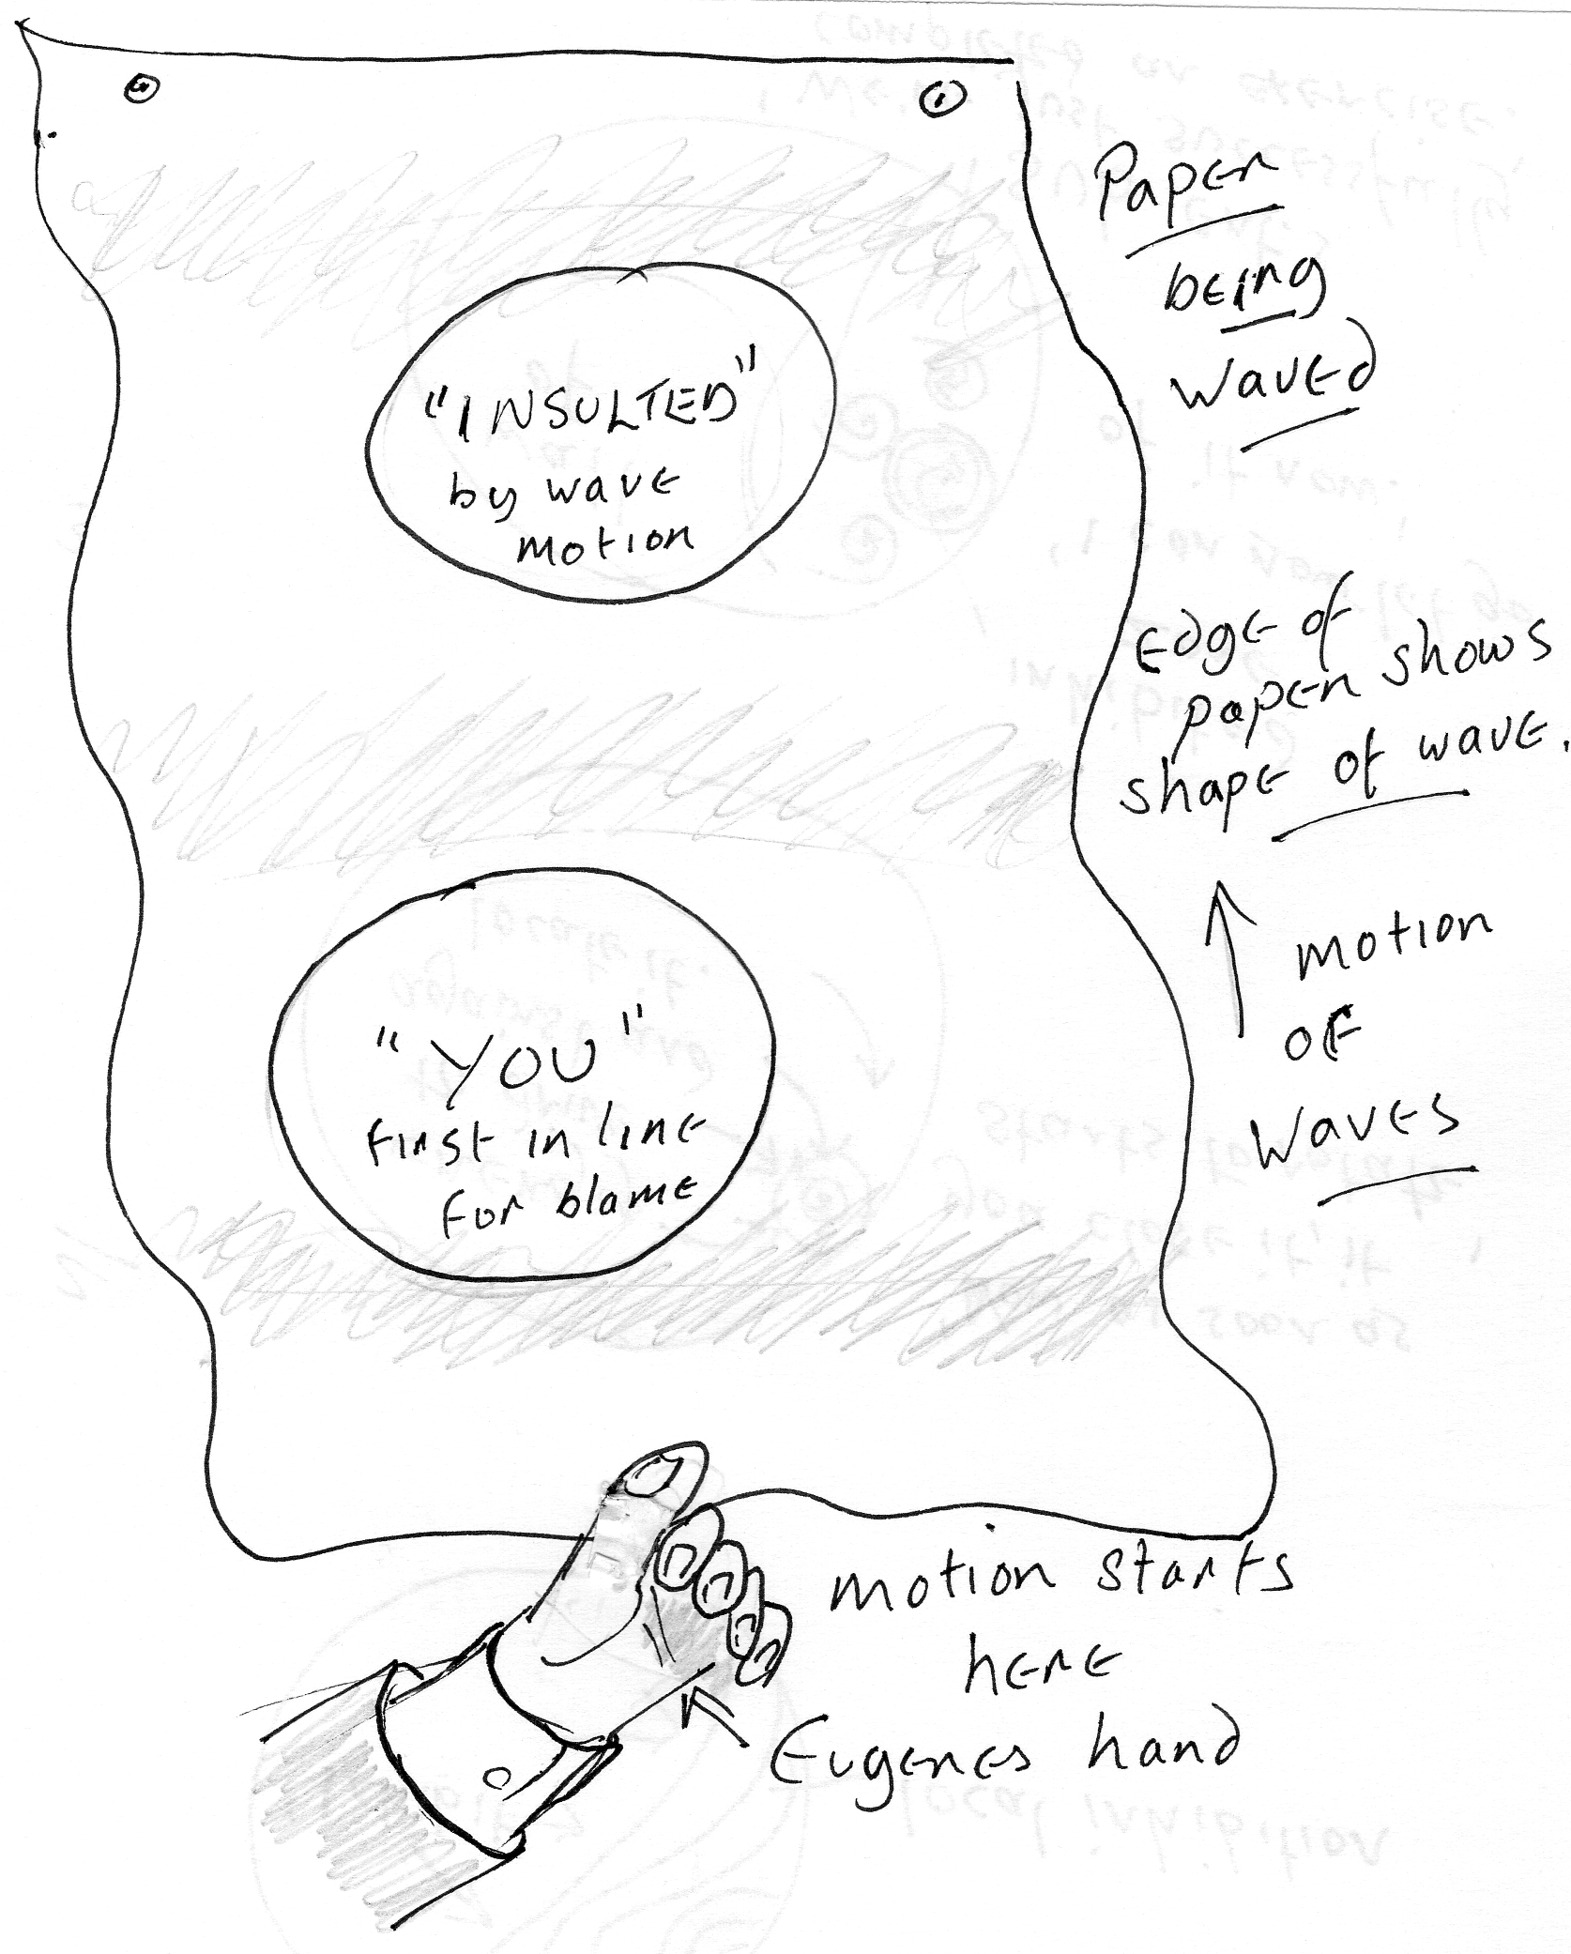
Supposing we draw a circle on the paper here and another circle down here. Now this is a fact – this is you, this is another fellow called ‘insulted’. Now a motion starting here reaches here, and goes beyond. Who started the motion that went like that? I did over here. Has this one below insulted that one above? Has there really been an insult? Not at all - it is an essential nature of sentient power to produce motions throughout itself.
If you are identifying with that signature, the motion with a direction on it will be assumed to being caused by the first being in line.

So the little boy knows this with his pea-shooter . . he gets in a bus queue and he looks up the queue – inserts one behind the ear of the man in front. All the man in front knows is he’s been hit from behind. So he turns around, and the one behind gets shouted at. There is no such thing as individual causation. All causation is of the sentient power. The individual, as such, can do nothing. ‘Of myself I can do nothing, I can do all things in Christ- my Pappy ‘.

Once that is fully grasped, you cannot be insulted. Because this thing, knows nothing whatever about the formal content of this [perhaps referring to the two circles, ‘insulted’ and ‘you’] couldn’t define it if you tried. Can’t insult because he’s under stimulation from the absolute – he suffers all the time. And the measure of his suffering is the measure of his identification. Break identification there is no suffering. Suffering means to be passive to a stimulus. To be passive to a stimulus is to be at the mercy of it. And the absolute is stimulating every form all the time; that’s the one to get at, that’s the chief insulter.

Insult means – jump into. Who is jumping into all those circles I’ve drawn? Only the paper – the circles are on and of the paper, he has every right to insult them – might is right. It appears that IMS is insulting RW,
. . but it’s not, the paper is insulting everybody. [58 min 30]

Why? in order to break identification. Why? Because they are better off without it. Then why did he make them in the first place? The answer is he didn’t make them in the first place. They are eternal facts with super-stresses on them imposed in the contingent reaction. The paper moves and there is a motion from here, across the intervening state of the finite which impinges upon there and collects there. Between two bodies there is a contingent stimulus, which doesn’t come immediately from the paper. There is a movement in my right hand and in my left hand to bring them together; they clash when they hit. It’s not from the original will to move them, I didn’t will the clash, I just willed to bring them together. The clash resulted from bringing them together. But in the bringing together they become more clearly aware of what they are, and this makes them, progressively, more and more aware of what they are not. And it is what they are not which is the trouble.

So we have to un-become the individuated man, so we can not be insulted, except by God, by the infinite and that we don’t mind. He’s the gentlest insulter we know of. We never attribute causal power to another being and therefore we cannot be worried about him.

If you saw a large lorry rolling down the hill with nobody at the wheel with the brakes off and you are on a narrow lane, between two big banks, and you could not get away and it rolled over you. You wouldn’t feel vexed with it – you may feel vexed with the driver for not leaving the brake on but that is because you would assume he had responsibility. If you understand that no individual is any better than that lorry going down the hill, you won’t be vexed. But if you know that it was this paper that took the brake off, you won’t be vexed with the driver either.

It is only by such meditation that you can release yourself from this error of inhibiting a reaction to a stimulus by individual effort instead of by transparency. You can see the mechanical error can’t you? That the incoming energy as you feel it about to overwhelm you, you hammer at it. You succeed, you hammer it into a corner, and you think, ’Made it, what a clever bloke’. You take the energy you put against the wall, and examine your ‘clever bloke ‘ concept – some of the wall expands – something on the inside is still there. It’s as simple as that. [1 hr1 min 19]
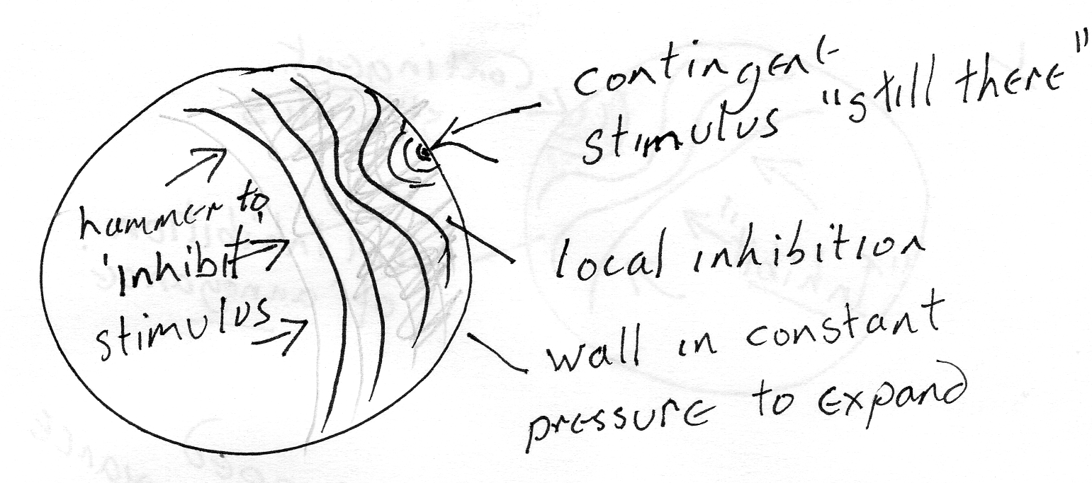

[End of recording]

I can do all things through Christ which strengtheneth me.” Philippians 4:13 KJV
[I am guessing that these are the initials of people present in the audience, this sounds like RW’s voice questioning here]

