Opposition

Contents
Passive and Active Knowledge. 2
Exercise to Make Things Active. 3
Opposition. 3
Noah 4
Motion. 4
Venus and Mars 5
Rotations of Force 6
Freedom 6
Re-incarnation. 6
Mind & The Nature of Ideas. 7
Light. 8
Body, Mind and Soul. 8
Geometry. 9
Mystic Initiations. 11
The Phases of Being. 11
Entropy 12
Sharpness 13
Ham Shem and Japheth 13
Music 14
The Doctrine of The Elect. 15
The Infinite Field 15
Society 16
The Four-fold Man 17
If We Don’t Become What We Eternally Were, We Can Never Be Happy. 18

Transcribed by J. Bailey
With diagrams and arbitrary headings by J. Bailey.
Editir’s comments are in square brackets

Passive and Active Knowledge.
... university ... during the period of a lecture, the students are very frequently convinced that they know what he's talking about, and so they don’t bother to make notes. and then they go home and find that they’ve forgotten all about it and can’t remember the subject matter.
The reason for that is that understanding can be done for one person by another. It has quite a lot to do with the confidence of the person giving the lesson, because if he knows his subject, he feels that he can actually explain it. And his confidence is felt, and then the students become confident. And when they are confident, they are quite sure that they’re understanding what he means ... simply because they feel confident.
Obviously, this question is really about spiritual development. But spiritual development and intellectual development are very intimately linked. We’ll do a diagram to prove that in a moment. And therefore the same rule applies. A person can feel confident of his own subject matter and therefore create the confidence in the listeners, so that they can actually comprehend what he is talking about for the time being.
Now, if this is true, is the state transitory?
The answer is, generally, Yes.
Can it be maintained by personal effort?
The answer is, Yes, if the personal effort can be made over a long enough period. And this, of course, is that horrible existential problem, Who is the individual under consideration?
Every person has to make his own efforts, and if he actually made efforts whilst the teacher is talking about it, instead of merely accepting the understanding in a passive sense — because factually you can be made to understand a thing passively by the conviction of the teacher — to make the lesson your own, you have to convert your passive acceptance to an active penetration to the problem of relations.
A child passively learns A, B, C. But if you listen to the quizzes that school children have in various contests on T.V. you'll find that they don’t understand the meaning of what they're saying. They just recite verbatim things they have learned, or they fail to recite them. But there’s no real comprehension of the subject. It is a passive memory. [2:38]
And passive memory is no good, because as soon as you remove the stimulus, it disappears. The thing is to become a self-stimulating system, which means that you have to take the formal knowledge you are trying to acquire, and feed it into your own ears with your own voice, after you've had it fed in from another voice. It’s all a question of feedback. If you don’t actually make yourself feed the information back to your own organism, into your own brain, you are passive to it.
A person can understand for you, rattle your eardrums and create a sense of comprehension ... and you can be quite passive to it. That is, you are not deliberately repeating to yourself and comprehending what is being said.
Some years ago a teacher of mathematics was talking about the stupidity of his pupils, and he came to the point where he said that, If they had any more intelligence they would be able to understand a certain equation.
And I said, Surely the basis of this is that they must comprehend the nature of unity first.
And he said, Yes, that is true, but then any fool could define unity.
So I asked him to define it, and he found that he couldn’t define it. So he said that he would go home and think for a week about it, and bring the proper definition back.
And I said, And wat will you do if you can’t define it?
And he said, Give up teaching maths.
So the following week he came in and said, I’ve given up teaching maths.
And he became an actuary instead.

Now, the important thing is that his knowledge was only passive at that time. It was memory and nothing else.
You can say to a child, Twice one are two.
You can say to somebody, Add up seven and eight, and then say, now add up eight and seven. They come to two different answers. This is quite usual: that people can do a multiplication one way and not the other. Some girl might know what 9 x 6 is, and not know what 6 x 9 is. Not only girls of course.
But it does happen that if you merely receive the thing passively, you are left in that passive state. The information is not your own. You have to see what we mean by your own in a moment. But the question is here replied to by saying, somebody else can understand for you. You can feel you know something in their presence, which in fact is only passive and will disappear if you do not make it active. [5:10]

Exercise to Make Things Active.

The technique of making a thing active is really a question of:
- Verbalising the problem.
- Visualising it.
- Using your sense organs, your reason and your emotion.
- And feeding the information back by speech into your ear from outside ... and very frequently by writing or drawing the problem out so that you have made your body actively solve a problem instead of merely receiving the solution passively.

If the solution is given to you passively and you don’t work, it means that all you’ve really got is, engraved in your memory, a simple thing like, Two plus two equals four. Now any parrot can be taught to say this. So if you say two plus two, Polly says, Equals four, once you start the process.
Most human learning is of this order ... parroting. If you ask somebody to recite, say, the alphabet, stop them in the middle, and say, Now, recite it backwards, they can’t do it from where they are. They have to go forwards and then come up to it again and pay now, special attention.
If you ask people to subtract 3½ from twelve, all the way down, most people will get into trouble with it, because they have only passively acquired it in one way. So if it is to be maintained when the illumination has come, it can only be done so by active re-verbalisation by the listener. Now this is the exact opposite of the next question. [6:43]

Opposition.
It says, If opposition is necessary for our growth, how is it so many people and nations have been crushed by this very thing? Can you explain how they have benefited by being opposed?
In the case of the Tasmanian peoples they were benefited by being made extinct. Other nations have been made extinct. We know the history of lots of peoples in the world who have been thoroughly exterminated by superior types of people. So when we’re talking about opposition being necessary, we have to say, For whom, and in whose terms?
In the Old Testament there is a story about the chosen people coming across a valley full of people who were peacefully ploughing and getting on with living, and they didn’t fight. These people had no warlike feelings. As far as they knew they had no enemies. So the chosen people just exterminated them. And then they were eliminated. The problem was solved. Now this sounds like a terrible thing, and from the point of view of the people who are being killed, no doubt it looks like a terrible thing. So we can’t consider it merely from their point of view.
When 6,000,000 Jews were exterminated — or are reported to have been exterminated — in Germany, from the point of view of most Jews it was a bad thing. From the point of view of Victor Gollancz it was just part of an historic development, a dialectical process of genocide started by the chosen people, and then copied by the Germans, and played back on them. In his book on the Eichmann Trial he actually said, Why be surprised how people started this process of murdering nations? The Germans were only copying. As usual we were first.
So we’re going to consider this question of opposition ... how it is necessary. And we have to be very careful about people and nations. Many peoples have failed to recognise the necessity of the opposition, and the people who not realise that opposition is necessary, dodge the opposition ... and become weakened.
As soon as you dodge opposition you have started a weakening process. [8:58]

Noah
Let’s take the symbolic story of Noah and his three sons.
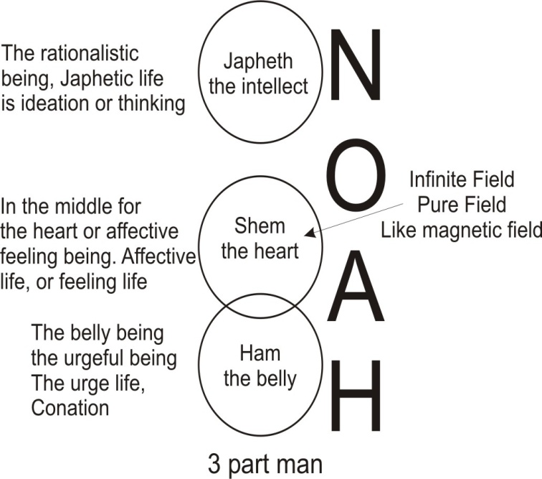
Now, Noah means the principle of intelligence itself. That’s the Anglicised form of the Hebrew. ‘Noûs’ is the form of the Greek for the same thing ... the Noetic principle. This is Greek in Yorkshire ... ‘nous’. This is intelligence. And this has three sons. The three sons embody themselves in parts of the organism. [9:33]
Shem in the middle here for the heart or affective feeling being. Ham for the belly being, the urgeful being, and there a Japheth here, for the rationalist being. Now there's a Japheth here for the rationalist being. Now, these are three aspects of consciousness. And every human being has these three. The Shem is the affective life, or feeling life ... affection is the psychological term for it. And the Ham is the urge life, conation. And the Japhetic life is ideation or thinking. And every human being has the three.
This means every group of human beings also have these three interacting throughout the group. Now we can see here why opposition is necessary. We start off with the Shem as the field. This Shem means a spirit that is substantialised or a dual aspected power ... power which on the one side is consciousness, on the other side is object of consciousness. On the one side initiative, on the other side, inertia. And Shem represents the infinite field. [11:05]
Now, prior to any spin or rotation — any vortical activity within the field — there are no things whatever. This is a pure field, like a magnetic field, and it’s rather a peculiar field because it is a magnetic field with no magnet in it. We are used to seeing a magnetic field round a magnet, round a bar of magnetised iron. And when we see this field, we are so used to seeing the field in association with a bar of iron — whether straight or bent like a horse-shoe — that we think that the field is a product of the iron. In fact, it is exactly the opposite. The iron is a condensation of the field.
Nobody in the 20th century in scientific circles believes in matter today, other than as a modality of a field force. This field force, when it is not viewed as a thing, is symbolised by Shem. And because it has no vortical spin in it, it is exactly like having a plain piece of paper with no drawing on it. And because there is no drawing on it, there is no possibility for that field becoming aware that it is a field. So this field has somehow to produce its own opposition, because this field, being the ultimate reality — it is the Infinite Sentient Power, the power that feels itself — this field, viewed as non-circumscribing, not producing little vortical spins within itself ... is objectless. [12:47]

Motion.
Now, a consciousness with no object, a pure sentience with no inner content, has no existence. It has no meaning, no significance. And therefore it is absolutely valueless. But because in fact it is power — and the essential nature of power is motion — then being infinite it must characterise itself by an infinity of different motions. Now of all the motions there are — considering the problems of motions, whether in kinetics or kinematics or any other scientific study — we will divide the motions up into two kinds:

1. A motion of translation.
2. And a motion of rotation.

If you like to take a hybrid, half a rotation and another half a rotation — dipped on the other side of the line another half — then you have undulation.
So undulation, here, is a hybrid of simple straight line translation and rotation.
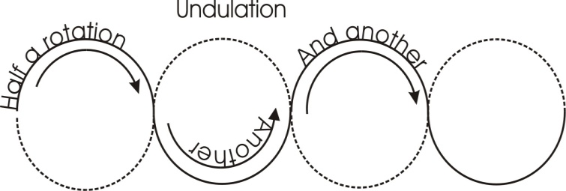
Now these are abstracted motions of the infinite field. If we have simply the field with no motion characteristics whatever, we have an absolute nothingness, a void, a mere potential of being ... with no being. They have a nice German word for this state/non-state. It is the word ‘ungrunt’. The grunt part should be well-sounded actually.
The ungrund.the word grund of course means ground, and the word un means un so that means the un-ground ... The Not Yet Ground.
Now you observe the word ground has the word ‘round’ in it, and the hard letter ‘g’ means ‘earth’. So it implies a rotating behaviour of a force. When you're talking about grinding things — whether you’re a miller grinding corn on the Dee, or any other fellow grinding things in an engineering shop — the grinding process is a rotating process. When we use the word ‘ground’ for the earth, we are referring to the earth after a certain process of rotatory opposition of motion has produced the tiny the little vortical spins that we call sub-atomic particles.
An electron is factually a field force with spin on it.
An atom is a complex of such spinnings.
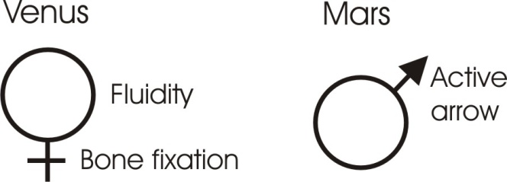
A molecule is just a more complex spin pattern.

Venus and Mars
But all these spin patterns that we know as the material world are simply a field force moving in a certain way. So if we don’t draw anything on the paper at all to represent zones of spin, we have an objectless sentience. And a sentience which is objectless cannot know itself objectively, and therefore it is as if it were nothing at all. It is represented in the zodiac with the planet Venus, a kind of pure passivity, a static light. Mars is the opposite, which means a frictive process of motion producing heat and beginning to produce forms. [16:20]
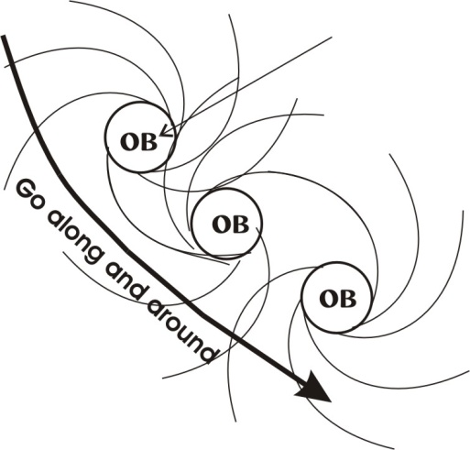
Now, supposing I begin to translate across the page to show within this void — remember the word ‘void’ means potentiality of form, the ‘oid’ is the root meaning ‘form’ the same as the root in the word ‘idea’ — as I begin to move across here — as we’ve said the power which is sentient can feel its own motion — when it is translating in this way, it feels that it is translating, but this translation is not an object. It is merely a state of motion apprehended by feeling with no intellective content. When I undulate the mind a bit like this, now we have a slightly different sensation because we feel the swaying. This sentient power feels itself to sway, but it still is not objective. To become objective it must make an ‘ob’, so it must rotate.
So if I now say, “let it go along and go around”, now it has made an object. It goes on again and makes another object and on again and makes another object, and on again... This is the origin of a lot of fret patterns in ancient works of art. The Greek frets which are squared up are based on this kind of cosmic doodle.

Rotations of Force
Wherever there is a rotation of force, there is an object for the duration of that rotation. And as soon as there is an object, then the sentient field has something upon which it can condense. As soon as that rotation occurs, one cycle means it has come to be for the period of that cycle. If we could persuade the energy to go round it again and round it again and round it again ... for as long as we can persuade that energy to go round, we have an objective content in being.
When we think about the life span of a human being from a baby to a corpse, we are talking about the persistence of rotating forces, and sub-forces within there like the force of the kidneys, the bladder, the spleen and so on inside, a totality of vortical behaviour patterns constituting a human being and persisting for a certain number of years. As long as we have rotation we have objectivity, and when we have one of these things in being, we have now got a centre upon which the field forces can move and bounce off. So the field force can feel itself impeded. But as soon as it feels its impedance it is already on the way to comprehending what it is in itself as non-impedance. [19:15]

Freedom
We can write the word ‘free’ for what it is before an object, and we write ‘dome’ for when it is an object. And we put the two together in the state of ‘free-dom’ which means that we are now aware that we have a consciousness that can initiate formal change, and we have a form already produced within that field of consciousness upon which we can condense.

Re-incarnation.
Now let's look at the problem here of reincarnation. When we go round, we incarnate ... that is, we embody a force within the rotation. Either we lock it up eternally or the energy in it comes out and goes away. But After it's gone away, it will turn around and make another object ... and then again another object. Now the object is merely the same thing as the energy that was free, but is now rotating. Such a zone is a zone of incarnation, and the energy which ran into it and then out of it is the re-incarnating energy.
Now let’s look at another aspect.
If I draw a dark circle here to represent the gross matter and we have the invisible field of consciousness round it, and instead of drawing a three-dimensional perspective drawing which would be confusing, or instead of drawing a two-dimensional one up and down, I’ll draw the diagram through half of it. I could draw the thing symmetrically around it but I’ll draw it just above it. So here this half represents a material point of resistance and here is the spirit.
Now if we said in Indian terms, that is Atma and this is Sthula.
[Sthula] This is the point of opposition.
[Atma] And this is the spirit.
If we like to write in there, STN for stone, Satan and such-like words, we have found the opposition, the objective reference point within the field.
Now this invisible form — no-form, the paper with nothing on it — is the spirit called the God-head theologically, and these two are acting upon each other. Now the force from the infinite is coming down, striking against this physical thing and returning. Now in the returning process of striking there, it is spinning. So at a certain point it produces a zone of rotation, not as gross as the one upon which it struck, and not as fine as the infinite from which it derived.
So we can say this is the Alpha [Spirit], this is the Omega [Sthula].

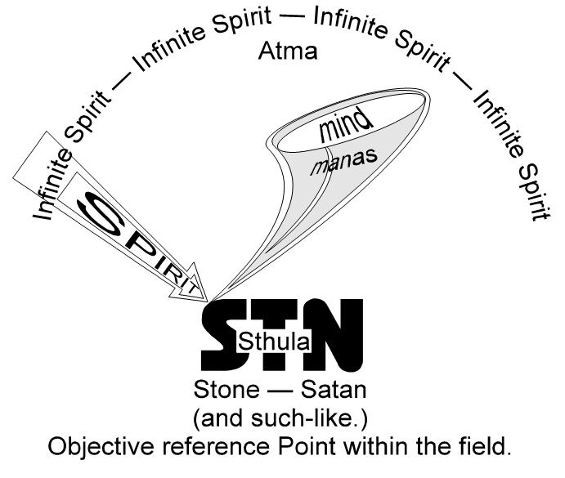
Mind & The Nature of Ideas.
Now, in between we have a process which is called the mind. [22:14]
That would be the ‘manas’ of Hindu philosophy, just the same root as mind, and they mean the same thing. Because when non-formed power strikes upon a formed power, it bounces from it, and in so-doing makes a form of motion in space. And the form of motion in space is formally like the thing upon which it struck, but without its density.
So in the realm of the mind we have here an idea. And down here [in the Sthula] we have a physical body, a soma. And this idea has arisen through the striking of the Infinite Sentient Power upon this precipitated point of resistance. So on the paper here we must imagine — I shouldn’t really write it, but I will — there’s the spirit, and here is the mind, and here is the body.
Now that three-fold division was used to simplify the thing, because factually it is the first mode of generation of a conscious, individual being. Without this physical body there cannot be individuation of the mind. The physical body is the precondition of the growth of Mind, because the mind is only the product of the interaction of a free with a domed energy. [free-dome]
The mind is simply representing the form of matter, and therefore in its first stage is bound to the body. This is why it is said even in the Christian religion, “First a physical body, and then a spiritual body."
We must have this physical experience, the point of resistance, the inertia.
And we must strike the spirit against it, let it bounce off ... and it produces an idea.
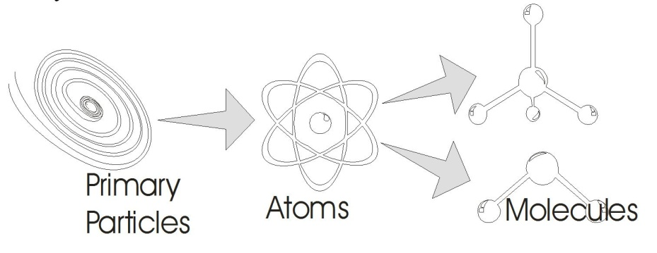
If you doubt it, give yourself a smart bang with one of your hard knuckles on some sensitive nerve, and you will discover you will get an idea in the process. And all our ideas are the product of free energy striking against bound energy and, being impeded, bouncing off and spinning, and producing a pattern like the object from which it struck. Now here we have the mind mediating between spirit and body, but because it has been the product of striking on the body, it is body orientated at this level.
So we could say, let’s draw a line through this zone of the mind. And we could say that in the first stage of mind, the mind is body-orientated. It remembers what it struck. It is an empirical scientist. It is a man who says, There is nothing in my mind except that which came from my five, physical, sense organs.
We know a lot of people in the world today called humanists, who declare that they believe this. Now if they were to think about the nature of idea they would know that they were wrong.

Because this idea in the mind can only arise by a force striking on an impedance.

Now they [humanists] admit that the impedance exists, namely the material world.
They admit the idea exists, but this idea can only arise by the action of a non-formulated force onto a formulated body.
So the mind then, is a product of a relation between spirit and body, but in the first stage the mind is body orientated ... because it wants further information. Now this body is the necessary opposition to the spirit ... necessary to create individuated cells. The spirit with no drawing on it, the spirit with no form, is like a nothing. And it is not even a ‘one’. It hasn’t got a unity yet, because a unity is already an integration of a plurality. So by making many vortical spins all over the place and condensing them — that is, compacting power onto the centre — it makes primary particles.
These primary particles are aggregated together, and make atoms. And these make molecules, and so on.
And all the time it is building itself up more and more complex resistances, and therefore building itself the possibility of an enriched mind. [26:50]

Light.
Now, there’s a very peculiar thing about this mind. Although it arises from the interaction of spirit and matter, of itself it can subsist without the body that generated it. Now we know this is true because in fact we get light from stars that left those stars millions of light years ago. Light is travelling at 186,000 miles per second. How far it travels in a year at that speed is quite a long way. The light that we get in the daytime from the sun is eight minutes old when it comes to us. And this is very important because it means that if by some cosmic cataclysm the sun were eliminated suddenly, we would still receive the light that left it, this side of eight minutes ago.
Now this light is an electro-magnetic wave phenomenon with a quantum aspect. It behaves as if it were a body of light, a photon. But this photon is a product of processes in the sun, and if we eliminated the sun, the light that has left it would not be eliminated.
Now if you think very carefully about this, it means that a mind — which again is a subtle form of the field energy — although it comes into existence through the action of a force on a physical body, the destruction of that body does not destroy that mind.
Now this is terribly important for the development of the human race, and the essential point of the doctrine of re-incarnation. The mind does not cease when the body that was the occasion of it spinning has ceased to exist.
That means the mind that we generate — the totality of ideas we generate in our physical body through the action of cosmic forces impinging on us — that mind does not cease to exist when our physical body disintegrates. [28:51]

Body, Mind and Soul.
So now we have a being which can subsist like the photons that have left the sun eight minutes ago, or the photons that have left stars millions of light years ago, which are coming to the earth now. It has a persistence beyond the physical body. It has a relative persistence. But this mind is sentient power, because there is nothing else. The infinite is itself a sentient power.
So this mind is now at a level where it is persisting with the memory of its physical experiences, which it derived from the clash of two forces:
[1.] The translating force of spirit.
[2.] The rotating force of matter.
And that sentient power, because it experiences its own motion, is made very, very happy by integrational motions, and very miserable by disintegration. So if there are any disintegrating motions — that is, un-assimilated ideas, any non-comprehended ideas in the mind — they constitute a mode of dissatisfaction in the mind.
Let’s now eliminate that body, and here we have a mind. Now this mind is a being, which is not a gross material being, but nevertheless it is an identifiable being because, formed, it is a spinning vortex of subtle force. So this subtle force, here, now — eliminate the body for a moment — the free spirit is now striking on the subtle force of the mind — the mind itself is a being — and bouncing off it again, between this spirit it produces another one, even more subtle than the mind. And this one we will call the soul.
Now if we were to put the yoga term to it, we would write Atma and Buddhi and Manas. Now these are the surviving beings in the ultimate process of evolution. Atma, Buddhi, Manas, constitute a trinity, which although generated initially (apart from spirit) generated initially by the body (the spirit itself is eternal), although generated by action upon that material body, they have a persistence as zones of spin within the field. So we now have a spirit, a soul, a mind. And this spirit is producing in the soul a much subtler type.

1. Just as the mind is bound to the body initially because its in-formation — the form within itself, its information — is a product of body occasioning resistance, therefore it’s orientated downwards.
2. So when this second zone is produced, namely the soul, then between the two there is an orientation of the mind upwards towards the soul.
So the mind now has two orientations.
And we call the upward orientation the higher mind, and the lower one, funnily enough, the lower mind.
Now the materialist mind of a humanist is by his own definition a machine, entirely conditioned by material processes. But the higher mind can do very funny things that the humanist cannot account for.
If a humanist sees a shape like this, and another shape like this, and another shape like this, and he calls those things triangles ... he says that he’s got the information about triangles from the material world. But in fact he has inside his mind a triangle that he has never seen, called perfect. [32:40]
All the empirical triangles are not perfect.
And the triangle in the mind is perfect because we can actually conceive a triangle with exactly the same length of sides and this triangle, because of its exactness, is perfect. But any empirical triangle we care to make will only be an approximation to it. So factually we have two kinds of ideas in the mind:
[1.] One from below and that is the sense-organ-derived idea of a triangle, the empirical triangle.
[2.] And the other one, the perfect triangle, which could not have come from below — although the materialists try to pretend so, by saying, “If you lap a lot of triangles over each other like this you will eventually arrive at the idea of a perfect triangle” — But that perfect triangle is an average triangle of all triangles, lapped over itself.

Geometry.
It still requires a function in consciousness to make this jump from the empirical relative imperfect to the absolute perfect. So here we have a zone in the mind which instead of thinking in empirical formal terms, and instead of thinking serially — conditioned by impulses from the body — thinks geometrically.
Now this word Buddhi is a word meaning pure intellect or pure illumination.
This is the word from which Gautama Buddha gets his title. Now when we conmsider geometry: if I draw a triangle, we factually can comprehend that triangle with its three sides in one moment of apprehension. Now, according to the mechanistic view we cannot. The mechanical mind looks at one side and the other side and the other side and then it runs round very quickly and adds them up in a serial manner. Now it is true: that this is how babies learn the alphabet, and learn how to count. But it is also true that you can comprehend the gestalt, the wholeness of that triangle in one moment ... that is, non-serially.

So factually in the mind we have two kinds of thinking processes:
[1.] A serial thinking process conditioned by material experience.
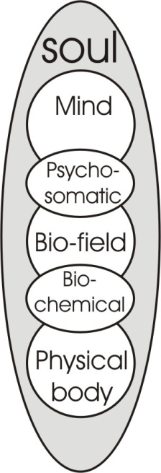
[2.] And a simultaneous comprehension process not conditioned by the physical body now, although initiated by the interaction of spirit and body originally, but now it is a self-stimulating force, so subtle that the next stage above it is pure spirit.

Now this pure spirit made this gross body as its necessary first point of opposition, and produced the mind by evolving upwards — we find the mind of this kind in the animal world — in order to bring itself so it could pluralise the infinite field of spirit and yet let that soul — that solo zone — behave like a spirit ... that is, freely.
So by this mode of opposition all that we call value and all that any human race has ever called value is created, namely by opposition, deliberately entered into. Not opposition complained about and rejected.
Now between any two of these there arises again, reflection interaction of forces. So the soul itself has a zone coloured by the mind below and free spirit above. So we find that the soul of man is represented quite accurately as conditioned by serial thinking processes, and these by the physical body.
So then we find that between any two of these circles we have again an intermediary zone, created by the reflecting energies across here. So between the mind and the physical body, we have another zone and this is the zone of the life-force. This is the zone we call the bio-field.

Now this [The Bio-Field] is actually a field of energy, that conducts
all the processes for living beings that are not reflexively self-conscious.

So a plant which seeks the light with its leaves, seeks water with its roots, has a life principle which is working through that physical body and lifting, changing the organisation of that body, and bringing it higher and higher towards spirit.
Now St. Paul says: the whole creation travails and groans to be delivered from vanity. He means that at the physical level where we suffer from inertia, the spirit inside, identified progressively downwards, is literally complaining about its own inability to direct itself. Its enemy is the inertia of the physical body. But this physical body inertia is a willed inertia, by spirit, in order to create soul.
Now here we have now a process of five types, four of them manifest and one — the spirit — non-manifest. Now if we want to again divide these, part of the life force is identified with the physical body so much, it constitutes a field of bio-chemistry. That is to say that there are processes going on in living beings that can actually be reproduced in the laboratory under test conditions. They are processes that are not found in the non-organic world, but they are nevertheless susceptible of chemical analysis. So the whole field of bio-chemistry is represented there.
And above this we have that life-force zone, which is not chemically conditioned, but is idea-conditioned. So this level we find is the zone of the psycho-somatic disease. We know very well [that] if we hit the body very hard, we can make the life-force feel depressed. But we also know that if we have a good comprehension of what it means to think positively — that is, in terms of spiritually illumined soul — we can actually deliberately cultivate a positive attitude, so that even a physical injury will be more quickly repaired than it would have been.
So within the field of the life-force, if we like, we could draw two circles, and also in the mind we have two circles. And now we have, altogether, seven zones. Now this is the way the primary unity became the septenary perfect being.
Simply by first of all the primary unity is a trinity, and then it creates the intermediary zones by internal reflection. And then it creates again, until it finally has a sufficient number of interactive zones.
Between these, of course, there are various grades. But there is not a continuous, but a discontinuous activity going on in between them. That is, there are actual jumps in consciousness between physical body sensation, biological feeling, and mentation processes of thinking, and simultaneous thinking, and free spirit. It isn’t a gradual sliding scale. It is a series of degrees. [40:17]

Mystic Initiations.
Now, in all religious and mystical initiations, the fundamental idea presented is one of degree ... one of grade. You have to go through the steps. You can’t slide through to spirit from body. You must focus. You must condense and rotate round there for a period of time, and ignore the rest. That is, learn the lesson of matter thoroughly, as if there were no spirit.
Then learn the lesson of life and body, as if there were no mind, soul and spirit. This lesson of life is the kind of thing that Rousseau tended to get caught up with, and that lots of young people think is very, very nice. I believe there was a programme about filling a room full of mattresses and all rolling about on it. This is beings who have been materialistically orientated, that is, young boys and girls who have just about stopped being fed by their mothers. In other words they've stopped being merely physical beings. And they're now climbing up to the field of life. The bio-field itself is now urging them to discover what life is about. The figure of Pan with the goat’s hoof and so on symbolises this kind of thing. We have to actually experience what it means to be urgeful ... thoroughly to comprehend that urge before we try to think. [40:41]

The Phases of Being.
Every baby has to go through all these phases. It is a spirit involved into a body. If it gets nourished and fed it becomes bound into the body-consciousness. When completely identified with the body, it does not know that there is a feeling in another body outside itself. So that if its mother’s behaviour does not conform to the pattern its own feeling requires, it just simply bites her or kicks her or scratches her, because to itself it is the only feeling being there is. It is a being which is a physical body, and beyond it there is nothing. So it is a body-being. It has not yet learned that there are other levels of being.
Now at a certain level it becomes aware of these urges rushing it in directions that cause pain, other directions which cause pleasure. It climbs very slowly into this phase and then it has a lot of experiences that are painful, and some that are pleasant. Now all the painful ones add up to being careful. [42:48]
As we’ve said before, if we take this as the ???? if say this is the head, the heart and the belly of man, that’s the lowest kind of man that we can think of. The man who believes that he is a mechanism of ideas derived from the physical body and a life force which is merely the energy aspect of the material body ... this kind of being is not a very high being, although he does get BSCs very easily. And when he does get them he climbs up to represent here the man of earth and he does not believe in the zone above him.

Each level has to be experienced

[1.] The baby has to be smacked. It has to be nappied, fed and so on. This fixes it in the body.
[2.] And then life urges in it will operate.
[3.] And then through being knocked about and defeated, it will begin to think. But it will still only think at first about the material situation that that caused the pain.
[4.] And then gradually, if it's lucky it will get some abstract ideas, because the spirit bouncing on this body, this life force and this lower mind, produces between the two ... a soul.
[5.] And this soul is the focus for spirit. It actually draws spirit together in itself and then radiates through the mind and illuminates that part of the mind — that frequency range of the mind — which is high enough to break the dominion of the physical.

Now when we're talking about reincarnation, the physical body is the essential of it, and it's the primary opposition that is absolutely needful for the creation of individual sentient beings who shall be free. [44:48]
Looking in terms of our question about opposition — whether of nations or individuals is really not important because the same principles apply — the opposition has to be faced consciously, with a full awareness that:
The purpose of the opposition is
degeneration of freedom
... the re-creation of spirit.
If any individual or nation rejects the opposition then it begins to degenerate because it believes that it is in fact a being for enjoyment only.

Seeking and Dodging Opposition
So we can actually — without bothering to name particular tribes — say that there were in the early days people which preferred to go towards warm climates rather than cold, people that going into these places found they were quite comfortable, thank you. And the grapes fell in their mouths, and bananas fell off the trees. And until a coconut fell off a tree, they didn't think of going north again.
The essential thing is that are factually, historically, peoples that moved towards the comfortable and the pleasant, and that historically these peoples, through dodging the opposition are those peoples that are declared by the opposition seekers to be inferior. All the peoples that are called inferior by the other peoples who call themselves superior are historically, demonstrably, people who dodged the harder aspects of life. [46:29]
[Question from Khen Rarcliffe] What would drive them into the harder aspects first?
Well if we remember that we have a human race within a certain terrain — let’s say between the two rivers in the Euphrates Valley, in Mesopotamia — now these people have appeared as a mutation, and they are growing and multiplying and spreading out. Now it is automatic that some of them will be unequal in energy to others. Because from this side one kind of wind is blowing here, and from this [other] side another wind is blowing. So that factually, the beings here [on the warm side] will become nesh. They will go and form the land of Cush later. Warm winds are blowing on these [on one side], and cold winds are blowing on these [on the other].
So these [on the cold side] will become hardier than these [on the warm side].
[Khen] There is no individual virtue there, then? In the fact that it occurred?
No individual virtue initially. But individual virtue nevertheless, because at any given moment when the wind blows, any one of these can decide to change sides. Now in fact those that were on the cold side, when they went to the warm side, began to perspire a bit and said, It’s rather hot round here, let’s go back up here, it’s nicer.
Personally I prefer to be cool rather than hot in a room. But there are people I know that actually like it quite hot. Of a temperature that I would say, very nice, I know one girl that thinks it is terribly cold. And therefore she would tend to move away from the situation that wouldn’t disturb me. Now this has something in my case something to do with processes, psychological processes, mental processes which actually generate more heat than muscle exercise does.
You know you can get overheated by thinking very vigorously, far quicker than you actually can by muscle exercise. You know that you see somebody blush if you say something unkind to them, and the mental process accelerates and they get very hot.
Now when we consider this, we’ll pretend for a moment there’s no individual virtue that can be determined. Later on we’ll show that there is no individual virtue and there is an eternal individual virtue in spirit itself. [48:55]

Entropy
Meanwhile, we will accept the doctrine of theoretical equality in a starting point. In other words, the primary entropy. This itself proves that it's false because entropy, if it ever existed, could not be disturbed. So we are really concerned with the dynamics of a field. Thus, regardless of race, colour, creed, etc. we will assert equality in this diagram.
Now those on the warm side are a little nesh. They don’t like the north-east winds.
Those on the that [other] side become hardened to it.
And as they are multiplying, begetting their children, they are spreading out on both sides. I’m keeping it in two directions to avoid a four-linear expansion. So over here, moving towards Europe and the north are some beings getting quite hard, so they start getting dressed, and the others don’t.
And the ones up in the north think, Well, even though I'm thoroughly dressed and nearly immobilised with bearskins, I’m still a bit nipped, so I will build myself a house. So he builds himself a very strong house, where there are some very strong gales.
But this fellow [the one in the south] is quite happy with a pile of straw round him, you see? And he makes a little lean-to of straws.

Sharpness
So this fellow who is moving towards the warmth is in fact not being presented with a very sharp stimulus. The sharpness of the wind and the sharpness of the mind are intimately related. Anybody that’s been out suddenly in the cold east wind from a warm room knows that they feel immediately sharper than they did ... even in consciousness.

Ham Shem and Japheth
So if you examine the etymology of these words, you will find words used psychologically to mean intelligence, sharpness, awareness and so on, have to do with hard times, and their antonyms have to do with relatively soft times. So here we have a people that are becoming sharper and sharper in their awareness, and are getting dressed and are building themselves very strong places to live in. And they are fighting harder for those places where the greatest amount of building material is. And on the other side they are getting softer and softer.
So now we find people of three categories: those who stay in the middle, those who move towards the warm countries, those who move towards the cold countries. The men in the middle are of Shem, the warm ones are Ham, and the cold ones are Japheth.

 | 1. | Those who move towards the cold countries. | Japheth
 | 2. | Those who stay in the middle. | Shem
 | 3. | Those who move towards the warm countries. | Ham

Now we belong, most of us, or at least most parts of us — because we are all a bit mixed — largely to the Japhetic stock ... that is, European stock. If anybody's got brown eyes or slightly curly hair, it implies an intermarriage at some point further back with the Semitic side, and if the curls are very, very tight, with the Hamitic side.
If we examine hair, shape of skull, colour of eyes and so on, we can place our ancestors somewhere along this gradient. Now, this is a real gradient.
On the one side we have the Ja-Phetic, those who affirm the analysis —the PH, and the cross ... the cross, meaning the opposition. [52:28]
Those [from the north] who become so pleased when they’ve discovered how tough they are, that when they go back to centre to trade, they find that the people from the warm lands who have come to trade with them haven’t got the same amount of force.
And gradually it develops in their mind that if you face opposition willingly, you will get tougher and tougher, and the other fellow will not be able to take advantage of you.
Now this is a very simple way of seeing the evolution of the human race into various sub-races. But it happens to be a true one which you can examine very carefully if you read history yourself and verify it. This migration towards warm climates has taken place, and the migration towards colder ones. And the colder ones became more objective, more intellective ... and the ones towards warmer climes, subjective and emotional.

Music
We find that the capacity for good jazz rhythms in the warm side is a product of remaining in contact with the bio-field pulsations. And the incapacity of the Japhetic type to feel the subtleties of these life rhythms produces Victor Sylvester. You might call him the particular aesthetic reflection of humanism in art. Everything has advantages and disadvantages, of course.
The essential thing is, if we turn the whole thing vertically and write the JA on the top and the HAM below, we now have a hierarchy of powers.
We have all the hot, comfort-loving powers of the belly,
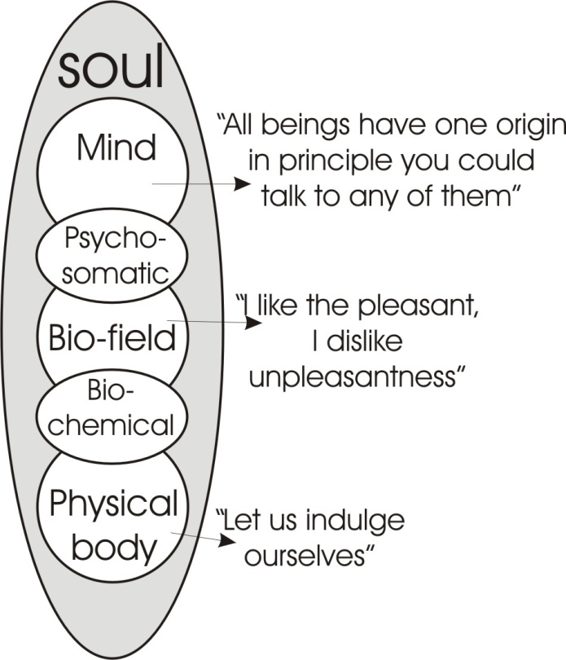
and all the cool, calculating, intellective forces of the head, and between these two are the affective processes. Now we saw how one circle is generated between two others.
So, between this lush, biological lover, the Ham force, and the Shem force of the heart, we have a zone here of which the highest point is the solar plexus and the lower point is the navel, and in the whole of this zone we have forces influencing the affective life from below, and from above, the forces of reason, of intellect, influencing that feeling life ... from above.
Now from below we say, Let us indulge ourselves”.
The feeling life says quite simply, I like it when it's pleasant, I dislike it when it's unpleasant, and I will only do those things that are pleasant. So I will talk to those people that give me a feeling of comfort and ease, and so on.” [55:18]
And the upper part says, reasonably, All these beings have one origin, and therefore, in principle, you could talk to any of them. And as comfort and pleasure are only part of the possibilities in manifestation, the upper part of your feeling-self responds to your reason, and allows you to talk to somebody you don’t like.
And when you deliberately talk to somebody you don’t like...
...and the more varied his field is compared with yours....
...the more information you get that you didn’t know before....
...the more you expose yourself to the opposition....
...the wiser, the more positive you become.
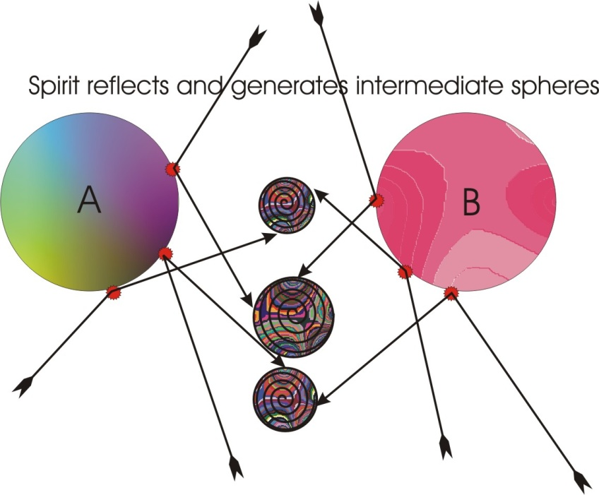
So that in actually relating yourself to these beings who are 'beneath your dignity' — if you are a Japhetic being — you learn how to play relatively passable jazz.
And in the same way, by not being too arrogant — which is a natural tendency of these [Hamitic] beings — and daring to relate themselves to the big white chief, they can learn how to make a nuclear bomb. And by swapping information like this, gradually there evolves a man who can do anything. The object of evolution is the creation of a being which is a zone of sentient power which, instead of being infinite — that is non-determined, non-reflexive — is actually a being with a sense of its own existence, plus the awareness of its free source and the formal products of all its experience adding up to its wisdom.
Now because no two of this beings can actually have identical experiences, because spirit is centring on a particle of matter there and on another particle of matter here and this one is aggregating round it a different pattern from this [other] other. Therefore every body is unique. Even two ball-bearings manufactured with the best skill we’ve got, even two ball-bearings are unique. If you test two ball-bearings for electrical resistance you'll find they differ. Even when we are trying to make them identical, we can’t do it. And in nature they don’t even try to be identical.
So all the materials of the universe in their complex relationships produce unique forms, with unique stresses and strains — within the planetary system, the solar system and the sidereal system — so that no two points of space are in the same stress/strain function. And therefore no two bodies are. And therefore when spirit reflects and generates the intermediary spheres, when it does those, it always makes a unique being. And therefore the unique being that it's finally made is a product of spirit and a point of reference.

The Doctrine of The Elect.
Now there is a very funny doctrine in most religions: the doctrine of The Elect. The Calvinists have taken this in one direction and said that certain beings are destined for salvation before they start. And even if they behave badly they are saved. Some other beings are not destined for salvation, and even if they behave well they are not saved.
Now, we've said assert a pair of opposites — if you can find a pair of opposites to assert — because the assertion of opposites is the same thing as freedom. [59:08]

The Infinite Field

Now let’s consider for a moment the infinity of the field. We are now going to examine whether it is really true that these beings started off equal, whether there is in fact an absolute identity of all the races of mankind, simply because they have an origin which is identical in spirit.
We have said that the essential characteristic of spirit is motion. And we have said that it is infinite. Now, because it is infinite, the motion characteristics of the infinite must include an infinity of patterns. Now this is a very important thing. Therefore if I draw a square in one place, and a triangle in another place, and a circle in another place, when I have done this, I have merely superstressed so that it can be made visible ... a fact of the infinite motion.
Namely that because it is infinite, it contains an infinity of possibilities there vibrating in the infinite. This means that there are square beings and triangular beings and circular beings within the infinite, before creation.
This means to say, if we like to draw the whole mesh — you see if I go like this [drawing on the white paper] — I will produce a certain kind of complex being here, and I could produce the same kind of being here except for one thing.
My diagram is static — but the infinite is dynamic.
And unless we had in the two motions, a third motion to compelled them into equality, we have no ground whatever for assuming them to be equal, and every ground for assuming that they are not. We have to have a co-ordinator to keep these two patterns exactly identical ... and that would be a third.
So if we examine the motions of an infinite field, and see that these motions are infinite and they contain an infinity of patterns — each pattern being unique before creation — then as soon as we start saying, All right, any centre is a point of condensation for spirit:—
If it condenses in this place there will be a circle.
If it condenses in this place there will be a triangle.
If it condenses in this place there will be a square,
because these places, with their own unique vibrational characters, are in the eternal. Now, this is the origin of the doctrine of the election of grace.
Because this one is eternally a square, and if there be a condensation upon it, it will create for itself a little material square being, which the free force will hit upon, and create for itself the original square. Now this original square is the psyche of this being before the material creation. But the material condensation of that is what that being needs in order to become reflexively aware of what it is within the eternal.
So any being within the eternal is willing to condense itself upon the centre to generate its own form. So eternal square beings condense to make squares, eternal triangular beings make triangles, eternal circular beings make circles. But each one has its virtue. And in the Absolute this one could shout, I'm a square, and this, I am a triangle, and this would say, I'm a circle.

Society
Supposing that we now put them in a social context in their condensed form. We now have a circle and a triangle and a square. Now, condensed in this time world of matter, they exhibit strange virtues:
This triangular one says I have got a nice base, you see, and because I've got less above this base, I have stability.
And this round one will say, Well, I can roll along.
And this square one could say, I could get together with a lot more and pile them up and make a big building. If he's very clever he can start piling them all over the joints, you know, and using half bricks.
The essential thing is to see that the formal differences between individuals on earth are eternal differences condensed and made objective, and that in the eternal they can all shout out whatever shape they are and it doesn’t matter. It is not materialised. But in the material world it is a fact ... that they have different functions. And within a social context we can arrange, them within a certain type of society, in a hierarchy of importances. [1:04:19]
I can say that for the bricks of society, I want beings that are relatively immobile. I want beings like in the Gospel of Barnabas. He says, Square stones are better than round stones, so if any of you beings feel like being round beings — that is, independent, self-contained, rolling stone beings — please do not be so within this early Christian church which I am trying to build. I want only squares.
So he built himself out of the squares. You stay there. You won’t roll about.
And then the triangular beings said, We have stability within ourselves. They said, well we don’t want to sit on top of the square beings like this, because then we are conditioned by the square beings below.
And the round beings said, We want to roll about.
So the triangular beings moved up and said, Well, you come in between us, and you can roll about as much as you like. You can mediate us.
Now symbolically, the triangular beings are beings which are more concerned with energy, and say they like running about, they like doing things, they like initiating things. They like changing things.
The round beings are those who like routine processes. They actually like it. They like to keep the books. They were the original clerks in the monasteries that manifest as clergymen today. And there are actually beings that like to be the solid square supports ... the real foundation of society. This is a genuine psychological characteristic in each person. If they are perfectly honest, some beings like routine clerical work.

 | Triangular beings  (nervous energy)  fire signs | Beings that are more concerned with energy. They like running about. They like doing things. They like initiating things. They like changing things.
 | Round beings  (intellective life)  air signs | Like routine processes. They actually like it. They like to keep the books. They were the original clerks in the monasteries that manifest as clergymen today. There are actually beings that like to be the solid square supports that are the real foundation of society. This is a genuine psychological characteristic in this person. If they are perfectly honest, some beings like routine clerical work.
( | Crescent beings  (feeling life)  water signs | Not put within the social system as such because it represents the artists, the musicians, the actors and so on who don’t want to be solid reliable beings and certainly hate routine and have no initiative.
 | Square beings  (physical body)  earth signs | Solidly reliable material beings.

Some beings like to be solidly reliable material beings. Some beings like to rush about and look for what wants changing, to initiate things.
Now, there’s another kind of being here that belongs in the bio-field and is ordinarily represented with a crescent ... the symbol of the moon and therefore of the water. And it is not put within the social system as such because it represents the artists, the musicians, the actors, and so on, who don't want to be solid reliable beings, who certainly hater routine and have no initiative. They say, We’d rather play about with pleasant things. They constitute a very large body of what you might call the mediocre and upper-mediocre artists of all kinds who would just pursue this pleasure force very nicely. And they have really no social function at all. But because they exist, then a certain utility, they have forced society to employ them at certain points. And they will become commercial artists like many of the great Italians of the renaissance were commercial artists employed by the church. Of themselves they are pleasure beings. [1:07:22]

The Four-fold Man
Now you might have noticed that really we're talking about the signs of the Zodiac. The earth sign, the water sign, the air sign and the fire sign.
Now there is our four-fold man again.
The square is your physical body.
The crescent is the fluids of your body and your feeling life.
The circle is your definitional inner-circle life ... the intellective life.
And the triangle is your nervous energy life.
And you notice the whole thing looks remarkably unstable as a structure, which means you’d better keep your eyes open otherwise you will fall apart.
So that it is really significant, and valuably so, to have such an image of a being:

1. To see that your solid body is certainly a good foundation.
2. Your pleasure life — mmm? — is a bit rocky.
3. Your intellective life goes round and round within the pleasure life.
4. And your spiritual life is balanced very precariously on the top of your intellective life.

And again we have the same process. You can either go upwards from the physical body, or downwards from the spiritual body to the physical one. but if you miss out any of these phases, so that you are unaware of just: —
What it means to be a physical being,
What it means to be a pleasure loving biological being,
What it means to be a purely intellective being ... like a well-educated German is,
Or what it means to be an energist who literally is not at all happy unless he's changing the face of the globe in some way or another.
Actually to train oneself in this is quite a good thing. You say, What Good is Opposition?
The answer is it makes you more aware of your own being and carries you progressively up towards freedom. We start as free spirit.

1. We become physical bodies first.
2. Then we become bodies with minds.
3. Between the mind and the body evolves the biosphere,
the sphere of life-forces, liking and disliking.
4. Between the mind and the spirit evolves the soul
within which comes the pure logos reasoning process.

When we have these processes all made conscious, then we are a free, self-determining being, and we have comprehended the meaning of the opposition. And whether we are an individual or a group or a nation, if we do not deliberately pursue the opposition that we need —and this is for every individual to decide what particular opposition he does need with perfect honesty — if we don't do it we cannot become what we are.

If We Don’t Become What We Eternally Were, We Can Never Be Happy.

The pursuit through time of the eternality of being which we were before we entered time, is directed by what we call divine dissatisfaction — which is simply really, disappointment with one’s own performance to date — until you reach the point of total awareness throughout the seven planes of being. And when this total awareness exists, then you do not need the gross-material body. [1:10:44]
You don’t need a body of inertia, because now you have the spirit, the soul, and the mind, as a force which has made itself solo — that is, unified itself — and given itself an evaluation process, a mentation process. And now it exists as a perfectly self-determined field of consciousness with no inertia whatever. Which means that it can do anything whatever that it cares to conceive within itself. The physical body is now done away with, and the body that we have is a body of power, absolutely self-determined and in no sense under a law.

It creates its law.

It is of its law.

But it is not under the law of the gross material world.

~~~~~ End ~~~~~

(Sthula sharira — physical body, conceived as consisting of five elements).
Romans 8:22 For we know that the whole creation groaneth and travaileth in pain together until now.

