Original Sin
Transcribed by J. Bailey (September 2001)
With diagrams and arbitrary headings by J. Bailey
Square brackets [ ] house the transcriber’s notes.
The Drawings on Page 5 were psyched by Eugene.
He said that in the case of Adam and Eve, one side of each face refused to be drawn.

Contents
Original Sin Error! Bookmark not defined.
Original Sin 1
Choice 2
The Last Adam 2
Cain and Abel 2
The Birth of Guilt 2
Sons of God and sons of men. 2
Choice 2
Man 2
Man and Human 2
Good and Evil 2
The Last Adam – Collapsing back into Unity 2
Planetary Influence 2
Good and Evil (pleasure/pain) 2
Mythological Cycles 2

~~~~~~~~~~~~~~

[Eugene begins by reading questions presented to him.]

A man has the possibility of allowing spirit to act through him, of becoming reflexively self-conscious. But has a particular man or woman actually the choice of this, or is it predestined which one will achieve this? It would seem accidental that certain people find a mode of teaching that has practical possibilities and is not the usual romantic delusion.

Why are we here rather than somewhere else, is a shortened version of this [laughter from the audience]. Have we made this choice or was it decided that we should do so?
Has, say, a planet the same choice? Could it move out of orbit to become free by an act of will, or is man the only being in the universe with the possibility of self-reflexive consciousness and choice. We are now calling ourself choice Watson. [Joyce Watson, Roy Watson had a wife and a ‘lady’ both called Joyce, Halliday always reckoned that they were his two J/choices]
But the statement here is A man, and A is sometimes said to be short for any man ... has the possibility of allowing spirit to act through him. This is unconsciously dualistic. The idea that a man can allow spirit, suggests that the man is not spirit. Whereas if man is not spirit, and spirit is the initiating power, the man who is not spirit cannot allow anything ... he can only suffer. So when it says a man has the possibility of allowing spirit to act through him, we have this unconscious dualism.
And really if you remember the Gospel — of Genesis, in particular — God breathed his spirit into man and man became a living soul. Not man got a soul separate from man. Man became a living soul ... through the influx of spirit. This spirit is initiative. It is this initiative which makes man active.
Now the question of whether a particular man or woman actually has a choice or is predestined.
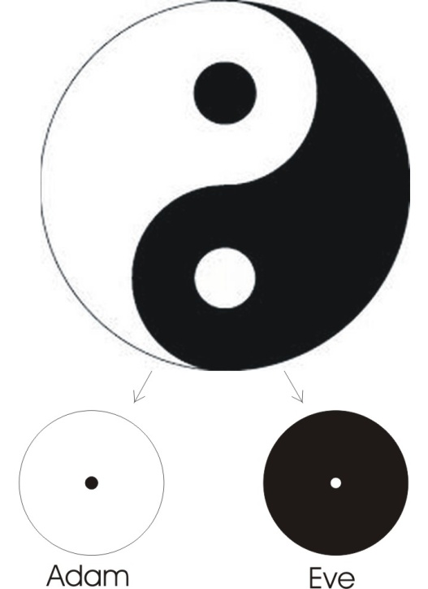
Let’s draw a diagram of the original sin of Adam. First we’ll draw Adam. Adam before Eve was taken out. On the sinister side of this cartouche we’ll place the dark, or Eve, and on the other side, the light side, we’ll place the Adam. And the original sin — sin meaning ‘missing the mark’ — is that internal decision — or lack of it — in Adam, which made it necessary to separate the Eve out of him. Eve, Khavah, meaning developmental power. Adam as hermaphrodite, male-female, was in a state of balance. He did not have to do anything, and he did not have not to do anything. He was an equilibrated, balanced being, and he could have disturbed his own balance, because he had spirit in him. [3:29]
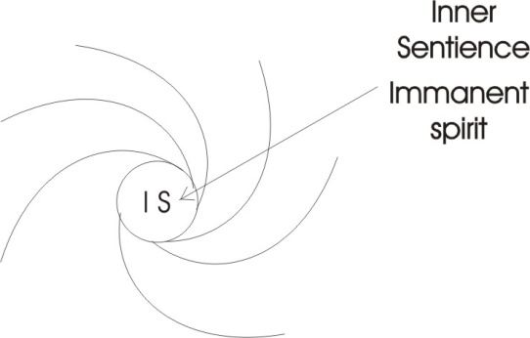
Now, remember that when a force rotates it can’t go to a dead centre, and therefore there is always immanent spirit inside. So we will have to draw a circle in the middle, and put the immanent spirit. By a strange coincidence we have got the ‘I’ on the Adam side and the serpent [S] on the Eve side.We have to see that this inner spirit is the initiating spirit, and could produce any kind of disturbance inside itself ... if it so willed. But there is nothing to constrain it to do so. Therefore, whether it does so or not depends entirely on itself. It did not do so. And when it was found that it did not do so, then the transcendent spirit that runs straight through all finites whatever, said, It is not good for man to be all one, or alone. Namely, the man is not developing ... he could have done but he wasn’t. So the transcendent spirit going through it, said, he needs a little assistance, and paraded for him in the form of external stimuli, symbolic of all the animals — and the animals are sub-human desires, forces below the level of the rational — these are all paraded before him and stimulated him. But these did not have the power to make him orientate his will towards them. So then it was decided to rib him, or take out the principle [B] of differentiation [R] from him, and separate it into a separate body. And the human beings became two beings. [05:28]
Now, at this moment, as soon as the separation had been effected, a stimulus hitting the Eve half has no rationality in it to stop it reacting. So it immediately responds to the stimulus. If the stimulus is painful it moves away, like an amoeba. If it is pleasant, it will move towards it. And as soon as it does so, then other half of it — which contains the formal, rational equivalent — being itself aware of its halfness, of its incompleteness, tends to move towards and to receive from the negative half, the stimulus, mediately.
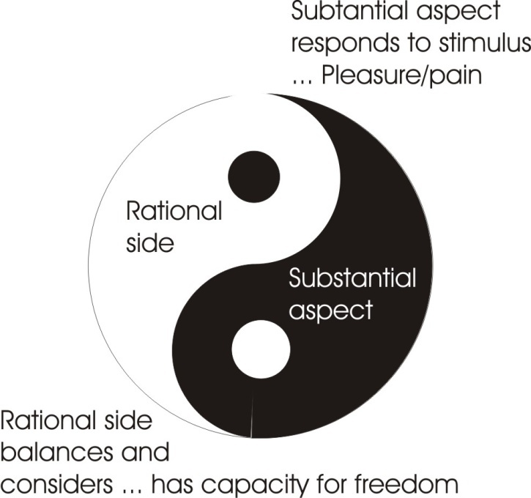
So the stimulus, the serpent, hitting the passive half of the being, causes it to react. This reaction is then referred to the rational part. And if it is pleasurable, as the passive part responds to the pleasure stimulus there will be a formal presentation, and the rational part will say, That is alright, it’s not painful. So we will get an acting through the female onto the male. The nature stimulus, represented by the serpent, acts on the substantial side of our being, and feeds through into the rational. [07:10]

Choice
And when we talk about choice we are talking about the power to take one pattern of action rather than another ... the power to take one and reject one. When we come to consider the nature of a particular man, we have to consider the nature of all men, by positing this human egg from which all derive. The first error of this human egg, this Adamic being, is to allow itself to be split, and then having allowed itself to be split, the rest follows. As soon as it has divorced its substantial aspect from its rational aspect, the substantial aspect begins to respond to stimuli.
Now, it’s apparent that the power to take and to reject in the passive half, is conditioned by pleasure/pain. When the stimulus is painful, then the tendency will be to move away from it ... and when it is pleasurable to move towards it. You could say there’s no choice in that, only if you said that the being necessarily moves away from the painful and necessarily moves towards the pleasure. But we didn’t say necessarily, we said tends to. It is inclined but it is not necessarily so, because an accumulation of painful situations can invert themselves, and an accumulation of pleasure stimuli can invert themselves and become pain. So there’s no absolute necessity about it ... but there is a tendency.
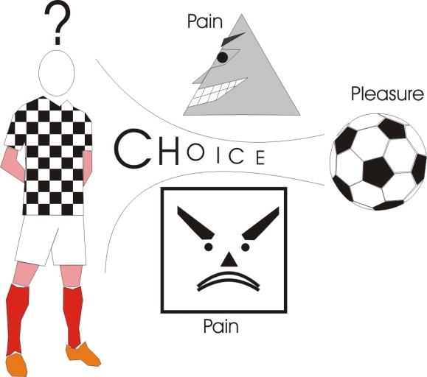
Now as long as the being is subjected to this tendency to respond, we will say that its choice is, for practical purposes, non-existent. Then the other side — which is the rational side, and can balance the various stimuli and consider them — has a greater capacity for freedom, because it stores up all the formal evidences of the stimulus situations in which the substantial half found itself. [09:32]
If it was discovered that the triangle produced a pain, and the square produced pain and the circle produced a pleasure, then if a complex situation were presented with a square, a triangle and a circle in it, we would find that we have two pains to one pleasure. But supposing there were no other pleasure in the world other than this one, and yet there is a pursuit of the pleasure ... but there is only one pleasure and there are two pains. Because of that pleasure, this being has the power to push itself towards the pleasure even though the pleasure is in the presence of two pains. So that there is an element of choice there and it depends upon this initiative side of the being.
And remember, every human being has both these aspects inside, and the so-called male is stressed on the initiative and idea, and the so-called female is stressed on the feeling and urge side. But every human being has both.
There is the original man. He has a capacity for formal juggling with the mnemic records of situational stimuli, and with the aid of these he can modify the reaction to an external stimulus of his substance. If I put my finger into a flame I can actually feel my finger not liking it. I can feel my finger trying to get out of it, but I have got the power to keep it in it ... because I can set myself a concept. I could say that in a certain situation it might be necessary for me to save my life by putting my finger into a flame because the flame might be round a rather an important thing, like the key to the front door which I forgot to pick out before the flame came up. If the pain situation has a key to life in it, I can force myself to endure the pain to get the key, and this is the basis of my choice.[11:42]
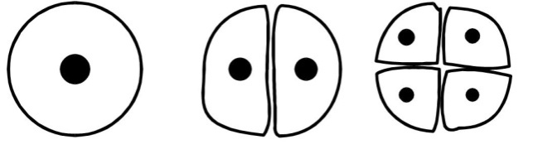
Now, when the human race begins to appear, it is simply an egg splitting itself and developing. Each one of these divides itself. We take again the whole egg, we divide it down the middle: that’s two beings. We divide it across and that’s four beings. And we go on doing this. This is the process that happens in every individual egg, and it is the actual process that has happened in the whole human race.
Now, if you take any cell — with a nucleus in it — out of your body, you have actually got a complete record of all the genetic factors of the line from which you are descended. Every single cell with a nucleus in it, in your body, has a complete genetic record. And therefore, if we take any one of these cells out, and treat it properly, it will grow into a human being. So when we consider the generation of the human race out of the Adamic line: we start with the Prime Egg. We split it into two and then it goes on splitting and multiplying.
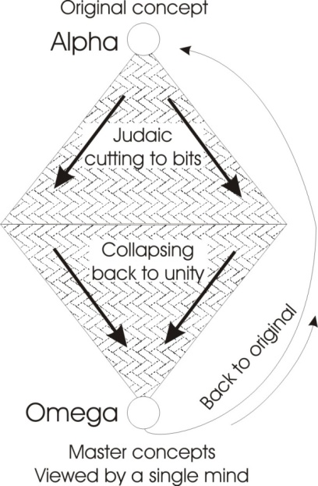
Now you can see that the original marriage must have been of two halves. Adam married Eve. After this their sons might have married mother until there were some daughters, and then they would have married the daughters. They would have married their own sisters. So we know that the human race begins in an incestuous relationship of the closest type. And if it were not so there could be no multiplication. But when the numbers have sufficiently multiplied, it appears to us, if they go into different countries, that there is a kind of marriage outside the family, but it isn’t really true. [13:31]

The Last Adam
When we start running these people back together again we are really restating earlier protoplasmic conditions in the human line. If we married them all together we would restate the original Adamic line, the original egg ... plus the experiential record of all the stages through it.
This is the concept of the Messiah: that when a sufficient number of inter-marriages have occurred after a wide experience, these are telescoped together again, and the last Adam appears. This is a title of Christ as the product of a line of people breeding together very carefully in order to produce a being who shall be able to solve the problem that Adam did not solve ... namely the problem of how to disturb your own equilibrium, and act from inside yourself instead of waiting for an external stimulus. [14:31]

Cain and Abel
Now at each level we see that the original sin — or missing the mark — of Adam, is carried in to the next generation. There’s Adam, Eve, Cain, Abel. Now, these two [Cain and Abel] are educated by somebody already deficient in initiative. Adam has already failed and had to be parted from himself, and made subject to the external stimulus situation. His son, therefore, is not going to get the correct education. It must be deficient in at least one respect ... namely, how to gain inner initiative. So that Cain murders Abel because he hasn’t really been educated properly by his father about the correct relation with the original spirit, or God. Adam disobeys God’s command and chooses to know good and evil, when he had been told not to. Having done so, he has himself a wrong relation with spirit ... which is initiative. So that when his sons Cain and Abel appear, then they’re going to be educated by a person already out of relation with spirit, out of relation with his own original initiative centre. Lacking through initiative, the children are going to have an experiential, empirical education.
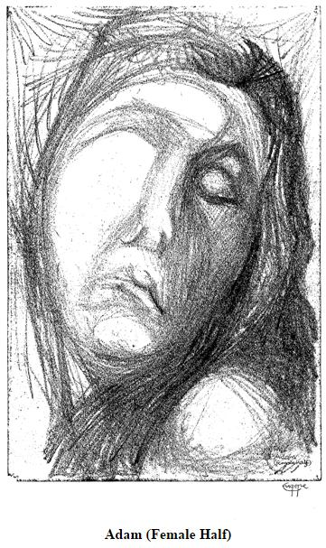
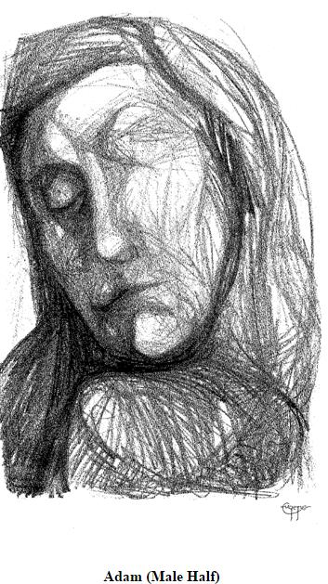
Now this fellow Cain is an empiricist. He depends on an external stimulus, so he is called a digger in the ground. He’s a kind of materalistic scientist. He’s going to go to the earth for his stimuli. Consequently, when by the law of the inequality of finites he has a brother, the brother must be different. So if Cain digs in the ground, Abel won’t. Because you don’t want everybody digging in the ground at the same time ... there are other things to do.
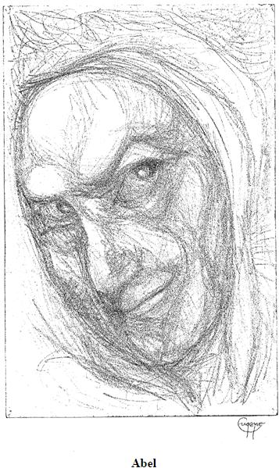
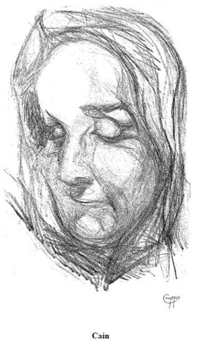
So there is herding for Abel to do. And herding is a very funny kind of occupation. It doesn’t require you to have hard, sharp tools to prod the passive earth and bang the secrets out of it. It requires you to have a certain care for the flocks. And therefore it breeds a consciousness of protectiveness. And therefore it refers the Abel consciousness back to the Father and the God. So because the occupation of Abel is minding sheep, his mind starts minding, taking care of things. He feels that he is taking care of sheep, and therefore as he knows he is only young, then some one is taking care of him.
Now he refers to father Adam and discovers that Adam is not taking care so well as he might. But he knows that somebody is taking care, and he knows that his father is generated, therefore there was a father of the father. So he believes that God exists as a caretaker, because he is a shepherd himself, and he knows he didn’t start it. Somebody started it. The Yogis have the same proof of the existence of God, because all Yogis have been taught by other Yogis backward, so there must have been a first Yogi. This first Yogi must have been God, because no finite particular man could teach himself. [18:17]
So in the same way, this Abel consciousness believes in God the Father. Therefore, when he makes a sacrifice to God the Father, his sacrifice is more acceptable than that of the empirical earth scientist ... or Cain. And because Cain is already extroverted and empirical, when he observes that the flocks of Abel are increasing quicker, and showing a more handsome profit than digging in the ground — which has actually been cursed or made relatively barren because of the error of Adam — the stimulus situation hitting Cain says, there is favouritism, we are both working very hard, but sheep are paying better than digging. So he becomes very annoyed. The stimulus energy goes in, upsets his balance, enrages him, and as in all such cases he strikes against the object that initiated this unpleasant feeling ... which happens to be Abel. So he kills him.
We now have a dead Abel whose spiritual blood goes back. Now it comes back again by cyclic law into the earth, and it starts crying out. That is to say, every dead person whose business on earth is unfinished, is trying to involve itself back in the protoplasmic line. Abel’s spirit was Adam’s spirit. The same animating spirit in the protoplasm of Adam, at the death of Abel returned into the Adam and complains about his early death. [20:00]

The Birth of Guilt
Now Cain’s protoplasm is Adam’s protoplasm, and they both resonate in the same way, and their affinities cause the spirit of Adam involving back into the spirit of Abel, back into Adam, to appear in Cain as conscience. Cain now feels guilty, because in actual fact the same protoplasm has had a fight with itself and murdered a portion of itself. So that Cain, when he had become an empiricist like his father, and his mother Eve, particularly like his mother, has exposed himself to the stimulus situation, has become a murderer, and has given birth to this guilt of killing on himself.
Now, the generation is going to come through the Cain until Eve gets another child.
The old Jewish patriarchs often didn’t think it worth mentioning girl children at all. So if you read Genesis you won’t find out the girls whom Cain and Abel married, because they were not of much account. But the fact was that there were some other children. And these children of Adam and Eve, the sisters of Cain and Abel, were married by Cain, and his children were generated out of this relation. But each child was born with the original determination of Adam to know good and evil — contrary to orders — and the guilt of Cain in murdering his brother, and the resonating demand for vengeance of Abel through the substance of those beings. [21:42]
We have to consider this, because we are considering whether a particular, any particular man, has choice in the problem raised.

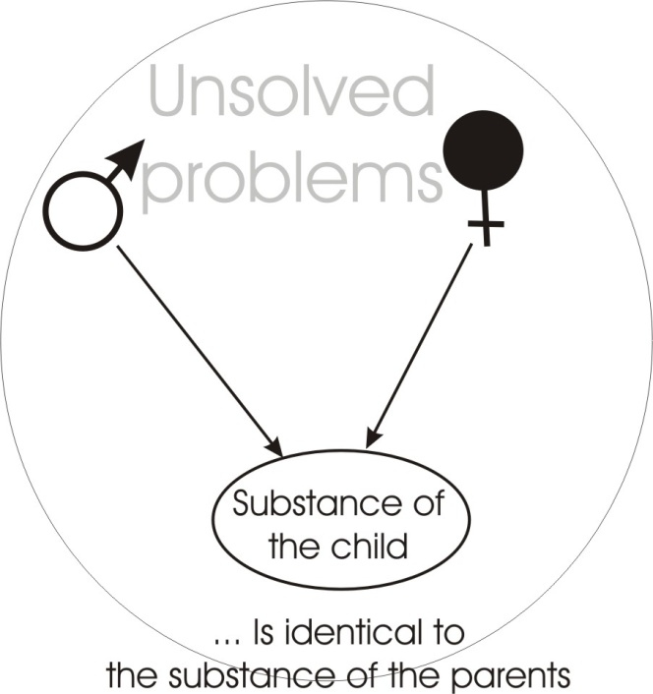
Sons of God and sons of men.
Every line out of Cain feels guilty of murder, because the actual protoplasm of Cain is parted and becomes children. A child is not other than a portion of the actual protoplasm of its parents. So it isn’t somebody else. And this is very important. The child faced with a certain decision is not a child cut off from its parents and their problems. It is the identical protoplasm, with the problem of the parents involved in that. And the parents’ problem is reappearing in the children, because the children are the protoplasm of the parents projected forward in time.
Now after a time it says that another son was given to Eve to make up for Abel. And this son, a nice fellow, had the consciousness that Abel had, of God the Father. And he generated a line, and all the children out of this line — also the product of an early incestuous relationship — because they had had this Abel consciousness are called in the Bible the Sons of God, or sometimes the sons of one man ... the unity principle as opposed to the plurality principle of Cain. Cain is an empiricist and an analyst. Abel sees everything together as somehow harmoniously bound in the same destiny. Cain is a separatist. [23:32]
Shakespeare says on one occasion, As I live by FOO-D I met a FOO-L in the forest. He makes this pun, As I live by this, so I met one of those. Now the person who says it in this particular play, is a figure of the devil. He lives by FOO which is POO, which is power ... plus D. In other words he lives by the analysis of power. But the FOOL, to the analyst, is a man who ties it all together and will insist on treating it as somehow not divided. So the analytical mind will always say to the non-analytical mind, you are a FOOL, because ‘L’ means to link, to tie together. You are pretending differences do not exist, but I can see them.’
♦ So we say that the sons of God on this side are really ‘L’ men. They’re the tying men. The men that are going to make the religious concepts that will bind people together.
♦ And on the other side are the D men ... or devilish men.
Now the analytical men go on dividing the universe up, and discovering all the particular secrets and getting to know more and more about less and less. And on the other side they know less and less about more and more ... which shows you the different evolution of science and religion. [25:09]
The fact is, that at each level a particular problem is presented, and then a portion of the protoplasm is separated out and becomes a child in the next generation, and the unsolved problem of the parents builds the environment into which the child is precipitated.
Now how much choice have we got?
We’ve always got this amount of choice: we like it, and we don’t like it. And looking at we like it and we don’t like it, plus our experience, we can say, sometimes pleasure leads to pain; sometimes pain leads to pleasure. So let’s balance them very, very carefully, and don’t be determined by either, separately. But balance the pleasure/pain and then feel for the correct action in that moment. When this is done, then you have choice. [26:21] [Here he mumbles about Joyce and having to cut that bit out, it’s a simple sound shift actually, the tongue is widely spread there, and this is hard voiced and this one isn’t’]
If we now look at this fact, any given human being today comes from two parents, and so on, backwards. All the problems of the parents which are unresolved leave an environment, and throw into that environment a portion of their protoplasm. So the environment is precipitated by the ancestors. The city of living has been built by somebody who was born before you. And the protoplasm that is now occupying that environment is some of the original protoplasm that is now suffering the consequences of the decisions made by the parent body. It is not other than. So there’s no injustice. It is the very tissue, now suffering the situation, that built the situation in the first place. This is a very important point, and it helps to remove resentment against parents, and explains why Kierkegaard said, As against the father the son is always in the wrong. As against the father, because it’s identical substance, and it’s silly to be your own enemy. [27:52]
The protoplasm that created the environment
is now the child of the parents who created it.

Choice
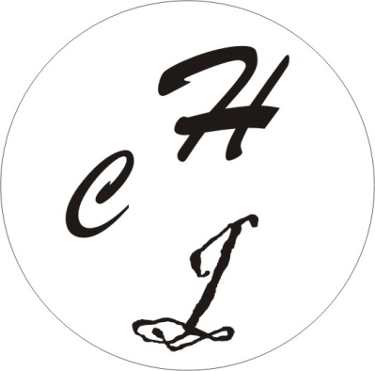
Now supposing we say that the end result up to any level of time — up to today, we’ll say — is that a certain body has inside itself C, H and J as its constituent reactive forms. Now, there’s a certain amount of pleasure on H, a certain amount on C, and a certain amount on J. But by the law of the inequality of finites, it can not have the same amount. And therefore if this being manages to keep quiet and allow these differences to express themselves internally, it will feel that one of them is more worthy than another.
Now supposing for a moment we have such a being, and it manages to quieten itself. It withdraws for a moment from the external stimulus situation, takes itself up into a garret, sits down and says, what do I really want? Now as soon as it is calm, the inherent differences of the three letters will manifest. When they do it will become quite apparent that it’s better to do one thing than another. Then a little bit of energy is released — very little is required — onto the sign that is going to be more profitable ... and then the whole process starts appearing in action.
But if a person is very confused — stays in the stimulus situation — it can only mean that some pleasure in the stimulus situation is holding it there ... unless we have a fascist government, when it might be somebody holding you there against your will. But assuming you’ve got no actual physical constraint by a naughty government, the thing that holds an individual in the environment is that there is still some pleasure to be got out of that environment. [29:44]
So if a person plays in a distracting environment, it’s because there is still some pleasure to be gained from it. And if he does play in it, then all the stimuli hitting him will cause a TURBA — as Boehme called it — it will then turbulate the whole being and the C and the H and the J will become very confused. We can not then actually see which one is the better. When you can’t see it you won’t know what to do. At one moment it might seem the H, the next the C and the next the J, and from moment to moment you vascillate in your purpose. And nevertheless, you have a certain amount of choice.
If you don’t like the confusion, there are two things you can do about it. You can do what Hamlet tried to do, take arms against a sea of troubles and by opposing end them, which leads to more trouble, or you can say, Well, I’ll just go and gather myself together and then decide calmly where is my best good. As soon as you have so decided it follows you will have a directive to go to a certain place: certain ideas will seem to you now more important. You have actually chosen these ideas. But you’ve chosen them clearly only when you were calm at the moment of choice. Whereas, if you were actually being turbulated by external stimuli, the close similarity between certain aspects of these Lak Chuh Juh, and so on, can confuse you and make you come to the wrong decision.
Now this point here … can a planet choose to leave its orbit? Let’s see whether a planet could choose to leave its orbit. [31:31]
Supposing we take the first case, a mass of incandescent gases. They are vibrating entities and…
[Indistinct recording]
… each one of those is a pleasure/pain point or a sentient power but, if we reduce it right down to a simple, and non-differentiate it, then choice is impossible for it outside. In other words, if we take the billiard ball and the cue hits it, the billiard ball cannot choose to refuse the cue. The cue is active and the ball is passive ... so the ball rolls. That’s because it hasn’t got sufficient organisation inside it — which is work, organisation means work done — there’s not been sufficient work done inside it for it to be able to catch the stimulus, and let it in and turn it round and then analyse it. The result is that the whole impact acts on the mass as if it were a simple. And being a simple it cannot have alternative courses of action. It must be passive to the stimulus.
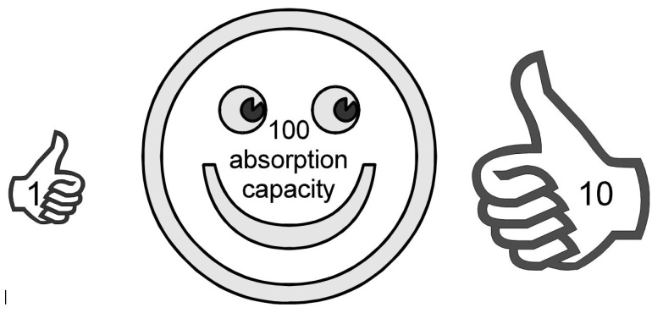
So if we now say that a planet in its solid state is something like a primary particle — namely, for practical purposes we can call it a simple — then a planet can not leave its orbit, because it cannot make the first step towards it. It cannot consider what it is like being out of orbit, and evaluate the pleasure-pain of out-of-orbit against in-orbit ... and therefore it cannot move. [33:24]
But when we come to a being with more parts than one, and inequality of stimuli hitting them — so we have a value of ten on there and a value of one on this side — then if the value of the incoming energy there is ten and on here one, and if the absorption capacity of the whole being is, say a hundred, then there would be more value in going towards ten than toward one.
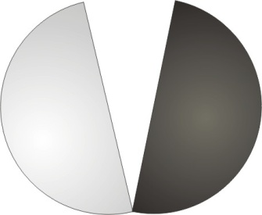
So if the being has two parts there is already a possibility of a double response. So if we made a billiard ball and half of it was ivory and the other half was steel, and we strike this thing very hard here with a cue, the response on the ivory side is different to the response on the metal side. And if we hit it very hard it will actually split it into two. And this kind of splitting into two is the same thing that we mean when we consider choice.
We [unclear words] take these words, and as soon as they go into the mind they split themselves according to their constituent parts. [34:44]

Man
When the question says, Is man the only being in the universe with the possibility of gaining reflexive self consciousness? ... then we can answer this question in two ways. We could say,
- If we confine our attention to the earth and consider that man is the being that we see walking about and we behave Cainishly — that is, empirically — we will have to say that it is the only being that man knows about and is defined by man as being supreme. It is a definition of man, by man about man. Therefore, naturally, it is supreme.
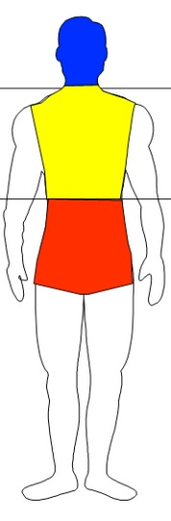
- But if we look at man in its proper significance, man means an evaluator, substance, activitous motion. If we say that any being is legitimately called man which is substantial, energised and moving, then obviously there are various types of man in the universe. There are simple men and complex men. When William Blake looked at a grain of sand, he said he didn’t see a grain of sand, he saw man. And some people thought he was a bit crazy because of this, because they thought that he had seen something shaped like that ... shaped like a man. And by man they meant something with a couple of arms and legs sticking out at various points. What he meant to say was, he had seen a substance, energy, moving there. He had seen a definite amount of sentient substance, which had swung in onto that point and concentrated itself. It was a man. But a billiard ball is a man in the same sense. But it is a very simple man.
If we take a congenital idiot boy, we can say he’s a man, because he has a kind of power of evaluating. He knows which school mistress he likes to be nursed with most, he knows which cake he likes best, and so on ... therefore he can evaluate. He is a substance, with an energy which moves in the substance, and this motion of the energy in the substance constitutes man. Therefore the congenital idiot boy is a man. Nevertheless, he’s not as good a man — from the point of view of empirical scientists — as, say, Hoyle or Lovell or somebody. He’s not sufficiently complicated in his responses to deal with certain astronomical problems ... nevertheless he is a man. [37:21]
So if we go right down the scale to the tiniest little precipitated entity, it is a man.

[Question from Khen Ratciffe] How does it evaluate as a grain of sand, if you define man as an evaluator how would we see that evaluating?
It responds differently to different stimuli.
[K.R.] It responds?
Yes. And that response itself is a product of sentient power there precipitated as a grain of sand. So although it can’t read Shakespeare, it can respond differently to different stimuli. If we take a grain of sand and we heat it in a certain way, we get a bit of glass don’t we? And if we kick it we might get something else, if we stroke it, something else, if we put it under great pressure something else. To each order of stimuli it will give a different response.
[K. R.] So really there’s no thing which could not be defined as man in this case…?
No. No thing whatever. Of course, this is a fundamental of Hindu Philosophy: that there is no absolutely inanimate matter ... because the Absolute is power sentience. So the tiniest thing, including the board [knocks the board] is sentient power, and therefore in its response — differentiated according to the nature of the stimulus — it is a man. The manipulation of the Djinn by the contemporary Arab Magicians is based on this fact ... that they are all men. They are sentient power, and you can talk to them. And if you know their language, you can hit them with the appropriate sonic stimulus that will cause them to respond in the way you want them to. This is the basis of mantra magic. The fact is that they do emit certain sounds. You know that they emit certain rays of light, and that by studying the rays of light and their position in the spectrum you can say what chemical it is. So if they have a visible spectrum, they also have an audio spectrum. They will emit certain kinds of sounds. In fact they are vibrating ... and received by the appropriate sensory organ of hearing, they can be heard. [39:43]
[Break in recording]
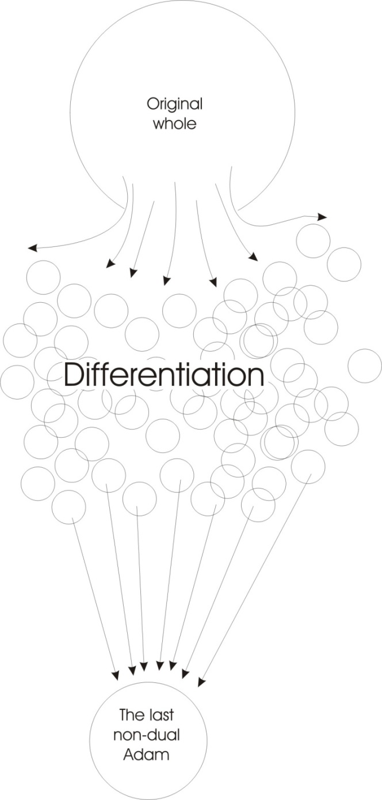
…and what they are reciting is their own name. So if you know their name you can conjure them because their name is their most favourite sound. And if their name is complicated — like a chemical compound — you can conjure by reciting the different parts. You actually do this with a man when you brain-wash him. He’s a complicated system, and through sound being primary in him he must respond to sound stimuli. And if you understand the imprinted form within him, then you can cause responses of a certain order by using only sonic stimuli. [40:19]

Man and Human
There are four other orders of stimuli at the sense level that you can also give him. The fact is that if we use the word man properly, then any point of evaluation is a man.
When we use the word Human we’ve taken two other things ... the glyph for spirit [H] and the glyph for go or prime urge [U]. A Human is a spirit [H] urging [U] evaluating [Man] being. So Human in that sense is higher than MAN. The anthropoid apes are so nearly man, and they can do so many operations, that apart from a greater amount of hair on them — and that’s not always true if you pick the right man — they are quite man-like. But HU-man means that there is an awareness of this spirit and that this spirit is the power operating in him. [41:18]
So we say that to be humane is really being something extra, something more than man. It means to have an awareness of the unity, of the solidity of all men. So humanity always feels warmer than mankind. Apart from the kind on the end of man, if you talk about man as one of the forms of life on earth, you don’t feel very warmly disposed towards to him. But if you say mankind, the kind makes you feel kindly disposed. But if you say humanity, already it feels warmer. And the whole association of the ‘H’ function in human, and the fact that everybody knows essentially and internally that spirit is initiative, and that spirit manifests at the alphabetical level as ‘H’, then there must be a pleasure about that letter. And therefore there will be this feeling. If you take the word HOME, and HUME, you will find that there is a peculiar sonic resonance in you which produces a certain feeling. Human is warmer than man. [42:36]
[break in recording]

Good and Evil
So when we examine again this possibility of choice, we will recap quite simply. Every existent human being on earth today is a bit of the protoplasm of the original human egg. The error of the original human egg was to choose to know good and evil, contrary to a command by spirit. Now Spirit commanded Adam not to choose good and evil because of the dialectical facts of spirit. To believe that there is good and there is evil and that these are severable, separatable completely, is to be a bad metaphysician. Therefore if you choose to see the world as good and evil and then reject the evil, you have turned yourself into a dualist. And you must then find yourself with a peculiar group of stimuli which you will call evil and you will have to account for their existence.
Now theologians have not managed to account for the existence of evil. It is still a problem ... the problem of evil, which philosophers and religious philosophers are concerned with, even today. Why is there evil? Spirit says, There isn’t any evil. If there is, then you are a dualist.
But nevertheless, some things exist that we don’t like. If we say that evil is the reverse of live then we can say, that is evil which causes us not to be alive. But then what do we mean by alive? Do we mean fixed in a given finite body, with a given education, a given set of clothes, a given address? If that’s to be alive, then it might be that we could show that evil is good. Because if we can show that evil means a division of the Absolute and the precipitation of finite separate beings, then good would be evil in a quite false sense. [44:48]
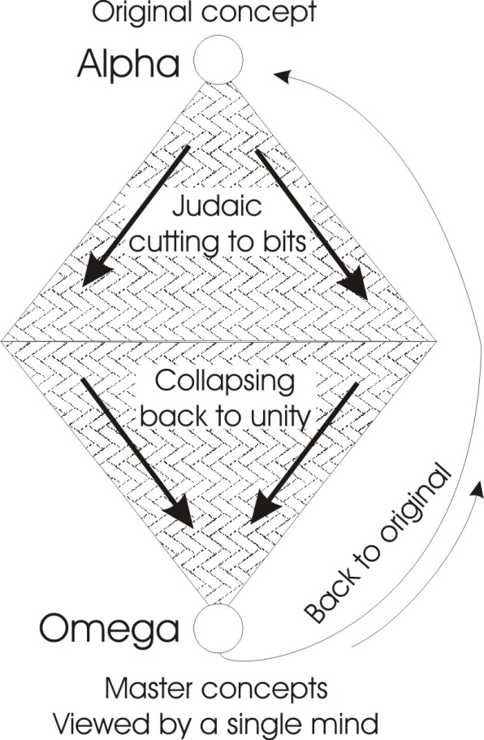
But if in fact the Absolute Power cannot sever itself, and that it is essentially always what it was — a non-dual Absolute Power Sentience — then any attempt to sever and pretend that there is a finite entity standing in its own right, and having no relation whatever with another finite entity, is false.
Now all the errors that have occurred historically, when man has related himself to the universe and to other men, have sprung quite simply out of this elementary error of Adam: dividing the Absolute non-different, pretending it is different and pretending that one half is good and the other half is bad — the good part is that which leads to pleasure, the bad part that which leads to pain — then try to get rid of the pain. And the mere fact that you have postulated something to get rid of causes all the troubles that arise. Because then you must protect your good with a wall. And then you must man this wall with archers, and they must continuously shoot every time they see an approaching stimulus, and try to kill it so that their good is not spoilt. That way the being becomes progressively made opaque in the very field where it thought it was good. And opacity is the same thing as immobility and immobility is the same thing as death. [46:21]
So the attempt to segregate the good is the first step towards death, towards immobility and finite block. And yet all these things come out of the fact that one original error was made, and that the original being who made it, the original human egg, having made that error and then the protoplasm splitting and becoming children, there was a progressive degeneration. Now, by degeneration we mean that the original wholeness being split, pluralisation occurred, and every succeeding generation differentiated itself out. So we have an expanding triangle going down. The thing is under the domination of Cain. It’s being analysed and broken up.

The Last Adam – Collapsing back into Unity
Yet there must be a term of this analytical process. And when the term is reached, then there must begin to occur in the next generation a collapsing of these analysed elements. And as this collapsing process begins, it comes gradually born into the consciousness of men that there is a term for the collapsing. And as all these diverse analysed elements collapse closer and closer together, it becomes apparent to men called prophets that at some crucial point all these elements that were analysed out in the fall, must be progressively brought together, and suddenly precipitate in the end result of the whole process ... the last Adam. [48:03]
Now it’s plain that that last Adam has appeared a couple of thousand years ago. The people called the Judaists today still think he hasn’t been. Nevertheless, factually there has occurred on earth some being who had enough reflexive self consciousness in him — that means power, internal form — to be able to oppose the whole structure of his day, and consciously invert it and force the rest of the world since then to consider the whole problem of this collapsing of the diverse back into a unity.
When St. Paul, carrying on this old process of diversifying and behaving like a Judaist and cutting everything to bits — when he was pursuing his analysis to destroy the Christian concept — his analysis went to the term. And he suddenly saw the absolute necessity of this process inverting itself. The descending triangle turns over, and the original human egg is necessarily at some point gathered together. Then he saw that this could occur economically far earlier than men thought it might do. Because all we need to do it, is a sufficient number of master concepts to be passed down through a series of generations, and these master concepts to be viewed by a single mind, and then all those concepts driven in to the original concept from which they derive. [49:52]
Now these master concepts are not so many as the rubbishy concepts that men can make. Now men are going on, long after the master concept has been objectified and incarnated. And they are going on multiplying rubbish and making up far bigger triangles. Every day, the average doctor will get a packet of literature from the various chemical houses, telling him what kind of new cures they’ve got for what new diseases they’ve invented. This is the multiplication of rubbish.
The multiplication of the master concepts occurred about two thousand years ago in its completion, and because of this fact, the whole zone of that time was vibrating. Every major civilisation of the time was expecting a Messiah, simply because the master concepts had been laid out over the world, and they were all resonating, and they were demanding the organism that could speak for them. And when there is such a demand, then suddenly there is precipitated out of all these resonances, the initial note from which they sprung. And that is the incarnation of the Christ. Then all these resonances appeared in him and he proceeds to take them all and project them forth. [51:24]
Now from that point we find another triangle coming in, and this is the triangle that Adam should have started and didn’t. So if we now say there was an Adam potentially able to come to the right decision — who was hidden in the Adam who didn’t — and has now been precipitated and incarnated out of the same protoplasm which has now come to the point of reversing the bad decision it made there, and therefore builds its true triangle from that point. So we find from the birth of Christ, a growth of individual responsibility, the overthrow of tribal inertias and so on, and the spreading out again, slowly through the centuries, of the master concepts made clear in the incarnation. And at that point the teaching is inserted that, every man can become a reflexively self-conscious being, can participate in this very principle of spirit — which is initiative — and has no necessity whatever to be dictated to by any external stimulus situation, because factually he has inside himself this last Adam ... who is also the first. [52:43]
We have the Alpha, the undetermined up there, and we have the Omega here. So we see that this question of whether any particular man has choice or not is fairly simple. We’ve always had the choice, to like and dislike. We’ve always had the possibility of evaluating likes and dislikes, and if we move in one direction rather than another, it’s quite simply because we prefer to move in that direction. We never stay in a crowded environment, if we are not constrained to do so by physical force, unless there’s still something there ... like a young boy staying late at the party because the girl he’s got his eye on hasn’t gone home yet. He doesn’t like anybody else, but he’s staying. Everybody’s drunk, the place smells, but he’s staying because the girl hasn’t gone yet. So he submits himself to tremendous pressures that he doesn’t like for the sake of the one bit that he does like. And it is really amazing how much pain and suffering a man can endure for very, very little pleasure. [53:54]
When he’s in such a stimulus situation, then he finds it extremely difficult to evaluate CH from J. But if he does really want to, there will be a movement in him, a tendency. So that as soon as he finds himself isolated, at home in bed, and he sees the difference, he will make for himself a resolution ... tomorrow it will be different. And after he’s made a sufficient number of such resolutions it will be different. But it won’t be different until he’s made a sufficient number. Because a definite number of Will impulses have gone in the other direction. And you cannot make a new direction, reverse an old direction, without putting into the new one exactly the same number of impulses ... plus one. [54:51]

Planetary Influence
[Question from the audience] Is this segment … the lower one starting from the Messianic figure, is this going to precipitate a multitude of points at the base of the triangle? I was wondering if you could equate that with the Zodiac. Saying the first position would be Aries, the second position Leo. And the next position Sagittarius.
Don’t let’s say that, shall we? Think that in private. Otherwise you might get all the other signs annoyed or something.
There’s something symbolic about that.
Luckily everybody’s got all the Zodiac inside them, and they can please themselves in which house they are reborn. Personally, I prefer the thirteenth point of the centre, because that’s where the arrow [Sagittarius] is supposed to be pointing. Did I say that?
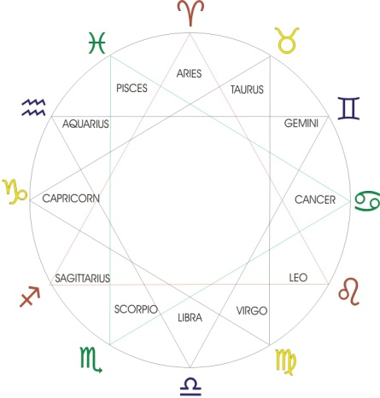
[The same questioner] In the question it said something about the planets. Well, astrology teaches or proposes that the planets have some effect upon a human being. And a planet is a very large mass compared with the human being and Plotinus’ teaching proposes that it must have some influence over the human being and thus accepts the idea that a planet is a very powerful being. You have suggested there I believe that the planet is instead a simply seen like a billiard ball. I this because one take the planets separately and not in their totallity possible solar?
Let us look at the generation of them. There’s the solar system, there’s the sun. The heat from the sun is diminishing towards the perimeter. Also, there are waves going across here, ripples being reflected back. Now, when this happens — you know perfectly well — wherever there’s a wave going a particular way and returning, there is a node. Now where those nodes occur there is a point of relative inaction. That is the point on which will drift other constituent motions, and will precipitate a
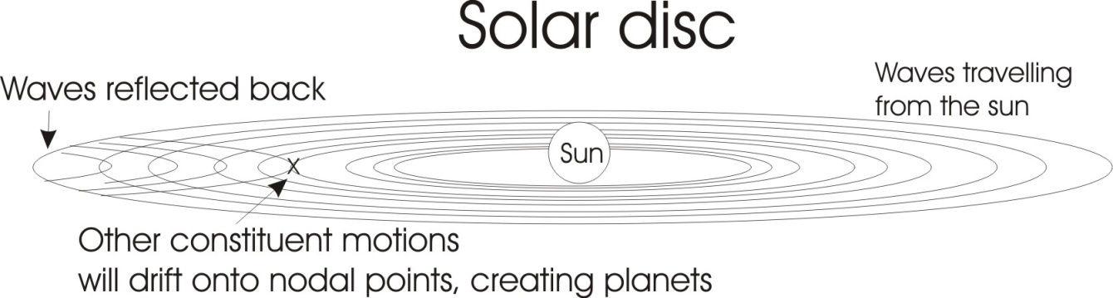
planet.

Now the visible planet in the sky is merely running around on one of these nodal bands. The real influence on the human being — say, on the earth — is all the constituent motions from all parts of the solar system. The particular nodal points are marked by planetary precipitations, and it isn’t the material body as such that is giving the influence, but the field that has precipitated that body that is giving the influence.
So when we come to consider the effects of these bodies, we know that no body at any distance can operate. There is no action at a distance. Always, action is where the action occurs. So if the whole solar system is vibrating and as a result of its vibrations is precipitating cosmic dust onto centres and making planets, then we have a state in which we have a disc vibrating and the relative forces acting at any distance from the centre are determined by the whole, not by the parts. And yet we have a measure in where the planet is up to, for the centre of activity of the field of a given order of vibrations. So the planet is really marking out where a centre of solar vibration is at any given moment. It’s the whole field that influences us, but the planets can actually tell us where the centre of agitation is at any given moment. [58:51]
So we really deal with a unifield and a solar unifield, here. Let us include the stars for a moment. And the whole condition of that solar disc — and by solar disc we do not mean the visible sun in the sky, we mean the whole system right up to the furthest orbit there is — it is within this that we are concerned with the so called solar influences, which are called planetary influences ... only by focusing on planets as markers of centres of agitation.
We can actually do this — I’ve actually got one at home — we can make a solar system come into being by simply vibrating a board in a certain manner. And then all the powder on the board builds itself up into little planetary structures, and then they begin to run round the board. And the actual vibrations of the board cannot be seen, but the board can be seen vibrating. And where the powder on the board precipitates, there it forms a planet out of this dust. But it is not the dust that’s making the influence, but the whole vibrating field. And nevertheless, that particle, precipitation, tells us where the centre of the vibration is at any given moment.
So a man is inferior to that system?
He is in-ferior literally because he’s internal to it. The in-ferior is in in-varying but this does not mean that he cannot control it, he is in the process of learning how. [1:00:34]
But the substantial aspect of those planets is simple ... the substantial aspect of man’s field is complex. And yet it would seem in the heirarchical order that the planets must be superior to man.
At any given moment of time the planet-man relation must be with one or other dominant. A planet may be influencing a man, and we might suddenly devise a mode of getting to that planet and completely destroying it, and dispersing all its dust all over the universe. We then influence it. It is entirely a question of how far we are in the evolutionary scale. There is a fight going on between these simples, these elemental forces ... and the complex one called man.
As man gains more and more complexities within himself, he gains more and more information from outside structures, and in so doing he gains the possibility of determining the influences that previously determined him.
There’s nothing to stop us flying to the moon fairly quickly now, putting a tremendous number of hydrogen bombs on it at one particular point and when it’s at its furthest part from the earth, firing them off and shunting it out of orbit. This would immediately alter the tides on earth. These things will be child’s play in a few years. So that although man has been dominated by the planets, he doesn’t have to remain so. [1:02:12]
When Christ appeared, he made the first statement about that for individual man. Prior to Him the Adamic error was disposing everybody, and this complete subordination to traditional paths had paralysed individuals. But the continuous paralysis spreading out like this had reached a point of complete analysis, and at that point there is a necessity for the collapse and a new synthesis ... and that occurred.
And from that moment he now says,
You have no excuse further to blame your ancestors for your position. You must individually act from your own individual centres. You must find out the error that Adam committed and undo it in yourselves. Is it not written ‘Ye are Gods’.
He says men are gods, if they knew it — therefore BE it. Don’t act like animals and be subordinate to mere men, when in fact you are gods. And a god is a being with its own good within itself and not outside itself. [1:03:24]

Good and Evil (pleasure/pain)
Can I ask you one question about this? Is it the accumulation of negativity in men that produce the negative results from incestuous relations which didn’t occur in the Adam, commencement of this system?
Shortly, yes. Yes. Without bothering to restate it again, the whole business we can state quite simply like this: once the being has not seized the initiative, it has committed itself to that external stimulus. That external stimulus is a negating influence, because energy from outside penetrates inside the being, and then the inner centre — which should have been sending out the orders — is met by a force from outside, and the external force can push it back and back and progressively negate it. It can literally carve chunks out of the possibilities of an individual.
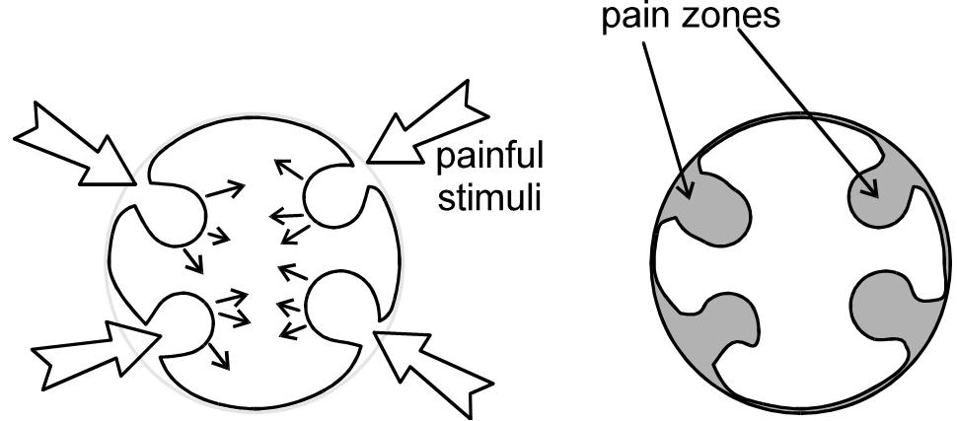
We’ve drawn an individual before, who when presented with a painful stimulus, as the energy runs in, the organism reacts by contracting inside itself all the tissue there, to try to isolate the pain stimulus. And as he does so, the pain, zoned off, lapses into unconsciousness. In other words he does not know what it is he has excluded because it’s painful, so he doesn’t want to know.
After a few such stimuli penetrating in and being walled off over the body, then the being actually thinks it is this shape, because the pain zones are unknown to it. So it has a totally false conception of its own character. If we remove these zones, then the being becomes aware that it is this shape — spherical — then it gains all the zones, all the territories and all their powers back again into its unific control. [1:05:47]
But from the moment that we have submitted to dictatorship from outside, the painful stimulus situation is the occasion for the appearance of these approaches to schizophrenia ... these dark zones, these pains which nobody dare look at.
One or two of you might have heard a painful zone calling out a little earlier this evening. When it did do, it departed. They do occur. When they do come out they can be very, very noisy. You find in the New Testament that some spirits were quite noisy. When they came out they made a loud noise. They can make very, very loud noises. But once they are out, then the being is aware of a change of shape. It has grown. It is bigger.
And the only enemy really, is this negativeness. And this negative is the imposition from outside of something we did not want to accept. And we didn’t want to accept it because Adam didn’t want to accept it. And he is the original protoplasm still persisting in our being ... and still not liking painful situations. [01:7:04]

Mythological Cycles
There were animals round the circle, I was interested to hear you say there was an animal stimulus there that was not in consciousness. Is that correct?
Oh, yes, that is true.
If that is the case, were the labours of Hercules concerned with these animals?
Quite a lot, yes.
It’s said that Hercules carried out these labours because he had slain his wife and two sons. Was that concerned with concepts and will?
Yes, yes.
And does that constitute the equivalent of the ……?
The Eve / Cain relationship? Yes.
And the animals in his labours: is there anything contained in the names that are used there?
Oh, yes. You’ll notice that in the Gilgamesh of the Babylonians that the Babylonian equivalent of Hercules doesn’t win at all. He goes out looking for immortality, and he doesn’t get it. The Babylonians didn’t. Their hero didn’t. And his friend, Enkidu, gets into trouble because he has a relation with woman. There’s a flood in it, in the Gilgamesh cycle, which is so much like the Jewish one that most scholars think the Jews pinched it from the Babylonians. They may have done, they may not. It’s fairly widely spread. That hero belonged to that people, and he made the same errors that those people made. Because, if a people worship a certain mythic content, that mythic content will work through them and go to its term. [1:09:27]
Thus the Germans are the only people in Europe who have gods who get defeated. And therefore there are continuous defeats. They conceive themselves as divine beings, and yet their divine beings are defeated.
I take it also that this action of Hercules is equivalent to the prodigal son going out and coming back again…
Yes. The thing to do is be very careful when you try to equate the labours of Hercules one-for-one with the Gilgamesh or with those of the Ramayana or with the equivalent in the Christian system of the twelve disciples, and so on. Be very careful if you try to equate them. Because the psychology of the nation that gave birth to that particular stress is not the same as another nation with another mythic stress. So you cannot put them in one-for-one correspondence without overlapping and linkage.
I notice that there appear to be equivalents in quite a lot of different mythologies and religions all the time. And also I notice that you get the Chaldeans emerging all the time also.
Yes, and they are known in Scotland as Caledonians, you know. [laughter. END]

Genesis 2:7 And the LORD God formed man of the dust of the ground, and breathed into his nostrils the breath of life; and man became a living soul.
Genesis 2:18 And the LORD God said, It is not good that the man should be alone; I will make him an help meet for him.
A sin in archery refers to missing the gold centre spot. It may not mean to be guilty [as it does in old English] it may simply mean to be missing, to be absent. The Hebrew root for the word sin, means to miss as in miss the mark. This also exists in a few English words: misconduct, misbehaviour to be not consciously there..
As You Like It; Act 2 scene 7. The line is spoken by Jaques.
Man — from the same root as manipulation and mensuration.
Genesis 2:16-17 And the LORD God commanded the man, saying, Of every tree of the garden thou mayest freely eat: But of the tree of the knowledge of good and evil, thou shalt not eat of it: for in the day that thou eatest thereof thou shalt surely die.
John 1:1 “In the beginning was the Word”. This sound is referred to in the Vedic scriptures as Shabdabrahman.
A couple of illustrations of what sound waves can do. There are many more on youtube. https://www.youtube.com/watch?v=CGiiSlMFFlI https://www.youtube.com/watch?v=3zoTKXXNQIU
John 10:34 Jesus answered them, Is it not written in your law, I said, Ye are gods?
Luke 4:33-36 And in the synagogue there was a man, which had a spirit of an unclean devil, and cried out with a loud voice, Saying, Let us alone; what have we to do with thee, thou Jesus of Nazareth? art thou come to destroy us? I know thee who thou art; the Holy One of God. And Jesus rebuked him, saying, Hold thy peace, and come out of him. And when the devil had thrown him in the midst, he came out of him, and hurt him not. And they were all amazed, and spake among themselves, saying, What a word is this! for with authority and power he commandeth the unclean spirits, and they come out.
Enkidu is a central figure in the Ancient Mesopotamian Epic of Gilgamesh. Enkidu was formed from clay and saliva by Aruru, the goddess of creation, to rid Gilgamesh of his arrogance. In the story he is a wild man, raised by animals and ignorant of human society until he is bedded by Shamhat. Thereafter a series of interactions with humans and human ways bring him closer to civilization, culminating in a wrestling match with Gilgamesh, king of Uruk. Enkidu embodies the wild or natural world, and though equal to Gilgamesh in strength and bearing, acts in some ways as an antithesis to the cultured, urban-bred warrior-king. Enkidu then becomes the king's constant companion and deeply beloved friend, accompanying him on adventures until he is stricken ill. The deep, tragic loss of Enkidu profoundly inspires in Gilgamesh a quest to escape death by obtaining godly immortality. [Wikipedia]

