Physical Body and Symptoms

Contents
The God and the Fallen Man 4
Epilepsy 6
Emotion v. Urge disorder 6
Intellect v. Urge disorder 7
Real existential 3-part man relation 7
Constipation 8
Penetration and the New Individual 10
Eggs and Sperm 11
Saturnine and Jupiteran Diseases 12
Mercurial Diseases 12
Martial Diseases 12
Venusian Disease 13
Vairagya 16
Sinus, Catarrh and Congestion 16
Fire: Aries, Leo and Sagittarius 17
Air: Libra, Aquarius and Gemini 18
Water: Cancer, Scorpio and Pisces 19
Capricorn, Taurus and Virgo 19
Intuition 21
Conscious Inhibition 22
The Permanent Conceptual Structure 22
Order in Chaos 23
What “IS” 23
Michelson Morley Experiment 25
Beings of Hereditament 27

A talk given by Eugene Halliday.
Transcribed by John Bailey; diagrams by the transcriber.
Time-stamps and transcriber’s notes are in square brackets [ ]
[Khen Ratcliffe] We were discussing the cause of disease, and what determines its ... the particular organ which it manifests in. Why should it contract in a particular organ? Can you talk about the significances of the various parts of the body in relation to the direction of the will which causes the upset?
Mmm.
I think the best way to that is to do the planetary symbols as used by the alchemists.
Well yes, I ... because the question really went on to the planetary symbols and their relation with that diagram, that absolute psychological diagram you drew last time with the nine points going in. I gather there’s a relationship between those and the planets and the chakras of the ... yoga isn’t there?
Yes… yes… yes.
The whole thing is so tremendously complex that it will be possible only to deal with the very meagre outline of it. Because, as you know, the physical structure of the human being is tremendously difficult to relate, part to part. [1:45]
I’ve just indicated there the evolution of two of the signs of the planets ... Saturn and Jupiter. These have to be understood, because you can have two fundamental faults which are opposed to each other. And we take the circle to represent all there is, all there is that’s the verb to be and remember to be means to be circumscribed, and therefore this circle encloses what is within it. So the circle means all. The cross inside at the intersection point of the two arms of the cross is each.
Each. The English word each is the same as the word itch, and the Sanscrit for will is icheha, itch. When you feel an itch, an urge to move, it is caused by the intersection of forces inside you, mutually stimulating each other so that one force stands as an irritant to the other.
So the cross with the intersection point and the two arms means each, the circle means all, and that therefore is called the universal glyph ... the universal symbol. You’ll find the great mystics saying that the cross in the circle, if properly understood, contains all the symbols. We want to express how it came to be, and use that symbol to express it. So we cut the circle in half. We’ve still got the cross in the middle. Now we’ve cut it, and we separate the two halves and put two crosses, one in each. Then we invert them and put the cross outside, and this enables us to say, the each over the all, and the all over the each. This is to remind us of the circle.
So in this one [Saturn] we say there is the each over the all ... that’s Saturn.
[In the other one] Here is the all over the each ... Jupiter.
Now remember that Saturn is the centripetal force pressing onto the centre, and Jupiter is the force flying away from the centre ... centrifugal force. There’s no gum on the back of the paper [an aside]. So that is Saturn, and this is Jupiter. And then we can see why Isaac Newton, reading this alchemical symbology in the works of Jacob Boehme, decided to abstract this concept and produce his laws of motion from it. That [Saturn] is contraction, that [Jupiter] is expansion. We can put them together and say: Contraction and Expansion both together equal rotation ... and the sign for rotation is Mercury. So this is like a bit of algebra ... alchemical algebra. Contraction/expansion = rotation. Saturn/Jupiter = Mercury. [5:52]
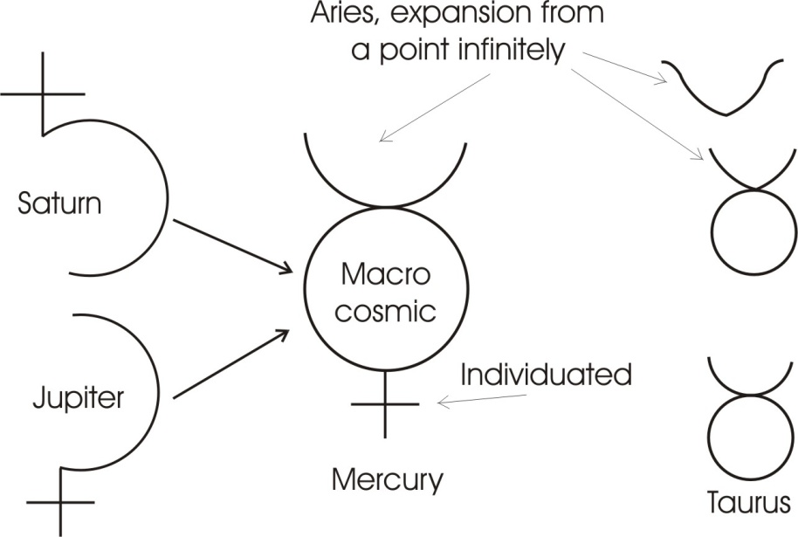
When we come to consider, this Saturn is the same as Satan. The Sat-Urn, Sat is Sanscrit for being, the base of the English verb to sit. When you sit you are positing on a point. You posit. Posit means power. P.O. is the root of the power, and sit is this concept of the cross [T] pinning a force [P]. So po-sit, posit, means the production of the finite at the intersection. And Jupiter is God the Father, or the generative power, which was responsible in the first place for the positing. Because if there had been no power to begin with there could have been no positing. It is very, very important to understand these two dialectically, because one of them presupposes the other, because both are derived from this.
So, God the Father, which the Jupiter ... if we put Du as god, Piter, Piter, you see, we change that to J.U. for Jupiter. The old form is Deu – Piter, God – father, and piter is the same as the name Peter — pitre, which means a stone.
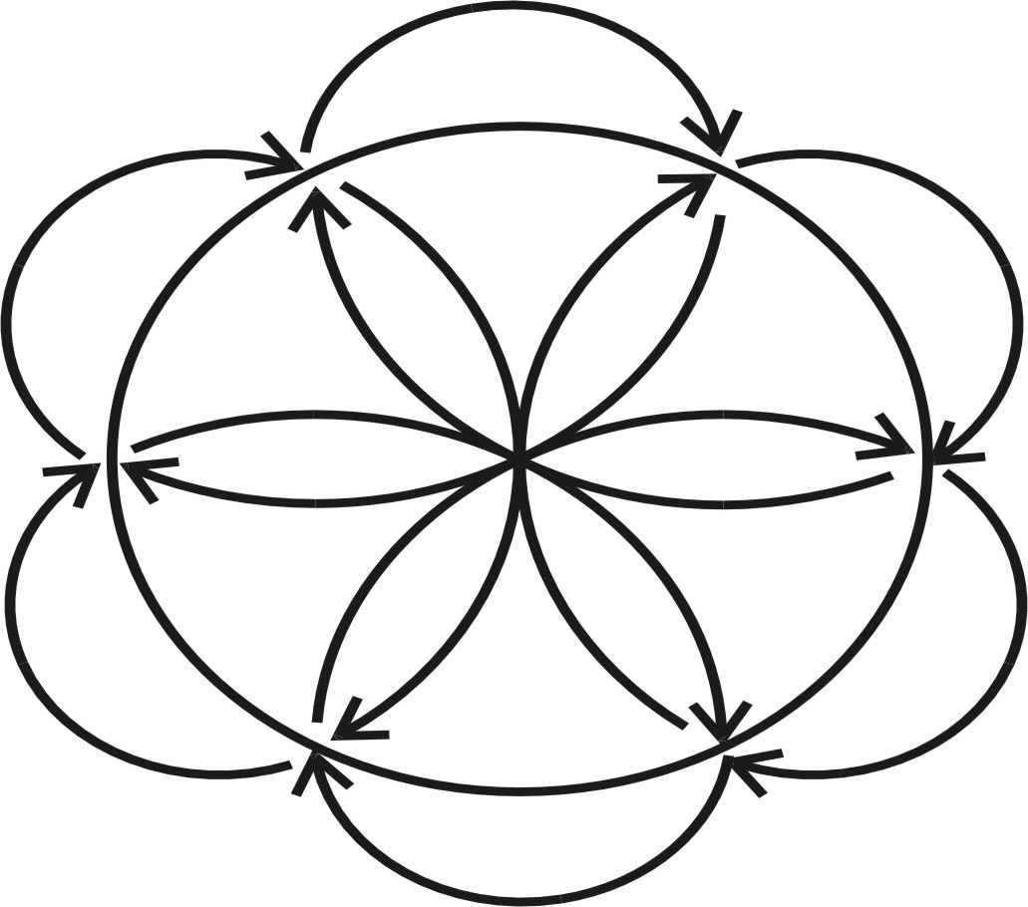
Now if we see that this represents the expanded state of the field, the expanded state of the field is opposite to the contracted state. So between the two there must be a state neither contracted nor expanded, and this is the state of the Mercury, which resolves the contradiction of the two. If we put together the contraction and the expansion, we immediately begin to see this existence again.
Ex-istere — out of six.
There are the six arms of the circle, three pressing in, three pressing out. Now if we take it in to the centre and then out to the perimeter and back in again, you see, we get this sort of thing. Out, in. You see? Out, in. This is going on all the time. The in and out are really aspects of the primary fact of rotation.
Now it is said that the father and the mother produce a son better than themselves. In which case the Sat-urn is female.
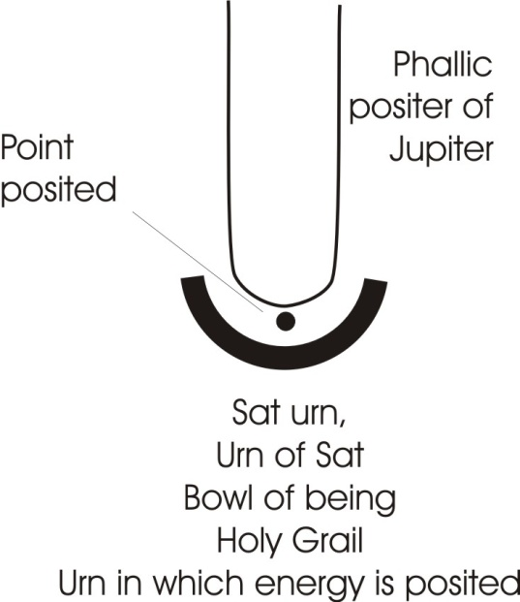
You may know a tradition that the devil is a woman. And when you remember the Sat-urn is the urn or bowl of being, this is like the Holy Grail in the Arthurian Cycle, that is the urn in which the energy is posited. This is the Phallic positor of Jupiter. This is the crater or mixing bowl of the Greeks, whence the word Creator comes from. This is the force pressing in, here is the mixing bowl, and the mixing bowl is female. So the Saturn — because it is an urn, a female containing concept — is the basis of the tradition that the devil is a woman. That is to say, this bowl of being has a certain passivity in relation to the force of the father.
Now you can see why the church has to be very guarded about these two symbols, because the contracting force is the creative force. That is, if there were no contraction there would never come to be any thing (there’s the point) posited. [10:11]

♦ Νow, positing is the same concept as creation.
♦ And expansion is the same concept as dissolution.
♦ And rotation is the resolution of all these processes, so that Mercury, who is the same as the Messiah, the Hermes, Thoth, is better than either Jupiter or Saturn, because he resolves them both, and keeps them in being.

And yet it is purely abstract thinking to think of one without the other, because you cannot get either contraction or expansion or rotation without the others. This is a trinity, and the basis of the trinities in all the religions ... and it must not be divided. You know that in the dogma it is said “You must not confound the persons, you must not divide the substance”. The substance is one, the persons are the three pira-sons, or sounding processes. [A discord is sounded on a piano here, followed by general audience laughter] ... that’s a very good sounding process.
Now, I hope we’ve got this right, because from it everything else derives. We’ve taken now the concept, the-half-circle, and we are supposed think of the incompleted half of it which represents infinity. The closed half which we’ve drawn I’ll dot the other part, but the part that we dot in shouldn’t be in at all, it represents infinity. The bottom half is the closed half which represents finity the finite world, and is the urn. Here is the completely closed part which is the time process and here is the each. That is all, that is each, and these are the horns of the dilemma. [12:16]
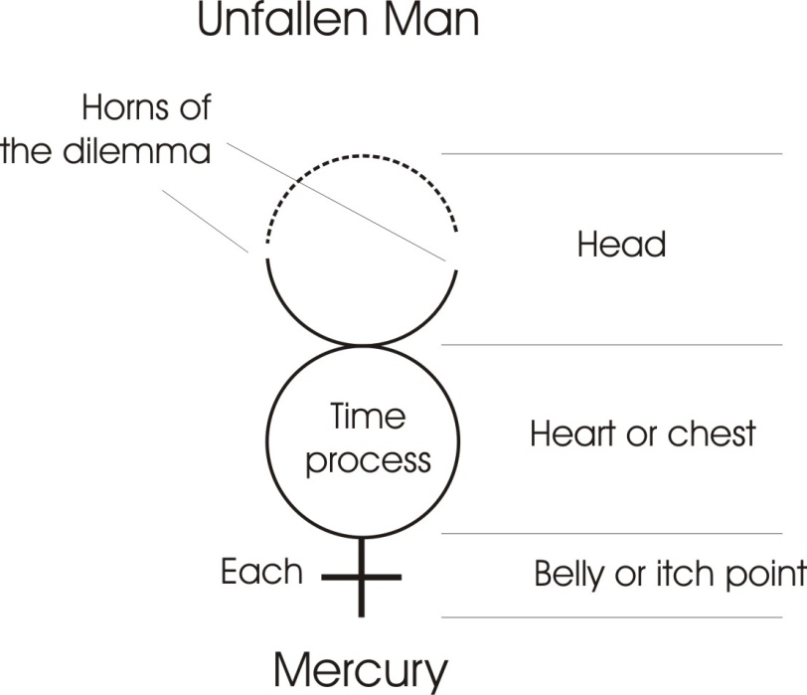
One of those horns represents Jupiter and the other represents Saturn. This is the inherent duality of the Absolute. So in the sign of Mercury we have the horns of the duality, the pos-negative, the wholeness, the rotation which makes the whole and the all, and the cross which symbolises the each, or itch or irritation point within it. We can then come to consider in relation to the human being that you can have two different orders of thought. Let us take this as a glyph of the unfallen man with the horns up, and say, that is the man’s head, that is his heart or chest, and that’s his belly or itch point. Now we can reverse this process and put the horns below.

The God and the Fallen Man
When the horns are above, it means the kind of man (technically that man is called a god) who is aware of the dialectical opposition inherent in existence. So he is never dogmatic with himself about where that thing is or is not, because he knows simultaneously that it is and is not whatever you care to mention. Remember we said before that the subject is never exhausted by the predicates, that when you said “S is P” you haven’t said what S is, you’ve merely said that it contains P. And no matter how many Ps you put, you won’t make S. So the subject is never exhausted by the predicates. So you cannot say all that there is to say about the Absolute. The man who knows that, refuses to be absolute about particular statements. And he has his horns up, his wholeness in his feeling, and down below on the body he knows that he is pinned. He is crucified. [14:25]
Now the fallen man is crucified in the reason department, because he thinks that his ideas, his logical ideas, are valid. He thinks that a thing is either black or white, that things are either A or not A ... he doesn’t know that they are both and neither. And this causes the horns to go below. And down below they symbolise the generative organ itself in its polar aspect.
Now in the case of the unfallen man the forces enter into the body, and they go round the body, and they loop round the body and then they go back again, and pass back to infinity. In the case of the fallen man the forces always come from the earth, through the sexual nature, through the emotions, up to the head, and condition the thoughts by the chemical stimuli from the generative organs.
So we can say that the fallen man is conditioned by the fact that all the stimulation to him comes from below, from the earth, from physical fact stimulating him. And most of the stimulus that comes to him is ancestral in bias, that is, it is based on the reactions of his ancestors to similar stimuli in the past. [15:57]

♦ So that the man who gets fed from below is the man on the pitryana; that is the way of the ancestors.
♦ And the man who knows he is fed from infinity is on the suryayana ... that is the way of the free being.

Remember surya means free affirmation, the Sanscrit for Sun, and pitri is the name for fathers. So if you are in the pit, if you are in a pitiable condition, it really means that you are being dictated to by ancestral images coming through the germ plasm — the sexual side of your nature — conditioning your thoughts. Whereas in the other case, your thoughts are totally unconditioned they have this dialectical opposition in them, you know that everything is and is not what it appears to be simultaneously, and you know that your physical body as such is circumscribed and limited, and the source of irritation. Therefore you are on guard.
Now when we come to relate this we can see immediately that the unfallen man is not likely to become ill. But as he is embodied it is possible to get at him ... like Christ was got at and crucified. But it is only possible to get at him providing he sticks his neck out on purpose, because he knows what he’s doing. So it isn’t very likely we’ll have to examine much about the kind of things that could be done to him, because he’s in control of the situation. [17:34]

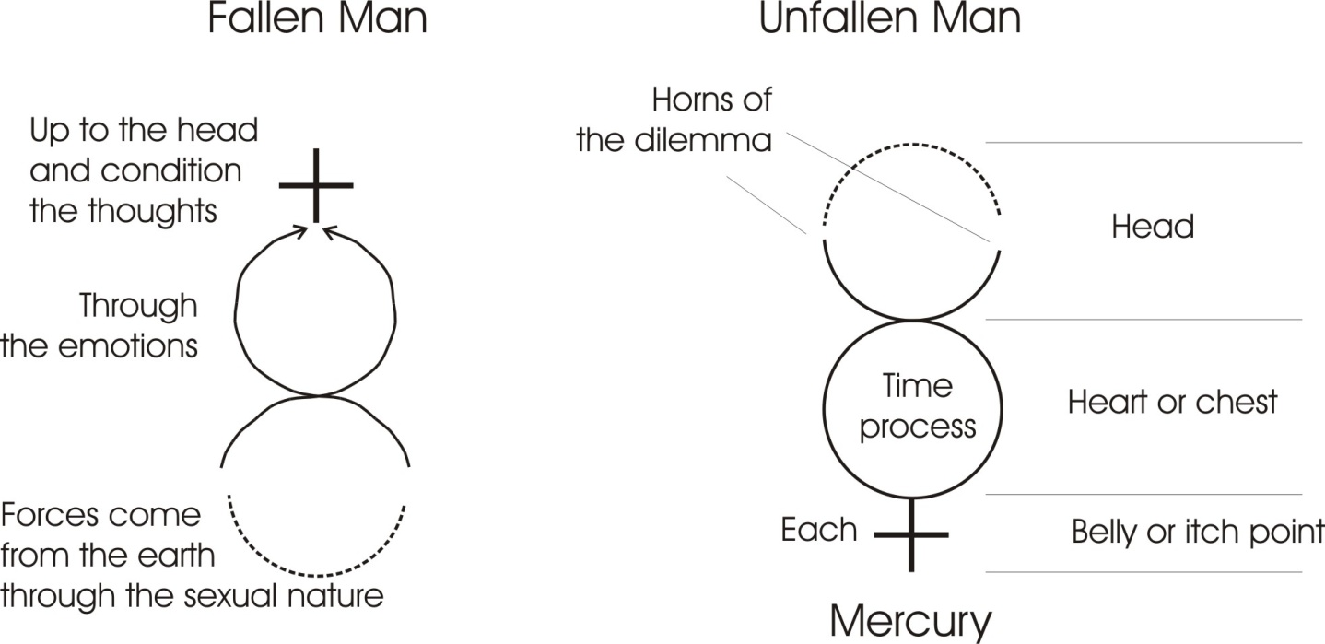
So we’ll consider the kind of thing that happens to this man [fallen man] because of the accent on him. So we’ll draw him again and consider the three kinds of things that could go wrong with him.
Now this feeling zone is the contested zone, if you remember. We have the urge from below coming up and the form from above coming down. And they produce rotation in the feeling zone.
Now, in its pure form, if we take the urge from below, it will never become ill unless it gets stopped. In the wild primitive state — say on the desert island madness — it would never become ill, but it would frequently become tired. If nothing stops it, it will simply expend itself. So we could say that the very primitive person, and for the purpose of this discussion we’ll pretend that such a person can exist, although this is not true because it’s an abstraction.
No being exists which is merely a pure urge.
No being exists which is merely a pure feeling, void of urge or thought.
No being exists which is merely a thinking being. [18:46]
But in order to clarify the kind of thing that can go wrong, we will pretend for a moment that there is a being of pure urge, and pure urge only. Now, unless he is stopped he cannot become ill. He can only become tired ... through energy expenditure. And once he’s become tired he will go to sleep, the energy will build up again, and he’ll wake up and start again. So that nothing can go wrong with this primitive unless we put a stopper on him.
Now let’s pretend for a moment that there is a person so stressed on that [urge] that these [feeling and thinking] factually do not exist as determinants of his action. Then we will have to say the only thing that could stop him would be something outside. So we’ll draw another being and pretend that it’s that one. And we’ll say that this being is being fed with energy and expending energy, and after a time this somebody comes along and they decide they are going to build a brick wall, there. They are fond of interfering, these people, so they build a brick wall so that the energy coming into him gets stopped on the wall and can’t go out. Now, the kind of reaction that he shows — the dis-ease, or lack of ease, which is all that disease means — the kind of reaction he will show is simply blocked will. He will get mad at it. He will hit the wall, and because he’s got no thought power, he will not stop hitting the wall.
You know the popular concept of a lunatic hitting his head on the wall. Well, when this becomes determinant in him, actually he’ll do it. They actually take their head, where the thinking is going on that’s annoying them, and hit it on the wall as an elementary shock treatment. In fact they invented shock treatment themselves ... because it does actually have a slight effect on your thinking processes if you bang your head on the wall pretty hard. You’ll get a headache and a great dullness, and then your previous clarity — which might have been a fearful imagery — is destroyed for the time being. [20:55]
So we’ll say that the only thing that can happen to the pure primitive urge type, is blocking from outside. And we see the nearest approximation to this in the case of people who have been driven by their urges to the point of complete anti-social behaviour when they find themselves then locked up in a mental home, and they are put into a padded cell because this urge is coming out, and they throw themselves against the door to try to get out.
You remember my telling you about one case, Khen, about a mental case I was talking to, who had broken his arm trying to run through the door of the pen. Now the room was only eight feet long, and he’d broken his arm as he charged at the door trying to get out. And this urge had driven him to try to get out. And the shock of the failure had knocked him into his thinking department a bit. And he then said, I made a miscalculation.
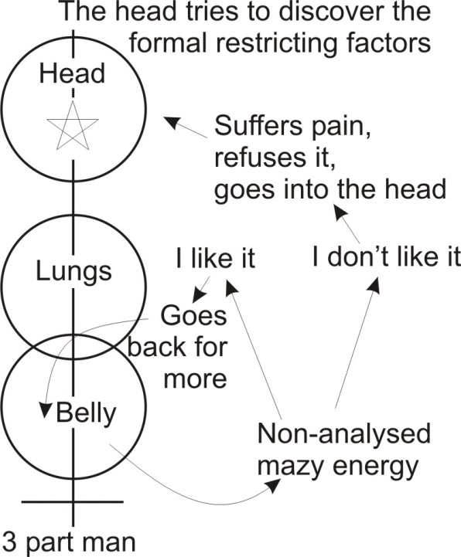
You know that when you fire a candle out of a gun it can penetrate a door.
If I could have got up enough speed I would have gone through the door, but, said he, I calculated only for three inches and I discovered the door was five. And that was a statement he made to me, and it sounded rational, only he would have needed a finer calculation and more running. His theory was alright. His calculations weren’t good.

Epilepsy
But that is the kind of disease you can get. And when you get it — in the purest form you can approximate to it in an existential human being — in general you will find it in a woman, not a man. That is to say, you’ll find it in someone with the consciousness pitched down in the pelvic region, because that is where the centre lives.
For instance in the case of epilepsy, epilepsy itself is caused by the gathering together of this energy when the person has been completely thwarted. And they drive it onto the centre down here — if it’s a woman, onto the uteral centre — they drive that energy and beat it onto it. And then a centre in the brain corresponding with it responds, and they just grip on it and punch it. And they hold the breath when they are doing it to get the necessary concentration, and they literally knock themselves out by the energy they build up. That is the pure type of reaction ... simple blockage. And the blockage would have to come from outside in the pure case.
Now in the case of an existential human being, a certain amount of blockage comes from two other places. This prime urge is not interested in pleasure or pain. This has to be understood: that the sexual nature is not interested in pleasure or pain ... that the relation itself is already pleasure-painful and painful-pleasurable. The two are inseparable together. They are the type of dialectical experience of the Absolute. What it is interested in is energy expenditure. And it doesn’t care to what length it goes to get that expenditure when it’s got the energy. [24:37]

Emotion v. Urge disorder
But in this department [emotion] there is another centre that’s concerned with I-like-it and I-don’t-like-it. So this centre tries emotionally to inhibit this [urge] when it drives so hard that the thing becomes painful. This sends a message saying, stop it. But if there’s a great deal of energy in there [urge] it won’t be able to stop it. And when the energy coming up here [urge], and trying to express itself, is caught with this one [emotion], this one twirls it round and tries to take off the energy that’s driving into the external act. And the result is that the energy in the emotional level twirls round and round and round, and you get a tremendous emotional outburst. This is a disease type of another order — a higher order if you like — because this one [urge] is not at all discriminating about pleasure or pain or idea. This one [emotion] does discriminate, I like it and I don’t like it. And it has the power to drain off some of that urge energy and dissipate it in emotional displays. Either screams of delight or screams of horror come out from the breathing apparatus, blowing itself out through your talking department.
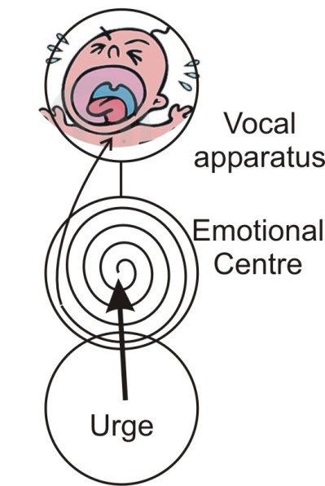
The power for the breathing and for the voice comes from this emotional region. So you get strange noises coming out of the person who is trying, without intellectual control, to drain off this urge power and spin it round and dissipate it in emotionalism. So we’ve got now another kind of disorder. Namely a disorder arising from the conflict between I-like-it and I-don’t-like-it, and simple positive urge. [26:31]
Now a third one is possible. We will eliminate this for a moment and draw a person who — we might as well put them all in — there’s the person trying to drain off the energy to make an emotional display which usually results in shouting, screaming and other funny noises. There’s a diagram of it, the inflow of the urge spinning round into the centre of the emotions, and jumping into the vocal apparatus and shout out, it’s horrid, or, it’s lovely, or something.

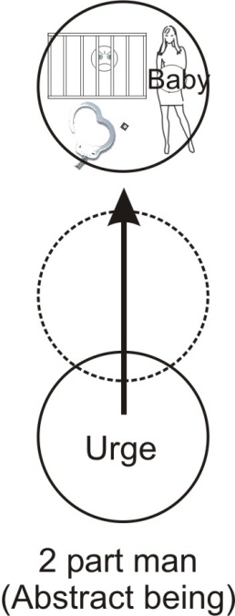
Intellect v. Urge disorder
And then here is an abstract one of the intellect pressing down without the emotional centre being operative. Because some people can actually force their feelings into a state of near death, so that they don’t apparently have any feelings, but they do have reasons and they do have urges. So the urge down here is driving up and is going to express itself in action, and this up here [intellectual centre] has a memory of all previous occasions, and it stores up every time this naughty urge was thrown into jail or some other place for indulging itself. And it sends a message straight down, it cuts across it and tries to stop it.
Now you immediately see what happens. The energy begins to pile up against this intellectual resistance. If it can’t get through, it forces its way up into the head and builds fantasy. That is to say, as there is nothing in this conceptual being, this abstract being — other than the urge experience and the memories of the urge experience and its results — so in the mind of this being there are all the ideas of all previous urge experiences. There’s no pleasure or pain or liking or disliking, but simply the fact that on various occasions the urge expressed itself and was stopped from outside. The police got it or something. So the urge power then rushes into the head and activates all the memories of the experience that are going on up there. And so the whole consciousness of the head becomes flooded with fantasies of primary urges.
Now that is an abstract being because we’ve left out the feeling. [28:59]

Real existential 3-part man relation
Now, if we consider the whole being again, we can see as the urge energy rises up through the feeling, drives into the feeling and then up into the head, we have the type of real existential relation that we find in people in various degrees. An energy in the urge department is our primary cause of the trouble. Because the person with no urges at all isn’t very troublesome to other people. They just passively lie about. But the moment the energy builds up sufficiently for them to move, or even a little bit of energy sufficient to complain about something, then they become a nuisance to other beings. The energy climbing up goes through the feeling, goes back into the nervous system, climbs up into the head and there in the head are the memories of all previous occasions when the urge has been allowed to expend itself, when the liking and disliking records here are also consulted, and all the laws of the land which are engraved on your head whether you like them or not, thou shalt not ... ten specimens of it. All those things are presented in the whole consciousness.
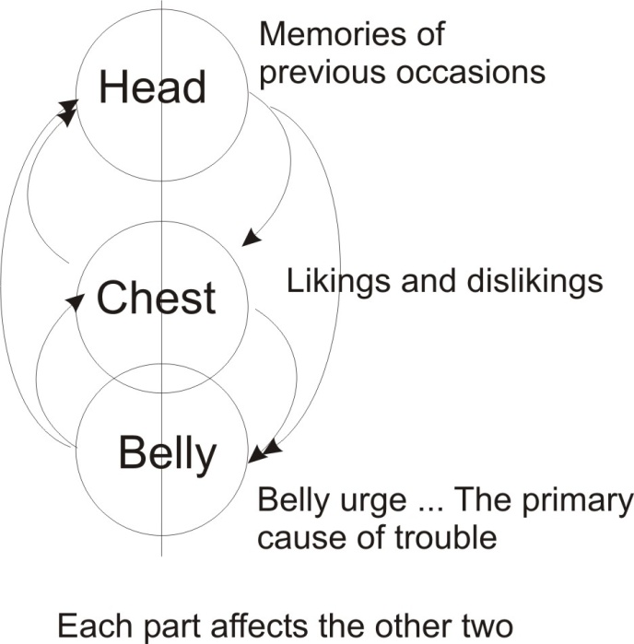
So the whole being then has an awareness that there is an urge, there is a liking and disliking, and there’s a great number of ideas of whether it is legal in whole or in part, and what is likely to happen from it. So we can say in a very, very simple manner there are three zones that can get into trouble in a human being. The belly zone, the chest zone and the head zone.
Now, if we remember the polarity in our star of David, we said that this one is a woman (we might put her a nice face on), and this one was a man. The one with the broad base refers to the pelvic stress, the one with the broad shoulders refers to the executive force stress and the man is stressed on his executive power or initiative power, and his intellect.
So we can say that in general, in a woman, the zone of trouble is below the diaphragm. Really it’s somewhere in the belly region that a woman can expect the cause of her troubles to begin.
It is somewhere in the head and the nervous system that the male can expect his troubles to begin ... simply because they are stressed in that way.
Where the treasure is there is the heart also, and you cannot get into trouble really, except where you value something. Now valuing is the same thing as stressing isn’t it? To value is to put a stress on. So when you value, you can write Saturn down ... that is to say, the centripetal force positing something. And you immediately see that if you start positing something, you are actually driving your tissue onto a centre, and in so doing you are causing the conditions of bad circulation. [32:44]

Constipation
Every time you concentrate, you surcharge the zone on which you concentrate with energy, and you pack it in, and cut down the free flow of forces in that zone.
You know that one of the chief diseases and chief causes of other diseases in human beings is called constipation. Now constipation is only the primary urge department — the worm which dieth not as the book says — which grabs onto a situation in a reflex manner. And it won’t let go, and so the free flow of materials through it is inhibited. And if that becomes chronic, a process of auto-intoxication occurs. The substances that should be eliminated are not, and they are putrefying, and the by-products of their activity and bacterial activity in them is creating toxins, which find their way into the blood stream and will produce a dullness in the head – various funny symptoms all over the body ... all these being the by-products of the chemistry which is simply a Saturnine complaint.
There’s a certain kind of person that you see sometimes with a greyish, leaden look. And they are frequently flat from front to back. They’re not round men ... round men are Jupiter men. They are flat men. We call them Saturnine men. Now these men tend, if they’re not careful, to covet something. And they flatten themselves in that covetous process. And they cut down the conditions of free circulation in themselves, and frequently they become hypochondriacs. They create the conditions where they can feel they are not well. Then they worry about not feeling well, and they contract again, and they have a vicious circle. You can tell them generally by the general disposition from front to back. They are quiet flattish, and their face planes in general are flat, and they have a greyish leaden sort of complexion. As opposed to the martial type which is very florid.
We’ll come back to these types in a moment.
So we’ve got now three major kinds of disorder, and a tendency for the lower kind there, the belly kind, to appear in the female, and the head and nervous system kind to appear in the male. So we can see that it’s only because a woman values that that it gets into trouble, because she puts a pressure on it. It’s only because a man tends to value his intellect that he puts a pressure on his thinker. Many a man starts trying to solve a problem up there which cannot be solved up there, but he drives the energy into that place in the erroneous belief that he can think it out ... and thinking is already Saturnine.
Now remember Satan. This same fellow, we can call him Saturn or we can call him Satan if we want. Satan is the being serpent. Ana means a serpent: not this serpent with tail in mouth — that’s ‘on’ — the running serpent. In fact that letter ‘S’ represents him already, on its own. So this Saturnine being contracts onto centres, and that process in consciousness is what we call tinkling. [36:26]
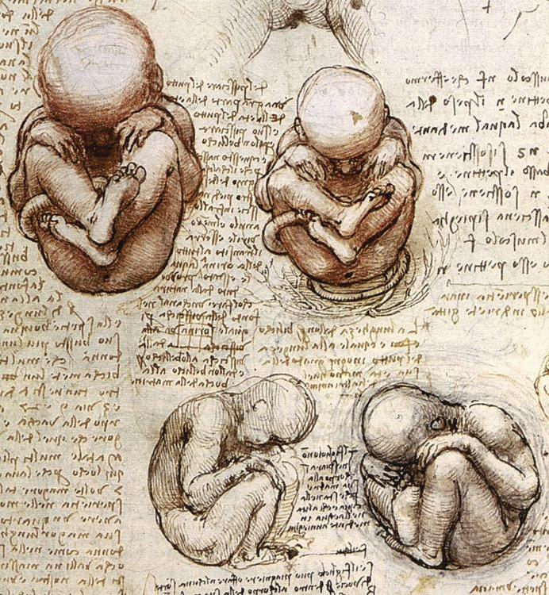
So a very strange thing happens. We said before that in the other analogy when we said that Saturn was an urn, we said it was female. Now we are saying that as it produces the point of contraction — which is form — it is male. This is the dialectical statement that we find in Genesis. Man was made in the image of God, male and female. Man is a hermaphrodite. Man is already a man-woman. The egg is already man/woman internally. As it begins to develop it goes through various changes, and at certain levels of being where it’s quite obviously going to be a human being, you cannot determine what its sex is. And in those days it is more like a woman than is like a man. That is to say that the primary urge is dominating it. And as it begins to develop, if the accent stays round the pelvic region, it will develop as a girl. But if the accent — and this depends on certain precipitates of forces inside it — begin to put the irritants, the itches into it, it begins to think. If the thinking gets 51% of the shares, the force is transferred from this pelvic region to the opposite end, to the head region. And it turns into a boy. You know that in order to do that, certain organs which are inside in a woman have to be pushed down to become a man. Because fundamentally we have this process, that is man and that is woman. You see, we have the two egg makers, and either a receiver or a positer, we’ve two egg-makers. In the male, that thing is up there. And if it doesn’t come down, it’s not made the grade as a male.
Drawing by Da Vinci
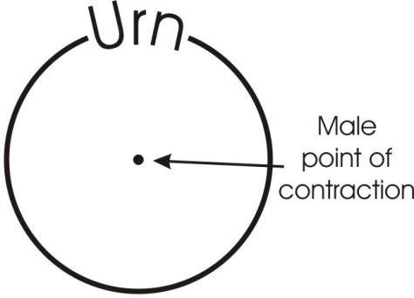
So we must understand always that a human being is an androgyne, a hermaphrodite. It is a male/female. And you can’t stop it being a male/female. Every woman who exists has a brain and a nervous system. Every man is already a woman in the pelvic region. And it will remain so as long as he has any urge, any drive. All the purpose comes in the volitional end from below in this fallen man, and if it stays down there it will be a woman. If it climbs up there it will become a man. And these two are polarised in the sense of form — the man — which we can represent by the dot in there, and the pelvic bowl, the circle.
So another hermaphroditic image is the point in the circle, where the circle represents that bowl seen from above, and that point represents the Jupiter force pressing into the bowl. Now we can see two main types of disease here we’ve already analysed, the disease of the bowl, which is wanting to receive — wanting is its dominant — and the disease of the thing posited, it wanted to posit. So there’s a tendency in the male to want to think. As a matter of fact, he’s always trying to work something out in his head, it doesn’t matter what it is. You can change the subject completely and he’ll try to work that out, because his bias is to try to find the form.
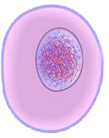
Whereas in the woman stress, the object is to receive and then nourish, in order to release a new form. In the case of the man it is to go away, get information, and bring the information back and put it in the bowl. [40:30]
Now let’s go back a little bit and consider this. We’ll do elementary mechanics in the division of the egg. Supposing that is a primary egg with its nuclear centre, and supposing there were only one of it and there was nothing else whatever, well then that being could have no experience. Experience is EX, it is what’s coming from outside. So if there were one being and no other being there could be no experience. Even though the being existed, there would be nothing outside it to experience.
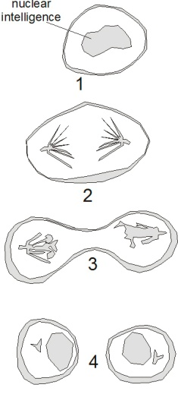
So supposing it decides that experience would be a good thing, it can only do so because there is a potential ex-perience felt inside it, but it’s an im-perience. This is the basis of intuition. Parts of this single cell being are rubbing against other parts inside. The fluid is circulating and flowing, and it can feel the movements of its own substance. There thus arises the idea that if it divides itself and makes itself into two beings, it can then have experience. That is, it can have stimulation from outside. So the nucleus splits and you have two cells which can knock against each other, stimulate each other and have more fun than they could do with only one. And if we call this one Adam, you can easily see why God said, It is not good for Adam to be alone. Alone is All one. There is the potential Eve in there, and it is here separated out.
Now let’s pretend for a moment there are two single cell beings, and they are identical and they move very, very slowly about. And they’re both having experiences, but they never meet again. So that the experience of this one is its own although it may occasionally hit this one. The experience of this one is its own although it may occasionally hit that one. So the position is very similar to the first position, only now it is duplicated.
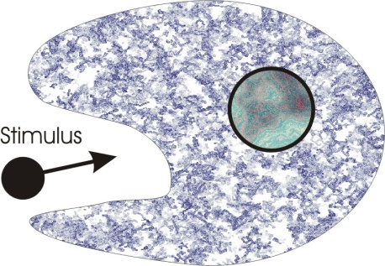
The only thing that’s been added is this contact. That is a value but it’s not a very big value. So then comes another thought. When the two touch each other, a ripple goes through both, and that ripple is the beginning of the femaleness. Because there’s a certain amount of sensuous joy in the ripple arising from the energy which stimulates it. So if we now enlarge one of those a moment, and say there is the stimulus, there’s the point of impact, and there’s a ripple of sensuous delight going through it, it follows that this will tend to move towards the stimulus to engulf it. This is the way an amoeba moves. The stimulus is always experienced as either pleasurable or painful. And if it is pleasurable, the whole substance of the animal flows round the stimulus to engulf it. So you can see this engulfing process is the female process. And this penetrating process is the male process.

Penetration and the New Individual
Now it becomes apparent that if these two remain equal, neither of them can penetrate the other. So it is decided then to shrink one of them and let the other one get larger. So then we take one and let it grow up and get nice and big — it’s got its nuclear spot — and we shrink the other one to a very tiny one, and we give it a little tail so that it can propel itself. [44:27]
Now this one is very, very mobile, swims about very rapidly, and the other one relatively static. And yet it is this one [sperm] that in its rapid dashings about is going to experience in a very short space of time that this one [egg] would take considerably longer to find. And in the head of this one — this is the sperm — is stored all the form of its experience. When it comes to the other one — the ovum — and penetrates it, then the ovum opens to let it in.
This is the strange fact: that when an ovum is being attacked from all sides by many sperms, it actually has the power to keep them all out. None of them has the power to penetrate it by their own efforts. But it feels over its whole surface for the strongest knocker. And when it’s felt and found where the strongest knocker is, it just opens its door, lets it in, and closes. After that there is no more opening. It doesn’t matter how many they are or how strong they are, they will not be allowed in. It closes. [45:44]
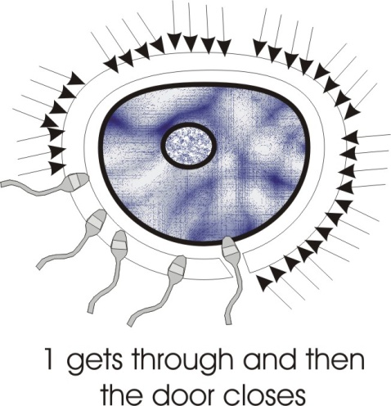
Now the reason for this is: there has to be a pairing of the experience of this one [sperm] and this one [ovum]. When that little sperm gets inside there, there’s a great mass of stuff which you can consider as nourishment — just as in an ordinary egg you have a yolk and white, one part is for developing your animal, and the other part for nourishing it — when it gets inside, it starts eating up all this stuff and it goes on doing this until there is a balance between them. And then there’s a process in which they fuse the formal information together. And then the process of division goes on to produce a new individual like we had before.
Now this is very, very important. Because you can see that all the form in us is derived from the form seeker in our ancestry, which we call the male. So we can say that all the form — that is all ideas, all formal knowledge — that we have at birth from our hereditament is derived from male ancestors, whether on our father or our mother’s side. Because your mother had a father too, and all the wilfulness in us and all the feeling side is derived from the mothers. You will understand later why Eve got Adam into trouble and not Adam got Eve into trouble.
We now have a very good and economical process whereby a very tiny but a highly mobile form collector goes about, and another being specialises in the absorption of form.
So we can take it again of these two kinds of diseases, there are diseases of the egg, and diseases of the sperm. Diseases of the expander which…

[Break in recording]

... is the rationale of the behaviour of the boy’s preference to the mother and the girl’s preference to the father. It is an attempt to restate the original hermaphroditic balance state. Because the balance was broken for economic reasons: to speed up the gaining of form, to specialise in absorption of form. [47:33]

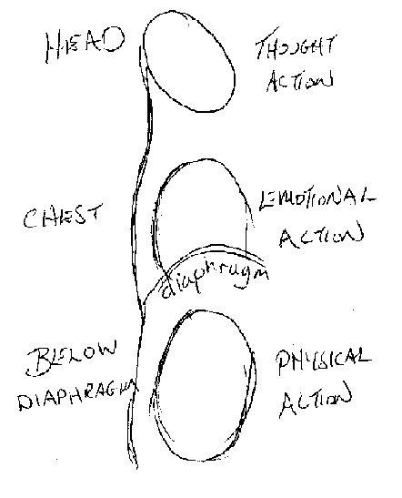
Eggs and Sperm
So when we come to consider again the two ends of the body, we can see that one part is concerned with absorption ... the food part. One part is concerned with form. We have our five senses up at the top closely related to the brain, so that we can collect form in the five modes from outside and store it up here And then it produces certain chemical changes, which produce variants at the other end, in the sperms which are created throughout the life process of a man.
You know that when a baby girl comes into existence she is equipped with a full complement of eggs. But the male doesn’t have them at birth, he makes them, beginning at puberty. And he continuously makes new ones, and the chemistry of them depends on his evolutionary level, that is the amount of experience he has. So that we will say the children of men who are older tend to be more serious than the children of men who are younger, because in general we can say that the father is more mature and more chemically balanced at forty than he would have been at sixteen. And so there is always this movement, a tendency, a striving to get equilibrium.
Drawn by Alan Roberts
So in the very, very simplest form we’ve now got a rationale of the kind of thing which we should look for in ourselves so that we can anticipate trouble, and defeat it before it has time to run away with us. The Tao says, Journey of a thousand miles begins with first step. If you can catch yourself in the very beginning of a process, and you know that that process, allowed to go to its logical term is going to put you in a hospital or in a grave, and you’re quite clear about it, and you don’t want to go in a grave — that’s an essential condition — then you will stop it. And you’ll stop it without much effort.
But if you prefer to go to the grave then you will go, and nothing will stop you. And there is such a thing as a will to death, when you are fed up with life and you can’t see any sense in it, and you then start contracting over the whole organism, cutting down on the circulation, and really committing suicide surreptitiously, in such a way that the insurance companies will still have to pay out on your policy. [50:09]

Saturnine and Jupiteran Diseases
So now we have this process. We are going to expand it a bit. We’re going to say Saturnine diseases — that is those of contraction in one of the three parts, in the pelvic region — this in the female produces all the uteral disorders and so on, and in the male it produces all these bladder disorders and kidney disorders, and so on.
Now the opposite of that is the expansion disorders, where people start getting bigger and bigger, and more and more florid. And they tend to knock themselves up, they have strokes and funny things, they get a high colour they look full of well-being. And the more well they look, the more dangerous it is for them, because they are expanding and they’re only finite beings, and they are just going on. You can see if you go in any of the say the Waldorf barbers in the 10 o’clocks or something like that. You see rows of these expanding beings ... shining away. You see hardly ever a Saturnine fellow there, unless it’s the barber [laughter].

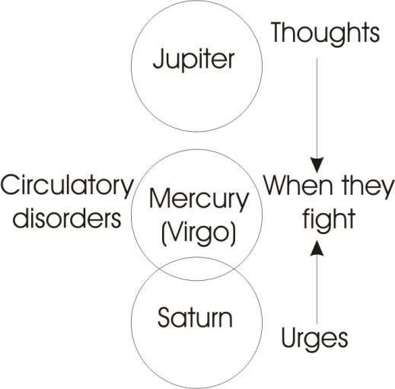
Mercurial Diseases
Then we have the mercurial diseases which derives from the conflict between these two, and they are circulation disorders. Remember Mercury rules in Virgo, and Virgo is the sign of the circulation. So circulatory disorders are the product of a fight between what goes on down there [pelvis] and what goes on up there [head].
When your thoughts fight your urges you have circulation trouble. As a matter of fact if you feel an urge coming up and you say, you know, sex rears its ugly head, Down Fido, your master’s broke, or something like that, and then you get a terrible turbulation. This turbulation is felt round here, and it gradually localises itself. Just under the ribs on the left side you’ll find it. It’s not in the gross physical body, this. This is a subtle chopper. Below the heart and just under the ribs sometimes it grinds round, starting like a stitch. It is the turba of Boehme. It is actually caused by a fight between your urge energy and your idea and it goes round.
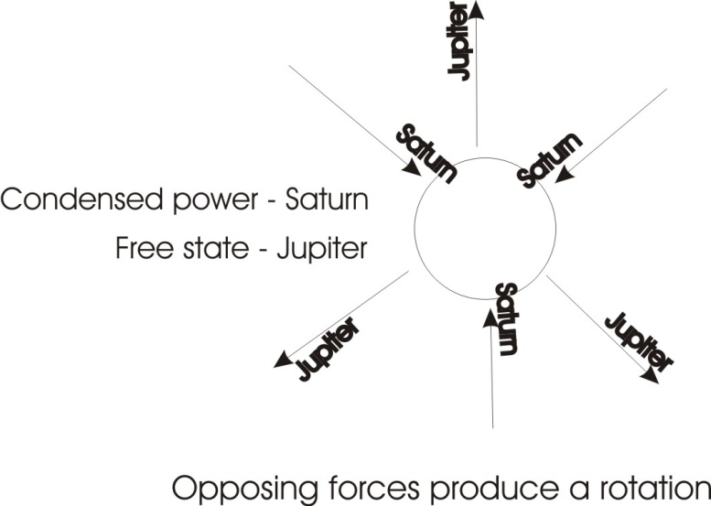
Sometimes you want to do something and somebody you considered of no account has the Fiat and says it can’t be done. And you think, The little so-and-so, I could wipe him out, but he’s worked the boss, or something like that. And then you feel this terrible churning going on around here. That churning is a Mercurial disease and it causes the whole of the blood to circulate round the body, which raises your blood pressure. And simultaneously various bad chemicals are coming in.
Now when we take these three — you remember we said these are the three nails of the cross — well we take this one, and let it represent the conjunction with that one ... Mars. Remember the sign of Mars is the circle with an arrow coming out of it, and we said that if we get Saturn and Mars and Mercury we’ve got the three nails of the cross.
Now we can’t have this Mercury rotation unless there is some space ... which belongs to Jupiter.
And we can’t have the rubbing or friction to make the heat, unless we have some Saturn contraction.
And we can’t have the rotation unless we have both Saturn and Jupiter. [53:45]

Martial Diseases
So the only difference between a healthy rotation and an unhealthy one is the relative stress on contraction — the Saturnine — or expansion — the Jupiteran. We will now consider in an abstract sense the Martial diseases. Martial diseases are the disease of desire — not primary dark urge, which is really unconscious, it just comes straight through you — but the conscious desire which you find a certain kind of man has. We find he’s a high colour man in general. Very frequently reddish in the hair, and reddish in the face, and that man has the diseases related to anger. If he is cross he becomes very angry, and the anger is only the evidence of the turbulation with the stress on the Saturnine. You see, if he did not commit himself to a point — there it is — if he did not value something, and grab at it and say, This is what I’m about to do, then he could not get annoyed if somebody stopped him. The essential condition of this martial trouble is that first you must declare your aim, then you must pin your ego consciousness on it and say, I have spoken, and then somebody must come and stop you doing it, and then you’ve got a drive.
Supposing this is the object and you’ve decided you are going to appropriate that. So there’s you, the circle, there’s your energy flying out to hit it, and somebody comes along with a nice piece of wood and they’ve pushed back your arrow of energy. [55:38]
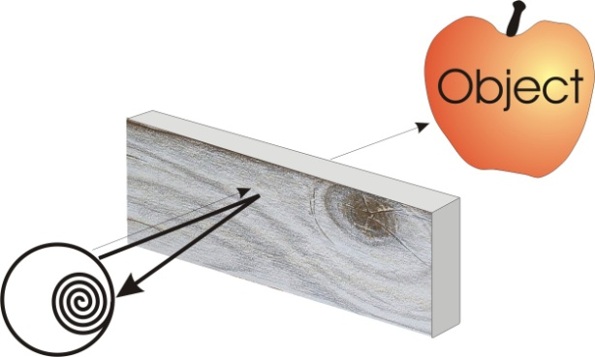
Now you see what will happen in this diagram. If we let the thickness of that line represent it extended there, and this pushes it back, half way it will be twice as thick, won’t it? You see, if we push it right back here, then all that energy has gone inside the being, and it starts spinning round. And it gets him very, very annoyed and it’s very, very bad for his chemistry. It produces all sorts of internal stimulation. And if the person is very young and hasn’t got elastic arteries and so on, it can just break through the walls with the pressure.
So you see, we can consider the Martial diseases as an abstract idea, that really can’t exist unless these other things are conspiring together to make them. [56:27]

Venusian Disease
Now, there’s another kind of disease opposite to the martial one, the Venusian disease or venereal disease as they used to call it before space was invented. Now, just as the martial disease is energy flying out and expressing itself and saying, I am about to accomplish, the disease of the Venus kind is a person that’s so terribly passive that they can’t be bothered to circulate, unless somebody comes and circulates them. This is the kind of anaemic …
[Break in recording]

… certain kind of person. You don’t see them so often in men. If you see a man like it you’d be surprised and think he’s wishy-washy. Because it isn’t for the man to be passive. But the Venus type of girl is in general pale, blondish, has a peculiar passivity, which passivity is a challenge to the men, and she knows it. So she cultivates it and hopes that somebody’s going to come and stir her bowl for her. Somebody’s got to do her circulating.
Now she has a peculiar kind of disease. Anaemia derives from it and all the diseases that derive from a low oxygen level in the blood, and a low iron content in the blood. You see, iron relates to Mars. Now copper relates to Venus. So we could say, from a priori considerations — although medically this has not been proved — that treatment by copper here would make that worse. She’s already loaded with the copper value. Copper is the basis of copulation. What she wants is a fiery force to come and sweep her off her feet and circulate her a bit. And when that happens, she tends to grow into a peculiar being, and she moves nearer and nearer to the necrophile’s delight. She tries to approximate to a corpse-like pallidity, most provocative to red-headed gentlemen [laughter in audience]. Now actually these occur in large numbers in universities and they are always doing…
[break in recording]

… you can pick them out immediately. They are called the necrophile’s delight. They specialise in this pale …[indistinct] … technique. [59:03]
On the Mars side we have the sun disorder, and it’s opposite the moon. And the sun and the Mars disorder are related very much together, and the moon and Venus are related very much together, except that whereas in the case of the Martial one it is entirely a matter of desire — desire floods the person and he must do it — in the case of the solar type, he is a fellow of will. He doesn’t do it by desire, he does it by will. The thing hasn’t come into him as a desire, it carries him away. It could be anything at all. I could get hold of that and say, you can’t have that, and that is enough. If I say, you cannot have it, then he will have it. He’s not concerned with desiring to have it. He may not desire to have it. He wills to have it if you oppose him. So really he is the perfect specimen for practising negative suggestion on. You say to him, on no account wash up [laughter] ... and straight away the apron is on, you see.
Now the opposite of that will to go against the command, is this other will to go with the command before you’ve had time to command it: a sort of anticipation of the command, you see. You’d like me to do so-and-so wouldn’t you? ... and suddenly they are there. It’s very, very hard to get rid of them. You can see the relation between this and the Venus. It’s that the Venus just lies about wilting, waiting for the necrophile to come in, you see, whereas the moon one goes out looking for him, says, Please sir, are you a necrophile. [more laughter]. Now this is a very important difference.
We’ve exhausted now the abstract consideration, in outline, of the seven processes. And we’ve got three pairs and an odd one. We must consider this very carefully. [01:01:02]

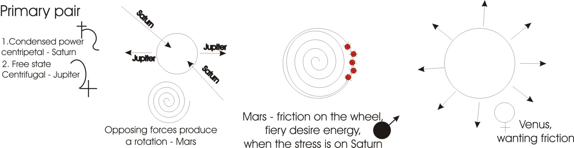

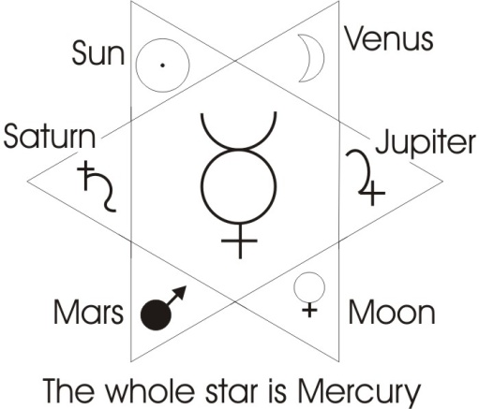
The primary pair is Saturn and Jupiter, because the contraction of universal substance produces the point which is form, the expansion of it produces the space in which that point can move. The resultant of both is the rotation — the Mercurial wheel. Mars is the fiery desire energy arising from the friction of the wheel when the stress is on Saturn. And Venus is the state of it when the stress is on Jupiter so the friction isn’t enough. These pale lily-like girls haven’t got enough friction in them. They want friction. So in general they’re not very hairy girls. They’re rather smooth-skinned girls. In fact you should, after a bit of practice, be able to take one square inch, put it under the microscope and say, That’s one. Mainly by the size of the hair potential of it.
Now in the case of the Sun and the Moon you have this, I will do it from myself, and the other is, I will you do it to me. Commit to memory the difference between the Venus that just sits there and lets you make your mind up, and the Moon that says, You do want to do so-and-so, don’t you? These are the two processes. That’s three pairs and an odd one, and the odd one represents the whole process.
The Mercurial wheel involves all the other six. So we can put our Solomonic star in there and we can allot to these in pairs of opposites, you see, and we’ll put down here Mars and Venus. We’ll put there the Sun and the Moon. And we have put the six in, and the whole of it stands for Mercury. And you can then see why Mercury is the Messiah. That is, he is the Logos, the ratio of all beings. He’s all things to all men ... that’s what it says in the book about him. This is the Universal Being. And remember, we’ve proved, before it is a sentient substance, knows what it is doing, is quite conscious of this six-aspected nature of his being. And balance is health. And lack of balance is unhealth…
Break in recording

…unity. I think now we’ve got sufficient there to indicate the main types. And we’ll just rapidly run through them again, and say that from this diagram we prove that all diseases whatever will have circulatory symptoms. The circulation is one of the things that goes wrong, no matter what else is wrong. You see, you stick a dirty pin in your arm, and your circulation will go up. You swallow a bit of poison, your circulation will be interfered with ... because the circulation is the circulation of the whole field, which is prior to all the oppositions within it. And then we consider round about, again, very, very quickly over-stressing of contraction in the body, and that generally produces a small type of person with a sort of dryish character, dryish skin ... leathery. You sometimes see little fellows, very wiry and very tight, and they have a tendency towards certain disorders. The opposite is that very large, expanded, self-made, rosy-cheeked gentleman, who’s almost disappearing in infinity with his success [laughter]. Gout is an example. Gout is go-out. It is too much has been put in, now it’s coming out. So you start swelling up…
[Break in recording]

… the effects are very good tonight [laughter]. We didn’t rehearse it [more laughter]. Now have we got any particulars in relation to this? It’s no good going on to particular details until we’ve understood precisely what this is about.
You see, to pick on what the liver does and what the kidneys do, and what the spleen does and so on, what different parts of the brain do ... because the funny thing is that the secretions of the different parts of the brain an inch apart are quite different. Just like the chemistry of the blood is totally different in different parts of the body, because different organs are pouring different substances into it. So the important thing is to grasp the real nature of this and get these fundamentals right.
I begin to see that the first things you’ve got to try and spot is where the person is centred.
Yes.
Once you’ve got the centre then you can start to work on it.
Yes, where the treasure is, there the heart is also.
As you rise in being, up to a point would your complaints be more complex until such time as you’ve got to the stage where you can know at the beginning of the start of something that you can stop it happening?[01:07:18]
Yes, that’s right. Now remember that in a real environment with real people, you will find together ... supposing we take the least polar number is two, you may get a Saturnine man and a Jupiter man in the same room, arguing the case. The Saturnine man won’t let go of his point. You see, the Jupiter man is convinced that that point is trivial. You see, the world is bigger than that and in any case it’s in my hand. Now, they begin to react on each other. The little man tends to drive the big man to concentrate on things that he would not look at. You see, and the big man is trying to force the little man to expand his consciousness. And this is why people swap symptoms when they start talking to each other [mystery in the voice produces laughter in the audience]. Because there’s an actual change in the body.
You find that even a relatively mediocre spiritualist medium could pick up by ordinary feeling, the symptom, stress in the body. It’s not difficult to do with a bit of practice, once you stop the intellectual centre going. You can feel that person, identify with them, then you find the stress in your organism. It belongs to that other person. This kind of thing goes on spontaneously between mothers and children. A mother with a new baby is linked in the feeling so much that it can’t do anything without her feeling it.
So exchange of symptoms occurs.
You get a man who’s relatively a pure type, a pure Martial type you see, and he comes against a man who’s Saturnine, who instead of coming out and fighting him back in his way, he drives onto his centre, and just thinks dirty words instead of hitting him. Now they start acting on each other, and they have an effect ... a mutual contagion. When Boehme says, Where is the hammer that could strike my bell? he’s talking about this possibility of finding a particular stimulus that you could give to somebody because you know their stress. This in the New Testament is called the keys of loosing and binding. You know somebody is locked in a certain part of their organism, and it’s up to you to decide whether you will give them the stimulus to let them out or not. Because sometimes if you let them loose prematurely they may run about and do something very stupid, and then you’ll have a bigger problem to solve than you had the first time. Which many people know instinctively, and therefore they inhibit too-rapid cure. Because many of the diseases are self-inflicted to stop behaviours which would lead it to difficult situations ... like work and things like that [audience chuckles]. Much of it is so self-induced.

Vairagya
I get the idea that most of these contractions would not get hold of you if you had detachment though could it? You can’t get contractions if you’re detached to the
Contraction is attachment. The whole concept of the word vairagya in yoga is the most important concept from the practical point of view. I think we’ve had it before ... we’ll write it down again.
This is Vai-Rag-Ya, this a is put in specially ... ‘vi’ ragya.
This [V] means to develop.
This [Rag] means rage or desire
This [Ya] means affirmation.
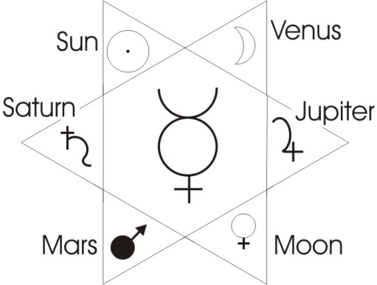
Now they very unfortunately translate vairagya as indifference. It doesn’t mean indifferent. It means, when you affirm your desire’s developments to the limit — in other words you work out logically where you must cease if you release a certain desire — then, if that desire does not carry you into a place that you’d like to be in, it dies. So as it dies, they have said it’s indifference. It isn’t indifference. It’s a clear, conscious awareness that it’s going to take you somewhere you don’t want to go.
So this concept vairagya is the concept of that state that you attain when you know that you prefer freedom to bondage. Therefore you say, Any stimulus whatever will lead me into a state of unbalance ... ‘imbalance’, they call it these days. This state of unbalance is simply a stress on one or other, or a group of one or two of these, such that the whole rotation becomes eccentric.
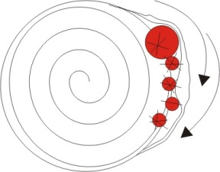
You can see what happens if we start letting this thing grow, the circle will start getting a bump on it, you see. And then the energies flowing round can’t flow round easily. You know that if you bend a pipe and there’s water in the pipe, at the bend, the pressures in the water going round the bend are not the same as they are in the straight bit, are they? So if you distort your form, you are creating trouble for yourself. The ideal form is the perfect sphere. We’ve got an approximation to it in the brain itself. It is slightly distorted like an egg, because we are teleological ... that is, we are purposeful beings as individuals. But the less individual purpose we have, the more we approximate to the spherical head. And the subtle form — the one upon which this one is built — in the perfectly balanced person is a sphere.

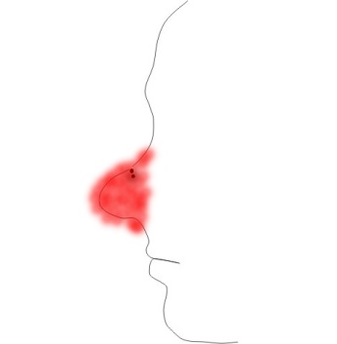
Sinus, Catarrh and Congestion
And when you become interested in a thing there’s a genuine flow of energy toward the thing, which distorts your form. So if we wanted to say, Here is a man who is not interested in something, and here is a picture of another man interested in something, and an interested man [laughter].
You get that distortion. There’s a real energy flow towards the object. And therefore when it comes to circulate round this difficult bend, the end of the nose tends to go red because of the friction. This isn’t merely fun, you know. This is a real process that goes on. You see a kind of cheeky look, what you might call an animal healthy look, about the nose of a person who has a lot of energy inside that’s directed towards the opposite sex.
It’s not accidental that popular wisdom says you can tell by the nose. The nose is an indicator, because the nose is really a phallic prolongation on the head. It’s the first hunting organ of sex and food, and therefore it’s nervously very, very closely linked with the lower regions. In fact one of the strange, mysterious things in yoga anatomy of the subtle body, is that there is a nerve going from the right nostril to the left testicle: an actual nerve track in the subtle body. There is a cross over. They mention that one particularly because it has to do with control of the will.
And you know all this sinus trouble and catarrhal trouble up here is primarily sexual in origin: it’s a congestion below reflecting itself up here. You see this one is anal, that one is phallic. This duality belongs to your judger in the two lungs.
And this thing up here belongs to your heart. This is the one behind here that the Chinese call the secret heart, as opposed to the fleshly heart. They say there is a heart of flesh that jumps when you get excited, and a secret heart that doesn’t jump when you get excited. The secret heart is in there. So there’s a relation between your breathing rate and the thing you look at. There’s a relation between the girl you are chasing and your nose. There’s a secretion, a mucous secretion actually starts in the sinuses in the nose at about puberty in the male, that wasn’t there before ... which produces those snuffling boys and so on for a period. If they get over it they will be alright. But it is there. These things have to be realised for what they are. They are very intimate, deep connections with different parts of the body. The body is folded over in a very mysterious way. [1:16:28]
You see if we take the head, and the chest and the belly, and draw a line through it, we can pretend that this lower part is in water and is a reflection of the upper part. We can then understand why the French word for head is really the word for these things down here [tète, testes]. There is on there an accent [in the tète] which implies an immediate S in the Latin. So the tète is really the test. Everything down there can be laid up and put on the head. And the lower part of the chest is related to that part, and the upper part to this. So you will find that in emotional breathing, the top part of the chest starts going, which it normally doesn’t do. And you get clavicular reactions. The collar bone will start being lifted up, where the thinking process is causing a shift from the lower urge centre down there where the deep breathing process goes on, to the upper one which is less stable. So you can see there’s a sort of mirror image there in the man. This means that for every disorder down here, there is a corresponding symptom up here if you know how to look for it.
You know there’s a thing in medicine called referred pain. You may get a pain in one place but it doesn’t belong there, that’s just the end of a nervous connection. It’s like shouting at a man in Piccadilly and then he’d go on his bus all the way to the terminus and shouts at another fellow who can’t imagine why he is being shouted at ... that’s referred pain. It’s just the same in the nervous system. You may get a damage in one place: a stimulus goes all the way down and appears in another place.
Now referring these things back to their proper sources is the idea. So if somebody complains about a symptom here, it doesn’t follow that that is the source of it. The source of it may be a conflict up there. And on the other hand, if somebody complains of a dull headache there, the cause of it may be down here in congestion. The whole thing is wonderfully and curiously made in this mirror manner. Now, we’ve seen that the broad outline of the six planets, and the seventh, the Mercury which contains all. [01:19:29]

Fire: Aries, Leo and Sagittarius
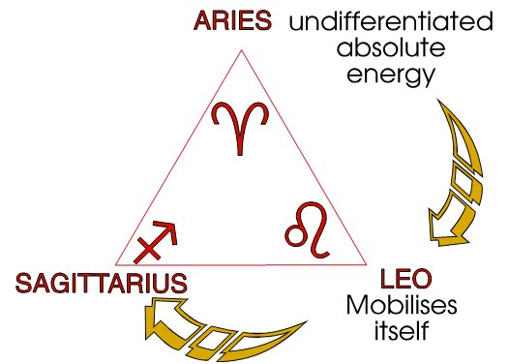
Now, let’s run rapidly through the signs of the Zodiac ... the Ram, Leo, and Sagittarius, and have a look at them. Those are the three signs of the nervous system. They are the three fire signs.
And this one [Aries, the Ram] is the undifferentiated energy sign. So the symptoms in such a person tend to spread all over the body ,.. they’re not so localised.
If we take the Leo function — that’s the head of the person, you see, you see the sign of the Ram in the head, very often marked very clearly in the skull front area of certain people — the Leo here is the heart centre.
And the Sagittarian force there is the centre that controls the thighs. So this kind of person has got drive down here on the great trochanters, the great law [tora] singing [cantor] bones ... the vertical posture between the animal and man. There’s an animal drive there pushing. And that drive is very valuable if directed, and it’s a nuisance if it’s not, because it causes quite a lot of leg breaks and hip troubles and so on, to a person who’s banging about with that centre dominant. This one causes the great expansion of the heart, the pioneering tendencies, and the inability to accept defeat.
And this one [Aries] causes the nervous troubles which tend — from the undifferentiated nature of the Ram character — to appear right through the body. So you can get a thousand symptoms from one little cause in a person born or stressed in that way. Now that’s also ruled by Mars, and therefore we can expect double trouble for a person in that department who is also not very well trained in control of the desire. You can expect the symptoms to shift, to appear over the whole body, to disappear, to appear in this corner, that corner, and so on. In fact such a person can be the despair of a doctor who gets one set of symptoms one day and a totally different set another day — now they’re in the big toe, now they’re behind the right ear, and so on — because actually they are flying about in the nervous energy. And they are not even in the physical body frequently... they are in the subtle body. So you can’t even guarantee to find yourself an organic cause if you examine the physical body. Because it isn’t the seat of the trouble. [01:22:20]

Air: Libra, Aquarius and Gemini
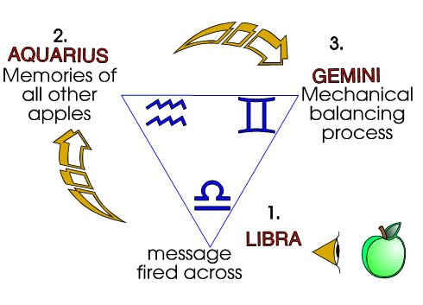
Now we’ll take next the air signs. We have Libra, and from Libra we would expect the perceptual organs themselves to be a source of trouble. You see, the five senses will be providing data which are not being properly assimilated, so that every suggestion that comes from outside receives a bit of attention. And as all the suggestions are not coordinated, it tends to produce a split in the person. So that this person, like the Ram person, produces a variety of symptoms all over, but they are not of a nervous order. They are more of an intellectual order, and we mustn’t confuse nervous energy with the intellectual order that says, This, and not this. Because this order of decision belongs in the lungs: the I like it — I don’t like it department.
Then we have the Aquarian position, and this is the field of the memory. We find that this is the person dominated by the memory of events ... not always their own events. Such a person can read symptoms. You should never give them a medical book, because whatever they read, they’ve got. And furthermore they can remember it an awful long time. And frequently they are very suggestible about these things. So that if anybody does diagnose them, they remember the diagnosis ... and add it to the others that they’ve already acquired. And as they happen to be a passive — like the memory is — you frequently find that kind of thing re-enforced by that lily-pale anaemic behaviour. So that you get this peculiar tendency to imagine a million undefinable disorders. And whatever you say, that could be it, and probably is, and so is the other one that you can’t have with it.
Because you know many diseases, you can’t have because you’ve got another one ... they exclude each other, like hot and cold left ear at the same time.
Now the Gemini function here is a disorder of the reasoning department, which is comparing two things at a time. In the case of the Libra it looks at everything, separately ... it doesn’t co-ordinate it. This thing [Aquarius] accepts it and absorbs it like the memory, and this department [Gemini] continuously compares it. So this person [Gemini] frequently spends the whole night awake thinking about the troubles of the day and wondering whether it should have said this or that, and whether tomorrow it should say this or that.
So in the Genesis 49 definition of this sign, you’ll find that he collects his information in the day, and he divides the spoil at night. All through the day he is gathering his data. All through the night he’s thinking where it should be put: this and not this [the twelve tribes correspond to the twelve signs of the zodiac]. And this actually produces insomnia quite a lot in these people, which again affects the whole process. [1:25:46]

Water: Cancer, Scorpio and Pisces
Now we’ll go onto the water signs. The sign of cancer the crab, which is a feeling sign. It’s an undifferentiating feeling, and this person is so diffuse that they cannot define the symptom at all for you. Everything is so vague:
Where is the pain?
I’m not sure that it’s there or on my right elbow.
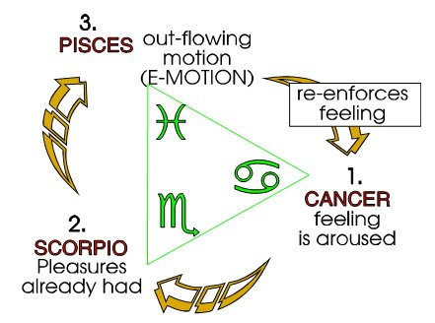
It could be anywhere. They’re not even certain that it’s in the body ... but it’s somewhere. That kind of person is very, very hard to diagnose, because really, diagnose is the wrong thing to do with them. What they want is formulation, clarity, which is the thing that they feel like wanting least. That is moon dominated, and therefore you expect that person to say, Act on me. Treat me. I don’t know what it is, but treat me. That’s the kind of person that fills many a doctor’s surgery ... they just go there. They don’t care what they’re treated with or by, as long as they’re treated.
Then there’s the Scorp’ sign, Scorpio, which is the sign of the water with Mars in it which makes it desireful. This is a feeling full of zeal. And this person is terribly zealous, you see. Whatever they’ve got wrong with them, it’s caused by zeal. And if you give them a treatment, they zealously take the treatment. And frequently they defeat the treatment by zealously taking it, because they won’t get rid of the cause. You give them a thing, and you say take these fifty pills in a fortnight, you see, so he saves them all up and a fortnight he swallows them all up, again and again. You just don’t know how to deal with him because he’s so zealous. He attaches himself to things.
And then you have the Pisces type, and this type is emotional ... they gush all over the place. They have a thousand things which they think are marvellous, but they’re all feeling things ... emotions. So their symptom is an emotional. If they have a pain, it isn’t the pain that matters. It’s, Can I utilise the pain to have a relation at the emotional level? Oh, Doctor, what is happening to me?
This kind of nuisance isn’t quite the same as this one. This one [Pisces] doesn’t sit there like this one [Cancer] and say, Diagnose me, I don’t want a Doc. This one [Scorpio] says, How interesting, how terribly thrilling, he says, I’ve got acute appendicitis!, and so on.
That’s the broad outline.

Capricorn, Taurus and Virgo
Now we come to the earth signs.
The sign of the goat [Capricorn]. And this person is concerned with absorption, and at the purely material level of food it is taking food in, and it’s in food intake that the trouble will come. You can expect a gulletal reaction. If they don’t like it, they kick it out. You know, you’ll get yourself a drive, a lift of the gullet to kick out what they don’t like. And in this Go-At or drive in the urge, you can expect they will be rushing to do something materially, and then when materially they are stopped, the reaction will be somewhere in the gullet, in the food absorber department. They’ll kick it up. And they’ll get the head of the stomach and kick it out through the diaphragm. They’ll tear it. They’ll push it up to here and say they’ve got heartburn and look down and you’ll find the stomach’s there. It’s all driving its way up all the time.
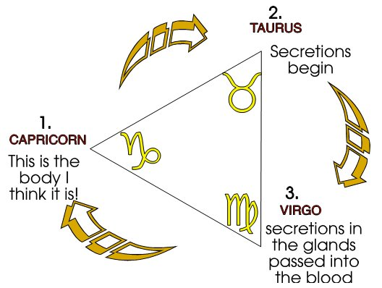
Now, then there’s the bull sign [Taurus], you see. And this is a slow, passive sort of fellow. People think he’s often very, very gentle, and it’s in the glandular secretion that his trouble is, as a rule. He gets all sorts of blocked up secretions that won’t come out. And he just gently goes along with the yoke on, bearing his disorders quietly, and he can last a long time bearing them. [01:30:01]
And then we come to the great problemable Virgo, which is the circulation in so far as it affects the gross material structure of the body. This is a very solid person. They generally look very strong physically, and they’re remarkably immovable. They’re actually ruled by mercury, and yet they’re an earth sign ... which is immobility. Their immobility is that there is a sort of churning process going on in them. So you expect that the symptom will appear where the blood is going through the physical tissues — not where it’s circulating through the arteries, and so on, and veins — where it’s actually got to get through the tissues in the solid parts and in the bones. You’ll find this peculiar slowing down of it, and a heavy, turbid feeling about them. And whatever kind of treatment you give them, they’ll take it very, very slowly, and they will recover if at all, very, very slowly. But they will feel, if they do recover, it will be a genuine recovery [all said in a very slow, measured tone].
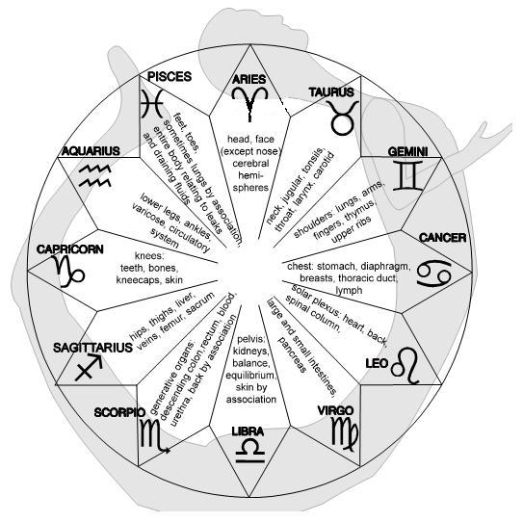
Now that is a very, very quick outline of those processes and if we take them all down and wrap them round the ...

[break in recording]

... and we’re getting all these going down the body slowly. We’re getting the Libra function here, and the Sagittarian function on the thighs and the Goat on the knees, and Aquarius on the shins and Pisces on the feet. In general that is the general place of stress in such a person. Now remember for a moment we’re ignoring heredity which complicates this. In its purest form you would always get the symptom at that level. And you can expect that some of the symptoms will appear ... perhaps next week I’ll do a fairly large drawing of this, and then we can discuss the relation of it. Because it is very helpful. But remember, in that form it is an abstract idea.
We have to consider a whole series very rapidly.
- The sidereal influences of the stars themselves.
- Solar influences, planetary influences. Terrestrial influences. Lunar influences going round it.
- And then the terrestrial influences include the terrain, its type, mountains, valleys and so on, climate, so on.
- Chemistry of the ground which gives you energy through the food.
- And then your nation, your family, your hereditament.
All those things constitute the concrete fact.
In the case of the fallen man there must be a very close relationship between the environmental pressures and the nature of the breakdown.
Oh, yes.
Because of the way in which the strain ...
Oh yes.
Is there something in man which is baser ... deeper than all these things that can control all of them.
Oh, yes. But first of all you’ve got to know what it is you’ve got to control. Give a man a motor car and you say, Well, you’re greater than the motor car.
He says, Where’s the gear lever, etc.?
It’s a modern car, it’s concealed. Just sit in it.
You don’t know where anything is. You see, your body is that vehicle. If you don’t know where anything is, how can you control it? Although you are a controller, if you don’t know at what point to apply the power, if you can’t understand a conditioned reflex, then you can’t understand how to release yourself from so many things that derive from it. Knowledge of the machine is essential. Without it, although you’re very, very great, your greatness counts for nothing. [1:34:38]
Would it be intuition once again, that would prevent the ...
[break in recording]

... that’s what we call grace at the ordinary level. He’s giving you something you haven’t yet worked for. Gratia: it’s free ... it’s free. It’s saving you from a lot of symptoms that you would otherwise exhibit.

Intuition
I see this intuitional process as something that’s always keeping you at the right equilibrium ...
Yes.
... without a lot of going round trying to work it out and that sort of thing.
Mm.
You are constantly brought to that equilibrium all the time.
The more you understand about that, and the more you’ve learned to become conscious of it ... the more you know. Not the less you know. Intuition teaches you about your motor car ... if you’ll let it. So that when you meditate on intuitive truth, you will find out something about the nature of your own organism and how it works. Because it was made by it [by intuition].
You see, one of the things I’m very interested with regard to choice of thought is where the biasing operation starts. Any thought that comes to you, what, when you start to think about them, you start to accept them don’t you?
Well you see, the whole thing, until you’ve learned to become reflexively self-conscious, is haphazard. It’s not under your control. Luckily, intuition helps some people. But it doesn’t help all people. There are 20,000 new cases annually of breakdowns in England. The world figure’s absolutely tremendous, of people breaking down. Not because intuition doesn’t exist, but because they cannot take notice of it. They hear it and immediately push it out of the way, because it’s not in line with their private purpose.
You see, the problem is created by stress, privation. Stress a particular and you have obscured a wider issue.
If you’re getting more detached, I mean that you’re not stressing yourself so much, your intuition will work better won’t it?
Oh, yes. Must do.
So that’s an essential tool ... getting this intuitional flow to start ...
Oh, yes.
... you have to detach yourself from the sort of thing that can stress you.
That’s right. Well in fact, if you attain complete detachment, at the moment you do, you understand the universe. That doesn’t guarantee that the next moment you will not restate a private purpose. Your will is still your own. You can understand it and lose it again.
But nevertheless the purer you want, the better your chance.
Oh, yes. In fact if you come to the point where you haven’t got any particular at all, then your awareness becomes universal. And it becomes a permanent state. The whole thing is to lift yourself out of the realm of accident, isn’t it? To get yourself out of the position where things come from outside and hit you, whether you want them or not. You go to the position where you can select what’s going to happen to you.
This is why it is said that people in general are at the mercy of accidents. They don’t have destiny. Anything can happen to them. But if you begin to cut down on your private purposes then you begin to get a destiny, which is the same thing as a destination ... you’re going somewhere.
That’s why you need this big idea ... universal principle.
Mm. [01:39:08]

Conscious Inhibition
This is very similar to Freud’s analysis, isn’t it? I wanted to ask you about the amount of energy you use in inhibiting these things ... must cause friction.
Yes.
It cou
ld eventually make you very static. Is that right?
Only if it’s done unconsciously. You see, the whole point about Freud’s analysis is this: he’s talking about unconscious elements that have been pushed down unconsciously. And they produce a stasis underneath. You become completely blocked by unconscious ideas, and then they start finding their own way out and expressing themselves in peculiar behaviour. Now if you deliberately hold an idea in consciousness and do not allow it to express itself although you are aware of it, the effect is totally different from if you are not aware of it and still inhibit it.
You take an idea that there’s something that you’re not allowed to do in the street. And instead of saying, Good gracious I’m not that kind of person, and push it out of your mind like Freud is talking about, you say, So it’s not the kind of action a fellow does in the street. You’re conscious about it, so you inhibit it. But you know what it is you are inhibiting. It then goes in a totally different manner. It beats in a different manner, it gets different associations, and it builds a highly complex conceptual structure that gives control. And nothing is becoming unconscious. Therefore nothing can work against you. [01:40:51]
Can you in that way then prevent the ill-effects?
Oh yes. There aren’t any ill-effects with conscious self-controlled elements.

The Permanent Conceptual Structure
[Khen] Is this control of that area which you drew last week next to the still centre, isn’t it? Where the immanent spirit is?
Yes. Permanent conceptual body.
[Khen] This was a point that Lawrence was talking about on Tuesday. What actually happened to that particular department as you got more control? Was it that you were absolutely aware of what was going on in that state?
Mm [affirmative].
[Khen] This is what you said now wasn’t it?
Yes. You’ve got a permanent conceptual structure round the hole in the wheel.
[Khen] That really is the immortal body isn’t it?

Order in Chaos
That’s the immortal body. You’re aware of it, and it is not stated to yourself serially what you are aware of. You are aware of the whole of it. You can select any bits in opposites from it, and play it out. It’s permanently there. It’s a geometrical structure. It’s a self defining thing — like all geometry is — and it can’t be broken, because all its parts are defined in terms of all the others. So if you’ve got one, you’ve got the lot. Once you’ve seen that a circle with a diameter through it, and another one at right angles to it quarters the circle, and that all subsequent partitions must conform, you’ve got a concept there that can’t be broken. [01:42:40]
So in reality in the mechanical man, that is a state of chaos, whereas in the immortal man, the finely balanced man, that is the very thing he’s integrating.
Yes. It’s no chaos to him.
[Khen] No, no, I say in the first state, in the state of the mechanical man it’s chaos isn’t it, because everything has been pushed sort of ... as a box room which has got full of junk and nobody knows where anything is in it. Whereas the man who has really been in the centre of the box room and is quite aware of where everything is simultaneously ....
So the same elements are in the chaos man ...
[Khen] Oh, quite, yes.
... as in this immortally ordered man. Only the difference is, one of them has got order, the other one not. It’s the question of the filing cabinet. But not an arbitrary filing cabinet like A, B, C, etc., in an office, but a filing cabinet of formal fact that formed fundamentally geometrical can be defined in very, very few terms in such a way that you have a simple ball which contain the solution of all problems.
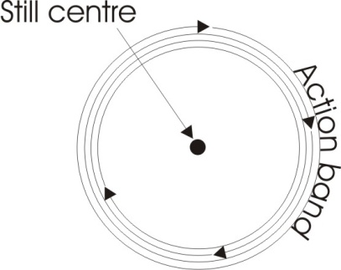
[Khen] And he knows that in varying situations it’s necessary to come further out through that other band to the perimeter, to the point even of ... I would say at this point, seeing things in that six-fold nature. That is, if he’s dealing on the perimeter he must be dealing in a plurality, and the further he goes in he would then be in a dualist and finally we would like to use the word totality or oneness, one or the other, it doesn’t matter, does it?
Well in totality implies one.
[Khen] Yes.

What “IS”
You can’t have that total unless you unify. You can’t have the unity unless you see the necessary relationship between the differences. Remember, difference is only doing two. De-facere ... doing two. And to do two is to get the wheel and spin it and notice that two emerge from it, because the centre is still and the perimeter is moving.
You’ve got duality out of a very simple unity by simply getting a disc — which is what, a piece of card — stick a pencil in the middle of it, spin it. We know that no part of that disc is moving relative to any other part, really. Nevertheless the centre of it is moving slower than the perimeter. This is the identity of opposites. It moves ... it doesn’t move. The perimeter is quick ... and it isn’t quick, not relative to the centre, because the disc is one and it’s going round relative to something outside itself ... not relative to itself. Relative to itself it’s not moving. So the soul is entirely still in itself, and yet in this kaleidoscopic universe it’s apparently being battered by a multitude of stimuli. Yet that isn’t so, because everything in the universe is simultaneous.
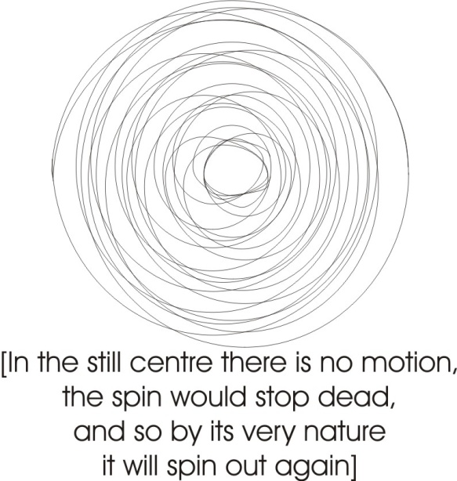
What IS, is simultaneous. So that everything is beating in the universe, and the beats diminish from the centres only through the imposition of beats from other centres. There’s an apparent serialisation of events, although all the events are simultaneous. Actually, all the future years that we will come to are already laid out. Like the past ones are in the memory, so the forward ones are in the Universal memory. And that doesn’t stop us choosing. We can choose from our memory in the past. We can choose from universal memory in the future, and decide where to go to. So although the whole thing is laid out, we’re still free to run about the map. [01:46:40]
When we use the diagram of the wheel, in the wheel is a theoretical point that has no dimension. How are we to regard the diagram in relation to what you’re talking about?
That stillness in the wheel is not theoretical, it’s practical. Look. In fact if we start taking a spin in — and remember, it’s a force we’re drawing — it cannot stop, can it? And it can’t go spiralling inwards and come to the logical term ... it would stop dead. It’s a motion. So in fact, what is does is go in and start coming out again. And it keeps going in and then going out again like that. All it does is going in and going out. But it never goes in there, so that centre is an existentially still centre. It’s not merely a conceptual centre ... it’s a real centre of stillness, a centre of untouched paper like that. So that the transcendent paper and the immanent paper there .... are identical essentially. And yet that one is inside and that one is out, and that’s your individual self and that’s the transcendent absolute. And yet they are identical, and all this chalk mark here is only action. In the action band, this rotation band here, the law band. It can’t do more than do that. It can never go to the dead end, it has to come out ... otherwise it will stop.
You get some kinds of spiral lines you can paint on a disc like that, and you spin it, your eye is drawn in and pulled out alternately. And it’s exactly that that’s happening. There’s no real motion. If you take the real as being the absolutely permanent, then motion is an illusion. That which is not absolutely permanent philosophically is not called the real ....it’s called the appearance. And the Pi Ra in appearance, means this rotation.
I’ve been a bit puzzled by this centre, because in the mechanical sense, it is only a point, isn’t it?
That’s Euclid. Not in the mechanical sense ... in the Euclidean sense it is. In the mechanical sense it’s bigger than a conceptual point, it’s a finite existential zone.
Well when I say in the mechanical sense, I mean in an actual wheel in a machine, the only part is the part which has no dimension, it’s so small.
No. You see, if you take an ordinary thing like a steel flywheel, you know that’s it’s made of molecules and it’s made of atoms, don’t you? So if we take the structure of that wheel here, with molecules and atoms, actually at the centre of that wheel there’s a space, like there is in that one ... round which it rotates. Because if there was not, you couldn’t move. Space is the precondition of motion.
Looking at it that way, the space that doesn’t move goes right through the wheel?
That’s right. Now that’s the whole thing. That’s why in that word space, you’ve got the ace. The ace is the aitch, or spirit. Space is the nearest thing we’ve got to it. And the only fault with it in European philosophy is this: when we take the Saturn concept and talk about precipitation, you see, or contraction onto a point. Prior to introducing this concept of contraction we have a line, which is neither contracted nor expanded. So imagine that that line is a definite amount of substance, and it decides to contract onto a point there. Then it must have exhausted this ... attenuated it somewhat, mustn’t it? [1:51:14]
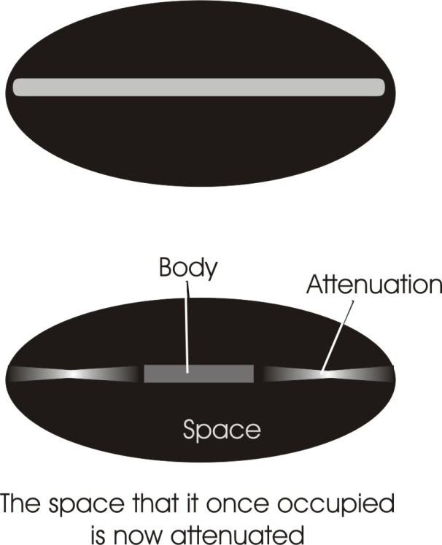
Yes.
Now it is this attentuatedness that we call space. You see? The attenuatedness. The Sanskrit for it is spanda, you see? The English word span. If you stretch your hand and feel what it’s like to do so, that’s actually the way the universal substance feels it ... as a span.
This is similar to the pole between the pole of a magnet and a piece of iron.
Yes ... yes, the same ground. You see, now we’ve taken that as a finite, but really this line is infinite. So we aught to put another one here, you see, and another one here. This is a plane through the absolute substance. So for every point of precipitation — Saturn — there is a Jupiter or expanded zone. And the pull is that way on that one and that way on that one, isn’t it?
Now if we do a perspective drawing of this, here’s a circle. So there’ll be a zone there, look, where the pull is neither that way nor that, won’t it? That’s space again. We call this a body, and we call this space. And the space is a precondition of the body. The body is the condensation, and the space is an attenuation of absolute substance.

Michelson Morley Experiment
When you get the elastic and stretch it, you see, well where you’ve got hold of it, it gets thick, and in between it goes thin. It’s that attenuation we call space.
You know the Michelson Morley experiment ....
Yes ... yes.
They thought they could detect a substance that we call space ... they found nothing, didn’t they?
Well, originally they thought they’d found nothing but later it was found that there was a slight distortion. [1:53:19]
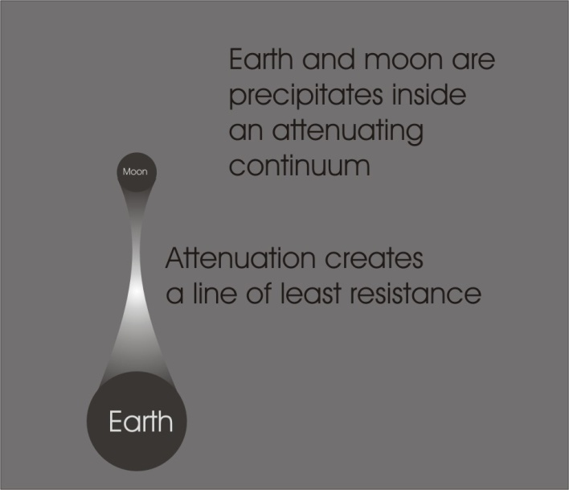
At that stage they hadn’t proved or disproved the existence of an aether.
Einstein has made the aether unnecessary as a concept, hasn’t he? Well he hasn’t really you know, he’s thrown the word out and retained another concept ... the space time continuum. He’s swapped the word aether for the word continuum.
Let’s pretend that this is the earth, and that’s the pole. We’ll say it’s the North Pole. Supposing the earth is turning, and supposing that earth itself is a precipitate inside an attenuated continuum ... the space time continuum. There’s the moon, another one. So there’s an attenuation in between there. Now if there’s an attenuation between there, we know that there must be a movement like that mustn’t there ... between it? And it’s that movement that constitutes the line of least resistance between the earth and the moon, doesn’t it ... which causes the water to try to rise up because there’s a line of least resistance there. That’s the cause of the tides. Now supposing the earth is rotating like that, it follows therefore that the field — that is, the continuum condition — must experience, there’s the atmosphere, a drag on the atmosphere, mustn’t it? And there on the continuum outside it, beyond the ionosphere and so on, there must be another drag. And if it’s going round that way look, the drag on this side must be in the opposite direction. So when you consider the velocity of light on this side and this side, the measurement are not equal. And the drag here compensates for this doesn’t it? This is why the Morley Michelson experiment apparently produced no result.
They tried to get a direction which was in line with the earth motion through space, and the direction which was at right angles to its motion through space. And if there’d have been a difference in the result it would have shown the existence of a base substance. But they didn’t get any difference.
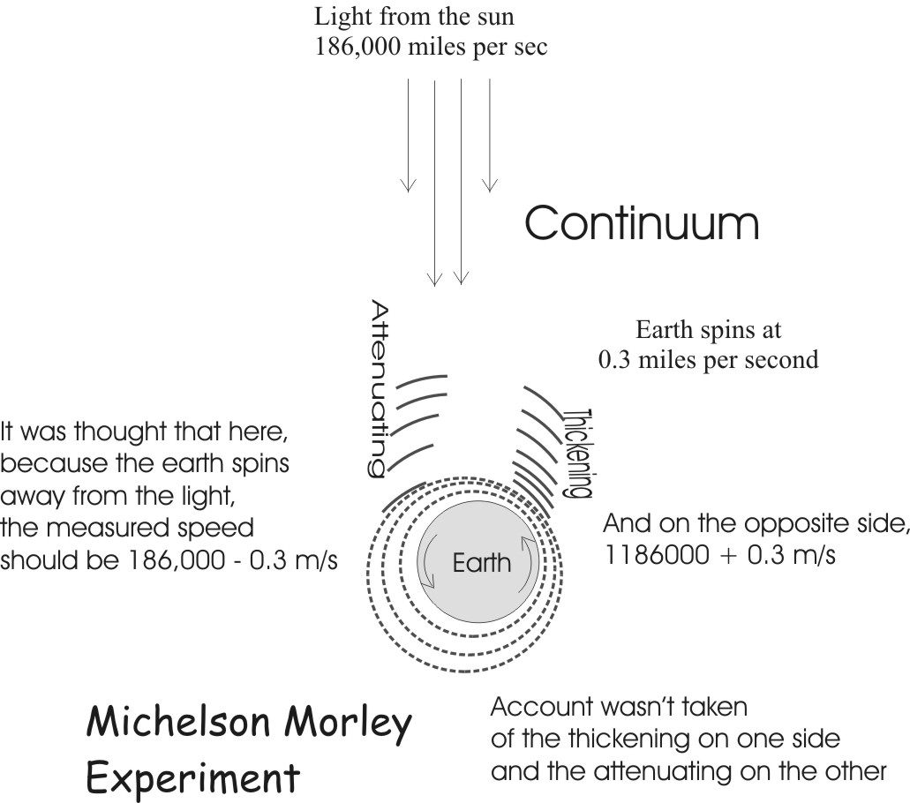
No. That’s because they were confused about matter and substance. The simplest form of it is, draw a diameter through the earth, say that that’s the equator of the earth as seen from above, say that the speed is 18 miles per sec there, and the same here. Say that these are rays of light from the sun, and that’s 186,000 per sec isn’t it? So on this side, because the earth is running towards it, a measuring instrument should measure 186000 and 18, and on that [other side] minus 18, shouldn’t it? That’s what it didn’t show. But it couldn’t show it because of the straining here which is carrying away that which should be added, and on the other side piling up that which should be subtracted. [1:56:31]

So it cancels.
Mm. It’s a continuum. And Einstein by throwing out the word aether hasn’t removed the fact of the continuum, he’s merely altered the term. All he’s thrown away is the concept of the aether as defined in the 19th century. Now that aether as defined in the 19th century was a solid. That is to say, there is nowhere where it is not.
It’s rather a large one to calculate for the density of the aether.
Mm.
They reckoned that it was the most dense thing there was.
Yes, in which case there’s no possibility of motion in it. You see, if we take the concept of infinity; you know god is everywhere: there is nowhere where he is not. This makes him even more solid than Monte’s aether. Doesn’t it? Because, supposing we say, well alright, let this pencil represent him, and we’ll just take a section out of reality and shade it with pencil, and we mustn’t leave any white paper, must we? And we block it up like this ... that’s the meaning of solid, isn’t it? We can’t put any more in it. That’s what it is.
Now consider that everything derived in that theory is derived from the shading ... isn’t it? Now if that is so, you cannot allow that a portion of the shading there can travel from there to there, because there’s shading all the way through it ... in the way. So if the aether was as defined, as dense as it was defined — and ideally it was supposed to be perfect density — motion is impossible.
And we go back to Parmenides in the fifth century B.C. who said precisely that ... the earth is solid, therefore nothing changes. Change is apparent.
And if we let this white paper represent spirit, there is nowhere where that is not, only we have not drawn a thing, and therefore we do not have to solve the problem of the propagation of things, because the paper isn’t supposed to move. [1:58:45]
Well might it be like a piece of string? If we said that a piece of string is a base substance, and we had a knot in the string which is created out of the base substance, but a knot has formed, and the knot can be moved along the string but the string itself doesn’t move?
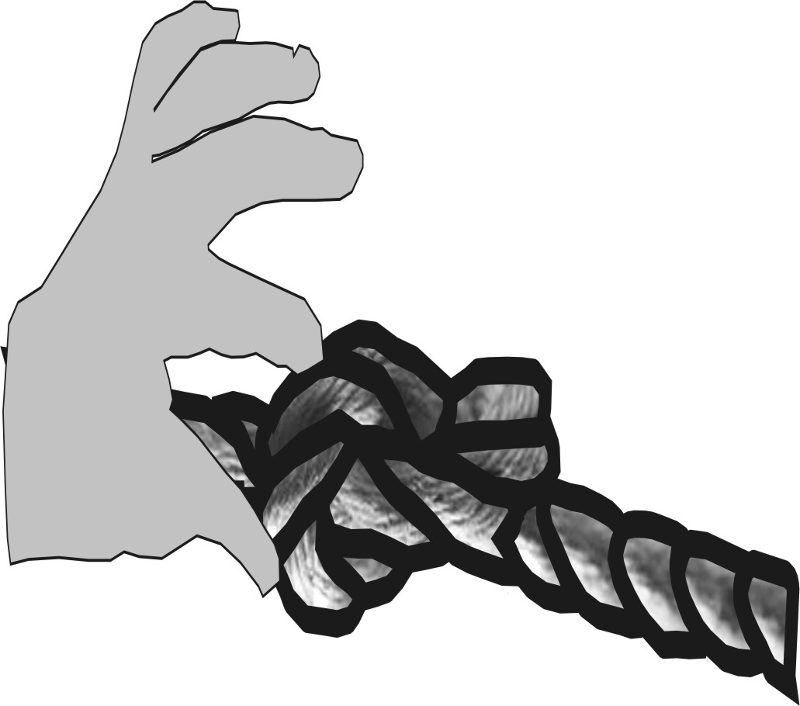
That’s what you call the world line view, you see. There is your piece of string, and you twirl it about and get a knot on it there, loosely, and then you get a bloke with a nice thumb and finger to push it along, don’t you?
You’ve got to account for the finger and thumb squeezing it along.
You’ve got to define what it is on either side of the string.
You see, a visual image like that should be drawn, and then you won’t fall into the trap. [1:59:37]
Well, an analogy ... we know it can’t be the whole story ....
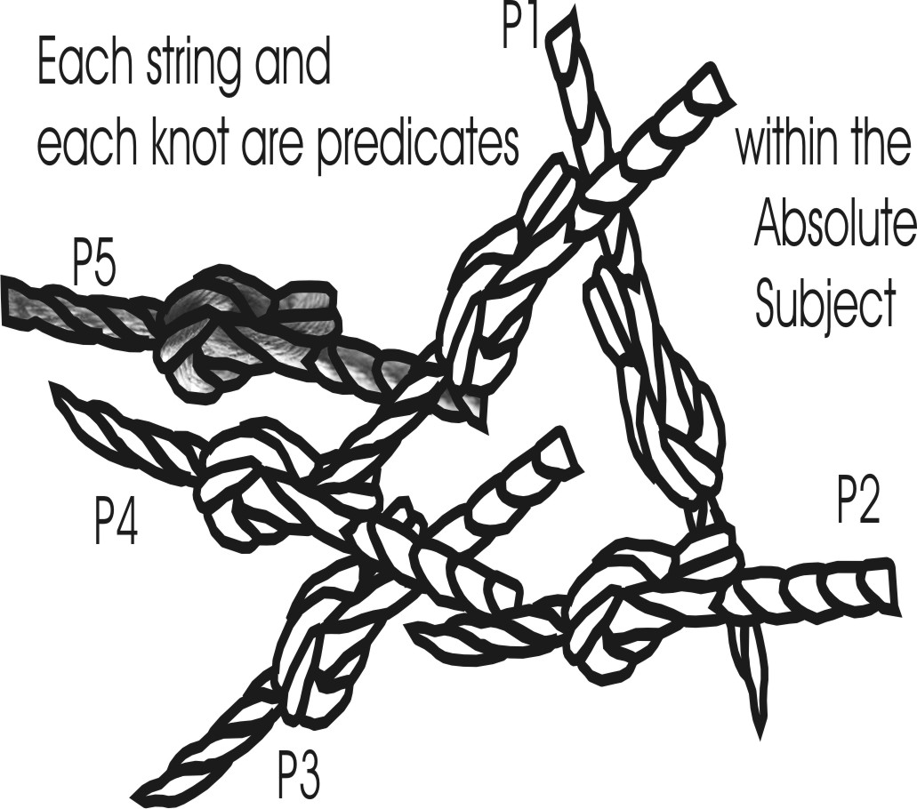
When it’s pinned ... its dead. It’s pinned, you see. It’s one of the predicates, one of the possible predicates of the absolute subject. You can’t exhaust it.
Supposing we said here is an example of a knot on the string, and here’s another piece of string with a knot there. You see, and there’s another piece with a knot there, and so on. You could fill the whole universe with pieces of string in contact with each other, with knots in them, all travelling in different directions. If we used the word node instead of knot it’s the same thing. We can talk about the nodes of being ... some philosophers do. We can call each one of these a world line, each one of those a nodal point, and talk about the relational transmission of nodal points. And it doesn’t solve anything. We’ve taken a visual image which is P, a predicate, and it has ignored how we managed to say there’s a plurality of strings if they’re in perfect contact. [2:00:48]
We couldn’t take it to be the whole, but taking it as a model it might help to get the answer.
Well, it might help you to get rid of another one not so good, but it won’t help you to get the answer. Because of that you see? And at the end you have to write ... [writes something on the white board] ... don’t you? So the model can never give it that. The subject, the predicate one, predicate two, predicate to the n^{th} ... it’s got no unity until you say plus S again. And you’ve got a worse thing to solve than that. Because how is it that if it is S, that you have apparence in it. What’s the relation between P1 and P2 if is isn’t S. P2 and P^{n} if it isn’t S; P^{n} and S if it isn’t S; and S and the first P if it isn’t S? It’s inexplicable.
One thing, in learning, as say in a school, on the educational method and so forth .... they can’t give someone some new knowledge or information until they’ve related it to what they already know. If the knowledge is thrown at them without it related to what they already know ....

Beings of Hereditament
Well according to Plato, there is nothing you don’t know. And if a child really knew nothing, you couldn’t even begin to teach it, because it would have nothing inside to relate it to. Factually, a child has been an egg, hasn’t it? And it is sentient, isn’t it? So that if you smacked the child with a nice hand, you see — one nice smack — it feels it. If you then condition the reflex by saying “smack” it gives it a stimulus on the ear, one on the tissue of the body, and the two become associated. It then thinks that the name of what’s just happened is smack.
Although you’ve taught him a second thing then.
What?
That is related to the first thing ...
You haven’t, you know ...
... you’ve taught him a word ...
... because that egg, that egg is derived from his father who was slapped before him.
You taught him a second thing which is a word, related to the unpleasant feeling when he was smacked before.
All you’ve done is re-stimulate a latent memory of the slapping his ancestors have had. Because his absolute ancestor is the Absolute Substance ... the first Slapper/Slappee. Otherwise you have this impossible: how do you impart the first knowledge, if you can’t impart knowledge unless there’s something to respond?
That’s the failure of the tabula rasa, you see ... the plain sheet. If it’s really plain, whatever you put into it is meaningless, so it cannot retain it.
To re-cognise is to cog, to fit. We don’t come in empty, we come in as beings of hereditament. You watch a little girl, she plays with a dolly. Watch a little boy, does he play with a dolly? [2:04:28]
No.
No he doesn’t ... he doesn’t like it. There’s something in him that doesn’t like it. He wants to pull a train to bits or something instead.
Yes, there must be something there to begin with.
You can’t begin to educate it, unless the form is already there. That’s the doctrine of an omnicist. The idea that everything is already in you, and what you do with the education is stimulate it so it bounces out. You get a form and knock on the outside of it, and the similar form on the inside responds. And your ancestors have already done it.
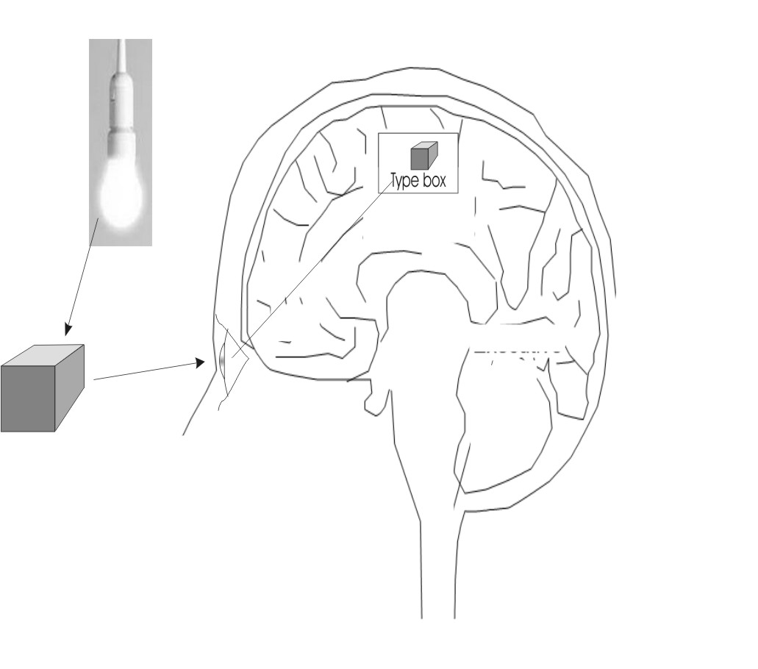
You know last week you showed us a diagram where the stimulation is received by the eye, it might be a box or something, and then the stimulation is passed on to the brain ...
... at three points ...
... the eye and the type box ...
There’s the light, there’s the box, there’s the ‘type’ box up there.
... well, does that diagram represent what’s called the association of ideas?
Well it covers it. But you see, this is the zone of association. This first time you see a box, if it were the first time you wouldn’t know what it was. All you get is a stimulus here. Now the fact that that isn’t true but that there is already a response in the child to it, it sees so-and-so and it puts its hands like this ... to something else goes like that. You see, if there were no relation whatever up here, the type boxes and type sticks and so on ....
Well the ‘type’ box must be there then, already!
Oh, yes.
... that wasn’t put there.
No, that’s it. It’s the ivory box of the Freemasons ... the skull. See that square box is only a spherical box squeezed, isn’t it?
Yes. Well, basically a box. And a box could be any shape.
Mm. And all boxes are distortions of boxness, and closedness. Every closure has its ‘type’ economically as far as surface area is concerned is a sphere. A sphere is the most economical surface area you’ve got for a given volume.
One strange thing this leads me to, you know, is that in all dealings with space — well first of all — in all everyday dealings with space, we regard it as three dimensional. The room has length, breadth and height. And you can extend that quite a good way, but it looks to me really that space aught to be regarded as radial ... a single dimension.
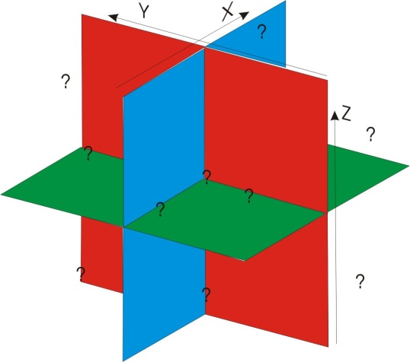
Yes. Well you must remember that 3-dimensional space is abstract because it says this: there is a plane like that isn’t there, and there’s another one like that, and another one like that, if you like. It’s obviously abstract. Because what about all the other places in between? They pick those out because they are at right angles to each other. A right angle is a line that has no direction in it belonging to the other one. That’s its definition, you see.
If we take this angle and that, this one is going that way and that one is going that way. They are going approximately the same direction. But if we rotate one until it is going in a direction in no wise contained in the other ... we call that a right angle. And it’s an abstraction, isn’t it? [2:08:35]
So 3-dimensional space is an abstraction of what is called the plenum ... the fullness. Today they talk about multi-dimensional space. They’re just coming up against the concept of the plenum.
Well true space is 1-dimensional. It’s a radial dimension. If you take a light source as the example, light radiates in all directions from that point.
You see, it’s the words that are doing it on you. Di-mension means two measures. You can’t say it is 1-dimensional.
Well it’s the box that brought me to this, because most boxes are flat sided. They’re either oblong or square. And they’re a distortion of true space really.
An abstraction of it. Not a distortion.
Well, a sphere, a hollow sphere would be the perfect box.
Why hollow?
Because if it wasn’t hollow it wouldn’t be a box.
Why not a full box?
Well that’s the whole ...
[laughter] You see how tricky the words are? If you don’t nail those words you find yourself talking in circles. Is a box, full, a box?
Well, a box as a box ...
I can make a box of plaster of Paris. And I can then pour plaster of Paris of the same consistency into it and fill it up.
Then it becomes a block.
Does it? It’s a box ... full of plaster.
If it becomes one it’s welded itself together ... it’s become a block.
That doesn’t prove it, because I’ve had toffee stuck in my pocket, welded into my pocket. This is what we are talking about, this dialectical opposition, you see? Things are and they are not, simultaneously. If you take one bit out and swear this is it and not the other, it’s abstraction. When you get the hang of it really, it’s the ground of all humour and all leg-pulling, because people are so much in finite grooves, and you know that those grooves are false, and you know how they are false, and you can lift them out and put them in another groove if you want. They can’t stop you until they can control the machine of thought. Hence vocabulary control is necessary.
Yes.

Mark 9:43-48 And if thy hand offend thee, cut it off: it is better for thee to enter into life maimed, than having two hands to go into hell, into the fire that never shall be quenched: Where their worm dieth not, and the fire is not quenched. And if thy foot offend thee, cut it off: it is better for thee to enter halt into life, than having two feet to be cast into hell, into the fire that never shall be quenched: Where their worm dieth not, and the fire is not quenched. And if thine eye offend thee, pluck it out: it is better for thee to enter into the kingdom of God with one eye, than having two eyes to be cast into hell fire: Where their worm dieth not, and the fire is not quenched.
Genesis_1:27 So God created man in his own image, in the image of God created he him; male and female created he them.
Genesis 2:18 And the LORD God said, It is not good that the man should be alone; I will make him an help meet for him.
1 Corithians 9:22/23 To the weak became I as weak, that I might gain the weak: I am made all things to all men, that I might by all means save some. And this I do for the gospel's sake, that I might be partaker thereof with you.
Matthew_16:19. And I will give unto thee the keys of the kingdom of heaven: and whatsoever thou shalt bind on earth shall be bound in heaven: and whatsoever thou shalt loose on earth shall be loosed in heaven.
Genesis 49:27 Benjamin shall ravin as a wolf: in the morning he shall devour the prey, and at night he shall divide the spoil.
In the Euclidean proposition, the point is fixed in space.
This figure works out at miles per minute. Actual speed at the equator is 25000/24/60/60 = approximately 0.29 miles per sec.
The name of an epistemological theory that individuals are born without built-in mental content and that all of their knowledge comes from experience and perception. Generally, proponents of the tabula rasa theory favour the "nurture" side of the nature versus nurture debate when it comes to aspects of one's personality, social and emotional behaviour, and intelligence. [Wikipedia]

