# Pursuit of Aim

Contents

Pursuit of Aim 1

Transcribed by J. Bailey 1

The Centre of a Circle 1

Empire 3

Declaration of Aim 3

Declaration of a Fight 6

Active and Passive Energies 6

The Self-contradiction of Control Ideas. 8

Non-Duality 9

Daring To Be Defenceless 10

The Kingdom of Heaven 11

Mutual Transcendence 12

Adam Wants a Helper 13

The Nature Language 15

French ‘main’ — German ‘hand’ 16

Om and Namarupa 16

Credit and Merit 18

# Transcribed by J. Bailey

With diagrams and arbitrary headings by J. Bailey

Comments are contained in square brackets [ ]

[Eugene begins, as usual, by reading out a question handed to him at the beginning of the talk, of which this recording misses the first few moments…]

…pick up compasses to draw a circle, I would have to be very quick.

I won’t read the rest of the question for a moment.

## The Centre of a Circle

We’ll consider this problem with the centre. We are often drawing circles, and here it’s been noticed that we’ve been drawing circles as if we could draw a circle without positing something we’ve not drawn actually ... a centre. And it was noticed here, that the mere fact that we can draw a circle at all, presupposes that we’ve already mentally posited a centre. And the statement here is made, *if we imagined a free centre* ... that is, one that was not constrained into any one point.

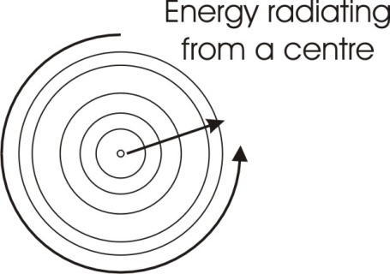We’ll imagine we start, we posit the centre, and we start to draw a circle, and we travel so far that the centre jumps over here. We would have to then go like this. Centre might go round here. And therefore, if we have a centre that is continuously translating, we cannot describe a circle with it. Now this might not seem tremendously important metaphysically, but really it is very important. Because, when we draw a circle, we have already posited a centre for it, and this circle is simply a demonstration of the fact that we have posited an invisible centre. We put the centre, and then we measure from the centre to a certain distance, and then keeping our eye on that distance, we translate. And the distance remaining the same, then a circle is drawn.

It obviously follows that the determination of this circle is a product of the centre and the radius ... the distance from the centre. If we imagine that this radius sweeps out a zone, keeping itself still in the middle, moving only on its edge ... the radius translating, with one fixed point and the other free, will describe a circle. The length of that radius we could consider to be an expression of the amount of energy radiating from the centre. We can now imagine that that centre is a point of issuance — or an essence point — from infinity, welling up at right angles to the plane of the circle, and flowing out along the radius, and losing force as it is flowing out, until finally it can’t flow further. And while it is doing that, it is sweeping out a space. And then see the amount of space swept out by that radius is really a measure of the force welling up from the essential centre. And this word *centre*, which we’ve done before, tells you that there is a singing law function in it, similar to cantor. A cantor in the synagogue is a man who is singing praises to God. And the centre of any being is a source of energy, a well from which forces come up and spread out. [4:04]

So if we say a man is feeling well, we are really referring to the fact that that man is in touch with the energies from the centre, which are flowing out without inhibition. But if he is feeling not well, it means that he’s become unaware of that centre.

Now if we imagine the centre to shift continuously, we could not circumscribe it with a finite, and therefore we could never find the limits of the issuance or the essence coming from that centre. And consequently we would never have a completed expression. And we tend to look for a completed expression as finite beings, because a complete expression seems to us to be secure. Now let’s see why this is so.

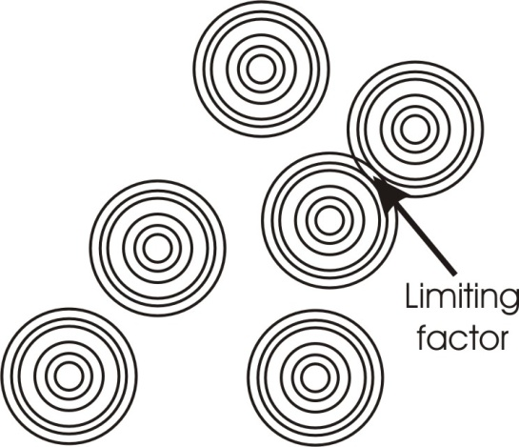The centre of infinity is everywhere. So we could put a dot down anywhere we like to represent it. Forces issue from the centre and flow out, and they flow until they meet a certain resistance. And the resistance is always the flow from another centre. So that unless we have a plurality of finite beings, we cannot create limits.

If we tapped all over the paper, the paper representing the spirit — and make an infinite number of centres, and then let from those centres force-of-spirit issue, and spread out from all centres — then wherever the centre forces from different places meet, a limiting factor will appear. And this limiting factor is the same thing as the body limit of which a being is conscious.

Remember, the white paper represents spirit, intelligence, consciousness, initiative, and so on, and consequently that white paper is aware of all these points simultaneously. It is aware that issuing to all these points is force, and that these forces although they all belong to spirit, issuing from centres to perimeters, press against each other and bring-to-be limiting factors, or zones of resistance. [6:44]

## Empire

These limiting factors are now the marks of empire. Remember, we said about the word *empire*, that it is a substantial, pi-ration or rotation.

We take a zone, we mark it out by swinging the radius, and we mark it with an ‘M’ to signify the substantial energies within it. And we know that the limits of dominion of an empire, are simply the limits of the radial force from the centre’s authority.

Every empire has been built on piracy ... which you know. Which means that there have always been beings going out, positing energies, and differentiating the environment into which they entered. And this *piration* is the idea basis, which when substantialised, becomes empire. So the first men who see the possibilities of differentiating the world, and go out personally, and press as far as they can ... are pirates. And after they have gone to a certain limit, the issuing energies from their countries of origin come along, and fill the place up with commodity translations ... or *trade* as we would call it. And then that is an empire.

Now empire, by very definition of the pi-ratio, is necessarily finite. And it is finited because throughout infinity there are other centres also doing exactly the same thing. So the limit of the authority of any given empire is that determined by other empires.

And we have a concept of the Beast[1], of leviathan, of the state as anti-Christ. If we take it that any empire or any finited substantiated zone — claiming to be the sole authority is claiming what is in effect impossible — then we can understand the meaning of the leviathan as an anti-Christ force. Any empire is necessarily finite, and any finite is necessarily limited by other finites ... all having their seat in infinity.

Each circle could represent an individual human being, as well as an individual state ... or a nation. The same law operates between individuals. In the centre of every individual there is an essential spirit, coming out and pushing to the limit of that body, and trying to express itself in the environment. It is met by opposing forces from other centres. And according to the degree of pressure that it feels against it, so it can find out the possibilities of its own essence. [10:14]

## Declaration of Aim

And we have another question here related to it, where it says that,

…the declaration of an aim is to start an opposition within oneself. The Will, not wanting to be bound by the declaration, puts into motion action steps, which will eventually destroy the fulfillment of the aim.

If we declare an aim, we have divided, and we have locked up and tied together differentiated points.

To declare is already to formulate ... and therefore to finite.

We take an individual who declares his aim, then he must be, in declaring his aim, finited in the consciousness identification. In other words, he is no longer equating himself with the white paper or the Infinite Consciousness when he declares an aim. As soon as an individual declares an aim, he has finited himself, identified with a finite, and underneath he’s perfectly aware that his infinite self, the spirit in him, could not possibly be satisfied ultimately with the fulfilment of that declared aim.

So that declared aim can only be a temporary aim. It cannot be an eternal one.

So that underneath, on the declaration of an aim, there is an immediate reminder that all declared aims are finite. And therefore there’s a preparation inside to get ready for the period when that declared aim shall be fulfilled, in order to transcend that declared aim and do something else.

This means that as soon as you declare an aim to yourself, you have actually declared the contrary aim, simultaneously. And it is only a matter of time before you will have to admit it.

Supposing the great Will to Dominate, which we represent by ‘R-M’, to rule the substance. We declare that we will rule infinitely. We are cleverer than Hitler, who wanted to rule only for a thousand years. We are going to rule infinitely and eternally. So we posit that from a given finite centre we will be able to send out radial forces to infinity, and dominate infinite force.

Now as soon as we say this, we see immediately the ridiculousness of it. We cannot, from a finite centre imagine infinite energies coming up, translating to infinity, and dominating all other centres that might exist. We can imagine a clash between two fairly contingent beings, resulting in a victory of one of them over the other. But we can’t imagine that any finite is actually empowered sufficiently to dictate to the infinite number of centres in the Absolute.

It therefore is obvious that the declaration to rule Absolutely comes up against this deepest awareness in ourselves of the impossibility of doing any such thing. So that there is an immediate compensating activity inside, to explain to ourselves why we will fail when we do fail. In other words, we safeguard ourselves against the failure to dominate infinity, which we know must come. [14:16]

Now supposing we declare an aim at all. We have in fact fixed it, and in that fixation we have posited that that aim is only for a time. If we recognise that the aim is for a time, we can declare the aim for a time, and then say, *and at the end of that time I will abandon it*. If we are so clear that we can abandon it — we are so clear that we can do away with it when we come to the term, and we actually succeed in doing away with it — it means that we have not suffered from inertia.

If we declare an aim, and say we will finish with it at a certain date, and in fact we fulfil it so well that our energies are running into it, and we find difficulty in stopping it, then the inertia will try to make us go beyond the declared end. And at a certain point we will be refuted. An example is of a fellow I know who a few years ago declared that he'd make a certain amount of money in five years and then stop, and devote himself to art. Now, he worked very, very hard, and he made the amount of money he had declared he would make in five years, in three.

And instead of stopping he said, *Well, I did say I would work for five years*.

So he decided to extend the definition of the amount of money he had to make, and changed the definition to, *as much as can be made in five years*. Now that was inertia, making him carry on beyond his target money. And the energies running towards that money had so piled up that he could not in fact stop it at that time.

So I said to him, *If you don’t stop now, in five years you will find it harder to stop than you do now ... because you will have two more years of extroverting on this target*.

But he said that he was sure he could stop, because he had promised himself five years. So at the end of the five years, he had more money than he had anticipated, but he then decided that because he had attained the aim so easily, it wasn’t really a fair test of his powers, and he should work for another three years. [16:56]

Now he went on doing this, and about the seventh year after this declaration, he suddenly had a very violent attack of kidney trouble, and he was disqualified from further work for a bit. But when he recovered from that, the inertia of *the making* had grown. Because now he had been knocked down by an illness, and he felt he could have made more if he hadn’t have been made ill. So the inertia of the initial aim pushed on further. And since about 1942 he’s been through a series of illnesses and breaks down — [*as an aside*] is it ‘breaks down’ or ‘breakdowns’ — and he still has this inertia. But now he hasn’t got the physical capacity to attain those things. He *has* done himself quite a lot of harm in the process.

Now, he can’t stop in the mind. He can’t perform in the body the things he wanted to do. He wasn’t constitutionally very strong in the first place. He cannot perform in the body, but he’s still galloping in the mind. So he thinks that some time in the future when he’s recovered physically, he will have a go and transcend all previous records, and hit the several times millionaire class, and show that if he’d have kept his health, he could have done it ten years earlier.

The point is that when an aim is declared, a definite amount of energy has been circumscribed ... which means that a certain amount of energy has come from centre and pushed to a perimeter. And the perimeter is always determined by the amount of energy pressing from outside from other centres.

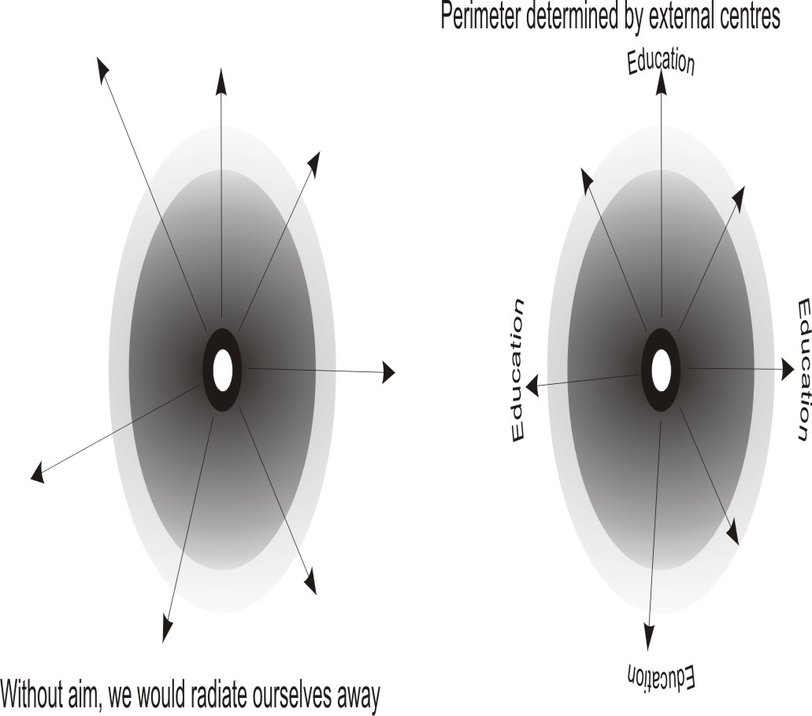

When you come to define inside yourself as a human being, as a social being, as a traditional being, you are really being circumscribed by your education, even in the very form of your declaration. Thus if you are a Hottentot, the thing you will define as an aim will not be the same as if you are an Englishman, because your vocabulary will determine the form of the declaration. Which means that the pressures of tradition, the behaviour patterns of other people now no longer extant, are pressed upon you. Your essential energies have come out and met those social limiting factors or definitions, and where you have felt sufficient strength to push them a bit further, you have declared that you will push your perimeter to such a distance.

But where the social pressures are manifestly too great to overcome, no attempt is made to reach that far, and a lesser definition is set up for the time being.

So this declaration of aims depends on the finite situation. When you have got that finite situation declaring inside your own consciousness, you will tend to think that you have declared an aim. Whereas in fact, if we were to remove all the factors from outside the individual, declaration of aim would be impossible. [20:32]

Remember when we said, [*scrolls through the paper which is used for illustration*] when we said that a centre sending a force from itself to infinity would not get that energy back, and consequently could not know the nature of the energy it had sent, we said in effect that a being sending a force into infinity cannot declare an aim. But if it sends it as far as it can, and on the way out that energy is met by a resistance, and that resistance reflects it back, then the amount of force with which the reflection comes, stimulates the being which is the source of that force, and makes it say, *I think I could send it a bit further …farther*. So it is the reflected energy from a limiting factor in the environment that determines the so-called *declaration of aim*.

In infinity we would not define aims at all. We would simply radiate ourselves away. But in a finite situation, the reflected energy from other finites is the cause of the declaration of aim. [21:58]

## Declaration of a Fight

And you’ll see this in small boys. A small boy won’t declare that he will beat another boy in a contest, unless he’s already seen that boy beaten by another boy that he thinks he could beat in any case. There is always something in the environment which has been reflected back, and the strength of the returning motion is the cause of the declaration.

Supposing we take any being at all measuring itself against another being. We’ll take two men who think they can fight. One sends out a declaration, *I will grind you to powder*.

And the other man opens his mouth and shouts back, *I bet you won’t*.

Now the violence in the tone, the compacted energy of the returning tone is taken as a measure of response to the challenge, and some sort of indicator of how much hope of success you have.

A sends out a challenge to B, and B bellows back to A, *See if you can do it*.

Now, if A has a sufficiently rough response from the tone, and feels that A’s being is already disintegrating from the verbal shock, it tends to withdraw the declaration and say, *I was only fooling*.

But if the tone that comes back is very, very soft and veiled, and somewhat timid, and says, *Please don’t*, then he will tend to say, *And I’ll tear your ears off as well* … extra.

So this fact that the energy sent out from a challenging centre being reflected back, and the character of the reflected motion disturbing the initiating centre, this is the cause of the so-called declaration of aim. So we see that declaration of aim in this sense is not particularly brilliant from the point of view of the individual. The individual cannot declare an aim unless he challenges in a finite situation, and some entities in the finite situation return that energy back with a certain amount of force. [24:30]

## Active and Passive Energies

Now, there’s another part to this second question here ... which is not a question, so much as a statement.

It is said that the translating energy is more aware than the rotating energy. And the latter is therefore passive. But what of the translating energy which comes within the orbit of the rotating energy … is this not then passive to the rotating energy?

This is the same problem viewed from a slightly different level.

If we take the white paper to symbolise the infinite spirit again, and not being circumscribed, it is pure initiative, is non-inertic ... then it is the Supreme Active Being. God is defined as pure act. There is no inertia in him, and no mere potential. He is pure act. Which means that he’s an absolutely non-inertic initiative intelligent force.

Now when a certain amount of force rotates, then in the fact of rotating, it has established a self-stimulating system. And this is the meaning of inertia, the in-working[2]. It is affirming the working within. Now as soon as it does so, it has finited the object of consciousness for itself, and is therefore passive to this force from outside. [26:16]

All the energy involved inertically in *being*, is subject — from the translating energy — to stimulation, where it taps its perimeter. And this perimeter stimulation produces changes within the inertic system, which that system has not itself initiated. It is all being used up in simply *being*, and the translating forces hitting on its perimeter in-form it. And then when it refers to the forms within itself which it has not created, and tries to operate from them, it is really passive to this translating stimulus.

The question then says, “*what is the relation of the force translating within the inertic system?*”

Let’s represent the inertic system simply by rotation, and imagine that there are some forces wandering about inside that are not rotating. And we'll have to be very careful. To keep them not rotating, we must make sure that they don’t get their tail-in-mouth, and so on. We can see that immediately we do this, that the translating forces cannot translate infinitely within a closed place. It can wander about for a certain length of time, but gradually he will block up this zone with motion.

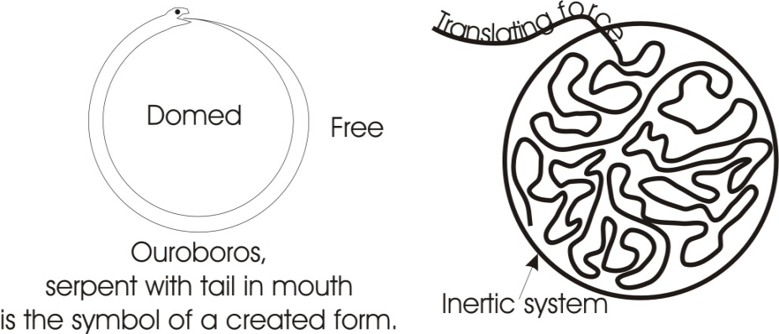And because of this limiting factor, the inertia factor of the perimeter, the energies which were translating in time inside this finite zone, at a certain level will have to rotate ... because they will be blocked. They cannot wander indefinitely. So an order is imposed by the fact of the rotation, on the inner forces which are translating.

Imagine this circle represents a man and he takes in a bit of food which is energy from outside, and that food energy is digested and then carried into the body. Although at first it might wander about and produce discomfort, as in the case of indigestion and headaches and so on in some foods, nevertheless the whole body cycle, the rotation of the nervous impulses, the circulation of the blood, the fact that the body is a cyclic entity, gradually imposes upon this introduced energy of the food, the order. Remember the *ord* in order is the same thing as the *rote* in *rota* and the *rod* of office[3]. So the order is simply the fact that the thing is forced to rotate. That means that we cannot have a force finited within a zone that will remain disorderly, eternally. Which means that the internal energies inside any closed system must become passive to the closure.

Now the forces outside the rotating system are the spirit that we call the spirit of God. And this is active, and stimulates the inertic system itself. And the inertic system itself, in its rotation, imposes order — cyclic rotation — on the forces within itself. So if the rotating system is passive to the Infinite outside, it is active to the one inside, and therefore the inner forces are passive to the infinite. [30:21]

We can see here that an individual being who thinks he can do something from himself as an individual, is grossly deceived ... *grossly* deceived because there is a contingent gross relation. When it says, *Of myself I can do nothing*[4], that is, a finite being declared as such. The more clearly I define my finity, the more finite I become in my application. Of myself as a finite individual I can do nothing, because I have circumscribed nothing. I am zero.

Outside, there are stimulating forces of the spirit, hitting and producing reverberations within. Those reverberations brought in, in this manner, are enlightenments. They are determined by the character of the stimulus from outside.

So the whole process of inner formulation inside the finite depends upon this external stimulus factor. So the finite being of himself cannot do anything at all, because as an inertic structure the whole of his forces as an individual, are involved simply in *being*. So if I identify with myself as an existential being, and I keep my eye on my finite perimeter, in the act of doing so I finite my capacities. That is, I go under the law of the definition of inertic systems. As soon as I accept the definition of myself as a finite gross body, I go under the law controlling finite gross bodies. But I don’t have to accept that definition, because factually there is no separation between the paper inside — the paper under the drawn circumscription — and the paper beyond it. [32:31]

All is spirit, and spirit is initiative, and therefore even inside this circumscribed being, initiative intelligence *IS,* and need not accept the circumscribing line as a statement of absolute reality. I can accept my gross body as a limiting factor relatively, to distinguish it from the chair upon which I am sitting. And at the same time I can be aware that there are other forces than the gross, radiating, even at a very low level ... the warmth of the body and so on, and certain electrical and magnetic emanations transcending that finite self. And the moment I get this transcendent consciousness — that is I refuse to accept the definition of the gross body as ultimate — then I become aware of field forces beyond the gross body, and begin to participate in something over and above the merely gross contingent. [33:39]

There’s a little autobiographical statement here about this free centre thing:

Thinking about the free centre needing a free perimeter, which of course is equivalent to no perimeter, just like a free centre could only be an unbecoming in any place at any moment of a centre that was, I felt I must take this circle off the paper, set up in the mind a picture of vectoring forces about a free centre. Then I would have a look at it and see what sort of surface or perimeter it would have. Of course it only made me dizzy ... but I've thought.

The name is wrong. Turning forces, moments, are what should be drawn. A moment is a unit of time. I became excited. I thought “I am going to see the space time relationship”, and that means a leap out. You need a shift in consciousness to see that. Then the whole thing escaped and I felt deflated.

Now, what was seen was that every finite circumscription has been described round a centre, and the centre has already been posited before the circle is drawn. Because to draw a circle anywhere at all, first we must say, *We will draw the circle round this point, or round this point*, but the point is always there. So in positing a finite circumscription, we have already posited the control factor, the centre. And yet we need not have placed it here, we could have placed it anywhere whatever.

And from this arose the idea that if the centre was to travel and you started to circumscribe it but it kept on the move, you would never actually enclose it, and this would give rise to a transcendent awareness ... which of course it must do. [35:55]

## The Self-contradiction of Control Ideas.

But it is equivalent to doing this: take any control idea and posit that as a centre, and round it posit the definition as a perimeter. Take a term and define it: say *democracy* is the central idea, and *government of the people by the people through the peep hole,* and so on, is the extended definition of the centre. When you’ve said that, you have limited your consciousness, objectified it, and placed yourself under the law governing those ideas. If you retain those ideas now, you will not be able to get out of them.

In the mono-ideistic state of certain mental disorders, people do get fixed with such a continuance of idea ... cyclic presentations. But if we take that idea, and we begin to define it, and then shift the idea, we will find that the perimeter will shift with it. And this will help us to transcend the idea that we started with.

Supposing we take democracy again, and we say, *democracy is government of* … , and then we shift, *I don’t mean democracy, I mean people in general*. People in general is … what is it? It’s no longer government of the so-and-so. People in general trying to control themselves is … what is it? … people in general trying to control themselves. What is *control* and what is *people*? The thing splits. [37:38]

Now as soon as a thing splits in this manner we have to define *people* and *control*. Now we find that people, etymologically, signifies lack of control. There’s a little arch at the back of the knee from which this word derives its root [popliteal], and a preoccupation with sexual activities that goes with it. And if you threaten emasculation, and the being then immediately promises to behave, or bends the knee in obedience. then that being deserves to be called a *people*, or *a member of the people*. So lack of control and fear of deprivation of energy, is the mark of people. Whereas the other idea, the idea of control, is exactly opposite.

So we find that the idea that we wanted to tie as central and surround an extended definition, actually had in itself its own contradiction. It had tied together the idea of beings that lack self-control and the idea of control: the idea of *demos*, disintegrating substances, and the idea of the *crat*, of control, of government. So the thing is self-contradictory. This immediately releases you from the idea of democracy.

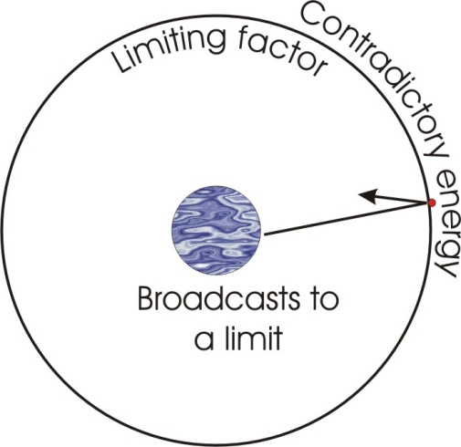Once you’ve seen that *demos* means lack of control and the *cracy* means control, then you cannot believe in democracy, because it refutes itself. This allows you to transcend that idea. Now if you discover that every idea that you posit as central can be defined in the same way, and contains within itself its own refutation, then you get the idea of the continuously shifting centre.

We’ve already seen that this particular centre's split into two, where as soon as we start to define the nature of these people that through fear of deprivation of power, will obey; and we have to define ‘power’ and ‘obedience’; and when we come to define ‘obedience’ we are talking about a relation between beings, where one being is superior and gives orders, and the other's inferior and takes them; or we come to define ‘power’ we’re talking about causation, and cause implies a relation between active/passive ... the thing is splitting out all the time, and continuously transcending the definition from which we started. [40:16]

Now, if we accept that no matter what definition we start with, if we declare it — that is, make it clear — we will necessarily, in the act of clarifying it, begin to expose a self-contradiction in it. This self-contradiction is the ground of the necessity for giving up the individual as such. Remember, that when a centre broadcasts to a limit, this limiting factor that reflects back its energies is the same thing as contradiction. If there is no contradiction, then there is no awareness in that finite. This returning energy, the reflecting energy from another being, is the same thing as a contradictory energy, and as declaration is only possible where energy is sent out or reflected back, then every declaration is evidence of contradiction.

Now in the Tao Teh Ching it says, *He who does not declare his aim cannot be said to fail*. And William Blake says, *He who kisses the joy as it flies lives in eternity’s sunrise*. This is the same statement from two different points of view.

If a being discovers that identification with his finity, and sending out energies from that finity, results in a return and a declaration from himself — and that declaration, being broadcast, produces further reactions to the refutation of the declared aim — then he will learn not to declare. But not to declare his aim is the same thing as not to identify with his finity. If he doesn’t identify with his finity, well then he will become that which he is before the identification … that is to say, not different from the Absolute Spirit.

## Non-Duality

Now the Absolute Spirit represented by the white paper cannot contradict itself. Contradiction can occur in a fold, but it cannot occur in the essential paper itself. So if we do not declare our aim, we can still get on with life, pushing, and taking no notice of motions reflecting back and trying to force us to a declaration, but committing ourselves to an infinite progression, and refusing to take any definition given to us on the way to it. [43:10]

Now this means that we have to learn to ignore the responses that other beings make to our actions. On another occasion we said that in order to discover the kind of force resident in you — the wherewithal to function — if you send out a force and hit it against an object, and that object hits back at you, then you will know something of the character of the stimulus you sent out, insofar as it is reflected. This means that you can learn something about your own nature by seeing how other people react to it. But we are now saying that you should never accept this reaction as ultimate.

Something is being said about you, but what is being said about you is being said as much about that *other* finite being as it is about *this* finite being. And what we want to do is transcend all these limiting factors.

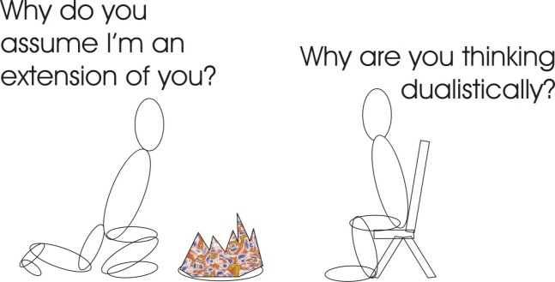Last night a fellow said to me, putting coal on my fire, *Why do you assume that I am an extension of you?*

And I replied, *Why are you thinking dualistically?*

Now, at that moment he was doing a certain act, and he was identified with his finite body. And he was saying, *There is another finite body over there, with an intelligence in it like mine, but that intelligence is assuming that this body is that body”* … which is not going on at all. [45:08]

The assumption here was simply that there is no difference between that centre and that centre, and indeed between those centres and any other centres anywhere else. And there being no identification with the physical body as such, there was at that moment no reason why this body rather than this body should do that particular act. But this particular body being more identified in the zone of that consciousness, thought that there might be this process going on … of identification with bodies. It was not actually going on.

Now when he made this statement, he declared something ... he made clear. But what he made clear was that he was identified with the gross material body. That was a declaration of a limiting factor that he had imposed on himself.

Now when I spoke, I put a question, *Why are you thinking non-dualistically …thinking dualistically?* [Eugene appears to quickly correct himself here]. That is to say, cross out all these rotations and then there is identification with the white paper. And then it’s a matter of economy whether that particular body or this particular body does it. If you can accept that fact, obviously you’re going to expose yourself, because it might be more economic for this body to do it on another occasion while that body lies down and reads a book.

Now, it’s fear in most people, and in people as such, that they, if they accept the non-duality, may find themselves economically in the position where they have to do all the work. [47:51]

*[... a possible break in the recording at this point.]*

This means to say that to aim is to precipitate oneself into a finite situation. But all finite situations place you under The Law.

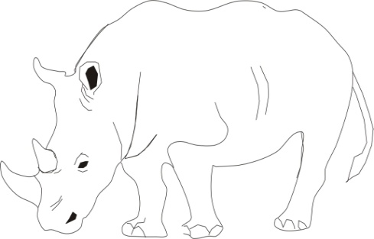Now again, the Taoistic definition of a sage is very like Christ’s definition of one, only it says it more openly. *He who leads an aimless life will arrive*. Now, at what? To aim, by definition, is to posit a substantial point, and to aim your energy to act on that point. So all aiming is finiting of energy, finiting of one’s consciousness, identifying with the finite situation, and in the fact of that identification going under the law of the form of the aim.

Thus if a youthful enthusiast aims to become the world’s best bowler, he commits himself to practising very, very hard in a certain way. If he doesn’t practise and concentrate and identify, he’s not going to be any good at it. In the process he becomes progressively less and less and less universal. [49:22]

## Daring To Be Defenceless

If we look at the rhinoceros — you see, with the nice big nose it’s got, and small eye — this once upon a time was a man. We’ve said this before: that all the animals and the plants and the minerals are really degenerate forms of the cosmic man. This is a man — you can tell by the leer in the eye that it was a man actually — this is a man who decided that it would like to go to people, wherever they were. So it projected a lot of energy down to the end of its face, and pushed it up, and grew itself a hard projection.

Now having grown it, it had committed itself to use it. And every animal that has grown special means of defence has finited itself and identified with its finity, and thus gone under the law. This rhinoceros has gone under the law of *proddery*. Simply because it’s committed itself to substantiate its being as a prodder, that prodder commits the psyche which projected it to a continuance of it. It is now an inertic prodding being. And you know that the rhinoceros in heraldry becomes the unicorn. And because of this wonderful piece of horn that it grows, the rhinoceros needs protection from the government. Because people keeping chasing the rhinoceros and cutting it off and grinding it up to make aphrodisiacs. [*Laughter* *from the audience*.]

This of course is sympathetic magic from a very low level. But the fact remains that even in this enlightened day, rhinoceroses are pursued for the sake of the mysterious potency of that horn. And that horn is simply the gross objectification of the Will to Prod. And its chemistry is actually irritant in the ‘prod’ sense. And it has committed itself in that way. [51:32]

The Taoists used to say that the monkey that bothers to make itself very colourful will be pursued. And the bird with the beautiful tail — the peacock of course — has been turned into a garden ornament. Whatever its purpose was in doing it, as soon as it has declared its aim, it goes under the law governing that sort of being.

So if you do declare your aim, if you admit that you are a Liberal, or a Conservative or whatever it is, you’re in trouble ... as soon as you declare your aim. To have an aim is to be finite.

Now, we’ve said before that when the human being is born, it is, of all the animals, least equipped to take care of itself. It has no horns on its head, it can’t peck like a chicken, it hasn’t got any long fangs like a sabre toothed tiger, hasn’t got long good nails like an eagle, and so on. It is quite defenceless. And this defencelessness of the human child is the very type of image used by the Taoists, because its defencelessness is that which forces other beings to take care of it. If you can dare to be defenceless, somebody will take care of you. That is the lesson of the baby.

Whereas in the case of all the animals that specialise in defence weapons — like the elephant, the rhinoceros, the stag and so on — the magnificence of their defences is the occasion for them being hunted and killed and hung on the wall. When Christ says, *If we do not become as children we cannot get into the kingdom*, he's making the same statement[5].

The child’s bones are not bones. They’re just like weak rubber. Because of this, the Taoists say when the baby falls, like the drunken man it doesn’t break a bone. It falls relaxed, because it’s so ignorant, it doesn’t know that falling is dangerous yet. Later on when it’s grown up and been taught not to fall because it’s dangerous, it will hurt itself. If we can practise the same kind of non-identification as the child has, only in a way the child can’t, that is, aware of the fact ... having lost it and regained it, then we’ve got the kingdom of heaven. [54:05]

## The Kingdom of Heaven

Now the kingdom of heaven is that which transcends this gross. In Genesis it says that the kingdom of heaven, or the heaven, is the firmament between the waters above and the waters below[6]. The first circumscription of the macrocosmic sphere is called the firmament, and it is said this firmament is called ‘heaven.’ This heaven is from a verb ‘to heave’, ‘to heave up’.

From a centre a force has pushed up. It has pushed up as far as it could and then a limiting factor — the fact that it is finite, means that there will be one at a certain distance — causes the energies to be able to go no further. And therefore the heaved-up is as far as you can push. That’s your heaven. For any individual, the heaven is simply the optimum that that being can define for itself at the moment that it exists.

Thus you find a very small child might say, *Heaven is where you get free lollipops*.

And a Mohammedan will say, *Heaven is where there are streams, and palm trees, and beautiful girls*.

And a German will say, *Heaven is where wild boars run about, get killed and immediately come to life again for a fresh start*, and so on.

Each heaven is simply the optimum idea defined from a given centre.

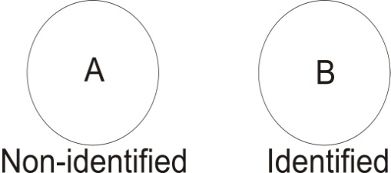Now *The* Heaven is the Infinite definition or the ‘No Definition’ as the Japanese would say. If we refuse to accept any finite definition, we consider the thing from the outside, and say, *We will take the infinite, and refuse to accept any limiting factor that we come across*. And thereby we will transcend all limitation.

Now we can do it in two ways.

## Mutual Transcendence

Supposing this represents an individual ‘A’, and here is another individual ‘B’.

‘B’ accepts his limitation. He’s identified with it.

But ‘A’ aspires beyond it, so he refuses to accept this definition as ultimate, and says, *The fact that it is circumscribed presupposes something beyond the circumscription*. So he takes his conscience beyond it. When he’s gone outside it, he’s transcended his own limitations. He then comes across another limitation, imposed on itself by another being.

Now if he has the power not to accept the limitations of his own being, then he will have the power not to accept the limitations imposed on him by another person’s definition. So [*the following as an aside to a question thrown from the audience*] *…which one, this rhinoceros? It’s a rhinoceros. Isn’t it a rhino? Will you accept it for the time being? Yes, you’ll have to. I’m imposing on you.*

The ‘A’ being, having transcended the definition of its own finity, comes to another definition of another being’s finity, and says, *I’m not going to accept your definition either. Why should I?*

‘B’ sets up a definition that says, *I am not ‘A’. I don’t like ‘A’. I’ve excluded ‘A’*.

But ‘A’ transcends the definition ‘A’ and therefore says to ‘B’, *I agree with you that you are not ‘A’, and I am not ‘A’ either, so I’m coming in*.

So he actually transcends all the limiting factors of all other beings when he’s suddenly able to transcend the finiting definition of the being from which he starts. This means that there are no closed doors for him.

If you take Christ’s statement about the married people who become one flesh[7]. He’s saying that two people — we'll do it this way for a change — two people shall become one flesh. He’s not saying that this person will give some to that, and that to that, but they shall become one flesh. He’s saying that their energies will do this together in such a way that there will be non-difference between them. Now this is the same thing as the defeating of the attempt of the lady to remain herself, or the gentleman to remain himself. He starts off with a definition of himself; she has a definition of herself; then they get married. They discover that the definitions they had no longer apply to themselves as they are. There’s been transcendence of the definition from both sides. ‘B’ has refused to accept ‘A’s definition of ‘A’, and ‘A’ refuses to accept ‘B’s definition of ‘B’. And so there’s mutual transcendence. [59:40]

## Mutual transcendence..jpgAdam Wants a Helper

It was because of this that Eve was taken out of Adam ... to make him transcend the definition of himself as, *not fit to live alone*. Remember that Adam, when he was created, was innocent, or as some cynics say, *he was a bit of a dope*. He said, *I want something to play with*. And all the animals were brought to him and he examined them all and said, *They won’t do. I must have something special*. And he wanted something like himself. So God then took out of Adam a portion of himself, the irrational portion, and separated it.

Now Adam had a definition of himself that said, *If I can get somebody to help me, then I can do something marvellous*.

And God said to him, *Really you could do this quite well from yourself, but if you don’t like the idea, we’ll take out of you — because all is absolutely not-different — that thing which you think you need outside, and we’ll put it outside. And now you can relate yourself to it, and see if it will help you as you thought*.

Now the rest of the history of society is this mutual help [laughter from the audience] which Adam had occasion now to view with suspicion. He thinks it’s a kind of unilateral compact to produce annoyances every day.

Now God, who is all seeing in the first place, was determined to make quite sure that Adam would never again ask for assistance when he’d been through it, and that he would be quite happy to create from himself, from his own centre. And therefore he said, *now the desire of the woman shall be to the man, and the man shall rule over the woman[8]*. A lovely piece of propaganda. This is to create a tension situation immediately.

Straight away, of course, the man felt terribly upset about that, because there’s nothing he wanted to do less than rule over his helpmeet. And really he didn’t want to rule at all ... he wanted to be helped. And of course the moment he wanted to be helped, she had to determine the form of the help. And as she is essentially irrational and therefore formless, the form of the help she gives is always formless help ... called being-ambitious-for-him, you see, without knowing what direction to push.

Now this gradually produces a tension situation, forcing clarity in him. And he becomes progressively more and more aware that he’d been much better on his own ... a thing he cannot believe initially, because of this tendency to look for the helpmeet.

So when God took out the Eve, or the developing part of Adam, and posited it separately from him, and created this tension situation between them, in effect, He had made sure that man would progressively transcend his definition.

Now this is very important, because when a man is born, for some peculiar reason he is generally born of a mother, and this biases him to believe that ladies are essentially kind-hearted. And this makes him want her for a helper. And as long as he wants her for a helper, he will not use his own initiative. He wills outwards into relation and wants mummy to do it for him.

Now he discovers that there’s a horrible fellow called ‘daddy’ who constantly interferes with this relation, so he decides to murder daddy if possible, and if not, eventually to find another mummy for himself. So he then takes an image of the mammy, and he looks for it outside ... and eventually he sees a girl with some formal similarities to the mammy, and he attaches himself to that.

Now he thinks that’s his new mammy. In Indian terms it would be quite legitimate for a man to look for his mammy in his wife. And the Indians actually philosophically say that a man should try to find in one girl his daughter, his sister, his wife and his mother. And if he gets the lot of them, he'll be very, very satisfied. Now that’s one of the main causes of Indian degeneration for a couple of thousand years.

Now if he does find any help at all from the female — as he defines help — he can only remain soft and uncreative. But luckily there is running through all the female line this Will, which is irrational ... that is, Willed Irrationality. It’s really a Will to transcend all formulations. So that if you invent a refrigerator that works for it, it wants one that works better next time, because the Will to transcend all the definitions produced by the male is an essential part of the female. So there’s an eternal dissatisfaction in the female Will. [1:05:20]

Now the peculiar thing about this is that this eternal dissatisfaction is orientated towards the man ... as God said, *And the desire of the woman shall be to the man*. [Genesis|3:16]. So although she is eternally dissatisfied by nature, and must remain so as long as she is a woman, she is tied by his law of spirit — which is paradoxical — to a finite that can never satisfy her. And there’s something in her that makes her hang on to it, although she knows it’s no good. She is forced by the Absolute to orientate herself towards a finite, whilst at the same time running through her are more yearnings than Cleopatra ever had. She’s yearning for infinite satisfactions, and she is tied to a finite being whom she knows perfectly well has no capacity for satisfying anything properly. And yet she can’t let go of him.

Now she can’t let go of him because the Absolute is driving her towards him, so that he can have with him a yearning for infinite satisfaction, which is the same thing as transcendence of anything he’s ever done so far that’s any good. And she refuses to let go of him. So she is the thorn in his side that drives him continuously to let go of the thing he’s done that he thinks is pretty good, and posit something else better.

Now this relation is the guarantee of human evolution. In the process of course, quite a lot of people go down in the battle of life. Most of them go into neurosis through the pressure of the infinite yearnings upon the finite mental capacities. To avoid this — and I’m talking here specifically to males — the only thing to do is to avoid identification with any finite aim, and to admit that there is a committal to infinite self-realisation, and that the chief aid to this attainment is the female Will that comes in, full of infinite yearnings, plus an orientation towards the finite, which must fail to give them ... and thus giving rise in the man to the necessity for transcending all his definitions of himself as he makes them.

Now, if you consider the mechanics of this very carefully, you'll realise that it’s the only possible arrangement for a being to evolve, once there has been a closure back to the infinite. When there has been a closure, there is set up a rotating inertic system. Of itself it cannot break out. That means it is eternally held in, and must be tremendously bored with itself unless energies from outside come into it. [1:08:29]

Now, because it’s entirely using up its energies in being, it cannot create. And because of this there is a necessity for it to part. So some transcendent force, represented in Genesis as God coming in, and saying to Adam, *Well, I will cut a piece out of you and externalise it*.

Now, the inertic part here of self-stimulation — this is self-imagery, the idea, *I am a finite* — now has something outside itself which is stressed on the Will aspect, and this Will is wanting infinite satisfaction.

Now this, self-imagery — this is like Adam in his narcissistic phase, saying, *I’m a great guy* — this narcissistic Adam, is kept in relation by the devotion of the Absolute, through the woman, onto him. This causes his definition to be proved wrong progressively. So he has to extend his definition. And gradually he will have to see that there is inside him some unformulated Will ... or a yearning for infinity.

This means that in every man there is discovered a woman. There is discovered in man this fact: that his self-imagery is one in which he can never be fully satisfied unless his image is greater than any image introduced to him from outside. So if that man thinks he’s doing very well, and he tells the wife, *I am doing very, very well*, the wife picks up the daily paper and says, *There is a man here who is doing better*.

Now this is all very good for the evolution of the individual, providing there is an acceptance on the part of that individual in the necessity for transcending every definition of himself that he’s ever had, or every definition of himself that in time he may have. [1:10:44]

## The Nature Language

[A question here from Khen Ratcliff in the audience]

We had a strange question the other night as to what sort of vocabulary Adam would have when he named the animals and these things.

Well of course that’s a kabbalistic question that is often raised. Whatever Adam said was the name ... that was the name of it. Now the idea generally is taken by scholars to mean that whatever he called them, he called them, and that was that ... there was nobody to argue with him. But the real meaning of it is: every animal has a form, and every letter has a form, and an animal with complex forms should be represented by a number of letters in a certain relation. Because sound, being the formative principle of the universe — every formal complex, every animal, every vegetable, and so on, every form complex — if you were to reduce its frequencies to the audio level, then you would hear the true name of that thing. So that the true name is really the sound emitted by that formal complex.

Thus if you take a, say a bell, you cast a bell of a certain shape. If you cast a bell of another shape, its tone will be different. So you could say that bell is called Tinkle, and this bell is called Dong. Now that would be a correct relation, to say, *It is saying what it is* ... because sound is the formative principle.

We’ve said before that sight is superficial. It only gives you the light reflected on a surface onto the eye. But sound penetrates in beings. You can take a wax apple that looks like a real apple, and a real apple, and tap them and hear the difference. You cannot be deceived about the substance of a thing if you tap it. It doesn’t matter how cleverly it’s made, if you make a steel-ball-solid and a steel-ball-hollow and tap them, you hear the difference when you cannot see the difference.

So sound is more informative. And Adam’s naming of the animals is simply that he saw into their being, and was sensitive enough to receive the complex tone, the unity principle which was the complex of all the constituent tones of the vibrating parts. So here names were accurate. And this science of naming has passed from Adam through a long line of teachers, and gave rise to the whole doctrine of magical incantation, and so on. Once upon a time the human language was such a language, called the nature language. Because the human beings at that time, the Golden Age, were so sensitive that they actually heard the sounds of nature and the sounds of substances, and they named them according to those sounds — the onomatopoeic base of language, you see — but much more deeply than is thought by philologists of today.

[Khen with another question…]

Today’s names then would be determined by the psychology of the particular people for the particular interpretation.

Yes, well, we can see that is quite valid, even so. Supposing we take a Frenchman who is a pi-rationalist, leaking a bit — and we take a German, who is Deutsche or a Teuton to himself. Now this man represents a certain complex of terms. And this man represents another complex. [1:14:35]

So supposing we give to those two men the same concept as an object, and we present them, say, with the moon. Now this is an object vibrating at a certain frequency, and a certain form complex is in itself. It vibrates and its vibrations, crossing over the substance of these other beings, produces a resultant tone. That resultant tone is the language of each nation. So there is a genius of each nation responding to one fact, in a way specifically, exactly as resultant tones are produced when we strike two together.

## moon.jpgFrench ‘main’ — German ‘hand’

So if we see that, say, one root for hand is ‘man’, and we see that the people that count in that way — *man* means to evaluate — are saying Substantial [m] Energy [a] Motion [n]. So if we say that’s the *mana*[9], or we put an ‘I’ in it for the French *[Fr:_main]*, you see, we are talking about a counting process. Because this kind of being is stressing on counting.

But a German being is concerned with power locations. So he won’t have the ‘M’ so he puts ‘H’… see? And he calls it *han*. And then he puts his limiting factor ‘D’ because we always discovers that his power has a limit ... where another power posits another ‘D’ that way. So we find in effect that all the languages like the romance languages — have the meaning, romance languages — use certain words, have ‘M’ in them signifying their substantial stress, and desire to rule the world, and to prefer mother to father. You see? And therefore we expect mariolatry out of those people. But out of the *hand* people we expect power applications, and the preference for the strong arm. [1:16:59]

And we find, in effect, that we can divide the human races up into three main categories, according to whether they are stressed on the idea, the feeling or the urge ... and that their languages spring out of these, because their beings are such vibration complexes. So whatever objects are presented to them, they are seen differently. The resultant tone arising in their mind in this case is ‘m-n’ [French] and in this case is ‘h-n’ [German].

Now the failure of the French as a people is the progressive imposition of ‘m-n’ functions on them. That is to say, they are inertic. They have a lady ruling them in their mind, and they really are very, very fond of comfort and security and sensuality, and pleasure. And to get it, they count. And by *count*, they mean, *consider the motions of that substance*.

Whereas the other people say, *Well, we are not going to count. We’re just going to hit as hard as we can. If anybody’s got it and we want it we’ll hit very hard. And we won’t bother to explain why we're hitting, because there is no explanation for that, other than that we're hitting*.

So the French always try to explain why they should go to war. But the Germans just go. And it’s only when you get a foreigner going into Germany that you will find any attempt to explain why they should fight at all. From themselves, they just fight ... and there’s no explanation needed.

So in this question of the language of Adam, we talk about the Adamic language, we're really talking about what Jakob Boehme would call the Natuursprach, the nature language that is really the language of things as they themselves vibrate and produce complexes of tones ... which *are* their real names.

## Om and Namarupa

Which means to say that if you recite the sound ‘A’ [pronounced ‘ah’], you are really resonating with all beings that have what ‘A’ means in the universe. So that you must, in reciting ‘A’, become awake. If we take A-U-M, [Eugene pronounces it as ah oo mm] which is the extended form of the Om:

|  |  |
| --- | --- |
| ‘A’ means awake  ‘U’ means dreaming,  and ‘M’ means asleep.  And the ‘M’ belongs to the belly land.  And the ‘U’ here belongs to the urge of the conqueror, the lionhearted gentleman.  And the ‘A’ is the energy up here, in the ‘awaking’ department. |  |

So that the OM is said to have these three letters in its being. Then if you recite those three together with the mouth closed [here, Eugene pronounces this sound], and know that they are in it, when you do so, you are placed in contact with all energies which are vectored into substance. So it then comprises all that is ... but it doesn’t comprise what isn’t. So that the OM only gives you the universal object. It doesn’t give you the transcendence. But when you’ve got the universal object, you can cross it off. And then what remains is transcendence. [01:20:26]

So when you are invoking at all, if you know the true name of a principle — a spirit, a demon and so on — then if you recite it, you will in effect bring your being into resonance with that principle. And then it must come into your consciousness, and you will begin to penetrate to the mechanics of its being. And as you understand the way it works from that, *then* you will be able to manipulate it.

Hence the lists that we have in the Clavis Ceremonis and so on — great lists of demons’ names. But if you look at the meaning of those demons you’ll find that they are spiritual intelligences, correctly named, letter by letter, and that if you meditate on them, you will become as clever as that particular thing, as you resonate with it ... as in the case of a phychaesthetic experiment where you identify by first writing down a symbol, and then identify with the symbol, and then the intelligence governing that symbol comes in.

And all magical formulae depend upon that fact: that there is no being in the world that is not a name. Hence the nama-rupa is really inseparable ‘name’ and ‘form.’ You notice that this ‘rupa’ [in nama-rupa] is the same thing as the ‘p-r’ function again, backwards. You see? So the Sanskrit ‘rupa’, meaning ‘form’, is the same as the Greek concept reversed.

And this ‘nama’ and ‘a-man’ is the same thing. A man is the being that names things. What he names is form. And form is name, because name is the sound aspect of form. So if you say the eye sees *rupa* and the ear hears *nama* from the same object. That being so, it means that it is quite important what kind of ideas you entertain in your mind, because an idea always has letters in it.

See, the baby hasn’t got, hasn’t got hold of an idea. It is a possibility of all ideas. But until its ears have been rattled with words, it hasn’t got hold of one in separativity. But as soon as you set up an idea, you’ve set up a differentiating factor within yourself. And if you hold it, it will work.

So that it is more correct to say that men are thought, than that they are thinking. Because — as we saw before, right from the beginning with your question — the tappings of the Absolute on the closed sphere of being, informs the being by introducing enlightening vibrations into it. So those forms entering are really thinking. And the individual who’s identified with the finite sphere and believes that he is doing the thinking, is deceived. There is thinking in process, but he is not doing it. This is why the most important exercise in Buddhism is the simple statement that, not, *I am thinking about the moon,* but, *there is thinking*. This breaks the erroneous idea that the individual as such is conducting the process. It is then realised that there is simply stimulation from outside and inside, and the resultant, and that is the form or object of consciousness. But there is no statement that it is ‘I’ that is causative. And when identification with that is taken off, then a complicating factor is removed, and then the truth of the formal relationship of inside/outside is seen, because the false stress of the individual is taken off. [01:24:30]

## Credit and Merit

So, why can’t you take the credit …[there is an indistinct question here]

Well, ‘taking the credit’ is an expression that, if you analyse, will be nearly meaningless, wouldn’t it? It means ‘assuming something’. That there is belief that you are the source of a certain kind of motion. But if you penetrate to that motion you would discover that no finite can be the source of it at all. The source of all form, of all motion, is the Infinite. And the intersections of those motions of the infinite, constitute so-called individuated thoughts. The individuated thoughts, therefore, are resultants of infinite motions, and cannot cause themselves. So if you identify yourself by naming yourself as a finite, you automatically disqualify yourself for any merit whatever. [01:25:46]

[Khen Ratcliffe asks] How would you define merit in this case?

In this case?

Mmm. Thinking of the solutions. One man can recognise a solution quicker than another man — or in a lot of cases the other man cannot — primarily because he has become clear about certain of these motions in himself…

[unclear beginning to this reply] …said that there is recognition in certain zones that doesn’t occur in other zones.

Although the same forces, or the same stimuli, appear to be present.

The definition of ‘merit’ in the Defence of The Devil [one of Eugene’s Blue Books] implies that there has been Reflexive Self-consciousness ... and then a definition made from the level of Reflexive Self-consciousness of something to be accomplished ... and then a committal of the Will onto that thing. So that the Will objectifies itself as that thing, and becomes that very thing. And that is merit. And that is the only kind of real merit there is ... where consciousness, intelligence, force …

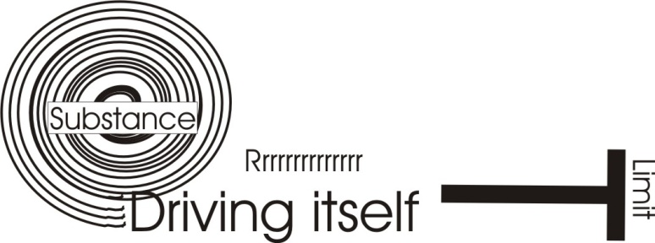It’s really like an aim isn’t it?

…*is* its own aim. This is the meaning of, *become what thou art*. Because we are absolutely force. If we get hold of ourselves [M] and drive ourselves [R] until we become thoroughly aware that we’ve reached the term of existence — so that any further move will be a return — that is the ‘T’ at the end of ‘merit.’ That means a contraction of consciousness down, instead of a leakage and splurge out into the temporal world. Notice, that leakage of consciousness into the sense world through the body, is exactly opposite to the transcendent consciousness that ignores division.

If you leak into the five-sense world you are losing energy. If you derive the definition of the finite, you are gaining infinite energy.

~~~~~~~~~~ end ~~~~~~~~~~

1. Job|41:1-8, Revelation|19:19-20, Revelation|20:4
2. In-ert-ia, in-work-ya, in-work-affirming.
3. See Grimm's Laws. B > P ~~~~~ D > T ~~~~~ G > K > X,
4. John|5:19 Then answered Jesus and said unto them, Verily, verily, I say unto you, The Son can do nothing of himself, but what he seeth the Father do: for what things soever he doeth, these also doeth the Son likewise.
5. Luke|18:17 Verily I say unto you, Whosoever shall not receive the kingdom of God as a little child shall in no wise enter therein.
6. Genesis|1:7-8 And God made the firmament, and divided the waters which were under the firmament from the waters which were above the firmament: and it was so. And God called the firmament Heaven. And the evening and the morning were the second day.
7. Mark|10:8-9 And they twain shall be one flesh: so then they are no more twain, but one flesh. What therefore God hath joined together, let not man put asunder.
8. Genesis_3:16 Unto the woman he said, I will greatly multiply thy sorrow and thy conception; in sorrow thou shalt bring forth children; and thy desire *shall be* to thy husband, and he shall rule over thee.
9. *Other examples of the root ‘man’.*

   Manciple: An officer or servant who purchases provisions for a college. Manubiary: Pertaining to the spoils of war. Manuable — of money: of a handy size. Mantissa - Math. The decimal part of a logarithm.