Reading
Reading 1
The Human Being 2
Gospel of John 3
The Letter ‘B’ 4
Circumscription and Moral 4
A Governing Concept When Reading 5
The Trinity 5
Play Analysis and the Incompleteness of the Stanislavki Method 8
H-M-N 9
Apollo and Dionysus 11
Conditioning V. Invocation 11
Mediaeval Passion Plays 12

Transcribed with diagrams and arbitrary headings by John Bailey, December 2009.
The editor’s additional comments are in square brackets[ ]

Have we any bright suggestions tonight? Hasn’t Beth got some stimulating questions?

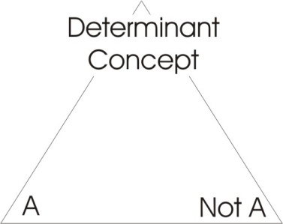
Well, we’ll start off with a little idea which sprang up in discussion a few days ago, about reading to get some benefit out of what is being read. It’s related also to the problem of choice. And you remember that when we were considering choice, we made a triangle, and then on the base we put A and not-A. And then at the top we had some determinant concept to which we refer when we have to decide whether something is A or not-A.
When we come to read, we should read either for amusement, or for information, or to determine our attitude and action to life in some way. And in order to do so we must have a governing concept, so that when we are reading the book we can continuously bring this concept into the field of the book, and examine the ideas presented by the author in the light of the governing concept.
We know that some books have a preface, and in the German some of them have a nachwort that says at the end what it was supposed to be about. If the preface or the nachwort is relevant to the book, it should help you. And it should help you by saying something about the subject matter of the book, by illuminating its governing concept ... out of which the book springs. A book, really, is an idea developed over a series of chapters or a number of words, or a juxtaposition of letters. We are dealing with the alphabet, and the alphabet arranged in various ways conveys all the ideas that human beings — who use language to think with — do in fact manipulate.[02:40]

The Human Being
Supposing we take our concept of the human being, and the H-M-N, I’ll put the H in the middle to represent the chest, the M below for the substance and the N above for the knowhow ... N for knowhow ... that’s the nous or nous [pronounced nws and na-us]. When we come to examine anything whatever presented to us in a book, if we have this governing concept we can test the validity of the book in terms of a 3-fold idea. This H represents the power of the source, precipitated into the individual. And that same power condenses, and by circulation encloses a zone, which it then fills up with its own motions. And when it has filled itself up to the limit, we say it has reached optimum power saturation, which is the same thing as optimum substantialisation.
M means substance.
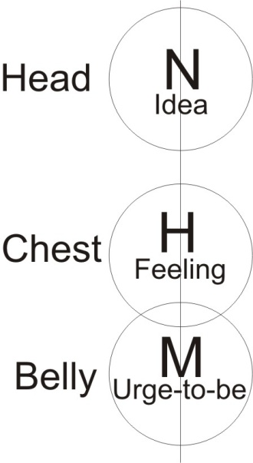
H means power. It is that power which by rotating and then closing and contracting itself produces substance. Substance is power locked up and thrown down — that’s the sub in sub-stantia — and therefore we can say there is no substance other than power, self precipitated.
When the power then has precipitated a sphere of itself, by itself, and by compacting itself has made a substance, then further activities of this power upon this substance change the form of the substance into these new determinants. And the new determinants, these formal changes are represented by N.
The N negates the uniformity of the substance, and in so doing introduces differentiating factors into it.
Now that nous is form and the word for form in the Greek is idea. An idea in the head is simply a form in the mind. But there are no forms in the mind other than forms produced by power, self-precipitated into substance, and then acted upon by further power, to produce modifications.
You know the rule that we make: No being can know other than the modifications of its own substance. When that power precipitates itself as substance, then whatever happens in that place will be the object of consciousness in that zone. The idea of form, perceived in that substance, is simply the product of the activity of the power within that substance.
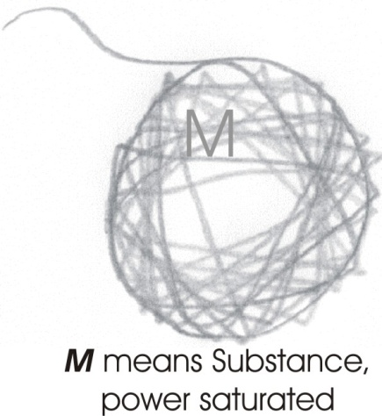
Now the power field itself is felt as feeling. The substance itself is felt as a will-to-be, an urge to exist. The coherence of substance, gravity, the tendency for substances to integrate, to mass, to coalesce is all symbolised in this letter M. Idea, feeling, and we can call it if we like the urge-to-be down here, these three we can consider to be manifestations of the Absolute.
Now they are not in fact severable. You cannot cut them and put them away from each other totally. To believe so is abstract thinking. You cannot take an idea and cut it out of the substance of your being — so that the idea is insubstantial — and still retain the idea. The idea is the form of a substantial modification, produced by power which has itself become that substance.
So when you are reading a book — I hope it’s a serious book — about anything whatever, you should ask yourself, What is the substance of this book, what is this power of this book, and what is the form of the book? The Latin form, forma is the Greek translation ... the translation of the Greek idea. And in Saxon of course it is shape. Shape, form, idea, mean the same thing: circumscription characterised, or characteristic limitation ... idea, form, shape.
Now the substance of a book is the urge-to-be which manifested in the author, and caused him to bring that book to be. The substance in our bodies, which we get by intake of food, is also precipitated by the urge-to-be. People who lose the urge-to-be lose their appetite, and as the appetite diminishes, then the substance diminishes. So there’s an equation between the urge-to-be and the appetite of a person.
Now we can be on different levels. This urge-to-be — which is substantial — once it has brought itself into simple being — like a uniform substance, the ivory of a billiard ball — is not satisfied with being in that state. It wants to do something else. And not only that, there are forces outside that also want to do something with that ivory ... they attack it. Whatever the substance is, it has an enemy: namely power outside it. That power may invade it, in the form of cosmic radiations, or bacteria. It may invade it in many ways. But as soon as a being comes into finite existence, that being is under attack from forces which themselves have not got the urge-to-be in precisely that form. [09:49]
We then look in the book we read for the urge-to-be, which made that book precisely that book and not another. We see just how much the author has felt in himself the meaning of this urge ... has become aware of the characteristics of the field which have produced this being rather than another. And we examine the ideas, the forms, shapes, which the power has induced in the substance in order to clarify itself.
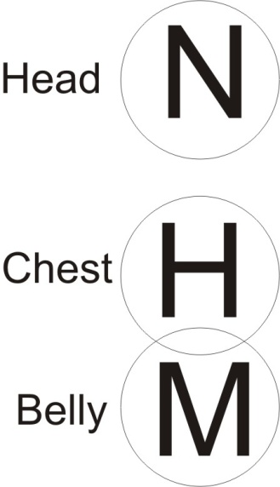
When we take the first power, the field, and we deliberately remove M-N from it — the man, the evaluator — then we take field consciousness as such, with no determinant factors in it at all. Now, as soon as we remove the M-N — that is the motion of the substance, or substantial motion — we have removed the man, men, mensuration concept, and therefore we have a pure field, unmeasurable, undefinable, infinite.
That field is not nothing as a mere negation, because that field is a field of feeling.
We are in this room. The walls circumscribe us. The walls are made of substance and have a certain form, with approximate right angles at the corners, and so on. This confines our attention. But our attention is a tension within a field. We feel immediately that the walls are not infinitely thick, but they are only finitely thick, and beyond it there is space. There is the park, there is Liverpool, there is the world, the solar system. This field extends infinitely, and we have immediate awareness — not reasoned awareness — immediate awareness of this infinite extension of the field.
This field then, in its pure form, without M or N, is an abstract idea. You cannot in fact sever the field, because if you say I am an individual man, M-N, and I will now proceed to abstract H, the field, in fact you are deliberately ignoring the abstractor himself, the M-N. And therefore you are really pretending that you are doing something which you are not doing. The man, the evaluator, is pretending that there is a field with no man in it. But it is a man who is pretending, and therefore he is really abstracting, he is taking out from the consciousness something — M-N — and throwing it away. And pretending it doesn’t exist. Factually it does. [12:47]
Now in every kind of concrete thought, the concrete objective fact for pure consciousness contains M-H-N, the great Mahan; or it contains the M-H-N, the MaHuN, another Yiddisher name, a very wealthy family; or the divine HuMaN. Now, if we remember that these three are always present and are not severable, then we can understand certain metaphysical facts. We can consider the world’s religions in their proper form. The field, which is undefined, undefinable when considered abstractly, is factually the power which substantially occupies space, and formally moves in space. All the negating factors, or limiting factors — represented by N which represents this actual boundary which negates the infinite and thus posits the finite — all those things are within the field. The packing of power within a negative zone subtantialises it, and again this is within the field. [14:09]

Gospel of John
Now, in the Gospel of John it says, In the beginning was the Word and the Word was with God and the Word was God. But in the English one, they have left out a slight difference which occurs in the Greek, where the words the god and a god are used. Although there’s no definite article in the Greek, the statement is used with the definite article, The God, and without it, god, which is translated really a god. So there is the God and a god. [14:43
[In the beginning was the Word and the Word was with The God and the Word was a God]
Now this Field Absolute is The God, but the largest finiting, the largest sphere — than which we can conceive no larger — is a god. And that God is the God of worshippers within it. When we say in him we live, move and have our being, we can mean either in the macrocosmic body of God, the Christ body, the Logos body, or we can mean the Infinite Field. When Christ says that no man has seen the Father, he is referring to this field, which being infinite, being undefinable, is absolutely and forever unseeable in any sense of the word finitely. And nevertheless that field is the power which is doing the seeing of this Cosmic Logos.

The Letter ‘B’
Now all body — by the meaning of the letter B — is circumscribed. You pronounce B by closing your mouth, packing energy behind it substantially, air, and thus filling the mouth and then exploding it. You really pile up M, you hum-mmmm, and then you press hard and release it suddenly and mmm-B occurs. This B — which is the English word booth, and the Hebrew beth, a house — means a closure, and a compact energy in it. To be is therefore to be circumscribed. And every circumscription, no matter how big, is within the infinite. The infinite is undeterminable, undefinable, because to define is to set a limit ... the fin in define is the end or limiting factor. [16:46]

Circumscription and Moral
If we think that any form — no matter how marvellous — is the end, with a sense of final goal beyond which there is nothing, if we think that that goal is the purpose of man, we are already worshiping what is called in the bible, the beast. That is to say, a finite structure — no matter how clever, no matter how kind and considerate to widows and things — we are considering a welfare state. And the word state is from that root sta, static, and so on ... to stand. And insofar as the thing is circumscribed, there are infinite possibilities beyond it.
Now, the realm of the circumscribed is the realm of the moral. The M, the substantial, and the ruling principle, the ruling activity [R], and the ligature, the L within it which ties it together. So that morality is related to substantial existence, and the ruling activities required to keep that system in being. This is why Christ left no moral doctrine, a thing that had been complained of many times by unspiritual thinkers. People who — state-established religious people — who think that the state of things on earth, the welfare state or something else of a finite order, perfectly done is the purpose of spirit. They are moral people, and they require you to behave in that manner which will establish and preserve this finite system.
So if you came to consider all the literature on moral philosophy, if the books are any good and not written by a certain gentleman who writes for a very cheap publisher and compiles his works undigested from encyclopaedias, if they are not written by him they will be — he’s written about forty books on different subjects, this particular fellow — if they are not written by him, they will be about a substantial situation, and the necessary behaviour that people must conform to, in order to keep it in being. And it is such a substantial situation with all the behaviour patterns necessary to keep it in being ... this is referred to in the bible as the beast. Because, in effect it is like a beast. You see the beast is represented as head orientated to the ground, to where its food is, to matter. So that the beast mentality is directed down into this material system. The beast likes comfort, the beast does not create unique new things, and so on. The beast is in the groove, it repeats over and over again, and no matter what kind of beast it is, it hasn’t got inside itself the power to change itself and become other than it is. [20:08]
If a mutation occurs at the level of beast, it can only occur because an alien force — a cosmic radiation or a chemical force — acts on the genetic factors in it, and forces a change; the change being forced from outside. And this is why the animals are not human. The essential thing about the human being is that he can — without waiting for a cosmic force, without waiting for a given chemical — can find inside himself an awareness, the field awareness, which being refined, makes him aware of the cosmic ideas, and which makes him aware of the urge-to-be a thing. And he then has the power, at the feeling level, of preferring one thing to another from the absolute end ... instead of from the end of material stimulation. [21:05]
So a human being differs from an animal in this ... not in degree, like the evolutionists pretend. It isn’t a difference in degree between an ape and a man. The difference is absolute, because the authority of man comes from inside man, and has power to battle against invading forces. But the animal hasn’t. The animal is determined by the nature of the stimulus, and the nature of the matter involved in its being. This is a determinant difference that must always be remembered. We mustn’t allow that man is simply a mineral become a vegetable, become an animal ... just slightly improved. He comes from the opposite end, from the end of pure consciousness, pure field awareness.

A Governing Concept When Reading
When we then read the book, we have this governing concept. We say to ourselves we are going to look at the book in every way possible to us, and use as a guide this 3-fold scheme. You know what we say, qui bono ... to whom the good? When something is being said, Who is getting the benefit over this thing? We say it, and then we say, What is the particular urge-to-be manifested in this book? What is the author trying to bring into being? What is the level of his feeling awareness that makes him try to bring that into being, and what is the particular idea structure which he uses to try to justify bringing it into being?

The Trinity
Now you then have a 3-fold yardstick. Now the letter Y, although it sometimes sounds like an ‘I’ in English words, is pronounced with a slight attack on it in the Hebrew, so instead of saying Israel, as we would say it, they would say Yisrael. They attack it with a Yuh. Now this little attack means affirmation. So ya, yes, yeah, and so on, all come out of this primary attack ... the Yuh.
Now if you look at a mystical diagram of this 3-fold power, you will find three letters, and they are in Hebrew the yods, those yod letters are really drawings primarily of the hand of god, like this. Cut that hand off at the wrist, and that is the form of that letter. And the word Yod in Hebrew means hand. And the hand is the symbol of this power to create, to be in the hand of god.
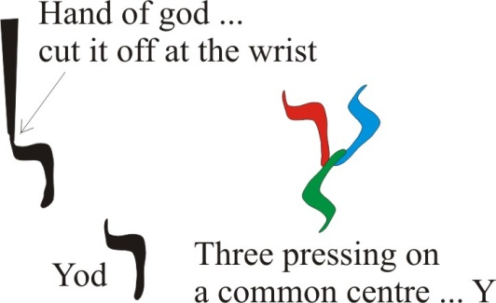
Now there are three of these, pressing onto a common centre here, to make this letter Y. And because they are points, jots, dots, iotas, they are points of source energies for the 3-fold structure of man. So there are three yods here.
- There’s the affirmation, the executive power that makes ideas,
- the affirmation of the field energy,
- and the affirmation of substance.
These three must be kept quite distinct when you are reading a book. You know that the trinity in Christianity is a difficult concept until you get to the level of concrete thinking. You must not divide the substance ... you must not confound the person. There is the Father, the Son, and the egressing spirit or Holy Ghost. The father is not the Son, the Son is not the Father and the Ghost is neither of them. But this Ghost proceeds equally from the Father and the Son. [25:04]
Now although they are different, they are not absolutely ‘other’. They are functionally different, and they are different persons. And it’s very important to get this concept of the personal difference right.
Inside the human being you will find an awareness of an idea. This awareness of the idea is actually busy making ideas. And this is a fact.

- There’s something in you that actually is orientated to making ideas. And this you could call the idea person ... the per-son, the persona, this through-sounding, per-sona, through-sounding.
- There is something sounding through one of these centres, which is determined to make idea.
- There’s something sounding through another, a little concerned with the idea, but it’s concerned with the feeling accompanying the idea, which is really the field state, the vibrational field state which results when an idea is produced, and which itself is cause of the idea produced. [26:12]
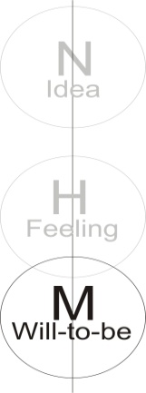
So we have inside ourselves this person, this through-sounding energy, which makes ideas. And we have also, simultaneously — but quite other, but not severed from this person, this through-sounding-energy — that feels the value of the ideas so made. And we also have this person which appears as the urge-to-be.
So we have factually a 3-fold experience in ourselves. We have an urge-to-be, regardless of what we’re going to be ... the urge-to-be before we know what we’re going to be. We urge-to-be before we find out what anybody wants to be, and before they have a clear idea of what’s worthwhile being. And before we’ve discovered anything about sensitivity of feeling, to see whether it’s worthwhile bothering to be, there is the urge-to-be.
This urge-to-be, which manifests as JT [John Thomas] and MT [?] in the individual, this urge-to-be is simply an urge-to-be. It is a definite amount of energy from infinity, appearing finitely, and producing individuated substances. It is only concerned to produce substances. The urge-to-be, extending the urge-to-become, the urge to precipitate oneself into the future, the ground of the procreation urge, is not concerned with the quality of what is produced, the appropriateness-to-the-time of what is produced, whether there’s any room for what is produced ... it is simply being, urging itself into expression, urging itself into existence ... the urge-to-be, regardless of whether the thing that’s going-to-be is rubbishy or not. [28:08]
A cabbage with its resident urge-to-be, if it were not controlled it would overgrow the earth, and so would an elephant, and so would every other form of life ... unless they were mutually restricted by these contradictory urges-to-be in all finite forms. And then any single life would extend throughout the whole of infinite space, and bore itself still with its essential identity. So this urge-to-be is factually a separate thing from this power that manifests as idea.
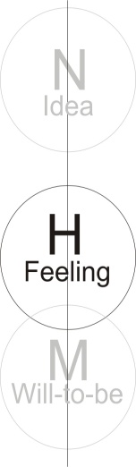
The man who is stressed in the idea level, and his urge-to-be is not very strong, he might languish, he might faint in a chair. And nevertheless while he is fainting he is having exquisite ideas, beautiful ideas ... like an arabesque. And all the energies in him — are the ideas of a different frequency from the urge-to-be — all those energies might come in and be terribly powerful, and fill his mind with intellectual propositions, and he may thoroughly enjoy himself at the idea level, and have no urge-to-be whatever, no urge to push himself into the M level, to substantiate himself ... because that person is only concerned with the ideas. And he may have no feeling. It isn’t a question of liking or disliking at the pleasure/pain level. It is a question of the energy that formulates.
In the same way another being may be stressed at the level of the feeling person. The energy sounding through — the personal feeling energy — will just like and dislike whatever is presented. It has no urge-to-be in it, and it has no idea in it ... it’s simply liking and disliking. It’s a flux with which it presses itself a little and then stops in case it hurts itself. Then it expands itself a little, and then it stops in case it hurts itself. And so it’s pulsing all the time. It’s saying, I think I like it ... it’s a bit too hard I’ll go back ... I think it’s a bit too far I’ll go back. And this pulsating, feeling life is then a separate being in its own right.
Now these three cannot be severed. You can’t take a knife and cut them, and yet they are totally different. And this is a fact inside every human being. [30:45]
- You have an idea. You can look at the idea, and simultaneously you can feel that you don’t like the idea. And in the idea department you will hear a voice saying, but this is eminently reason, and no doubt fix the situation and should be the formal control for all activities.
- And the feeling says, I don’t like it.
- And the urge-to-be says, I’m busy at the moment round the corner ... with a widow who’s got an off-licence.
Now, these three things happen, and the men who write books — most of whom don’t know how these three things operate — are busy trying to bring-in-to-be certain things, and there’s a certain amount of feeling there, and a certain number of ideas. The ideas are rationally supposed to justify this urge-to-be, which makes them write the book.
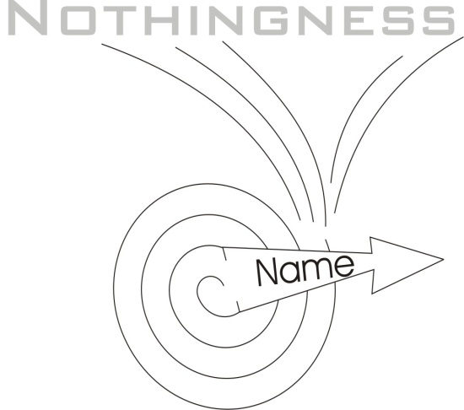
There’s a book called The Hidden Teaching Beyond the Hidden Teachings. Now that kind of book comes from an urge-to-be in a man. There’s really no idea correspondent to it. But he has an urge-to-be a writer. So he writes another book ... because he wants to make books. He hasn’t got an idea, because he wrote the final book rather prematurely last week. But the urge-to-be is still there, so he writes another ... The Final Teaching beyond the Ultimate. Now it doesn’t matter how silly the title is, there will be buyers, because the urge-to-be will want to read the book about the beyond-the-ultimate ... because it’s naturally an energy that throws itself out perpetually into infinity. And it can do so, because it’s drawing its energy from infinity. So it’s like a little doorway considered ... [can’t make out a phrase here ??????] ... it brings from infinity and it’s fixed spins round and throws them back again. And on the outgoing, it writes its name. On the in-going there is nothingness. This urge-to-be then, can make an author produce a book, and another book, and a book to end books, and then a book to explain the book to end books, and so on, infinitely, simply because it’s the product of the urge-to-be. [33:08]
Now the rational structure very quickly exhausts itself in dialectical principles. That is to say, the simple logic of either/or, and the fact of the identity of opposites, very quickly circumscribes the possible books that may be written in subject matter. But it does not in any way affect the urge-to-be. So when the final book has been adequately written — which was no doubt in German — then somebody will re-write it in English. And then a German will get hold of it and translate it again ... and it will come out differently.
I’ve got a copy of a book which is written in English from notes made by Jeremy Bentham. And it’s so obscure that a Frenchman translated it into French. And when the publisher wanted to do it in English, he didn’t get the original, he got the French translation because it was so clear, and then did it back into English. And it’s a much better book. Now this is the urge-to-be that publishers have .. the urge-to-be booky ... to keep pushing them out.
We then have a 3-fold yardstick to test anything whatever that we are reading. We can test of course what people are saying as well, because books are only sayings recorded.
All the time, we’re dealing with a being which has these three persons inside. There is a concrete whole, and because of the Law of the Inequality of Finites, every author must be finitely stressed differently from others. That means the mere fact that he has made a book means that he is presenting you with a stressed account of some aspect of the universe, for some purpose. Probably the best books in the world are really compensation books, to offset the other best books. Because the best books are very powerful ... they move people. And the people who can be moved by the best books are invariably moved too far, and therefore they need another best book of the opposite order, to push them back again. [35:20]
If we remember this simple 3-fold principle, then whatever we are reading, we will find out very quickly whether it is sensible.
Publishers on their paper jackets today give you a blurb that says something about the author, and something about the book. If you read it, it may tell you what the book is supposed to be, what urge has brought it into being. It is fulfilling a long-felt want [audience chuckle]. And the form of the want has precipitated the book. But at the back of it all is the urge-to-be pushing people, to find something that people want, because of the urge-to-be. These three cannot be separated, severed, and made into disconnected entities. So if anybody accuses you of believing in ideas only, and you want to justify yourself — balance yourself — you must say that no idea can exist which is not in a field, which is feeling the characteristic action of that idea, that is itself equipped with an urge-to-be. [36:33]

Play Analysis and the Incompleteness of the Stanislavki Method
We were discussing last night certain aspects of acting, and the necessity for analysis of a play, because a particular play, through inadequate analysis of the first act, had gone badly. The unity had been destroyed, because the first act was considered to be humorous, and the second and third manifestly were not. And the trouble arose because the first act was very strongly charged with dialect. And the dialect had a peculiar kind of humour in itself. But underlying it, the subject matter was quite serious. And we then discussed the necessity — or otherwise — of analysing a play structure right through. And immediately there was a reaction, That would breed intellectualism.
Now, if we removed the analysis completely, you don’t bother to read the play before you put it on. And when this was pointed out, it was seen that there could be a happy medium. When presenting a play, it’s not a bad idea to read it first. And each person in it should read his own part, and think a little about the relations, but all this is intellectual activity. If, when the analysis is done, then the person refers only to ideas and nothing else, then the acting performance will be deficient in the urge-to-be. There would be no drive behind it. Also he will not feel adequately the relation between the idea forms and the audience reaction.
The danger of intellectualism is abstraction. That is, taking the idea, and pretending you can have an idea valid in and of itself, which is not substantially the product of an urge-to-be, and is not itself felt. [38:25]
I don’t know if any of you saw the little short program on the Stanislavksi Method stuff on a program recently, where an analysis was made, a triangle analysis of an actor, another actor, and an audience.

- It was said that a certain kind of actor never lets his mind go outside himself. He doesn’t know that there’s an audience, and he doesn’t know that there’s another actor. This is the kind that we would actually call a Narcissus. He is reflecting on himself. It’s sufficient for him actually to be on the stage, and to act. If you think there aren’t any such, then you are mistaken ... there are. One I know, who actually says he doesn’t care if nobody comes, and he doesn’t care if there’s no audience, and if the other actors all get the flu and don’t turn up. He can go on and do his part. And he wants no more. And he’s quite serious about this, because he feels that he is sufficient in his own emotions and interpretations to satisfy himself. That was called actor number one.
- Then there was another actor, who was aware that there was an audience, but he was totally unaware that there was another actor. So he played to the audience. He tried to amuse the audience, to frighten the audience, to move the audience ... but he didn’t know there was another actor. That was the second type.
- Then there was the third type that knew there was another actor.

And here, the analysis really was incomplete, because they only had the three types. This kind knew that there was another actor, and they concentrated on the play, and luckily he’d got another actor of the same order. And between them, they created a tension in their interrelation, such that the audience were forced to take notice of them. Now when this Stanislavski expert represented this diagram, immediately one of the students said, Are we supposed to forget that the audience exists completely? Because he felt that it was incomplete. We’d had a Narcissistic actor; and we’d had one that was aware of the audience but not of another actor; and then a third actor, who was aware that there was another actor.
But in fact every actor who is top level, knows his job, is aware of the other actor, and he is aware of the audience reaction to himself, and to the other actors, and to the significance of the play ... simultaneously. And the man who can do this has what is called good timing. He doesn’t lose a line. If his brother actor on the stage gets a slight snigger from the audience lasting five seconds, he doesn’t come in with his line on the third second, and lose it. He just holds it sufficiently. He might even say the first two words, but he’ll repeat them again at the very moment the laughter is dying, and bring it up again. So really there is another order of actor: the one who is aware of the whole situation; who knows there’s an audience; who knows there are other actors; and who knows that there is a play of significance. Now this is a fuller analysis than the one that came. You can see immediately, if we take the actors as individual human beings, there are individual human beings ... even actors are individuals.

- An individual may be a Narcissus, he may be so saturated with himself that he can go into his own single room flat, stand before a full length mirror, and admire himself ‘til bedtime. This actually happens.
- Another individual can be aware of his effect on a group of people, and at the same time be totally indifferent to his relation with any other individual within in that field. That’s the second.
- Another one may be aware that there is another individual, and relate to that individual, and totally forget that there is an audience. Sometimes children pick up strange words because two such adults have forgotten that they are not alone, and they talked on their own level, and they don’t know there’s an audience.
- Now, if you’re really aware that there is an audience, obviously — as consciousness is a catalyst — it must modify your conversation. And if you see here a sound, and there a smile, and there a look of indifference in a large number of people, it must, if you are aware of it, modify somewhat the demands made on the situation.
- But still that’s only the actors and the audience relation. At the back of all of it is the play and its significance.

When Shakespeare said, All the world’s a stage, he mean what he said. It is a stage. A stage is when you stand on the earth for a period. The Absolute comes down — there are degrees — stands on the earth, sta-ge [sta-stand, ge-earth] stage, and then goes back again. It is a stage in the development, the de-veiling or removing of the veils from the optics, by meditation upon the source ... spirit, from which we derive. Now all the men and women on this earth are at a stage of development requiring external stimulation from the world of matter, and from each other. And in that process of mutual stimulation, they are made aware of higher degrees of being. If we then know the purpose, it is like knowing the plot of the play, knowing the significance of the plot. And we then keep this ground significance, and we use this significance to make our 3-fold analysis. [44:57]

H-M-N
So if we now look back at this H-M-N, this human being, and we see that the Field Absolute has precipitated substances — I say ‘substance’ plural, because each zone of compaction is a unific substance, it has produced substances — and then between these substances, relations. And the form of activity of the substances, which is the M, conditions the substantial state of other beings. All is produced by this field, which is felt. And this feeling state, prior to this precipitation of substances, is the Pure Light of the Absolute ... it’s the clear light in the Tibetan Book of The Dead. It’s called the clear light in lots of Buddhist works. It’s called the clear light because it has no shadow of turning in it.
Now, no shadow of turning means there are no rotations. This field absolutely is light, because light is a propagation, a motion of this power. And when it is not considered to be rotating, turning, there is no shadow in it, there is no shadow of turning ... it is the clear light.
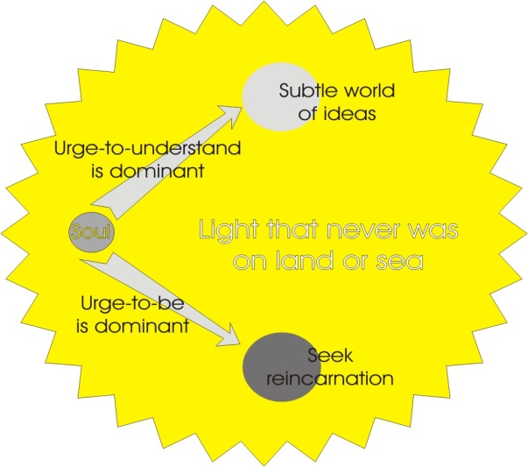
When it is experienced — which it is in post-mortem states, and it is in certain meditations — the ... [?] ... arises of losing it ... because it is undefined. It is a pure ocean of equable light. The light that never was on land or sea. But that light is itself permeating every form, every finite, so that all finites are transparent to it, and therefore they are as if lost in that ocean of light. So that all the individual men call value is transcended in that light, and therefore although people reach it in their post mortum state, they usually fall either to M or to N very shortly afterwards.
If they have the urge-to-be dominant they fall back into incarnation at the material level, or strive to do so. If they have the urge to understand the form of their experience, then they move into the subtle world of ideas. Now it’s obvious that the urge-to-be is the cause of incarnation, and the urge-to-understand is the cause of the movement in the opposite direction. [47:52]
You have field energy, and the field energy may appear as substance, and it may appear as form. But if it appears as substance only, it produces a unific mass inertia. If it appears as form or idea, then understanding of the relations— fundamentally mechanical — of the forms, appears in the mind, and then the inertia, mass inertia, is overcome.
And this is the 2-fold tendency of the field energy. To precipitate a mass which then becomes inertic and repeats itself ... and to precipitate form. And the form tends to break the inertia. But the inertia, if dominant, tends to stop formal development.
Now, the male mind tends to break into the idea world, and the female mind into the substantial. And so we would find in the mediaeval scholastics, the statement, that the soul of the woman is moving in this direction [substantial], and is not of a rational bias. Now, remember rationality is only formal presentation, and if abstracted from the field and urge-to-be becomes, in effect, a pseudo-entity. It has no reality if you deprive it of its substance, and of its feeling experience. And yet in itself, it gives you the rational — that is, the proportional, formal — relation of the things that have got the urge-to-be and do exist in the field.
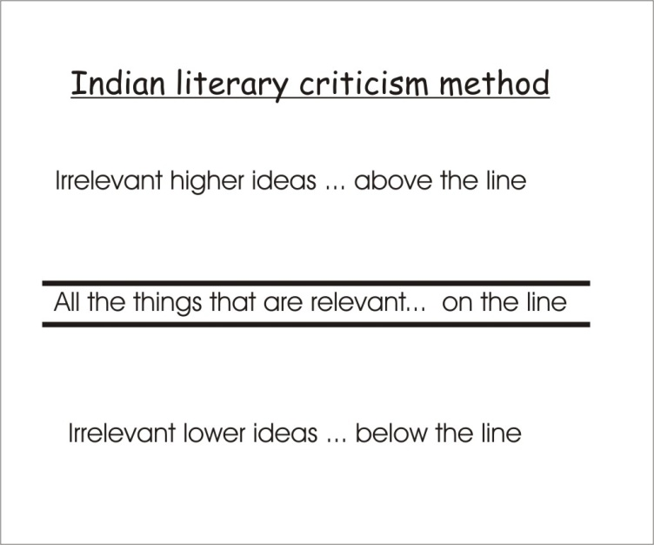
We return to the books for a moment. When we read a book, let’s look at it, try to find out what was the urge-to-be which precipitated the substance of this book. We can do this by examining the ideas in the book ... what he claims to be doing. And we test the idea structures for consistency, to see whether the thing he states is actually carried out.
The Indian method of doing this, in literary criticism, is to read the beginning of the book — a preface if there is one — then the end of the book, and to write what it said at the beginning and what it said at the end down, and then to draw a line. And then to read the book very carefully. And all the things that are relevant you write on this line; all the things that are irrelevant to it, and if they’re really higher ideas, you write up here, and all the things that are irrelevant and lower ideas you write below this line.

Apollo and Dionysus
Now if you do that with any book, you will find that most of them stick out with sore thumbs all over. They have been made by men in general who have been biased, either on idea — the philosophers, the Pi men, all the Greek Philosophers who begin with a P, like Plato and Pythagoras and Proclus and so on — all those men are concerned with the formal analysis. They tend to devalue the urge-to-be and we could say that they are Apollonian. They are order men. They like to rationalise the state, and say how it should be run. Plato’s Republic is typical.
The urge-to-be men are Dionysian. They are going to break every form produced by the rationalists, because they want to carry on being and becoming. So there will be a conflict between books written from M and books written from N. And if an author is not sure of himself — and that means an author — then there will be some elements of M and some of N in him, fighting. And when they fight together, they always produce a feeling of indecision in the book.
So you clarify the formal content of the book, and the substantial ground of the book, and you use these two ideas to test how clear the man’s ideas were, how much energy he had backing those, and how much feeling awareness of the conflict between these two were in his organism. [52:33]
Have we any thoughts about that?

Conditioning V. Invocation
One of the things that often is said to me with regard to actors and things like that is that there must be to a certain extent, when a person is acting out an event, a tendency towards invocation ... could that be so?
Um. I would say nearly 100% of actors would think you were being a little mysterious.
What I was thinking about was there must be a certain amount of energy in a particular event. When you re-enact that thing, event, completely, would it help to be an invocation on top of it?
It would, but you would not then conform to the definition of an actor, as used by an actor. If you said to an actor, You are invoking the entities in the play into your being, in an imaginary sense, which is what you mean, he would be terribly surprised and also he’d be a bit frightened.
It’s amazing. I don’t know if he’s doing it ... what I’m asking is: could he be doing it?
He could only do it if he were aware that he were doing that ... and that was his intention. [53:50]
What I’m thinking about is ... I’m thinking about actors who play for a long period a highly emotional play, a part, a highly emotional part, in which he was supposed to be, say, a mental case, and actors who’d done this for a certain period actually became like this ...
Yes well you have to distinguish there between conditioning the nervous system by sheer repetition, and invoking, calling in, transcendent forces. The magician is calling in forces outside himself. He’s invoking spiritual energies — calling them in — but he knows they exist.
Now, the actor who may play the part of a neurotic is, by repetition of a certain behaviour pattern, conditioning the nervous system, and establishing a line of least resistance. And if he does — it is what they call — a rather unlucky act, and has a long run of 600 performances, then the nervous system would have been knit in such a way that it wouldn’t respond in any other way. But that wouldn’t be invocation. That would be a pure mechanical process of conditioning, like a Pavlov dog, whereas invocation is of a totally other order.
Now I know a few actors who actually know that it’s possible, and in their own work do — when they can get away with it — practice invocation. Sometimes they don’t invoke the author’s intention as an individual, because the idea trying to get through the author was bigger than the author knew about. So they invoke the idea that he would have dealt with, if he had been aware of it. When that comes through it comes through very forcefully, and very strongly. But it does tend to make the other actors look weak, so it has to be pulled down deliberately, in order to avoid destroying the unity of the play.
But they must be kept perfectly separate.
Repetition of an act in which you believe that you are simply giving an interpretation of a character by physical behaviour, using your voice, intonation and so on ... that is merely a conditioning process at the physical and psychological level. Whereas an act of invocation is taking a transcendent spirit — transcendent to the individual magician — and by a certain process of heightening the will, to bring a resonance relation between the will of the individual magician and this transcendent force, in such a way that the transcendent force — which is always seeking a body ... every spirit seeks a body is a rule — if the magician elevates his will to that point, then that transcendent spirit was just waiting for somebody to do that. And immediately he calls ... it comes in. [56:56]
There arises the problem of banishing ... which is just as hard as invoking. It is actually done by a system of opposite forces ... when it is done successfully. [57:13]

Mediaeval Passion Plays
The mediaeval Passion Plays would be attempted invocation though, wouldn’t they?
They were not so intended, no. They were intended to teach more-or-less church doctrine, in a fairly simple form, and to make it visible, and to determine the attitude of people towards certain doctrines ... to condition behaviour, really. You know that actually the actors were not all professionals — few were — and they would select from their citizens, people to play the parts. And they would then present one of these Passion Plays, simply as an action determined for people.
And of course people began to enjoy them ... as plays. And they had to introduce little amusing bits to keep the attention of the audience. And very quickly the church leaders discovered that those presentations were not doing what they aught to do. They weren’t making people aware of religious doctrine ... they were merely biasing people to enjoy the play. And so the church decided to discontinue them. And when they did, then the laity took them over. And really, our theatre is an evolute of religious drama, which aimed at conditioning the activity of people. So it is not invocation at all.
Where invocation occurs it can only occur with individuals who have reached a certain level of understanding ... that is, their ideas are right about it; they have a definite urge-to-be, to become; and they have a field awareness, which makes them able to resonate, to respond with these transcendent forces.
We must never be deceived by a superficial similarity between two processes which really come from opposite ends of the universe. Just like the scientific concept of evolution, and the real concepts behind religion. At one end you have the free, and the other end the domed. The whole man has free-dome [freedom].
The scientist is concerned with dome analysis.
The true religious mind is concerned with the free, and how to get more of it.

~ End ~

Act 17:28 For in him we live, and move, and have our being; as certain also of your own poets have said, For we are also his offspring.
Joh 1:18 No man hath seen God at any time; the only begotten Son, which is in the bosom of the Father, he hath declared him.
There are many references to the beast in the Revelation.
In other talks Eugene has given the word ‘life’ the acronym of the Law of the Inequality of Finite Existence.
http://en.wikipedia.org/wiki/Stanislavski's_system
William Shakespeare's As You Like It Act II Scene VII: All the world's a stage is a phrase that begins a monologue by Jaques.

